**Упражнение 1**

**SET SERVEROUTPUT ON**



DECLARE

v_fname VARCHAR2(20);

BEGIN

select first_name into v_fname FROM employees

WHERE employee_id=100;

END;



------------

DECLARE

v_fname VARCHAR(20);

BEGIN

SELECT first_name

INTO v_fname

FROM employees

WHERE employee_id = 100;

DBMS_OUTPUT.PUT_LINE(' The First Name of the Employee is ' || v_fname);

END;

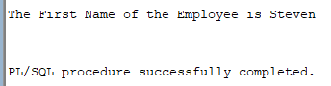

--------------------------

DECLARE

v_myName VARCHAR(20);

BEGIN

DBMS_OUTPUT.PUT_LINE('My name is: '||v_myName );

v_myName := 'John';

DBMS_OUTPUT.PUT_LINE('My name is: '||v_myName );

END;

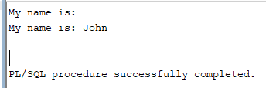

----------------

DECLARE

v_myName VARCHAR(20):= 'John';

BEGIN

v_myName:= 'Steven';

DBMS_OUTPUT.PUT_LINE('My name is: '||v_myName);

END;

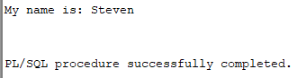

----------------------------------

-- exercise 1 --

DECLARE

v_first_name VARCHAR2(20 BYTE);

v_last_name VARCHAR2(25 BYTE);

v_employee_id NUMBER(6, 0) := &employee_id;

BEGIN

SELECT

first_name,

last_name

INTO

v_first_name,

v_last_name

FROM

employees

WHERE

employee_id = v_employee_id;

dbms_output.put_line('My first name is ' || v_first_name || ' and my last name is ' || v_last_name);

END;

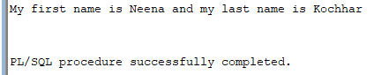

-- exercise 2 --

DECLARE

v_first_name VARCHAR2(20 BYTE);

v_last_name VARCHAR2(25 BYTE);

v_salary NUMBER(8, 2) := &salary;

BEGIN

SELECT

first_name,

last_name,

salary

INTO

v_first_name,

v_last_name,

v_salary

FROM

employees

WHERE

salary > v_salary

AND ROWNUM <= 1;

dbms_output.put_line('My first name is '

|| v_first_name

|| ' and my last name is '

|| v_last_name

|| ' and my salary is '

|| v_salary);

END;

