**Упражнение 4**

select count(*) from employees;



----

BEGIN

INSERT INTO employees

(employee_id, first_name, last_name, email, hire_date, job_id, salary)

VALUES(employees_seq.NEXTVAL, 'Ruth', 'Cores', 'RCORES',CURRENT_DATE, 'AD_ASST', 4000);

END;



---

select count(*) from employees;



---

**rollback;**



-----------------------------------------------------------------------------------------------------------------

SELECT first_name, salary FROM employees WHERE job_id = 'ST_CLERK';

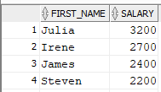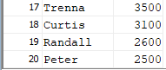

---

DECLARE

sal_increase employees.salary%TYPE := 800;

BEGIN

UPDATE employees SET salary = salary + sal_increase WHERE job_id = 'ST_CLERK';

END;



---

SELECT first_name, salary FROM employees WHERE job_id = 'ST_CLERK';

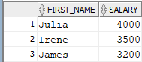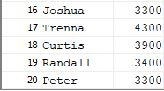

---

**rollback;**



------------------------------------------------------------------------------------------------------------

**Създаване на таблица employees2**

CREATE table employees2 as (select * from employees);



---

DECLARE

deptno employees2.department_id%TYPE := 10;

BEGIN

DELETE FROM employees2 WHERE department_id = deptno;

END;



--------------------------------------------------------------

DECLARE

v_rows_deleted VARCHAR2(30);

v_empno employees2.employee_id%TYPE := 176;

BEGIN

DELETE FROM employees2 WHERE employee_id = v_empno;

v_rows_deleted := (SQL%ROWCOUNT || ' row deleted.');

DBMS_OUTPUT.PUT_LINE (v_rows_deleted);

END;



---------------------

**Изтриване на таблица employees2**

