**Упражнение 5**

**set serveroutput on**

DECLARE

myage number:=31;

BEGIN

IF myage < 11

THEN

DBMS_OUTPUT.PUT_LINE(' I am a child ');

END IF;

END;



DECLARE

myage number:=31;

BEGIN

IF myage < 11

THEN

DBMS_OUTPUT.PUT_LINE(' I am a child ');

ELSE

DBMS_OUTPUT.PUT_LINE(' I am not a child ');

END IF;

END;



DECLARE

myage number:=31;

BEGIN

IF myage < 11

THEN

DBMS_OUTPUT.PUT_LINE(' I am a child ');

ELSIF myage < 20

THEN

DBMS_OUTPUT.PUT_LINE(' I am young ');

ELSIF myage < 30

THEN

DBMS_OUTPUT.PUT_LINE(' I am in my twenties');

ELSIF myage < 40

THEN

DBMS_OUTPUT.PUT_LINE(' I am in my thirties');

ELSE

DBMS_OUTPUT.PUT_LINE(' I am always young ');

END IF;

END;



**Пример с NULL**

DECLARE

myage number;

BEGIN

IF myage < 11

THEN

DBMS_OUTPUT.PUT_LINE(' I am a child ');

ELSE

DBMS_OUTPUT.PUT_LINE(' I am not a child ');

END IF;

END;



SET VERIFY OFF

DECLARE

grade CHAR(1) := UPPER('&grade');

appraisal VARCHAR2(20);

BEGIN

appraisal :=

CASE grade

WHEN 'A' THEN 'Excellent'

WHEN 'B' THEN 'Very Good'

WHEN 'C' THEN 'Good'

ELSE 'No such grade'

END;

DBMS_OUTPUT.PUT_LINE ('Grade: '|| grade || ' Appraisal ' || appraisal);

END;



DECLARE

grade CHAR(1) := UPPER('&grade');

appraisal VARCHAR2(20);

BEGIN

appraisal :=

CASE

WHEN grade = 'A' THEN 'Excellent'

WHEN grade IN ('B','C') THEN 'Good'

ELSE 'No such grade'

END;

DBMS_OUTPUT.PUT_LINE ('Grade: '|| grade || ' Appraisal ' || appraisal);

END;



DECLARE

deptid NUMBER;

deptname VARCHAR2(20);

emps NUMBER;

mngid NUMBER:= 108;

BEGIN

CASE mngid

WHEN 108 THEN

SELECT department_id, department_name INTO deptid, deptname

FROM departments WHERE manager_id=108;

SELECT count(*) INTO emps FROM employees WHERE

department_id=deptid;

WHEN 200 THEN

SELECT department_id, department_name INTO deptid, deptname

FROM departments WHERE manager_id=200;

SELECT count(*) INTO emps FROM employees WHERE

department_id=deptid;

WHEN 121 THEN

SELECT department_id, department_name INTO deptid, deptname

FROM departments WHERE manager_id=121;

SELECT count(*) INTO emps FROM employees WHERE

department_id=deptid;

END CASE;

DBMS_OUTPUT.PUT_LINE ('You are working in the '|| deptname||' department. There are '||emps ||' employees in this department');

END;



**Преглед на данните в таблица locations**

select * FROM locations;

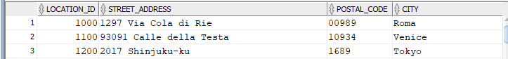

----

DECLARE

v_countryid locations.country_id%TYPE := 'CA';

v_loc_id locations.location_id%TYPE;

v_counter NUMBER(2) := 1;

v_new_city locations.city%TYPE := 'Montreal';

BEGIN

SELECT MAX(location_id) INTO v_loc_id FROM locations

WHERE country_id = v_countryid;

LOOP

INSERT INTO locations(location_id, city, country_id)

VALUES((v_loc_id + v_counter), v_new_city, v_countryid);

v_counter := v_counter + 1;

EXIT WHEN v_counter > 3;

END LOOP;

END;



--------

**Преглед на данните в таблица locations**

select * FROM locations;

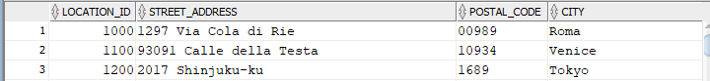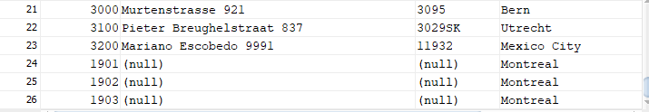

---

**Отказ от вмъкването на данни**

**rollback;**



**Преглед на данните в таблица locations**

SELECT * FROM locations;

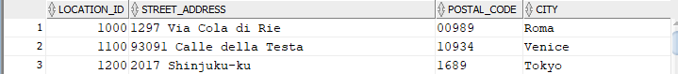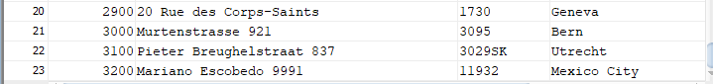

-----

DECLARE

v_countryid locations.country_id%TYPE := 'CA';

v_loc_id locations.location_id%TYPE;

v_new_city locations.city%TYPE := 'Montreal';

v_counter NUMBER := 1;

BEGIN

SELECT MAX(location_id) INTO v_loc_id FROM locations

WHERE country_id = v_countryid;

WHILE v_counter <= 3 LOOP

INSERT INTO locations(location_id, city, country_id)

VALUES((v_loc_id + v_counter), v_new_city, v_countryid);

v_counter := v_counter + 1;

END LOOP;

END;



**Преглед на данните в таблица locations**

SELECT * FROM locations;

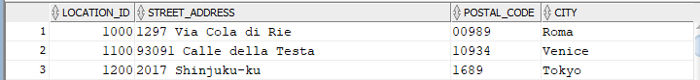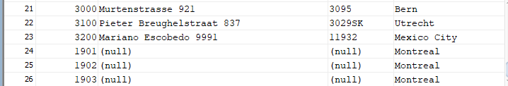

---

**Отказ от вмъкването на данни**

**ROLLBACK;**



**Преглед на данните в таблица locations**

Select * FROM locations;

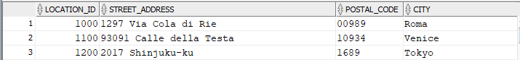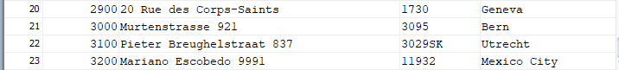

---

DECLARE

v_countryid locations.country_id%TYPE := 'CA';

v_loc_id locations.location_id%TYPE;

v_new_city locations.city%TYPE := 'Montreal';

BEGIN

SELECT MAX(location_id) INTO v_loc_id

FROM locations

WHERE country_id = v_countryid;

FOR i IN 1..3 LOOP

INSERT INTO locations(location_id, city, country_id)

VALUES((v_loc_id + i), v_new_city, v_countryid );

END LOOP;

END;



**---**

**Преглед на данните в таблица locations**

Select * FROM locations;

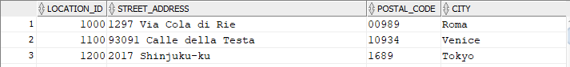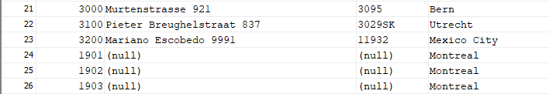

**Отказ от вмъкването на данни**

**ROLLBACK;**



DECLARE

v_total SIMPLE_INTEGER := 0;

BEGIN

FOR i IN 1..10 LOOP

v_total := v_total + i;

dbms_output.put_line ('Total is: '|| v_total);

CONTINUE WHEN i > 5;

v_total := v_total + i;

dbms_output.put_line ('Out of Loop Total is: '|| v_total);

END LOOP;

END;

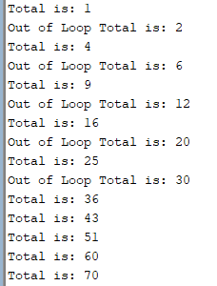

DECLARE

v_total NUMBER := 0;

BEGIN

<<BeforeTopLoop>>

FOR i IN 1..10 LOOP

v_total := v_total + 1;

dbms_output.put_line ('Total is: ' || v_total);

FOR j IN 1..10 LOOP

CONTINUE BeforeTopLoop WHEN i + j > 5;

v_total := v_total + 1;

END LOOP;

END LOOP;

END two_loop;

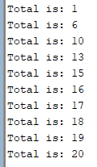

**Зад 1.** Изведете брой служители от зададен номер на отдел, ако номерът е > 30. Изведете съобщение при номер <=30.

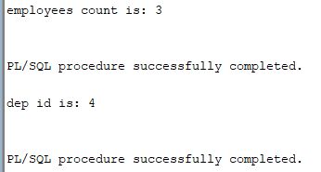

**Зад 2.** Задайте номер на отдел от клавиатурата. Ако номерът е:

- 10, изведете средната заплата за отдела

- 30, изведете сумата от заплати за отдела

- 80, изведете брой служители в отдела

В противен случай изведете въведения номер на отдел.

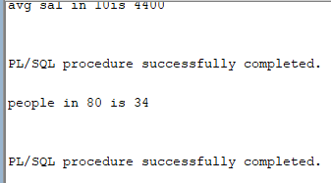

**Зад 3.** За служители от 142 до 148 изведете годишния доход с подходящи съобщения.

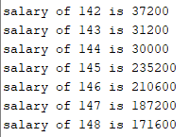

**Зад 4.** Намерете номера на регион Европа и вмъкнете ред с данни за България – **BG, Bulgaria** в таблица countries.

**Зад 5 .**Изведете

11

12

13

21

22

23

31

32

33

като използвате цикли за формирането на стойностите.

