**Упражнение 7**

SET VERIFY OFF

---

SET ECHO OFF

----

DECLARE

v_deptno NUMBER := 10;

CURSOR c_emp_cursor IS

SELECT last_name, salary, manager_id FROM employees WHERE department_id = v_deptno;

BEGIN

FOR emp_record IN c_emp_cursor

LOOP

IF emp_record.salary < 5000 AND (emp_record.manager_id=101 OR emp_record.manager_id=124) THEN

DBMS_OUTPUT.PUT_LINE (emp_record.last_name || ' Due for a raise');

ELSE

DBMS_OUTPUT.PUT_LINE (emp_record.last_name || ' Not Due for a raise');

END IF;

END LOOP;

END;



DECLARE

CURSOR c_dept_cursor IS

SELECT department_id, department_name FROM departments WHERE department_id < 100

ORDER BY department_id;

CURSOR c_emp_cursor(v_deptno NUMBER ) IS

SELECT last_name, job_id, hire_date, salary FROM employees WHERE department_id = v_deptno

AND employee_id < 120;

v_current_deptno departments.department_id%TYPE;

v_current_dname departments.department_name%TYPE;

v_ename employees.last_name%TYPE;

v_job employees.job_id%TYPE;

v_hiredate employees.hire_date%TYPE;

v_sal employees.salary%TYPE;

BEGIN

OPEN c_dept_cursor;

LOOP

FETCH c_dept_cursor INTO v_current_deptno, v_current_dname;

EXIT WHEN c_dept_cursor%NOTFOUND;

DBMS_OUTPUT.PUT_LINE ('Department Number : ' || v_current_deptno ||

' Department Name : ' || v_current_dname);

IF c_emp_cursor%ISOPEN THEN

CLOSE c_emp_cursor;

END IF;

OPEN c_emp_cursor (v_current_deptno);

LOOP

FETCH c_emp_cursor INTO v_ename, v_job,v_hiredate,v_sal;

EXIT WHEN c_emp_cursor%NOTFOUND;

DBMS_OUTPUT.PUT_LINE (v_ename || ' ' || v_job || ' ' || v_hiredate || ' ' || v_sal);

END LOOP;

DBMS_OUTPUT.PUT_LINE('----------------------------------------------------------------------------------------');

CLOSE c_emp_cursor;

END LOOP;

CLOSE c_dept_cursor;

END;

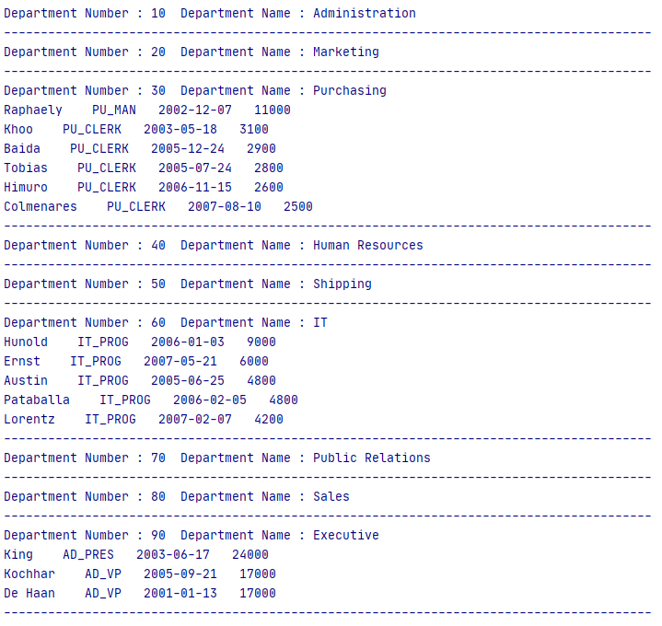

SET VERIFY OFF

---

DELETE FROM top_salaries; -- Изтрива записи от таблицата, ако я има

---

CREATE TABLE top_salaries (salary NUMBER(8,2)); -- Създава таблица, ако я няма

Въвежда в таблица top_salaries първите 5 най-големи заплати

DECLARE

v_num NUMBER(3) := 5;

v_sal employees.salary%TYPE;

CURSOR c_emp_cursor IS

SELECT salary FROM employees ORDER BY salary DESC;

BEGIN

OPEN c_emp_cursor;

FETCH c_emp_cursor INTO v_sal;

WHILE c_emp_cursor%ROWCOUNT <= v_num AND c_emp_cursor%FOUND LOOP

INSERT INTO top_salaries (salary) VALUES (v_sal);

FETCH c_emp_cursor INTO v_sal;

END LOOP;

CLOSE c_emp_cursor;

END;

---

SELECT * FROM top_salaries;

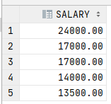

Създайте таблица emp.

DROP TABLE emp; -- Изтрива таблицата, ако я има

CREATE TABLE emp AS SELECT * FROM EMPLOYEES;



PL/SQL код, който за служители с длъжност **'ST_CLERK'** и със заплата по-голяма от 3000 променя длъжността им на **'SR_CLERK'** и повишава заплатата им с 10%.Проверете резултатите в таблица emp.

Използва секурсор сFOR UPDATE и клаузата CURRENT OF за обновяването.

**DECLARE**

**CURSOR C_Senior_Clerk IS**

**SELECT employee_id,job_id FROM emp**

**WHERE job_id = 'ST_CLERK' AND salary > 3000**

**FOR UPDATE OF job_id;**

**BEGIN**

**FOR Emrec IN C_Senior_Clerk**

**LOOP**

**UPDATE emp**

**SET job_id = 'SR_CLERK',**

**salary = 1.1 * salary**

**WHERE CURRENT OF C_Senior_Clerk;**

**END LOOP;**

**COMMIT;**

**END;**

---

**SELECT * FROM emp;**

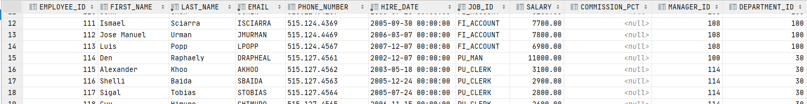

**Примери от теорията:**

DECLARE

CURSOR c_emp_cursor IS

SELECT employee_id, last_name FROM employees

WHERE department_id =30;

v_empno employees.employee_id%TYPE;

v_lname employees.last_name%TYPE;

BEGIN

OPEN c_emp_cursor;

FETCH c_emp_cursor INTO v_empno, v_lname;

DBMS_OUTPUT.PUT_LINE( v_empno ||' '||v_lname);

END;



DECLARE

CURSOR c_emp_cursor IS

SELECT employee_id, last_name FROM employees

WHERE department_id =30;

v_empno employees.employee_id%TYPE;

v_lname employees.last_name%TYPE;

BEGIN

OPEN c_emp_cursor;

LOOP

FETCH c_emp_cursor INTO v_empno, v_lname;

EXIT WHEN c_emp_cursor%NOTFOUND;

DBMS_OUTPUT.PUT_LINE( v_empno ||' '||v_lname);

END LOOP;

END;

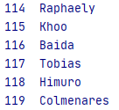

DECLARE

CURSOR c_emp_cursor IS

SELECT employee_id, last_name FROM employees

WHERE department_id =30;

v_emp_record c_emp_cursor%ROWTYPE;

BEGIN

OPEN c_emp_cursor;

LOOP

FETCH c_emp_cursor INTO v_emp_record;

EXIT WHEN c_emp_cursor%NOTFOUND;

DBMS_OUTPUT.PUT_LINE( v_emp_record.employee_id ||' '||v_emp_record.last_name);

END LOOP;

CLOSE c_emp_cursor;

END;

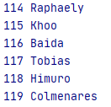

DECLARE

CURSOR c_emp_cursor IS

SELECT employee_id, last_name FROM employees

WHERE department_id =30;

BEGIN

FOR emp_record IN c_emp_cursor

LOOP

DBMS_OUTPUT.PUT_LINE( emp_record.employee_id ||' '||emp_record.last_name);

END LOOP;

END;

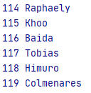

DECLARE

CURSOR c_emp_cursor IS SELECT employee_id,

last_name FROM employees;

v_emp_record c_emp_cursor%ROWTYPE;

BEGIN

OPEN c_emp_cursor;

LOOP

FETCH c_emp_cursor INTO v_emp_record;

EXIT WHEN c_emp_cursor%ROWCOUNT > 10 OR c_emp_cursor%NOTFOUND;

DBMS_OUTPUT.PUT_LINE( v_emp_record.employee_id ||' '||v_emp_record.last_name);

END LOOP;

CLOSE c_emp_cursor;

END ;

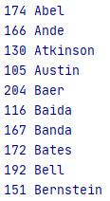

BEGIN

FOR emp_record IN (SELECT employee_id, last_name FROM employees

WHERE department_id =30)

LOOP

DBMS_OUTPUT.PUT_LINE( emp_record.employee_id ||' '||emp_record.last_name);

END LOOP;

END;

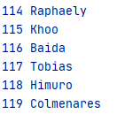

DECLARE

CURSOR c_emp_cursor (deptno NUMBER) IS

SELECT employee_id, last_name FROM employees WHERE department_id = deptno;

v_empno employees.employee_id%TYPE;

v_lname employees.last_name%TYPE;

BEGIN

OPEN c_emp_cursor (10);

LOOP

FETCH c_emp_cursor INTO v_empno, v_lname;

EXIT WHEN c_emp_cursor%NOTFOUND;

DBMS_OUTPUT.PUT_LINE( v_empno ||' '||v_lname);

END LOOP;

CLOSE c_emp_cursor;

OPEN c_emp_cursor (20);

LOOP

FETCH c_emp_cursor INTO v_empno, v_lname;

EXIT WHEN c_emp_cursor%NOTFOUND;

DBMS_OUTPUT.PUT_LINE( v_empno ||' '||v_lname);

END LOOP;

END;

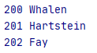

----------------------------------------------------------------

**Зад. 1.** Създайте PL/SQL блок с декларация на курсор, с име C_DATE_CUR, полета – номер, фамилия и дата на постъпване; както и параметър на курсора от даннов тип DATE.Изведете информация за всички служители, които са постъпили на работа след определена дата, въведена от клавиатурата. Тествайте с дати 2007-01-01, 2008-02-03.

hire_date > 2007-01-01

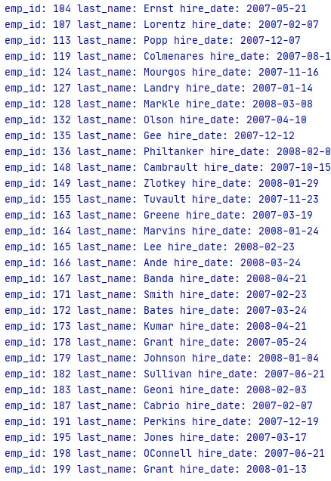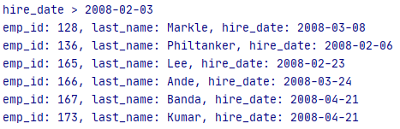

**Зад. 2.** Изведете за всеки идентификатор и име на страна, данните за всички локации за страната. Използвайте два курсора, като вторият курсор приема като параметър идентификатора на страната.

