**Курсова работа №1**

**по Проектиране и администриране на бази данни**

**Изготвил:** Петър Димитров Попов

**Класно отделение:** 12282

**Факултетен номер:** 111-7419

**Задание:**

Да се проектира и реализира БД за склад за ел. уреди, която да поддържа данни за:

* Категории стоки – код на категория, описание.
* Уреди – код на уред от категория, описание, ед. цена.
* Клиенти – номер, име, фамилия на клиент, ЕГН.
* Поръчки – номер на поръчка за клиент, дата.
* Детайли на поръчката – включва няколко уреда за поръчка, брой.

Да се изведе справка за номер на клиент, име, фамилия на клиент, ЕГН, номер на поръчка за клиента, дата на поръчката, код на уред, описание, ед. цена; брой, сумата за уредите, код на категория, описание. Подредба по номер на клиент.

1. **Конекция като sysdba и създаване на нов потребител - petar**

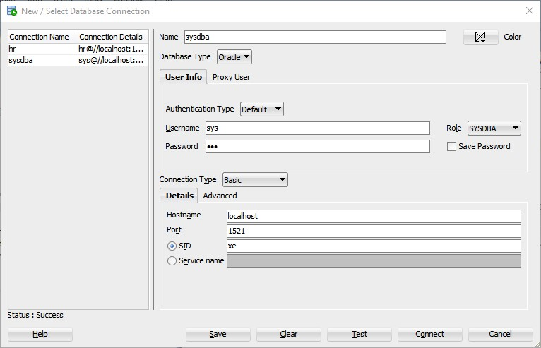

|  |
| --- |
| CREATE USER petar IDENTIFIED by &pass;  GRANT "DBA" TO petar;  UNDEFINE pass; |

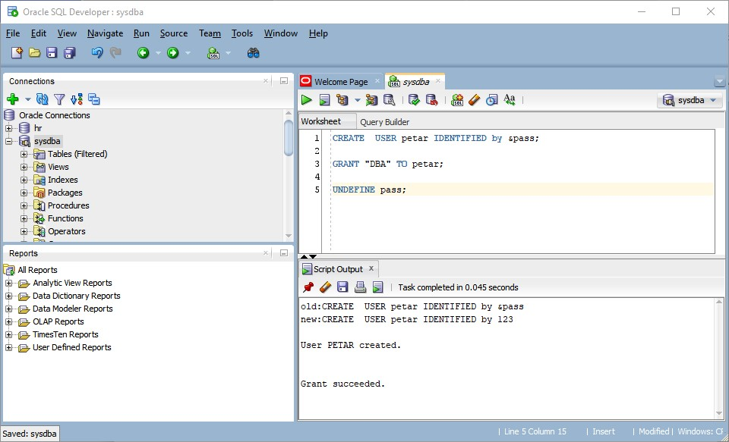

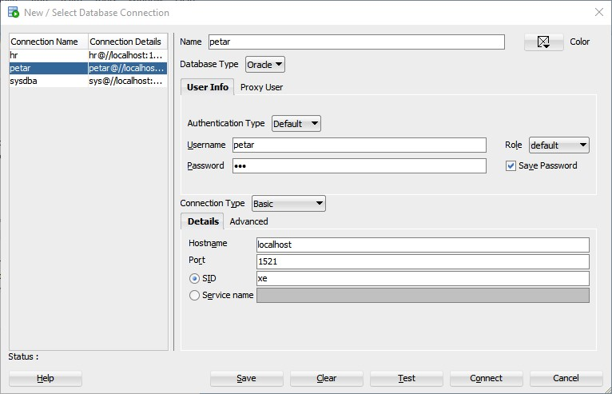

1. **Създаване на таблиците**

|  |
| --- |
| CREATE TABLE PROD_CATEGORIES  (  CAT_ID NUMBER,  CAT_DESCR VARCHAR2(30) NOT NULL,    CONSTRAINT PK_PRODCAT_CID PRIMARY KEY (CAT_ID)  );    CREATE TABLE PRODUCTS  (  PROD_ID NUMBER,  CAT_ID NUMBER NOT NULL,  PROD_DESCR VARCHAR(30) NOT NULL,  PROD_PRICE NUMBER(8,2) NOT NULL,    CONSTRAINT PK_PRODS_PID  PRIMARY KEY (PROD_ID),  CONSTRAINT FK_PRODS_CID_PRODCAT_CID  FOREIGN KEY (CAT_ID)  REFERENCES PROD_CATEGORIES(CAT_ID)  );    CREATE TABLE CLIENTS  (  CLIENT_ID NUMBER,  CLIENT_FIRST_NAME VARCHAR2(20) NOT NULL,  CLIENT_LAST_NAME VARCHAR2(20) NOT NULL,  CLIENT_UCN CHAR(10),    CONSTRAINT PK_CLNTS_CLID  PRIMARY KEY (CLIENT_ID)  );    CREATE TABLE ORDERS  (  ORDER_ID NUMBER,  CLIENT_ID NUMBER NOT NULL,  ORDER_DATE DATE NOT NULL,    CONSTRAINT PK_ORDRS_OID  PRIMARY KEY (ORDER_ID),  CONSTRAINT FK_ORDRS_OID_CLNTS_CLID  FOREIGN KEY (CLIENT_ID)  REFERENCES CLIENTS(CLIENT_ID)  );  CREATE TABLE ORDER_DETAILS  (  ORDER_ID NUMBER NOT NULL,  PROD_ID NUMBER NOT NULL,  PROD_COUNT NUMBER NOT NULL,    CONSTRAINT FK_ORDRDET_OID_ORDRS_OID  FOREIGN KEY (ORDER_ID)  REFERENCES ORDERS(ORDER_ID),  CONSTRAINT FK_ORDRDET_PID_PRODS_PID  FOREIGN KEY (PROD_ID)  REFERENCES PRODUCTS(PROD_ID)  ); |

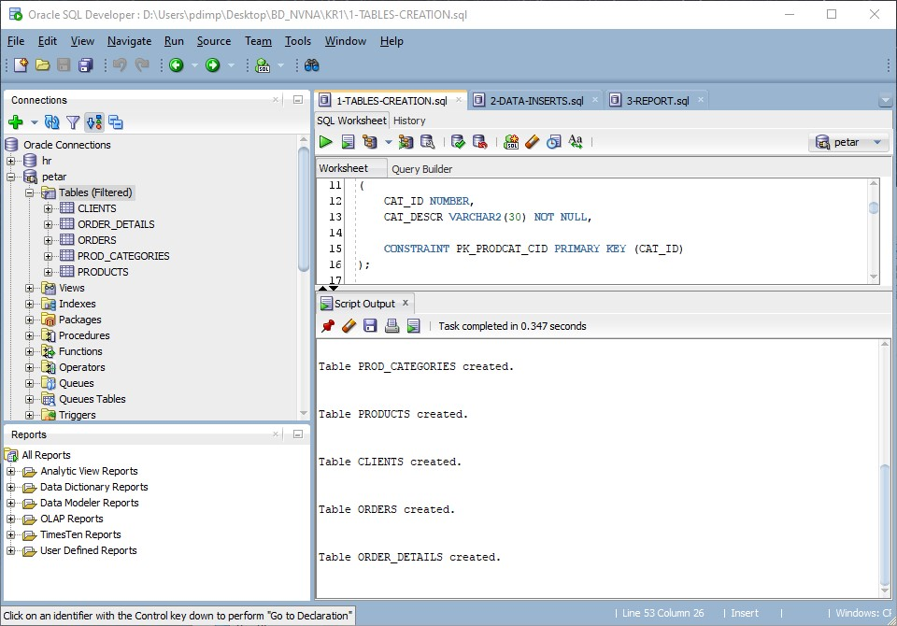

1. **Вмъкване на данни в таблиците**

|  |
| --- |
| INSERT ALL  INTO PROD_CATEGORIES (cat_id, cat_descr) VALUES (100, 'Phones')  INTO PROD_CATEGORIES (cat_id, cat_descr) VALUES (200, 'Notebooks')  INTO PROD_CATEGORIES (cat_id, cat_descr) VALUES (300, 'Tablets')  INTO PROD_CATEGORIES (cat_id, cat_descr) VALUES (400, 'Drones')  INTO PROD_CATEGORIES (cat_id, cat_descr) VALUES (500, 'Kitchen supplies')  INTO PROD_CATEGORIES (cat_id, cat_descr) VALUES (600, 'Garden supplies')  SELECT * FROM dual;  INSERT ALL  INTO PRODUCTS (PROD_ID, CAT_ID, PROD_DESCR, PROD_PRICE) VALUES (106, 100, 'Kids phone 4S', 19.99)  INTO PRODUCTS (PROD_ID, CAT_ID, PROD_DESCR, PROD_PRICE) VALUES (107, 100, 'Gaming phone 12XS+', 2499.99)  INTO PRODUCTS (PROD_ID, CAT_ID, PROD_DESCR, PROD_PRICE) VALUES (108, 100, 'Work phone 10', 149.99)  INTO PRODUCTS (PROD_ID, CAT_ID, PROD_DESCR, PROD_PRICE) VALUES (109, 100, 'Home phone 3G', 9.99)  INTO PRODUCTS (PROD_ID, CAT_ID, PROD_DESCR, PROD_PRICE) VALUES (110, 100, 'Brick 1', 9.99)    INTO PRODUCTS (PROD_ID, CAT_ID, PROD_DESCR, PROD_PRICE) VALUES (211, 200, 'Mega Note', 1499.99)  INTO PRODUCTS (PROD_ID, CAT_ID, PROD_DESCR, PROD_PRICE) VALUES (212, 200, 'Noted One', 1999.99)  INTO PRODUCTS (PROD_ID, CAT_ID, PROD_DESCR, PROD_PRICE) VALUES (213, 200, 'Brick Mega Gaming 3', 9999.99)  INTO PRODUCTS (PROD_ID, CAT_ID, PROD_DESCR, PROD_PRICE) VALUES (214, 200, 'Gaming Pro 10', 4999.99)  INTO PRODUCTS (PROD_ID, CAT_ID, PROD_DESCR, PROD_PRICE) VALUES (215, 200, 'WorkBook 12', 1479.99)    INTO PRODUCTS (PROD_ID, CAT_ID, PROD_DESCR, PROD_PRICE) VALUES (301, 300, 'Kiddy Tab 2', 49.99)  INTO PRODUCTS (PROD_ID, CAT_ID, PROD_DESCR, PROD_PRICE) VALUES (302, 300, 'Worker Pro', 149.99)  INTO PRODUCTS (PROD_ID, CAT_ID, PROD_DESCR, PROD_PRICE) VALUES (303, 300, 'Gamers Wish', 349.99)  INTO PRODUCTS (PROD_ID, CAT_ID, PROD_DESCR, PROD_PRICE) VALUES (304, 300, 'WorkingTab 3', 299.99)  INTO PRODUCTS (PROD_ID, CAT_ID, PROD_DESCR, PROD_PRICE) VALUES (305, 300, 'HomeTabby', 199.99)    INTO PRODUCTS (PROD_ID, CAT_ID, PROD_DESCR, PROD_PRICE) VALUES (436, 400, 'Military Drone 10', 1999.99)  INTO PRODUCTS (PROD_ID, CAT_ID, PROD_DESCR, PROD_PRICE) VALUES (437, 400, 'Medical Drone Pro Health', 2999.99)  INTO PRODUCTS (PROD_ID, CAT_ID, PROD_DESCR, PROD_PRICE) VALUES (438, 400, 'Spying Drone 2', 199.99)    INTO PRODUCTS (PROD_ID, CAT_ID, PROD_DESCR, PROD_PRICE) VALUES (501, 500, 'Blender', 49.99)  INTO PRODUCTS (PROD_ID, CAT_ID, PROD_DESCR, PROD_PRICE) VALUES (502, 500, 'Toaster', 21.99)  INTO PRODUCTS (PROD_ID, CAT_ID, PROD_DESCR, PROD_PRICE) VALUES (503, 500, 'Microwave', 149.99)  INTO PRODUCTS (PROD_ID, CAT_ID, PROD_DESCR, PROD_PRICE) VALUES (504, 500, 'Juicer', 69.99)  INTO PRODUCTS (PROD_ID, CAT_ID, PROD_DESCR, PROD_PRICE) VALUES (505, 500, 'Coffe grinder', 36.99)  SELECT * FROM dual;  INSERT ALL  INTO CLIENTS (CLIENT_ID, CLIENT_FIRST_NAME, CLIENT_LAST_NAME, CLIENT_UCN) VALUES (1001, 'Ivan', 'Ivanov', '1524023512')  INTO CLIENTS (CLIENT_ID, CLIENT_FIRST_NAME, CLIENT_LAST_NAME, CLIENT_UCN) VALUES (1002, 'Ivanka', 'Ivanova', '1525623512')  INTO CLIENTS (CLIENT_ID, CLIENT_FIRST_NAME, CLIENT_LAST_NAME, CLIENT_UCN) VALUES (1003, 'Vanio', 'Ivanovich', '1524468512')  INTO CLIENTS (CLIENT_ID, CLIENT_FIRST_NAME, CLIENT_LAST_NAME, CLIENT_UCN) VALUES (1004, 'Venci', 'Venciev', '7584652310')  INTO CLIENTS (CLIENT_ID, CLIENT_FIRST_NAME, CLIENT_LAST_NAME, CLIENT_UCN) VALUES (1005, 'Pesho', 'Peshov', '7526213252')  INTO CLIENTS (CLIENT_ID, CLIENT_FIRST_NAME, CLIENT_LAST_NAME, CLIENT_UCN) VALUES (1006, 'Gosho', 'Goshev', '7563125262')  SELECT * FROM dual;  INSERT ALL  INTO ORDERS (ORDER_ID, CLIENT_ID, ORDER_DATE) VALUES (5168, 1001, '31-may-98')  INTO ORDERS (ORDER_ID, CLIENT_ID, ORDER_DATE) VALUES (5615, 1001, '2-may-98')  INTO ORDERS (ORDER_ID, CLIENT_ID, ORDER_DATE) VALUES (8456, 1003, '1-may-99')  INTO ORDERS (ORDER_ID, CLIENT_ID, ORDER_DATE) VALUES (8452, 1005, '4-may-00')  INTO ORDERS (ORDER_ID, CLIENT_ID, ORDER_DATE) VALUES (7897, 1003, '21-may-11')  INTO ORDERS (ORDER_ID, CLIENT_ID, ORDER_DATE) VALUES (1567, 1004, '11-may-20')  INTO ORDERS (ORDER_ID, CLIENT_ID, ORDER_DATE) VALUES (1256, 1002, '23-may-85')  INTO ORDERS (ORDER_ID, CLIENT_ID, ORDER_DATE) VALUES (5631, 1002, '16-may-98')  INTO ORDERS (ORDER_ID, CLIENT_ID, ORDER_DATE) VALUES (9542, 1006, '17-may-98')  SELECT * FROM dual;  INSERT ALL  INTO ORDER_DETAILS (ORDER_ID, PROD_ID, PROD_COUNT) VALUES (5168, 437, 10)  INTO ORDER_DETAILS (ORDER_ID, PROD_ID, PROD_COUNT) VALUES (5168, 436, 2)  INTO ORDER_DETAILS (ORDER_ID, PROD_ID, PROD_COUNT) VALUES (5615, 215, 14)  INTO ORDER_DETAILS (ORDER_ID, PROD_ID, PROD_COUNT) VALUES (8456, 501, 1)  INTO ORDER_DETAILS (ORDER_ID, PROD_ID, PROD_COUNT) VALUES (8452, 107, 3)  INTO ORDER_DETAILS (ORDER_ID, PROD_ID, PROD_COUNT) VALUES (7897, 436, 110)  INTO ORDER_DETAILS (ORDER_ID, PROD_ID, PROD_COUNT) VALUES (1567, 502, 2)  INTO ORDER_DETAILS (ORDER_ID, PROD_ID, PROD_COUNT) VALUES (1256, 305, 2)  INTO ORDER_DETAILS (ORDER_ID, PROD_ID, PROD_COUNT) VALUES (5631, 213, 8)  INTO ORDER_DETAILS (ORDER_ID, PROD_ID, PROD_COUNT) VALUES (9542, 503, 9)  SELECT * FROM dual;  COMMIT; |

1. **Describe на таблиците и Select на всички вмъкнати данни**
2. **PROD_CATEGORIES**

*- DESCRIBE PROD_CATEGORIES;*

|  |
| --- |
| Name Null? Type  --------- -------- ------------  CAT_ID NOT NULL NUMBER  CAT_DESCR NOT NULL VARCHAR2(30) |

*- SELECT * FROM PROD_CATEGORIES;*

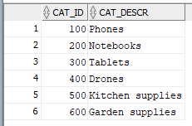

1. **PRODUCTS**

*- DESCRIBE PRODUCTS;*

|  |
| --- |
| Name Null? Type  ---------- -------- ------------  PROD_ID NOT NULL NUMBER  CAT_ID NOT NULL NUMBER  PROD_DESCR NOT NULL VARCHAR2(30)  PROD_PRICE NOT NULL NUMBER(8,2) |

*- SELECT * FROM PRODUCTS;*

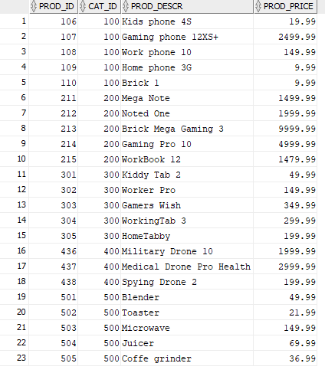

1. **CLIENTS**

*- DESCRIBE CLIENTS;*

|  |
| --- |
| Name Null? Type  ----------------- -------- ------------  CLIENT_ID NOT NULL NUMBER  CLIENT_FIRST_NAME NOT NULL VARCHAR2(20)  CLIENT_LAST_NAME NOT NULL VARCHAR2(20)  CLIENT_UCN CHAR(10) |

*- SELECT * FROM CLIENTS;*

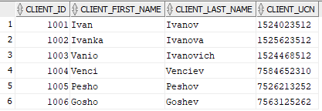

1. **ORDERS**

*- DESCRIBE ORDERS;*

|  |
| --- |
| Name Null? Type  ---------- -------- ------  ORDER_ID NOT NULL NUMBER  CLIENT_ID NOT NULL NUMBER  ORDER_DATE NOT NULL DATE |

*- SELECT * FROM ORDERS;*

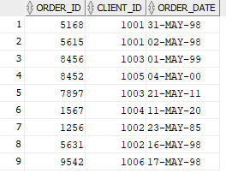

1. **ORDER_DETAILS**

*- DESCRIBE ORDER_DETAILS;*

|  |
| --- |
| Name Null? Type  ---------- -------- ------  ORDER_ID NOT NULL NUMBER  PROD_ID NOT NULL NUMBER  PROD_COUNT NOT NULL NUMBER |

*- SELECT * FROM ORDER_DETAILS;*

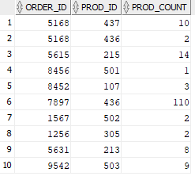

1. **Графично и писмено представяне на таблиците и техните връзки**

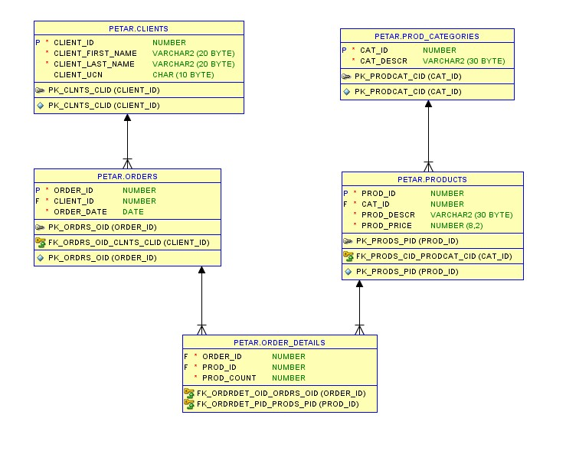

***Таблица CLIENTS и ORDERS:***

- една самостоятелна връзка, независима, един към много осъществена чрез primary key PK_CLNTS_CLID по колона CLIENT_ID от CLIENTS и foreign key FK_ORDRS_OID_CLNTS_CLID по колона CLIENT_ID от ORDERS. Един клиент осъществява много поръчки (1:n)

***Таблица PROD_CATEGORIES и PRODUCTS:***

- една самостоятелна връзка, независима, един към много осъществена чрез primary key PK_PRODCAT_CID по колона CAT_ID от PROD_CATEGORIES и foreign key FK_PRODS_CID_PRODCAT_CID по колона CAT_ID от PRODUCTS. От една категория има много продукти (1:n)

***Таблица ORDERS и PRODUCTS***

- една връзка много към много - реализира се чрез 2 връзки 1 към много с помощта на трета таблица (ORDER_DETAILS) осъществено по следния начин: чрез primary key PK_ORDRS_OID - колона ORDER_ID от таблица ORDERS, primary key PK_PRODS_PID - колона CAT_ID от таблица PRODUCTS и съответно foreign key FK_ORDRDET_OID_ORDRS_OID - колона ORDER_ID от таблица ORDER_DETAILS, foreign key FK_ORDDET_PID_PRODS_PID - колона PROD_ID от таблица ORDER_DETAILS. Много продукти се включват в много поръчки (n:m)

1. **Извеждане на справка от всички таблици**

|  |
| --- |
| SELECT  C.CLIENT_ID,  C.CLIENT_FIRST_NAME,  C.CLIENT_LAST_NAME,  C.CLIENT_UCN,  O.ORDER_ID,  O.ORDER_DATE,  O_DET.PROD_ID,  P.PROD_DESCR,  O_DET.PROD_COUNT,  P.PROD_PRICE,  O_DET.PROD_COUNT * P.PROD_PRICE AS FINAL_PRICE,  P.CAT_ID,  P_CAT.CAT_DESCR  FROM CLIENTS C  JOIN ORDERS O  ON C.CLIENT_ID = O.CLIENT_ID  JOIN ORDER_DETAILS O_DET  ON O.ORDER_ID = O_DET.ORDER_ID  JOIN PRODUCTS P  ON O_DET.PROD_ID = P.PROD_ID  JOIN PROD_CATEGORIES P_CAT  ON P.CAT_ID = P_CAT.CAT_ID  ORDER BY  C.CLIENT_ID,  O.ORDER_DATE; |

