**Упражнение 8**

SELECT location_id, street_address, city, state_province, country_name

FROM locations

NATURAL JOIN countries;

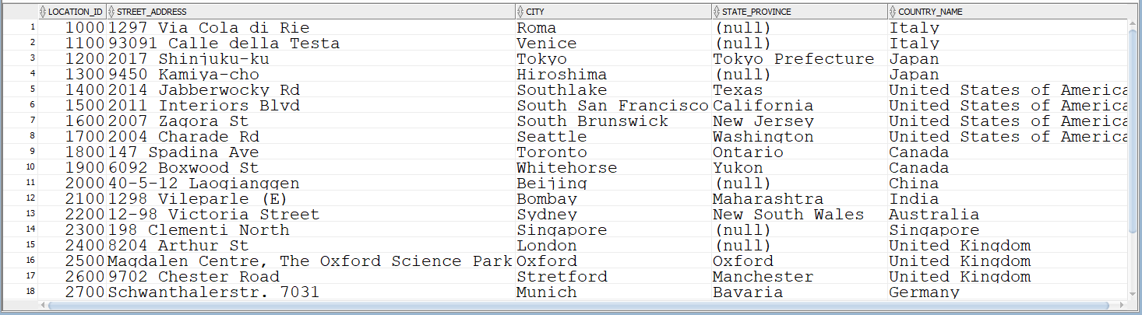

SELECT last_name, department_id, department_name

FROM employees

JOIN departments

USING (department_id);

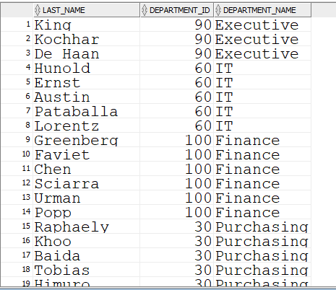

SELECT e.last_name, e.job_id, e.department_id, d.department_name

FROM employees e JOIN departments d

ON (e.department_id = d.department_id)

JOIN locations l

ON (d.location_id = l.location_id)

WHERE LOWER(l.city) = 'toronto';

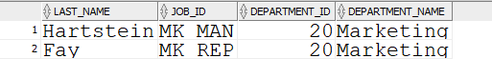

SELECT w.last_name "Employee", w.employee_id "EMP#",

m.last_name "Manager", m.employee_id "Mgr#"

FROM employees w JOIN employees m

ON (w.manager_id = m.employee_id);

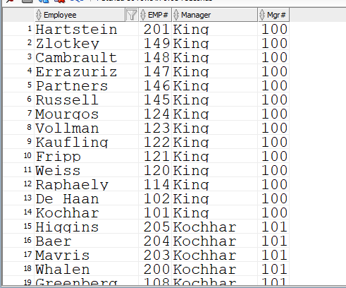

SELECT w.last_name "Employee", w.employee_id "EMP#",

m.last_name "Manager", m.employee_id "Mgr#"

FROM employees w

LEFT OUTER JOIN employees m

ON (w.manager_id = m.employee_id)

ORDER BY 2;

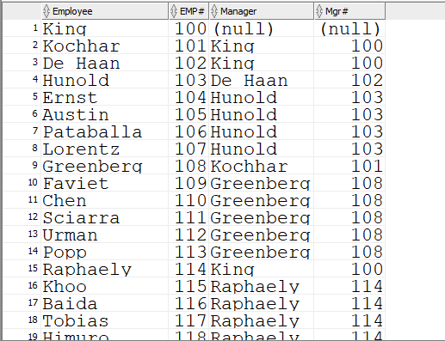

SELECT e.department_id department, e.last_name employee,

c.last_name colleague

FROM employees e JOIN employees c

ON (e.department_id = c.department_id)

WHERE e.employee_id <> c.employee_id

ORDER BY e.department_id, e.last_name, c.last_name;

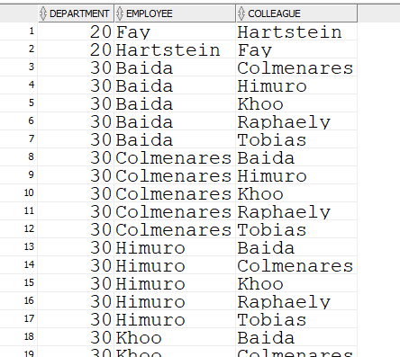

SELECT e.last_name, e.hire_date

FROM employees e JOIN employees davies

ON (davies.last_name = 'Davies')

WHERE davies.hire_date < e.hire_date;

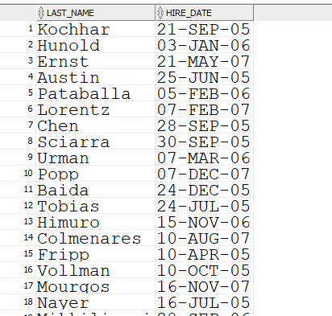

SELECT w.last_name, w.hire_date, m.last_name, m.hire_date

FROM employees w JOIN employees m

ON (w.manager_id = m.employee_id)

WHERE w.hire_date < m.hire_date;

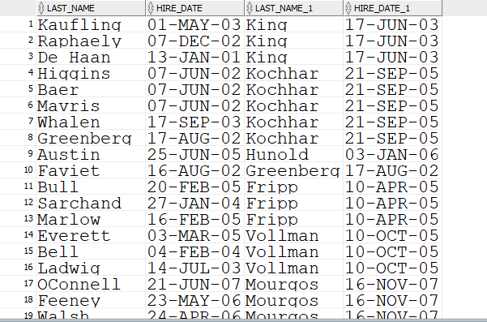

SELECT r.region_id, r.region_name, c.country_id, c.country_name

FROM regions r JOIN countries c

ON (r.region_id=c.region_id);

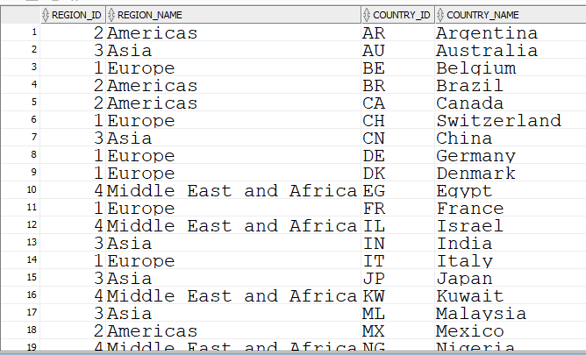

1. Създаване на таблица JOB_GRADES

CREATE TABLE JOB_GRADES

(

GRADE_LEVEL VARCHAR2(3)

, LOWEST_SAL NUMBER

, HIGHEST_SAL NUMBER

);



1. Структура на таблица JOB_GRADES

DESCRIBE job_grades



1. Въведете данни в таблица JOB_GRADES. Данни от таблица JOB_GRADES



SELECT * FROM job_grades;



1. Извежда фамилия, длъжност, име на отдел, заплата, категория (grade_level) в зависимост от това в какъв диапазон е заплатата.

SELECT e.last_name, e.job_id, d.department_name,

e.salary, j.grade_level

FROM employees e JOIN departments d

ON (e.department_id = d.department_id)

JOIN job_grades j

ON (e.salary BETWEEN j.lowest_sal AND j.highest_sal);

