Disclosure Pilot AI

by
Ronald Cook
www.linkedin.com/in/ronald-cook-programmer

August 2026

Disclosure Pilot AI

Introduction
The primary objective of this project is to demonstrate the feasibility of using Large Language Models (LLMs) to build a fully functional, end-to-end software application. To showcase this capability, a sample program was developed for accountants to generate SEC Form 10-Q and Form 10-K financial reports. The technical architecture of this application consists of a React frontend, a FastAPI backend, a PostgreSQL database, and Arelle Viewer.

Document Structure
This report is organized into distinct sections:
- Section 1: What are 10-K and 10-Q Filings? – Explains the difference between a company’s annual report, Form 10-K, and Form10-Q.
- Section 2: React Frontend – Demonstrates the software's functionality and user interface through detailed screenshots.
- Section 3: Arelle Viewer – Illustrates the operation of the Arelle validation tool, which highlights iXBRL tags within the HTML filing.
- Section 4: Architecture & Scope – Explains the framework and limited scope of this program.
- Section 5: Database Schema – Lists the structure of the PostgreSQL database tables, which contain the financial accounting data.
- Section 6: Accounting Fundamentals – Reviews the foundational accounting principles and background relevant to the application.
- Section 7: LLM Analysis – Evaluates the current state of Large Language Models, separating practical capabilities from industry hype.
- Section 8: AI Agent Tutorial – Describes the AI agent employed to perform two particular functions in this application, Management's Discussion and Analysis (MD&A) and Notes to Financial Statements.
- Section 9: Data Generation Prompting – Outlines the methodologies used to prompt Meta AI to generate realistic, sample financial data. (Not required in real business environment with existing database.)
- Section 10: Powershell Script Prompting – Describes how to prompt Claude to generate application Powershell scripts. Also, shows prompt for Gemini to create script explanations.
- Section 11: Code Development Prompting – Explains the prompt engineering strategies used with Claude to generate the core codebase for the application.
- Section 12: iXBRL Prompting – Specifies the iterative prompt strategies used with Claude to generate an iXBRL transformer for the application.
- Section 13: Testing – Outlines how the application code and financial dataset were tested.
- Section 14: Tools – Provides an overview of each software tool.
- Section 15: Discussion – Examines significant issues associated with the application.
  - Conclusion: Key Takeaways for LLM-Assisted Development – Highlights importance of understanding LLM prompting dynamics and iterative strategies.

Target Audience
This document is designed for individuals navigating the integration of AI into software engineering, specifically:
- Aspiring Developers who leverage AI assistants for basic tasks, but feel hesitant to architect end-to-end systems with complex LLM models.
- Industry Skeptics doubting the capability of AI to generate high-quality, production-grade code.
- STEM Students who rely on AI to complete assignments but may struggle to build real-world applications because they have not learned proper software design principles.
- Executives & CEOs slashing development teams to cash in on AI gains are ignoring history: massive productivity breakthroughs consistently trigger higher demand, expand total employment, and shorten the workweek.
Note: Google Gemini and Meta AI were used to assist in drafting portions of this document.

Section 1 - What are 10-K and 10-Q Filings?
It’s incredibly common to hear people use "10-K" and "Annual Report" interchangeably, but they actually serve different audiences and have distinct purposes.

Think of it this way: the Form 10-K is the raw, unvarnished data required by the government, while the Annual Report is the company's glossy storytelling piece meant for the public.
Here is exactly how they differ across the key areas:
Feature | Form 10-K | Glossy Annual Report
Primary Audience | Regulators (SEC), institutional investors, and financial analysts. | Shareholders, potential customers, employees, and the general media.
Format & Tone | Strictly text and numbers. Dense, legalistic, and completely devoid of marketing fluff or color. | Highly designed. Features photographs, corporate branding, infographics, and a letter from the CEO.
Key Focus | Detailed financial disclosures, legal risks, internal controls, and granular market data. | Corporate vision, strategic goals, highlights of the past year, and future market opportunities.
Filing Requirement | Mandatory by law to be filed with the SEC within 60 to 90 days of the fiscal year-end. | Not technically required by the SEC, though usually distributed ahead of the annual shareholder meeting.

Why the confusion?
The line gets blurry because of something called the "Wrap-Around" method.
To save money and time on printing, many companies will write a glossy, beautifully designed opening section (with the letter from the CEO and a summary of performance) and literally "wrap" it around their actual, legal Form 10-K filing.
So, if you download a company's Annual Report and it suddenly shifts from a colorful magazine layout to hundreds of pages of black-and-white financial tables, you are looking at a combined document.

Which one should you read?
- Go to the Annual Report if you want to understand management's high-level philosophy, how they view their competitors, and what new products they are excited about launching.
- Go to the Form 10-K if you want to dig into the cold, hard numbers, see exactly how much debt they owe, or read the "Risk Factors" section where they legally must disclose everything that could potentially bankrupt the company.
Difference between Form 10-K and Form 10-Q
The core difference comes down to scope and frequency. Think of a Form 10-K as a company's comprehensive yearly biography, while a Form 10-Q is a quick, quarterly progress report.

Both are mandatory filings required by the U.S. Securities and Exchange Commission (SEC) for publicly traded companies, but they serve different purposes for investors.

Key Differences at a Glance
Feature | Form 10-K | Form 10-Q
Frequency | Once a year (covers the full fiscal year) | Three times a year (covers Q1, Q2, and Q3)
Audit Status | Audited by an independent CPA firm | Unaudited (reviewed, but not fully audited)
Size & Detail | Massive and deeply detailed | Shorter, focusing mainly on recent changes
Key Inclusions | Corporate history, executive pay, full market risk analysis, audited financial statements | Basic financial statements, updates on legal proceedings, minor risk updates

Form 10-K: The Deep Dive
Because the 10-K is published at the end of the fiscal year, it provides a panoramic view of the company’s financial health. It includes a detailed narrative of the business operations, market share, risk factors, and legal struggles.
Most importantly, the financial statements in a Form 10-K must be audited by an outside accounting firm. This audit gives investors a high level of confidence that the numbers haven't been manipulated.

Form 10-Q: The Pulse Check
The Form10-Q is designed to give investors a continuous look at how the company is doing throughout the year. It focuses strictly on the financial results of the latest quarter and compares them to the same quarter from the previous year.
Because companies have to put these together quickly every three months, the SEC does not require them to be audited. They are only reviewed by accountants, meaning they are a bit more raw and subject to adjustments later in the year.
Note: There is no Form 10-Q for the fourth quarter. The data for Q4 is rolled directly into the massive, final Form 10-K report.

Note: This application is focused on creating the Form 10-K and Form 10-Q reports, not the glossy annual report.

Form 10-K Table of Contents
The official SEC Form 10-K is divided into four distinct parts spanning 15 core items (plus a few specialized sub-items like Cybersecurity and Mine Safety). The standardized layout used by publicly traded companies in the United States is outlined below:

Part I
- Item 1. Business (Company overview, products/services, markets, and regulations)
- Item 1A. Risk Factors (Potential threats, vulnerabilities, and market challenges)
- Item 1B. Unresolved Staff Comments (Outstanding questions or issues raised by SEC staff)
- Item 1C. Cybersecurity (Risk management, strategy, governance, and incident disclosures)
- Item 2. Properties (Physical assets, plants, factories, and real estate holdings)
- Item 3. Legal Proceedings (Significant ongoing or pending lawsuits)
- Item 4. Mine Safety Disclosures (Applicable only to mining operators)

Part II
- Item 5. Market for Registrant’s Common Equity, Related Stockholder Matters and Issuer Purchases of Equity Securities (Stock performance, dividends, and share buybacks)
- Item 6. [Reserved] (Formerly Selected Financial Data; deleted by the SEC to eliminate redundancy)
- Item 7. Management’s Discussion and Analysis of Financial Condition and Results of Operations (MD&A) (Management's narrative explanation of the financial results, trends, and liquidity)
- Item 7A. Quantitative and Qualitative Disclosures About Market Risk (Exposure to interest rates, foreign currency exchange, or commodity price fluctuations)
- Item 8. Financial Statements and Supplementary Data (Audited balance sheets, income statements, cash flows, and footnote disclosures)
- Item 9. Changes in and Disagreements with Accountants on Accounting and Financial Disclosure
- Item 9A. Controls and Procedures (Evaluation of internal controls over financial reporting)
- Item 9B. Other Information (Disclosures that would typically require a Form 8-K but occurred during the fourth quarter)
- Item 9C. Disclosure Regarding Foreign Jurisdictions that Prevent Inspections

Part III
Note: Companies often "incorporate by reference" the information in Part III from their definitive proxy statement rather than reprinting it here, provided the proxy is filed within 120 days of the fiscal year-end.
- Item 10. Directors, Executive Officers and Corporate Governance
- Item 11. Executive Compensation
- Item 12. Security Ownership of Certain Beneficial Owners and Management and Related Stockholder Matters
- Item 13. Certain Relationships and Related Transactions, and Director Independence
- Item 14. Principal Accountant Fees and Services (Fees paid to the independent auditing firm)

Part IV
- Item 15. Exhibit and Financial Statement Schedules (The full list of legal documents, material contracts, and bylaws filed alongside the report)
- Item 16. Form 10-K Summary (An optional section allowing companies to provide a brief summary index)
Reading Strategy Tip: If you are analyzing a company's financial health, experienced investors usually skip straight to Item 7 (MD&A) to see how management explains the numbers in their own words, followed by Item 8's footnotes (also called Notes) to check for hidden liabilities or shifting accounting policies.
Notes: GAAP disclosures
While this application focuses on only 8 footnotes for simplicity, most corporate filings list 15 to 20 footnotes. Even though individual companies may alter the exact wording slightly based on their industry or specific operations, U.S. GAAP and SEC regulations mandate highly structured disclosures.

If you look across any major SEC Form 10-K, these are the 15 most common, standardized names for the Notes (footnotes) to the Consolidated Financial Statements:

1. Summary of Significant Accounting Policies
What it covers: The foundational "rules of the road" for how the company prepares its books. It details the basis of consolidation, the use of estimates, and brief summaries of depreciation and foreign currency translation methods.

2. Revenue (or Revenue from Contracts with Customers)
What it covers: Details the implementation of Accounting Standards Codification (ASC) 606. It explains when and how the company transfers control of goods or services, breaks down revenue by product lines or geographic regions, and explains contract assets/liabilities (like deferred revenue).

3. Debt (or Financing Arrangements)
What it covers: Details both short-term and long-term borrowing. It lists maturity schedules, interest rates, collateral requirements, and debt covenants (which can trigger defaults if breached).

4. Income Taxes
What it covers: Reconciles the difference between the statutory federal tax rate and the company's effective tax rate. It also discloses deferred tax assets and liabilities (such as Net Operating Losses) and reserves for uncertain tax positions.

5. Property, Plant, and Equipment, Net
What it covers: Breaks down physical assets (land, buildings, machinery). It discloses the cost, accumulated depreciation, useful lives utilized, and any asset impairment charges taken during the year.

6. Leases
What it covers: Governed by ASC 842. It breaks down operating and finance lease liabilities, right-of-use (ROU) assets, lease terms, discount rates, and future maturity pipelines.

7. Goodwill and Intangible Assets
What it covers: Breaks down non-physical assets (such as patents, trademarks, and customer lists) alongside goodwill from past acquisitions. It details the annual impairment testing process and any write-downs.

8. Commitments and Contingencies
What it covers: Reveals off-balance-sheet liabilities. It is heavily scanned by analysts to locate pending legal proceedings, regulatory fines, environmental liabilities, and purchase commitments.

9. Share-Based Compensation (or Stock-Based Compensation)
What it covers: Outlines how the company compensates employees using equity restricted stock units (RSUs) or stock options. It discloses the fair value assumptions (like Black-Scholes variables) and total compensation expense.

10. Segment Reporting (or Segment Information)
What it covers: Required if a company manages its business through multiple operational divisions. It breaks down revenue, operating income, and assets by operating segments as reviewed by the Chief Operating Decision Maker (CODM).

11. Fair Value Measurements
What it covers: Breaks down how the company values its financial instruments (investments, derivatives, etc.) using the three-level hierarchy (Level 1: observable market prices, Level 2: indirect inputs, Level 3: unobservable/internally modeled inputs).

12. Pension and Other Postretirement Benefits
What it covers: Discloses the funded status of defined-benefit pension plans or other post-employment benefits (OPEB). It breaks down the plan assets, projected benefit obligations, and demographic/discount rate assumptions.

13. Acquisitions and Divestitures (or Business Combinations)
What it covers: Explains the financial details of any company purchased or sold during the fiscal year. It includes the purchase price allocation (how much went to cash, inventory, Intellectual Property (IP), and goodwill) and pro forma revenue.

14. Related Party Transactions
What it covers: Discloses transactions with executives, directors, major shareholders, or affiliate companies. It ensures transparency regarding potential conflicts of interest or non-arm's-length terms.

15. Subsequent Events
What it covers: Discloses any material events that occurred after the balance sheet date but before the 10-K was officially issued. Examples include post-close acquisitions, debt refinancing, or devastating legal rulings.

This application implements only 8 common 10-K Item 8 Notes, listed below:
Basis of Presentation
Summary of Significant Accounting Policies
Segment Information
Income Taxes
Earnings Per Share
Commitments and Contingencies
Short-term and Long-term Debt
Leases

Form 10-K References:
https://www.sec.gov/files/form10-k.pdf
https://www.sec.gov/files/reada10k.pdf#:~:text=Data%E2%80%9D%20requires%20the%20company's%20audited%20financial%20statements.,the%20information%20presented%20in%20the%20financial%20statements.
https://asc.fasb.org/Login
https://asc.fasb.org/105/showallinonepage
https://www.colonialfilings.com/edgar-downloadable-form-templates/#Form10-K
https://www.investor.gov/introduction-investing/general-resources/news-alerts/alerts-bulletins/investor-bulletins/how-read

Form 10-Q Table of Contents
Unlike the extensive yearly Form 10-K, the Form 10-Q is the streamlined quarterly financial report required by the SEC. It is much tighter, focusing strictly on updating investors on the company's financial status and material changes over the last 3 months. It consists of just two main parts spanning 11 total items:

Part I – Financial Information
- Item 1. Financial Statements (Unaudited balance sheets, income statements, and cash flows for the quarter)
- Item 2. Management’s Discussion and Analysis of Financial Condition and Results of Operations (MD&A) (Management’s narrative explaining the quarterly performance, revenue changes, and liquidity)
- Item 3. Quantitative and Qualitative Disclosures About Market Risk (Updates on exposure to market factors like interest rates or currency fluctuations)
- Item 4. Controls and Procedures (The quarterly evaluation of disclosure controls and internal reporting mechanisms)

Part II – Other Information
- Item 1. Legal Proceedings (Updates on new material lawsuits or significant developments in existing legal battles)
- Item 1A. Risk Factors (New or significantly modified risks since the last 10-K; smaller reporting companies often omit this unless a major shift occurred)
- Item 2. Unregistered Sales of Equity Securities and Use of Proceeds (Details on stock buybacks or private sales of shares)
- Item 3. Defaults Upon Senior Securities (Disclosures if the company fell behind on paying interest/principal on major debts)
- Item 4. Mine Safety Disclosures (Applicable only to mining companies)
- Item 5. Other Information (Disclosures that would have triggered a Form 8-K but happened to occur during the quarter, including insider trading arrangement disclosures under Rule 10b5-1)
- Item 6. Exhibits (The legal attachments, executive certifications like Sarbanes-Oxley, and interactive financial data files)
The Big Difference: The Form 10-Q financial statements in Part I, Item 1 are unaudited. While an independent CPA firm must review the Form 10-Q numbers before filing, they do not undergo the full, rigorous audit required for the Form 10-K.
Form 10-Q References:
https://www.sec.gov/files/form10-q.pdf
https://www.quantillium.com/blog/sec-form-10-q

Section 2 - React Frontend
This section illustrates how the application works, by walking through each screenshot, from login to final document creation.
Running the Application
To setup and run the application see the Start-Here-Setup.docx file, under docs/installation.

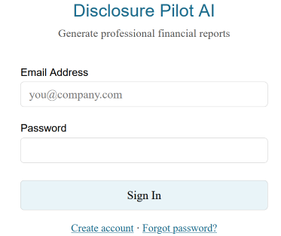

Enter default email and password:
email: zx@qaz.com, and password: qwerty
After a successful sign in, the Home Page should open.

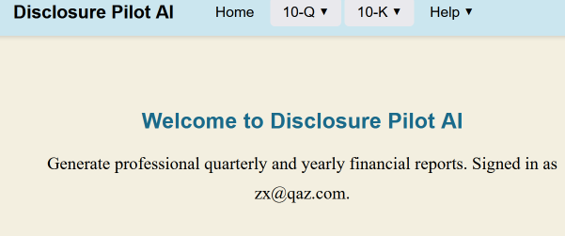

The menu structure is:
Home
10-Q: Prep, Report, EDGAR
10-K: Prep, Report, EDGAR
Help: User Guide, About

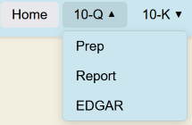

Workflow 10-Q 2025 Q2
- 10-Q Prep page → Select year, 2025 + quarter, 2 → Load financial statements
- Review balance sheet, income statement, cash flow, and stockholders equity tables
- Click Save Financials → creates item010-Financial-Statements.docx in sec10q-q2/part1/
- Click Generate MD&A → AI generates narrative via LangGraph + Ollama
- Edit narrative in the text area
- Click Save MD&A → creates item020-MDA.docx in sec10q-q2/part1/
- Click Generate Notes → AI generates narrative via LangGraph + Ollama
- Edit narrative in the text area
- Click Save Notes → creates item011-Notes-to-Financial-Statements.docx in sec10q-q2/part1/
- 10-Q Report page → Click Generate Form 10-Q Report → merges all docx item files into sec-10q-2025-q2.docx
- 10-Q EDGAR page → Click Generate 10-Q EDGAR HTM(iXBRL) → converts sec-10q-2025-q2.docx to sec-10q-2025-q2.htm

The 10-Q Prep page allows the user to review the 10-Q balance sheets, income statement, cash flow, and stockholders’ equity.

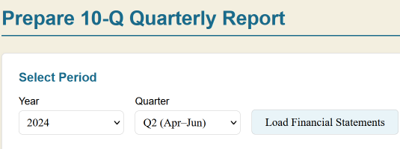

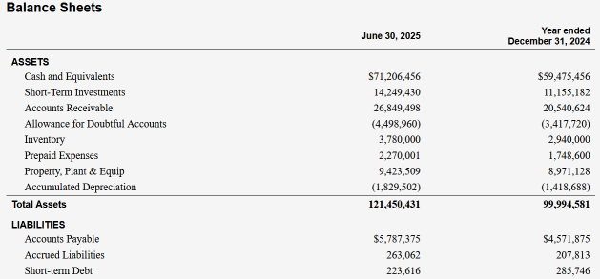

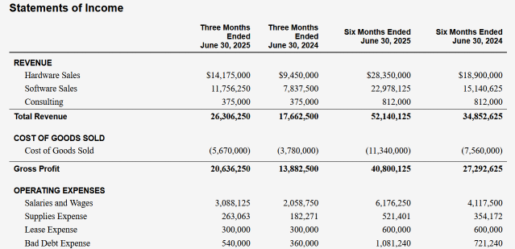

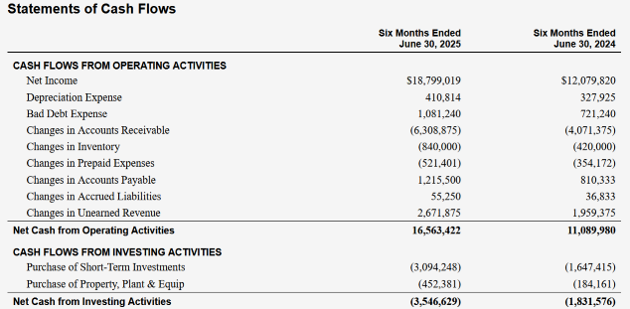

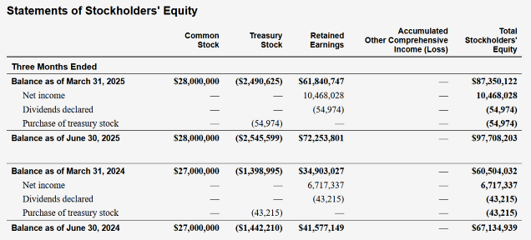

Before generating the Management Discussion and Analysis (MD&A), the MD&A Factors panel allows the user to edit key elements as input to the analysis, depending on the financial results. For example, if net income is positive, then Strategic Initiatives could be “investing in R&D”. On the other hand, if quarterly net income is negative, Strategic Initiatives could be “cost cutting measures”. Risk Factors may apply to both scenarios. Critical Accounting Estimates consider special cases, such as changes in income tax rules.

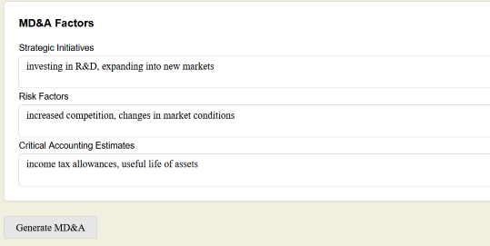

When the user clicks on Generate MD&A, an AI agent function uses the financial statements and company information to create the MD&A narrative, which the user may then edit. An excerpt is shown below.

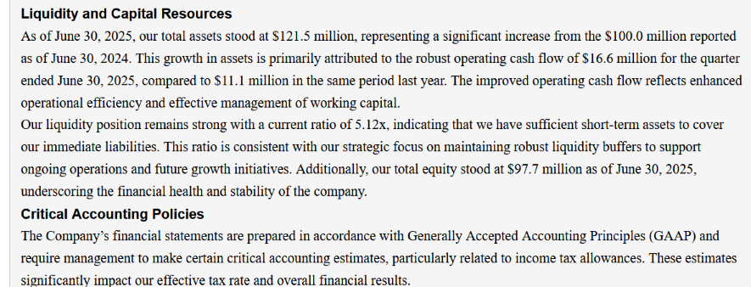

After completing the MD&A edit, the user clicks on Submit MD&A to save the narrative to a specific file that will become part of the 10-Q report.

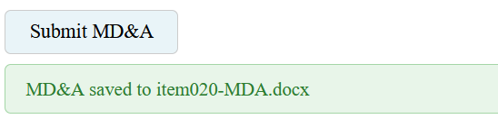

The Notes to Financial Statments panel lists the notes input by the user on the file, note_list_10q-q2.toml, under AppIO/user_input. There is a separate file for each quarter, because financial conditions may change from quarter to quarter.
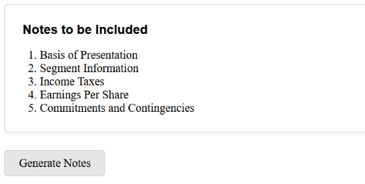

When the user clicks on Generate Notes, an AI agent function uses the financial statements and company information to create the Notes narrative, which the user may then edit. An excerpt is shown below.
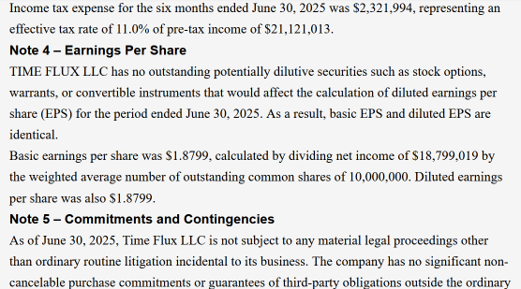

After completing the Notes edit, the user clicks on Submit Notes to save the narrative to a specific file that will become part of the 10-Q report.
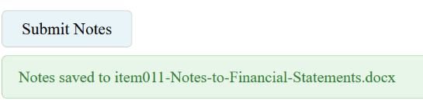

The Report 10-Q page allows the user to merge all the separate 10-Q items into the 10-Q report, and save to a file.
Caution: Since several docx files may be prepared externally to this application, the user must ensure that all items are completed and approved before creating the final 10-Q report.

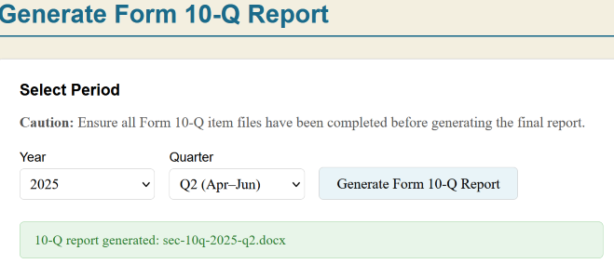

The 10-Q EDGAR page allows the user to convert the 10-Q report into an Edgar HTML file, ready to process with Arelle validator and viewer, illustrated in the next section.
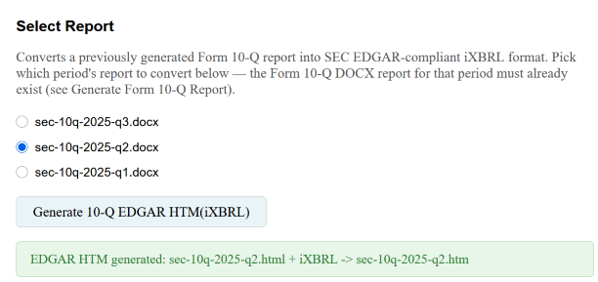

The 10-K prep, report, and EDGAR pages match the 10-Q pages in how they work, and are not shown here.

The User Guide dialog briefly describes the application menus.

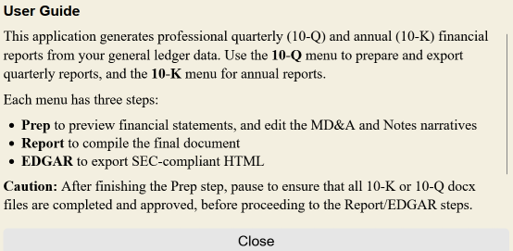

The About dialog just displays the application version.
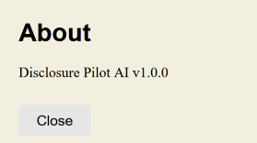

React Client references:
https://thepythoncode.com/article/fullstack-notes-app-with-fastapi-and-reactjs
https://www.bairesdev.com/blog/react-spa-single-page-application/
https://www.geeksforgeeks.org/python/fastapi-templates/

Fastapi Server references:
https://realpython.com/fastapi-python-web-apis/
https://fastapitutorial.com/blog/serving-html-fastapi/

Section 3 – Arelle Viewer
Arelle for Windows is a free, open-source desktop application designed for managing XBRL data. Navigating Arelle's interface can feel a bit overwhelming at first because it maps out highly technical, multi-layered XBRL structures. Powered by its built-in iXBRL Viewer plugin, it allows users to interactively view, validate, and analyze Inline XBRL(iXBRL) files directly within modern web browsers. While the upcoming section explores iXBRL in full detail, this section focuses purely on demonstrating how Arelle extracts and highlights data within HTML filings.
Settings
From the Windows app list select Arelle, and the desktop app opens as illustrated below:
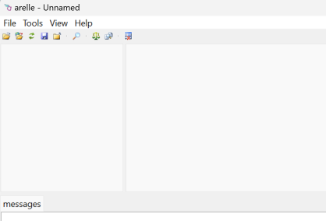

Before looking at our 10-K file, we need to choose some settings.
Under Tools → Validation:
- choose “Disclosure system checks”.
- Select disclosure system: choose “US SEC (Edgar Filing Manual Pragmatic)”.
- Base taxonomy validation: select “Use disclosure system settings”.
- choose “Unit Type Registry validation”. It prevents errors like using meters for Profit, or using USD for Area.
- choose “OIM validate xBRL-XML documents”. Calculations 1.1 requires OIM - Open Information Model, so conversion between XML <-> JSON <-> CSV is lossless.
- do not choose “Validate all files as Report Packages”. For just validating a single htm file directly, leave it off. A report package is a zip file that contains one or more XBRL, Inline XBRL, xBRL-CSV, xBRL-JSON. If the zip contains META-INF/reportPackage.json it's a Report Package.
- do not choose “Validate all files as Taxonomy Packages”. A Taxonomy Package holds a taxonomy itself - the schemas + linkbases that define the reporting rules (.xsd, -lab.xml, -pre.xml, etc). If the ZIP contains META-INF/taxonomyPackage.xml it's a Taxonomy Package. If just validating a normal filing (report.htm), leave it off.
- Warn on duplicate facts: select “Inconsistent”. In the messages panel, Arelle uses a single format to list both inconsistent and consistent warnings. Because consistent warnings are not errors, they should be ignored. Only inconsistent warnings should be flagged and fixed.

Under Tools → Calc linkbase: select “Calc 1.1 round to nearest mode”.
Under Tools → iXBRL Viewer → Settings: select “Launch on Load”, “Copy Script”, and “Highlight facts on startup”.
Under View → Edgar Renderer: select “Show filing data”, “Show redlining and redactions”, “Show table menu”, and “Validate before rendering”.
Under Help → Manage plug-ins: click on “Select” button, from the list choose “Edgar Renderer”, and click OK.
(Optional) Under Help → Manage packages: click on “Locally” button, from directory, C:\AppIO\user_input, choose “us-gaap-2026.zip”, and click OK.
Restart Arelle.

Now, to open a Form 10-K file: File → Open file → sec-10k-2025.htm → Open
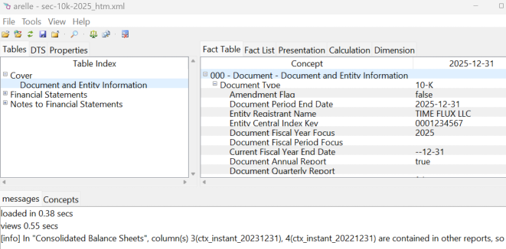

Browser Directly
When the 10-K file, sec-10-k.htm, is opened directly with a browser, the iXBRL tagged elements are not highlighted. The embedded tags do not interfere with normal HTML viewing.

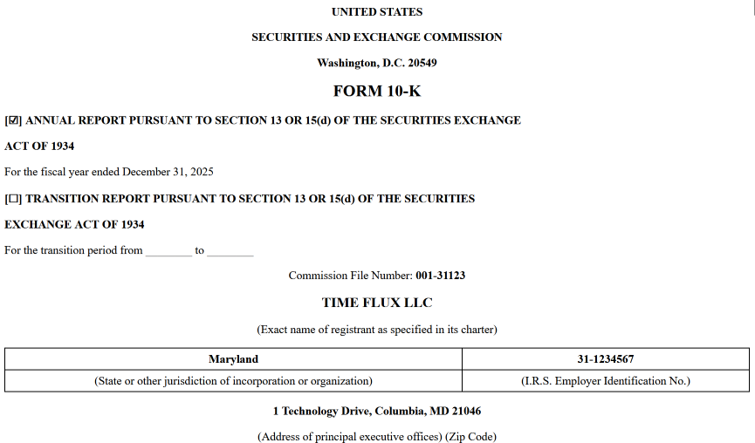

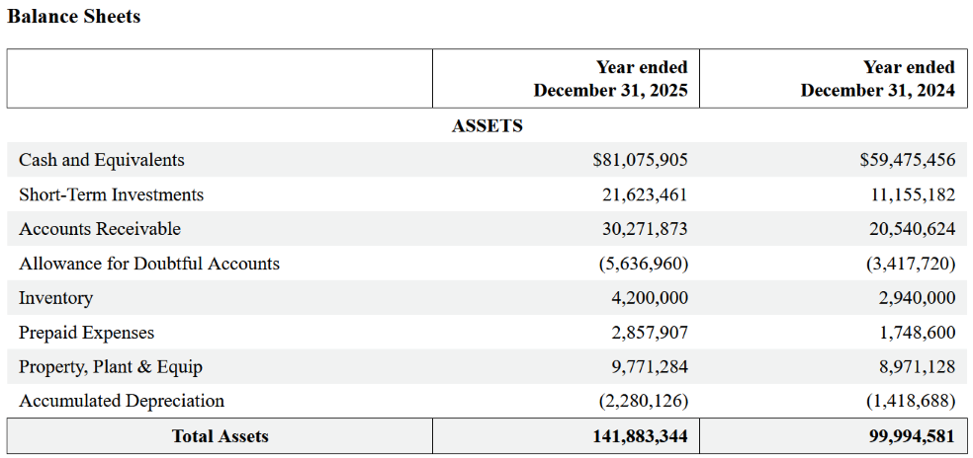

Inline Viewer
The Arelle “Inline Viewer” web page displays the HTML file just like the SEC Filings, because Arelle adds orange border styles to highlight the iXBRL tagged items between two orange lines.

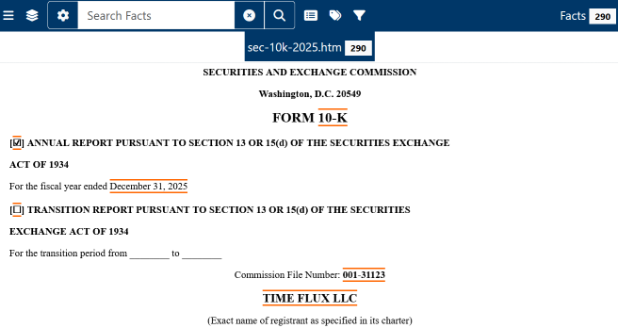

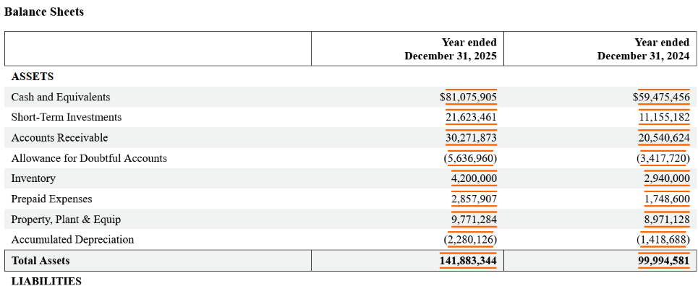

Sample Notes

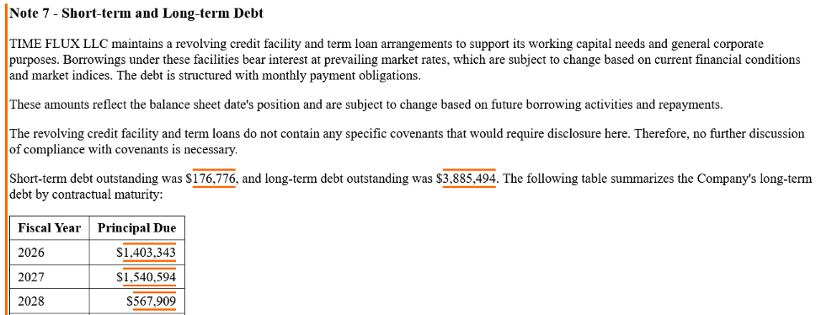
Inline CSS
If you inspect one of the items with orange border, you will see some true false conditions, plus a border color, like the following:
[enabled-fact="true"][inline-block-fact="true"][selected-fact="false"]{outline:solid 2px #FF6600;}
When you load an SEC filing report into the interactive Arelle iXBRL Viewer, the viewer injects custom data attributes into the HTML. This specific CSS block handles how a data tag behaves visually when you interact with it:
- [enabled-fact="true"]: The element contains a valid, interactive iXBRL financial tag.
- [inline-block-fact="true"]: The tag is rendered structurally as an inline-block layout element.
- [selected-fact="false"]: The tag is currently active/visible on the page but is not the one you have currently clicked or highlighted.
- {outline:solid 2px #FF6600;}: Applies a solid, 2-pixel-thick orange outline (#FF6600) to any element that matches all three conditions at the same time. This lets you immediately spot unselected, yet active financial figures on the statement page.
If you inspect the web page near the top, you will see
html → head → body → iframe → html → head → style → body…
where “style” contains a list of conditions/css like the sample above, which apply to various parts of the filing. For example, in the Notes section, there is an orange border on the left side of each paragraph.
iXBRL Validation
In the lower half of the Arelle GUI, there are two tabs: messages and Concepts. We are interested only in the messages panel, which lists a few temporary files, plus any validation issues, such as:
Invalid linkbase name, must match "{base}-{yyyymmdd}_pre.xml": tifx-pre.xml
Calculation inconsistent … reported sum 35,596,507 computed sum 57,640,378
To save the messages, got to Tools → Messages log: choose “Save to file”, and in the file dialog box, choose a log file.
Invalid or inconsistent data must be resolved during development validation testing, as described in the subsequent iXBRL section.
Rounding issue: if you see a message as below, where the difference is only 1 dollar, you may ignore it, since Arelle computed the value without the raw data.
[calc11e:inconsistentCalculationUsingRounding] Calculation inconsistent from us-gaap:NetIncomeLoss in link role http://www.tifx.com/20251231/role/IncomeStatement reported sum [28305785, 28305785] computed sum [28305786.0, 28305786.0] context ctx_dur_20250101_20250930 unit USD - sec-10q-2025-q3.htm 632, 639, 646, 662, 901, 903, 1020, 1023

Arelle References:
https://arelle.readthedocs.io/en/latest/command_line.html
https://arelle.readthedocs.io/en/2.41.6/
https://arelle.org/arelle/pub/
Section 4 - Architecture & Scope
Behind the application’s clean and straightforward user interface lies a sophisticated data compliance engine designed to handle the heavy lifting of generating SEC Form 10-Q and 10-K reports. The system leverages a decoupled frontend and backend architecture. This separation ensures that complex data orchestration, financial calculations, and AI-driven agent workflows run seamlessly behind the scenes, far removed from the primary user view.
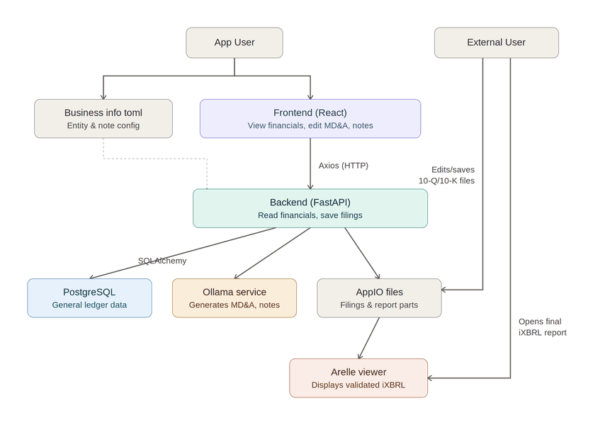

The AppUser manages business_info.toml directly and accesses the React frontend to review financial data and refine MD&A/Notes content. Front-end actions trigger Axios calls to a FastAPI backend. FastAPI reads financial records from PostgreSQL via SQLAlchemy, invokes Ollama to draft MD&A and Notes narratives, and outputs both single .docx files and assembled filings into AppIO. Simultaneously, External Users drop custom .docx components into AppIO and then open Arelle to validate and inspect the resulting iXBRL filing.

Core Repository Structure
The main codebase is cleanly separated into a Python backend, documents, and a modern React frontend.

/disclosure-pilot-ai/
├── backend/
│ ├── app/
│ │ ├── agents/ # AI agent implementations
│ │ ├── api/ # FastAPI route handlers & endpoints
│ │ ├── core/ # App configurations, security, & database setup
│ │ ├── models/ # User authenticaton database ORM model (SQLAlchemy)
│ │ ├── schemas/ # Input/output validation contracts (Pydantic)
│ │ └── services/ # Core business logic layer, database ORM models (SQLAlchemy)
│ └── tests/ # Backend unit & integration test suites
├── docs/ # Project description and setup
└── frontend/
├── dist/ # index files
└── src/
├── api/ # Axios clients & HTTP wrappers
├── components/ # UI widgets: menus, tables, editors, dialogs
├── hooks/ # User authenticaton context
├── pages/ # Top-level views
├── styles/ # Global CSS module
└── tests/ # Frontend UI & unit tests

Boot Sequence

Backend main.py → Frontend HomePage.jsx
The table below traces the full startup path of the application, from the FastAPI process launching in main.py through to an authenticated user landing on HomePage.jsx in the React frontend. The sequence spans two phases: (1) server/process startup, which happens once when the backend launches, and (2) the browser/client boot, which happens each time a user loads the page, culminating in an authentication check that decides whether they see the login page or the home page.

Boot Sequence Summary Table
Stage | File / Component | What happens
1. Server start | main.py | Uvicorn imports app.main:app; FastAPI instance is created and CORS middleware attached.
2. Config load | main.py / app.core.config | settings loaded (DB_HOST, OLLAMA_HOST/URL, WIN_APPIO_DIR, REPORTS_DIR, etc.); each is logged at startup.
3. Routers mounted | main.py | auth, report_10q, and report_10k routers registered under /api/auth, /api/10q, /api/10k — before the SPA catch-all so API paths always win.
4. Static assets mounted | main.py | If FRONTEND_DIST exists, /assets is mounted to serve the Vite JS/CSS bundles.
5. Browser requests "/" | main.py → index.html | serve_root() (or the SPA catch-all) returns index.html, which references the built JS bundle and CSS file.
6. React boots | main.jsx | createRoot(...).render(<App />) mounts the React tree into #root inside index.html.
7. Routing auth context set up | App.jsx | BrowserRouter wraps the app; AuthProvider (from useAuth.jsx) wraps everything so auth state is available app-wide.
8. Session check | useAuth.jsx | On mount, AuthProvider reads access_token from localStorage. If present, calls authApi.getMe() to fetch the user and validate the token; if absent, loading is set to false immediately with user = null.
9. Root route resolves | App.jsx (AuthRoute) | While loading is true, a "Loading..." placeholder is shown. Once resolved: if user exists, redirect to /home; otherwise render LoginPage.
10. Login form shown | LoginPage.jsx | User is presented the Sign In form (with toggles to Create Account / Forgot Password).
11. Credentials submitted | LoginPage.jsx → useAuth.jsx | handleSubmit() calls login(email, password), which POSTs to the backend auth endpoint, stores the returned access_token in localStorage, then calls getMe() again to populate user in context.
12. Redirect to home | App.jsx (AuthRoute) | Because user is now set, AuthRoute re-renders and issues Navigate to /home.
13. Protected layout renders | ProtectedLayout → HomePage.jsx | The /home route renders inside the authenticated layout; HomePage.jsx reads user from useAuth() and displays the welcome message, including the signed-in user's email.

Data Workspace (AppIO)
Input and output data is stored separately from the application code, as listed below.
AppIO/
├── reports/
├── sec10k/
├── sec10q-q1/
├── sec10q-q2/
├── sec10q-q3/
└── user_input/
Before describing the report document layout, the user must understand the user_input files, listed here:
business_info.toml
item001-10-k-cover.docx
item001-10-q-cover.docx
note_list_10k.toml
note_list_10q-q1.toml
note_list_10q-q2.toml
note_list_10q-q3.toml
us-gaap-2026.zip

The business_info.toml file contains basic company information such as name, description, ticker, address, filer status, auditor, shares, etc. Some of this data is applied to the report cover page as substitution variables as seen in item001-10-k-cover.docx and item001-10-q-cover.docx. (Notice: the parameters “legal_proceedings” and “purchase_commitments” are special inputs for the “Commitments and Contingencies” note, to be used only when either of these conditions become abnormal (see notes_agent.py, but no code change required). Rather than setting these parameters, the user may also just edit the note directly from the frontend.)
The notes list file, note_list_10k.toml, may be edited by the user each year to select which Notes to the Financial Statements to include in the 10-K report, by setting the “select” parameter to “true”. Similarly, the note_list_10q-qi files may be edited for each quarterly 10-Q report. Notice: when adding new notes, sometimes the Python code must be modified (see notes_agent.py, notes_registry.py, and xbrl_tagger.py). Currently there are three placeholders for new notes in notes_registry.py: Stock-Based Compensation, Fair Value Measurements, Business Combinations. Use these placeholders as templates for adding more notes as desired.
The last file, us-gaap-2026.zip, is a convenience for the Arelle validation and viewer tool, to store taxonomy information locally rather than downloading from the internet.

API Endpoints
The Application Programming Interface (API) endpoints are summarized below for the connections between the frontend (client.js) and backend (auth.py, report_10q.py, and report_10k.py). See schemas.py for the request and response objects, such as QuarterlyRequest and FinancialStatements, for the 10-Q endpoint: /api/10q/financials.

Auth Endpoints
Method | Path | Description
POST | /api/auth/register | Create new user
POST | /api/auth/login | Login → JWT token
POST | /api/auth/reset-password | Reset password
GET | /api/auth/me | Current user info

10-Q Endpoints
Method | Path | Description
POST | /api/10q/financials | Get financial statements
POST | /api/10q/save-financials | Save item010-Financial-Statements.docx
POST | /api/10q/mda | Generate MD&A narrative
POST | /api/10q/save-mda | Save item020-MDA.docx
POST | /api/10q/notes | Generate Notes narrative
POST | /api/10q/save-notes | Save item011-Notes-to-Financial-Statements.docx
POST | /api/10q/generate-report | Merge → sec-10-q.docx
POST | /api/10q/generate-edgar-html | Convert to EDGAR HTML

10-K Endpoints
Method | Path | Description
POST | /api/10k/financials | Get annual financial statements
POST | /api/10k/save-financials | Save item081-Financial-Statements.docx
POST | /api/10k/mda | Generate annual MD&A
POST | /api/10k/save-mda | Save item070-MDA.docx
POST | /api/10k/notes | Generate annual Notes
POST | /api/10k/save-notes | Save item082-Notes-to-Financial-Statements.docx
POST | /api/10k/generate-report | Merge → sec-10-k.docx
POST | /api/10k/generate-edgar-html | Convert to EDGAR HTML

SQLAlchemy Database Interface
SQLAlchemy serves as the backend Object-Relational Mapper (ORM) and SQL toolkit, providing object-oriented access to the underlying SQL databases.
Module & Schema Mapping
- Authentication: auth.py accesses the applogins schema to handle user authorization (notably via get_user_by_email).
- Financial Services (10-Q / 10-K): financial_service.py accesses the bookkeeper schema. Key query functions include:
  - get_chart_of_accounts
  - get_loans
  - get_gl_balances_cumulative
  - get_gl_balances_range
  - _acct_bal_as_of
Data Serialization
User login responses are returned to the frontend in the AppUser class, specified in user.py.
Financial query results populate specific row-level data models in schemas.py (BalanceSheetRow, IncomeStatementRow, CashFlowRow, and StockholdersEquityRow). These are grouped as lists inside a parent FinancialStatements wrapper class and sent to the frontend as a structured payload.

Document Generation Workspace (AppIO)
To successfully compile massive, highly regulated regulatory filings, the application uses a modular, multi-file assembly strategy. Each official item of an SEC Form 10-K is generated as an independent document snippet before being systematically compiled into the final master report. (The Form 10-Q files, not shown below, are listed under sec10q-q1, sec10q-q2, sec10q-q3.)

AppIO
├── reports/
│ ├── sec-10q-2025-q1.docx # Final Compiled 10-Q Q1 Report
│ ├── sec-10q-2025-q2.docx # Final Compiled 10-Q Q2 Report
│ ├── sec-10q-2025-q3.docx # Final Compiled 10-Q Q3 Report
│ ├── sec-10k-2025.docx # Final Compiled 10-K Report
│ │
│ └── sec10k/ # Granular 10-K Component Registry
│ │
│ ├── intro/ # Document Preliminaries
│ │ ├── item001-10-k-cover.docx # Cover Page
│ │ └── item002-10-k-TOC.docx # Table of Contents
│ │
│ ├── part1/ # Part I: Operational Disclosures
│ │ ├── item010-BusinessProfile.docx
│ │ ├── item01A-Risk-Factors.docx
│ │ ├── item01B-Unresolved-Staff-Comments.docx
│ │ ├── item01C-Cybersecurity.docx
│ │ ├── item020-Properties.docx
│ │ ├── item030-Legal-Proceedings.docx
│ │ └── item040-Mine-Safety-Disclosures.docx
│ │
│ ├── part2/ # Part II: Financials, MD&A, and Notes
│ │ ├── item050-Common-Equity.docx
│ │ ├── item060-Reserved.docx
│ │ ├── item070-MDA.docx # Management's Discussion & Analysis
│ │ ├── item07A-Disclose-Market-Risk.docx
│ │ ├── item080-AuditorReport.docx
│ │ ├── item081-Financial-Statements.docx
│ │ ├── item082-Notes-to-Financial-Statements.docx
│ │ ├── item090-Disagreements-with-Accountants.docx
│ │ ├── item09A-Controls-Procedures.docx
│ │ ├── item09B-Other-Information.docx
│ │ └── item09C-Disclosure-Foreign-Inspections.docx
│ │
│ ├── part3/ # Part III: Corporate Governance
│ │ ├── item100-Directors-Exec.docx
│ │ ├── item110-Exec-Compensation.docx
│ │ ├── item120-Beneficial-Owners.docx
│ │ ├── item130-Certain-Relationships.docx
│ │ └── item140-Accountant-Fees.docx
│ │
│ ├── part4/ # Part IV: Exhibits
│ │ ├── item150-Exhibit-Schedules.docx
│ │ └── item160-Form-10-K-Summary.docx
│ │
│ └── sigs/ # Signatures
│ └── item999-10-K-Signatures.docx

Architectural Design Choices
Even though the final Form 10-K (or Form 10-Q) report is submitted to the SEC as a single, consolidated file, the system deliberately processes individual sections as separate documents. This architectural choice was made to simplify application logic and support collaborative workflows:
- Distributed Authoring: Separate files allow different internal employees or outsourced teams to work on specific sections simultaneously without version control conflicts.
- Third-Party Integration: Certain sections are naturally generated by external software or specialized vendors. For instance, item080-AuditorReport.docx is typically prepared and delivered by an outside auditing firm.

Application Limitations
To maintain a highly focused project scope, the application's direct editing and generation capabilities are strictly limited.
Key Takeaway: The software only edits and produces six specific files (for 10-K):
1. item001-10-k-cover.docx (Cover Page)
2. item002-10-k-TOC.docx (Table of Contents)
3. item070-MDA.docx (Management's Discussion and Analysis)
4. item081-Financial-Statements.docx (Balance Sheet, Income Statement, Cash Flow Statement, Stockholders Equity)
5. item082-Notes-to-Financial-Statements.docx (Notes to Financial Statements)
6. sec-10k-2025.htm (Complete Filing with iXBRL)
Important: Create the remaining .docx item files outside of this application.
The primary function of the application is to compile and merge the entire collection of individual .docx item files into the final, cohesive Form 10-K or Form 10-Q report ready for submission to the SEC.
While report files are not overwritten, the many .docx item files are assumed to be overwritten in this application. Thus, to preserve these files from year to year, the user may zip them up in an archive.
Notice: This application is a proof-of-concept demonstration for generating 10-K and 10-Q filings, not an accounting platform.
- Read-Only Operation: The app never inserts, updates, or alters the underlying financial database.
- Simplified Schema: Designed for clarity rather than live operations, the database omits complex items like stock option compensation, other comprehensive income (foreign currency, pension liability), business acquisitions, deferred taxes, and closing entries.
- Synthetic Data: Historical data is AI-generated solely to allow users to simulate filing reports.
- Limited Disclosures: The backend implements only eight note types for the Notes to Financial Statements, whereas standard corporate 10-Ks typically include 15–20.

React Client references:
https://thepythoncode.com/article/fullstack-notes-app-with-fastapi-and-reactjs
https://www.bairesdev.com/blog/react-spa-single-page-application/
https://www.geeksforgeeks.org/python/fastapi-templates/
Fastapi Server references:
https://realpython.com/fastapi-python-web-apis/
https://fastapitutorial.com/blog/serving-html-fastapi/
https://fastapi.tiangolo.com/reference/apirouter/#fastapi.APIRouter.get--example

Section 5 - Database Schema
This section outlines the relational database architecture for the bookkeeper schema, hosted on a PostgreSQL instance. The tables are structured to ensure absolute data integrity, performance optimization, and auditability for financial transactions.
1. Architectural Overview
The schema comprises seven primary tables structured to manage a multi-currency double-entry journal ledger, operational sub-ledgers (Accounts Payable and Accounts Receivable), fixed asset tracking, depreciation logs, and master reference entities (Customers and Vendors). Transactional balances are strictly guarded at the database level via deferred constraints and system views.
2. Detailed Table Specifications
2.1 Table: bookkeeper.chart_of_acct
Master metadata directory defining the comprehensive structure of financial accounts and normal balance rules.
Column Name | Data Type | PK? | Description / Constraints
account_number | VARCHAR(10) | YES | Primary Key. Unique index code for the account.
account_name | VARCHAR(100) | NO | Standard financial title of the specific account.
account_type | VARCHAR(30) | NO | Top-level categorization. CHECK constraint ensures values match: 'Asset', 'Liability', 'Equity', 'Revenue', 'Expense'.
account_subtype | VARCHAR(30) | NO | Sub-classification layer for finer reporting granularities.
normal_balance | VARCHAR(6) | NO | Standard accounting balance type. CHECK constraint restricts to: 'Debit', 'Credit'.

2.2 Table: bookkeeper.vendors
Master reference table containing validated corporate credential details for suppliers and external vendors.
Column Name | Data Type | PK? | Description / Constraints
vendor_id | VARCHAR(15) | YES | Primary Key. Unique identifier for the vendor/supplier.
vendor_name | VARCHAR(50) | NO | Official trade or commercial entity name of the vendor.

2.3 Table: bookkeeper.customers
Master directory storing validated identity profiles for corporate, institutional, and individual commercial consumers.
Column Name | Data Type | PK? | Description / Constraints
customer_id | VARCHAR(15) | YES | Primary Key. Unique identifier for the client entity.
customer_name | VARCHAR(50) | NO | Legal commercial or personal name of the customer.

2.4 Table: bookkeeper.journal_entries
The central transaction ledger tracking document headers, publication dates, and validation state checkpoints.
Column Name | Data Type | PK? | Description / Constraints
id | BIGSERIAL | YES | Primary Key. Autoincrementing unique ledger entry identifier.
entry_date | DATE | NO | The explicit posting or execution date. Defaults to CURRENT_DATE.
description | TEXT | NO | Auditable narrative describing the business purpose of the transaction.
status | VARCHAR(15) | NO | Lifecycle state of the entry. Defaults to 'DRAFT'.
created_at | TIMESTAMP W/ TZ | NO | System record creation timestamp. Defaults to CURRENT_TIMESTAMP.

2.5 Table: bookkeeper.journal_lines
Atomic double-entry transaction fragments. Contains individual line-item allocations mapping debits and credits to target sub-accounts.
Column Name | Data Type | PK? | Description / Constraints
id | BIGSERIAL | YES | Primary Key. Autoincrementing identifier for the transaction line.
journal_entry_id | BIGINT | NO | Foreign Key reference to bookkeeper.journal_entries(id) ON DELETE CASCADE.
account_number | VARCHAR(10) | NO | Foreign Key reference linking lines to bookkeeper.chart_of_acct(account_number).
debit | NUMERIC(15, 4) | NO | Absolute debit amount. Must be non-negative. Defaults to 0.
credit | NUMERIC(15, 4) | NO | Absolute credit amount. Must be non-negative. Defaults to 0.
currency | VARCHAR(3) | NO | Three-letter ISO currency identifier. Defaults to 'USD'.  *Constraint*: chk_debit_credit_exclusivity enforces that a line must have a positive Debit OR Credit, but not both.

2.6 Table: bookkeeper.accounts_payable
Tracks operational sub-ledger liabilities, procurement obligations, and audit trails to settlement records.
Column Name | Data Type | PK? | Description / Constraints
ap_id | VARCHAR(15) | YES | Primary Key. Unique identifier for the accounts payable record.
vendor_id | VARCHAR(15) | NO | Foreign Key reference to bookkeeper.vendors(vendor_id).
invoice_date | DATE | NO | The date the invoice was officially generated by the vendor.
due_date | DATE | NO | The contractually bound settlement deadline.
amount | NUMERIC(15, 4) | NO | The gross absolute financial liability value.
status | VARCHAR(15) | NO | Payment or processing state. CHECK: 'UNPAID', 'PAID', 'VOIDED'. Defaults to 'UNPAID'.
currency | VARCHAR(3) | NO | Three-letter ISO currency identifier. Defaults to 'USD'.
recognition_entry_id | BIGINT | NO | Foreign Key linking to the originating entry in bookkeeper.journal_entries.
settlement_entry_id | BIGINT | NO | Foreign Key linking to the final payment entry in bookkeeper.journal_entries.  *Constraint*: chk_ap_payment_trail mandates settlement_entry_id must be populated if and only if status is 'PAID'.

2.7 Table: bookkeeper.accounts_receivable
Tracks active incoming credit claims and asset volumes due from customer consumer accounts.
Column Name | Data Type | PK? | Description / Constraints
ar_id | VARCHAR(15) | YES | Primary Key. Unique invoice claim identifier.
customer_id | VARCHAR(15) | NO | Foreign Key reference to bookkeeper.customers(customer_id).
invoice_date | DATE | NO | The date the commercial invoice was generated and issued.
due_date | DATE | NO | The contractual settlement deadline for the customer.
amount | NUMERIC(15, 4) | NO | The gross absolute financial asset volume claimable.
status | VARCHAR(15) | NO | Collection state. CHECK: 'UNPAID', 'PAID', 'VOIDED', 'BAD_DEBT'. Defaults to 'UNPAID'.
currency | VARCHAR(3) | NO | Three-letter ISO currency identifier. Defaults to 'USD'.
recognition_entry_id | BIGINT | NO | Foreign Key linking to the revenue recognition entry in bookkeeper.journal_entries.
settlement_entry_id | BIGINT | NO | Foreign Key linking to the customer payment entry in bookkeeper.journal_entries.  *Constraint*: chk_ar_payment_trail mandates settlement_entry_id must be populated if and only if status is 'PAID'.

2.8 Table: bookkeeper.assets
Maintains an active operational inventory of capitalized objects and long-term tangible corporate assets.
Column Name | Data Type | PK? | Description / Constraints
asset_id | VARCHAR(15) | YES | Primary Key. Unique identifier for the fixed asset item.
asset_name | VARCHAR(100) | NO | Descriptive commercial name of the capitalized asset.
purchase_date | DATE | NO | Acquisition date for accounting tracking.
cost | NUMERIC(15, 4) | NO | Gross historical acquisition or production cost volume.
service_years | INTEGER | NO | Estimated useful operational lifetime projection in years.
dept | VARCHAR(15) | NO | Cost center allocation or organizational department tag.
currency | VARCHAR(3) | NO | Three-letter ISO currency identifier. Defaults to 'USD'.

2.9 Table: bookkeeper.depreciation
Records recurring systematic book-value write-downs of assets across operational fiscal cycles.
Column Name | Data Type | PK? | Description / Constraints
depreciation_id | VARCHAR(15) | YES | Primary Key. Unique depreciation ledger row index.
asset_id | VARCHAR(15) | NO | Foreign Key reference link matching target bookkeeper.assets(asset_id).
year | INTEGER | NO | The operational fiscal year of the logged depreciation expense.
annual_depreciation | NUMERIC(15, 4) | NO | The absolute value expensed as depreciation during the specified year.
accumulated_thru_year | NUMERIC(15, 4) | NO | Total cumulative depreciation written off up to the logged year.
currency | VARCHAR(3) | NO | Three-letter ISO currency identifier. Defaults to 'USD'.

3. Database Views & Performance Layer
3.1 View: bookkeeper.general_ledger
Acts as an auditable public transaction log exposing only finalized operations. It automatically resolves and joins transaction headers and detailed lines to report posted journals. It includes line items if and only if the header status is explicitly set to 'POSTED'.
3.2 Performance Indexes
To facilitate high-throughput reporting, sub-second queries, and instant reconciliation reviews, the database implements specific relational performance indexing paths:
• idx_journal_lines_entry: Fast lookup index on journal_lines(journal_entry_id) to accelerate transaction construction.
• idx_journal_lines_account: Optimization index on journal_lines(account_number) ensuring rapid sub-account evaluations.
• idx_journal_entries_date_posted: A partial conditional index on journal_entries(entry_date) filtered WHERE status = 'POSTED' to optimize general ledger views.
4. Business Rules & Operational Constraints
Double-Entry Integrity: Strict transactional balance is protected via a row-by-row procedural trigger (bookkeeper.enforce_journal_entry_balance()). The constraint trigger trigger_enforce_balance acts AFTER INSERT, UPDATE, or DELETE on any line-item. It is defined as DEFERRABLE INITIALLY DEFERRED, meaning the PostgreSQL engine permits temporary transaction imbalances while compiling line-items, but verifies and strictly throws a rollback exception if the aggregate Debits minus Credits do not sum to exactly zero at commit execution.
Line-Level Mutual Exclusivity: Every transaction fragment row in journal_lines must have a single clear financial direction. The CHECK constraint chk_debit_credit_exclusivity guarantees that either debit > 0 and credit = 0, or credit > 0 and debit = 0. Negative financial value logs are completely blocked.
Currency Uniformity: Across all sub-ledgers, transaction logs, and primary ledgers (journal_lines, accounts_payable, accounts_receivable, assets, and depreciation), a standard string default value of 'USD' is natively applied if explicit ISO currency codes are missing.
Sub-Ledger Paper Trails: Both Accounts Payable and Accounts Receivable tightly bind operational invoicing to general journal lines through recognition and settlement links. If an invoice status transitions to 'PAID', database constraints mandate that the settlement journal entry identifier must be populated with a valid transaction reference, providing a pristine audit trail from operations directly to financial reports.

Section 6 - Accounting Fundamentals
1. Overview & Architectural Context
This section describes the financial accounting logic for the financial application. To maintain strict precision and auditing integrity, the application uses a double-entry bookkeeping architecture built on top of a relational PostgreSQL schema (bookkeeper). Every economic event impacting the organization is recorded atomically across balanced debits and credits, creating an unalterable audit trail that serves as the single source of truth for downstream financial reporting.
2. Core Ledger Database Schema & Validation Constraints
The application ledger relies on two central tables to track transactions: bookkeeper.journal_entries and bookkeeper.journal_lines. These mirror the traditional accounting concept of a 'Journal Entry' and its corresponding 'Journal Lines.'
• bookkeeper.journal_entries: records the transaction-level metadata, including the entry_date, text description, and transaction status (e.g., DRAFT, POSTED).
• bookkeeper.journal_lines: stores individual debits and credits. Each line enforces mutual exclusivity via the chk_debit_credit_exclusivity constraint, ensuring that a single line contains either a debit or a credit, but never both.
DATABASE INTEGRITY CONSTRAINT: To guarantee that the fundamental accounting equation (Assets = Liabilities + Equity) remains in perpetual balance, the database enforces a transactional constraint. An AFTER INSERT OR UPDATE OR DELETE constraint trigger (trigger_enforce_balance) executes the PL/pgSQL function bookkeeper.enforce_journal_entry_balance(). This function aggregates total debits minus total credits for the modified journal_entry_id. If the net balance does not equal zero, the database rolls back the transaction and throws a fatal exception.

What is the Chart of Accounts?
The chart of accounts (COA) organizes financial information into five core account types (or categories)—assets, liabilities, equity, revenue, and expenses—typically using a standardized numeric coding system to establish a clear reporting hierarchy. In essence, the COA acts as the master data model that translates raw, day-to-day operational transactions into the clean, consolidated line items that ultimately populate your balance sheet, income statement, and 10-K reports. See database table, bookkeeper.chart_of_acct. For each of the five account types, there are a few subtypes, as listed below.

Account number | Account name | Account type | Account subtype | Normal balance
1000 | Cash and Equivalents | Asset | Current Asset | Debit
1050 | Short-Term Investments | Asset | Current Asset | Debit
1100 | Accounts Receivable | Asset | Current Asset | Debit
1150 | Allowance for Doubtful Accounts | Asset | Contra Asset | Credit
1200 | Inventory | Asset | Current Asset | Debit
1300 | Prepaid Expenses | Asset | Current Asset | Debit
1500 | Property, Plant & Equip | Asset | Fixed Asset | Debit
1550 | Accumulated Depreciation | Asset | Contra Asset | Credit
2000 | Accounts Payable | Liability | Current Liability | Credit
2100 | Accrued Liabilities | Liability | Current Liability | Credit
2200 | Short-term Debt | Liability | Current Liability | Credit
2300 | Unearned Revenue | Liability | Current Liability | Credit
2500 | Long-term Debt | Liability | Long-term Liability | Credit
3000 | Common Stock | Equity | Paid-in Capital | Credit
3100 | Retained Earnings | Equity | Retained Earnings | Credit
3200 | Treasury Stock | Equity | Contra Equity | Debit
3300 | Dividends Paid | Equity | Contra Equity | Debit
4000 | Hardware Sales | Revenue | Product Revenue | Credit
4100 | Software Sales | Revenue | Product Revenue | Credit
4200 | Consulting | Revenue | Service Revenue | Credit
4300 | Interest Income | Revenue | Non-Operating Revenue | Credit
5000 | Cost of Goods Sold | Expense | Operating Expense | Debit
6000 | Salaries and Wages | Expense | Operating Expense | Debit
6100 | Supplies Expense | Expense | Operating Expense | Debit
6200 | Lease Expense | Expense | Operating Expense | Debit
6300 | Bad Debt Expense | Expense | Operating Expense | Debit
6400 | Marketing Expense | Expense | Operating Expense | Debit
6500 | R&D Expense | Expense | Operating Expense | Debit
6600 | Depreciation Expense | Expense | Operating Expense | Debit
6700 | Legal & Professional Fees | Expense | Operating Expense | Debit
7000 | Interest Expense | Expense | Non-Operating Expense | Debit
8000 | Income Tax Expense | Expense | Tax Expense | Debit

In addtition, there is a “normal balance” that indicates the side, debit or credit, where increases are recorded. Understanding this removes confusion around debits and credits. Note that both credits and debits are allowed, the normal one is for increases, the opposite one is for decreases.

Debit Normal Balances
- Assets: Resources owned by the business (e.g., cash, equipment); increased with a debit, decreased with a credit.
- Expenses: Costs to run the business (e.g., rent, utilities); increased with a debit, decreased with a credit.
- Dividends / Drawings: Money taken out by owners; increased with a debit, decreased with a credit.
Credit Normal Balances
- Liabilities: Debts owed to others (e.g., loans, accounts payable); increased with a credit, decreased with a debit.
- Equity: Owner or shareholder stake in the company; increased with a credit, decreased with a debit.
- Revenue (Income): Money earned from sales or services; increased with a credit, decreased with a debit.
Contra Accounts
- Opposite Balance: These accounts reduce a parent account and carry the opposite normal balance (e.g., Accumulated Depreciation is a contra-asset with a normal credit balance).
- Error Detection: If an account shows the wrong balance type (like cash showing a credit), it usually signals a recording mistake.
Step-by-Step Transaction Examples & Ledger Representation
The following seven operational examples illustrate how transactional workflows populate the bookkeeper schema tables. For consistency, all entries are modeled with a status of POSTED, making them visible to the bookkeeper.general_ledger view.
Example 1: Application Initialization via Common Stock Sale
Scenario: The application is seeded by issuing common stock to founders for $25,000,000 in cash. To immediately fund production, $5,000,000 of that cash is allocated to establish starting raw materials and finished inventory, leaving $20,000,000 as liquid cash.
Account Number | Account Name | Account Type | Debit (DR) | Credit (CR)
1000 | Cash and Equivalents | Asset (Current) | $20,000,000.00 | $0.00
1200 | Inventory | Asset (Current) | $5,000,000.00 | $0.00
3000 | Common Stock | Equity (Paid-in Capital) | $0.00 | $25,000,000.00
TOTAL |  |  | $25,000,000.00 | $25,000,000.00

Example 2: Capital Asset Acquisition via Long-Term Debt
Scenario: The company secures corporate facilities and manufacturing equipment, purchasing Property, Plant & Equipment (PP&E) for $10,000,000, fully financed via a long-term bank loan. This instantiates rows in the bookkeeper.assets and bookkeeper.loans operational tables, linked directly to the journal ledger.
Account Number | Account Name | Account Type | Debit (DR) | Credit (CR)
1500 | Property, Plant & Equip | Asset (Fixed) | $10,000,000.00 | $0.00
2500 | Long-term Debt | Liability (Long-term) | $0.00 | $10,000,000.00
TOTAL |  |  | $10,000,000.00 | $10,000,000.00

Example 3: Hardware Product Sale (On-Credit)
Scenario: The company fulfills a bulk order of physical units for an enterprise client. The hardware is sold on open account terms for $1,500,000, creating an Accounts Receivable asset and populating the sub-ledger bookkeeper.accounts_receivable.
Account Number | Account Name | Account Type | Debit (DR) | Credit (CR)
1100 | Accounts Receivable | Asset (Current) | $1,500,000.00 | $0.00
4000 | Hardware Sales | Revenue (Product) | $0.00 | $1,500,000.00
TOTAL |  |  | $1,500,000.00 | $1,500,000.00

Example 4: Software Subscription Sale (Cash Settlement)
Scenario: Enterprise clients purchase cloud software licenses totaling $2,500,000, processed through an electronic gateway and deposited instantly into the company's operating cash account.
Account Number | Account Name | Account Type | Debit (DR) | Credit (CR)
1000 | Cash and Equivalents | Asset (Current) | $2,500,000.00 | $0.00
4100 | Software Sales | Revenue (Product) | $0.00 | $2,500,000.00
TOTAL |  |  | $2,500,000.00 | $2,500,000.00

Example 5: Cost of Goods Sold (COGS) Recognition
Scenario: To match the revenue recorded in Example 3 with its direct economic cost, the application reduces asset inventory and records an expense for the historical production cost of the items shipped, which totals $800,000.
Account Number | Account Name | Account Type | Debit (DR) | Credit (CR)
5000 | Cost of Goods Sold | Expense (Operating) | $800,000.00 | $0.00
1200 | Inventory | Asset (Current) | $0.00 | $800,000.00
TOTAL |  |  | $800,000.00 | $800,000.00

Example 6: SG&A Expense Disbursal (Salaries and Wages)
Scenario: Operational overhead representing Selling, General, and Administrative (SG&A) expenses is recorded. For this period, the company processes payroll disbursements for administrative and sales staff totaling $700,000, settled out of operating cash.
Account Number | Account Name | Account Type | Debit (DR) | Credit (CR)
6000 | Salaries and Wages | Expense (Operating) | $700,000.00 | $0.00
1000 | Cash and Equivalents | Asset (Current) | $0.00 | $700,000.00
TOTAL |  |  | $700,000.00 | $700,000.00

Example 7: Corporate Income Tax Expense Accrual
Scenario: Based on preliminary quarterly operating performance, the company computes its corporate tax provision. It recognizes $300,000 in tax expense, deferred as an outstanding short-term obligation under accrued liabilities until the formal tax filing date.
Account Number | Account Name | Account Type | Debit (DR) | Credit (CR)
8000 | Income Tax Expense | Expense (Tax) | $300,000.00 | $0.00
2100 | Accrued Liabilities | Liability (Current) | $0.00 | $300,000.00
TOTAL |  |  | $300,000.00 | $300,000.00

4. Database Row State Representation
The following tables demonstrate how the database stores the relational state inside journal_entries and journal_lines for the seven transactions recorded above.
Table: bookkeeper.journal_entries
id | entry_date | description | status
1 | 2026-06-17 | Initial seed transaction via founder common stock sale | POSTED
2 | 2026-06-17 | Acquisition of manufacturing equipment and facilities via loan | POSTED
3 | 2026-06-17 | Bulk commercial hardware sales on open account terms | POSTED
4 | 2026-06-17 | SaaS infrastructure customer annual renewal billing | POSTED
5 | 2026-06-17 | Cost of goods sold matching recognition for hardware delivery | POSTED
6 | 2026-06-17 | Bi-weekly operational corporate payroll disbursement | POSTED
7 | 2026-06-17 | Estimated quarterly corporate tax provision accrual | POSTED
Table: bookkeeper.journal_lines
id | journal_entry_id | account_number | debit | credit
1 | 1 | 1000 | 20000000.0000 | 0.0000
2 | 1 | 1200 | 5000000.0000 | 0.0000
3 | 1 | 3000 | 0.0000 | 25000000.0000
4 | 2 | 1500 | 10000000.0000 | 0.0000
5 | 2 | 2500 | 0.0000 | 10000000.0000
6 | 3 | 1100 | 1500000.0000 | 0.0000
7 | 3 | 4000 | 0.0000 | 1500000.0000
8 | 4 | 1000 | 2500000.0000 | 0.0000
9 | 4 | 4100 | 0.0000 | 2500000.0000
10 | 5 | 5000 | 800000.0000 | 0.0000
11 | 5 | 1200 | 0.0000 | 800000.0000
12 | 6 | 6000 | 700000.0000 | 0.0000
13 | 6 | 1000 | 0.0000 | 700000.0000
14 | 7 | 8000 | 300000.0000 | 0.0000
15 | 7 | 2100 | 0.0000 | 300000.0000

5. Generation of Financial Statements
At the close of an accounting reporting cycle, the application queries the unified general ledger database view (bookkeeper.general_ledger) to aggregate row-level debit and credit activity. These net balances generate the organization's primary financial reports.
The Income Statement
The Income Statement details the financial performance of the entity over a specific duration of time. It isolates operating and non-operating performance metrics by evaluating the core equation: Net Income = Revenue - Expenses
Income Statement Line Item | Amount ($) | GL Source Accounts Involved
Hardware Sales Revenue | 1,500,000.00 | 4000 - Hardware Sales (Example 3)
Software Sales Revenue | 2,500,000.00 | 4100 - Software Sales (Example 4)
Total Revenue | 4,000,000.00 | Subtotal of Revenue Accounts
Cost of Goods Sold (COGS) | (800,000.00) | 5000 - Cost of Goods Sold (Example 5)
Gross Profit | 3,200,000.00 | Revenue minus Direct Product Costs
Selling, General & Administrative (SG&A) | (700,000.00) | 6000 - Salaries and Wages (Example 6)
Income Tax Expense | (300,000.00) | 8000 - Income Tax Expense (Example 7)
Net Income | 2,200,000.00 | The 'Bottom Line' Transferred to Equity

THE ACCOUNTING BRIDGE: Net Income does not remain standalone. It serves as a continuous bridge that updates the entity's financial positioning on the Balance Sheet. During the closing entry process, the net earnings balance of $2,200,000 shifts from the temporary income statement accounts into the permanent equity account 3100 - Retained Earnings under Equity, expanding the cumulative capital value held by shareholders.

The Balance Sheet
The Balance Sheet provides a structural snapshot showing the exact financial position of the company at a definitive point in time. It measures what the firm owns versus what it owes, validating the foundational identity: Assets = Liabilities + Shareholders' Equity

Balance Sheet Classification & Line Items | Net GL Balance ($) | Derivation Mechanics & Account Activity Source
ASSETS
Cash and Equivalents | 21,800,000.00 | 1000: $20,000,000 (Ex 1) + $2,500,000 (Ex 4) - $700,000 (Ex 6)
Accounts Receivable | 1,500,000.00 | 1100: $1,500,000 (Ex 3) outstanding commercial invoices
Inventory | 4,200,000.00 | 1200: $5,000,000 starting allocation (Ex 1) - $800,000 COGS (Ex 5)
Property, Plant & Equip | 10,000,000.00 | 1500: Fixed manufacturing plant acquisition value (Ex 2)
TOTAL ASSETS | 37,500,000.00 | Sum of all corporate resources under management
LIABILITIES
Accrued Liabilities | 300,000.00 | 2100: Estimated quarterly corporate tax obligation (Ex 7)
Long-term Debt | 10,000,000.00 | 2500: Outstanding bank loan principal for capital asset (Ex 2)
TOTAL LIABILITIES | 10,300,000.00 | Sum of all outstanding external legal claims
EQUITY
Common Stock | 25,000,000.00 | 3000: Par value capital funding injected during initialization (Ex 1)
Retained Earnings | 2,200,000.00 | 3100: Retained profit bridged directly from the Net Income pool
TOTAL EQUITY | 27,200,000.00 | Total net internal equity value held by corporate owners
TOTAL LIABILITIES & EQUITY | 37,500,000.00 | Verification: Liabilities ($10.3M) + Equity ($27.2M) = $37.5M
Verification: Liabilities ($10.3M) + Equity ($27.2M) = Assets ($37.5M)

References to Financial Accounting:
https://medium.com/@abdulazizalthobaiti96/creating-an-accounting-information-system-part-1-the-journal-58aff3cd8f11
https://databasesample.com/database/accounting-ledger-database
https://www.pacificabs.com/knowledge-center/blog/small-business-accounting-essential-chart-of-accounts-every-owner-should-know/
https://www.ispirer.com/blog/best-database-for-financial-accounting-apps
https://www.hyperbots.com/glossary/audit-log-finance
https://onspring.com/resources/blog/what-is-an-audit-trail/

Section 7 - LLM Analysis

1. How Large Language Models Work
Prompt-based AI relies entirely on Large Language Models (LLMs). To convert a user's prompt—such as turning software design specifications into functional Python code—the model relies on a process called training.
During training, the model's millions of internal weights are adjusted over multiple iterations until an optimal goal is met. This specific training methodology is called Reinforcement Learning from Human Feedback (RLHF), which relies on human evaluation of a dedicated training dataset.
Mathematically, the core of LLM processing involves:
- Matrix multiplications to compute outputs.
- Partial derivatives for backpropagation, which mathematically updates the model's weights.
Once training is complete, these weights, which represent complex numerical relationships between words, are saved as an LLM model for the next phase called inference. When you input a new prompt, the software uses these optimized weights to compute a response, seamlessly turning design specs into code. Note, there is no backpropagation or weight updates in the inference phase.

2. Debunking LLM Terminology
Despite how impressive the output looks, it is important to clarify what LLM software actually is—and what it isn't.
- Is it intelligent? No.
- Does it learn or reason? No.
- Does it understand English or your specific questions? No.
- Does it always produce correct results? No.

The Library Analogy
If LLMs don't understand or reason, how do they generate acceptable responses? The answer is simple: by lookup!
Imagine a vast library containing every publication ever written. When you submit a request, a librarian looks up the absolute best set of documents that matches your prompt.
An LLM operates just like this library lookup process, only it is executed via matrix algebra using millions of model weights. Because it is fundamentally a lookup system, if a concept was never published, the AI cannot know anything about it.

3. Minimizing Mistakes and Hallucinations
Because LLMs absolutely require existing source material to look up, they will make mistakes or invent meaningless responses—known as hallucinations—when they run out of accurate references.
To counter this limitation, LLM software can use a technique called Retrieval-Augmented Generation (RAG). Instead of relying strictly on static, pre-trained knowledge, the RAG feature allows the LLM to dynamically access external documents, which significantly helps the model avoid hallucinations.
LLM References:
https://medium.com/@amallya0523/how-an-llm-understands-input-the-math-under-the-hood-114ac69f96c6
https://poloclub.github.io/transformer-explainer/
https://www.understandingai.org/p/large-language-models-explained-with
https://medium.com/@atifhussain/dont-get-fooled-by-llm-hype-why-understanding-goes-beyond-tutorials-7c15ee154476
https://www.gilesthomas.com/2025/09/maths-for-llms
https://medium.com/@anjalitanikella/understanding-the-math-behind-llm-models-and-fine-tuning-them-ee4ca222823f
https://medium.com/@kiplangatkorir/mathematical-foundations-of-large-language-models-541b196ccf84
LLM hallucination:
https://www.cnn.com/2026/04/23/business/ai-hallucination-sullivan-cromwell-nightcap

Section 8: AI Agent Tutorial
An AI agent is not just a chatbot that answers a single question. It is a program that takes a goal, holds state, makes decisions, and performs a sequence of actions to reach that goal. The application implements two AI agents, both using the local version of ChatOllama LLM. One agent produces the Management's Discussion and Analysis (MD&A), while the other produces Notes to Financial Statements (Notes). In the application’s MDA function (mda_agent.py), the agent uses a ReportState that flows through six specialized nodes. It is designed to act like a senior financial analyst: it receives raw financial data and produces a formal MD&A item for an SEC 10-Q or 10-K filing. Similarly, the Notes function (notes_agent.py), is designed like the MDA function, and is not described below.

Benefit
Modularity: each node does one job (validate, compute, enrich, generate, review).
Accuracy: Python calculates numbers before the LLM sees them.
Compliance: a dedicated review node checks SEC language.
Traceability: you can log state after any node.

Graph-Based Agent Networks: Graphs, Nodes, and Edges
Modern frameworks model agents as computational graphs, such as LangGraph, GPTSwarm, Burr, and Mastra, where agent behaviors are represented as interconnected nodes and edges that coordinate reasoning, tool use, and control flow. This framework provides clear architectural control over the agent's behavior. The graph manages the shared state, a sequentially updated data payload, that is passed systematically from one step to the next. A Node represents a discrete unit of computation within the graph.
Each node performs a specific operation on the current state and returns an updated state. Examples of nodes include an LLM calling a specific prompt, an execution block running a SQL query, or a data validation function. An Edge defines the transition pathway between nodes.
Edges connect the output of one node to the input of another. There are two primary types of edges: Standard Edges, which dictate a sequential transition from Node A to Node B, and Conditional Edges, which evaluate the current state to dynamically route the execution path to different nodes based on some criteria. If a conditional edge is reached, the data is evaluated to decide if the state should loop backward (e.g., for error revision) or advance forward.

How to Code It
The MDA agent’s workflow is built as follows:
workflow = StateGraph(ReportState)
workflow.add_node("analyze_financials", analyze_financials_node)
workflow.add_node("validate_financials", validate_financials_node)
workflow.add_node("compute_kpis", compute_kpis_node)
workflow.add_node("enrich_context", enrich_context_node)
workflow.add_node("generate_mda", generate_mda_node)
workflow.add_node("compliance_review", compliance_review_node)
workflow.set_entry_point("analyze_financials")
workflow.add_edge("analyze_financials", "validate_financials")
workflow.add_edge("validate_financials", "compute_kpis")
workflow.add_edge("compute_kpis", "enrich_context")
workflow.add_edge("enrich_context", "generate_mda")
workflow.add_edge("generate_mda", "compliance_review")
workflow.add_edge("compliance_review", END)

The Six Nodes
analyze_financials: Node 1 – initializes ReportState, sets status="analyzing", runs the three _summarize_* helpers to create balance_sheet_summary, income_summary, cash_flow_summary.
validate_financials: Node 2 – checks that Total Assets ≈ Liabilities + Equity, verifies prior-period data exists, and records any validation_issues.
compute_kpis: Node 3 – calculates deterministic metrics (YoY revenue growth %, net margin %, operating cash margin) and stores them as kpi_summary.
enrich_context: Node 4 – injects business_description, key initiatives, and acquisition details so the LLM does not create bracketed placeholders.
generate_mda: Node 5 – builds the system prompt ("senior financial analyst...") and user prompt with summaries and KPIs, for each MD&A susbsection (e.g. Overview of Business and Highlights, Results of Operations, Liquidity and Capital Resources, etc. ). Then ChatOllama is called, llm.invoke(), in a loop over each MD&A subsection. The loop is necessary to avoid degraded narratives when token limits are reached if all subsections are combined into one prompt.
compliance_review: Node 6 – runs a second LLM pass to ensure Forward-Looking Statements disclaimer, Liquidity and Capital Resources headings, and factual tone are present.

Input
The MDA agent accepts financial data as input, which include balance sheet, income statement, cash flow, and time periods. See schemas.py: BalanceSheetRow, IncomeStatementRow, CashFlowRow.

What the LLM Does
The Node 5 LLM, generate_mda, does not store sentences. It creates them at runtime because it:
Recognizes the genre — it's been trained on thousands of real 10-K MD&As, so it knows the SEC boilerplate ("Forward-Looking Statements disclaimer," "Liquidity and Capital Resources", etc.).
Fills the outline — it takes built-in headings and expands each one into paragraphs, weaving in the numbers passed to it (e.g. $70M revenue, $3.4M operating cash).

Output
After node 6, compliance_review, the state["mda_narrative"] contains the final MD&A text, returned as the MDAResponse(narrative, validation_warnings, …), which the user may review and save to a file. If the reponse is a warning, the user can then check the financial data for any discrepancies.

Node Diagram
Visual reference for the workflow.add_node:
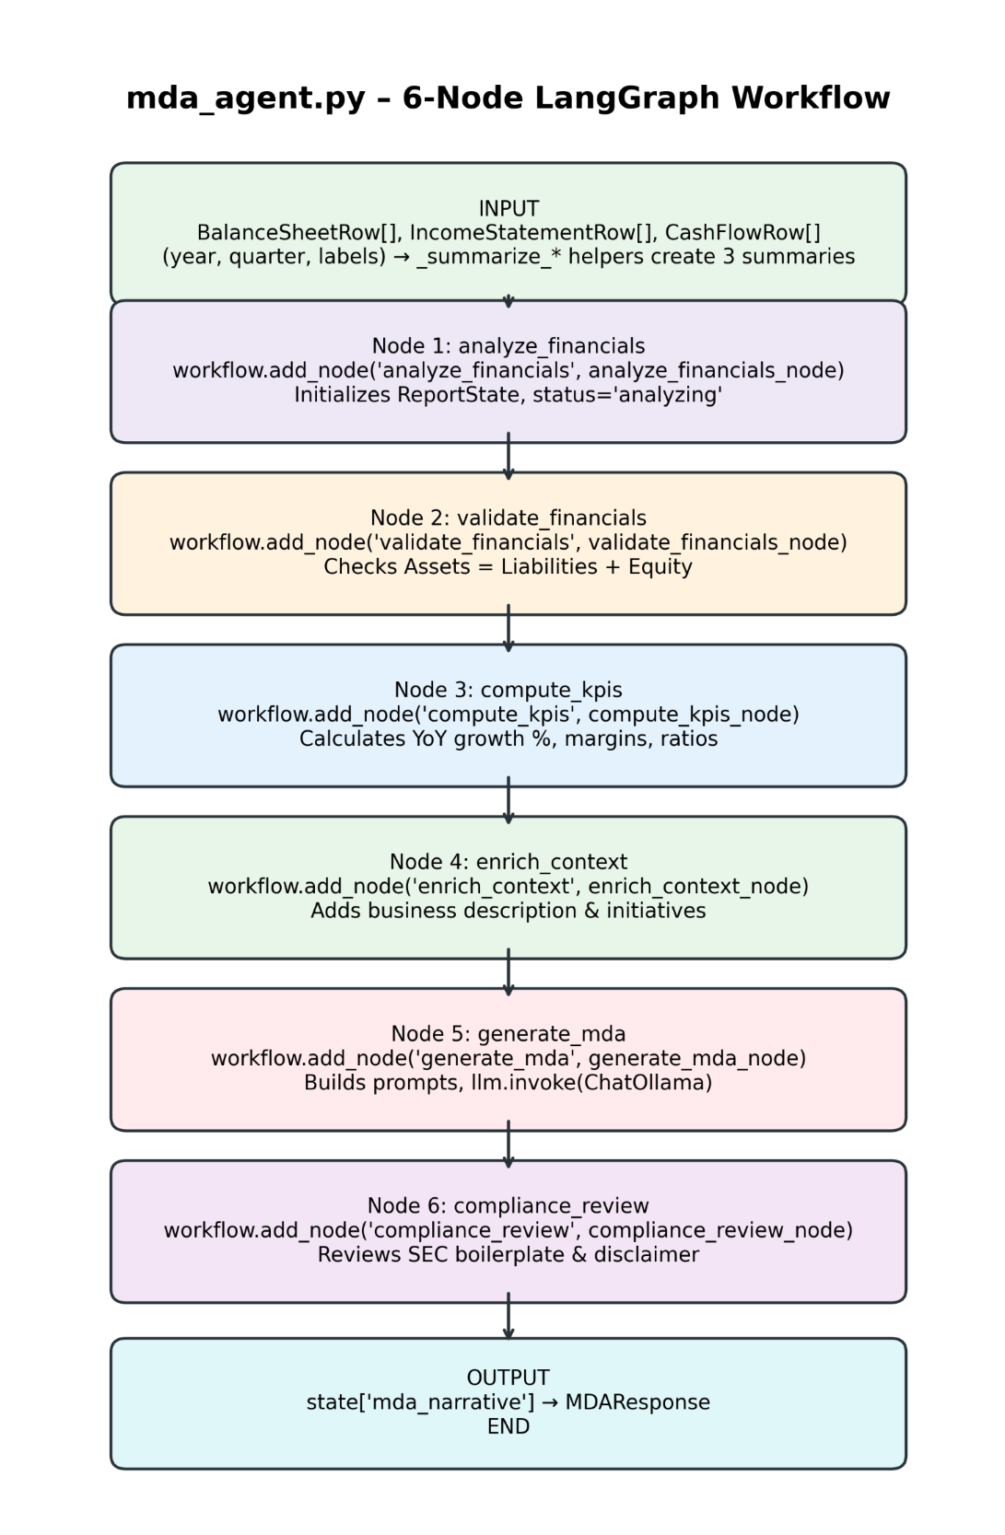
AI Agent References:
https://alain-airom.medium.com/pros-and-cons-using-containerized-ollama-vs-local-setup-d9bdf225bbb5
https://www.langchain.com/langgraph
https://github.com/metauto-ai/GPTSwarm
https://burr.apache.org/
https://mastra.ai/

Section 9 - Data Generation Prompting
This section outlines the methodology for leveraging AI to generate realistic sample data for the PostgreSQL database. Keep in mind the code described here is temporary. Once the dataset is generated, the code is no longer required. In a real business environment, the database would already exist, and there would be no need for any simulated data.

The Data Generation Pipeline
A Python script, build-accounting-workbook.py, developed in collaboration with Meta AI, was used to generate an Excel workbook containing data sheets for each of the nine database tables. Once the workbook was generated, each sheet was converted into a CSV file (by Meta AI) and imported manually into the database. The complete detailed prompt can be found in meta-ai-instructions.docx, which serves as the master document referencing all dependent files.

Source Documentation & Inputs
To ensure the simulated data accurately reflected realistic business operations over a four-year period, several reference files were prepared prior to prompting the AI:
- Database Specification: Detailed the exact structural schema for all nine database tables.
- Asset Ledger: Listed every business asset alongside its name, cost, purchase date, and useful service life.
- Core Instructions: Defined the foundational requirements for generating financial accounting data compliant with 10-Q and 10-K reporting standards.

The Iterative Refinement Process
Generating high-quality, coherent financial data is inherently iterative and requires a significant amount of patience to master. Over multiple trials, the instructions were continuously updated as different data constraints became apparent:
- Financial Guardrails: Predefining annual revenue and expense targets was critical; without them, the AI consistently generated net losses year over year.
- Asset Variety: Providing an explicit asset file prevented the AI from generating an unrealistically small number of assets.
- Transaction Logic: The AI defaulted to cash payments unless explicitly instructed to simulate credit transactions.
- Scope Management: A careful balance was required; overloading the AI with too much detail simultaneously caused it to fail to generate any data at all.

AI Capabilities & Observations
One notable behavior of Meta AI was its ability to actively engage with the prompts rather than just passively reading them. Throughout the process, the AI asked clarifying questions to improve the dataset's integrity.
Example: During the generation process, Meta AI asked: “Would you like to generate the balance sheets, income statement, and cash flow?”
This was not part of the initial prompt requirements. It demonstrated the AI's inherent understanding of accounting principles, showing it could autonomously transform raw ledger information into structured financial statements without needing explicit procedural instructions.
Unfortunately, the instructions prompt did not specify using python class structures. All code was written within a single file. Because it was only meant to generate a one-off dataset, and because it worked well, there was no compelling reason to refactor. Thus, the resulting code is not as readable as the application code, discussed in the next section.

Section 10 – Powershell Script Prompting
Originally, this application used a Podman container, which worked well, but seemed to be overly cmplex for a Windows desktop application. Claude was prompted to replace the Podman container with some simple Powershell scripts. Then, Gemini was prompted to explain those scripts to users unfamiliar with Powershell.
Claude Prompt to create Powershell scripts
Podman refactoring question
Podman only runs on Linux. Podman has complex config files.
We have a Windows based application that uses an external database, Postgresql, an external LLM, ollama, an external xbrl validator, Arelle, and external IO files, AppIO.
I was wondering why we are using Podman?
Our application code is basically React and FastApi.
Why do we need a special packaging framework?
What about a simple zip (or equivalent) file, without any special framework?
Can we eliminate podman completely, and use Powershell scripts to package, install, and run the application?
The Powershell scripts
Claude created three Powershell scripts: install.ps1, check-connections.ps1, and run.ps1.
Description of install.ps1:
- Verifies Python 3.13 and Node are present on the host.
- Creates a Python venv under backend\.venv and installs backend\requirements.txt.
- Installs frontend npm deps and runs the Vite production build.
- Copies the built frontend (frontend\dist) into backend\static, which FastAPI
serves directly (see StaticFiles mount in app\main.py).
Description of check-connections.ps1:
- Preflight check: verifies PostgreSQL, Ollama, and the Arelle taxonomy host are reachable before starting the app.
- Reads connection targets from environment variables already loaded by run.ps1 (DB_HOST/DB_PORT, OLLAMA_BASE_URL, ARELLE_TAXONOMY_URL).
- Each check is short-timeout and non-fatal by default
- Failures are reported clearly, and the script exit code reflects overall pass/fail so callers can decide whether to abort.
Description of run.ps1:
- Runs the Disclosure Pilot AI reporting app: one FastAPI/uvicorn process serving the API and the built React app (see install.ps1 for the build step).
- Port to listen on. Defaults to 8000.
- Run from the repository root: .\run.ps1
- Requires a.env file in the repo root (copy and edit from.env.example).

Gemni Prompt to explain scripts
Assume the user is not familiar with Windows Powershell. In a docx file, explain step by step what each script does, and explain each powershell command once.
Script Explanations
The following explanation of the Powershell scripts was generated by Gemini, based on the prompt above and given the 3 script files.
PowerShell Executive Overview & Beginner Primer
Welcome to the PowerShell automation documentation for the Disclosure Pilot reporting application. If you have never used Windows PowerShell before, command-line scripts can initially look like a complex foreign language. However, PowerShell is simply a tool built into Windows that automates repetitive computer tasks—such as checking network connections, installing software components, and starting applications—by giving direct instructions to the operating system. It prepares the system environment, builds compiled assets, and stages files so the application runs without needing container software like Docker or Podman.
The Disclosure Pilot management suite relies on three core automation scripts written in PowerShell: check-connections.ps1 (verifies system health), install.ps1 (builds and installs the application), and run.ps1 (configures and launches the application). This guide breaks down each script step-by-step so you understand exactly what happens behind the scenes.
📌 POWERSHELL SYNTAX QUICK PRIMER: PowerShell uses small commands called 'Cmdlets' (pronounced command-lets) formatted as Verb-Noun (e.g., Get-Command, Start-Process). Variables start with a dollar sign ($variable) and store data. Symbols like & or | act as tools to run commands or pass data between them.

Connectivity Preflight Checker (check-connections.ps1)
Before starting a complex application like Disclosure Pilot, it is essential to confirm that all required external services are active and reachable. The check-connections.ps1 script acts as a 'preflight inspector'. It verifies three key dependencies:
PostgreSQL Database: Ensures the main database server is accepting connections on its TCP port.
Ollama AI Engine: Checks that the local Artificial Intelligence service responds to web HTTP requests at its API endpoint.
Arelle XBRL Taxonomy Host: Confirms that financial taxonomy definitions (like US-GAAP 2026 schema standards) can be fetched over the web.
Step-by-Step Execution Workflow
• Step 1: Set Timeout Parameter: The script accepts a customizable timeout (defaulting to 4 seconds) so network checks respond quickly without freezing.
• Step 2: Initialize Results Storage: An empty results array ($results) is created to collect the outcome of each connectivity test.
• Step 3: Define Network Testing Functions: Two helper functions are declared: Test-TcpPort (opens a raw network connection to check databases) and Test-HttpEndpoint (sends a web request to check AI and taxonomy web hosts).
• Step 4: Execute Service Connectivity Tests: The script reads target addresses from environment settings and runs tests against PostgreSQL, Ollama, and Arelle host URLs.
• Step 5: Output Styled Results & Exit Status: It prints colored [OK] or [FAIL] lines in the console. If any check fails, it exits with error code 1; if all pass, it exits with code 0.
Technical Deep-Dive & Code Breakdown
The script uses.NET networking objects directly from Windows to test network ports without requiring third-party software :
function Test-TcpPort($Name, $HostName, $Port, $TimeoutSec) {
$client = New-Object System.Net.Sockets.TcpClient
$async = $client.BeginConnect($HostName, [int]$Port, $null, $null)
$ok = $async.AsyncWaitHandle.WaitOne($TimeoutSec * 1000)
...
}

In this function, New-Object creates a low-level network client ($client). It attempts to connect asynchronously to the specified host and port. If the connection succeeds within the timeout period, it returns a custom object marked Ok = $true. For web services, Invoke-WebRequest sends a fast 'HEAD' request (or falls back to 'GET') to verify that the HTTP web server responds properly.
PowerShell Command Reference (check-connections.ps1)
Below is an explanation of each PowerShell command and construct introduced in Script 1:
PowerShell Command / Construct | Type | Plain-English Purpose & Action
param(...) | Keyword | Defines input parameters for the script (e.g., TimeoutSeconds = 4).
[int] | Type Cast | Restricts a variable or parameter to strictly hold whole integer numbers.
$results = @() | Array Syntax | Initializes an empty array structure to store multiple test result items.
function Name() | Keyword | Defines a reusable block of code that carries out a named task.
if / else | Control Flow | Evaluates boolean conditions to execute different blocks of code.
return | Keyword | Exits a function immediately and passes back a result object to the caller.
[PSCustomObject]@{...} | Object Constructor | Creates a structured data object containing customized properties (Name, Ok, Detail).
try { } catch { } | Error Handling | Catches runtime errors gracefully (e.g. network timeout) without crashing.
New-Object | Cmdlet | Instantiates.NET framework objects (e.g., System.Net.Sockets.TcpClient).
[System.Environment]::GetEnvironmentVariable() | .NET Method | Reads environment variables (like DB_HOST or OLLAMA_BASE_URL) set in Windows.
Invoke-WebRequest | Cmdlet | Sends HTTP requests (HEAD / GET) to web services and checks response status.
Write-Host | Cmdlet | Outputs text messages directly into the console window.
-ForegroundColor | Parameter | Sets display color of text printed by Write-Host (e.g., Green, Yellow, Cyan).
foreach ($item in $list) | Loop | Iterates through each element in a collection to print individual test results.
-f (Format Operator) | Operator | Fills in placeholders ({0}, {1}) in formatted text strings.
exit <code > | Keyword | Terminates the script process (0 = success, 1 = failure).
$_ | Automatic Var | Represents the current object in pipeline or exception object in a catch block.

Installer & Build Script (install.ps1)
The install.ps1 script handles the automated setup of both the Python backend and the React frontend of the Disclosure Pilot application. It prepares the system environment, builds compiled assets, and stages files so the application runs smoothly.
Step-by-Step Execution Workflow
• Step 1: Strict Error Policy: Sets $ErrorActionPreference = 'Stop' so any failure immediately halts execution to prevent half-installed states.
• Step 2: Prerequisite Validation: Uses Assert-Command (wrapping Get-Command) to verify that Python 3.13, Node.js, and npm are installed and available on system PATH.
• Step 3: Environment Cleanup: Clears stale PYTHONHOME or PYTHONPATH variables that could cause Python virtual environment creation to fail.
• Step 4: Python Virtual Environment Setup: Creates an isolated Python venv at backend\.venv, upgrades pip, and installs required packages from requirements.txt.
• Step 5: Bytecode Compilation: Executes Python's compileall module on backend source code to catch any syntax errors prior to runtime.
• Step 6: Frontend Build Execution: Navigates into frontend directory using Push-Location, executes npm install and npm run build, and restores original directory via Pop-Location.
• Step 7: Static Asset Staging: Cleans out backend\static, creates a fresh folder, and copies the compiled production frontend dist files into it for FastAPI to serve.
📌 DIRECTORY STACKING CONCEPT: Push-Location and Pop-Location act like a directory bookmark system. Push-Location saves your current folder path before entering a subfolder (like frontend), and Pop-Location automatically brings you right back when work is completed.

PowerShell Command Reference (install.ps1)
Below is an explanation of each new PowerShell command and construct introduced in Script 2:
PowerShell Command / Construct | Type | Plain-English Purpose & Action
$ErrorActionPreference | Preference Var | Configures how PowerShell treats non-terminating errors ('Stop' turns them into terminating exceptions).
$PSScriptRoot | Automatic Var | Stores the directory path where the currently executing script resides on disk.
Join-Path | Cmdlet | Combines path segments (e.g. root + 'backend') into a valid filesystem path.
Get-Command | Cmdlet | Searches system PATH to verify if an executable (py, node, npm) exists.
throw | Keyword | Generates a custom error exception and halts script execution immediately.
& (Call Operator) | Operator | Executes external commands or programs (e.g. & py -3.13 --version).
2>$null | Redirection | Suppresses error output streams by sending error messages to null.
[System.Environment]::SetEnvironmentVariable() | .NET Method | Modifies or clears process environment variables (used to clear stale Python variables).
Test-Path | Cmdlet | Checks whether a specified folder or file exists on disk, returning true or false.
$LASTEXITCODE | Automatic Var | Contains the exit code returned by the last run external program (0 = success).
Push-Location | Cmdlet | Saves current working directory to stack and switches into a target directory.
finally | Block Keyword | Guarantees execution of cleanup code (Pop-Location) even if errors occur inside try block.
Pop-Location | Cmdlet | Restores active working directory back to the folder stored on location stack.
Remove-Item | Cmdlet | Deletes existing folders or files (-Recurse removes subfolders, -Force ignores prompts).
New-Item | Cmdlet | Creates new file system items (-ItemType Directory creates new folders).
Out-Null | Cmdlet | Discards command output so nothing displays on the terminal screen.
Copy-Item | Cmdlet | Copies files/folders from source to destination (-Recurse includes all subfiles).

Application Launcher Script (run.ps1)
The run.ps1 script serves as the production startup command for Disclosure Pilot. It reads configuration from a.env environment file, resolves variable references, configures database connection strings, runs connectivity checks, optionally launches the user's browser, and starts the FastAPI web server.
Step-by-Step Execution Workflow
• Step 1: Parameter & Switch Parsing: Accepts optional parameters: -Port (default 8000), -NoBrowser (skip auto-opening browser), and -StrictPreflight (abort on preflight failure).
• Step 2: File Existence Validation: Ensures that required environment files (.env) and Python virtual environment executables exist before proceeding.
• Step 3: Variable Interpolation Engine: Reads.env line-by-line using Get-Content, parses key-value pairs into a hashtable, and runs up to 10 regex passes to expand nested variable references (e.g. resolving ${WIN_APPIO_DIR} inside other paths).
• Step 4: Default Fallbacks & Path Assembly: Applies default settings for database and AI hosts if omitted, and configures FRONTEND_DIST to point directly at backend\static.
• Step 5: Preflight Integration: Invokes check-connections.ps1 to test connectivity. If checks fail and -StrictPreflight is enabled, startup aborts.
• Step 6: Background Browser Auto-Launch: Unless -NoBrowser is passed, spawns a background job via Start-Job that waits 2 seconds before launching the web browser to target URL.
• Step 7: Web Server Launch: Changes folder into backend and runs Uvicorn server via Python virtual environment on the designated port.
Deep-Dive: Multi-Pass Variable Expansion & Background Jobs
In configuration files, settings often reference other settings (e.g., DATA_PATH = '${APP_DIR}\data'). Standard script readers often fail to expand these, treating '${APP_DIR}' literally. The run.ps1 script solves this by using a loop combined with Regular Expressions (.NET Regex):
$maxPasses = 10
for ($pass = 0; $pass -lt $maxPasses; $pass++) {
$anyExpanded = $false
foreach ($key in @($envTable.Keys)) {
$value = $envTable[$key]
$expanded = [System.Text.RegularExpressions.Regex]::Replace(
$value, '\$\{([A-Za-z_][A-Za-z0-9_]*)\}',
{ param($m) $refName = $m.Groups[1].Value... }
)
}
}

Additionally, to launch the browser without blocking the web server startup, run.ps1 uses Start-Job. Start-Job creates an independent background process that waits 2 seconds (Start-Sleep -Seconds 2) and opens the browser (Start-Process) while the main script starts Uvicorn immediately.
PowerShell Command Reference (run.ps1)
Below is an explanation of each new PowerShell command and construct introduced in Script 3:
PowerShell Command /  Construct | Type | Plain-English Purpose & Action
[switch] | Parameter Type | Defines a boolean toggle flag on command line (true if specified, false if omitted).
@{} | Hashtable Syntax | Initializes a key-value pair dictionary structure ($envTable).
Get-Content | Cmdlet | Reads the contents of a text file (.env) line-by-line into PowerShell.
ForEach-Object | Cmdlet | Processes each item coming through the pipeline individually.
-split | Operator | Splits strings into an array based on a delimiter character (e.g. splitting key=value).
.Trim() /.StartsWith() | .NET Methods | Trims leading/trailing spaces or tests string prefix during file parsing.
for ($i=0; $i -lt $max; $i++) | Loop | Standard counter loop for repeating code blocks a fixed number of times.
[Regex]::Replace() | .NET Method | Replaces regular expression pattern matches with dynamic values (used for.env expansion).
Start-Job | Cmdlet | Runs a block of code asynchronously as a background process thread.
Start-Sleep | Cmdlet | Pauses execution for a specified duration in seconds (-Seconds 2).
Start-Process | Cmdlet | Launches an executable application or opens a URL in default web browser.
$using:Port | Scope Modifier | Allows background jobs (Start-Job) to access variables defined in script scope.

Script Blocking Issue
# To make PowerShell fully accept and output Unicode (UTF-8), enter:
$OutputEncoding = [Console]::InputEncoding = [Console]::OutputEncoding = [System.Text.Encoding]::UTF8

# Set your user account permanently (doesn't need admin) to
# RemoteSigned (rather than Bypass) as the safer permanent choice — it
# allows locally-created scripts (like these) to run freely, but still
# requires a digital signature for scripts downloaded from the internet,
# so you're not fully disabling the protection, just exempting your own
# local files. Enter:
Set-ExecutionPolicy -Scope CurrentUser -ExecutionPolicy RemoteSigned

# Since install.ps1 was downloaded through the browser/chat interface,
# Windows tagged it with a hidden "Mark of the Web" (an NTFS alternate
# data stream called Zone.Identifier), so PowerShell treats it as remote
# — hence the identical error even after changing the policy.

# Enter directly:
Unblock-File .\unlock.ps1
# Then call it to unblock the scripts below
.\unlock.ps1

# Fix — strip that tag from each file:
Unblock-File .\install.ps1
Unblock-File .\run.ps1
Unblock-File .\check-connections.ps1
Unblock-File .\test-backend.ps1
Unblock-File .\test-frontend.ps1
Unblock-File .\backend\Activate.ps1
Unblock-File .\backend\Deactivate.ps1

Section 11 - Code Development Prompting
This section outlines best practices for prompting Large Language Models (LLMs) to generate a realistic backend (Python). The following methodology was successfully employed using Claude Sonnet 4.6/5 to build a comprehensive internal financial reporting application.

1. Top-Level Instructions (Instructions.docx)
The following high-level prompt establishes the global context, technology stack, and architectural boundaries for the LLM.

System Prompt
OBJECTIVE:
1. Create an internal Windows application for generating quarterly (10-Q) and yearly (10-K) financial reports.

2. Adhere strictly to the following technology stack:
| Layer | Technology |
| OS | Windows 11
| Frontend | React 18, Vite, Recharts |
| Backend | FastAPI, Uvicorn, Python 3.11 |
| ORM | SQLAlchemy 2.0 |
| Validation | Pydantic v2 |
| Authentication | JWT |
| Database | PostgreSQL 18 |
| AI Workflow | LangGraph, LangChain |
| LLM | ChatOllama (gemma3) |
| Docx Generation | python-docx, docxcompose |

3. DATABASE READ ACCESS: The core financial database is already populated. The application must treat financial tables as READ-ONLY. Refer to `gem-db-init.sql` for schema structures.
4. DATABASE WRITE ACCESS: User authentication details must be stored and managed in a separate database schema. Refer to `app-users-spec.txt`.
5. ENVIRONMENT: Refer to `.env.example` and `yml-notes.txt` for environment configuration variables.
6. BACKEND SPECIFICATION: Implement backend business logic as detailed in `Backend-Design.docx`.
7. FRONTEND SPECIFICATION: Implement frontend user interfaces as detailed in `Frontend-Design.docx`.

Engineering Insights & Analysis
- Context Setting (Obj. 1): Instantly anchors the LLM to the domain-specific nuances of SEC financial reporting (10-Q and 10-K), preventing generic code generation.
- Stack Constraints (Obj. 2): Because desktop and enterprise applications can be engineered in countless configurations, explicitly locking down libraries prevents the AI from mixing incompatible paradigms.
- State Management & Permissions (Obj. 3 & 4): Explicitly partitioning read-only data (financials) from read/write data (user credentials) avoids architectural confusion and protects production data.
- Infrastructure as Code (Obj. 5, 6, & 7): Modern LLMs excel at infrastructure configuration. Providing environment templates ensures the generated Containerfile and compose files sync perfectly with the code.
- Iterative Decomposition (Obj. 8 & 9): AI possesses vast baseline knowledge of web architecture. To get predictable results, you must restrict its focus to the specific UI layouts and endpoints defined in your sub-specifications. Expect multiple iterative refinements to perfect your layouts and logic.

2. Backend Specifications (Backend-design.docx)
This prompt narrows the scope to specific implementation patterns, security protocols, and data layers.

Detailed Backend Prompt
INSTRUCTIONS:
1. Architecture: Implement code using clean Python class structures.
2. Data Access: Use SQLAlchemy 2.0 to interface with the PostgreSQL database (refer to `gem-db-init.sql`).
3. Query Pattern: Use the modern `self.db.execute(stmt).scalar()` syntax for queries. Do NOT use the legacy `self.db.query()` syntax.
4. User Security Schema: Refer to `app-users-spec.txt` for handling application user accounts.
5. Authentication Handler: Use the `fastapi.security` module to manage backend auth. The backend must explicitly handle:
- User account registration
- Secure password resets
- Standard user login
6. Session Management: Implement stateful JWT tokens. Initiate the application workflow by serving the login form to the frontend client.
7. Post-Auth Routing: Upon successful JWT validation, serve `index.html` to the frontend client.
8. Data Validation: Enforce strict request and response validation using Pydantic v2 schemas.
9. Hardware Acceleration: Integrate the NVIDIA Container Toolkit to leverage GPU CUDA processing capabilities.
10. Reporting Module A: Refer to `Form-10-Q-design.docx` for granular implementation logic.
11. Reporting Module B: Refer to `Form-10-K-design.docx` for granular implementation logic.
12. Testing: Generate comprehensive test suites using `pytest` with an in-memory `sqlite` database layer.

Engineering Insights & Analysis
- Coding Style (Obj. 1): Without specifying object-oriented class structures, LLMs defaults to scripting or functional paradigms arbitrarily.
- Enforcing Modern Syntax (Obj. 3): LLMs are often trained on outdated documentation and legacy codebases. Explicitly banning patterns like db.query() forces compliance with modern SQLAlchemy 2.0 standards.
- Handling Context Ambiguity (Obj. 4 & 5): Clarifying that "users" refers to application accounts rather than database connection users prevents major security holes. Outlining edge cases like "password resets" ensures the AI covers basic features it might otherwise skip.
- Lifecycle & Tooling (Obj. 6, 7, 8 & 9): Establishes explicit execution order and hardware dependencies up front.
- Modularity (Obj. 10, 11): Refers to lower level details separately to hint at a modular design.
- Test Isolation (Obj. 12): Asking the AI to mock PostgreSQL with SQLite in pytest ensures fast, reliable unit testing without risking live data environments.

3. Financial Reporting Specifications (Form-10-K-design.docx)
As the system moves toward core financial data generation, the level of instructional detail increases significantly.

Detailed 10-K Prompt Excerpt
INSTRUCTIONS:
Upon receiving a frontend request for a 10-K filing compilation, compute and structure the following data:

ITEM 8: Financial Statements and Supplementary Data
Query the database general ledger and chart of accounts (see `gem-db-init.sql`) to dynamically compute and construct the following outputs:
- A detailed Balance Sheet spanning two (2) trailing years.
- An Income Statement spanning three (3) trailing years.
- A Cash Flow Statement spanning three (3) trailing years.

Engineering Insights & Analysis
- Dynamic Synthesis vs. Static Views: LLMs struggle when required to aggregate multi-year data dynamically from a raw transactional ledger rather than pulling from pre-formatted database tables. The code must map disparate accounts into a unified, chronologically sequenced layout.
- The "Excel Reference" Strategy: Claude frequently struggles with the abstraction of complex, multi-year ledger aggregations. To resolve this, feed the LLM actual mock spreadsheet structures (e.g., bal_format.xlsx). Providing explicit backend schemas and target frontend layouts provides the exact blueprint the AI needs to generate flawless parsing logic.

Summary Principles for AI Software Engineering
1. Top-Down Architectural Decomposition: Always structure your development prompts from macroscopic system requirements down to microscopic, procedural logic.
2. Modular File-Based Contexts: Group prompts into specialized specification files that mirror your intended software directory layout. This prevents context pollution and keeps code generations clean and maintainable.

Reference Materials:
Full-Stack AI Development Insights:
https://dev.to/mr_nova/using-chatgpt-and-claude-for-full-stack-app-development-cgm
Building Production Apps with LLMs:
https://leadershiplighthouse.substack.com/p/how-i-built-a-production-app-with
Rapid Full-Stack Engineering Case Study:
https://shiftmag.dev/how-i-built-a-full-stack-app-in-6-days-with-the-help-of-ai-7564

Section 12 - iXBRL Prompting
This section details an iterative prompting strategy for engineering a Python-based backend file convertor using Large Language Models (LLMs). This exact methodology was successfully leveraged with Claude Sonnet 4.6/5 to develop an iXBRL transformer capable of generating EDGAR-compliant 10-K and 10-Q filings in HTML format. The Arelle iXBRL validator was used to verify the filings.
1. What is iXBRL?
To understand the complexity of the EDGAR iXBRL filing format, a number of terms must be defined.
XBRL (eXtensible Business Reporting Language) is the digital barcoding system for business data. Instead of presenting financial statements as flat text or static PDFs, XBRL assigns a unique, standardized element(or concept) to every single metric (such as "Revenue" or "Net Income") based on an official taxonomy. This transforms financial reports into machine-readable data, allowing regulators, investors, and automated software to instantly extract, compare, and analyze corporate performance without the headache of manual data entry.
iXBRL (inline XBRL ) takes this efficiency and gives it a human-friendly face. In the early days of XBRL, companies had to prepare two separate files: a formatted document for humans to read and a clunky XML file for computers to scan. iXBRL solves this double-work by embedding the XBRL elements directly into a standard HTML web page. The result is a single, unified document that renders as a beautifully formatted, readable financial report on any web browser, while automated software can simultaneously peer under the hood to extract the exact data points.
Taxonomy is a comprehensive, structured digital dictionary of financial and non-financial reporting terms. Most US filers use the standard US GAAP Financial Reporting Taxonomy. A taxonomy is much more than a flat list of terms. It is composed of two primary layers that work together, elements and linkbases.
Example element for Total Revenues on Income Statement:
<!-- Core element for Revenues -->
<xs:element name="Revenues"
id="us-gaap_Revenues"
type="xbrli:monetaryItemType"
substitutionGroup="xbrli:item"
xbrli:periodType="duration"
xbrli:balance="credit"/>
Example Label Linkbase which connects the element tag to human-readable text labels:
<!-- STEP 1: Locate the raw element in the core taxonomy schema -->
<loc xlink:type="locator"
xlink:href="us-gaap-2026.xsd#us-gaap_Revenues"
xlink:label="loc_Revenues"/>
<!-- Total Label (Used at the bottom of an Income Statement section) -->
<label xlink:type="resource"
xlink:role="http://www.xbrl.org/2003/role/totalLabel"
xlink:label="lab_Revenues_total"
xml:lang="en-US">Total Revenue</label>
<!-- STEP 3: Tie the locator to the labels using Arcs -->
<labelArc xlink:type="arc"
xlink:arcrole="http://www.xbrl.org/2003/arcrole/concept-label"
xlink:from="loc_Revenues"
xlink:to="lab_Revenues_total"/>

The htm file already has the proper label: “Total Revenues”. Why do we need a label linkbase?
When automated software or the SEC processes a 10-K filing, they don't look at the pretty HTML page. They use an XBRL parser to pull the raw facts out into a database. Once extracted, the HTML layout disappears. The software is left with a flat database record that looks like this:
- Concept: us-gaap:Revenues
- Value: 15500000
- Context: FY2025
If an automated software program (like Bloomberg) wants to display this data inside their own custom data grid without re-rendering the company's original, messy HTML website, it queries the Label Linkbase to find out what that tag is officially called in plain English, e.g. “Total Revenue”
However, a single element can mean different things depending on where it appears in a 10-K. The label linkbase allows the same exact tag to change its display name. Since the linkbase is not stored along with the element, how can the automated software know what display label to use?
Since the HTML file, the taxonomy file, and the label linkbase file are all physically separate documents, how does the analyst software bridge the gap? The missing piece of the puzzle is another linkbase file: the Presentation Linkbase.
The Presentation Linkbase acts as the "director" or layout map for the report. It tells the software exactly how to arrange the data on a screen and explicitly dictates which label role to fetch from the label dictionary for any given section, such as Income Statement.
Here is exactly how the analyst software connects the dots across these separate files. the software resolves what label to display by following a strict three-step chain of command:
1. Raw facts from 10-K HTML → Look up position → 2. Presentation Linkbase
Finds "preferredLabel" → 3. Label Linkbase → Extract Text → Human Sees: "Total Revenue"

The analyst software checks the Presentation Linkbase to see where us-gaap:Revenues sits in the report structure. The preferredLabel attribute explicitly tells the software: "When displaying this specific tag inside the Income Statement section, do not use the default label. Use the totalLabel role instead."
XML
<presentationArc xlink:type="arc"
xlink:arcrole="http://www.xbrl.org/2003/arcrole/parent-child"
xlink:from="loc_IncomeStatementLineItems"
xlink:to="loc_Revenues"
order="5.0"
preferredLabel="http://www.xbrl.org/2003/role/totalLabel"/>

A Simple iXBRL HTML Example
Here is a short, simplified example of how Inline XBRL tags (using the <ix:> namespace) wrap around standard HTML text to make a financial figure readable by both humans and machines:
HTML
<!DOCTYPE html>
<html xmlns="http://www.w3.org/1999/xhtml"
xmlns:ix="http://www.xbrl.org/2013/inlineXBRL"
xmlns:us-gaap="http://fasb.org/us-gaap/2026"
xmlns:iso4217="http://www.xbrl.org/2003/iso4217">
<head>
<title>Inline XBRL Demonstration</title>
</head>
<body>
<h2>Financial Highlights</h2>
<p>
For the fiscal year ended December 31, 2025, the Company is pleased to report that its
<strong>
<ix:nonNumeric name="us-gaap:Revenues " contextRef="FY2025">Total Revenue</ix:nonNumeric>
</strong>
was
$<ix:nonFraction name="us-gaap:Revenues "
contextRef="FY2025"
unitRef="usd"
decimals="0"
scale="0">15,500,000</ix:nonFraction>.
</p>
</body>
</html>

What's happening here: A human viewing this in a browser simply sees: "its Total Revenue was $15,500,000." However, an XBRL parser reads the <ix:nonNumeric> and <ix:nonFraction> tags and instantly logs that the GAAP accounting concept ‘Total Revenue’ for the ‘FY2025’ context equals 15500000 US Dollars.
Where are the xs:element name="Revenues" and label xlink: Total Revenue? They are hidden in configuration files, listed below, which are separate from the html file.

It looks exactly like a normal HTML webpage or document but contains hidden iXBRL tags directly behind the financial text. The iXBRL format allows analysts and regulators to read the financial statement as a standard HTML document while allowing automated software to read the data-rich tags in the background. The SEC mandates that this structured format cover all financial statements, footnotes, and the cover page information. Here, footnotes means “Notes to Consolidated Financial Statements”, which is contained in item 8 of the From 10-K, and item 1 of the Form 10-Q. In addition to the main HTML file (with extension.htm), some iXBRL configuration files must be developed, as listed in the following table, with the file suffixes: .xsd, _pre.xml, _cal.xml, _def.xml, and _lab.xml.

Summary Checklist for a 10-K Submission Bundle
File Extension | Component Type | Purpose | Required?
.htm | Inline XBRL Document | The actual HTML report containing embedded financial tags. | Yes
.xsd | Extension Schema | Declares custom elements and metadata blueprints. | Yes
_pre.xml | Presentation Linkbase | Defines the organizational hierarchy and display order. | Yes
_cal.xml | Calculation Linkbase | Defines mathematical relationships (e.g., $A + B = C$) for validation. | Yes
_def.xml | Definition Linkbase | Establishes dimensional relationships for complex tables/footnotes. | Yes
_lab.xml | Label Linkbase | Attaches human-readable text labels to standard and custom elements. | Yes

2. Top-Level Instructions (Instructions.docx)
The following high-level prompt to Claude establishes the global context:
For the 10-Q and 10-K , the SEC requires xbrl xhtml format. Research how we can create a file transformer functon to add xbrl tagging to the 10-Q and 10-K html files.
First, we need us-gaap mappings like this:
"accounts receivable":"us-gaap:AccountsReceivableNetCurrent".
Second, we need to parse the html and add the special xbrl tags.
3. First Iteration
Claude created the mappings, like this:
Label | iXBRL Tag
"cash and equivalents": | {"concept": "us-gaap:CashAndCashEquivalentsAtCarryingValue",  "type": "instant", "balance": "debit", "negate": False}
"short-term investments": | {"concept": "us-gaap:ShortTermInvestments",  "type": "instant", "balance": "debit", "negate": False}
"accounts receivable": | {"concept": "us-gaap:AccountsReceivableNetCurrent",  "type": "instant", "balance": "debit", "negate": False}
"inventory": | {"concept": "us-gaap:InventoryNet",  "type": "instant", "balance": "debit", "negate": False}
"property, plant & equip": | {"concept": "us-gaap:PropertyPlantAndEquipmentGross",  "type": "instant", "balance": "debit", "negate": False}
"total assets": | {"concept": "us-gaap:Assets",  "type": "instant", "balance": "debit", "negate": False}
... | ...

This is just a small sample of the complete list of iXBRL mappings. With just one example in the prompt instructions, Claude was able to lookup the whole mapping list based on the labels used in the financial tables for this application. Then Claude created the python data structure to hold the mappings. All done within a few minutes. However, the actual iXBRL tagging code took several iterations to complete without errors.
4. Error Analysis (arelle-msg-log-1.txt)
The Arelle xbrl file validator was used to check the 10-K htm file after each iteration. Then the message log, such as arelle-msg-log-1.txt, was uploaded to Claude to analyze and fix any issues in the iXBRL transformer.
A few examples from Arelle validation:
The context identifier CIK 1234567 is not 10 digits - sec-10-k.xhtml 29
Warning, Inline XBRL ix:header is recommended to be nested in a <div> with style display:none
Instance fact missing schema definition: us-gaap:CostOfGoodsSold of Inline Element ix:nonFraction - sec-10-k.xhtml 514
Inline element ix:nonFraction fact us-gaap:IncomeTaxExpenseBenefit fact us-gaap:IncomeTaxExpenseBenefit type decimal transform ixt:num-dot-decimal value error: -7009009 - sec-10-k.xhtml 574
Example of Claude fix:
For the value error: -7009009
Comment: Negative XBRL values must be expressed using the sign="-" attribute.
HTML update:
<td class="number"><ix:nonFraction name="us-gaap:IncomeTaxExpenseBenefit" sign="-" contextRef="ctx_dur_20250101_20251231" unitRef="USD" decimals="0" id="f4de28396" format="ixt:num-dot-decimal">7009009</ix:nonFraction></td>
5. Final Version (xbrl_tagger.py)
Besides the python code, xbrl_tagger.py, the following configuration files were developed for handling iXBRL:
tifx-20251231.xsd
tifx-20251231_cal.xml
tifx-20251231_def.xml
tifx-20251231_lab.xml
tifx-20251231_pre.xml
Note that _lab.xml includes only a few custom labels, because most data uses standard labels.
For this demonstration application, the backend codebase is pre-configured with a suite of the most common financial notes (currently just 8, but designed to be extended). Users select the specific notes required for a given filing cycle (e.g., selecting 6 notes in Year 1 and 8 notes in Year 2).
Each note requires precise iXBRL tags mapped to its specific contents; for example, the Income Taxes note relies on the us-gaap:IncomeTaxExpenseBenefit tag. If this mapping is not hardcoded, programmatically distinguishing between different financial values (such as a tax expense versus pre-tax income, which are both raw dollar amounts) becomes incredibly complex.
Because the Notes section was generated by ChatOllama LLM, Claude evaluated numerous scenarios to tag each note accurately. A key breakthrough was adopting a hybrid approach: combining ChatOllama’s text narrative with deterministic financial data to eliminate hallucinated numbers. Even then, narratives were someimes unreliable. It was the Gemini LLM that advised a refactoring of Python code using a more advanced ollama model, looping over each note separately to avoid token limits, and setting enhanced ChatOllama arguments.
After many many iterations, all issue were fixed, and the 10-Q and 10-K files were successfully converted to iXBRL format, acceptable by the SEC EDGAR system, according to the Arelle validator.
XBRL References:
https://www.xbrl.org/the-standard/what/ixbrl/
https://www.xbrl.org/the-standard/how/getting-started-for-developers/
https://www.xbrl.org/the-standard/why/ai-future/
https://www.sec.gov/data-research/structured-data/inline-xbrl
https://www.sec.gov/files/edgar/filer-information/specifications/xbrl-guide.pdf
https://specifications.xbrl.org/work-product-index-group-base-spec-base-spec.html
https://www.sec.gov/search-filings
Arelle References:
https://arelle.readthedocs.io/en/2.41.6/
https://arelle.org/arelle/pub/

Section 13: Testing
Testing financial applications comes with its own set of challenges. While the previous section focused on validating iXBRL filing files, this section covers traditional unit and integration testing. To ensure complete data integrity, you need to verify several critical stages of the data pipeline:
- Data Extraction: Confirming that the program extracts the precise data required from the database.
- Data Transformation: Verifying that data is correctly transformed from the general ledger into financial statements, such as the balance sheet.
- Data Transmission: Ensuring that information transfers seamlessly and accurately from the backend to the frontend.
- Data Presentation: Validating that the final user interface correctly displays the intended data.

Testing Methodologies
To address these complexities, a combination of automated constraints, independent cross-validation, and specialized testing frameworks was implemented.

1. Built-In Validation
Certain fundamental accounting principles serve as built-in tests within the application. For example, the balance sheet uses the core accounting equation to ensure that total assets always equal the sum of total liabilities and total equity.

2. Independent Cross-Validation (LLM Auditing)
To rigorously confirm that the primary application (built by Claude) transformed data into the financial statements correctly, a separate, independent program was developed using a different LLM: Meta AI.
- This secondary program independently performed the exact same data transformations.
- The outputs—including balance sheets, income statements, and cash flow statements—were then systematically compared against each other to identify and resolve any discrepancies.

3. Framework-Specific Testing
Comprehensive unit testing was integrated across both layers of the application's architecture:
- Backend: Unit level tests were executed using the pytest framework.
- Frontend: User interface and component functionality were validated using Vitest and React Testing Library.

Backend Tests (test_backend.py)
Uses pytest with a SQLite in-memory database. All tests run without a live PostgreSQL instance — schema-qualified table names (e.g. bookkeeper.general_ledger) are transparently rewritten to flat SQLite equivalents by a session-level fixture that patches session.execute.

Test QuarterDates
Tests the _quarter_dates and _year_dates helper functions that compute fiscal period boundaries.
Test | What it checks
test_q1 | Q1 runs from January 1 to March 31.
test_q2 | Q2 runs from April 1 to June 30.
test_q3 | Q3 runs from July 1 to September 30.
test_leap_year_q1 | Q1 end date is still March 31 in a leap year (2024).
test_year_dates | Annual period runs from January 1 to December 31.

Test GetChartOfAccounts
Tests the get_chart_of_accounts function that fetches account definitions from the database.
Test | What it checks
test_returns_all_accounts | All 17 seeded chart-of-accounts rows are returned.
test_fields_present | Each row contains account, acct_name, category, and acct_subtype keys.
test_ordered_by_acct_id | Rows are returned in ascending account number order.
test_category_mapping | Account 1000 (Cash and Equivalents) is correctly categorized as "Asset".
test_revenue_accounts_present | Exactly two revenue accounts exist in the seeded data.

Test GLBalancesCumulative
Tests get_gl_balances_cumulative, which sums debit-minus-credit balances through a given date (used for balance sheet accounts).
Test | What it checks
test_cash_balance_after_q1 | Cash account (1000) has a positive cumulative debit balance through 2024 Q1.
test_excludes_retained_earnings | When exclude_acct_type is passed, account 3100 (Retained Earnings) is absent from the result.
test_excludes_dividends | The dividends account (7000) is also excluded when the retained-earnings filter is applied.
test_no_future_entries | 2024 Q1 GL entries do not appear in balances computed through 2023-12-31.

Test ComputeRetainedEarnings
Tests _compute_retained_earnings, which calculates cumulative retained earnings from the opening balance through any given date.
Test | What it checks
test_includes_opening_balance | As of 2022-12-31, retained earnings equals the seeded opening balance of $15,000,000.
test_adds_net_income | After 2023 activity (revenue $1M, expenses $500K), retained earnings increases by $500K.
test_subtracts_dividends | 2024 Q1 dividends of $25K are subtracted from retained earnings.
test_prior_period_less_than_current | Retained earnings at 2024 Q1 end are greater than at 2023 year-end (net income positive).

Test BuildBalanceSheet
Tests build_balance_sheet, which produces a two-period balance sheet from the general ledger.
Test | What it checks
test_returns_list_of_rows | Returns a non-empty list of balance sheet row objects.
test_no_dividends_row | The Dividends Paid account does not appear as a balance sheet line (it is an equity adjustment, not a balance sheet item).
test_no_retained_earnings_double_count | Exactly one Retained Earnings row exists — it is not duplicated by the chart-of-accounts loop.
test_retained_earnings_value | The Retained Earnings row value matches the result of _compute_retained_earnings for the same date.
test_has_asset_liability_equity_rows | The output contains rows from all three balance sheet categories.

Test BuildIncomeStatement
Tests build_income_statement, which produces a multi-period income statement with optional year-to-date columns.
Test | What it checks
test_returns_revenue_and_expense_rows | Output contains both Revenue and Expense category rows.
test_revenue_positive | All revenue rows have a non-negative current_period value (credit-normal accounts).
test_ytd_columns_populated | When YTD date ranges are provided, ytd_current and ytd_prior are populated on every row.
test_ytd_none_when_not_requested | When no YTD dates are passed, ytd_current is None on all rows.

Test BuildCashFlow
Tests build_cash_flow, which produces a classified cash flow statement.
Test | What it checks
test_returns_all_sections | All required section headers and summary lines are present (Operating, Investing, Financing, Net Increase in Cash, Beginning/Ending Cash).
test_net_income_positive | Net Income is positive because seeded revenue exceeds seeded expenses.
test_dividends_negative | Dividends Paid is zero or negative, reflecting a cash outflow.
test_cash_end_equals_begin_plus_net | Cash at End of Period equals Cash at Beginning of Period plus Net Increase in Cash.

Test GetQuarterlyStatements
Tests the get_quarterly_statements facade that assembles all three statements for a given quarter.
Test | What it checks
test_returns_seven_values | Returns a 7-tuple: balance sheet, income statement, cash flow, period label, prior label, balance sheet prior label, and dates dict.
test_period_label_format | The current-period label contains the correct quarter-end month and year (e.g. "March 31, 2024").
test_bs_prior_label_is_year_end | The balance sheet prior-period label references the prior December 31 year-end, not a quarter end.
test_prior_label_is_quarterly | The income statement prior-period label references the same quarter in the prior year.
test_dates_dict_keys | The returned dates dictionary contains all seven expected keys.
test_invalid_quarter_raises | Q1, Q2, and Q3 all complete without error (Q4 is reserved for yearly reports and is rejected at the API layer).

Test Report 10Q Endpoints
Tests the FastAPI /api/10q/financials endpoint using TestClient with dependency overrides for the database session and authentication.
Test | What it checks
test_financials_endpoint_200 | A valid POST with year 2024, quarter 1 returns HTTP 200.
test_financials_response_has_balance_sheet | The response body contains a non-empty balance_sheet array.
test_financials_response_has_labels | The response body contains period_label, prior_label, and bs_prior_label fields.
test_financials_invalid_quarter_rejected | Posting quarter 4 returns HTTP 400.
test_financials_requires_auth | Without the auth override in place, the endpoint returns 401 or 403.

Test AuthService
Tests user creation, password hashing, and password reset directly against the database.
Test | What it checks
test_password_hash_and_verify | A hashed password verifies correctly; a wrong password does not.
test_create_user_in_db | A new user row can be inserted and retrieved, and the stored hash matches the original password.
test_duplicate_email_rejected | Inserting two rows with the same email raises a database exception (unique constraint).
test_reset_password_updates_hash | After updating password_hash, the new password verifies and the old one does not.

Frontend Tests (test_frontend.test.jsx)
Run with:
Uses Vitest and React Testing Library. All API calls are intercepted via vi.mock("../api/client"). React-router-dom and useAuth are also mocked so individual components render in isolation without a router or auth context.

BalanceSheetTable
Tests the balance sheet display component in isolation using fixture data.
Test | What it checks
renders the Balance Sheets title | The heading "Balance Sheets" is present in the DOM.
shows current period column header from dates.quarter_end | The column header is derived from dates.quarter_end and displays as "March 31, 2024".
shows prior period column header as Year ended Dec 31 | The prior-period column shows the bsPriorLabel prop (year-end label).
renders ASSETS, LIABILITIES, EQUITY section headers | All three section group headers are rendered.
renders account names | Individual account names such as "Cash and Equivalents" and "Retained Earnings" appear in the table.
renders Total Assets row | A "Total Assets" summary row is present.
renders Total Liabilities + Equity row | A "Total Liabilities + Equity" summary row is present.
renders without crashing when data is empty | Passing an empty data array still renders the title without errors.
falls back to bsPriorLabel when dates.prior_year_end is absent | When the dates object is empty, the component uses the bsPriorLabel prop for the prior-period column header.
shows dashes for zero values | Accounts with zero balances display "—" rather than "$0".

NavBar
Tests the top navigation bar for the presence of all required links.
Test | What it checks
renders Home link | A "Home" link is in the navbar.
renders Quarterly 10-Q link | A link containing "10-Q" is present.
renders Yearly 10-K link | A link containing "10-K" is present.
renders Help link | A "Help" link is present.

LoginForm
Tests the login/sign-up/reset-password form component.
Test | What it checks
renders email and password fields | Both email and password inputs are present and properly labelled.
renders login button | A "Sign In" button is present in the default login mode.
shows toggle to sign-up mode | Clicking the sign-up toggle switches the form to sign-up mode and shows a sign-up submit button.
shows toggle to reset password mode | Clicking the reset-password toggle switches the form and shows a reset/send button.
calls onLogin with token on successful login | On a successful API response, the onLogin callback is called with the JWT access token.
shows error message on failed login | On a 401 response, an error message is displayed.
does not submit with empty fields | Clicking Sign In with blank fields does not make an API call.

Prep10QPage
Tests the quarterly report preparation page.
Test | What it checks
renders year and quarter dropdowns | Both year and quarter selects are present and associated to their labels.
year dropdown contains current and 4 prior years | The year select has exactly 5 options.
quarter dropdown only shows Q1, Q2, Q3 | Q1, Q2, Q3 options exist and Q4 does not.
renders Save Financials button | A save button is present.
renders Save MD&A button | A "Submit MD&A" button is present on initial render.
renders Generate 10-Q Report button | A "Generate 10-Q Report" button is present on initial render.
fetches financials when year/quarter selected | After selecting year 2024 and quarter 1 then clicking "Load Financial Statements", tenQApi.getFinancials is called with (2024, 1).
shows acknowledgement after Save Financials | After loading financials then clicking "Save Financials", a success message referencing item010.docx appears.

Report10QPage
Tests the page for generating the final 10-Q report document.
Test | What it checks
renders year and quarter dropdowns | Both selects are present and properly labelled.
renders Generate Report button | A "Generate 10-Q Report" button is present.
shows acknowledgement after report generation | Clicking the generate button triggers the API call and displays a success message referencing sec-10-q.docx.

Edgar10QPage
Tests the page for converting the 10-Q report to SEC EDGAR HTML format.
Test | What it checks
renders Generate EDGAR HTML button | The generate-HTML button is present.
shows acknowledgement after HTML generation | Clicking the button triggers the API call and displays a success message referencing sec-10-q.htm.

Prep10KPage
Tests the yearly report preparation page.
Test | What it checks
renders year dropdown only (no quarter) | A year select is present, and no quarter select exists (yearly reports do not use quarters).
year dropdown contains current and 4 prior years | The year select has exactly 5 options.
renders Save MD&A button | A "Submit MD&A" button is present on initial render.
renders Generate 10-K Report button | A "Generate 10-K Report" button is present on initial render.

HomePage
Tests the application home page.
Test | What it checks
renders welcome message | The home page displays a message matching "Generate professional quarterly and yearly financial reports".

HelpMenu
Tests the Help dropdown with User Guide and About dialogs.
Test | What it checks
renders User Guide link | A "User Guide" button/link is present.
renders About link | An "About" button/link is present.
User Guide dialog opens on click | Clicking "User Guide" opens a dialog whose body contains application description text.
About dialog shows version number | Clicking "About" opens a dialog displaying a version number.

React Testing References:
https://fastapi.tiangolo.com/reference/testclient/
https://dev.to/felipewind/python-fastapi-tutorial-to-test-http-client-requests-2ah9
https://jnikenoueba.medium.com/unit-and-integration-testing-with-fastapi-e30797242cd7
https://medium.com/@dilip.bhaidiya/mastering-react-js-testing-with-jest-a-comprehensive-guide-1acada2b9586
https://www.browserstack.com/guide/selenium-react-tutorial
Python Testing References:
https://realpython.com/pytest-python-testing/
https://circleci.com/blog/pytest-python-testing/
https://medium.com/@ronakchitlangya1997/pytest-a-beginner-guide-f9d4919cd427

Section 14: Tools
A variety of software tools were used to build the application. This section provides a brief overview of each tool's functional description and competitive advantage.
Frontend Development & Visualization
React
React is an open-source JavaScript library developed by Meta for building dynamic, component-based user interfaces. It uses a Virtual DOM to optimize rendering performance by only updating components whose data changes. Compared to Angular, React is significantly more lightweight, unopinionated, and features a flatter learning curve. It gives developers total architectural freedom and benefits from a massive ecosystem, making it easier to integrate third-party libraries without forcing a rigid framework structure.
Vite
Vite is a modern frontend build tool that leverages native ES modules in the browser to deliver instantaneous server start times and lightning-fast Hot Module Replacement (HMR) during local development. Compared to Webpack, Vite provides a drastically faster developer experience by avoiding the need to pre-bundle the entire application before spinning up a local environment. Production builds are managed via highly optimized Rollup configurations out of the box.
Recharts
Recharts is a composable charting library built specifically for React applications. It leverages SVG elements under the hood to construct highly customizable, responsive, and reusable data visualization components. Compared to Chart.js (or its React wrappers), Recharts fits natively into the React lifecycle and component paradigm. It allows developers to customize declarative sub-components (like XAxis, Tooltip, or Bar) as direct children, rather than forcing configuration through large, complex JavaScript objects.
Backend & Core Python Services
FastAPI
FastAPI is a modern, high-performance web framework for building APIs with Python, fully powered by standard Python type hints. It natively supports asynchronous programming out-of-the-box using the ASGI specification. Compared to Flask, FastAPI delivers vastly superior performance metrics comparable to Node.js and Go, alongside automated interactive documentation generation (via Swagger UI). It eliminates extensive boilerplate code by using native asynchronous execution and strict type checking.
Uvicorn
Uvicorn is a lightning-fast ASGI (Asynchronous Server Gateway Interface) web server implementation for Python. It acts as the production-grade engine running asynchronous frameworks like FastAPI or Starlette. Compared to Gunicorn (traditionally used for WSGI applications), Uvicorn is built specifically to process non-blocking asynchronous connections natively using `uvloop`. It allows a single process to handle thousands of concurrent requests smoothly without crashing or stalling.
Python
Python is a high-level, interpreted programming language known for its clear syntax, readability, and extensive standard library, making it the premier language for web development, data science, and AI/ML ecosystems. Compared to Java, Python enables drastically faster rapid prototyping and iterative development cycles due to its concise syntax and dynamic typing. It boasts a universally superior ecosystem for artificial intelligence and machine learning integrations.
Arelle
Users can interact with Arelle via an Interactive GUI.
Arelle processes HTML files by validating both the structure of the document and the XBRL data embedded inside it. When an iXBRL file is loaded into Arelle, the platform performs several steps:
It verifies contexts (entities, periods) and numeric units, ensuring they match standard taxonomies like US GAAP.
It runs checks specific to the selected filing manual (EFM for the US SEC) to catch missing values or incorrect data types.
It enforces calculation linkbases (checking totals, subtotals, and dimensional aggregations), while flagging inconsistencies or mathematical warnings.
Arelle is the premier tool relied upon by technology vendors and regulators for iXBRL data quality assurance.
Data Management & Security
SQLAlchemy
SQLAlchemy is an advanced Object-Relational Mapper (ORM) and SQL toolkit for Python, providing database administrators and developers with the full power and flexibility of SQL inside an object-oriented design patterns format. Compared to Django ORM, SQLAlchemy is completely decoupled from any overarching web framework, offering far more granular control over complex database queries, multi-table joins, and intricate optimization patterns without requiring hacky workaround.
Pydantic
Pydantic is a powerful data validation and settings management library for Python that enforces type hints at runtime, providing user-friendly, structured error strings when validation fails. Compared to traditional standard JSON Schema validators or custom validation scripts, Pydantic is significantly faster (compiled via Rust in V2) and seamlessly coerces input data into strongly-typed Python objects, rendering it highly dependable for robust API request validation.
JWT (JSON Web Tokens)
JWT is an open industry standard (RFC 7519) used to securely transmit information between parties as a compact, self-contained JSON object, heavily used for stateless user authentication and authorization headers. Compared to Session-based authentication, JWTs completely eliminate the requirement to maintain a centralized session store or database on the server side. This architecture allows backend services to scale horizontally across servers instantly by validating cryptographic signatures locally.
PostgreSQL
PostgreSQL is a highly robust, open-source object-relational database management system (RDBMS) renowned for its extreme reliability, extensive feature set, and strict standards compliance. Compared to MySQL, PostgreSQL handles complex analytical queries, concurrent writes, and advanced data structures like JSONB arrays dramatically better. It functions flawlessly as a powerful hybrid relational-document database without sacrificing transactional ACID guarantees.
AI & Orchestration
LangGraph & LangChain
LangChain provides an extensive framework for building LLM-powered applications, while LangGraph extends it to build stateful, multi-actor, and highly cyclical agentic workflows. Compared to simple linear LLM chains, this combined stack enables developers to build complex, non-linear agent architectures capable of error-correction, looping reasoning paths, and maintaining state over massive, long-running processing pipelines.
ChatOllama
ChatOllama (via Ollama) is an integration interface that allows developers to host, serve, and run large language models locally on individual workstations or private infrastructure. Compared to cloud-hosted APIs like OpenAI GPT-4, ChatOllama ensures complete data privacy and zero API usage costs by pulling, managing, and running open-source models (like Llama or Mistral) entirely within a secure, offline local machine context.
Claude
Claude is a family of cutting-edge foundational large language models engineered by Anthropic, meticulously designed for advanced reasoning, coding, and deeply contextual analysis tasks. Compared to GPT-4 in development applications, Claude models (particularly Claude Sonnet) display exceptionally superior code generation capability, more nuanced logical reasoning, and a much cleaner, less verbose technical writing style.
Gemini
Google Gemini is Google's multimodal AI family and assistant that understands text, images, code, audio, and video. It powers chat, Search summaries, Workspace, and developer tools for reasoning, writing, coding, and data analysis. Its competitive advantage is deep integration across Google Search, Android, Workspace, and Cloud, plus long-context reasoning and real-time, web-grounded information at global scale.
Meta AI (Llama)
Meta AI represents the suite of highly sophisticated, state-of-the-art open-weights large language models (Llama series) distributed openly to the global research and enterprise developer community. Compared to proprietary closed alternatives like Google Gemini or OpenAI, Meta's open weights empower organizations to fine-tune models on proprietary enterprise datasets and deploy them self-hosted on local infrastructure, ensuring total architectural independence.
Powershell
Windows PowerShell is Microsoft's native command-line shell and scripting language designed for task automation and system management. For Windows desktop applications, native scripts outperform Docker because they run directly on the host OS with zero virtualization overhead. They seamlessly interact with Windows APIs, the registry, and GUI elements, whereas running desktop apps through Docker adds unnecessary Linux/VM complexity.

Section 15: Discussion
While this prototype demonstrates functional capability for generating Form 10-Q and Form 10-K filings, commercialization requires careful consideration of structural and regulatory constraints. Although all public companies must file these forms, the underlying systems and presentation requirements vary significantly across organizations.
Key Limitations to Commercialization
The following issues limit the direct reusability of the current implementation as a standardized commercial product:
1. Design Deliberations: The prototype employs a frontend user interface (UI) for visualizing the financial statements and editing the MD&A and Notes narratives with internal AI assistance. The backend also has the function to merge all component docx files into a single Form 10-K or Form 10-Q report. What are some alternative designs?
Architecture Alternatives

The frontend is not strictly necessary: the backend can generate financial statements, write them directly to .docx, and merge all component files into a final Form 10-K or 10-Q report. Narrative sections like MD&A and Notes could be edited directly in a standard word processor, with or without external AI assistance.
Conversely, if users want AI-assisted editing across other report sections, the frontend could be expanded into targeted mini-applications. Each mini-app would pair a dedicated frontend and backend to handle specific 10-K or 10-Q items (e.g., Legal Proceedings or Cybersecurity) whenever standard templates require customization.
Decision Options
- Backend-Only: Eliminate the custom frontend. Generate statements programmatically and edit narrative .docx files directly using standard word processors.
- Status Quo: Retain the existing combined frontend and backend to support current financial statement visualization and MD&A and Notes editing workflows.
- Modular Expansion: Build out focused, item-specific mini-applications with tailored frontend and backend AI capabilities.
- All of the Above: Implement any option at the customer’s discretion.

2. Database Interface Variability: The prototype relies on a simulated database that approximates real financial data. In practice, accounting databases differ substantially in schema design, chart of accounts, data models, and governance practices. As a result, the database interface developed for this demonstration is unlikely to transfer to another client without significant re-engineering.
3. Financial Statement Presentation Diversity: Although the Securities and Exchange Commission (SEC) prescribes a standard item structure for Form 10-K filings, companies exercise considerable discretion in formatting. Balance sheets, income statements, and cash flow statements exhibit wide variation in line-item grouping, terminology, level of detail, and footnote integration. This diversity constrains the reusability of the front-end presentation layer.
4. Backend Processing Constraints: Given the wide variation in filing formats and the limited reusability of both the data access layer and the user interface, the intermediate backend logic—which transforms raw accounting records into filing-ready structures—is also unlikely to be portable across implementations without modification.
5. LLM-Assisted Development Considerations: The application was created with assistance from large language models (LLMs). For filings of regulatory significance, stakeholders may question the traceability, validation, and auditability of LLM-generated code. While comprehensive testing can mitigate risk, acceptance of this methodology may require additional governance and documentation compared to traditional software engineering.
6. Runtime Generation of MD&A and Notes: Two critical components of Form 10-K, the MD&A and Notes, are currently drafted at runtime using an LLM (ChatOllama) to populate narratives for subsequent human editing. Unlike the development-time use of Claude, which does not execute during operation, ChatOllama operates within the live application. This introduces questions regarding accuracy, consistency, and regulatory defensibility. The requirement for human review provides a mitigating control, but does not eliminate reliance on generative output for material disclosures.
7. iXBRL Notes Issue: Beyond the reliability of LLM-generated narrative in Form 10-K notes, inline XBRL (iXBRL) tagging presents a major structural challenge. Because the disclosure requirements and number of notes vary by company, predicting which iXBRL tags will be required is highly difficult. For this simplified application, the backend codebase is pre-configured with a suite of the 8 most common financial notes, but needs to be extended for any particular real company. Users select the specific notes required for a given filing cycle (e.g., selecting 20 notes in Year 1 and 17 notes in Year 2).

Strategic Opportunity
Despite these limitations, the project highlights a compelling use case for LLM-accelerated development. Because each company maintains a unique accounting database and adopts a customized filing format, a one-size-fits-all product is impractical. Tailored implementations are necessary, and LLMs offer a distinct speed advantage for creating such made-to-order solutions.
Two viable approaches emerge:
1. Iterative Adaptation: Prompt the LLM to modify the existing codebase to accommodate a specific client's data model, filing presentation requirements, and initial notes baseline.

2. Greenfield Generation: Direct the LLM to generate a new application, or multiple mini-applications, from first principles for each client, incorporating lessons learned from prior implementations.

The demonstration confirms technical feasibility but also underscores why direct commercialization as a standardized product is not advisable. The value lies not in reuse, but in rapid customization—an area where LLM-assisted development provides meaningful competitive advantage, provided appropriate human oversight is maintained for regulatory content, particularly in the case of the MD&A and Notes.

Conclusion: Key Takeaways for LLM-Assisted Development

This application demonstrates the capacity of Large Language Models (LLMs) to significantly accelerate development cycles by generating both functional code and realistic sample data. However, maximizing the efficiency of these tools requires a nuanced understanding of prompting dynamics and iterative strategies.
Notably, this project relied exclusively on the free tiers of the selected LLMs, which delivered very satisfactory performance. However, Claude Sonnet 5 occupies a category of its own; while its free version proved highly skilled, it was constrained by a strict rate limit of one prompt every four or five hours. Upgrading to a premium tier would have significantly mitigated this bottleneck and improved development turnaround times. Therefore, it is impossible to estimate the total number of hours to create this application.

LLM Summary
- Meta AI: Successfully generated the Python code required to build a standard accounting spreadsheet with simulated data, which was imported into the application's database. Used the “Thinking” level in the Meta prompt interface. The “Contemplating” level did not work well for coding. Meta AI also wrote portions of this document.
- Gemini: Drafted the vast majority of this document with high accuracy, and created significant improvements to the database schema. It also helped to improve the instructions prompting the Meta AI task, and suggested refactoring the Notes python code to overcome the shortcomings of ChatOllama models. Used 3.6 Flash model with Extended Thinking option.
- ChatOllama: Effectively authored the Management's Discussion & Analysis (MD&A) and Notes to Financial Statements for both the Form 10-Q and Form 10-K reports. Recall ollama models are downloaded to a local computer, so that the application can run without any internet connection. Choosing an ollama model depends on the amount of VRAM/RAM available. This application has been tested with 16GB RAM, and 8GB GPU (VRAM). Based on the struggle Claude had with MD&A and Notes processing, it would be worthwhile to experiment with a larger GPU and upgraded model to compare narrative results. Used ollama qwen2.5:7b model with 8GB GPU.
- Claude: Delivered high-quality Python and React code to power the core application, as well as a file transformer to add iXBRL tags to HTML. It also significantly improved the instructions for prompting the Meta AI task. Used Sonnet 5 model with Medium level thinking option.

Best Practices for Effective Prompts
- Be Specific: Because LLMs strictly follow instructions, prompts must be highly detailed and exact to achieve the desired output. If the LLM seems to misinterpret the prompt, ask a different LLM to check the prompt for accuracy. In the current project, Claude corrected serious flaws in the instructions given to Meta AI to generate the dataset.
- Manage Complexity: Avoid overloading a single prompt with excessive detail. Too much dense complexity can increase processing ("thinking") time or cause the model to fail to provide a response entirely.
- Leverage Specification Files: Instead of typing exceptionally long prompts, use platforms or environments that support attaching reference and specification files directly to the project.
- Assume no Memory: Even though the LLM generates most of the files for a project, do not assume they are saved in the LLM datastore. When making code updates or fixes, upload the existing files in case the LLM has “forgotten” them.

Managing the Iteration and Refinement Process
- Anticipate Iteration: Initial outputs may not perfectly align with project requirements, which can cause development frustration. Overcome this by continually refining and iterating on the prompts until the desired outcome is achieved.
- Avoid Manual Debugging: When the LLM generates code that fails or produces incorrect output, avoid fixing it manually. Instead, write a prompt detailing the exact issue and attach a file containing any error messages. Note that Claude Sonnet has proven particularly effective at self-correction in this application.

Speed vs. Quality: The LLM Illusion

Don’t let rapid-fire delivery fool you; a fast response isn't always a finished one.
  - The Mirage: The AI spits out a complete answer in minutes.
  - Hidden Cost: You spend the next several hours (or days) prompt-engineering fixes for hidden mistakes, glaring omissions, and unwanted "features."
The Takeaway: If a "fast" output requires dozens of iterations to actually become useful, it didn’t save you time - it just rescheduled the work. Avoid this situation by redesigning the prompts, or restarting the LLM conversation.

- Handle Minor Tweaks Carefully: When an output is nearly complete and requires only minor adjustments, prompt the LLM to make those specific tweaks. Remember to update your original specification files simultaneously so they remain accurate for future use.
- Know When to Restart: Accumulating too many small tweaks can lead to overly convoluted responses in which the LLM attempts to patch together multiple updates. If the structure becomes messy, it is sometimes more effective to update the core specification files and restart the project fresh from scratch.

Case Study: Second Opinion

If an LLM gets stuck in a loop of applying band-aid fixes to failing code, bring in a second model for a fresh perspective.
When automating iXBRL tagging for 10-K Notes, Claude struggled to handle weak narrative outputs from ChatOllama, constantly offering superficial workarounds that failed. Seeking a second opinion from Gemini broke the cycle. Gemini identified the root structural issues and recommended three key fixes:
- Loop Refactoring: Process each note individually within a loop rather than all notes at once, to avoid issues with (1) token memory window and (2) maximum response length.
- Model Upgrade: Upgrade the underlying Ollama model for better narrative quality.
- Parameter Tuning: Pass enhanced arguments into the ChatOllama function.

Case Study: Strategic Guidance vs. Blind Execution
After making changes to an mda agent, a developer tasked Claude with refactoring a related notes agent. When Claude began updating the Python code, the developer interrupted and instructed Claude to log internal execution data first. This exchange highlights four key principles of developer–AI interaction:
- LLMs lack proactive foresight: Focused solely on refactoring, the model didn't independently consider logging diagnostic data first.
- Unchecked execution leads to wasted work: Without human intervention directing the AI to inspect logs, the LLM would have blindly rewritten the codebase.
- Context drives reasoning: Once Claude analyzed the logged data, it concluded that refactoring was completely unnecessary.
- The developer must think carefully before prompting the LLM to do any major code modifications.
Even though LLMs can effectively process new information to adapt their approach, they rely on human developers to provide the right context and ask the necessary questions.

The Developer's Ultimate Role
While LLMs dramatically accelerate code implementation, they cannot replace the core responsibilities of a software engineer. Developers must still write clear design specifications, direct system architecture, and remain accountable for identifying and correcting AI-generated mistakes.
LLM Impact
Despite headlines suggesting AI is replacing software engineers, companies cutting headcount are missing a better alternative: shortening the workweek. For instance, if AI yields a 20% boost in coding productivity, a company could reduce working hours by 20% while maintaining the exact same output. Rather than cutting salaries by 20% to match those reduced hours, employers could offer a 10% hourly raise. This creates a win-win scenario: the company captures a 10% overall gain, and employees enjoy significantly more leisure time with only a minor impact on total income—ultimately boosting morale and retention.
AI References
https://fortune.com/2026/08/10/jersey-pump-principle-ai-bet-could-stall-history/
https://finance.yahoo.com/technology/ai/articles/layoffs-tied-ai-hurt-worker-130409156.html
https://siepr.stanford.edu/publications/policy-brief/what-really-happening-jobs-separating-ai-hype-reality
https://www.ciodive.com/news/leaders-await-revenue-boost-ai-2030/810173/

