**UI/UX Assignment**

**IIT Kanpur (https://iitk.ac.in)**

1. 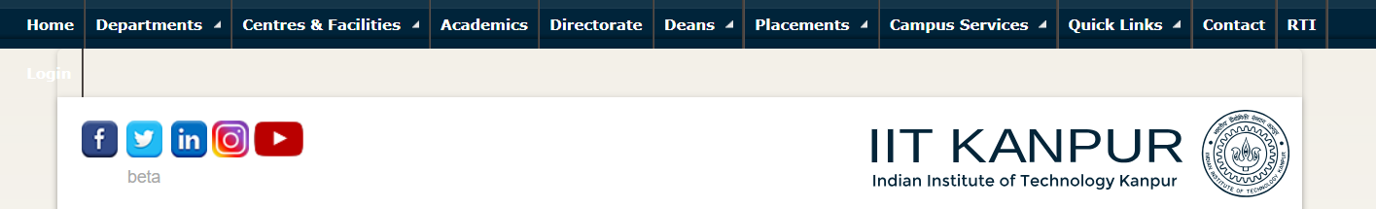  
   **Problem** - The Navbar is not fixed at the top. Fixed navbar makes it easier to navigate. You can read (scroll) to the bottom of the page, and then navigate to another page (using the fixed navbar) without having had to scroll to the top again.  
   **Solution** – Apply CSS style property - position: fixed, to make it fixed to the top of the page.
2. A white rectangular object with a blue background

   Description automatically generated **In Light Mode**  
   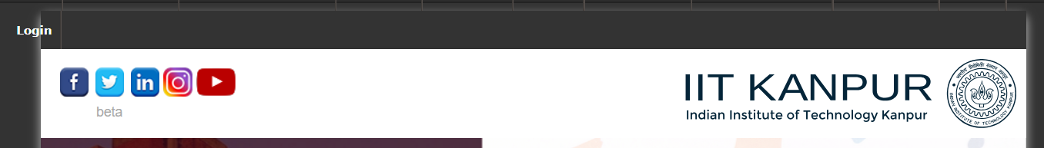  
   **In Dark Mode  
     
   Problem** – Login link is not visible while in light theme mode.  
   **Solution** – Add click addEventListener on both mode changing buttons. Store which mode is currently shown in a global variable. Depending on which mode is selected change the color of login button.   
   During dark mode use – color: white; and during light mode use – color: black;  
   Also initially make login button color black as the site loads in light mode.
3. A screenshot of a computer

   Description automatically generated  
   **Problem** **–** At the bottom of the page there is an empty container containing an iframe which is not loaded leading to the empty space.  
   **Solution –** Check iframe is loaded using below given code  
   This was taken from https://stackoverflow.com/questions/9249680/how-to-check-if-iframe-is-loaded-or-it-has-a-content.
4. 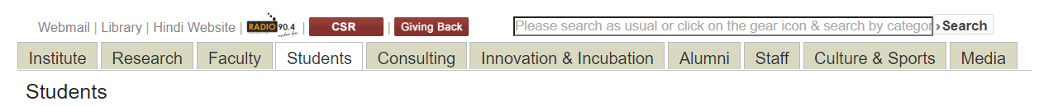  
   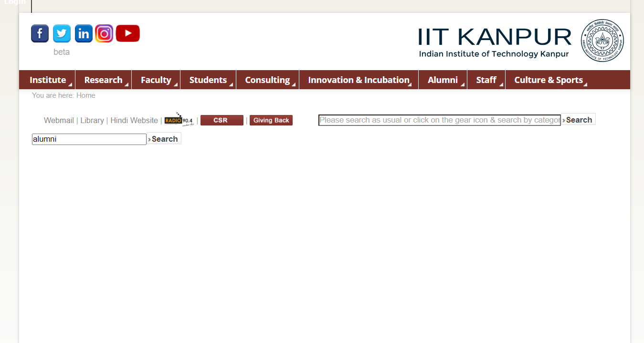  
   **Problem** - Search Bar is not working. Also there should be more space given for search bar as it forms an important part of the webpage for navigating without going through every option available.  
   **Solution** – Search in the database if particular keyword exists for any link or heading.
5. 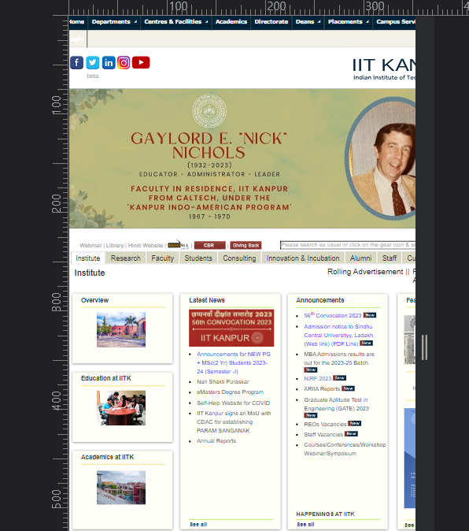  
   **Problem –** Site is not responsive on mobile version. We have to zoom in to look at everything.  
   **Solution –** Use media queries or responsive width units like %, vw or use Javascript(not recommended) to allow responsiveness.
6. 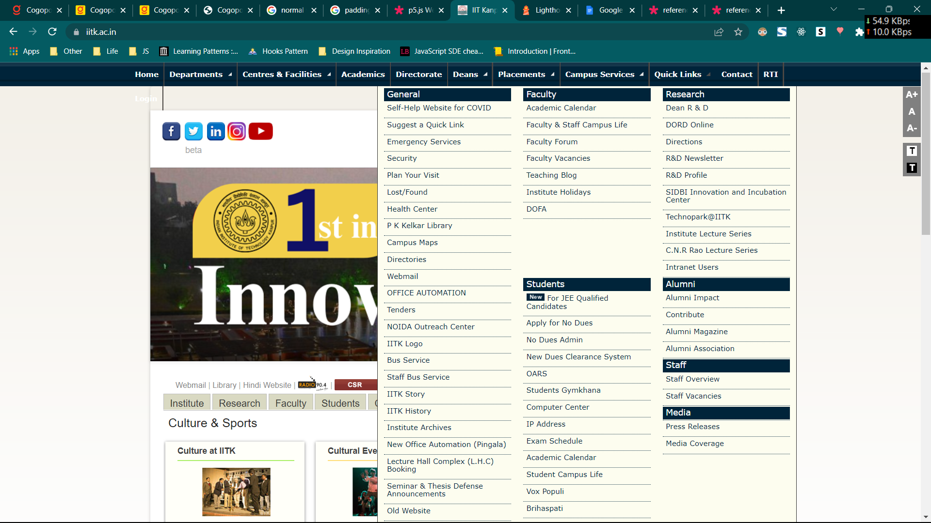  
   A screenshot of a computer

   Description automatically generated  
   **Problem -** While hovering over the links in the navbar, there are various links which gets popped up. We must go through each of them to finally select we require. Also hovering is not best to open a big modal like element as it is removed as move away from small navbar items.  
   **Solution –** Instead of hover use click event to open the dropdown and provide a search bar inside the dropdown to search for specific links.

**IIT Roorkee(**[**https://iitr.ac.in**](https://iitr.ac.in)**)**

1. 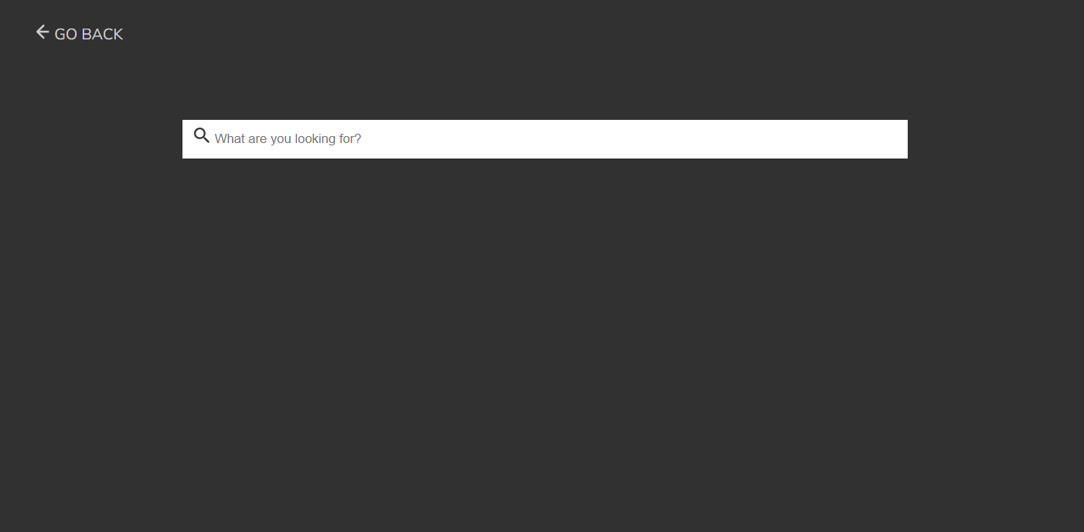  
   **Problem –** No option to initiate search and look for results.  
   **Solution –** Eitherprovide a automated search using onChange event handler on input or provide a search button search when we click on the button.
2. A close up of a person's face

   Description automatically generated  
   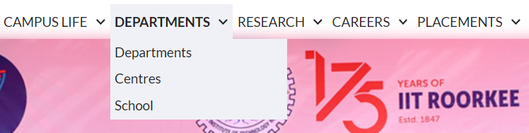  
   **Problem –** Research option in the navbar does not have any dropdown but still shows the icon to dropdown.  
   **Solution –** Remove the icon or use property display: none.
3. 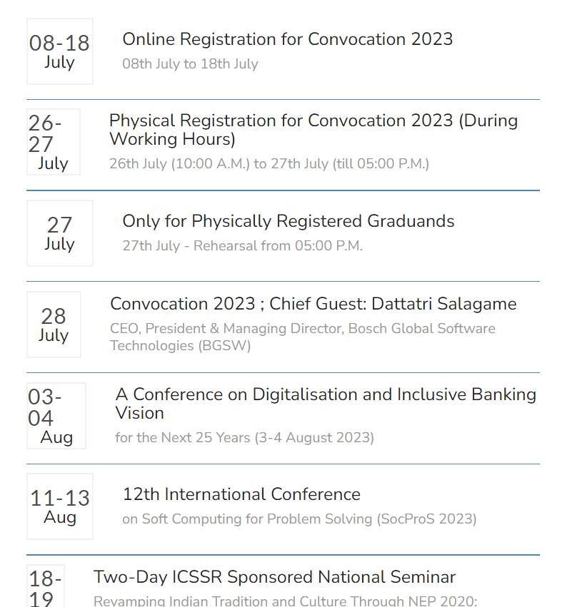  
   **Problem -** The dates are not well-aligned and have variable width creating unsymmetry.  
   **Solution** – Use flex property, give date flex: 1 and its content flex: 3.5. Result looks like below which looks more pleasing and easy to read.  
     
   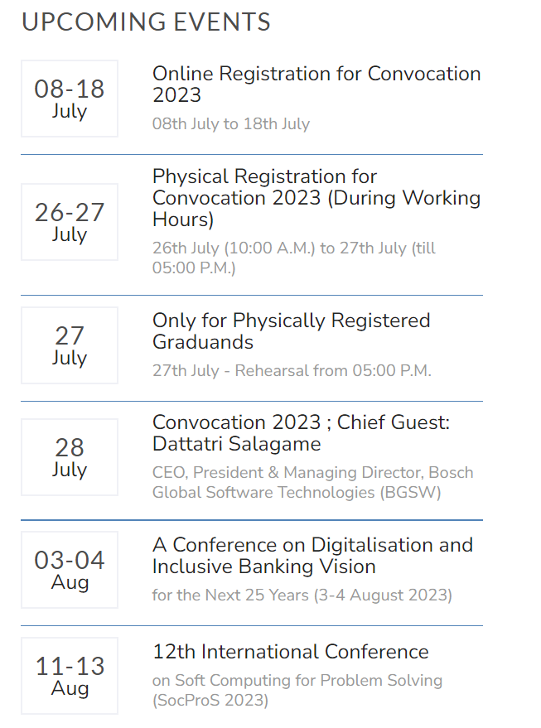
4. 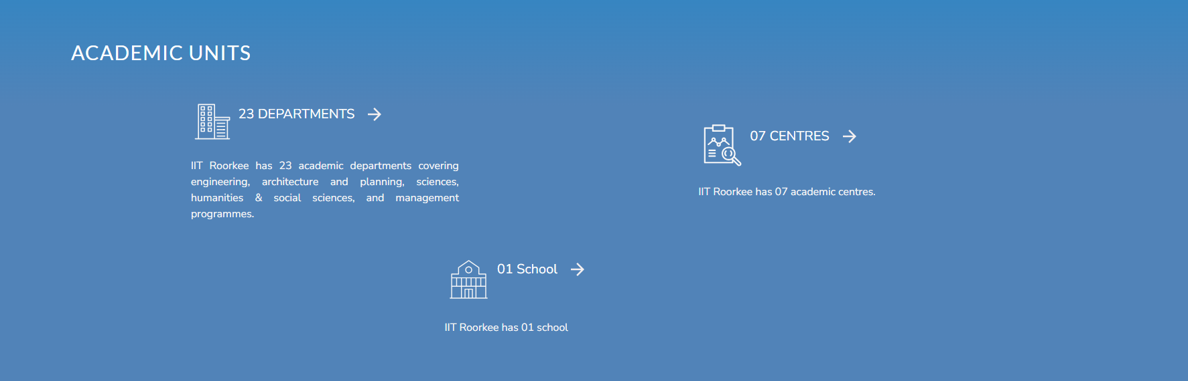  
     
   **Problem -** For a large screen font-size is small and due to variable height and alignment looks unsymmetrical.  
   **Solution –** Increase font-size.   
   Add some shadows to separate each of the container from each other and add a min-height to each container.   
   Move title to top by using justify-content: space-between; and move text content to just below title using align-self: stretch;  
   Result look like this  
   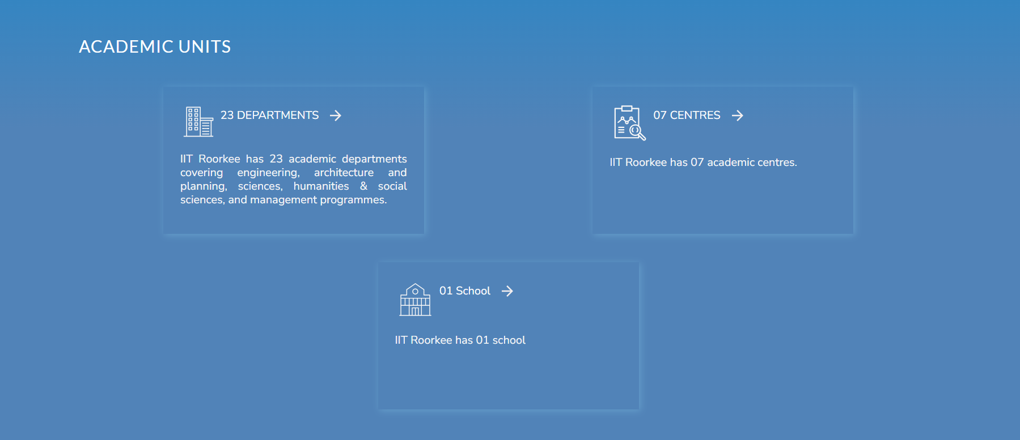
5. 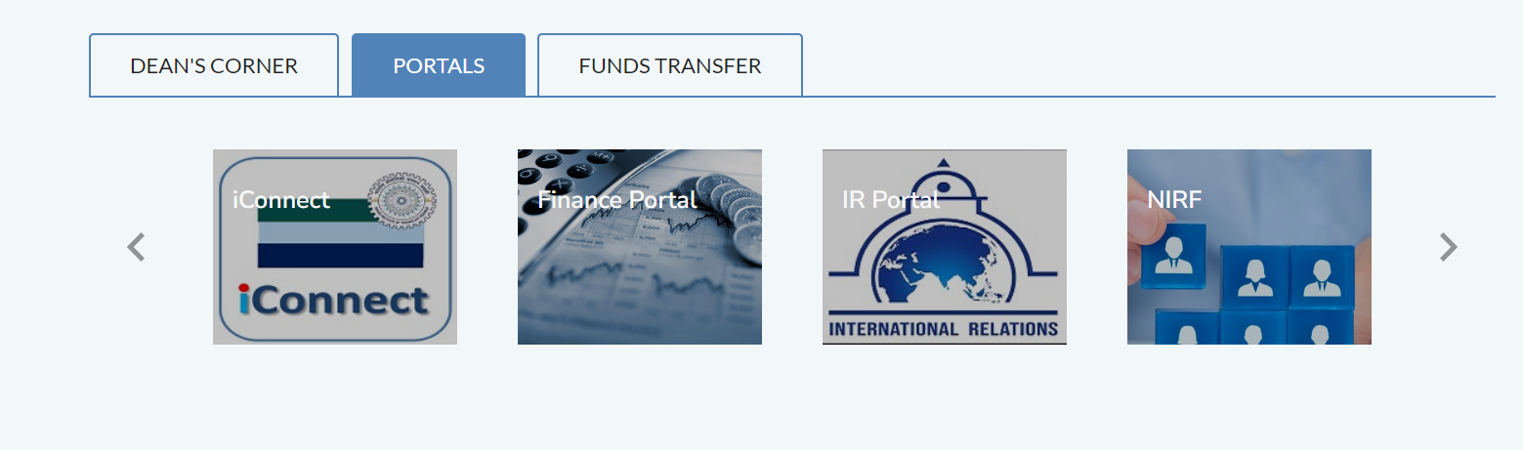  
   **Problem –** Contrast between Text and background image is low leading to low readability.  
   **Solution –** We can either add a dark colored colour over image or over the text.   
   We can do this by adding a linear/radial gradient between transparent and a low transparent dark color(#000000aa).   
   Result look like this  
   