BLINKIT SALES ANALYSIS

* Data Cleaning: (Used Excel)

**Standardizing the *Item_Fat_Content* field (e.g., converting 'LF', 'low fat' to 'Low Fat') ensures consistency, improves reporting accuracy, and prevents duplicate categorizations. The presence of multiple variations of the same category (e.g., LF, low fat vs. Low Fat) can cause issues in reporting, aggregations, and filtering. By standardizing these values, we improve data quality, making it easier to generate insights and maintain uniformity in our datasets.**

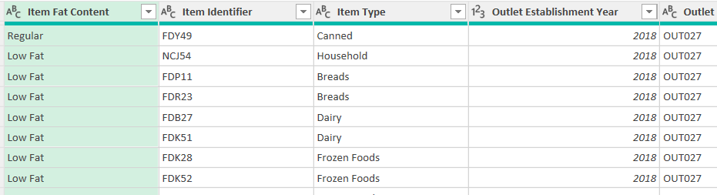

* KPI’s :
* Total Sales :

-- TOTAL SALES IN MILLIONS

SELECT CAST(SUM(Sales)/1000000 AS DECIMAL(10,2)) AS Total_Sales_Millions FROM dbo.blinkit_cleaned ;

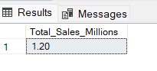

* Average Sales :

-- AVERAGE SALES

SELECT ROUND(AVG(Sales),2) AS Average_Sales FROM dbo.blinkit_cleaned ;

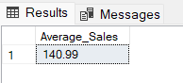

* No Of Items :

-- NUMBER OF ITEMS

SELECT COUNT(*) AS No_of_items FROM dbo.blinkit_cleaned ;

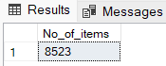

* Average Rating :

-- AVERAGE RATING

SELECT AVG(Rating) AS Avg_rating FROM dbo.blinkit_cleaned ;

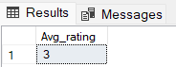

* GRANULAR REQUIREMENTS:
* **Total Sales by Fat Content:**

SELECT item_fat_content, CAST(SUM(Sales)/1000000 AS DECIMAL(10,2)) AS Total_Sales_Millions FROM dbo.blinkit_cleaned

GROUP BY item_fat_content ;

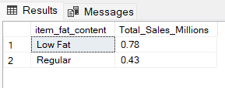

* **Total Sales by Item Type:**

-- Extracting top 5 items based on total sales

SELECT TOP 5 Item_Type ,

CAST(SUM(Sales)/1000000 AS DECIMAL(10,2)) AS Total_Sales_Millions,

FROM dbo.blinkit_cleaned

GROUP BY Item_Type

ORDER BY Total_Sales_Millions DESC ;

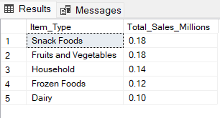

* **Total Sales Across Different Outlet By Fat Content:**

SELECT Outlet_Type, Item_Fat_Content,

CAST(SUM(Sales)/1000000 AS DECIMAL(10,2)) AS Total_Sales_Millions

--ROUND(AVG(Sales),2) AS Average_Sales,

--COUNT(*) AS No_of_items,

--AVG(Rating) AS Avg_rating

FROM dbo.blinkit_cleaned

GROUP BY Outlet_Type, Item_Fat_Content

ORDER BY Outlet_Type, Item_Fat_Content, Total_Sales_Millions DESC ;

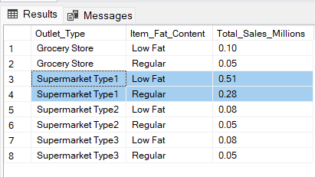

* **Total Sales Across Different Outlet Location For Each Fat Content:**

SELECT Outlet_location_type,

ISNULL([Low Fat],0) AS Low_fat,

ISNULL([Regular],0) AS Regular

FROM

(SELECT Outlet_location_type, Item_fat_content,

ROUND(SUM(Sales),2) AS Total_Sales

FROM dbo.blinkit_cleaned

GROUP BY Outlet_location_type, Item_fat_content

) AS SourceTable

PIVOT

(

SUM(Total_Sales)

FOR Item_fat_content IN ([Low Fat], [Regular])

) AS PivotTable ;

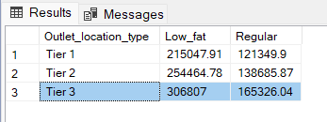

**Explanation of the Query**

This SQL query retrieves total sales data for different outlet location types, categorized by item fat content ("Low Fat" and "Regular").

1. **Subquery (SourceTable)**
   * Groups data by Outlet_location_type and Item_fat_content.
   * Calculates the total sales for each combination, rounding to two decimal places.
2. **PIVOT Operation (PivotTable)**
   * Transforms the Item_fat_content values into column headers ("Low Fat" and "Regular").
   * Uses SUM(Total_Sales) to aggregate sales data for each outlet location type.
3. **Final Output**
   * Replaces NULL values with 0 using ISNULL() to ensure completeness in the result.
   * Returns sales figures for each Outlet_location_type, with separate columns for "Low Fat" and "Regular" item sales.

* **Total Sales By Outlet Establishment:**

SELECT Outlet_Establishment_year,

ROUND(SUM(Sales),2) AS Total_sales

--ROUND(AVG(Sales),2) AS Avg_sales,

--AVG(Rating) AS Avg_rating

FROM dbo.blinkit_cleaned

GROUP BY Outlet_Establishment_year

ORDER BY Outlet_Establishment_year ;

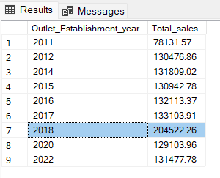

* **All Metrics By Outlet Size:**

SELECT Outlet_Size,

ROUND(SUM(Sales),2) AS Total_Sales,

ROUND(SUM(Sales)*100/SUM(SUM(Sales)) OVER(),2) AS Percentage_Sales,

ROUND(AVG(Sales),2) AS Avg_sales,

COUNT(*) AS Outlet_count,

AVG(Rating) AS Avg_rating

FROM dbo.blinkit_cleaned

GROUP BY Outlet_Size ;

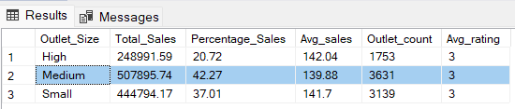

* **All Metrics By Outlet Location Type:**

SELECT Outlet_Location_Type,

ROUND(SUM(Sales),2) AS Total_Sales,

ROUND(SUM(Sales)*100/SUM(SUM(Sales)) OVER(),2) AS Percentage_Sales,

ROUND(AVG(Sales),2) AS Avg_sales,

COUNT(*) AS Number_of_items,

AVG(Rating) AS Avg_rating

FROM dbo.blinkit_cleaned

GROUP BY Outlet_Location_Type ;

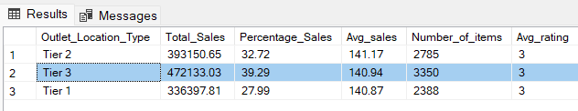

**KEY INSIGHTS :**

1. **Customer Preferences Drive Sales** –
   * Higher sales in specific categories suggest that customer preferences should be analyzed and used for personalized promotions and product recommendations**.**
   * Outlets with higher sales of "Low Fat" products may have more health-conscious customers. Introducing healthier product options or promotions can boost customer satisfaction and loyalty.
2. **Outlet Type Influences Sales Performance** –

* + Different outlet types (e.g., Supermarkets vs. Grocery stores) show varying sales trends, indicating that store format impacts consumer purchasing behavior.

1. **Older Outlets May Need Revamping–** 
   * Sales trends across outlet establishment years could indicate that older stores need improved promotions, renovations, or better stock management.

### ****Estimated Overall Sales Increase:****

* **Inventory Optimization** → **5-10%** increase by reducing stockouts and overstocking.
* **Targeted Promotions & Pricing** → **10-15%** increase by aligning offers with customer preferences.
* **Outlet-Specific Strategies** → **5-8%** increase by tailoring marketing to location-based demand.
* **Store Revamping & Customer Experience** → **5-10%** increase by enhancing older stores and improving in-store experience.

With proper execution, **sales growth of 20-30%** can be achieved over the next **6-12 months**, depending on customer response and market conditions