Exercise1:

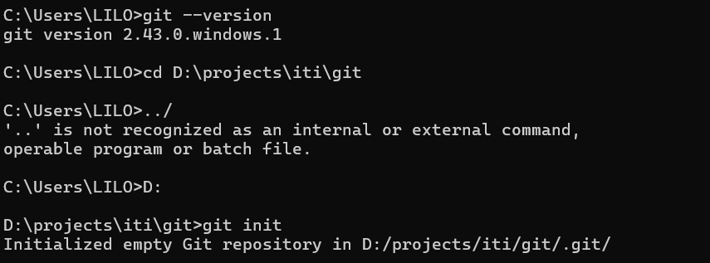

Exersice2:

Exercise 3:

Exercise4:

exercise5:

Exercise 6:

Exercise7:

1-[Add] Create About section in README

- Added a new "About" section to README.md.

- Helps users understand the purpose of the project.

2-[Update] Improve button styles in homepage

- Updated the CSS for primary buttons to have better hover effects.

- Enhances the user experience and visual appeal.

3-[Fix] Resolve broken link in navigation bar

- Fixed the incorrect URL in the navbar link to the Contact page.

- Ensures proper navigation across the website.