**Software Requirements Specification**

**for**

**LicenseHub**

**Version 2.0 approved**

**Prepared by  
Paweł Małecki**

**30.01.2024**

**Table of Contents**

**1. Introduction 3**

1.1 Purpose 3

1.2 Document Conventions 3

1.3 Intended Audience and Reading Suggestions 3

**2. Overall Description** 3

2.1 Product Perspective 3

2.2 Product Functions 5

2.3 User Classes and Characteristics 6

2.4 Operating Environment 6

2.5 Design and Implementation Constraints 7

2.6 User Documentation 7

2.7 Assumptions and Dependencies 7

**3. External Interface Requirements** 7

3.1 User Interfaces 7

3.2 Hardware Interfaces 7

3.3 Software Interfaces 8

3.4 Communications Interfaces 8

**4. Other Nonfunctional Requirements 8**

4.1 Performance Requirements 8

4.2 Safety Requirements 8

4.3 Security Requirements 9

4.4 Software Quality Attributes 9

4.5 Business Rules 9

# **Introduction**

## **Purpose**

*The purpose of this document is to inform the development process of LicenseHub - software for efficient license management.*

## Document Conventions

*Glossary:*

| *LH* | *LicenseHub* |
| --- | --- |
| *DB* | *database* |
| *UI* | *user interface* |
| *GUI* | *graphical user interface* |

## Intended Audience and Reading Suggestions

*The intended audience for the this document includes:*

* *Industry professionals who may find value in the software as an educational resource or as a tool for potential application in their organizations.*

# **Overall Description**

## **Product Perspective**

*The LicenseHub is a comprehensive software solution designed to centralize and streamline the management of software licenses while also providing robust customer management functionalities. Aims to facilitate efficient license tracking, compliance management, and enhanced customer interactions, all within a single, cohesive platform.  
It is not intended to replace existing enterprise resource planning (ERP) or customer relationship management (CRM) systems but rather complements them by addressing the unique complexities associated with licensing.  
The software will interface with external systems, primarily the clients' software applications using the server. These interfaces enable seamless communication for license verification, software updates, user notifications, and general data synchronization.*

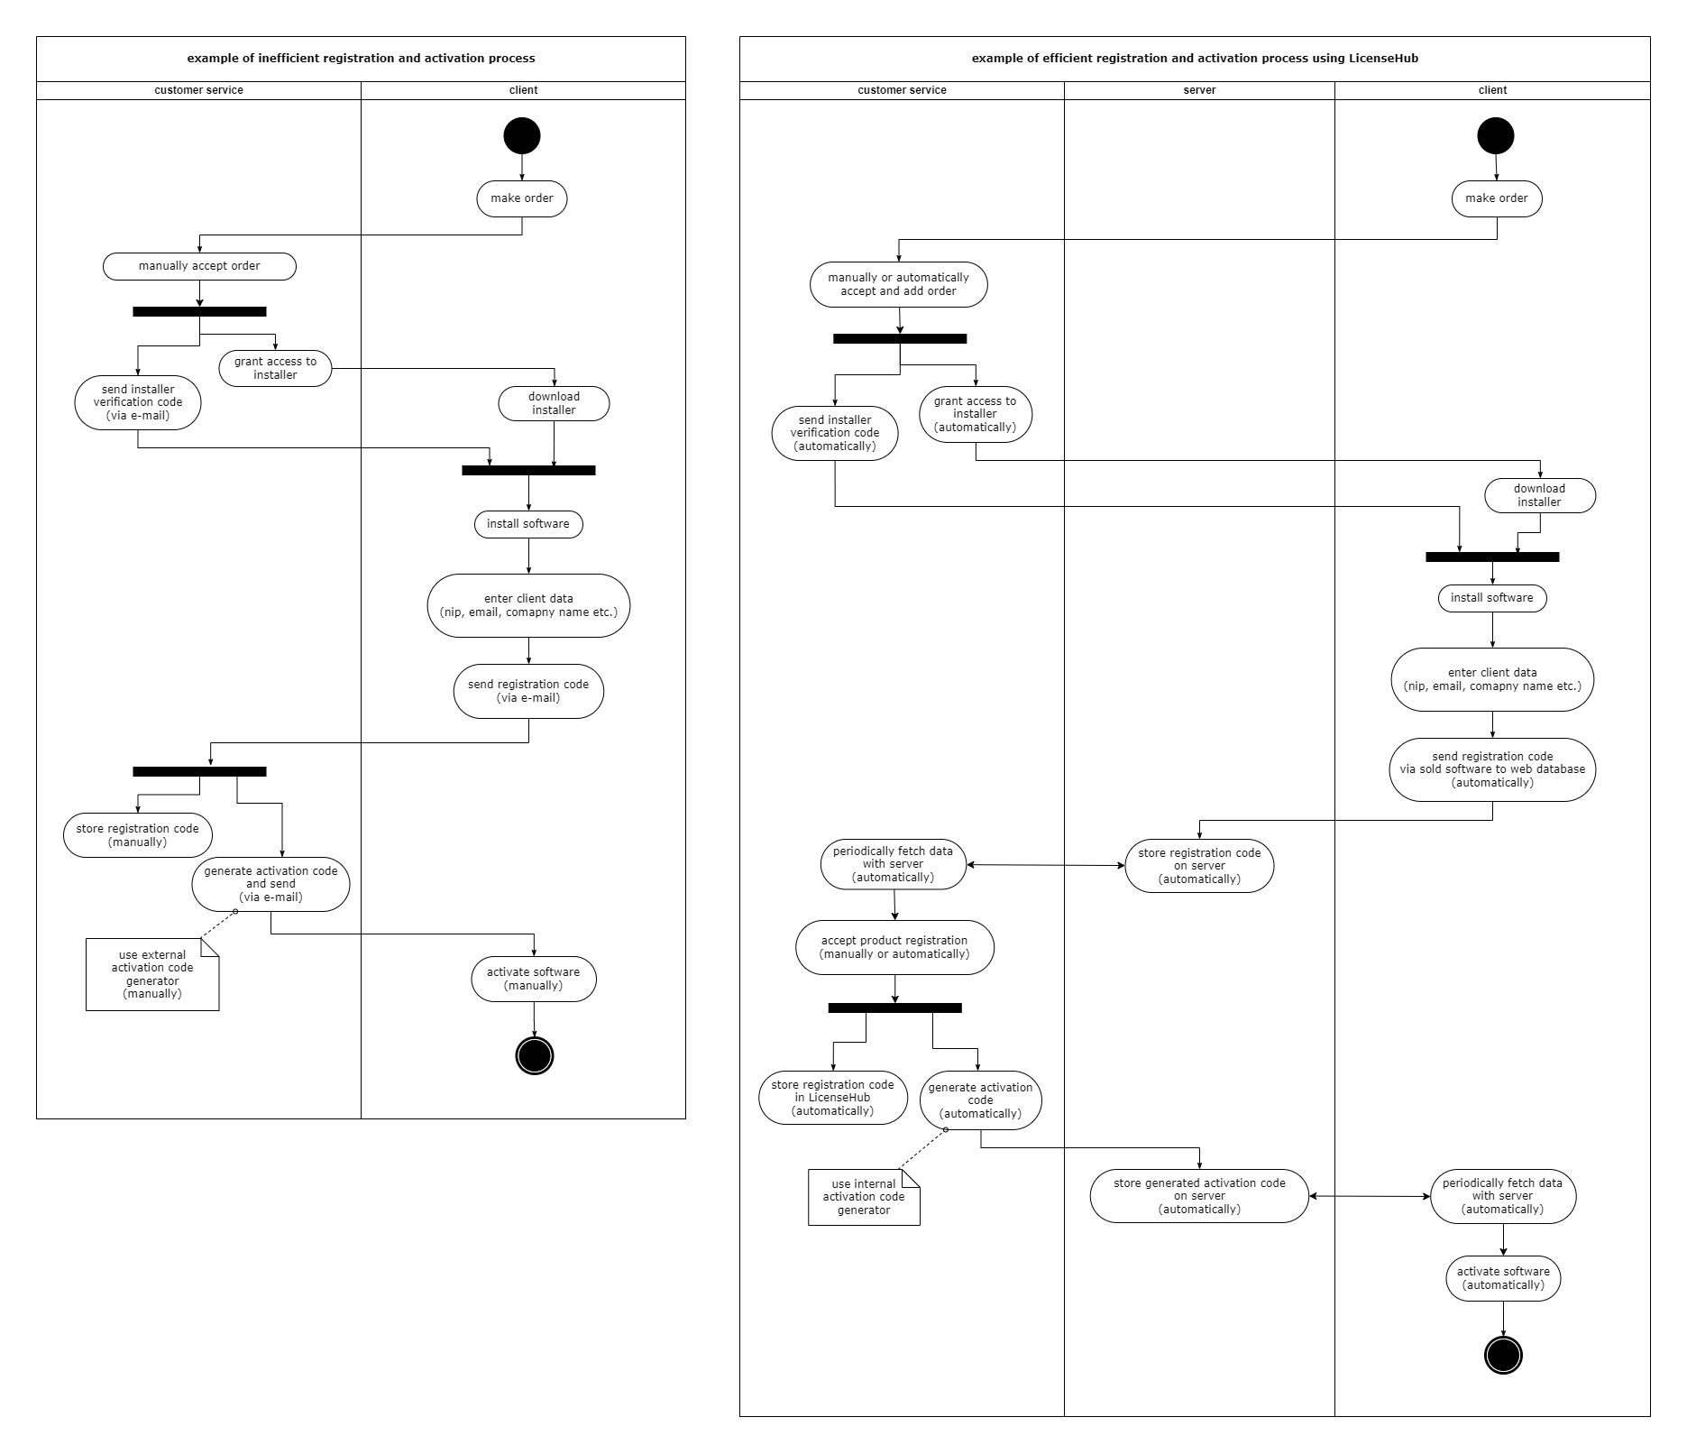

*Diagram 1. UML sequence diagram for registration and activation process*

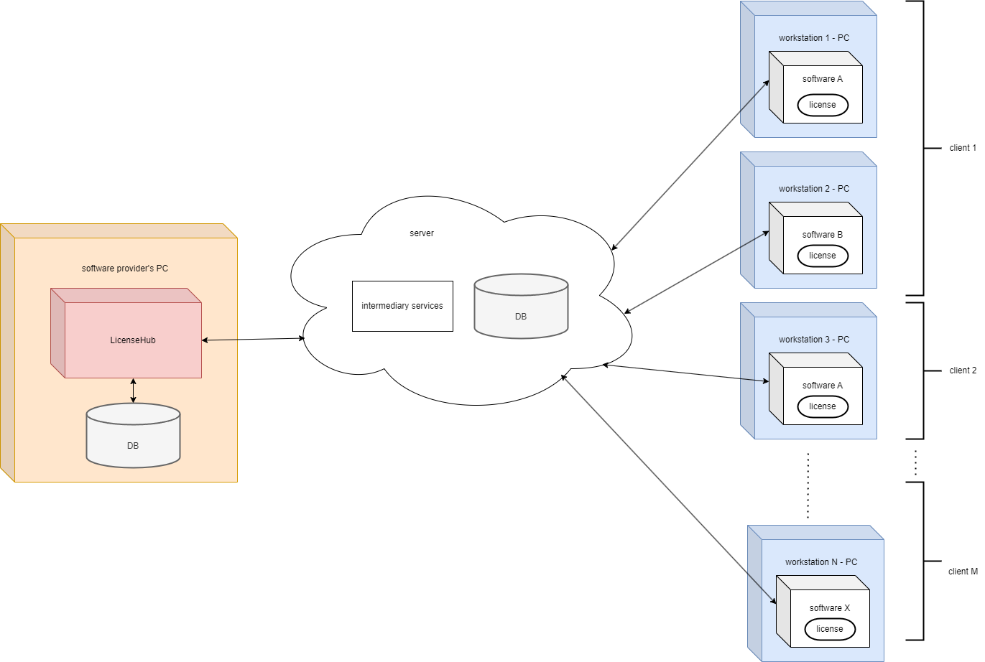

*Diagram 2. UML deployment diagram*

## **Product Functions**

*Functions below collectively address the essential aspects of LicenseHub.*

1. *Customer Management:*
   1. *Add and edit customer (company) details.*
   2. *Manage employee information within a company.*
2. *License and Product Management:*
   1. *Use defined different types of licenses.*
   2. *Add and edit software products.*
3. *Order Management:*
   1. *Create and edit orders.*
   2. *Change order status.*
4. *Workstation and License Assignment:*
   1. *Assign software products and employees to workstations.*
   2. *Transfer licenses between workstations.*
5. *Backup and import the database.*
6. *Generate reports on license expiration dates, company details, and contact information.*
7. *Notify customers about new products via the server.*
8. *Software Updates:*
   1. *Add software updates to the server.*
   2. *Notify users with active licenses about updates.*
   3. *Track the current software release number on workstations.*
9. *Documentation Management:*
   1. *Add user manuals and usage examples to the server.*
10. *License Activation:*
    1. *Generate activation codes for license activation and send them to customers via server.*
    2. *Store activation codes.*

*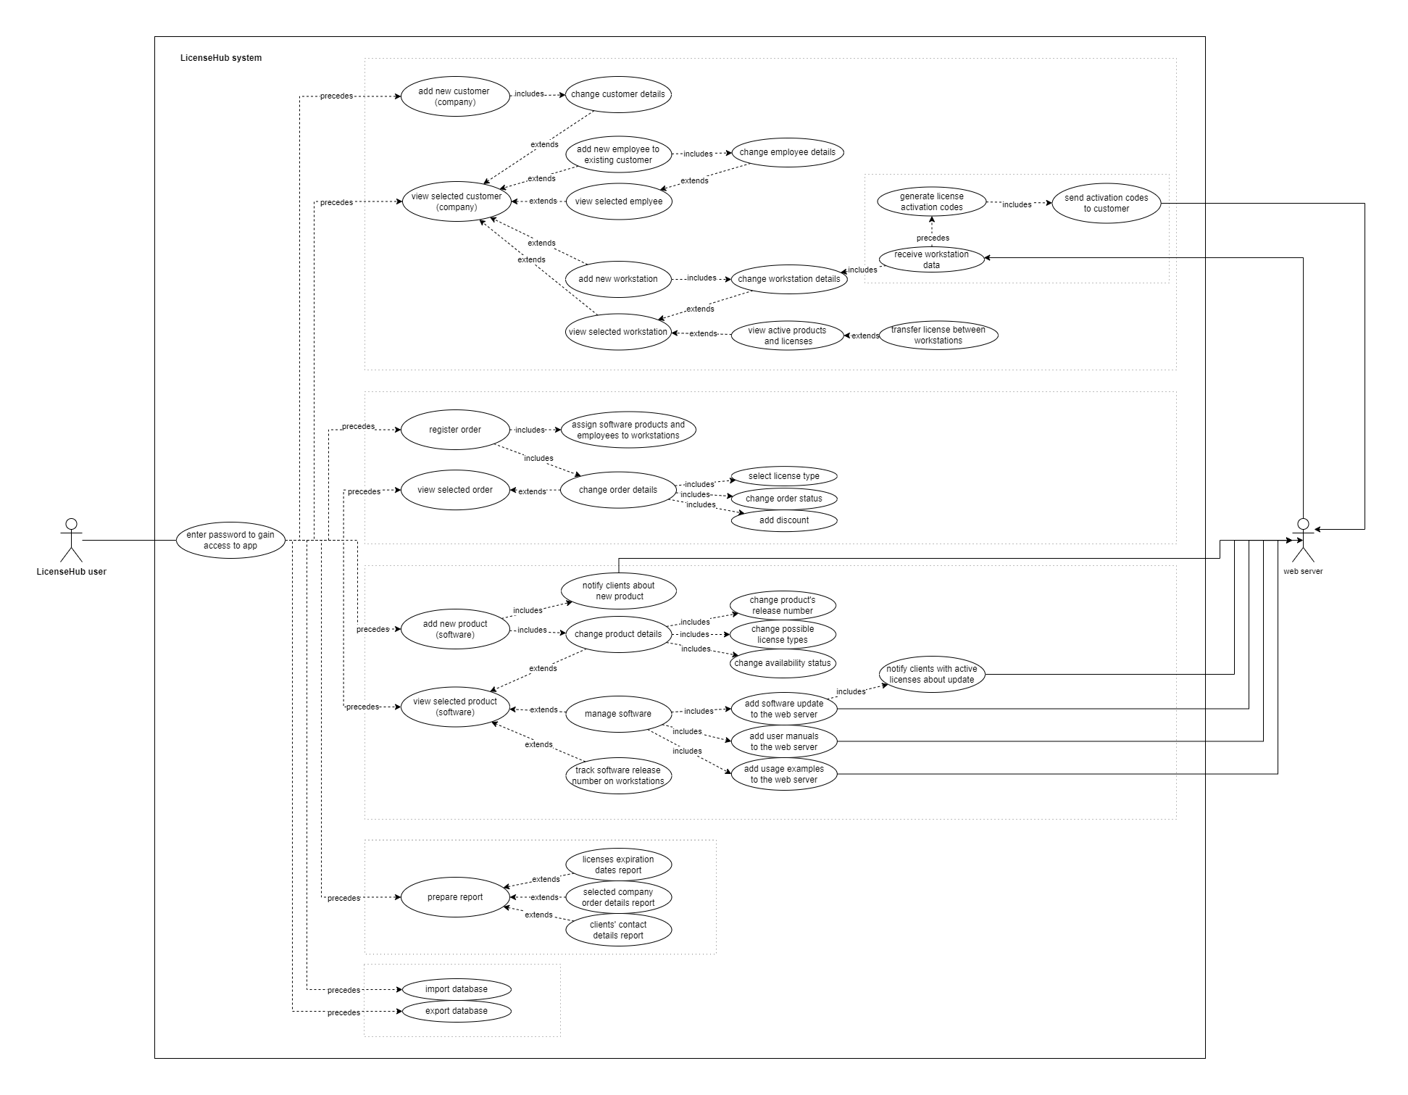  
Diagram 2. UML use case diagram*

## **User Classes and Characteristics**

*The intended users of the system are small business owners and entrepreneurs who seek an efficient solution to provide both license and customer management. The target audience includes individuals and organizations with limited resources and a need for a user-friendly, cost-effective software solution.*

## **Operating Environment**

* *LH will be designed to operate in the Windows OS versions 10 and 11, and may not be compatible with other operating systems.*
* *An Internet connection is required for communication with server.*

*Note: This document focuses exclusively on LicenseHub requirements. Server Requirements and Client-Side Requirements are not taken into consideration.*

## **Design and Implementation Constraints**

* *LicenseHub is a project developed by a single student and operates with a* ***zero-budget*** *constraint.*
* *Project has a strict* ***deadline of January 20th****. All development, testing, and documentation efforts must be completed within this timeframe.*
* *Given the time constraints, development and testing will follow an* ***incremental approach****.*
* *Testing efforts will* ***prioritize the core functionality*** *of LH. Critical bug fixes will be addressed promptly, with a focus on ensuring essential features are stable and reliable.*
* *Project assumes* ***compatibility with the sqlite database****, compatibility with other database systems requires additional customization.*
* *App is developed with a primary focus on the Polish market, and as such, the UI will be available in the* ***Polish language****.*
* *A* ***backup and recovery*** *mechanism must be in place for the database to prevent data loss.*

## **User Documentation**

*tbd user manual*

## **Assumptions and Dependencies**

*Let us assume that the required web server infrastructure is already developed and available for seamless integration.*

# **External Interface Requirements**

## **User Interfaces**

*LicenseHub will stick to the Windows Forms GUI standards.*

*Essential GUI elements:*

* *Login UI*
* *Client Management UI:*
  + *Employee Management UI*
  + *Workstation Management UI*
* *Product Management UI*
  + *Release Management UI*
* *Order Management UI*
* *Settings UI*

## **Hardware Interfaces**

*Operate in a standard computing environment.*

## **Software Interfaces**

| ***Software used*** | ***Description*** |
| --- | --- |
| *Operating system* | *LH is designed to run on Windows operating system for its best support and user-friendliness.* |
| *Database* | *sqlite* |
| *framework* | *.NET 8* |
| *GUI framework* | *Windows Forms* |

## **Communications Interfaces**

*LicenseHub communicates with the FTP server to*

* *transmit license activation codes*
* *receive workstation data*
* *put and manage software updates, user manuals and usage examples*
* *periodically synchronize license data to ensure up-to-date with the server*

*Connection information needed to set up LicenseHub:*

* *Hostname or IP address of the FTP server.*
* *Username and password for authentication.*

# **Other Nonfunctional Requirements**

## **Performance Requirements**

* *LH shall provide a responsive UI with a maximum response time of 2 seconds for standard operations, such as server data retrieval, adding products, orders, customers, employees, workstations and generating reports.*
* *The system shall support at least 50 concurrent users without significant performance degradation.*
* *DB queries shall have a response time of less than 1 second for typical operations.*

## **Safety Requirements**

*LicenseHub shall have a documented and tested* ***disaster recovery plan*** *in place, including regular backups and procedures for restoring data in the event of system failures or data loss.*

## **Security Requirements**

* *LH shall implement robust* ***error handling*** *mechanisms and* ***logging*** *functionalities and report errors promptly. Logs shall be regularly monitored for potential security incidents.*
* *LH shall support user authentication methods, such as* ***password authentication****, to protect clients’ sensitive information.*
* *LH shall implement encryption for data transmission and secure storage of sensitive information.*

## **Software Quality Attributes**

### *Usability: LH shall provide an intuitive user interface with clear navigation.*

### *Performance Efficiency: LH shall respond to user inputs within 2 seconds for standard operations.*

### *Security: LH shall provide protection against unauthorized access.*

### *Maintainability: LH's codebase shall be well-documented, allowing for the addition of new features.*

## **Business Rules**

* Customers are companies consisting of at least one employee.
* Not every customer is required to have an order.
* Each order is associated with a specific customer.
* One order is considered one invoice.
* Each order contains at least one license.
* Each license is binded to only one software on a single workstation or to none.
* One or more employees can use a single workstation.
* License can be transferred from one workstation to another already existing workstation or a new one only after:
  + being deactivated from the previous position
  + replacing the hard drive
  + additional arrangements between a client and software provider