**CIS 568**

**DATA VISUALIZATION**

**PHASE 2**

**GROUP 8**

**Exploratory Visualizations for OTT Platforms**

Ishan Bhargava

Pranav Nanaware

Prithvi Ramasamy Balu Krishnan

**Expected Outcome:**

The HTML consists of the following:

* Geospatial Choropleth:

This interactive map is designed as a gateway to uncover the extensive contributions of various countries to OTT platforms such as Netflix, Amazon, Disney, and Hulu. With just a simple click on any country within this dynamic map, it’ll be redirected to a page with visualizations of bar charts and line charts.

Reference: https://www.mapchart.net/world.html

The country wise page will contain above bar chart which will compare number of movies and tv shows across the 4 platforms for that country. It will also contain a trend chart representing the trend of movie duration through years.

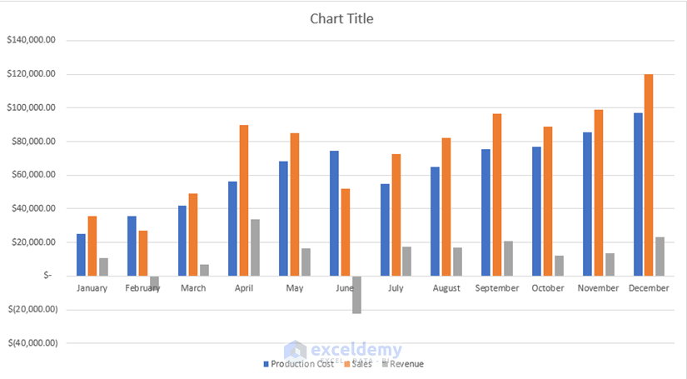

Reference: https://www.google.com/url?sa=i&url=https%3A%2F%2Fwww.exceldemy.com%2Fmonth-to-month-comparison-excel-chart%2F&psig=AOvVaw12AFP8TukHu4j_BitJEuBE&ust=1699381963713000&source=images&cd=vfe&opi=89978449&ved=0CBEQjRxqFwoTCNjx-JKEsIIDFQAAAAAdAAAAABAE

* Bar Chart Race:

We will place a racing bar chart on the homepage of our web page which will show how the content catalogues of popular streaming services like Netflix, Amazon, and Disney+, Hulu change over time. By using the play and pause feature, you will be able to observe the growth or decline in the number of movies and shows available on these platforms at different points in time.

Reference: https://observablehq.com/@d3/bar-chart-race

* Chatbot:

We plan to integrate a custom language model chat feature specifically designed for CSV data analysis. This will allow users to converse with the data directly, asking questions and receiving specific information in response.

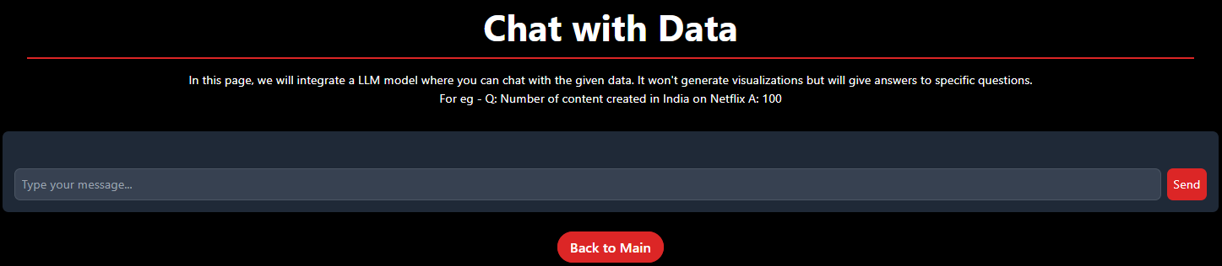

**To-Do:**

* GeoJSON File Creation:

The foundation of our interactive Geospatial Cartogram lies in the accurate representation of global geography. To ensure accuracy, we will refine our geographic data, focusing on the latest political boundaries and geographic markers to create a representative and up-to-date GeoJSON file.

Currently we are processing the data by combining data from four different sources.

* Graphs and Charts:

We’ll be replacing the placeholder charts with the actual ones once our GeoJSON file is complete.

* Chatbot Improvement:

We will expand the chatbot's ability to answer a broader range of data-specific questions, allowing for deeper dives into the dataset, such as querying specific viewer statistics or comparing content performance metrics.

**Links:**

Hosted Webpage: <https://p-nanaware.github.io/dv-project/index.html>

GitHub Repo: <https://github.com/p-nanaware/dv-project>