Add Title Here, up to 12 Words, on One to Two Lines

Author Name(s), First M. Last, Omit Titles and Degrees

Institutional Affiliation(s)

Author Note

Include any grant/funding information and a complete correspondence address.

# Runge-Kutta

## solution

The goal was to implement a Runge-kutta solution in code and then use the same to plot paths using arbitrary initial conditions. I chose the domain for initial conditions to be [-1, 1] for both the x and the y, while the domain over which I would plot the paths was [-2, 2]. I choose to draw the paths on phase portrait embedded in a quiver plot so as to more clearly and comprehensively show trajectories movement in the whole vector space. All plots use the same initial conditions which are randomly generated each time the program is ran. However, each plot represents a superposition of vector fields and trajectories for a single µ each time.

##### Accuracy

In terms of the code. I used the python decimal module for all arithmetic. This when compared to other python datatypes for dealing with numerals such as float and int has the relative advantage that decimal numbers are represented exactly. The decimal module facilitates without prejudice both exact unrounded decimal arithmetic and rounded floating point arithmetic. The decimal module also came in handy in dealing with bigger numbers than those supported by the hardware. This was achieved by using a custom precision.

## Results

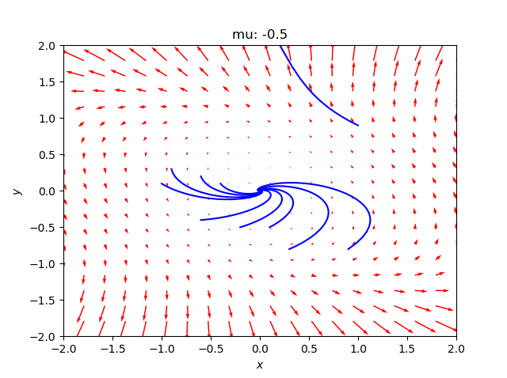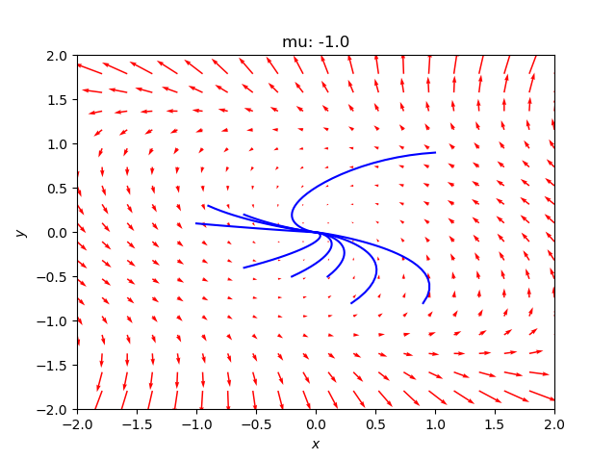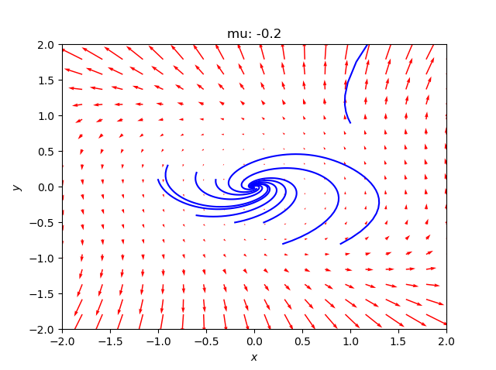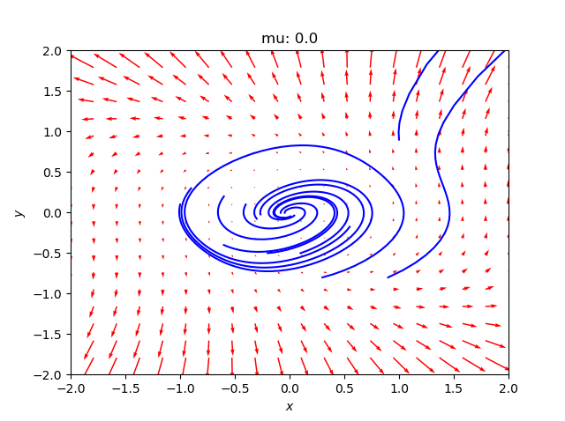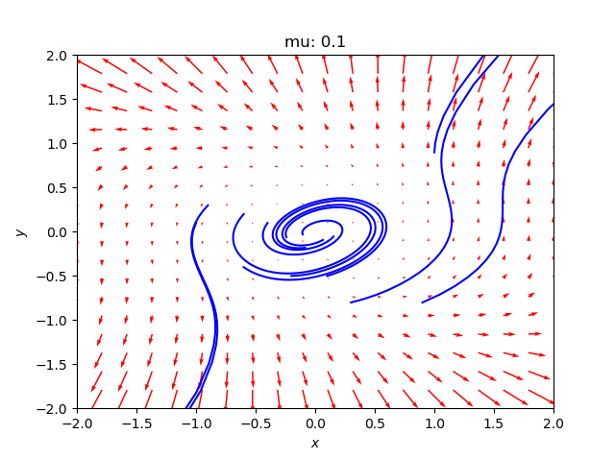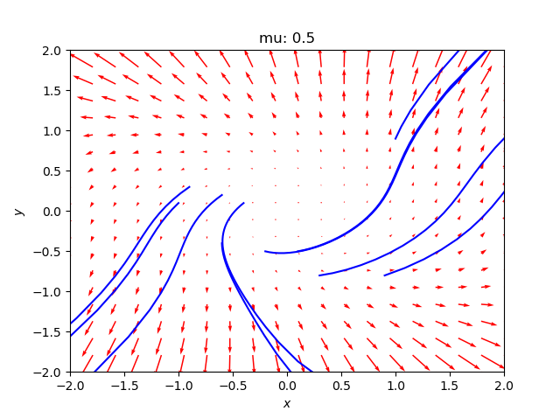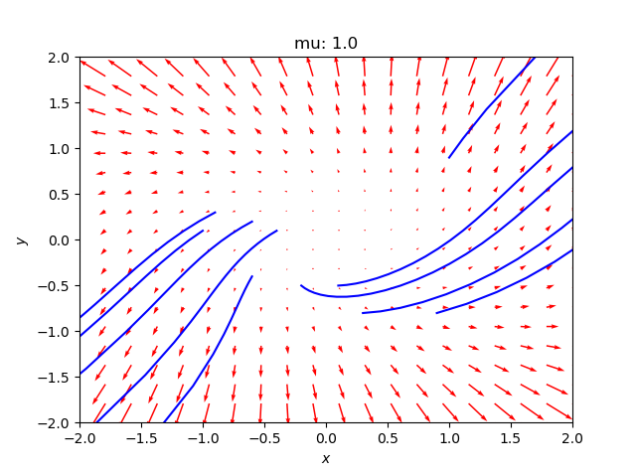

As seen in the above phase plane, one sees a spiraling effect for when µ < 1, for points in close vicinity to the origin. The 2 order od

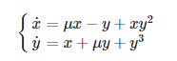

can be written:

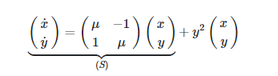

which appears, in the vicinity of the origin (x, y "small enough"), as a little perturbation of system (S).

# Hopf bifurcation

## Hopf Bifurcation

Most dynamic systems contain both parameters and variables, such that the equation has a set of parameters on which the equations and their solutions depend. A bifurcation is said to occur when the behavior of the model changes qualitatively from one set of parameters to another. For instance, a stable equilibrium point might have become unstable.

In A Hopf Bifurcation, a variation of the parameters destabilizes a stable focus, and the attractor becomes an asymptotically stable, periodic solution (limit cycle) seen as a closed curve in a phase portrait.

There are 2 types of a Hopf bifurcation:

* Supercritical Andronov-Hopf Bifurcation: here, the limit cycle has zero amplitude at the parameters resulting in the bifurcation, however the amplitude grows as the parameters move further into the limit-cycle regime
* Subcritical Andronov-Hopf bifurcation: here a stable limit cycle surrounds an unstable limit cycle that in turn surrounds the equilibrium point. The unstable limit cycle shrinks down to the equilibrium point, which becomes unstable in the process. For systems started near the equilibrium point, the result is a sudden change in behavior from approach to a stable focus, to large -amplitude oscillations.