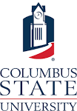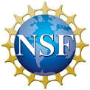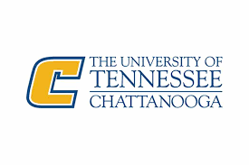

**NSF Workshop on**

**Interdisciplinary and Collaborative Research in**

**Cybersecurity**

Columbus, Georgia

May 2nd, 2019

Sponsored by

Columbus State University

University of Tennessee at Chattanooga

TSYS Corporation

Synovus

Aflac

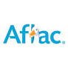

C:\Users\wang_shuangbao\AppData\Local\Microsoft\Windows\INetCache\Content.MSO\409F517A.tmpC:\Users\wang_shuangbao\AppData\Local\Microsoft\Windows\INetCache\Content.MSO\ED9A78C.tmp

**Advancing Interdisciplinary and Collaborative Research in Cybersecurity**

TSYS School of Computer Science, TSYS Center for Cybersecurity

Columbus State University

4225 University Avenue

Columbus, GA 31907

*(Tentative)*

Wednesday, May 1, 2019

7:00-8:30 PM Welcome Reception\*

Thursday, May 2, 2019

8:30-8:50 Registration

8:50-9:00 Welcome remarks (Provost Dr. Bordelon)

9:00-9:30 Speaker:   
Tony Skjellum, Professor, Chair of Excellence, Director of SimCenter, UTC

9:30-10:00 Speaker:   
Paul Wang, Professor, TSYS Endowed Chair in Cybersecurity, CSU

10:00-10:20 NSF Initiatives and Calls for Proposals

Dr. Eammon Kelly, Senior Adviser, Assistant Director, NSF

10:20-10:50 Coffee break

10:50-12:00 Presentations:

Dr. David Umphress, Director, Cyber Research Center, Auburn

Dr. Csilla Farkas, Professor, USC

Dr. Rodrigo Sardians, Auburn

Dr. Farah Kandad, UC Foundation Associate Professor, UTC

Dr. Mark Yampolskiy, Assistant Professor USC

Dr. Donald Reising, Assistant Professor, UTC

12:00-1:00 Lunch

1:00-2:10 Presentations – second group of university participants

2:10-3:00 Presentations – Industry participants (5)

3:00-3:30 Coffee break. Open discussion: Funding Opportunities.

3:30-4:00 Plenary Discussion: Closing Thoughts and Next Steps  
Tony Skjellum, Paul Wang, Eamonn Kelly