- Setting up for the screening
First, we need to assess whether the identified articles are relevant. The first step is to skim through the titles, abstracts, and keywords to identify relevant studies. This step will be performed in https://www.rayyan.ai/. Rayyan is a web platform that greatly simplifies this process by highlighting relevant keywords in the documents.
Below is a walk-through on how to use Rayyan (more information can also be found at https://help.rayyan.ai/hc/en-us/articles/22697630697617-Getting-Started-with-Rayyan-A-Quick-Start-Guide, and I will be happy to address any questions).
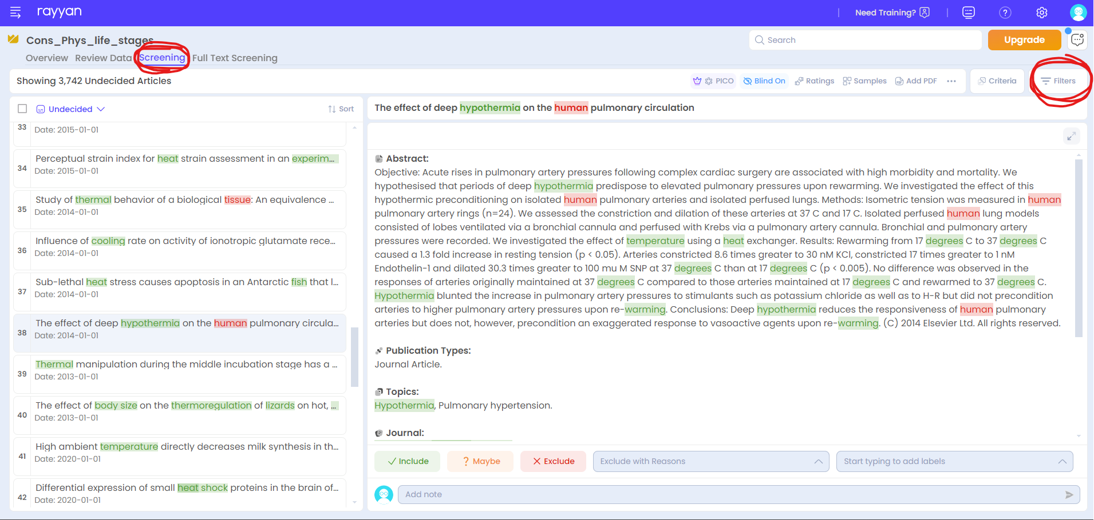
This is the screen you should find when you log into the project. Make sure you are on the “Screening” tab (see above), and that you active the filters on the right-hand side (see red circles above).

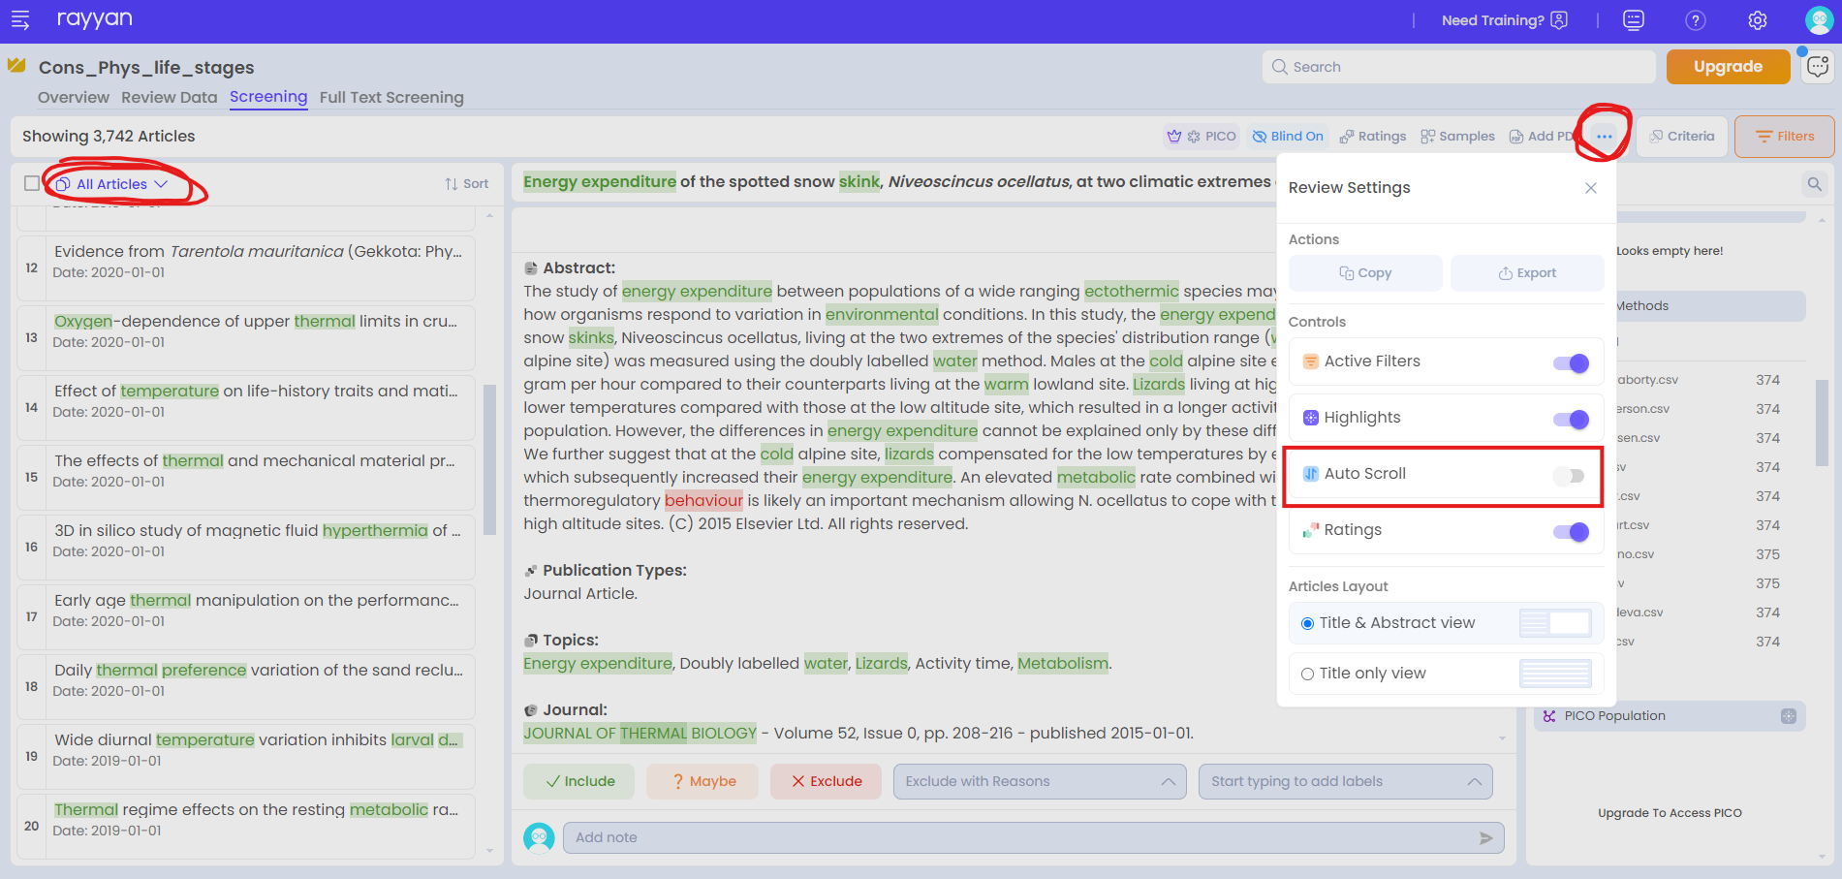
I also strongly recommend turning “Auto Scroll” off. Also avoid filtering articles (keep to “All articles”; or make sure to refresh regularly if you use “Undecided”). See above.
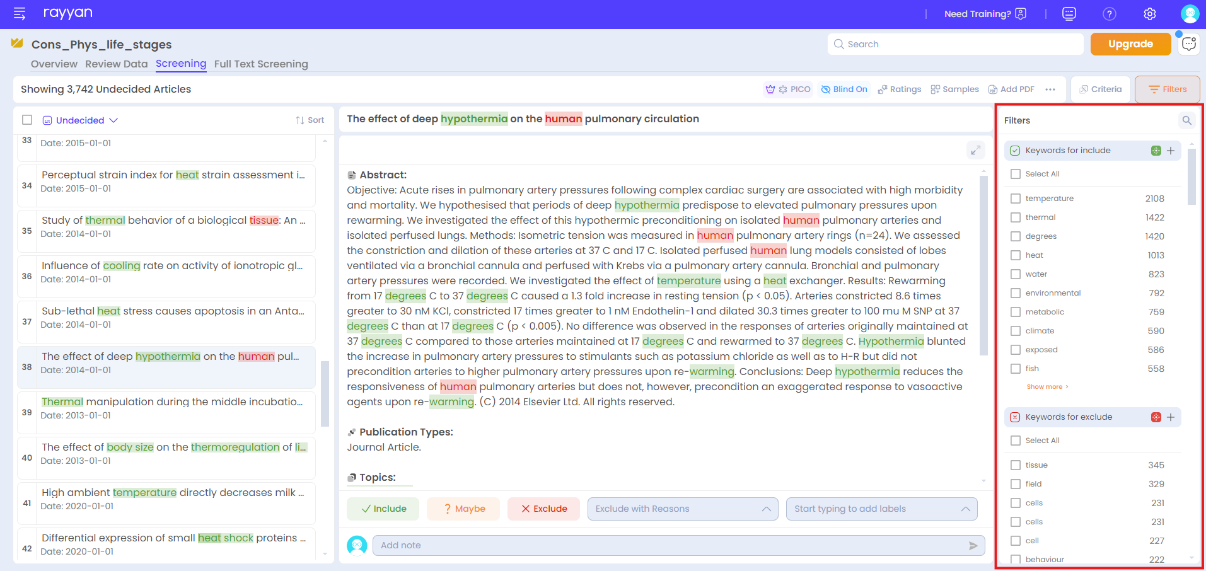
Once you have activated filters, you can find “keywords” to “include” or “exclude”. It will basically highlight relevant keywords in green, and potentially irrelevant keywords in red. I have already added some keywords in both sections, but it is a good idea to add relevant/irrelevant keywords in those sections as you go through papers – it will help everyone

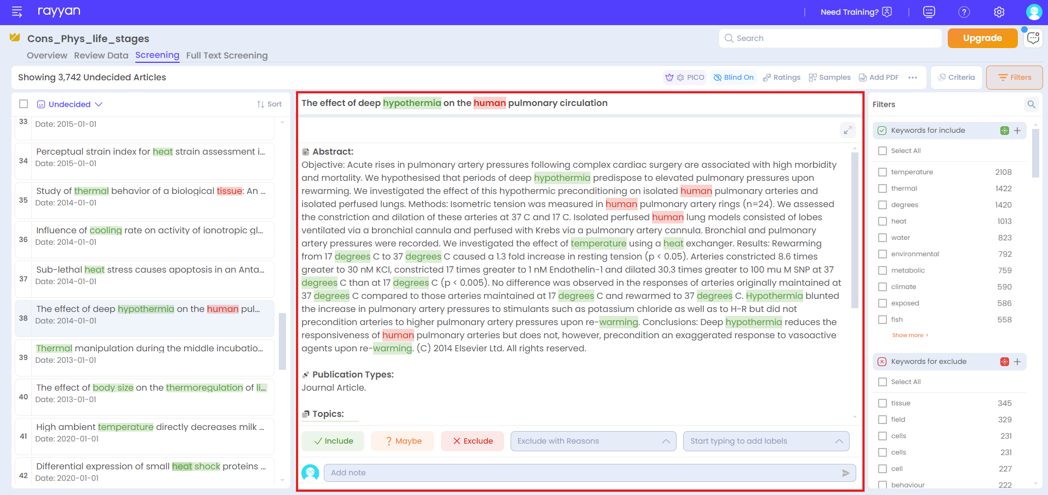
In the middle panel, the title, abstract, and keywords should be displayed with relevant keywords highlighted in green, and irrelevant keywords in red. That is super helpful, and dramatically reduces the time it takes to screen the abstracts!
However, keep in mind that seeing words highlighted in red does NOT mean a study is irrelevant! It a visual guide to help you quickly identify red flags, but it is important to carefully look at those before you make a decision.

- Screening articles
We can now move onto the actual screening. Because we are performing a systematic review, we use precise criteria to decide on the inclusion or exclusion of the papers screened. All (abbreviated) criteria are listed in the decision tree below.
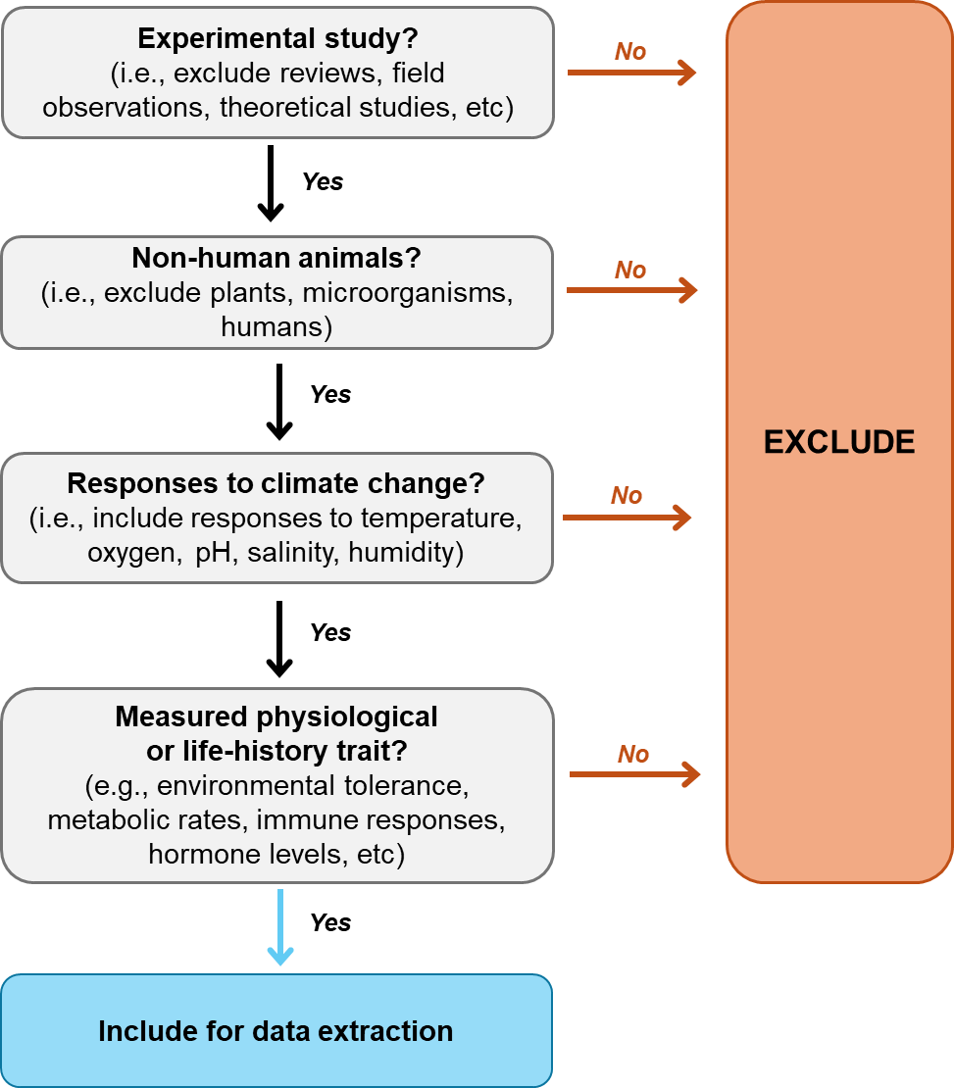
We will systematically review the literature to find studies that experimentally exposed living non-human animals to climatic stressors (temperature, oxygen, pH, salinity, humidity), and measured physiological and/or life-history traits. Therefore, we will exclude reviews, meta-analyses, field observations, theoretical studies, editorials, and other study types without experimental manipulations. Note, however, that we will include experimental studies performed in both laboratory and field settings, as long as climatic stressors were experimentally manipulated (e.g., modify operative body temperatures by adjusting nest depth of turtle eggs in the field). Relevant climatic stressors will include temperature, oxygen, pH, salinity, and humidity, but note that we may also include other, less common, climatic stressors if they are found in experimental studies (e.g., UV radiation levels). We will only focus on living non-human animals, hence excluding humans, plants, microorganisms, or cells/organs isolated before the exposure to the climatic stressor. We will only focus on physiological or life-history traits (e.g., environmental tolerance, reproduction, metabolic rates, immune responses, hormone levels, etc) to gain an overview of the field of conservation physiology broadly defined.
Please make sure you carefully read and understand each criterion. I recommend printing the decision tree and the description of each criteria, and having these in front of you while screening.
We will all be working on the same Rayyan project for the abstract screening. However, you have all been allocated a specific number of papers to screen. Make sure to filter to only screen the papers you have been allocated to.
To find the papers you have been allocated to, check the tab “Search methods” on the right hand panel (you might have to scroll down a little bit) and click on your name (see red rectangle below). This will filter out studies to your allocated papers.
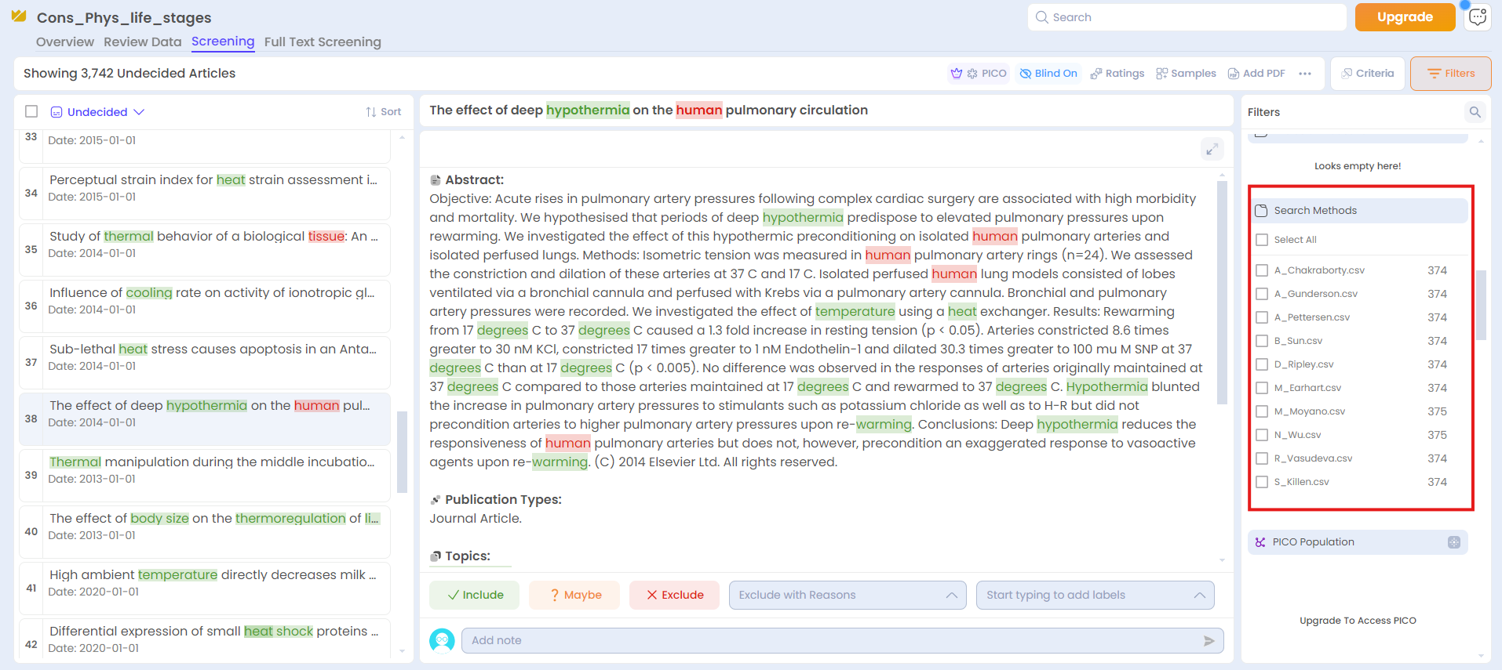
When you are ready, you can use the decisions in Rayyan (include or exclude; see red box below). No need to add reasons for exclusion, just tick “include” or “exclude”.
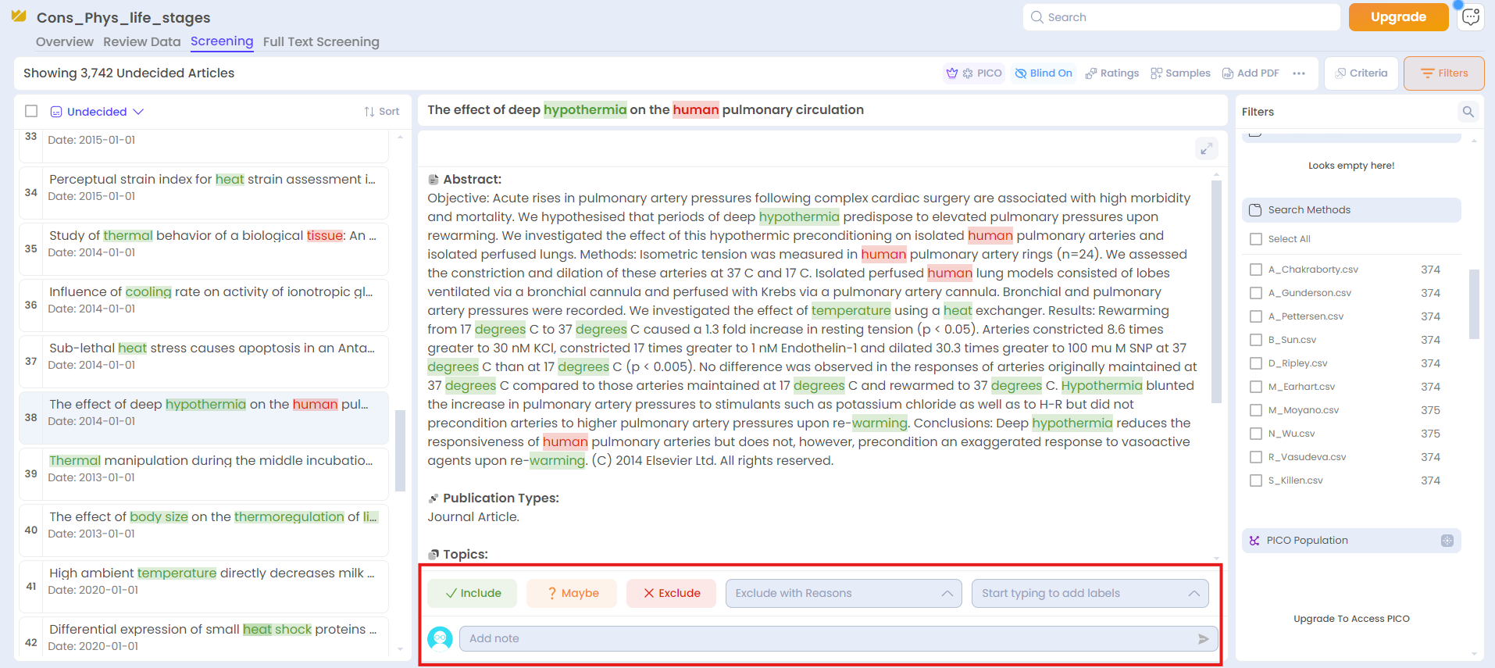
Some of the things to be wary of:
- We are only interested in experimental data, so please exclude field observations, reviews, meta-analyses, theoretical studies, editorials, etc.
- If the study does not have an abstract, please google the article and have a look at the PDF.
- If some of the criteria are hard to determine, have a look at the PDF.
In doubt, please use the “Maybe” decision, and add Notes so that I can understand why you are unsure. Please also email me if you have questions or if anything is unclear!

- Extracting data from studies
When a study matches all inclusion criteria, we will extract additional information from these studies. This will be done through a Google Form available here: https://forms.gle/Ljg5vy2mN5rTP3Uj6
You can decide to extract data from the included studies as you progress through the screening, or after you finish the screening. It might be quicker to do it progressively as you are already familiar with the content of the article.
All questions have descriptions, so it should be self-explanatory. However, if something is unclear, or you disagree with the categories, please let me know!
The content we need to extract is mostly available from the abstract, but you may need to look at the PDF in some instances. Most articles should be easily available through university subscriptions or Sci-Hub. If you cannot retrieve the article, feel free to contact me, I will try to get access to the PDF.
If you have any doubt during the data extraction, please email p.pottier@unsw.edu.au. This can help defining criteria more clearly and help everyone involved!
That’s it! Very well done and many thanks for your contribution! I hope you learned things along the way, and we can now confidently rant about how understudied embryos are .

