

How to get actual YNC Command

Ver 1.1

YAMAHA CORPORATION
AV Products Division

Revision History
Ver | Date | Author | Description
1.0 | Jun/16/2011 | M.Kawashima | Issue 1st Edition
1.1 | Jul/8/2011 | M.Kawashima | 4.A list of commands  -> The folder composition was corrected.

1 Preface 3
2 Function Tree 3
2.1 Find the Function Tree 3
2.2 General Appearance of the Function Tree 3
3 Command Generation 5
4 A list of commands 10
4.1 What is a list of commands? 10
4.2 The contents of a list of commands 11

Preface
In this document, the instructions of how to construct YNC commands are described in chapter 3 ; whereas, chapter 5 gives you the details of how to use the list of commands.

Function Tree

Find the Function Tree
You can find the Function Tree (with which you generate commands for AV devices)
from the following MS Excel file.
Func tree for comp functions sheet of devicename_Function_Tree.xls
(devicename will be AV device name)
e.g. ) V671_3071_FuncTree_1.10.xls
notice)When opening this file, please make sure that your computer’s security settings
will allow you to run macros.

General Appearance of the Function Tree
Look at the three sections circled in red in the below general appearance of the
Function Tree.
2
3
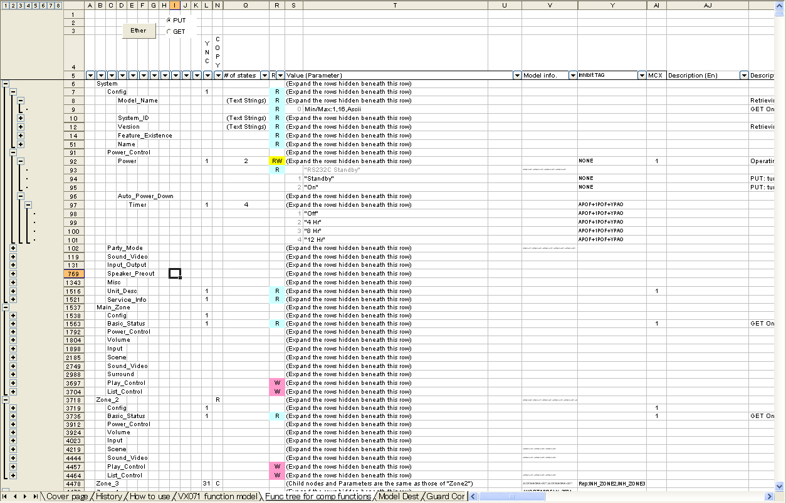
1

The section 1 shows the hierarchy of commands. The top of the tree is column B, the second layer is column C, third is column D and so on. The various layers can be viewed or hidden by clicking on the + or – boxes on the far left of the screen. By clicking on the + boxes on the left, you can view the lower layers of this hierarchy.The section 2 is used to automatically generate commands. The details will be elaborated in a later chapter.

These columns of section 3, starting from column L, define the exact rules for any particular command:
- YNC – a ‘1’ in this column means that a command is valid over YNC Protocol.
- Copy – a ‘C’ means there is a node that has the same tree structure on the same layer.
an ‘R’ in this column means that it is the top node of the same tree structure.
a ‘C’ means that it is a copy of the tree structure denoted by ‘R’ on the same layer.
- # of states – the total number of possible parameters of that particular command.
The total number of possible parameters will be 2 if On and Off are selectable.
- R/W – a ‘W’, “RW” or blank in the column R means that the parameter is valid in PUT commands. a ‘R’ means that the parameter is invalid in PUT commands and only used in GET commands.
- Value (Parameter) – The actual type of value that we can assign to that command, for example text or numerical value.
- Model info – indicates whether this command is excluded or exclusive for any
particular country. Refer to the sheet ‘Model Dest’.
1. (Blank) : No limitation. (All models and all destination are support this command)
Moreover, the definition is succeeded if there is a definition at the upper layer node.
2. "=xxxx" : Only model xxxx supports this command.
(Other models don't support this command.)
3. "=xxxx,=yyyy" : Model xxxx and yyyy support this command.
4. "JA" : Only destination 'J' and 'A' of all models support this command.
5. "-JA" : All models except destination except 'J' and 'A' support this command.
6. "UC=xxxx" : Only destination 'U' and 'C' of model xxxx support this command.
(Other models and other destination of model xxxx don't support this command.)
7. "-UC=xxxx" : Except destination 'U' and 'C' of model xxxx support this command.
(Other models, and destination "U" and "C" of model xxxx don't support this command.)
- Inhibit TAG – Indicated the guard condition of the command. Refer to the sheet ‘Guard Condition’.
- Description – Memo

Command Generation
You can easily generate YNC commands by using the Function Tree.
Select either PUT command or GET command.
- Choose either PUT or GET radio button of your choice in the Function Tree.
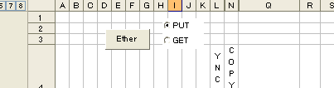

- Move the cursor to the desired node. Make sure that ‘1’ appears in the column L for YNC.
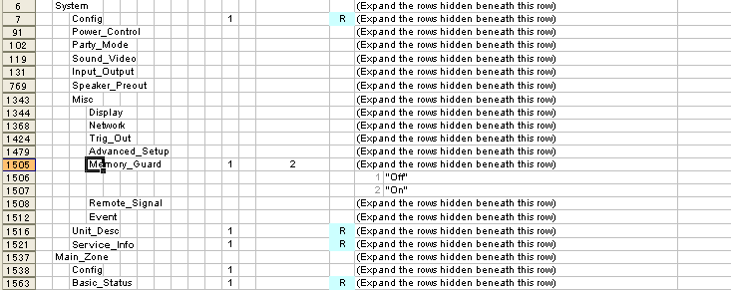

- You can still generate a Put command even if ‘1’ does not appear in the cell of the desired
node as long as ‘1’ is placed in the cell of the upper node.
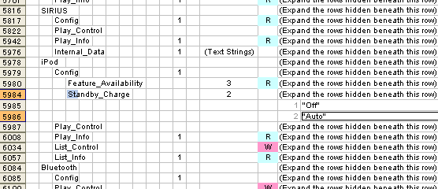

- Click on the ‘Ether button at the top of the spreadsheet, depending on whether you want a command of Ethernet communication. The command is also copied to the clipboard.
- Example of GET System-Misc-Memory_Guard
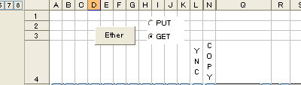
<YNC>
Here’s the file name when you select the GET command for
System-Misc-Memory_Guard:
GET_Ether-System-Misc-Memory_Guard.txt
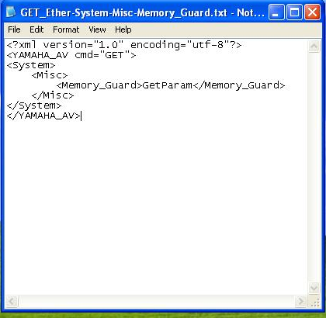
- Example of PUT System-Misc-Memory_Guard
<YNC>
Here’s the file name when you select the PUT command for
System-Misc-Memory_Guard:
PUT_ Ether-System-Misc-Memory_Guard.txt
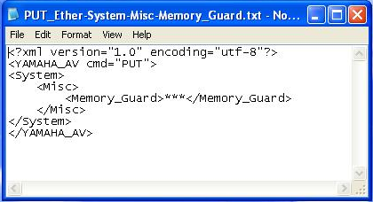
Replace *** for the actual parameter after generating the command. (Note 1)

Note 1)
The parameter to be replaced for *** varies, depending on the content of the column T in the Function Tree.
1. When the parameter is put in the parentheses of “”.
=> Directly specify the exact parameter you see in that column to replace for *** .
2. When the parameter starts with Min/Max.
=> 5 ways to specify the parameter. (m, M, and n shall be numerical values )
- Min/Max,m,M,n
=> Minimum=m, Maximum=M, and the number of Steps=n composed of numerical values.
- Min/Max,m,M,Hex
=> Minimum=m and Maximum=M composed of Hexadecimal values.
- Min/Max,m,M,Ascii
=> The minimum number of character strings=m and the maximum number of character strings=M composed of Ascii character strings.
- Min/Max,m,M,UTF-8
=> The minimum number of character strings=m and the maximum Number of character strings=M composed of UTF-8 character strings.
- Min/Max,m,M,Latin-1
=> The minimum number of character strings=m and the maximum number of character strings=M composed of Latin-1 character strings.
<<For your information>>
If you select a parameter along with a node from the Function Tree at the time of generating a PUT command, you can get a PUT command with the selected parameter already inserted in the output PUT command.
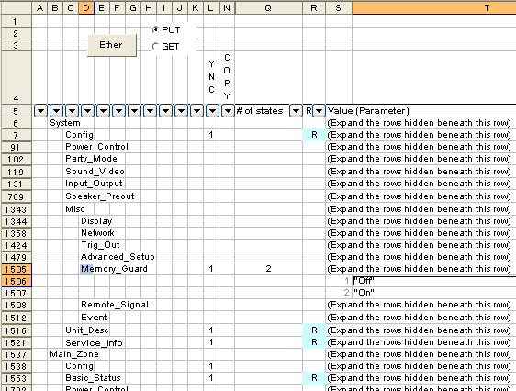

Look at the above Function Tree, select “Memory_Guard”(D1505) first and click “Off”(T1506) while you press Ctrl key, which allows you to select the two cells simultaneously. Then enter Ether button. You will get a command with the parameter of “Off”(T1506) already inserted in the command. This trick is valid only when the parameter in the column T is input in the parentheses of “”.

<?xml version="1.0" encoding="utf-8"?>
<YAMAHA_AV cmd="PUT">
<System>
<Misc>
<Mem_Guard>Off</Mem_Guard>
<Misc>
</System>
</YAMAHA_AV>

Cautions when you copy a node where ‘C’ appears in the column N.
Be careful when you generate a node where ‘C’ appears in the column N.
The tree below indicates that the alignment below Zone 3 is the same as Zone 2.

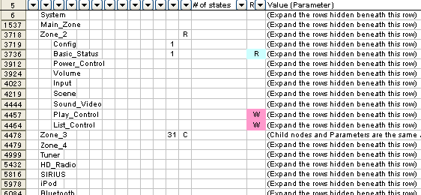

If you want to get the parameter status of Zone3-Basic_Status, you first need to generate a corresponding command from Zone 2. Then modify the command to fit it for Zone 3.
<YNC>
<?xml version="1.0" encoding="utf-8"?>
<YAMAHA_AV cmd="GET">
<Zone_3>
<Basic_Status>GetParam</Basic_Status>
</Zone_3>
</YAMAHA_AV>
GET_Ether-Zone_2-Basic_Status.txt
GET_Ether-Zone_3-Basic_Status.txt
<?xml version="1.0" encoding="utf-8"?>
<YAMAHA_AV cmd="GET">
<Zone_2>
<Basic_Status>GetParam</Basic_Status>
</Zone_2>
</YAMAHA_AV>

A list of commands
The various procedures of generating a command using the tool (Function Tree) are presented up to chapter 3.
In this chapter, as a reference, you will learn another way to generate a command with a list of commands instead of the tool.

What is a list of commands?
This is a list of all the commands necessary to control the AV device over YNC.
A list of commands is created in a text file so you can easily find the desired list of commands for the device you are looking for by applying the rule below to the file name.

YNC_Cmd_Samples ← Folder of YNC cmd samples
YNC_RX-A810_GET_x.txt ← All GET cmd list of each model
YNC_RX-A810_PUT_x.txt ← All PUT cmd list of each model
YNC_RX-A1010_GET_x.txt ← All GET cmd list of each model
YNC_RX-A1010_PUT_x.txt ← All PUT cmd list of each model
:
YNC_RX-A3010_GET_x.txt ← All GET cmd list of each model
YNC_RX-A3010_PUT_x.txt ← All PUT cmd list of each model

Note:
YNC_RX-A810_GET_L.txt
Region type (A,B,G,L,R,...U) ... Please disregard it.
YNC cmd type (PUT or GET)
Model Name (It is different according to the region.)

The contents of a list of commands
Such commands can be viewed when you open a list of commands in text editor.

YNC (Network)
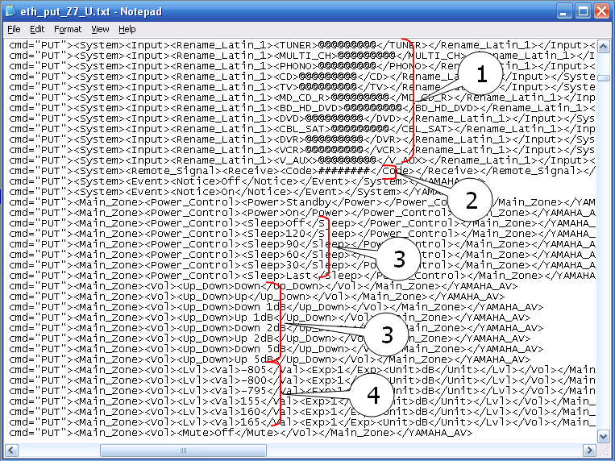

One command in each line and the commands are all laid out over the multiple lines in the same order as illustrated in the Function Tree.
You can copy a command to use but please be noted on the following points.

- In case that the parameter to be set (at the very right hand side of the node) in the PUT command was @ or #, replace it for an appropriate character string or numerical value.
For the section 1 in the above text file, replace @ for such a character as UTF-8.
The maximum number of the character strings or numerical values for the parameter shall be the same as that of @ in the text file.
See the Function Tree for the detailed information of the minimum number of character strings and string codes.
Apply the hexadecimal values (0-F) to # in the section 2.
The maximum number of the character strings for the parameter shall be the same as that of # in the text file.
See the Function Tree for the detailed information of the minimum number of character strings.
Example,
YNC (Network) :
<?xml version="1.0" encoding="utf-8"?>
<YAMAHA_AV cmd="PUT">
<System>
<Remote_Signal>
<Receive>
<Code>7A85FF00</Code>
</Receive>
</Remote_Signal>
</System>
</YAMAHA_AV>

Note : ‘7A85FF00’ is a command that specifies MuteOn/Off when the device is Z7.

- When several parameters exist for the same command like the section 3, it means that you are supposed to select one from them. But note that in the section 4, when the parameter is composed of numerical values only, possible parameters from the top three and bottom three are described in the text file. If you want to set a parameter belonging somewhere in the middle of the possible parameters, calculate the minimum and maximum values as well as the number of steps for your desired parameter.
- Look at the example in the above text file. The numerical values for Val are -805, -800, -795, ..., 155, 160, and 165 respectively. It tells us that the minimum value is -805, maximum value is 165, and the number of steps is 5. A command with the parameter -300 will be like this:

Example,
YNC (Network) :
<?xml version="1.0" encoding="utf-8"?>
<YAMAHA_AV cmd="PUT">
<Main_Zone>
<Volume>
<Lvl>
<Val>-300</Val>
<Exp>1</Exp>
<Unit>dB</Unit>
</Lvl>
</Volume>
</Main_Zone>
</YAMAHA_AV>

