Part 1: Unix Password cracking
I used a ParrotOS VM on my homelab and the provided Kali VM. Both ran john for a few days.
The left side has the usernames, and the right side has the passwords.

My ParrotOS:

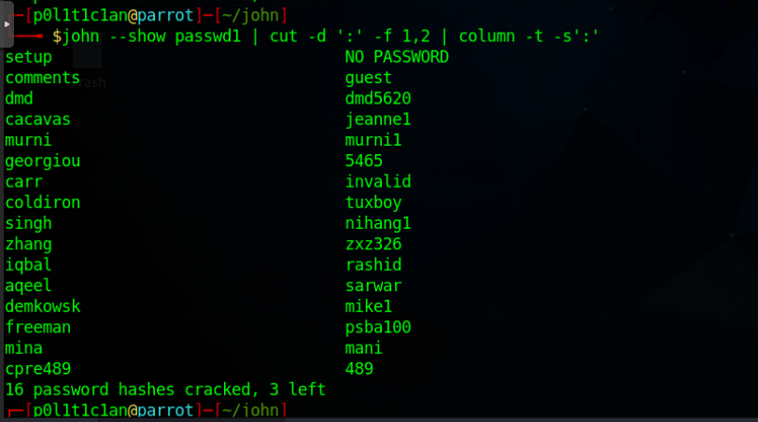

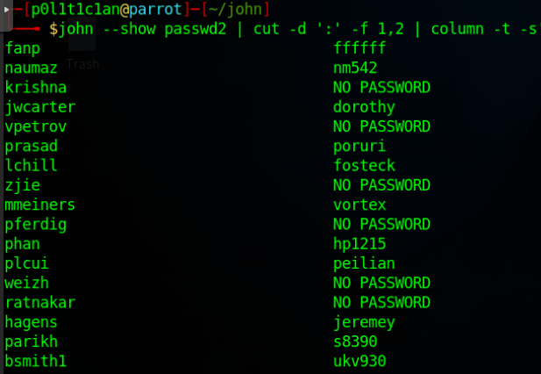
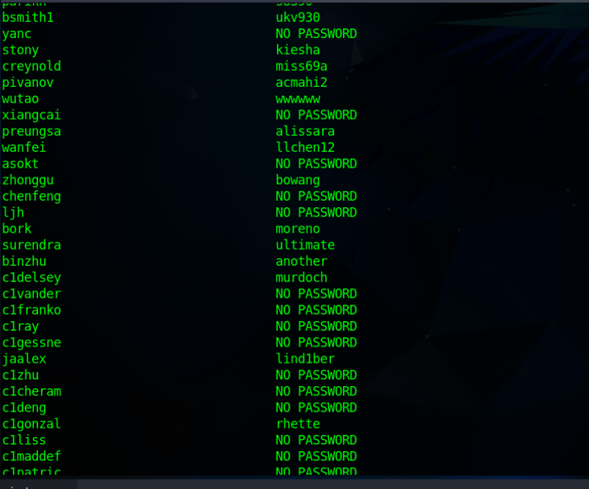

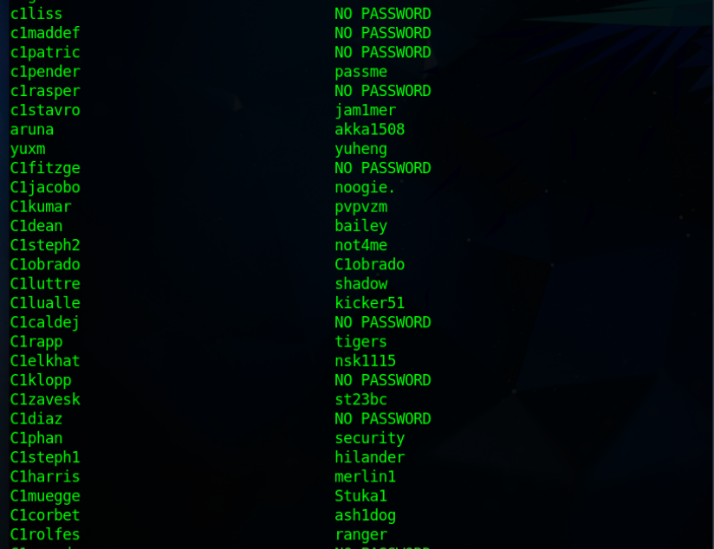
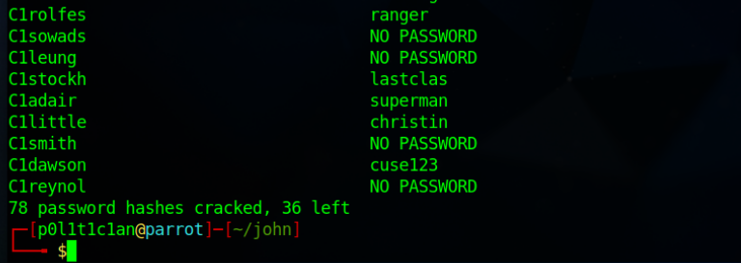

Kali:

It only found one more password, even though I let the Kali machine run for an extra day.

Username: kwhitake
Password: b1llet20

Part 2: XP Password cracking

I used ophcrack with the xp fast and small tables on my ParrotOS machine.

Screenshot of cracked passwords:

Usernames are on the far left and NT passwords are on the far right.

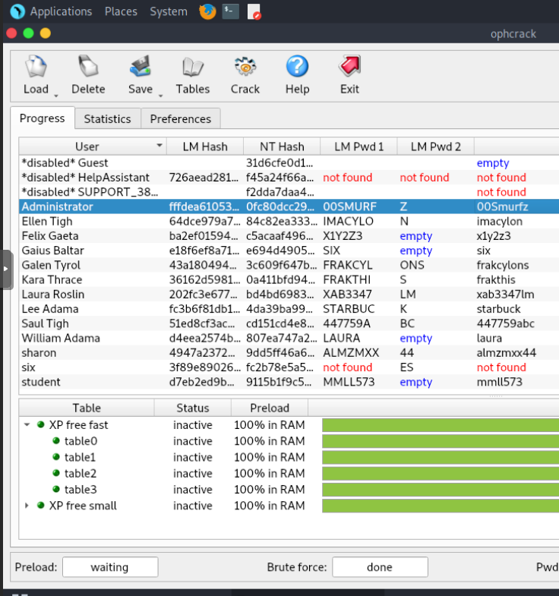

I could not find the passwords of the disabled accounts. As well, could not get the “six” account’s password but got the last 2 characters.

