Introduction

Device Fingerprinting Techniques In A World Of Untrustworthy Information: Final Paper
Jacob Boicken
Undergraduate Student of Iowa State University
jboicken@iastate.edu

Device or browser fingerprinting is a widely used way identify users across the internet and track their activity, which is generally used for advertising, tracking criminal activity, or preforming webpage analytics. However, fingerprints can also be used by a malicous web server to create a specific attack for the machine and browser that visit the site.
Now, many browsers come with features or are able to install plugins that minimize and modify the available information to fingerprint devices. This can be combined with network anonymization techniques such the use of TOR or a VPN to further reduce the amount of reliable information a web server receives to fingerprint a device.
With this ability for clients to create inconsistent fingerprints, this brings to question what is still consistent and cannot incorrectly reported or spoofed by a client device. To do this, I will be looking at the current methods for device fingerpriting. For each method, I will find countermeasures and defensive techniques discovered that make information unreliable or inconsistent for a single user. From this, we can determine what information/techniques can still be used against users who are trying to be anonymous.

Device Fingerprinting
According to [1], the goal of web tracking is to be able to identify the same user across multiple websites, without the need of them logging in. Device fingerprinting is a technique that is commonly utilized to preform web tracking by creating an identifier for the browser and machine that of a user. This is determined by information reported to the web server for usability [2].

Device Fingerprinting Technigues
From [2], a browser fingerprint is simply a set of information from a user’s device such as hardware and operating system information and browser configuration. This method does not store information on the browser. Rather, it collects a wide array of information and ties that to the user of the web session.

2.1.1. Basic Fingerprinting Fields

Table 1. Example of Browser Fingerprint comes from [2] and according to the paper the table “provides a full example of the main attributes collected in the browser fingerprint”. These fields come from 2 sources the HTTP header sent by the browser when requesting a web page and javascript reporting the features of the browser.

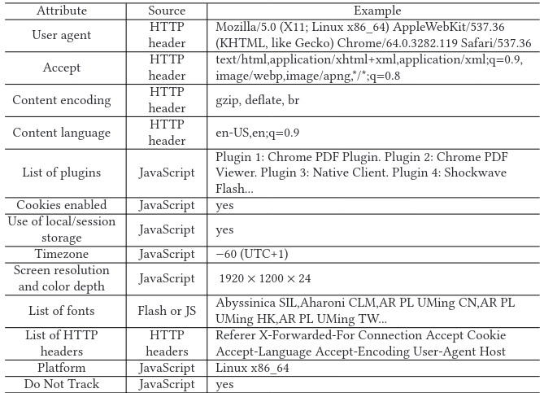Table 1. Example of Browser Fringerprint [2]

Based on where the source of the information or how the information is retrieved, we call the fingerprinting passive, as with HTML headers, or active, as with running javascript on the users browser [3]. Passive fingerprinting doesn’t go beyond the

2.1.2. HTML Canvas API

2.1.3. WebGL API

2.1.3. AudioContext

2.1.4. Browser Extensions

2.1.5. CSS Querying

Downfalls Of Tracking Methods
Below are why the methods I researched may only partially be use or not at all for testing:

IP Based Tracking
From [1], tracking based upon the IP address of the client is unreliable for multiple reasons. Many users may be behind a single or multiple NAT devices making them all have the same IP to the server. Additionally, the user could use a VPN or TOR anonymization system to mask their actual IP address and exit from the VPN provider or TOR network.

Browser Fingerprinting
From [5], there are many countermeasures to the browser fingerprinting techniques that makes many values unusable or unobtainable to a web server. Users can disable javascript, disable html5 canvas, limit colors and fonts, and disable plugins. These limit the amount of information that can be obtained about the device but also create a some level of uniqueness as not many people implement this as it is a sacrifice to usability. So there are still some fields that can be used to fingerprinting a device and attempts to prevent fingerprinting can be used to identify a user as well.

Persistent Storage
From [5], much of the issue with permanent or storage based tracking solutions is that the user has the ability to control them. They can remove the data that is put on their browser or utilize extensions to prevent the data from being stored at all. This mean that for an ignorant user cookies and other storage methods may be viable as a way to track them but not for knowledgeable users.
From [4], the major issue with this method is that you have to be redirected from one page to the next for each favicon. This method is easily noticeable for the end user. So the user would be able to tell they are being tracked and be inconvenienced trying to access the web page. This makes this method impractical to utilize because of this overhead.

References
[1] N. Vlajic, P. Madani, and E. Nguyen, “Anonymity of TOR Users Demystified,” in 2017 International Conference on Computational Science and Computational Intelligence (CSCI), 2017, pp. 109–114. doi: 10.1109/CSCI.2017.18.
[2] P. Laperdrix, N. Bielova, B. Baudry, and G. Avoine, “Browser Fingerprinting: A Survey,” ACM transactions on the web, vol. 14, no. 2, pp. 1–33, 2020.
[3] Nasser Mohammed Al-Fannah and C. Mitchell, "Too little too late: can we control browser fingerprinting?" Journal of Intellectual Capital, vol. 21, (2), pp. 165-180, 2020. Available: https://www.proquest.com/scholarly-journals/too-little-late-can-we-control-browser/docview/2499028130/se-2. DOI: https://doi.org/10.1108/JIC-04-2019-0067.

