  - In cipher block chaining, why does an error in a ciphertext block only effect 2 resulting plaintext blocks?
    - 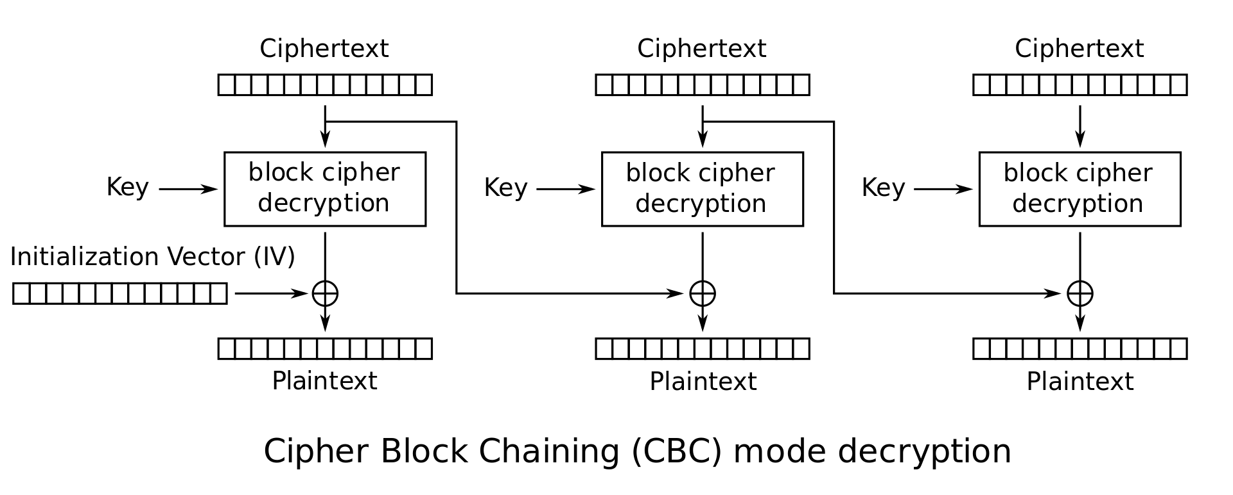
    - Picture above is CBC decryption from http://en.wikipedia.org/wiki/Block_cipher_mode_of_operation
    - One block of ciphertext is only used in two places during decryption. The first is decyrpting using the block cipher with the key and, the other, xoring the ciphertext with the next block’s output from the block cipher. So any number of bits incorrectly modified in one block of ciphertext only modifies two blocks of plaintext, its own and the next block.

  - Consider CTR mode (see: http://en.wikipedia.org/wiki/Block_cipher_mode_of_operation). What happens when a pair of users reuse the same nonce (or IV) for 2 separate sessions? (Assume they are using the same encryption key for all sessions.) How does this allow for an attack by an eavesdropper?

    - In counter mode, the IV is put through the block cipher with the key and then XORed with a block of plaintext. Then repeated, incrementing the IV. Reusing the IV and key means that the plaintext for all blocks is xored with the exact same bits.
    - An attacker can then, as with the OTP, XOR the ciphertexts together for the length of the shorter message. They then have the plaintext of both messages XORed together. The attacker can then see where the messages match or if there are a string of zeros in one message the other message will leak completely. As well, if the attack knows the format of one message like an email that can reveal the information of the other message by xoring the known plaintext.

  - If I can encrypt or decrypt 10^13 AES blocks per second (each with different keys), how many years would it take me to find a key that decrypts a block of ciphertext given known plaintext(using 128 bit keys)? Is the 10^13 encryptions per second reasonable for an attacker?

    - 2^128 possible keys / 10^13 decryptions per second (trying a different key per decrypt)
      - 34028236692093846346337460 seconds
      - 567137278201564105772291 minutes
      - 9452287970026068429538 hours
      - 393845332084419517897 days
      - 1079028307080601418 years
      - That is a guarantee that you find the key. It is almost certain that you would find it before going through every key.
      - This in not practical at all. This isn’t before the sun explodes.
    - 10^13 encryptions goes through 128 bits or 16 bytes per encryption
      - That is 160000 GB or 160 TB per second encrypted
      - That’s definitely not reasonable
      - In comparison, I checked wikipedia for AES preforamce: https://en.wikipedia.org/wiki/Advanced_Encryption_Standard#Performance
      - “On Intel Core and AMD Ryzen CPUs ... throughput can be multiple GiB/s (even over 15GiB/s on an i7-12700k).”
        - Modern CPUs can only get 10s of gibibytes a second in comparison to hundreds of thousands

  - Let's now assume that AES is broken in the sense that we can exclude 2^40 of the keys from our search. How many years are required? Is this a practical break of the algorithm or not?

    - On (2^128 - 2^40) keys / 10^13
      - Its still just 34028236692093846346337460 seconds and 1079028307080601418 years
      - 2^40 keys not mattering is negligible as they are done in a tenth of a second
        - Only, 1099511627776
      - So its still not practical. Way past the sun exploding.

- Given a proposed hash function, f, which breaks a message into a sequence of 256 bit blocks and then exclusive ors those blocks to create a 256 bit output. Would this be a good hash function? Why or why not? Justify by using two of the properties of good hash functions.

    - This is very bad hash function as the hash can be reused as the message itself or with a repeated sequence (in an even number of blocks) as they will cancel out in the xor. That input would then get the same hash value as the original message.
      - Concept: h(m) xor 1010... xor 1010.. == h(m)
      - With just h(m), no xor even occurs as it is 256 bits long
      - This also means the hash of a message that is up to 256 bits is just the message
    - This breaks each resistance property.
      - In Preimage, we know h(m) and need to find m’, and can just pass h(m) as m’ to get the same h(m’) == h(m)
      - In Second Preimage, we know m and sub-sequentially h(m) and need to find a different m’. Again can just use h(m) as m’ and get m != m’ and h(m) == h(m’)
      - In Collision Resistance, we get to pick m and m’ and can just set m to anything and m’ to h(m), then we get a matching h(m) == h(m’)

- Given a 128-bit Key, K, and two 128 bit messages, M1 and M2, where M1 and M2 differ only in their first bit.
  - If we encrypt both M1 and M2 with K using AES-128, to get C1 and C2 for ciphertexts, how similar will C1 and C2 appear?
    - In one round,
      - In the first round, we xor the initial key with plaintext message so only the first bit is different still
      - Then in the S-box step, we switch each byte out by a lookup table so the one bit difference makes the first byte completely different
      - In the Shift row step, we do not modify the top row so only the first byte is different
      - In mix column, the bits of the first byte spread across the bits of the entire first column so bytes 1, 5, 9, and 13 are different.
      - Then, xor with the next key. This is generated from the initial key given so both use the same key. (No change.)
    - The C1 and C2 are just changed in the 1, 5, 9 and 13th bytes. So the first byte is different then the next 3 are the same and repeat.

  - Given that this first byte will be in the upper left corner of state matrix, How many rounds in AES will be required before all bytes of the state matrix could be effected?
    - Continuing from the one round before (now second round)
      - The next sbox lookup only changes the bytes that are already different
      - The Shift row, then makes sure that one column has a byte originally from each other column but still only 4 bytes are different
      - Then each column now contains a changed byte, so the mix column step spreads the changed bytes among ever byte in the column.
      - Each of the bytes in the message have now been affected in 2 rounds
        - Only so many bits have been though (another round fixes that, I believe)

