1. (1 points) Please find all the apps installed and recently used on Betty’s phone.

All of the installed apps on the android phone that aren’t part of the base system operations are stored under /data/app so below is an image of said directory:

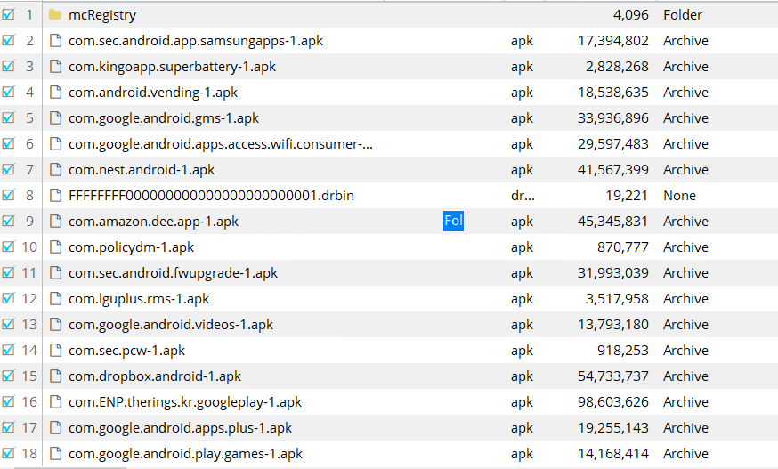

In /data/system, I found ./usagestats/ which contained usage-history.xml and usage file for each day 07/12 – 07/17. From this, I found one application that was run by itself being a com.android.systemui.recent.RecentActivity (which shows the recently used apps). I searched the command and found /data/data/com.samsung.android.providers.context/databases/ContextLog_0.db
This file contained many tables containing a mangae_app table and use_app table.

use_app containing the times when an application was used:
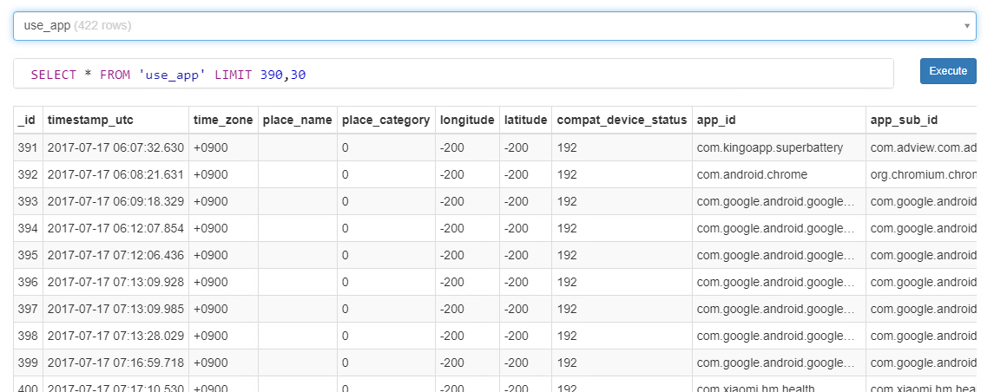

manage_app containing the timestamp for what I think is when the app was install or updated as it says installed_app_id
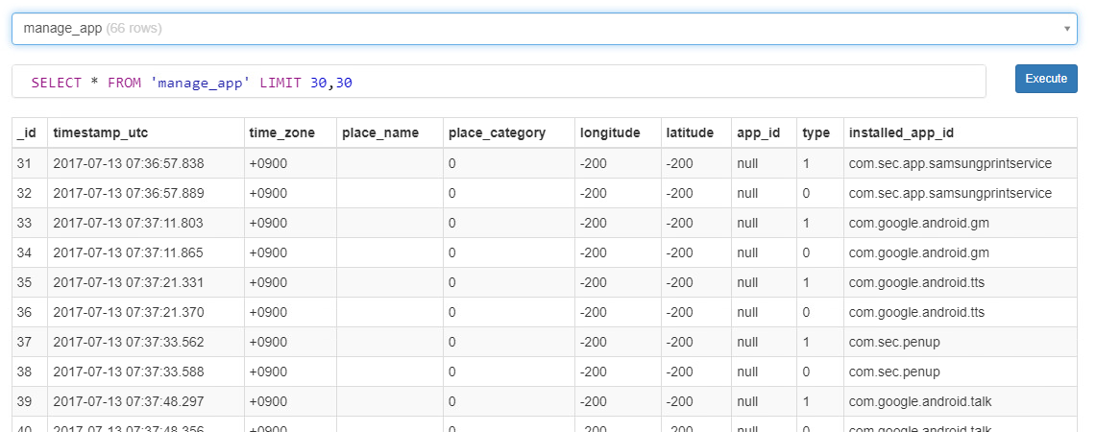
2. (1 points) Please find the browsing history of websites and videos.

From the phone image entitled data, I found the data stored on the all applications of the phone under /data/data/{application identifier}. I searched this data/data directory for the word history and found the a History file stored in data/data/com.android.chrome/app_chrome/Default/History.
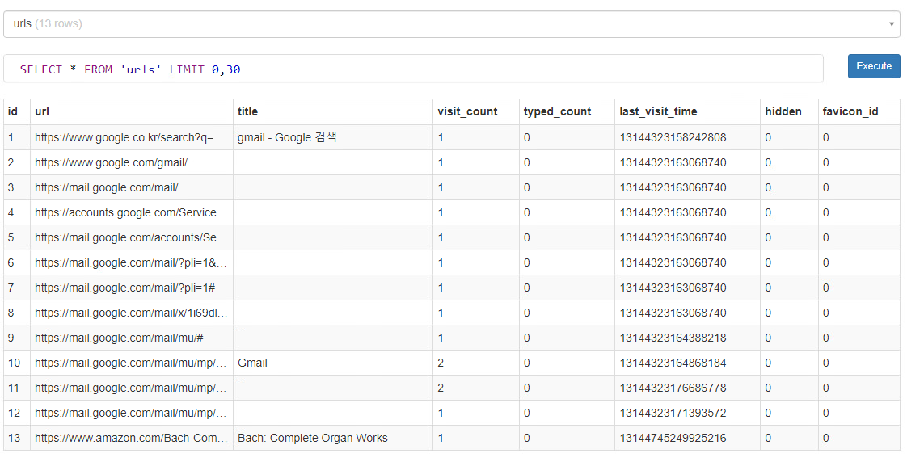

To find the video history, I searched in the chrome data directory and found a 000003.log data file under NTPSnippets. It contains a log of additional sites visited including many youtube sites with title of the webpage/video.

000003.log
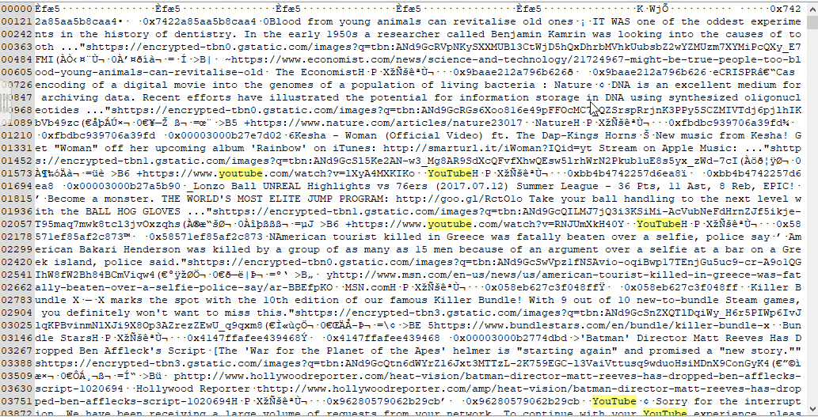
3. (2 points) Please find the chat history and emails.

I searched keywords FROM: and found databases in data/data/com.google.android.gm/databases.
I downloaded and viewed mailstore.betyhallym@gmail.com.db sqlite database. It contains messages, ads, and conversations tables.

Messages
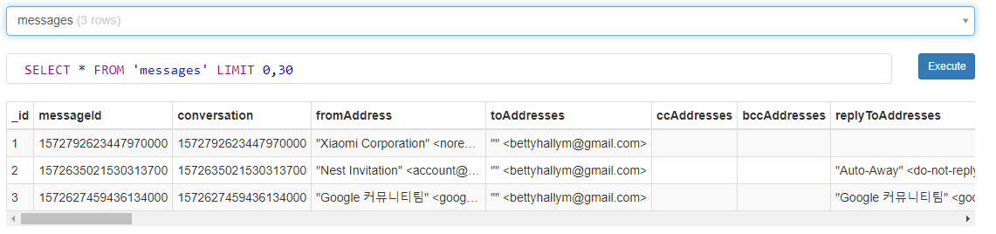

Ads
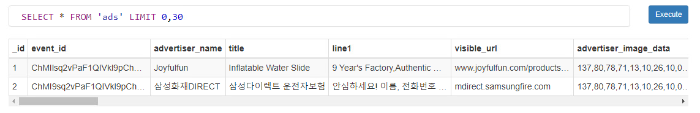

Conversations
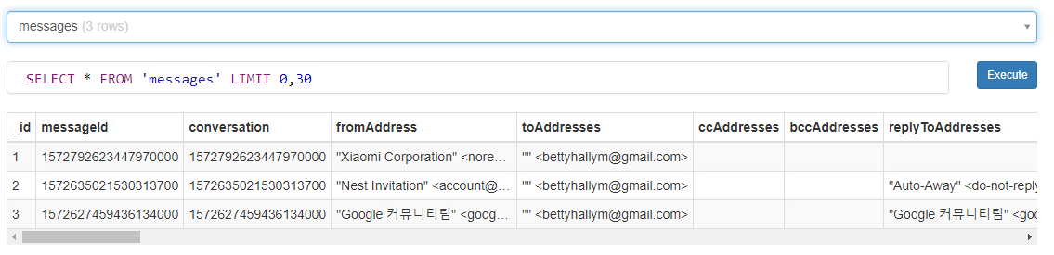

Looking for text chat history. I could not find any logs. I looked up where the text database is stored and found it is that located at /data/data/com.android.providers.telephony/databases/mmssms.db. In the database, all tables were empty except a metadata one just saying that it is en_US locale.

Empty tables:
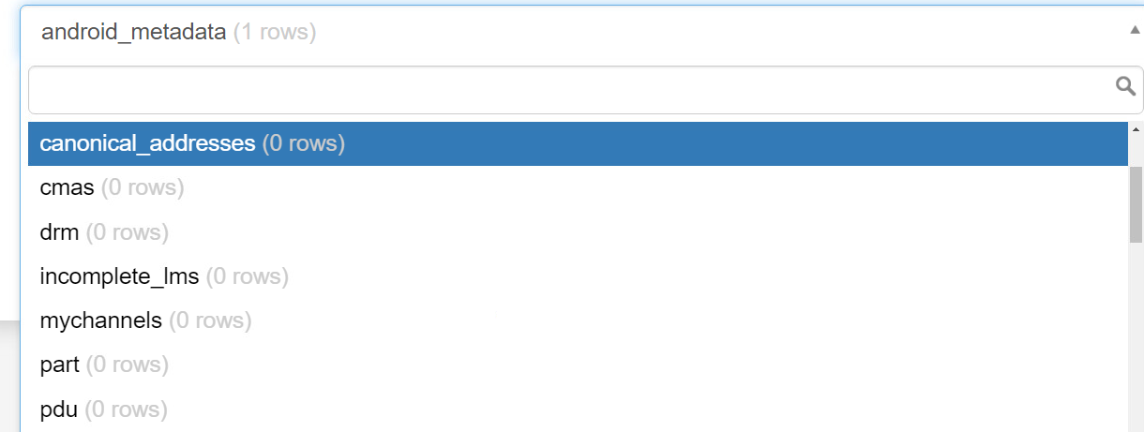
The empty sms table in database:
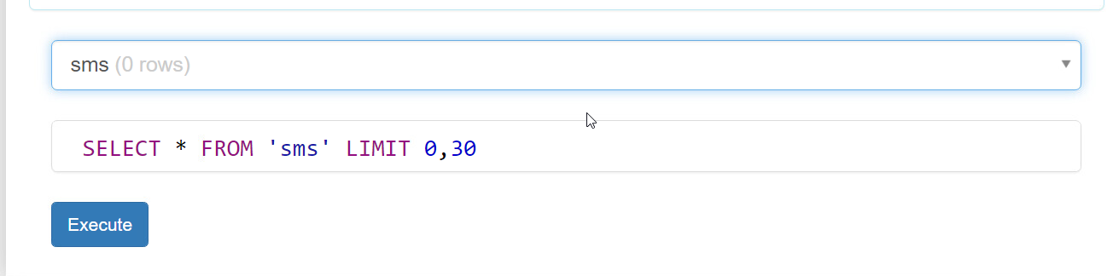

I then searched for phone numbers using grep and found none in Encase. And then, looked to see if the phone had any contacts and found none in /data/data/com.android.providers.contacts/databases/contacts2.db.

Empty phone numbers:
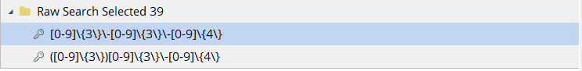
4. (2 points) Please find the history of usage between smartphone and wearable device.

From the email history, I found that the victim had set up Mi account with the company Xiaomi. I searched for Xiaomi and found a directory /data/data/com.xiaomi.hm.health. I searched this and found a ./database/origin_db_### file and ./files/mili_log.txt file. From the database file, I found many tables that showed activity tracking, heart rate, and other tables that show that this is for a fitness watch. As well, I found a device table that shows the bluetooth address for the watch confirming that. Some information on the wearables usage was found within a date_data table that shows daily distances.

date_data:
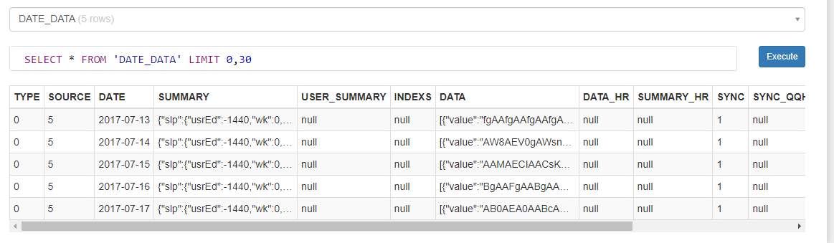

From the mili_log.txt file, I viewed the file in a text editor and searched for the bluetooth hw address in the log. I found the bluetooth communications between the watch and smartphone throughout many days.

Images of communications in the log file:
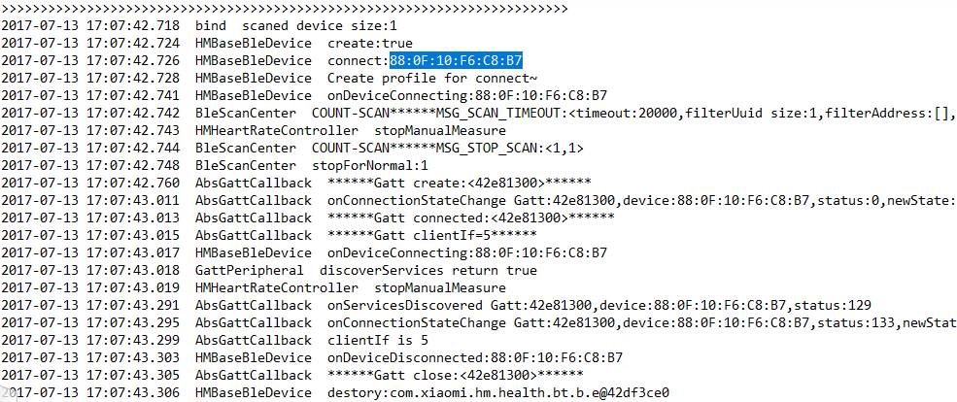

Raw communications:
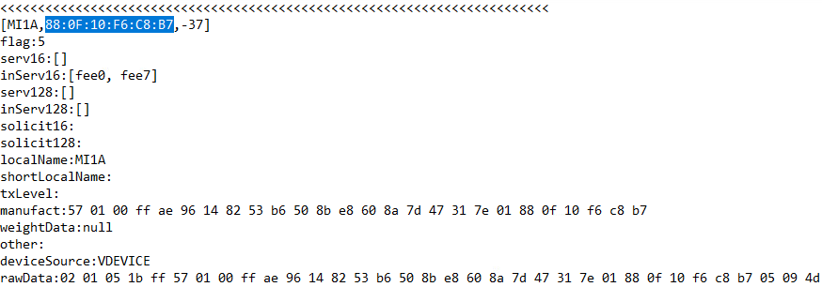

Later day communications:
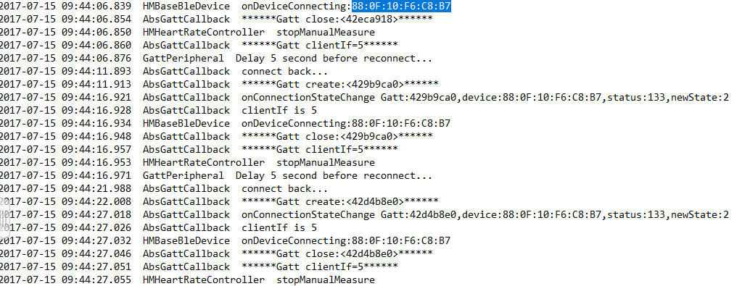
5. (2 points) Please find the timestamp when Amazon Echo is called by voice command “Wake
up”.

The time stamp is 1500270331742. I got by searching the Alexa web scrape zip file. I looked into each json file in the initial directory. And in the 13.json file I found the summary say “wake up” finding the timestamp.

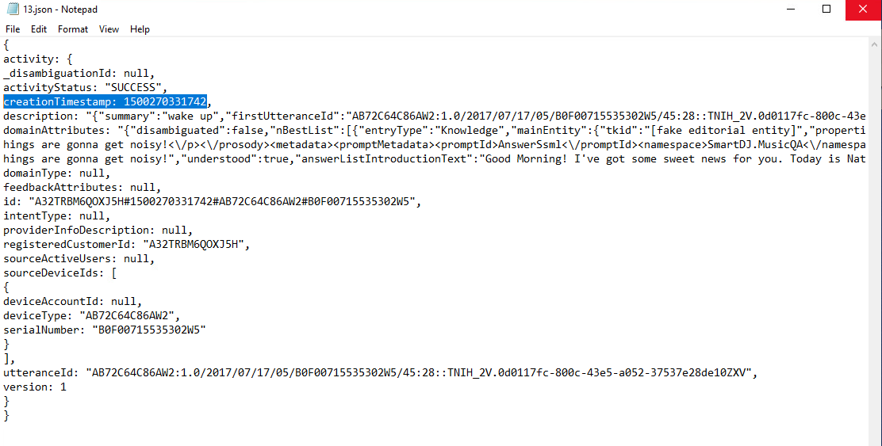
6. (1 points) Please find the IP address from Google OnHub diagnostic-report.

The WAN IP is 192.168.165.9 and internal LAN IPs for main and guest networks are 192.168.86.1 and 192.168.87.1.

I got the IP from reading the diagnostic report in notepad and searching for wan and looked through the man instances that it appears. I then found the output of an ip addr command which show both sides wan and lan IP addresses.

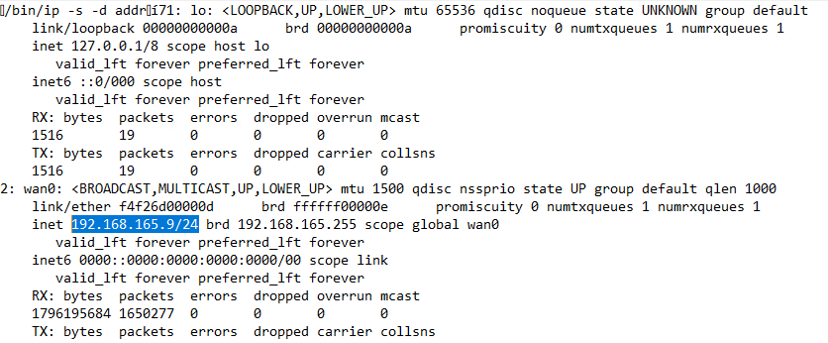
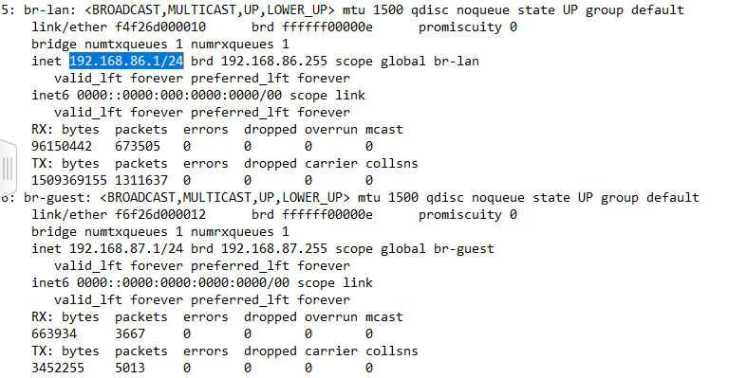

7. (1 points) Please build up Betty’s activity from these devices.

From the context_0.log file I found before, I think Betty installs the kingoapp superbattery, google nest, and amazon apps on the 12th. Then on the 13th installs the Xiaomi health app for her Mi Fit. And then on the 15th she installs a com.ENP.therings.kr.googleplay app which seems to be korean MMO game.

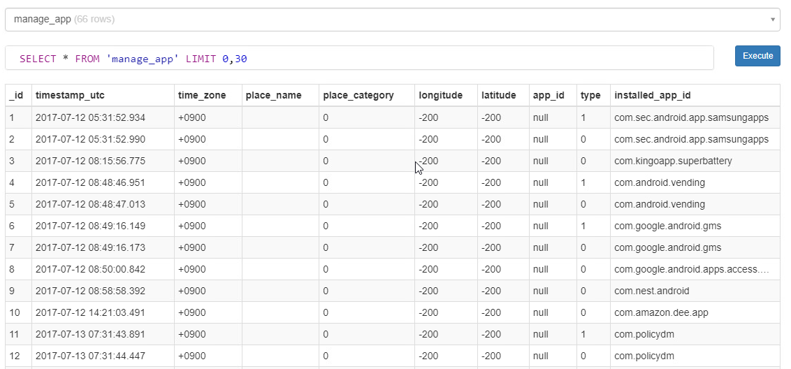

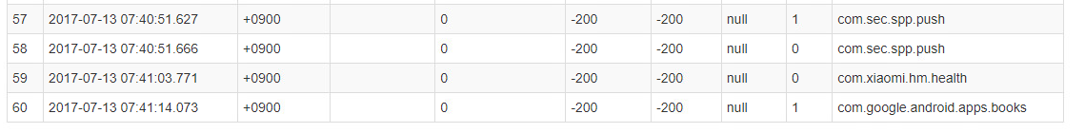

Betty’s web history – I can see that she visited google, gmail, and amazon.

From this stackoverflow post, https://stackoverflow.com/questions/20458406/what-is-the-format-of-chromes-timestamps, I learned that the last_visit_time is microseconds since Jan 1, 1601.

For the top timestamp, you do (13144323158242808 / 1000000) - 11644473600 and get 1499849558. Converting to the unix epoch and get:

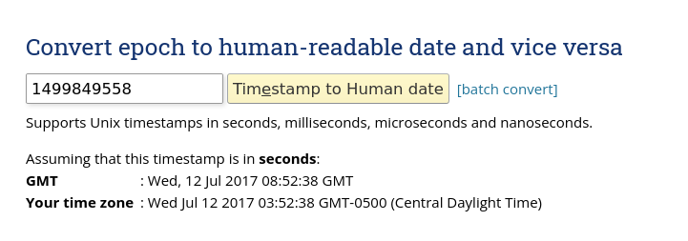

The bottom timestamp is:

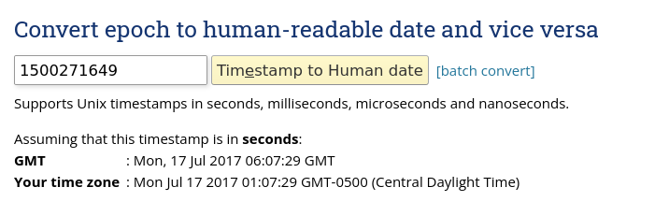

(For both we add 9 hours to the GMT. The bottom is 15:07:29. 20 minutes before the crime is reported.)
From the Mi Fit application log (mili_log.txt), Betty seems to register her account for the app on the 13th the login status changes from UNINIT to NEW. Then, on the next days it goes to OLD

Uninit:
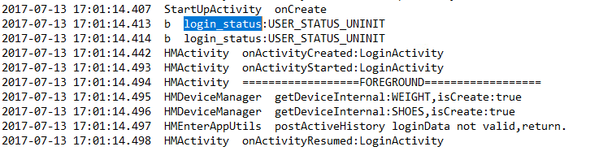

New:
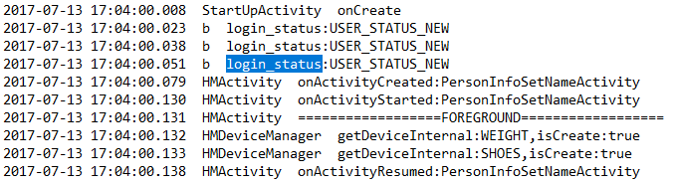

Old:
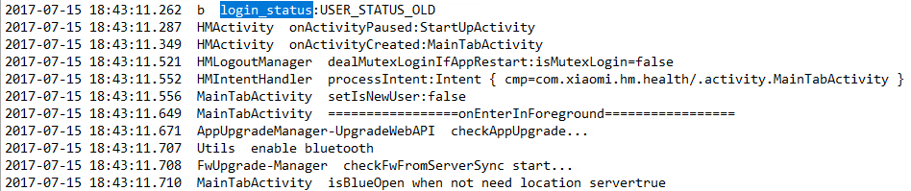

An hour before the crime is reported, we see her record/sync her weight and other information from the app:

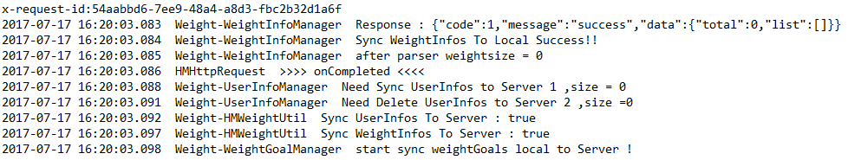

As well, we can see no walking activity from the Mi Fit as that ends at 2:20 that day in the log.
