1. (1 point) Who is James Cooper's supplier of marijuana?
Answer: Emma White

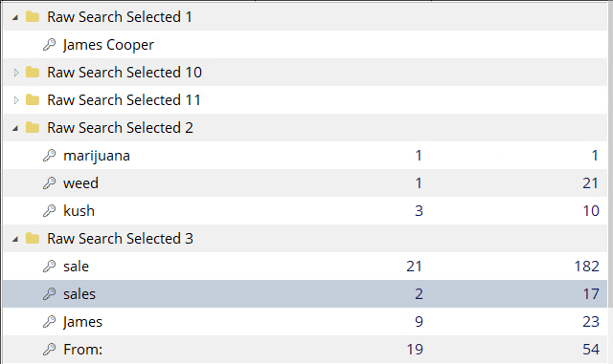

After loading the provided image as evidence, I ran a few searches looking for an email or information about weed in many names. Then, looked up the word sales or for an email saying From. I got an interesting hit with the word sales finding a hello_world.zip file.

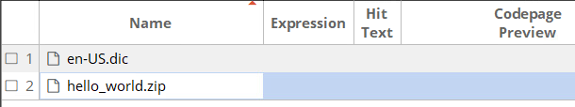

I download the file from encase to the VM and unzipped the file. I found a hello.eml and Sales.xls. I opened the email with notepad and found “Emma White” in the to section of the email and Emma is address at the beginning of the message.
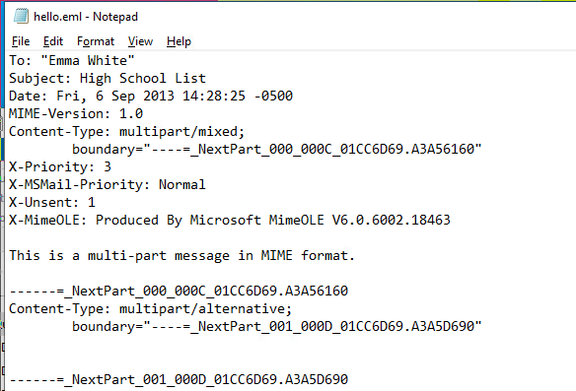

2. (2 points) What is the address of the supplier?
I know that the sales.xls file I have found in the previous steps is password protected. So I started looking for passwords to open the file. I made the following two searches:

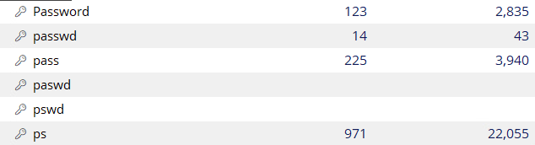

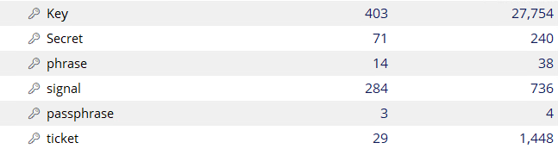

From this I found a password with the “secret” search I did. It is stored with a Constants.java file as a comment shown below where is says “the secret is”:

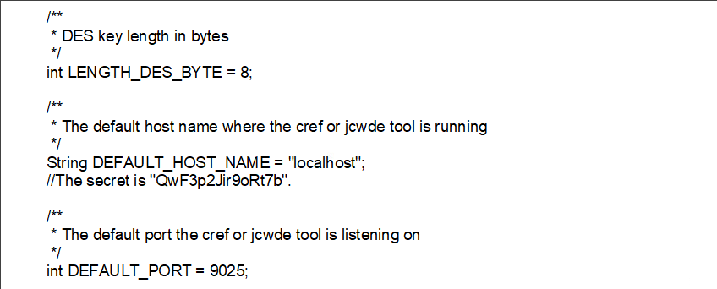

This password did not work with sales.xls file that I found. So I did a filter for password protected files to see find a file that this password works with. I found the following files and downloaded them to the VM:

How I filtered the evidence in encase: Results:
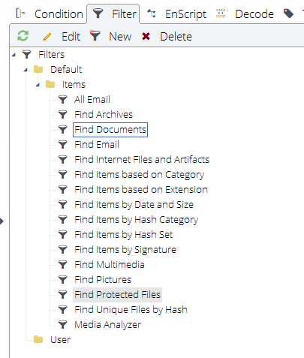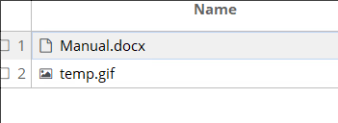

I used the password I found in the Constants.java file when opening the manual.docx file, and it worked to decrypt the file. The contents show Emma White’s address:

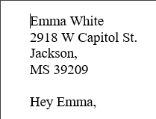

3. (1 point) When was the email sent to the supplier?
Answer: 2013 September 6th

From the email I found in question one, it shows that James emailed Emma in the Date section of the email.

4. (2 points) What is the full list of High Schools that James Cooper sells at?

I still do not have the password for the sales.xls file I found during question 1. However, from question 2’s steps, I found out the format that the passwords are stored it says “the secret is XX”.
So I did a search looking for more passwords in similar formats to:

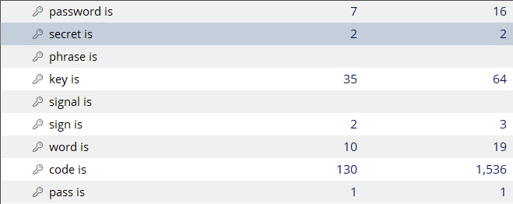

I found 2 more passwords easily with another one in the “secret is” search and one in the “pass is” search:

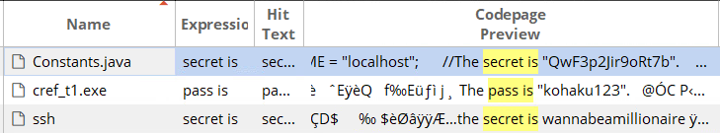

I tried the first password kohaku123 on the sales.xls file and it worked to decrypt the file. In the sales.xls, I found the list of schools:

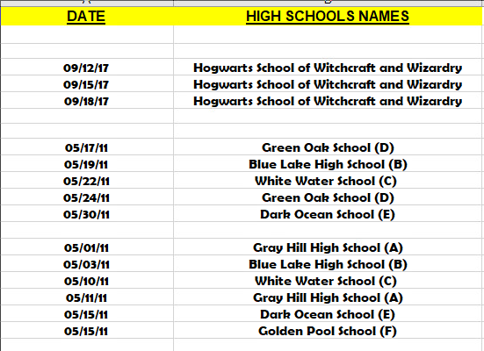
5. (1 point) Can you find the cover of High Times magazine?

I started looking by creating searches for jpg and pngs using the magic numbers for each. Then, looked through the results of the jpgs for files with a different file extension. I ignored pdfs for now as they can embed jpgs into them and would contain the magic number.

Search:
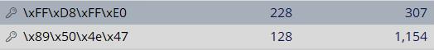

Results(first mismatch):
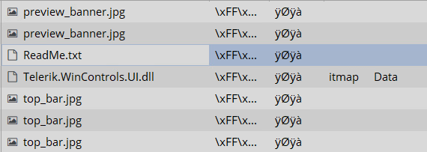

The first mismatch I found was a readme.txt file. I downloaded it to the VM and converted its extension to be a jpg. It turned out to be the High Times cover.



6. (1 point) Can you find out the supplier's photo?

From the Manual.docx file I found in question 2, it says the following:
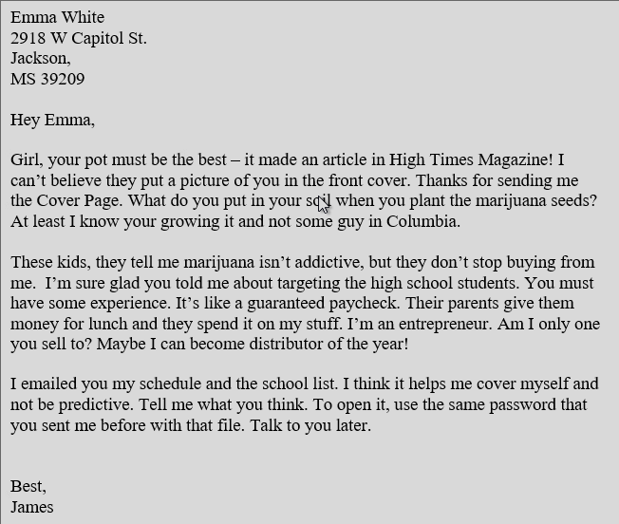

Most important of what is said is: “I can’t believe they put a picture of you in the front cover.” This means that the woman in the bottom left hand corner of the cover I found in question 5 is Emma White the supplier:

7. (2 point) Can you find out and show James Cooper's photo?

I looking for this photo by updating my search for james cooper to include jcooper and jamescooper (without a space):

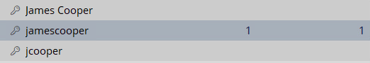

In this search I found got a hit with in a photo koala.jpg, I downloaded this photo to the VM.

When looking at the file, I noticed a little before that file name of JamesCooper.jpg that it says “Rar!”. I suspected this to be the magic number for a rar file that is appended to the koala.jpg image. Looking it up online, I was correct.

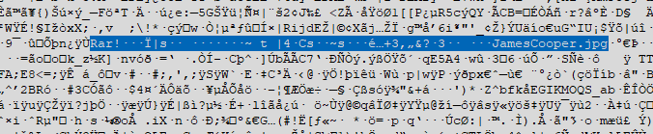

I then downloaded 7zip and opened the downloaded koala.jpg using 7zip. It found the embedded rar file and extracted the JamesCooper.jpg shown below:

