1. (1 point) Who is James Cooper's supplier of marijuana?
Answer: Emma White

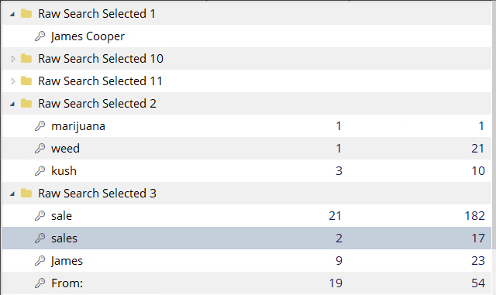

After loading the provided image as evidence, I ran a few searches looking for an email or information about weed in many names. Then, looked up the word sales or for an email saying From. I got an interesting hit with the word sales finding a hello_world.zip file.

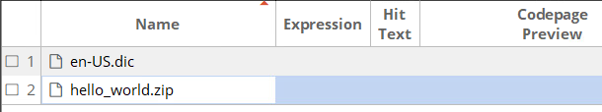

I download the file from encase to the VM and unzipped the file. I found a hello.eml and Sales.xls. I opened the email with notepad and found “Emma White” in the to section of the email and Emma is address at the beginning of the message.
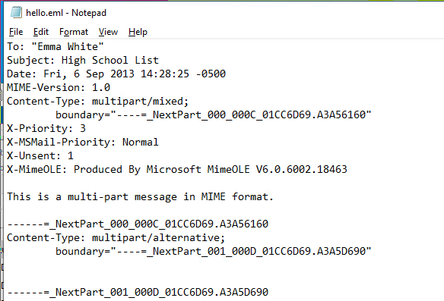

2. (2 points) What is the address of the supplier?
I know that the sales.xls file I have found in the previous steps is password protected. So I started looking for passwords to open the file. I made the following two searches:

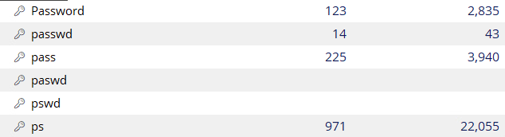

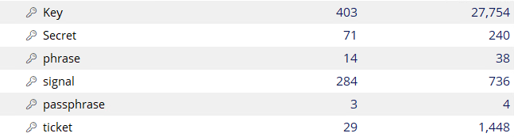

From this I found a password with the “secret” search I did. It is stored with a Constants.java file as a comment shown below where is says “the secret is”:

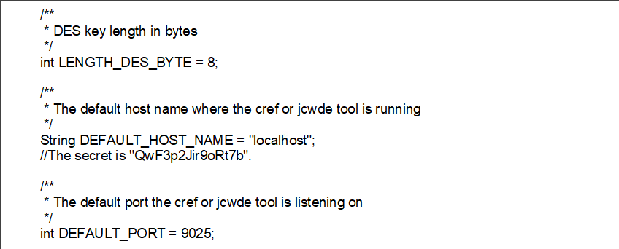

This password did not work with sales.xls file that I found. So I did a filter for password protected files to see find a file that this password works with. I found the following files and downloaded them to the VM:

How I filtered the evidence in encase: Results:
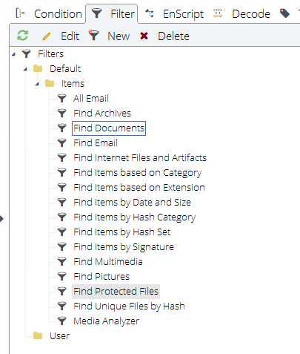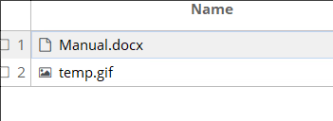

I used the password I found in the Constants.java file on the manual.docx file and it worked to decrypted the file. The contents show Emma White’s address:

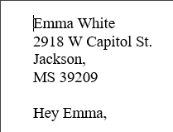

3. (1 point) When was the email sent to the supplier?
Answer: 2013 September 6th

From the email I found in question one, it shows that James emailed Emma in the Date section of the email.

4. (2 points) What is the full list of High Schools that James Cooper sells at?

I still do not have the password for the sales.xls file I found during question 1. However, from question 2’s steps, I found out the format that the passwords are stored it says “the secret is XX”.
So I did a search looking for more passwords in similar formats to:

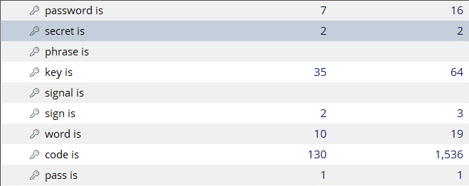

I found 2 more passwords easily with another one in the “secret is” search and one in the “pass is” search:

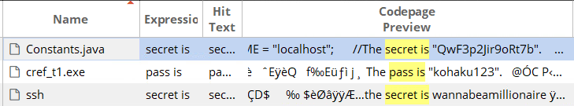

I tried the first password kohaku123 on the sales.xls file and it worked to decrypt the file. In the sales.xls, I found the list of schools:

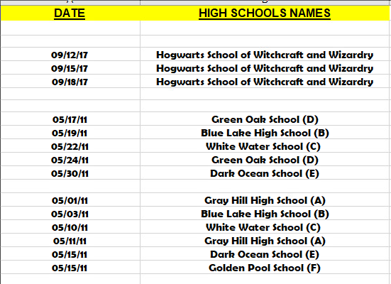
5. (1 point) Can you find the cover of High Times magazine?

6. (1 point) Can you find out the supplier's photo?
7. (2 point) Can you find out and show James Cooper's photo?

