1.) Applications can be roughly classified into two types based on I/O pattern: sequential and random. Which type of applications tend to have better I/O performance on hard disk drives? Why?

Sequential patterns have better performance on HDDs, because it reduces the distance the disk needs to spin to seek the next sector from the previous sector that was loaded. This is because when data is loaded sequentially, the sector that is loaded next is physically next the previous one reducing seek time. In random, the sectors aren’t likely to be next to each other, so it has a higher seek time.

2.) The figure above shows the basic workflow of paging with TLB. Assume the TLB hit ratio is R, which means the percentage of times that a page reference is found in the TLB. Also, assume the latency of memory access is L. Calculate the Effective Access Time (EAT) using R and L.

EAT = R * L + (1-R) * 2L

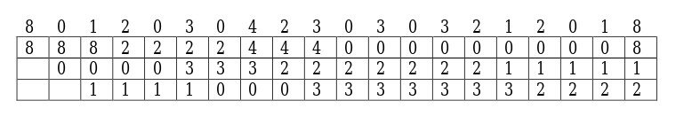

X X X X X X X X X X X X X

3.)
a.) Based on the memory content above, how many page faults are there for the given reference string?
13 faults

b.) Which page-replacement algorithm is used in the system?
FIFO

c.)
8 0 1 2 0 3 0 4 2 3 0 3 0 3 2 1 2 0 1 8
8 | 8 | 8 | 8 | 8 | 3 | 3 | 3 | 3 | 3 | 3 | 3 | 3 | 3 | 3 | 3 | 3 | 3 | 3 | 8
 | 0 | 0 | 0 | 0 | 0 | 0 | 0 | 0 | 0 | 0 | 0 | 0 | 0 | 0 | 0 | 0 | 0 | 0 | 0
 |  | 1 | 1 | 1 | 1 | 1 | 4 | 4 | 4 | 4 | 4 | 4 | 4 | 4 | 1 | 1 | 1 | 1 | 1
 |  |  | 2 | 2 | 2 | 2 | 2 | 2 | 2 | 2 | 2 | 2 | 2 | 2 | 2 | 2 | 2 | 2 | 2

