A. (5 points) The suspect kept 5 figures which are the envelope labels that contain the
contact information. Please find as many figures as you can.

For two of the images of envelopes, I found them by doing a search for jpeg magic numbers along with the filter of “actual files” and looking through the results manually. I found the following envelopes:

Disk/[root/]Disk/bin/gzip
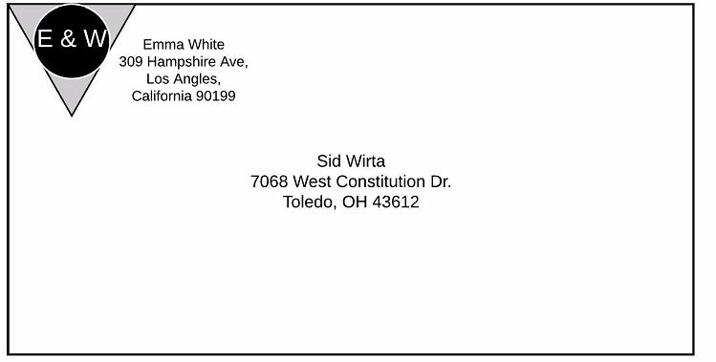

Disk/[root]/Disk/lost+found/found/win32/graphicssystems/ps_done.jpeg
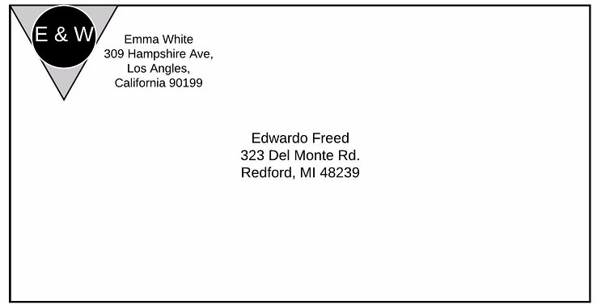

I then filtered for png magic number and got thousands hits but many were in ui jar files or qt dll files. So I looked through the files with one hit and found the follow envelope:

Disk/[root/]Disk/lib/security/hello.png
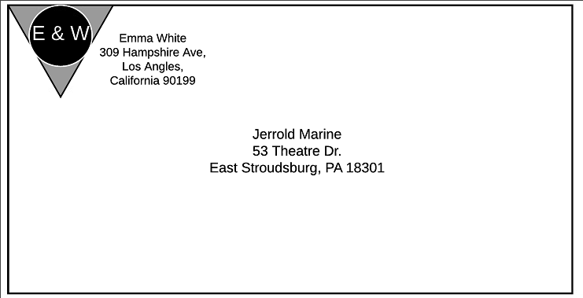

I then filtered for Rar magic number and found mypuppy2.7z. This had a puppy0.jpeg file stored in it.
This contained an envelope below:

Disk/[root]/Disk/usr/others/mypuppy2.7z/puppy0.jpeg
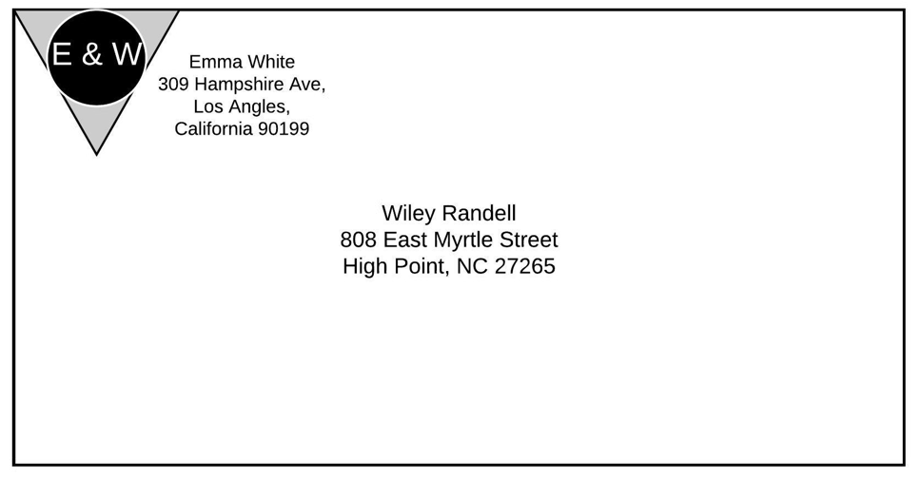

I could not find the last missing envelope. What I did find was 2 other files, which I suspected contained the last envelope that were encrypted
Disk/[root]/Disk/usr/others/mypuppy.gz and Disk/[root]/Disk/lib/modules/2.2.14-5.0/net/others/white.zip, which contains a white.bmp
I found an email using the email tab at the top of FTK. The movie.eml said the following:

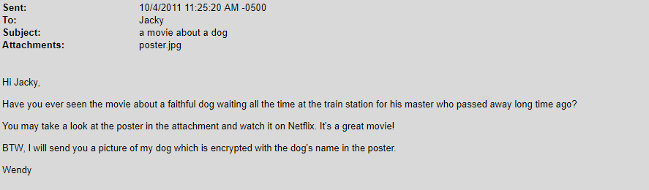

The message has a poster for the hachi movie from 2009. I tried the password hachi and then HACHI on the mypuppy.gz’s contents. The second all caps password decrypted another zip file inside it. This contained a mypuppy.jpg but it was only a picture of a dog.
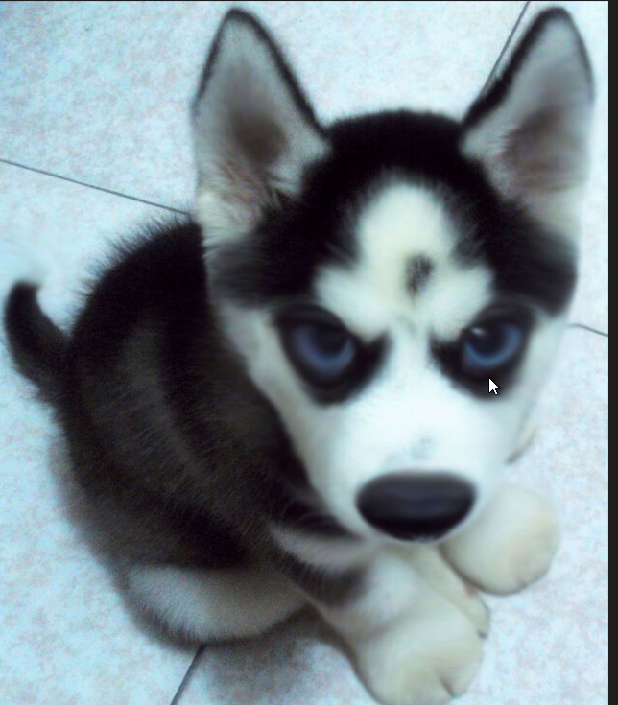

I then searched for passwd and found a hit in Disk/[root]/Disk/home/ftp/etc/shad that shows the following.

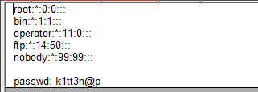

I tried this password, k1tt3n@p, to decrypt the white.zip file, but it did not work.
I could not find another password to decrypt this file.
B. (1 points) The suspect was found to use Firefox browser before. Please find the browsing
history and list the record which website the suspect visited before.

I looked up where user history is stored in the firefox browser and found out it is in the users profile under .mozilla (in the home directory ie Disk/[root]/Disk/home) from https://support.mozilla.org/en-US/kb/profiles-where-firefox-stores-user-data. They’re stored in an sqlite database called places. I then browsed in FTK to /home/drosen/.mozilla/ and exported the places.sqlite file. I then went to http://inloop.github.io/sqlite-viewer/ to view the sqlite database. I then selected the moz_places table in the database and got the following:
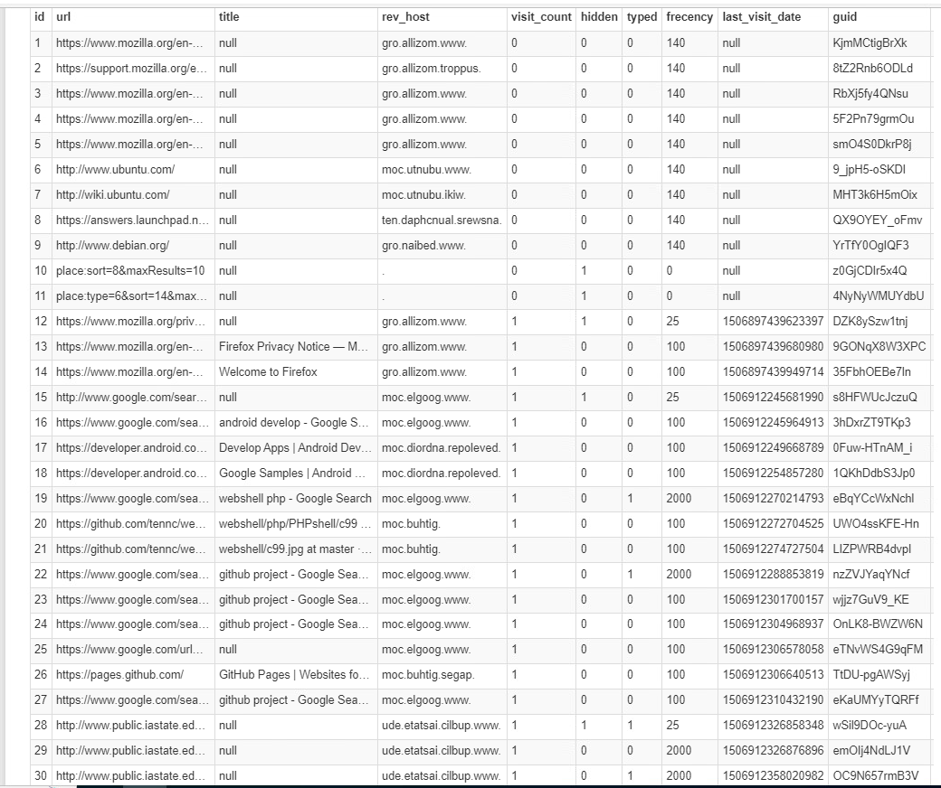
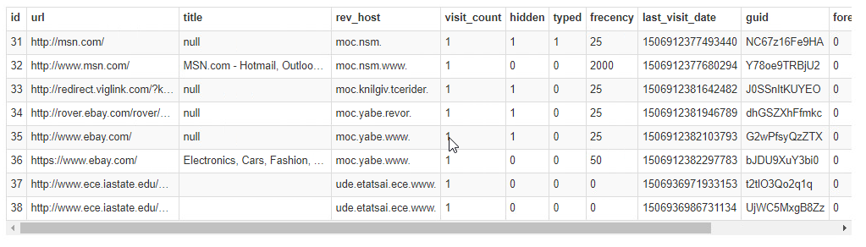

C. (1 point) Please list the browser cookie.

To get the browser cookies I did the same thing as I did for the last question. The mozilla site says that there is a cookies.sqlite file that holds the cookies. I downloaded the cookies.sqlite file that was in the home/drosen/.mozilla from FTK and viewed it using the same site as B.

Below are 2 pages of 30 entries of the cookies database.
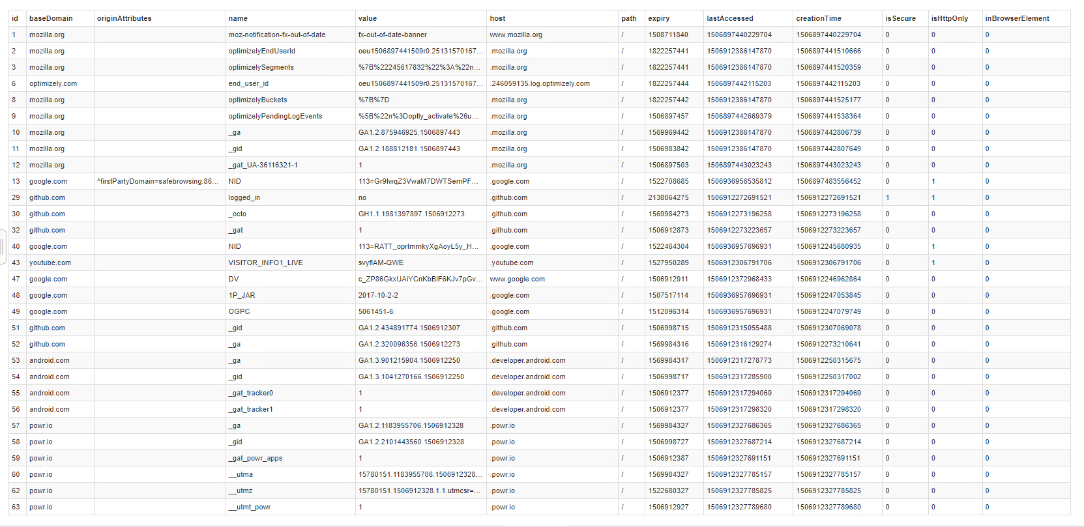

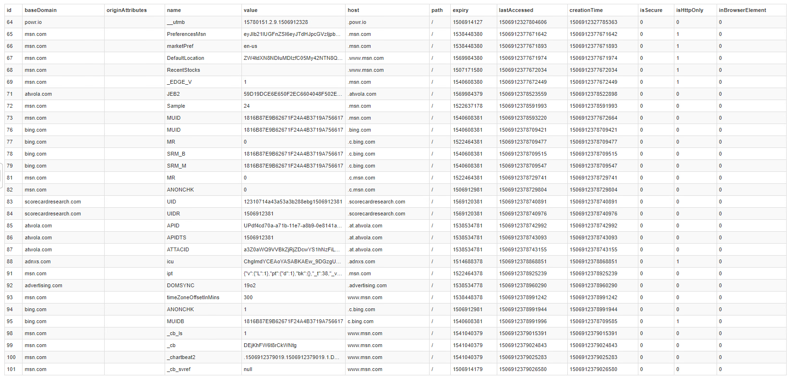
D. (1 point) The suspect built a public website and there is a pair of user and password which
the suspect used on website. Please find it out.

Still looking in the /home directory, I found a directory called httpd which I know is used by the http daemon. This stores information for the web page that the suspect would be developing. Inside the directory there is a html directory and an index.hmtl. This is shown below as rendered by FTK. It shows the username and password for the webserver.

User: lorien
Password: cpre536at17F

/home/httpd/html/index.html
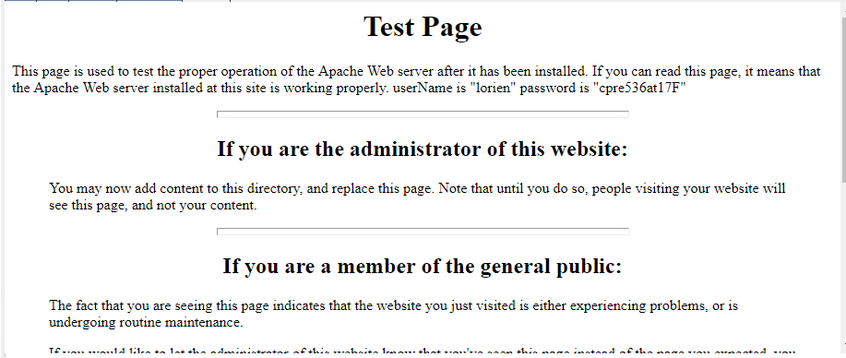

E. (2 point) The suspect used a fake first name for the illegal activities, please find her real
first name.

I found multiple emails using the email tab at the top of FTK. One is digest automatic email. One was a test to nobody and the last called movie.eml. The movie.eml said the following:

It looks to be the owner of the computer “Emma” White emailing her friend Jacky about a movie. She uses her real name in the email, Wendy.

