Detecting Hateful Comments and Compare Performances of Different Machine Learning Algorithms

Razwan Ahmed Tanvir
(2015-1-60-111)
Department of Computer Science and Engineering
East West University
Dhaka, Bangladesh
Razwantanvir8050@gmail.com
Shantanu Kumar Rahut
(2015-1-60-114)
Department of Computer Science and Engineering
East West University
Dhaka, Bangladesh
shantanurahut@gmail.com

Sharfi Rahman
(2015-1-60-134)
Department of Computer Science and Engineering
East West University
Dhaka, Bangladesh
sharfirahman@gmail.com

Abstract—The expansion of social media platforms brings into several issues. Huge amount of text data is generated each and every minute. With no monitoring of these text data, hateful or toxic contents are rampant. The harassment is growing as no detection is yet implemented to remove such comments. So identification of these toxicity is necessary. With this view in mind we have built a predictive model that identifies the toxic comments. The model is given a dataset that contains several example of toxic and non-toxic comments. Train and test dataset is made by splitting the dataset into two parts. Then various machine learning algorithms are applied to this dataset. We then compared different performance measures of different algorithms. Naïve Bayes, Logistic regression, Linear Support Vector Machine Classifier, Decision Tree Classifier and Random Forest Classifier are applied to train the predictive model. We found that Logistic Regression algorithm works best in terms of accuracy. Other algorithms also did perform well on different performance measure like precision, recall etc. We, in this paper provided an overview and the performances of these algorithms on this dataset.

Keywords— Toxic Comment, SVM, Accuracy, Precision, Naïve Bayes, Decision Tree Classifier

Introduction
We have applied various algorithms to the dataset we are working on. Accuracy of detecting of the toxic comments of different algorithms are different. We measured the accuracy of the following algorithms:
- Naïve Bayes
- Logistic Regression
- Linear Support Vector Machine Classifier
- Decision Tree Classifier
- Random Forest Classifier
These algorithm provided different results. The performance measure is different for each of the algorithms. We compared these algorithms on the same train and test dataset so that the decision of which algorithm works better on these algorithms can be taken. We found that Linear Support Vector Machine Classifier provides the best accuracy among the algorithms we applied. The other algorithm also did well in other performance measure. Later in this paper these performance measures are compared.

Related work
Several works have been done in the field of online harassment. Many researchers are trying to detect the toxicity in the text of social media platforms. Many approaches are followed to detect the bully or the harassment containing sentences in public platforms. Various machine learning algorithms are applied to the data set of detection of harassment. Researchers are now trying increase the accuracy of detecting hateful content in such platforms. Algorithms are now being modified to the context of the field of research. We in this experiment tried to detect the hateful comments from the dataset collected from Wikipedia comment section.

Preparing Dataset
Dataset we used to build the predictive model is collected from Kaggle. The dataset has a collection of numerous types of comments that are classified by the types of the harassments. The dataset has seven columns. The first column ‘column_text’ contains the actual comments from the Wikipedia discussion forum. The comments are then labeled in six classes that are 'toxic', 'severe_toxic' ,'obscene', 'threat','insult', 'identity_hate'. We then preprocessed this dataset to make only one class ‘hate’. If any comment is classified as any of the above six classes then we marked it as ‘hate’. Then we used this preprocessed dataset to train the predictive model to detect hateful comments.
Disclaimer: the dataset for this competition contains text that may be considered profane, vulgar, or offensive.

Model Training
The dataset was divided into two parts to train and test the built model. Training model is used to train the model for predict the input of the model and the test dataset is used to measure the performance of the predictive model. We split the dataset as the training set has 70% of the total data and the rest 30% is for the testing set. After splitting the dataset into training and test dataset we fit the training data to every model. Then we tested the performance of the models using the test dataset. Then the accuracies were calculated by generating the confusion matrix. And other performance measures like Precision, Recall and Prevalence are also calculated from the confusion matrix. The formula to calculate these are presented afterwards in this paper. Different parameters are tweaked to attain highest accuracies.

Performance
Different algorithms have provided us with different accuracies and different other performance measures. We calculated the accuracy of each of the algorithms from the confusion matrix. Confusion matrix is a convenient way of performance measure of any predictive model. We have calculated Accuracy, Precision and Prevalence of the above mentioned algorithms. Accuracy show that how often the classifier is correct. It is mostly used figure to rate any classifier. Again Precision determines when the model predicts yes, how often it is correct. Another performance measure is Prevalence where the frequency of occurring yes condition in sample. To measure the performance metrics, the use of confusion matrix is useful and convenient. A confusion matrix is introduced to represent the relation between the actual and predicted class. We can calculate various performance measure from the confusion matrix of any given algorithm along with its accuracy.

 |  | Prediction
Actual | Total= TP+TN+FP+FN | Positive | Negative
Actual | Positive | TP | FN
Actual | Negative | FP | TN

Table: Confusion Matrix

From this confusion matrix, accuracy is calculated by the equation,
Accuracy = 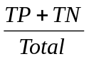

Precision = 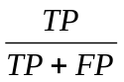

Now we represent the confusion matrices for all the algorithms we are interested in. Then from the confusion matrix we would calculate the accuracy of each algorithm and put them in comparison. For the aggregate view we put all the values of confusion matrix in one table.

Algorithm | TP | FP | FN | TN
Naïve Bayes | 2725 | 753 | 2244 | 42150
Logistic Regression | 2818 | 290 | 2151 | 42613
Support Vector Machine | 3664 | 943 | 1305 | 41960
Decision Tree Classifier | 3325 | 1127 | 1644 | 41776
Random Forest Classifier | 1864 | 83 | 3105 | 42820

From the above table we calculate all the performance measure we are interested in. We then arrange the values in a table.
The following table shows different performance measures of different algorithms:

Algorithm | Accuracy (%) | Precision (%) | Prevalence (%)
Naïve Bayes | 93.73 | 78.35 | 10.37
Logistic Regression | 94.90 | 90.66 | 10.37
Support Vector machine | 95.03 | 79.53 | 10.37
Decision Tree Classifier | 94.21 | 74.68 | 10.37
Random Forest Classifier | 93.34 | 95.73 | 10.37

Table: Accuracy, Precision and Prevalence of the algorithms
Recall attempts to answer the following question: What proportion of actual positives was identified correctly? Mathematically, recall is defined as follows:
Recall=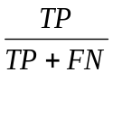
The following table shows the Recall of different algorithms:
Algorithm | Recall
Naïve Bayes | 93.73
Logistic Regression | 94.90
Support Vector machine | 95.03
Decision Tree Classifier | 94.21
Random Forest Classifier | 93.34

Table: Recall of the algorithms

The above table is represented in a graph for better representation of the recall measure of the algorithms. So below a histogram is plotted to observe the comparison:

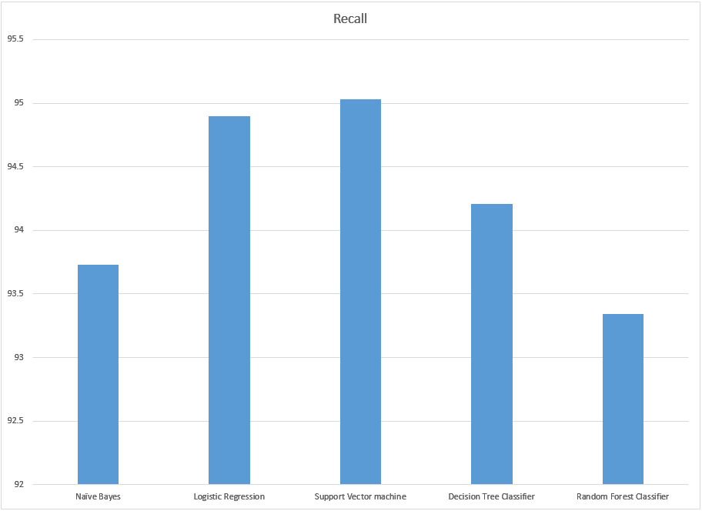
Figure: Recall of the algorithms

Comparison
The algorithms we applied show different performance measures. Linear Support Vector Machine Classifier provided the highest accuracy (95.03%) and the Random forest did the least performance in terms of accuracy (93.34%). But if we consider the precision performance measure then the Random Forest Classifier performed well in the dataset we are working on.
For better visualization we plotted the accuracy and the precision in two separate plots. Those are given below:
Algorithms and their accuracy:

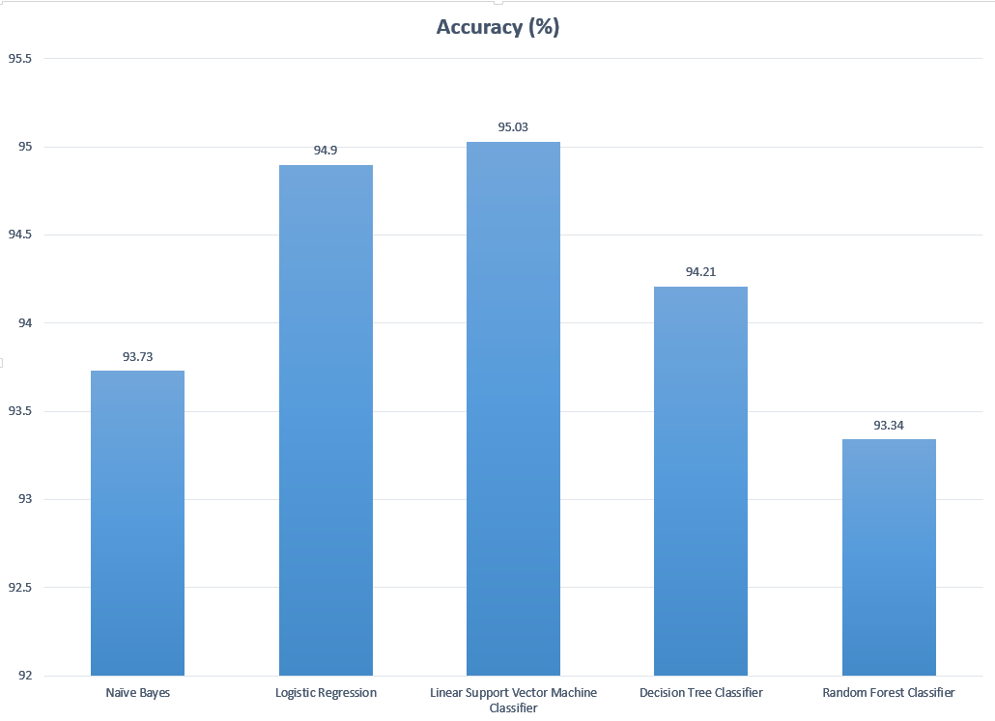
Figure: Applied algorithms and their accuracies

Now we plot the measures of the algorithms and their precision is a histogram:
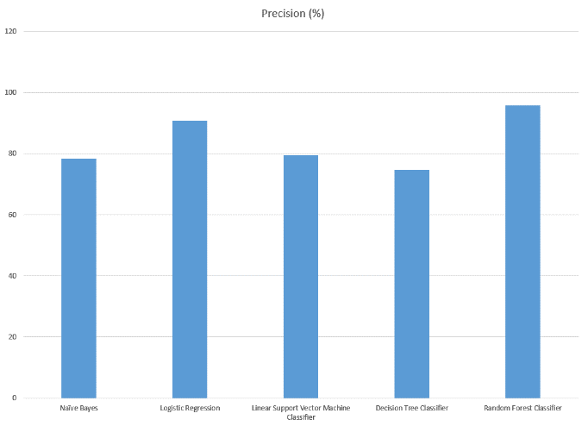
Figure: Applied algorithms and their precision

Conclusion
Text classification is done by applying various algorithms. There is no specific algorithm that is sure to work well in terms of text classification. We in this experiment of comparing five different algorithms have shown that the Linear Support Vector Machine Classifier works well in classifying hate comments. SVM provides higher accuracy compared to others. But the precision measure is low for SVM. In terms of precision and accuracy the Random Forest Model performs well. The accuracy of Random Forest Classifier is not that different from the Linear SVM classifier but the higher precision makes the Random forest algorithm more usable for the detection of hate comments in social media platforms.

References

- https://www.bullying.co.uk/cyberbullying/effects-of-cyberbullying/
- https://www.kaggle.com/c/jigsaw-toxic-comment-classification-challenge/
- http://www.dataschool.io/simple-guide-to-confusion-matrix-terminology/
- http://ieeexplore.ieee.org/document/6844675/?reload=true
- http://ieeexplore.ieee.org/document/7054943/

