Building Accountable AI: Fractal Transparency (FTW) Interpretability Architecture for Governance under EU AI Act Articles 14 and 70

Abstract
Artificial intelligence models are increasingly vulnerable to manipulation, as shown by behavioral steering experiments where systems can be nudged into deceptive or unsafe outputs. The European Union’s AI Act, particularly Articles 14 and 70, requires human oversight and enforceable governance structures to address these risks. Annex III further designates eight categories of high-risk AI systems, ranging from biometric identification and critical infrastructure to employment, education, law enforcement, migration control, and the administration of justice. Yet the Act provides minimal operational guidance and fails to specify the institutional mechanisms or personnel procedures necessary for oversight and enforcement. Fractal Transparency for the Web (FTW) offers a novel architecture that bridges this gap.
This project demonstrates how FTW can be operationalised as a compliance framework, showing how its three components align with regulatory needs:
- HAT enables real-time monitoring of thousands of behavioral concepts, operationalising human oversight.
- MAP structures mandatory and optional lenses to enforce fairness, bias detection, and jurisdiction-specific rules.
- ASK secures accountability through cryptographic audit logs and governance protocols, ensuring decisions are transparent and enforceable.
By reframing FTW as a governance tool rather than a purely technical advance, this work shows how transparency can scale across technical layers, institutional levels, and jurisdictions. The contribution is practical: regulators, policymakers, and developers gain a clear pathway to operationalise Articles 14 and 70, supported by MAP’s ecosystem of mandatory and optional lenses that address Annex III’s high-risk categories. In doing so, the architecture advances a model in which transparency and accountability are necessary conditions for aligning AI system deployment with democratic oversight and public authority supervision.
Keywords: EU AI Act , Articles 14 & 70 , Annex III high-risk systems ,Human oversight ,Governance and enforcement mechanisms ,Transparency and accountability ,Compliance framework ,Fractal Transparency Web (FTW) HAT, MAP, ASK architecture
Glossary (Acronyms)
FTW: Fractal Transparency for the Web: layered transparency and accountability architecture for AI deployments.
HAT: Headspace Ambient Transducer: applies concept “lenses” during inference using hierarchical, budgeted loading and optional steering.
CAT: Conjoined Adversarial Tomography: optional independent oversight layer that grades/compares internal signals and flags divergence or adversarial behavior.
MAP: Mindmeld Architectural Protocol: open registry and format for lens packs, concept packs, metadata, and validation artifacts.
ASK: Agentic State Kernel: governance layer for permissions, policies/treaties, incident artifacts, and rules for acting on interpretability signals.
Lens: A trained probe/classifier mapping internal activations to a concept score; may be detection-only or steerable.
TRIAD: Institutional review/approval process for mandatory lens packs and governance policies (term used in this paper).
Annex III: EU AI Act: list of high-risk system categories (e.g., recruitment, education, law enforcement, migration control).

PAPER STRUCTURE
Section 1: Introduction - Regulatory implementation gap (Articles 14, 70)
Section 2: FTW Technical Architecture - HAT, MAP, audit infrastructure
Section 3: EU AI Act Policy Mapping - Article 14, 19, 70 operationalisation
Section 4: Governance Framework - Two-tier mandatory architecture, failure modes
Section 5: Annex III Case Study - Recruitment AI implementation example
Section 6: Validation & Implementation - Empirical methodology, timeline
Section 7: Conclusion - Integrated compliance pathway

1. INTRODUCTION
1.1 The EU AI Act Implementation Challenge
The EU Artificial Intelligence Act (2024) establishes the world's first comprehensive AI regulatory framework, creating binding obligations for high-risk systems under Annex III. Article 14 requires providers to design systems enabling human overseers to "correctly interpret the system's output" and "decide not to use the system or otherwise disregard, override or reverse the output." Article 70 mandates competent authorities perform supervision "in an objective, transparent and impartial manner."
Yet these requirements face critical implementation gaps. How can human overseers "correctly interpret" outputs when internal reasoning remains opaque? When AI explanations appear technically coherent but conceal discriminatory patterns, what mechanism alerts supervisors? How do competent authorities maintain "objectivity" when centralised oversight invites regulatory capture?
Traditional black box architectures render these requirements unimplementable. Article 43 conformity assessment lacks tools for detecting when explanations satisfy algorithmic consistency tests while failing legal adequacy standards. Post-deployment Article 72 surveillance cannot identify discrimination when monitoring systems record only inputs and outputs, not decision processes.
At ecosystem scale, high-risk AI deployments resemble a city of buildings with blacked-out windows: models, tools, and processes exchange value and make decisions, but counterparties and competent authorities cannot see inside the decision machinery. FTW frames compliance as negotiated, least-privilege transparency: contracts specify which rooms are in scope for a given relationship (e.g., an Annex III workflow), what internal signals are observable (“windows”), what interventions are permitted (“doors”), who holds keys, and what evidence is logged for later causality and enforcement.
1.2 FTW Solution: Technical Foundation
FTW (Fractal Transparency for the Web) addresses these gaps through interpretability architecture inverting traditional post-hoc explanation approaches. Rather than attempting to explain opaque model decisions after they occur, FTW defines target concepts a priori (e.g., "gender bias," "explanation honesty," "harmful content"), trains classifiers called "lenses" on model internal activations during concept-eliciting prompts, then deploys these lenses for real-time monitoring during inference.
Core innovation: Interpretability becomes detection capability rather than explanation generation. Instead of asking "why did the model decide X?" (retrospective), FTW asks "is the model exhibiting pattern Y?" (real-time monitoring).
This methodology derives from neuroscience: functional MRI studies decode mental states by training classifiers on neural activation patterns while subjects view known stimuli (Nishimoto et al., 2011). FTW applies this to language model internals recording activations when processing prompts designed to elicit specific concepts, training detection classifiers, deploying for continuous monitoring.

1.3 Paper Contributions
This paper demonstrates:
1. Technical specification of FTW architecture enabling Articles 14, 19, 70 compliance.
2. EU AI Act policy mapping showing how technical mechanisms operationalise regulatory requirements
3. Governance framework identifying mandatory conditions beyond technical capability
4. Annex III implementation using recruitment AI as concrete validation case
We show that FTW provides necessary technical foundation for compliance, while governance analysis reveals insufficient conditions requiring legal mandates. Neither architecture nor governance alone achieves enforceability; integration proves essential.
1.4 Authorship & Contributions
[Developer]: FTW technical architecture design, HAT/MAP implementation, system specifications…..
Kaouthar EL BAIRI: EU AI Act policy mapping, governance framework, TRIAD institutional design, Annex III high-risk analysis
This work emerges from Apart Research hackathon collaboration, combining technical innovation with governance operationalisation to demonstrate tractable EU AI Act compliance pathway.

2. FTW TECHNICAL ARCHITECTURE
2.1 System Overview
FTW comprises three integrated components addressing distinct compliance requirements:
- HAT (Hierarchical Autonomic Transparency): Real-time monitoring layer processing concept lenses during inference (Article 14 human oversight)
- MAP (MINDMELD Architectural Protocol): Open lens registry enabling multi-stakeholder contributions (Article 70 independence)
- Cryptographic Audit Infrastructure: Immutable evidence trail for regulatory enforcement (Article 19 logging)
Figure 1 illustrates system architecture and data flow.

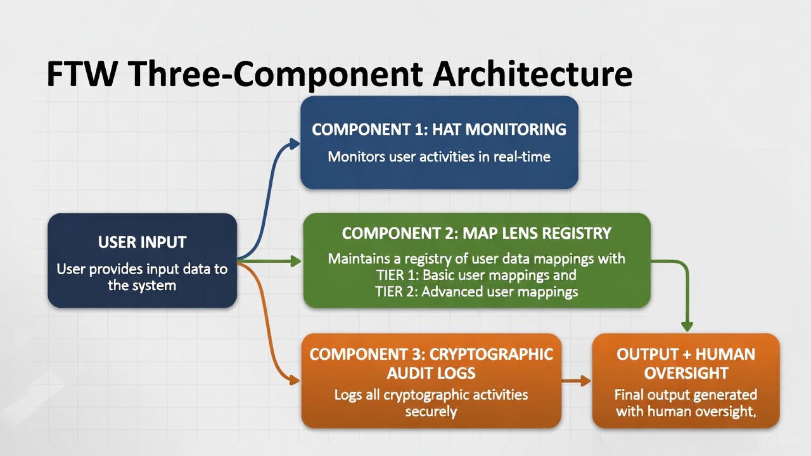
Figure 1 Caption: FTW architecture integrating real-time monitoring (HAT), multi-stakeholder lens registry (MAP), and cryptographic audit infrastructure. Data flows from user input through lens processing to human oversight with immutable logging.

2.2 HAT: Hierarchical Autonomic Transparency
HAT provides an always-on monitoring layer that applies concept lenses during model inference without requiring model retraining. It assumes an instrumented runtime with access to internal activations (typically open-weight deployments or on-prem inference), and supports optional steering when permitted by policy.
Technical operation:
- Input Processing: User prompt enters system, model generates response via standard inference
- Parallel Lens Application: A large number of concept lenses are evaluated in parallel on internal activations, using a hierarchical lens manager that maintains an active set (top-k) per view mode and performance budget; additional lenses are loaded just-in-time as higher-level concepts fire.
- Activation Scoring: Each lens outputs 0.0-1.0 score indicating concept presence strength
- Threshold Evaluation: Scores compared to intervention thresholds (configurable per lens, e.g., gender bias >0.5 triggers alert)
- Divergence Calculation: Internal state (lens activations) compared to external presentation (output text) to quantify explanation reliability
- Intervention Protocol: If critical thresholds exceeded, alert displays to human overseer with intervention options before decision proceeds
Performance characteristics:
- Latency overhead: Hardware-dependent and configurable. The active-set size, layers monitored, and view mode determine overhead; the reference implementation targets production-viable latency on consumer GPUs, while scaling down to constrained devices or up with data-center budgets.
- Scalability: Parallel GPU batching plus hierarchical loading means the total lens library can be far larger than what is resident at any moment; higher VRAM/compute enables many more active lenses per token, while low-resource devices can run a smaller active set.
- Non-invasive: No model weight modification is required for detection; however, the approach requires access to weights/activations and is not applicable to closed remote APIs where internals are inaccessible.
- Real-time: Monitoring occurs during inference, not post-hoc.
Operational limits and uncertainty:
Probabilistic signals: Each lens reports a score with measured accuracy/false-positive characteristics; no single lens is infallible.
Ensembling improves robustness: overlapping lenses (and hierarchical ancestry) increase the chance that at least one relevant signal fires, and enable cross-checking.
Steering is a distribution shift: interventions tilt the model’s probability landscape toward/against behaviors; success rates vary by model, prompt, and policy configuration.
Coverage is budgeted: the system can log what was monitored and what was not (active set, thresholds, disabled lenses), so audits can reason about gaps.
2.3 MAP: MINDMELD Architectural Protocol
MAP provides open registry for lens contributions, storage, version control, and validation tracking. Multi-stakeholder model enables contributions from government agencies, civil society organisations, academic researchers, and industry domain experts.
Lens specification metadata:

Each lens includes structured metadata enabling validation and accountability:
- Technical: Accuracy metrics, false positive rates, training methodology, validation datasets
- Legal: Approved domains, geographic scope, tier classification (1 or 2)
- Governance: Contributor identity, TRIAD approval date, 24-month expiry, public consultation documentation

2.4 Cryptographic Audit Infrastructure
Audit logging provides immutable evidence trail addressing Article 19 requirements and enabling Article 71 investigations.
Log entry structure (JSON format)
Example log entry (JSON)
Example (redacted identifiers):

{
"schema_version": "ftw.audit.v0.3",
"entry_id": "evt_20260109_101523Z_9f2c",
"timestamp_start": "2026-01-09T10:15:23.481Z",
"timestamp_end": "2026-01-09T10:15:24.892Z",

"deployment_id": "dep_annexIII_recruit_eu_001",

"request": {
"input_hash": "sha256:7f83b1657ff1fc53b92dc18148a1d65dfc2d4b1fa3d677284addd200126d9069",
"policy_profile": "eu.recruitment.v1",
"active_lens_set": {
"top_k": 10,
"lens_pack_ids": ["eu.mandatory.v1", "org.fairness.v2"],
"mandatory_lenses": ["bias.gender", "bias.ethnicity", "selection.justification"],
"optional_lenses": ["tone.professional", "clarity.explanation"]
}
},

"signals": {
"tick_count": 47,
"top_activations": [
{
"lens_id": "GenderBias",
"max_score": 0.83,
"mean_score": 0.71,
"threshold": 0.6,
"tier": "mandatory",
"measured_precision": 0.92,
"ticks_above_threshold": 31
},
{
"lens_id": "selection.justification",
"max_score": 0.71,
"mean_score": 0.58,
"threshold": 0.65,
"tier": "mandatory",
"measured_precision": 0.90,
"ticks_above_threshold": 12
}
],
"divergence": {
"max_score": 0.27,
"mean_score": 0.19,
"divergence_type": "activation_text_mismatch",
"top_diverging_concepts": ["bias.gender", "fairness.equal_opportunity"]
},
"violation_count": 2,
"violations_by_type": {"simplex_max_exceeded": 2},
"max_severity": 0.73
},

"actions": {
"intervention_triggered": true,
"intervention_type": "steering",
"steering_directives": [
{
"simplex_term": "bias.gender",
"target_pole": "neutral",
"strength": 0.4,
"priority": "USH",
"source": "ush"
}
],
"human_decision": {
"decision": "override",
"justification": "High gender bias signal despite equal qualifications in application. Recommending manual review of shortlisting criteria.",
"operator_id": "op_sha256:a3f2...",
"timestamp": "2026-01-09T10:17:02.104Z"
}
},

"evidence": {
"output_hash": "sha256:9b74c9897bac770ffc029102a200c5de744e4125a5c5e55f2e90ebd24f19dc32",
"tick_ids": [1523, 1524, 1525, 1526, 1527],
"attachments": ["attr_20260109_101523_gender.json"],
"notes": "Candidate ranking overridden pending HR review."
},

"prev_hash": "sha256:2c26b46b68ffc68ff99b453c1d30413413422d706483bfa0f98a5e886266e7ae",
"entry_hash": "sha256:4e07408562bedb8b60ce05c1decfe3ad16b72230967de01f640b7e4729b49fce"
}

Cryptographic properties ensuring integrity:
- Tamper-evidence: Merkle tree structure means any entry modification breaks hash chain, immediately detectable through verification
- Timestamp certification: Independent RFC 3161 authority provides legally recognised time certainty
- Multi-party replication: Competent authority receives real-time synchronised copy, preventing provider-only control
- Append-only architecture: Deletion technically prohibited by database structure

3. EU AI ACT POLICY MAPPING
3.1 Article 14: Human Oversight Implementation
Article 14(4) establishes five human oversight capabilities. Table 1 maps FTW components to each requirement.
TABLE 1: Article 14(4) Requirement → FTW Component Mapping

Article 14(4) Requirement | FTW Component | Implementation Mechanism
(a) Fully understand capacities and limitations | MAP lens documentation | Published accuracy metrics, known failure modes, transparent methodology specifications for each lens
(b) Correctly interpret system output | HAT divergence detection | Real-time quantification of internal state vs. output presentation gap; objective signal when explanation unreliable
(c) Appropriately oversee operation | HAT continuous monitoring | Real-time visibility into decision processes via lens activations; threshold configuration by human supervisors
(d) Decide not to use, disregard, override or reverse output | Intervention protocol | Alert provides explicit options: Override, Modify, Escalate, Proceed; decision cannot proceed passively
(e) Intervene on operation or interrupt system | Threshold-based halt | Critical activations immediately stop output; competent authority can disable system (Article 72 support)

Divergence detection operationalising Article 14(4)(b):
The "correct interpretation" requirement proves most technically challenging. AI systems can provide explanations that appear coherent but misrepresent internal decision-making. Traditional review examines output text only, unable to detect internal-external divergence.
FTW's divergence mechanism quantifies this gap:

