Group A0: Pixel-wise anomaly detection for AOS

Computer Vision Project 2021/2022

Pablo Díez Arrizabalaga

Laura Legat

Christian Willdoner

Daniel Schatzl

René H. Reich

ABSTRACT

In this document the project for computer vision laboratory in year 2021/22 of group A0 is described. Avoiding deep learning models, we developed an unsupervised model based on classical computer vision techniques capable of detecting moving anomalies in multiperspective images.

KEYWORDS

pixel-wise, anomaly detection, mask, occlusion, merging, unsupervised, forest, wood, human, rescue

1 DESCRIPTION

Initially, the proccedure presented in [1] was considered. Nevertheless, the unsatisfactory results obtained made us neglect both the Autoencoder and the Discriminator from our model, and only contemplate the RX detector. Along the same lines, using the OpenCV library we were able to apply classical image masking methods. Our final pipeline is shown in Fig. 1 and Fig. 2.

The database was composed of several samples each containing 7x10 images, 7 timesteps for 10 different views of the same scene. By merging the images on the camera axis, we obtained 7x7 images, of which we only used the 1st, 3rd and 7th (last) timesteps. Since we considered that these frames offered enough information to discern the movement of the people to detect from the background.

For the classification of the merged images, a modified Mahalanobis Detector (RX) was developed, which made use of the Mahalanobis distance in order to identify clusters. Once the different clusters were identified, their contours were observed and a binary image was obtained. Afterward, the binary images corresponding to 1st and 7th timesteps were multiplied, to later check which contours overlapped with the 3rd timestep. In order to filter the resulting image, a probabilistic method was applied, a standard deviation within the Gaussian distribution. Finally, the bounding boxes were drawn.

Based on this procedure, the results obtained for the validation set for average precision are 43.33 %.

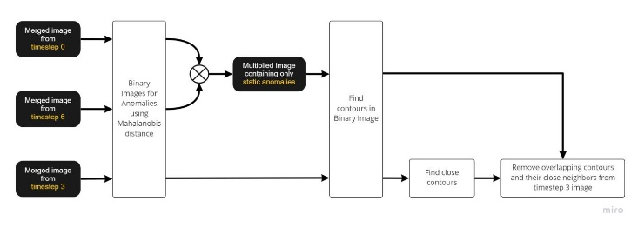

Fig. 1: Remove static objects

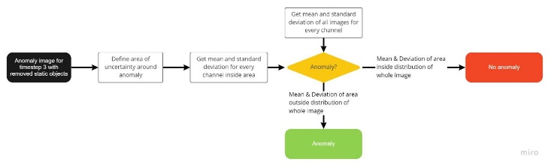

Fig. 2: Anomaly detection

REFERENCES

[1] Sertac Arisoy, Nasser M. Nasrabadi, 2021. Unsupervised Pixel-wise Hyperspectral Anomaly Detection via Autoencoding Adversarial Networks*. arXiv*, 1 (Jan, 2021)

Conference Location:El Paso, Texas USA

ISBN:978-1-4503-0000-0/18/06

Year:2018

Date:June

Copyright Year:2018

Copyright Statement:rightsretained

DOI:10.1145/1234567890

RRH: F. Surname et al.