In

P110072191

07/05/2021

iNTERACTIVE WEB SOLUTION

FOR UNIVERSITER CENTRE PETERBOROUGH

Table of Content

Introduction

Mood Board



Prototype

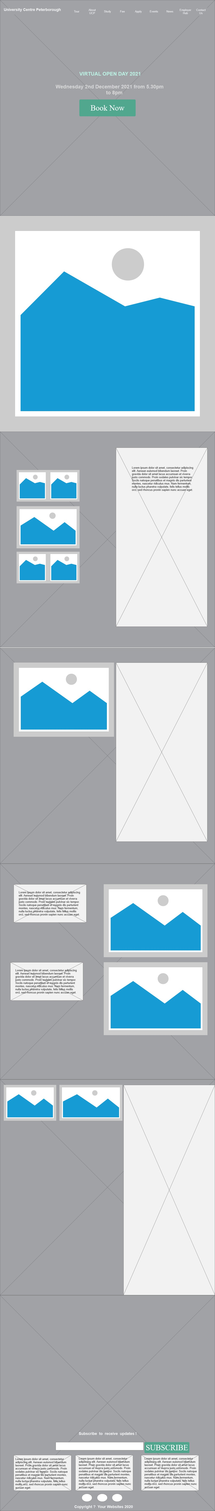

Index Page

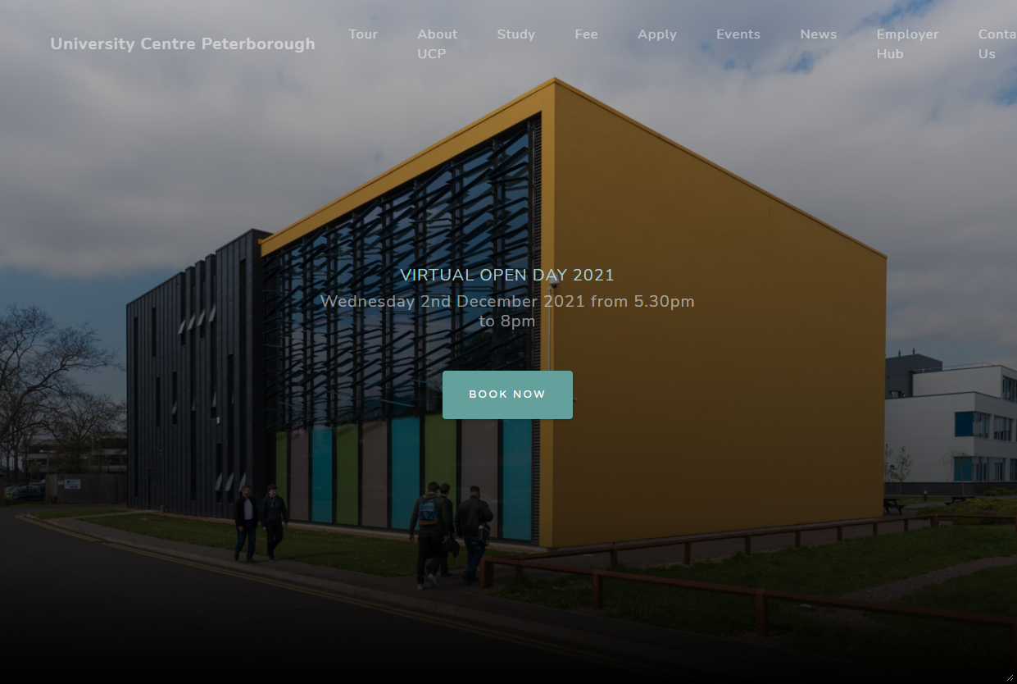

Interactive

