**Sea snot, see ya later: Hot water immersions are effective for controlling the invasive, biofouling tunicate, *Didemnum vexillum***

by

Payton Arthur, Hazel de Haas, Lauren Gill

A report submitted in partial fulfilment of the requirements of

APPLIED DATA ANALYSIS AND DIRECTED STUDIES

at

Bamfield Marine Sciences Centre

Instructor: Dr. Sara Wuitchik and Daniel Wuitchik

Teaching Assistant: Jenna Fleet

© Payton Arthur, 12/2021

Home University: University of Calgary

© Hazel de Haas, 12/2021

Home University: University of Victoria

© Lauren Gill, 12/2021

Home University: University of British Columbia

**Abstract**

Biofouling, the unwanted establishment of organisms on surfaces, impacts aquaculture facilities by decreasing product value and causing expensive damages to their equipment. The biofouling tunicate *Didemnum vexillum* poses a notable threat to aquaculture facilities as it is an invasive species with strong competition abilities and is rapidly expanding its range. In this study, we seek to determine the impact of combining high temperatures and freshwater treatments for different immersion times on *D. vexillum* as a method for controlling biofouling. We immersed *D. vexillum* in either freshwater or seawater at one of four different temperatures (12, 50, 70, and 90°C), for 60 or 120 seconds. We then analyzed the survival of the tunicates 3 weeks post treatment. We found that only temperature impacted survival with some tunicates dying at 12°C and 50°C but all samples dying at both 70°C and 90°C. Therefore, to maximize the effectiveness of biofouling removal efforts while limiting the amount of time and energy used, we recommend that aquaculture facilities use 60 second 70°C seawater or freshwater dips to control *D. vexillum* on their gear. Using this method to remove *D. vexillum* biofouling will help to decrease aquaculture gear damage, and reduce the spread of an invasive species.

# **Keywords**

Aquaculture, Colonial tunicates, Heat treatments, Freshwater, Mortality experiment

# **Introduction**

Biofouling, the establishment of unwanted organisms on aquaculture products or gear, is a major concern for marine shellfish farms (Adams et al*.,* 2011;Fitridge et al*.,* 2012). Biofouling leads to decreased quality of the shellfish product and can reduce the longevity of expensive gear (Fitridgeet al., 2012). Typical biofouling species include mussels, tunicates, barnacles, and macroalgae, which can be found growing on gear such as racks, floating pens, rope lines, and rafts (Adams et al., 2011). Annually, over 14% of operating costs for shellfish farmers go towards biofouling management (Adams et al., 2011). Due to the substantial economic challenges that biofouling poses for shellfish aquaculture, effective and efficient methods are necessary for removing these species. Invasive species are of particular concern to the aquaculture industry because they are often dominant and fast-growing, making them detrimental biofouling agents (Lambert, 2009).

Aquatic invasive species pose a prominent management challenge in the aquaculture industry (Rolheiser, et al.*,* 2012). An invasive species is an organism that causes ecological or economic harm in an ecosystem where it is not native (NOAA, 2021). Invasive species are often introduced through transportation vessels and aquaculture trade (Lambert, 2009). Government regulations regarding the spread of invasive species can often impose tight restrictions on the sale and distribution of aquaculture products (US Geological Survey, 2003). Therefore, this loss in sales paired with the cost of labour-intensive removal methods results in invasive species having a considerable negative economic impact on shellfish farmers (US Geological Survey, 2003). Biofouling invasive species can be diverse in form and taxonomic origin and include species of algae, molluscs, and tunicates (Fitridgeet al., 2012; McCarthy et al., 1997).

One such invasive tunicate is *Didemnum vexillum* Kott, 2002, a notorious biofouling agent within aquaculture shellfish farms (Switzer et al*.,* 2011; Rolheiser et al*., 2012)*. *D. vexillum* (Phylum Chordata, Class Ascidiacea) is an invasive colonial ascidian that has a characteristic tough outer layer called a tunic (Dijkstra et al., 2007; DFO, 2018). It is a highly pigmented tunicate which appears orange in colouration (Hirose, E. 2009, DFO, 2018). Originally native to Japan, *D. vexillum* has invaded globally, and was first recorded on the west coast of North America in 1998 and appeared for the first time in British Columbia in 2003 (Dijkstra et al., 2007). *D. vexillum* is a strong competitor for space (Dijkstra et al., 2007). This species can reproduce by means of fragmentation, in which fragments break off from the larger colony and reattach to the substrate to form a new colony (Carman et al., 2014). These fragments can disperse and grow, forming a suffocating carpet along the benthos after settlement (Dijkstra et al*.*, 2007; DFO, 2018). *D. vexillum* can smother mussel and oyster beds and hinder recruitment of other species (Dijkstra et al., 2007).

The establishment of *D. vexillum* can lead to altered circulation of water and nutrients, decreased feeding rate of shellfish and reduced value of shellfish products due to decreased visual appeal (Fitridge et al., 2012). Additionally, gradual temperature increases hasten the growth of *D. vexillum,* thereby increasing their rate of spread under a warming climate (McCarthy et al., 2007; Hawes et al., 2018). Due to its rapidly expanding range and dominant nature, *D. vexillum* is a threat to the aquaculture industry and considerable efforts are being made to facilitate its removal (Dijkstra et al., 2007).

To date, several methods for removing biofouling *D. vexillum* have been investigated*,* with varying degrees of success. These methods include utilizing biological control (Carman et al., 2009; Switzer et al., 2011), mechanical scrubbing (Switzer et al., 2011), freshwater dips (Rolheiser et al., 2012; McCann et al., 2013), and chemical treatments such as acetic acid, citric acid, or bleach (Switzer et al., 2011; Rolheiser et al., 2012; McCann et al., 2013). Biological controls to remove *D. vexillum,* such as snails or green sea urchins, were found to be ineffective at reducing biofouling (Carman et al., 2009; Switzer et al., 2011). Freshwater treatments had mixed results on *D. vexillum* survival, as shorter immersion times (up to 10 minutes) did not reduce growth, whereas longer exposure times (4 hours) resulted in successful eradication (Rolheiser et al., 2012; McCann et al., 2013). Mechanical removal of *D. vexillum* was effective in removing the tunicates, though was deemed inefficient given how labour intensive it was (Switzer et al., 2011). Finally, chemical treatments also had mixed results, with the most effective method proving to be short dips in acetic acid which completely eradicated tunicate growth in just 30s (Rolheiser et al., 2012). Despite the promising value of chemical treatments, upscaling this method may prove difficult and expensive for aquaculture facilities that already spend much of their annual operating costs on removing biofouling. One treatment that hasn’t been thoroughly explored is temperature as a method for controlling *D. vexillum* in an aquaculture setting.

Because most previous research on control of *D. vexillum* has considered the survival of affected shellfish products, there are very few studies that investigate high temperatures as a possible removal method*.*  The few studies that do explore heat treatments in other species of biofouling tunicates have been successful, and therefore heat treatments may have the potential to control *D. vexillum* biofouling (Minchin & Duggan, 1988; Sievers et al*.,* 2019). Sievers et al., (2019) explored a variety of removal methods including heat, organic acids, and combined treatments on two species of solitary tunicates. The authors found that exposures to high temperatures (40, 50, and 60°C) at several immersion times (10, 30, and 60s) were effective at eradicating a large proportion of biofouling organisms (Sievers et al., 2019). Also, when they combined heat and organic acid treatments, removal was more effective than when treatments were done independently (Sievers et al., 2019). Since heat has the potential to reduce the survival of tunicates (Minchin & Duggan, 1988; Sievers et al*.,* 2019), and freshwater (as previously mentioned) has mixed effects (Rolheiser et al., 2012; McCann et al., 2013), this experiment aims to combine these treatments to see if one treatment alone, or the interaction of both factors may reduce overall tunicate growth.

The objective of this study is to determine the effect of high temperatures, freshwater treatments, and immersion times on the survival of the invasive, biofouling tunicate *D. vexillum*. We hypothesize that combination treatments (high temperature and freshwater) with longer immersion times will cause the highest mortality due to the compounded effects of temperature and osmotic stress. We also investigated several proxies for survival in the event that survival was not obvious following three week; these proxies include pigment loss represented by change in mean red-green-blue (RGB) value after 48 hours, whether to tunicate reattached to the substrate, change in wet weight after 48 hours, change in wet weight after 3 weeks, and mold cover.

We specifically predict that treatments using high temperatures, freshwater and long immersion times will have the lowest proportion of tunicates that survive water dips. 48 hours after treatment, we predict that tunicates subjected to long immersion, high temperature freshwater treatments will display the most pigmentation loss. Additionally, we predict that after a 3 week monitoring period, tunicates treated with long immersion times, high temperatures, and freshwater will lose weight, have higher mold cover, and will not reattach to the substrate.

**Methods**

Study System and Data Collection

*Didemnum vexillum* was collected in Bamfield Inlet (Bamfield, BC, Canada; 48.8254° N, 125.1381° W) on October 22 and 23, 2021 from ropes hanging off of the Bamfield Marine Science Centre docks. On the day of collection, the sea surface temperature of the inlet was measured to determine the temperature for the control (ambient seawater temperature) treatment (12°C). Large chunks of *D. vexillum* were taken from 5 individual colonies. After collection, tunicates from each colony were cut using scissors to obtain 16 pieces per colony (80 total) with wet weights ranging between 6.5 to 7.5 g. Then, samples were placed into separate Tupperware containers with holes and were left to acclimate in a 12°C flow-through seawater table for 48 hours.

Experimental Design

To test the effects of heat and freshwater treatments, *D. vexillum* was exposed to either fresh or saltwater at 12°C (ambient seawater temperature), 50°C, 70°C, or 90°C. Temperature increments were chosen based on a pilot study and previous studies of temperature treatments on the tunicates *Styela clava* and *Ciona intestinalis* (Minchin & Duggan, 1988; Sievers et al*.,* 2019). Seawater was sourced from Bamfield Inlet and tap water was used for the freshwater. Tap water was used rather than dH2O to reflect the most affordable and readily available source of fresh water in an aquaculture setting. Immersion times were either 60 or 120 seconds. The three experimental factors were crossed, resulting in 16 treatment combinations (four temperatures × two water variations × two exposure times) with each treatment having five replicates (Fig. 1). The replicates included representatives from each of the 5 colonies. Seawater or freshwater was heated in a 1L beaker using a hotplate. Once the treatment temperature was reached, the tunicate sample was dipped into the water using forceps, held there for 60 or 120 seconds, then returned to the water tables.

After acclimation, sample wet weights and mean RGB (red-green-blue) values were collected. Pigmentation loss can be used as an indicator of mortality in tunicates (Piola et al., 2009; McCann et al., 2013, Ramsay, 2015). This method has been used in studies examining bleaching in corals (Gushi, et al., 2021), but has not been used for pigmentation loss in tunicates. Samples were photographed in a clear bowl on a laminated piece of white paper, using a methodology similar to England (2015). Lighting was standardized by taking the photographs in a windowless hallway with all ceiling lights and the camera flash turned on. Photographs were taken using a Nikon D50 camera on a tripod whose position was not moved throughout the entire data collection process. Wet weight and colour of the tunicates were recorded again 48 hours and three weeks after treatments. Tunicates that became moldy were transferred to another sea table to limit their effect on other samples.

RGB data was gathered using photograph analysis adapted from England (2015). Photographs of the tunicates before and after treatment were first white balanced in GIMP (v. 2.10.12; The GIMP Development Team, 2019) by selecting the laminated paper (included in each picture) which shifted the light intensity of the picture to a consistent, arbitrary standard value. The RGB values were then analyzed using ImageJ (v1.53k; Schneider, C. A., Rasband, W. S., & Eliceiri, K. W., 2012). The wand tool with a tolerance of 60 was used to outline the tunicate in the photographs and touched up with the brush selection tool. Then, the histogram tool was used to measure average RGB intensity. The means and standard deviations of these values were recorded.

Following three weeks, data on wet weight, attachment, survival, and mold cover were collected. Survival in the colonial ascidian *D. vexillum* is more difficult to determine compared to solitary species of tunicate. Mortality in solitary species of tunicate can be determined based on the colouration of the tunicate, its ability to feed and filter water, ability to open and close siphon, and response to stimuli (Ramsay, 2015; Sievers et al., 2019). However, the individual zooids of the colonial tunicate *D. vexillum* are very small, thus simple measures of ability to filter feed or response of the siphon are a logistical challenge. Other studies have analyzed colonial growth over time using image analysis software and survival based on tissue loss (Poila et al., 2010; Switzer et al. 2011; McCann, et al., 2013). Given the applied nature of our study, we decided to define survival based on the body condition of the tunicate three weeks following treatment.

Survival was assessed by whether the tunicate disintegrated when we attempted to transfer it to a different container. If the tunicate maintained its structural integrity following wet weight data collection, it was subject to a drop test. The tunicate was dropped from 20 cm; if the tunicate lost its original structural integrity, it was deemed to be dead. Attachment was determined by whether or not the tunicate had attached to its container and would stay attached when the container was moved. Finally, mold cover (Fig. 2) was qualitatively assessed by giving the tunicate a rating on a scale from 0-5, with zero being 0% mold cover then increasing by 20% increments for each value on the scale. Mean RGB values were not collected following three weeks as we had a definitive way to tell functional mortality, and thus we did not need a proxy. Three weeks was chosen as the amount of time to assess mortality as a study by McCann et al*.,* (2013) found that the health of *D. vexillum* colonies that appeared dead rebounded within that time.

Data Analysis

We tested all response variables for normality using a Shapiro-Wilk test (Royston, P., 1982) and RGB data after 48 hours (W = 0.98249, p = 0.3433) and wet weight after three weeks (W = 0.98952, p = 0.765) met the assumption of normality. For the variables that did not, we ran distribution fitting in fitDist from the gamlss package (Rigby R.A. and Stasinopoulos D.M., 2005). The best fit distribution for wet weight after 48 hours was determined to be the logistic distribution. As survival and attachment were measured in a binary (0 or 1) approach, the data were both best fit to the binomial distribution.

A full linear model was created for both RGB after 48 hours and wet weight after three weeks then reduced through a backwards stepwise Akaike information criterion (AIC) to get a reduced model (Sakamoto, Y., Ishiguro, M., and Kitagawa G., 1986; Table S1). The data for wet weight after 48 hours, survival, and attachment were modeled using a generalized additive model (GAMLSS) with the *gamls*s package (Rigby R.A. and Stasinopoulos D.M., 2005). The full model was run through model selection using a backwards step-wise generalized Akaike information criterion (GAIC; Chambers, J. M. and Hastie, T. J., 1991; Table S1). As only temperature explained the most variance in both survival and attachment, a Kruskal-Wallis test (Hollander, M. and Wolfe, D., 1973) was conducted to confirm that there were significant differences between treatments. As the Kruskal-Wallis test was significant, we conducted a Dunn Test to determine which treatments were different (Dunn, O.J., 1964). Finally, mold cover was measured on a 0-5 ordinal scale, so the data was analyzed using a cumulative linear mixed model, using the *ordinal* package (Agresti, A., 2002; Christensen, R. H. B., 2019; Table S1). All of the above analyses were performed in R (v. 4.1.1, R Core Team, 2021).

# **Results**

Survival

After 3 weeks, only tunicates subjected to 12°C seawater (50% survival), freshwater (60% survival), and 50°C seawater (40% survival) survived (Fig. 3). Temperature significantly impacted survival (Kruskal-Wallis, chi-squared = 26.171, df = 3, p = 8.78e-6; Table S2), which was driven by all three treatment levels. All tunicates subjected to 70°C (Dunn Kruskal-Wallis, Z = 2.82, p = 5.70e-05) and 90°C (Dunn Kruskal-Wallis, Z = 4.42, p = 4.75e-5) temperature treatments died regardless of water type and exposure time (Fig. 3; Table S3). Even though some survived, 50°C led to more deaths than the control (Dunn Kruskal-Wallis, Z = 2.82, p = 1.93e-2; Table S3).

Mean RGB after 48 hours

In general, higher temperatures resulted in larger average RGB values for tunicates 48 hours after the treatment (Fig. 4). From the backwards model selection, change in mean RGB was driven mainly by temperature (F(4, 65) = 4.18, p=0.0418; Table S1). This increase in mean RGB value was significantly higher in the tunicates that had been treated at 70°C (p = 0.00286) and 90°C (p = 0.0193; Table S4). Mean RGB values also increased for tunicates treated in freshwater, though this value was not quite significant (p = 0.0503; Table S4).

Attachment

After three weeks, the only temperature treatment that had samples attached to their containers was 12°C (Fig. 5). The median proportion of attachment was 1.2 times higher in seawater (0.6) than in freshwater (0.5; Fig. 5). However, only temperature had a statistically significant impact on attachment (Kruskal-Wallis, chi-squared=37.783, df = 3, p = 3.142; Table S2). Attachment proportion was significantly higher in 12°C compared to 50°C (Dunn Kruskal-Wallis Z = 5.018805, p-adj = 3.12e-06), 70°C (Dunn Kruskal-Wallis Z = 5.018805, p-adj = 2.60e-06) and 90°C (Dunn Kruskal-Wallis Z = 5.018805, p-adj = 2.08e-06; Table S3).

Change in wet weight after 48 hours

Tunicates decreased in wet weight after 48 hours in all freshwater treatments and almost all seawater treatments (Fig. 6A). Tunicates immersed at 50°C seawater were the exception in that the median change in wet weight of these samples was positive (+2.34 g for a 120 second exposure time and +0.17 g for a 60 second exposure time; Fig. 6A). From the backwards model selection, water type, temperature and the interaction between the two best explained the variation in the change in wet weight after 48 hours (Table S1). An increase in wet weight for samples subjected to 50°C seawater was the only significantly different treatment (p = 0.00922; Table S4).

Change in wet weight after three weeks

After three weeks, all tunicates (except for a single individual) lost weight (Fig. 6B). From the backwards model selection, change in wet weight after three weeks was driven by water type and temperature, however, there was no statistical difference between water treatments (Table S1). Change in wet weight after three weeks was only statistically significant for the 90°C temperature treatment (p = 0.0315; Table S4). While water type influenced weight loss at the 50°C and 90°C treatments, this was not statically significant (Fig. 6B). Immersion times did not have a statistically significant impact on change in wet weight after 3 weeks (Table S1).

Mold Cover

In general, mold cover increased with higher temperature treatments; this pattern was more pronounced in freshwater (Fig. 7). After three weeks, mold cover was higher for the 90°C freshwater treatment compared to the 12°C control (p = 0.0416; Fig. 7; Table S4). However, there was no statistically significant difference between the mold cover in both 50°C and 70°C treatments when compared to the control (Table S4). Water type and exposure time had no significant effect (Fig. 7; Table S4).

# **Discussion**

Summary of Main Results

We hypothesized that combining treatments of high temperatures and freshwater with longer immersion times would cause the highest mortality of *Didemnum vexillum*. Our results partially support our hypothesis, as we found that temperature treatments of 50°C, 70°C, and 90°C significantly reduced tunicate survival but only the latter two killed all tunicates. However, we found that water type did not significantly impact survival, indicating freshwater does not play a large role in controlling *D. vexillum*. Our hypothesis was also not supported regarding long exposure time as there were no significant differences in survival between the 60s and 120s exposure times. Our survival proxies reflected relatively similar trends to survival in response to heat, freshwater and immersion times. Thus, we suggest the most effective and energy-efficient method for eradicating *D. vexillum* is immersing the tunicate in 70°C water for 60s in either freshwater or seawater.

Survival in *D. vexillum*

After three weeks we found that all tunicates immersed in 70°C and 90°C water died regardless of immersion time and water type. This supports our first prediction because it shows that higher temperatures result in lower survival proportions of *D. vexillum*. Our measure of survival was a measure of functional mortality, such that even though there may have been a few individual zooids within the colony that survived, the colony itself had deteriorated to such a level that they would not withstand ocean currents and would be swept off aquaculture gear. Although we found that tunicates treated at 50°C had significantly higher mortality than the control, some replicates were still alive three weeks after treatment. Sincethe surviving *D. vexillum* can spread quickly through fragmentation, we are hesitant to recommend this temperature treatment for applied usage.

Although no previous research has investigated temperature as a method for controlling *D. vexillum*, other studies have looked at heat as a way to kill other biofouling tunicates. Studies using the solitary tunicate *Styela clava* have found results similar to ours regarding the success of different temperature treatments (Minchin & Duggan, 1988; Sievers et al., 2019). In a study by Sievers et al. (2019), 50°C immersions for 60s only killed 86% of *S. clava* samples. This agrees with our findings of the limited success of 50°C treatments. Dips at 70°C for 10 and 15s killed 100% of *S. clava* in a different study (Minchin & Duggan, 1988). This agrees with our findings that 100% of *D. vexillum* died at 70°C . However, our results do not agree with those of other tunicate species studied. For example, Sievers et al. (2019) found that 60 seconds of both 40°C and 50°C dips killed 100% of *C. intestinalis* samples whereas we found that only 70°C and 90°C treatments killed all *D. vexillum* samples. These apparent differences in whether the literature supports our findings is likely due to interspecific differences. Therefore, aquaculture facilities should be cautious when using our recommendations on other species as our findings may not be as effective on other biofouling organisms.

We found that freshwater did not significantly affect the mortality of *D. vexillum*. This therefore partially rejects our prediction regarding high temperature, freshwater, and long immersion times leading to low survival proportions. Other researchers found similar results when examining freshwater as a method for controlling biofouling ascidians. Rolheiser et al. (2012) found that shorter immersion times (0.5, 5, and 10 minutes) in freshwater actually increased *D. vexillum* growth. Another study investigated the biofouling ascidian *S. clava* and found that immersion in fresh water for 1 hour was also not an adequate amount of time for eradication (Minchin & Duggan, 1988). However, longer immersion times (4 hours) in freshwater have been successful in eradicating *D. vexillum* (McCannet al.*,* 2013). Regardless, immersion times longer than about 10 minutes are unlikely to be employed by aquaculture facilities due to energy and timing constraints (Rolheiser et al., 2012). *D. vexillum* may be especially tolerant to changes in salinity, which could explain its success in range expansion and invasion of new habitats.

Given that *D. vexillum* is such a prolific marine invader, is it likely tolerant to a range of temperature and salinity regimes, allowing it to outcompete native species (Gröner et al. 2011). A study by Gröner et al. (2011) investigated the impact of chronic and acute low salinity stress on two species of colonial tunicate: the invasive *D. vexillum* and the native *Diplosoma listerianum*. They found that *D. vexillum* had higher survival and growth compared to *D. listerianum*, and that it was more tolerant to short-term changes in salinity (Gröner et al., 2011). *D. vexillum* may employ a strategy similar to another species of tunicate, *C. intestinalis* when experiencing salinity stress; to maintain bodily ion concentrations, they halt siphonal pumping and close their siphons (Denny, 2008; Gröner et al., 2011). This is likely why we observed a negligible impact of short-term freshwater immersions on *D. vexillum,* making it an ineffective method for controlling *D. vexillum*.

We also found that our chosen immersion times did not significantly affect survival in *D. vexillum*. This therefore partially rejects our prediction regarding high temperature, freshwater, and long immersion times leading to low survival proportions. This lack of support is likely because our shortest immersion time, 60s, was sufficient in killing 100% of *D. vexillum* at 70 and 90°C. A study by Minchin & Duggan (1988) found that 10 and 15s immersion times in and 70°C seawater resulted in 100% mortality of *S. clava* (Minchin & Duggan, 1988). They used similar temperatures but shorter immersion times and yet found the same success in eradicating the tunicates. This indicates that immersion times shorter than 60s have the potential to be effective in controlling D. vexillum, however, it should be investigated further as this result could be species-specific.

Combined treatments of heat, freshwater, or chemicals have the potential to make controlling of biofouling species more efficient for aquaculture facilities. They can reduce the amount of energy, time, and resources required for large-scale eradications (Sievers et al., 2019). We predicted that heat treatments combined with freshwater would be more effective at controlling *D. vexillum.* This prediction was not supported by our results, but other studies have found success in combination treatments. A study by Sievers et al. (2019) found that it took 60s in 40°C seawater to completely eradicate *C. intenstinalis*, but when 2% acetic acid was added, it took only 10 seconds. They showed that combined treatments had greater efficacy in removing biofouling tunicates and required lower temperatures and shorter immersion times when acid concentrations were added (Sievers et al., 2019). Combining heat treatments with acids may be useful to reduce the immersion time for eradicating *D. vexillum.* However, research has only been done on solitary species of tunicate as opposed to colonial, thus it should be explored further in future research.

Summary and Interpretation of Survival Proxies

As we were unsure as to whether functional survival would be obvious following three weeks, we also investigated numerous other proxies for fitness; including changes in mean RGB, wet weight, mold cover, and attachment. Tunicate survival was lowest for 70°C and 90°C treatments, and this trend was also consistent with most of our survival proxies. *D. vexillum* subjected to 70°C and 90°C temperatures had significantly higher mean RGB values 48 hours after treatments in comparison to the control, meaning that they had lost colour. Pigmentation loss can be used as an indicator of mortality in tunicates (Piola et al., 2009; McCann et al., 2013, Aaron, 2015). While changes in mean RGB have not been used as proxies for fitness in tunicates in the past, it is commonly used for corals when examining coral bleaching. A study by Gushi et al., (2021) looked at changes in RGB values as an indicator for bleaching after corals were exposed to an herbicide. Similar to our results, they observed a trend of increasing RGB values when corals were exposed to higher temperature treatments (Gushi et al., 2021). Like corals, an increased RGB value indicates that the colour of the tunicate has become whiter. As colour is expressed by pigment cells (Hirose, 2009), this could indicate that 70°C and 90°C water immersions cause pigment cell death in tunicates.

Reattachment of *D. vexillum* to its substrate is another important variable that needs to be considered when removing biofouling from aquaculture gear. A study by Carman et al., (2014) found that *D. vexillum* fragments could reattach to artificial substrates and natural substrates in a temperature range from 3 - 10°C, with 10°C being the highest temperature that was tested. This is similar to our results as we found that tunicates exposed to 12°C could reattach to the artificial substrate, while those exposed to 50°C, 70°C and 90°C treatments did not. Since heat treatments prevent the reattachment of tunicates to the substrate, this method can be used as a strategy to mitigate the growth and spread of *D. vexillum*. After aquaculture gear is heat-treated and returned to the ocean, *D. vexillum* is unlikely to spread and establish new colonies as they cannot reattach to substrates. This would also have positive ecological implications as it mitigates the spread of an invasive species.

Tunicates treated at 90°C lost weight after 3 weeks and had significantly more mold than the controls. Tunicates subjected to high temperatures were decomposing and disintegrating following three weeks, which explains their drastic weight loss. The increased mold cover also indicates that they were decomposing. These findings are supported by the literature as previous studies found that dead *D. vexillum* was moldy and had extensive tissue loss (McCann, et al., 2013, Sievers, et al., 2019).

Change in wet weight after 48 hours was an inconsistent indicator for fitness as only the 50°C freshwater treatment had a change in wet weight that was statistically different from the seawater control. This means that in seawater treatments, increasing the temperature to 50°C results in tunicate growth. There exists minimal literature on the wet weight of tunicates subjected to hot water treatments however, there are studies on hydroids. Guenther et al. (2011), found that after 50°C immersions, the total weight of the hydroids decreased. This does not support our findings, because after 50°C immersions, *D. vexillum* gained weight. Therefore, further research should be done to see if this is a species-specific difference.An increase in wet weight could also indicate higher fitness. This is consistent with our findings that, at 50°C, only the seawater treatments had some survivors. A paper by Hillock and Costello (2013) has found that higher weight is linked to longer survival which therefore supports this theory. However, we did not observe the increase in wet weights for our controls, suggesting that wet weight after 48 hours should not be used to signal the success of *D. vexillum* mortality.

These findings partially support our predictions that tunicates treated with higher temperatures will have greater pigmentation loss, higher mold cover, and 3-week weight loss, and be unable to reattach, however longer immersion times and freshwater did not have an effect. We found that a change in wet weight after 48 hours is not a good proxy for survival. It was only impacted by 50°C seawater and thus lent no support to our prediction. 48-hour change in mean RGB, wet weight after 3 weeks, mold cover, and attachment are good indicators for survival. However, given that functional survival is apparent following three weeks, they are redundant.

Limitations and Future Research

This experiment had various caveats that should be addressed in future research. *D. vexillum* was collected in the late fall/early winter which is when the colonies show signs of regressions (Carman et al., 2014). Therefore, the heat-treated tunicates may have already been in decline when they were exposed to high temperatures. Thus, the results of our experiment may have differed if this experiment was repeated during the time of year when tunicates are actively growing. Aquaculture facilities should consider this when planning the best times to heat treat their gear, as treating the tunicate at times of the year when it is not actively growing might yield more successful eradications. To determine if this is true, it would be useful to repeat our experiment during different seasons.

Additionally, we found that *D. vexillum* does not do well in lab conditions as our control group had a 50% survival proportion. This could be due to unequal distribution of flow within our sea table and confinement to Tupperware containers which may have affected survivorship. This could have caused inflated mortality in treatments that otherwise may have had higher survivorship. Allowing *D. vexillum* to recover *in situ* as opposed to laboratory conditions would reveal whether the mortality experienced in our experiment was due to poor survival in laboratory conditions or due to the heat treatments (Switzer et al*.,* 2011).

Finally, the way in which we heat treated our tunicates might not be representative of how aquaculture facilities treat their equipment. We used tunicate fragments in our study which have a high surface area exposed to the heated water. When aquaculture facilities will be treating their gear, tunicates are attached to the gear, meaning there is a lower surface area exposed to the treatment. Consequently, survivorship may be higher for tunicates attached to aquaculture gear as opposed to fragments, however, this should be investigated further in future research.

There are many avenues for further research involving the eradication of *D. vexillum* that still need to be explored. Future research should consider using more exposure times of different lengths to narrow down the minimum length of time necessary to kill the tunicates. There was no significant difference in survival between our immersion times because our shorter immersion time (60s) was effective in killing 100% of *D. vexillum*. Thus, future research should investigate shorter immersion times (eg. 10s and 30s) to narrow down the minimum temperature needed to kill *D. vexillum*. For example, *S. clava* showed a 74% increase in mortality after increasing the hot water treatment temperature by just 10°C (from 40°C to 50°C; Sievers et al., 2019). Also, an exploration of energy efficiencies would be useful. As multiple treatment combinations are effective, it would be useful to determine which is more energy efficient: to kill the tunicate using higher temperature treatments (90°C) at shorter immersion times (10s) or lower temperatures (50°C) for longer immersion times (60s +). Maximizing energy efficiency can further help to minimize the economic impacts of *D. vexillum* biofouling on aquaculture facilities.

Future experiments should also examine combination treatments for controlling *D. vexillum* biofouling as there are promising results involving solitary tunicates (Sievers et al., 2019). By combining heat treatments with low concentration organic acids such as acetic or citric acid for short immersion times, aquaculture facilities could reap the benefits of effective biofouling removal while requiring less energy, labour, and time (Sievers et al., 2019). However, this remains to be tested on the colonial tunicate *D. vexillum* and it is unclear whether the added cost of purchasing organic acids is low enough to make this method more cost-effective. Therefore, this is an important area for future research.

Conclusions

Over the past 40 years, *D. vexillum* has drastically extended its range and is now a global invader (Switzer et al.*,* 2011). This colonial tunicate outcompetes native species for space and has serious ecological and economic implications (Dijkstra et al*.*, 2007; DFO, 2018). Additionally, aquaculture facilities worldwide are looking for the most effective way to eliminate *D. vexillum* biofouling on their aquaculture products and equipment (Carman et al*.,* 2010*,* Switzer et al*.,* 2011; Rolheiser et al*.,* 2012)*.* Here we suggest that heat treatments are an effective method for controlling the *D. vexillum.* Based on our results we recommend immersing aquaculture equipment at 70°C for 60s. We found that water type did not significantly affect the survival of *D. vexillum*, thus aquaculture facilities should use whichever water source is more readily available and easiest to obtain. Further research would be beneficial to refine specific temperatures and immersion times and explore the potential for combination treatments in order to maximize energy efficiency and subsequently minimize the costs for aquaculture facilities.

**Acknowledgments**

We would like to thank our Applied Data Analysis and Directed Studies instructors Sara Wuitchik and Dan Wuitchik for advising, reviewing and guiding us through this project and bestowing upon us the lovely nickname ‘Sea Cheese’. A special thanks to our TA Jenna Fleet for helping us along the way. Thanks to our peer reviewers Lyulu, Carsy, J-dawg, Declop, Gabriella, and Julia. Shoutout to Brenna and Andrew for sharing the lower teaching lab with us even though it reeked of moldy tunciates. We would also like to thank NOVA Harvest for meeting with us to discuss our experiment. Finally, we would like to thank all the tunicates who willing to sacrifice their lives for our study; specifically we would like to thank Moon-man, Drumstick, and PP for being the coolest tunicates on the block.

# **References**

Adams, C. M., Shumway, S. E., Whitlatch, R. B., & Getchis, T. (2011). Biofouling in marine molluscan shellfish aquaculture: a survey assessing the business and economic implications of mitigation. *Journal of the World Aquaculture Society*, *42*(2), 242–252. https://doi.org/10.1111/j.1749-7345.2011.00460.x

Agresti, A. (2002) Categorical Data Analysis. Second edition. Wiley

Carman, M. R., Allen, H. M., & Tyrrell, M. C. (2009). Limited value of the common periwinkle snail *Littorina littorea* as a biological control for the invasive tunicate *Didemnum vexillum*. *Aquatic Invasions*, *4*(1), 291–294. https://doi.org/10.3391/AI.2009.4.1.30

​​Carman, M. R., Morris, J. A., Karney, R. C., & Grunden, D. W. (2010). An initial assessment of native and invasive tunicates in shellfish aquaculture of the North American east coast. *Journal of Applied Ichthyology*, *26*(SUPPL. 2), 8–11. https://doi.org/10.1111/j.1439-0426.2010.01495.x

Carman, M. R., Grunden, D. W., & Ewart, D. (2014). Coldwater reattachment of colonial tunicate *Didemnum vexillum* fragments to natural (eelgrass) and artificial (plastic) substrates in New England. *Aquatic Invasions*, *9*(1), 105–110. https://doi.org/10.3391/ai.2014.9.1.09

Chambers, J. M. and Hastie, T. J. (1991). Statistical Models in S, Chapman and Hall, London.

Christensen, R. H. B. (2019). ordinal - Regression Models for Ordinal Data. R package version 2019.12-10. https://CRAN.R-project.org/package=ordinal.

Denny, C. M. (2008). Development of a method to reduce the spread of the ascidian *Didemnum vexillum* with aquaculture transfers. *ICES Journal of Marine Science*, *65*(5), 805–810. https://doi.org/10.1093/icesjms/fsn039

DFO. (2018) Pancake Batter Tunicate: *Didemnum vexillum*. https://www.dfo-mpo.gc.ca/species-especes/profiles-profils/pancakebattertunicate-didemnum-eng.html

Dijkstra, J., Sherman, H., & Harris, L. G. (2007). The role of colonial ascidians in altering biodiversity in marine fouling communities. *Journal of Experimental Marine Biology and Ecology*, *342*(1 SPEC. ISS.), 169–171. https://doi.org/10.1016/j.jembe.2006.10.035

Dunn, O.J. 1964. Multiple comparisons using rank sums. Technometrics 6:241-252.

England, C. (2015) Investigating the short-term colour-changing capabilities of the Tidepool Sculpin (*Oligocottus maculosus*). Instructor Dr. Sean Rogers and Dr. Tim Higham, Biology of Marine Fishes, 412, Bamfield Marine Sciences Centre, Bamfield, BC (Unpublished report on file at the BMSC Library)

Fitridge, I., Dempster, T., Guenther, J., & de Nys, R. (2012). The impact and control of biofouling in marine aquaculture: a review. *Biofouling*, *28*(7), 649–669. https://doi.org/10.1080/08927014.2012.700478

Gröner, F., Lenz, M., Wahl, M., & Jenkins, S. R. (2011). Stress resistance in two colonial ascidians from the Irish Sea: The recent invader *Didemnum vexillum* is more tolerant to low salinity than the cosmopolitan *Diplosoma listerianum*. *Journal of Experimental Marine Biology and Ecology*, *409*(1–2), 48–52. https://doi.org/10.1016/j.jembe.2011.08.002

Guenther, J., Fitridge, I., & Misimi, E. (2011). Potential antifouling strategies for marine finfish aquaculture: the effects of physical and chemical treatments on the settlement and survival of the hydroid *Ectopleura larynx*. *Biofouling, 27*(9), 1033–1042. https://doi.org/10.1080/08927014.2011.627092

Gushi, M., Ishibashi, H., Takayama, K., Yamashiro, H., & Takeuchi, I. (2021). Changes in the colour and photosynthetic efficiency of the hermatypic coral *Acropora tenuis* exposed to Irgarol 1051 at 30 °C seawater temperature. *Regional Studies in Marine Science, 47*, 101957. https://doi.org/10.1016/j.rsma.2021.101957

Hawes, N. A., Tremblay, L. A., Pochon, X., Dunphy, B., Fidler, A. E., & Smith, K. F. (2018). Effects of temperature and salinity stress on DNA methylation in a highly invasive marine invertebrate, the colonial ascidian *Didemnum vexillum*. *PeerJ, 6*, e5003. https://doi.org/10.7717/PEERJ.5003

Hillock, K. A., & Costello, M. J. (2013). Tolerance of the invasive tunicate *Styela clava* to air exposure. *Biofouling, 29*(10), 1181–1187. https://doi.org/10.1080/08927014.2013.832221

Hirose, E. (2009). Ascidian tunic cells: Morphology and functional diversity of free cells outside the epidermis. *Invertebrate Biology, 128*(1), 83–96. https://doi.org/10.1111/J.1744-7410.2008.00153.X/FORMAT/PDF

Kott, P. (2002). A complex didemnid ascidian from Whangamata, New Zealand. *Journal of the Marine Biological Association of the United Kingdom, 82*(4), 625–628. https://doi.org/10.1017/S0025315402005970

Lambert, G. (2009). Adventures of a sea squirt sleuth: Unraveling the identity of *Didemnum vexillum*, a global ascidian invader. *Aquatic Invasions, 4*(1), 5–28. https://doi.org/10.3391/ai.2009.4.1.2

McCann, L. D., Holzer, K. K., Davidson, I. C., Ashton, G. V., Chapman, M. D., & Ruiz, G. M. (2013). Promoting invasive species control and eradication in the sea: Options for managing the tunicate invader *Didemnum vexillum* in Sitka, Alaska. *Marine Pollution Bulletin, 77*(12), 165–171. https://doi.org/10.1016/j.marpolbul.2013.10.011

McCarthy, A., Osman, R. W., & Whitlatch, R. B. (2007). Effects of temperature on growth rates of colonial ascidians : A comparison of *Didemnum sp* . to *Botryllus schlosseri* and *Botrylloides violaceus*. J*ournal of Experimental Marine Biology and Ecology. 342*, 172–174. https://doi.org/10.1016/j.jembe.2006.10.036

McCarthy, T. K., Fitzgerald, J., & O'Connor, W. (1997). The occurrence of the zebra mussel *Dreissena polymorpha* (Pallas, 1771), an introduced biofouling freshwater bivalve in Ireland. *The Irish Naturalists' Journal, 25*(11/12), 413-416.

Minchin, D., & Duggan, C. B. (1988). The distribution of the exotic ascidian, *Styela clava* Herdman, in Cork Harbour. *The Irish Naturalists’ Journal, 22*(9), 388–393. https://www.jstor.org/stable/25539233

Myles Hollander and Douglas A. Wolfe (1973). Nonparametric Statistical Methods. New York: John Wiley & Sons. Pages 115–120.

NOAA (2021). What is an invasive species? National Ocean Service website, https://oceanservice.noaa.gov/facts/eutrophication.html, 10/05/17.

Piola, R. F., Dunmore, R. A., & Forrest, B. M. (2009). Assessing the efficacy of spray-delivered “eco-friendly” chemicals for the control and eradication of marine fouling pests. *Biofouling, 26*(2), 187–203. https://doi.org/10.1080/08927010903428029

R Core Team (2021). R: A language and environment for statistical computing. R Foundation for Statistical Computing, Vienna, Austria. https://www.R-project.org/.

Ramsay, A. (2015). Freshwater immersion to control the vase tunicate, *Ciona intestinalis*. *Aqua Info Aquaculture Notes*. Retrieved from: https://www.princeedwardisland.ca/sites/default/files/publications/af_ain262015.pdf

Rigby R.A. and Stasinopoulos D.M. (2005). Generalized additive models for location, scale and shape, (with discussion), Appl. Statist., 54, part 3, pp 507-554.

Rolheiser, K. C., Dunham, A., Switzer, S. E., Pearce, C. M., & Therriault, T. W. (2012). Assessment of chemical treatments for controlling *Didemnum vexillum*, other biofouling, and predatory sea stars in Pacific oyster aquaculture. *Aquaculture*, *364*, 53–60. https://doi.org/10.1016/j.aquaculture.2012.07.038

Royston, P. (1982). An extension of Shapiro and Wilk's W test for normality to large samples. Applied Statistics, 31, 115–124. doi: 10.2307/2347973.

Sakamoto, Y., Ishiguro, M., and Kitagawa G. (1986). Akaike Information Criterion Statistics. D. Reidel Publishing Company.

Schneider, C. A., Rasband, W. S., & Eliceiri, K. W. (2012). NIH Image to ImageJ: 25 years of image analysis. Nature Methods, 9(7), 671–675. doi:10.1038/nmeth.2089

Sievers, M., Dempster, T., Keough, M. J., & Fitridge, I. (2019). Methods to prevent and treat biofouling in shellfish aquaculture. *Aquaculture, 505*, 263–270. https://doi.org/10.1016/J.AQUACULTURE.2019.02.071

Switzer, S. E., Therriault, T. W., Dunham, A., & Pearce, C. M. (2011). Assessing potential control options for the invasive tunicate *Didemnum vexillum* in shellfish aquaculture. *Aquaculture, 318*(1–2), 145–153. https://doi.org/10.1016/j.aquaculture.2011.04.044

The GIMP Development Team. (2019). GIMP. Retrieved from https://www.gimp.org

US Geological Survey Nonindigenous Aquatic Species Database (2003). http://woodshole.er.usgs.gov/project-pages/stellwagen/didemnum/index.htm

# **Figures**

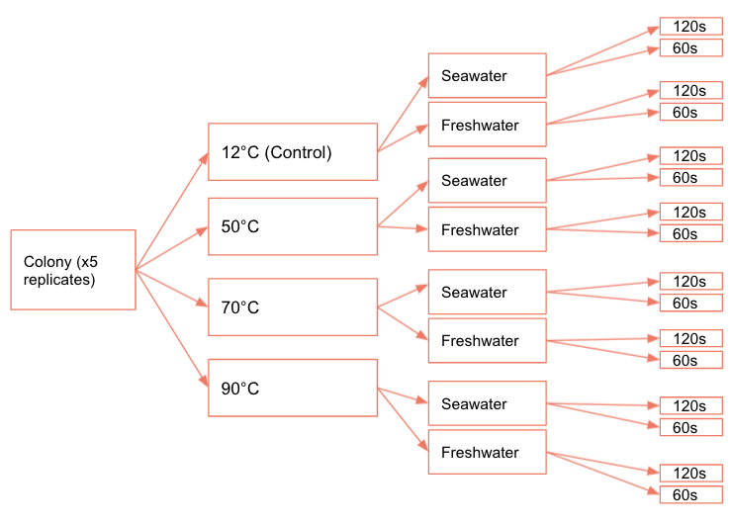

**Fig. 1.** Experimental design including the different treatments. Each treatment group has 5 replicates sourced from each of the five colonies

**Fig. 2.** Examples of mold coverage scale and sample tunicates to go with each rating. Note that mold sometimes appeared to be clear and thus, does not fully show up in the photograph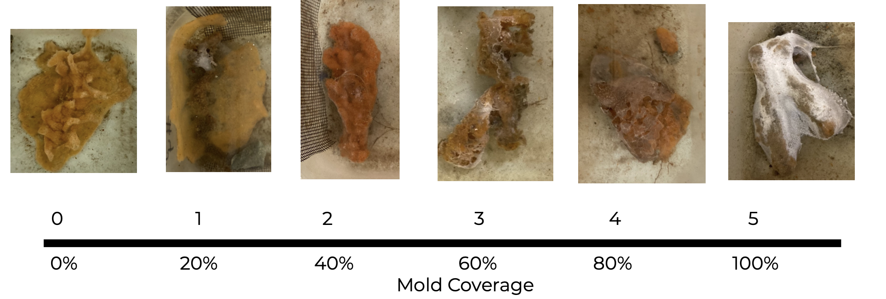

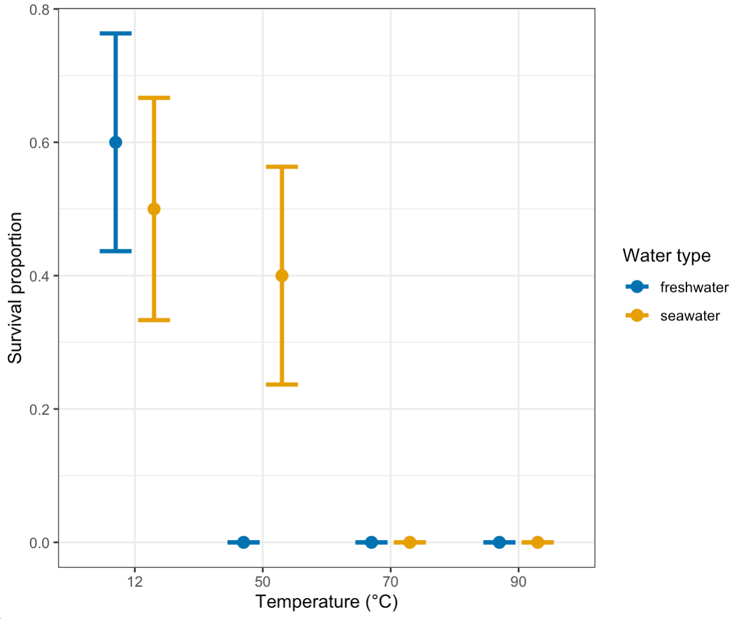

**Fig. 3.** The proportion of *D. vexillum* samples that were still alive three weeks after immersion in freshwater or seawater dips at four different temperatures . Survival proportion is the mean proportion ± standard error. Each point represents n=10.

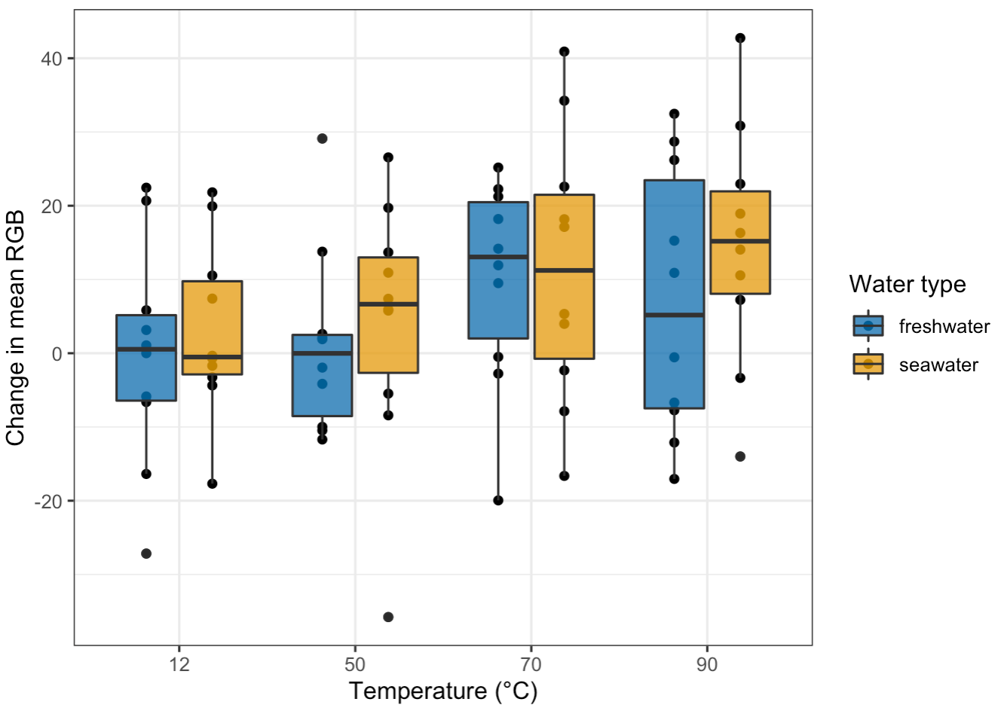

**Fig. 4.** Comparing change in mean RGB between initial mean RGB and mean RGB 48 hours after *D. vexillum* samples were subjected to freshwater or seawater dips at four temperatures. Each box represents n=10.

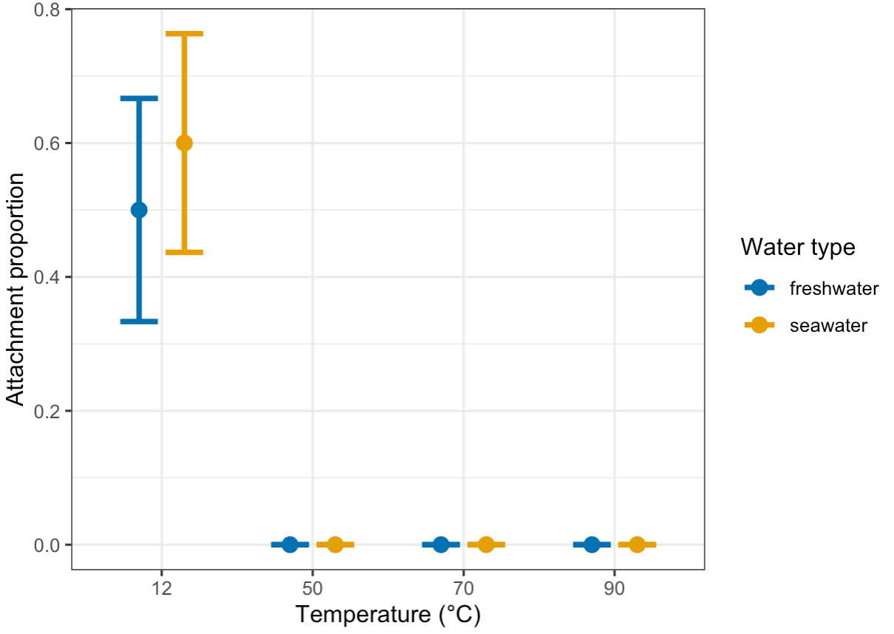

**Fig. 5.** The impact of the temperature of hot water dips on the proportion of *D. vexillum* that were attached to their containers at 3 weeks. Attachment proportion is the mean proportion ± standard error. Data was separated into freshwater and seawater dips. Each point represents n= 10.

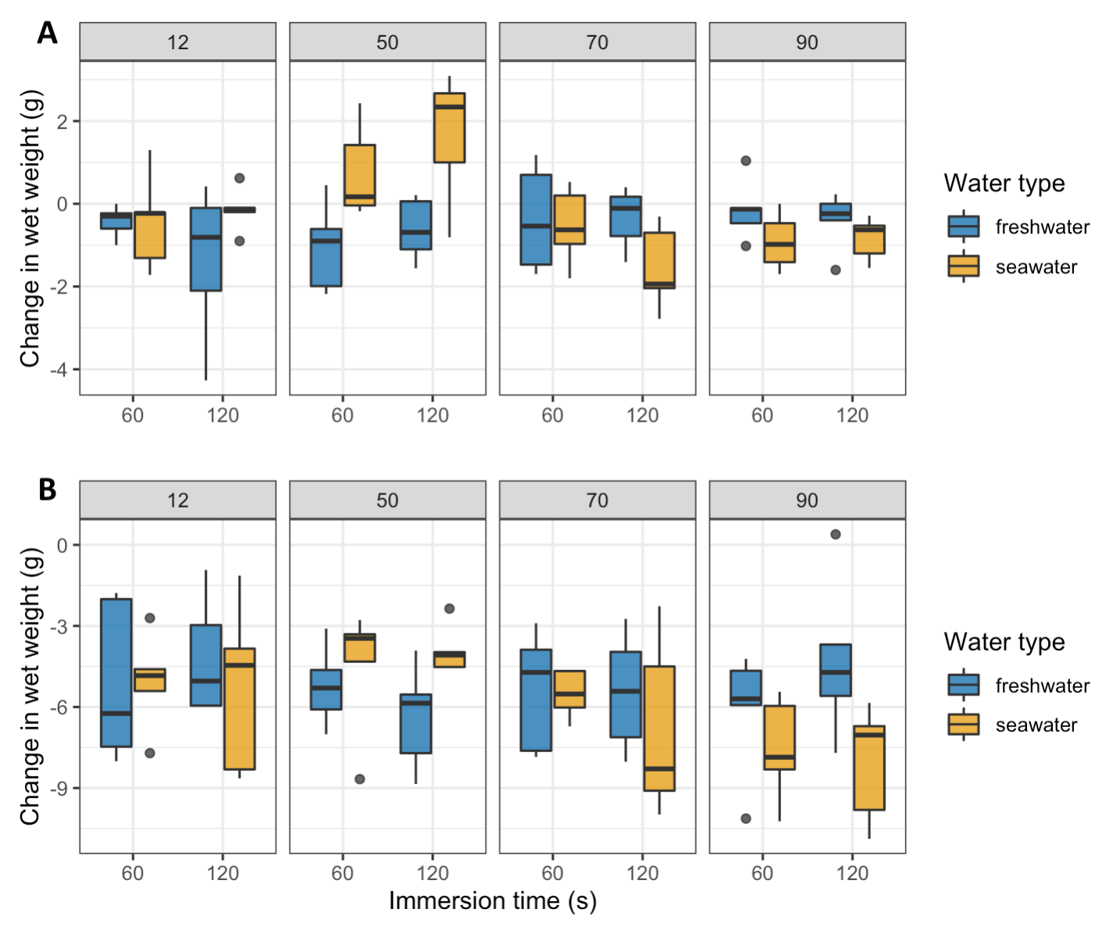

**Fig. 6.** Box plot comparing change in wet weight over a (A) 48 hours and (B) three week across exposure times (120s, 60s), water types (freshwater and seawater) and temperature (12°C, 50°C, 70°C, and 90°C) for *D. vexillum* samples exposed to hot water dips. Change in wet weight was determined by subtracting final wet weight after from post acclimation wet weight. Each box represents n=5.

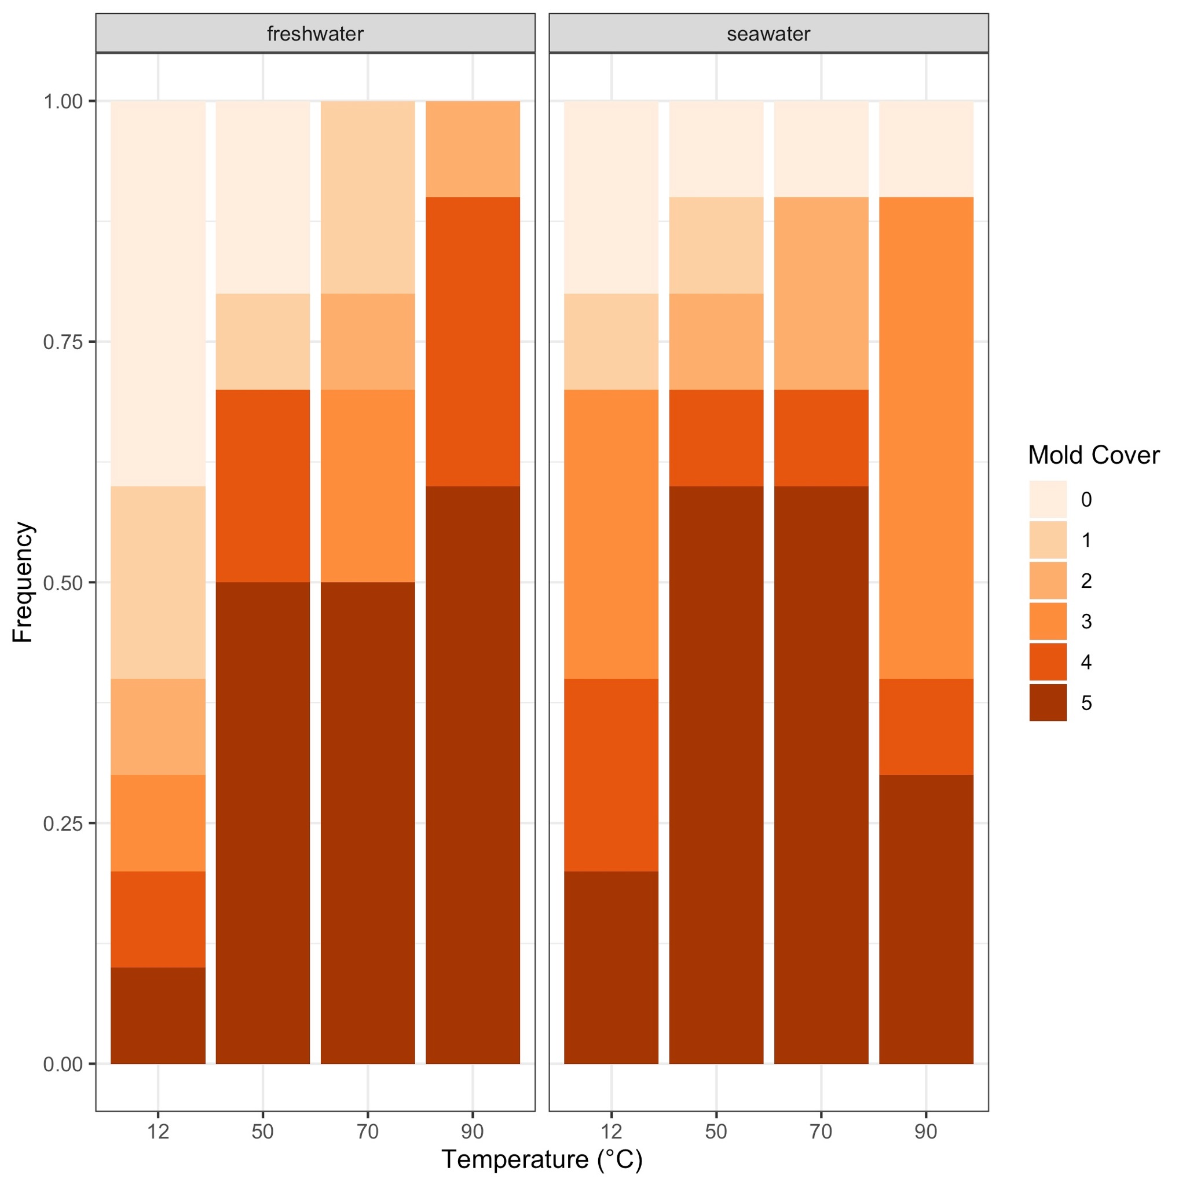

**Fig. 7.** Mold cover 3 weeks after temperature and freshwater treatment of *D. vexillum*. Mold cover was determined on a 0-5 scale, where 0 indicates no mold, 1 indicates 20% mold, 2 indicates 40% mold, 3 indicates 60% mold, 4 indicates 80% mold and 5 indicates 100% mold cover. Each stacked bar represents n=10.

**Supplementary Information**

**Table S1.** The full and final models of different response variables in exploring the impact of different temperature and water type immersions on *D. vexillum*. Transitions from full models to final models were obtained using backwards model selection. Variables in italics represent random effects.

|  |  |  |
| --- | --- | --- |
| Response Variable | Full model | Final model |
| Change in wet weight after 48 hours (g) | weight_change_48hr ~ water_type + temperature_c + exposure_time_s + water_type*temperature_c*exposure_time_s | weight_change_48hr ~ water_type + exposure_time_s |
| Change in wet weight after 3 weeks (g) | change in wet weight ~ temperature + water type + exposure time + temperature*water type*exposure time + *colony_id* | Change in wet weight after 3 weeks ~ water_type + temperature_c |
| Attachment | attachment ~ water_type + temperature_c + exposure_time_s + water_type*temperature_c*  exposure_time_s | attachment ~ temperature_c |
| Survival | survival ~ temperature + water type + exposure time + temperature*water type*exposure time + *colony_id* | survival ~ temperature_c |
| Mold Cover | n/a | mold_cover ~ water_type + temperature_c + exposure_time_s + exposure_time_s*  water_type*temperature_c + *colony_id* |
| Mean RGB after 48 hours | 48hr_rgb ~ exposure_time_s + water_type + temperature_c + exposure_time_s*water_type*  temperature_c + *colony_id* | 48hr_rgb ~ water_type + temperature_c |

**Table S2.** Chi-squared values, degrees of freedom and p-values from the Kruskall-Wallis tests performed on survival and attachment proportions of *D. vexillum* to their containers 3 weeks after being immersed in water dips using different temperatures, relative to a 12°C control. An asterisk indicates a significant p-value.

|  |  |  |  |  |  |  |
| --- | --- | --- | --- | --- | --- | --- |
|  | Survival |  |  | Attachment |  |  |
|  | Chi-squared | df | p-value | Chi-squared | df | p-value |
| Temperature (°C) | 26.171 | 3 | 8.781e-06 * | 37.783 | 3 | 3.142e-08 * |

**Table S3.** Z and p-values from the Dunn’s-Kuskall Wallace tests performed on survival proportions and container attachment proportions of *D. vexillum* 3 weeks after being immersed in water dips using different temperatures, relative to a 12°C control. An asterisk indicates a significant p-value.

|  |  |  |  |  |
| --- | --- | --- | --- | --- |
|  | Survival |  | Attachment |  |
| Temperature (°C) | Z | Adjusted p-value | Z | Adjusted p-value |
| 50 | 2.82 | 1.93e-02 * | 5.02 | 3.12e-06 * |
| 70 | 4.43 | 5.70e-05 * | 5.02 | 2.60e-06 * |
| 90 | 4.43 | 4.75e-05 * | 5.02 | 2.08e-06 * |

**Table S4.** The p-values of backwards model selection for the impact of different water types, temperatures, and exposure times of water dips of *D. vexillum* on the 6 response variables (survival, mean RGB after 48 hours, attachment, change in wet weight after 48 hours, change in wet weight after 3 weeks and mold cover). An asterisk indicates significant p-values.

|  |  |  |  |  |
| --- | --- | --- | --- | --- |
| Treatment | Mean RGB after 48 hours | Change in wet weight after 48 hours | Change in wet weight after 3 weeks (g) | Mold cover |
| seawater | 0.05026 | 0.0105 * | 0.271 | 0.166767 |
| 50°C | 0.55664 | n/a | 0.893 | 0.142722 |
| 70°C | 0.00286 * | n/a | 0.224 | 0.181027 |
| 90°C | 0.01925 * | n/a | 0.0315 * | 0.041566 * |
| 60s | n/a | 0.0331 * | n/a | n/a |
| 120s | n/a | n/a | n/a | 0.234606 |