**Website development information about idea and progression**

**P13202994**

# Tools and items used

* Github
* Bootstrap
* Adobe photoshop
* Brackets
* JavaScript
* HTML
* CSS

# Initial subject idea

From starting, I wanted to develop a single page website with lots of ideas in mind but at the end I concluded that I should do my website on this idea on my interest as it will be easy for me add the content and the development will be much easy and enjoyable for me.

# Initial design idea

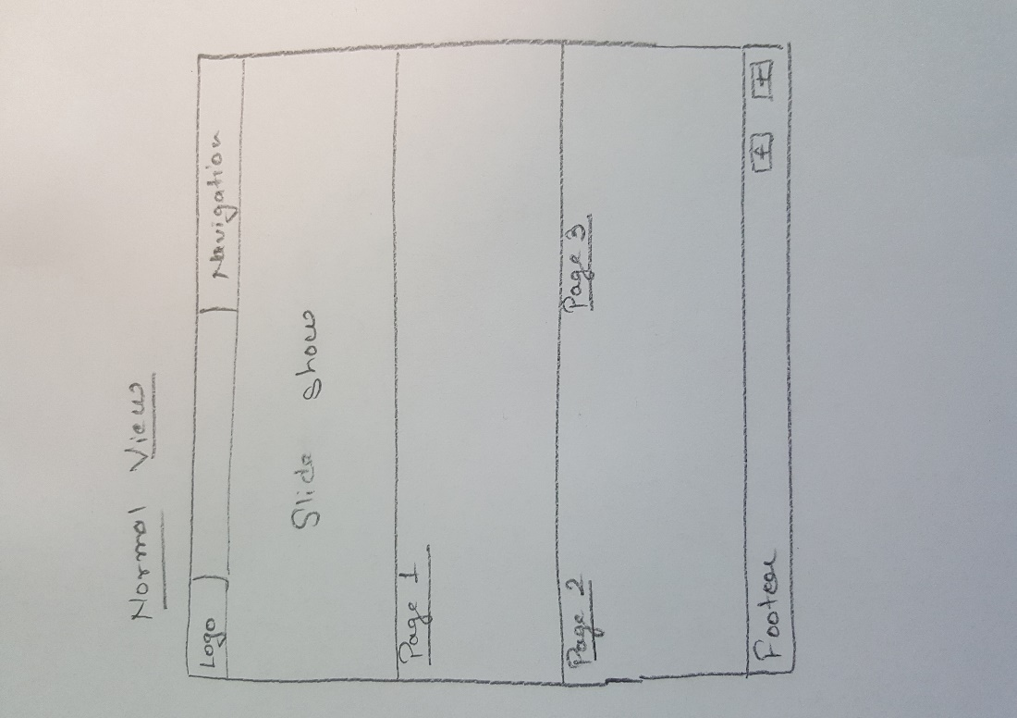I got the idea of single page website from various websites I came across while researching around the web and made my initial design on paper which I had to moderately change at later stages of development.

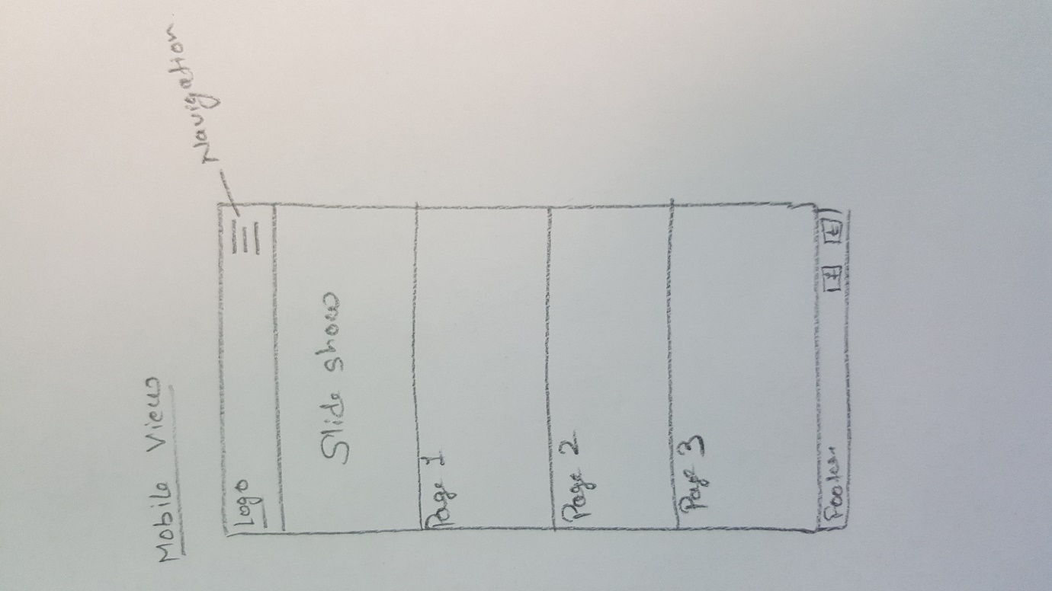

Figure 1- Desktop view of initial idea

Figure 2- Mobile view idea

# Final design

Before putting the idea into action, I again made my final design on a piece of paper and stick to that design till the end of development stage. I just needed to change some layout of the content in order to make it look good according to device size. The final design screenshots are given below:

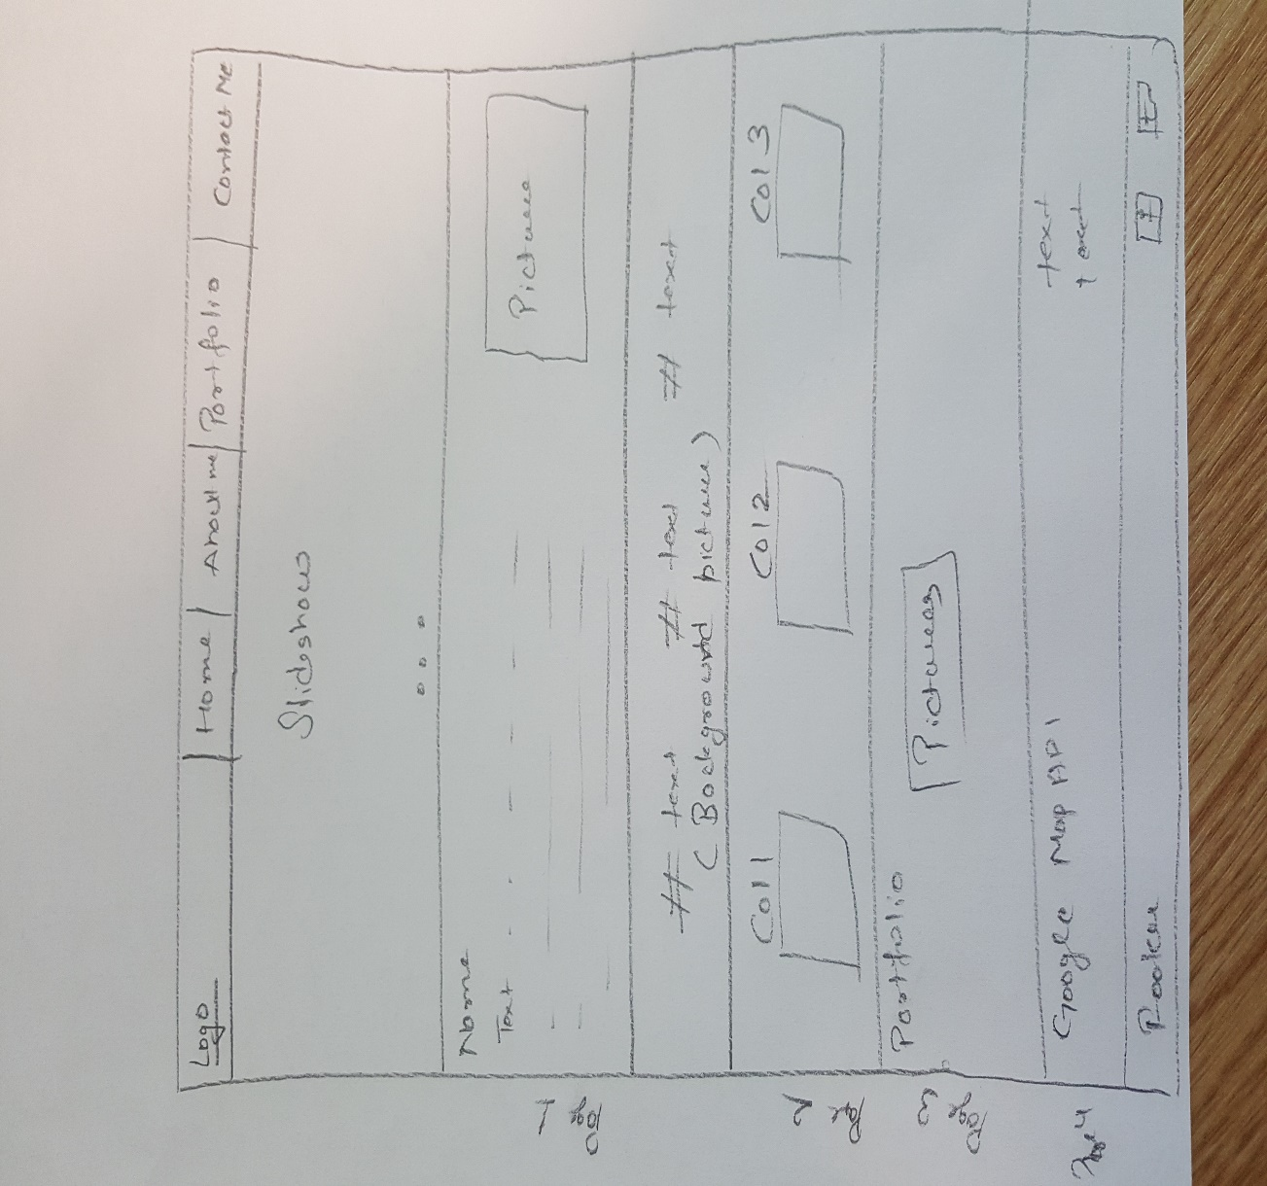

Figure 3- Desktop view

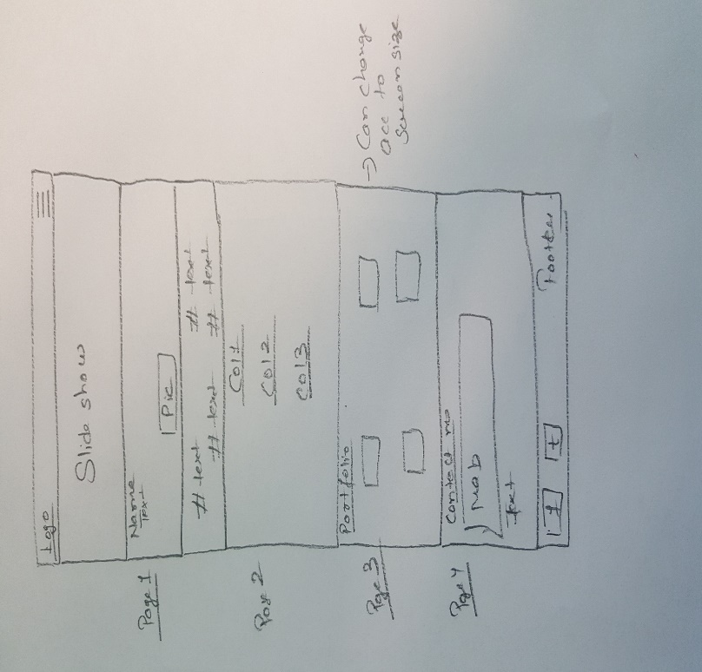

Figure 4- Mobile view

# Navigation

The navigation of the website is in two forms- normal view which is desktop view and other one is mobile view. The screenshots are given below:

C:\Users\RAJVIR SINGH\AppData\Local\Microsoft\Windows\INetCache\Content.Word\nav.jpg

Figure 5- Normal navigation view

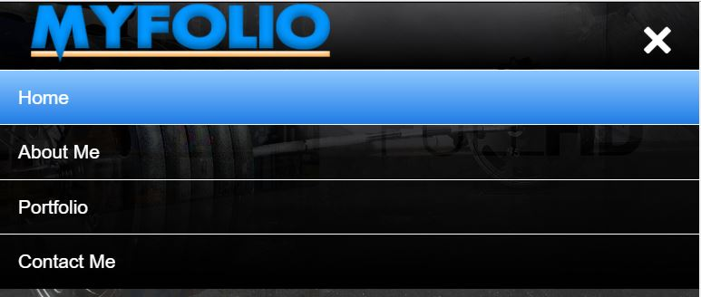

Figure 6- Mobile view navigation

## Pages

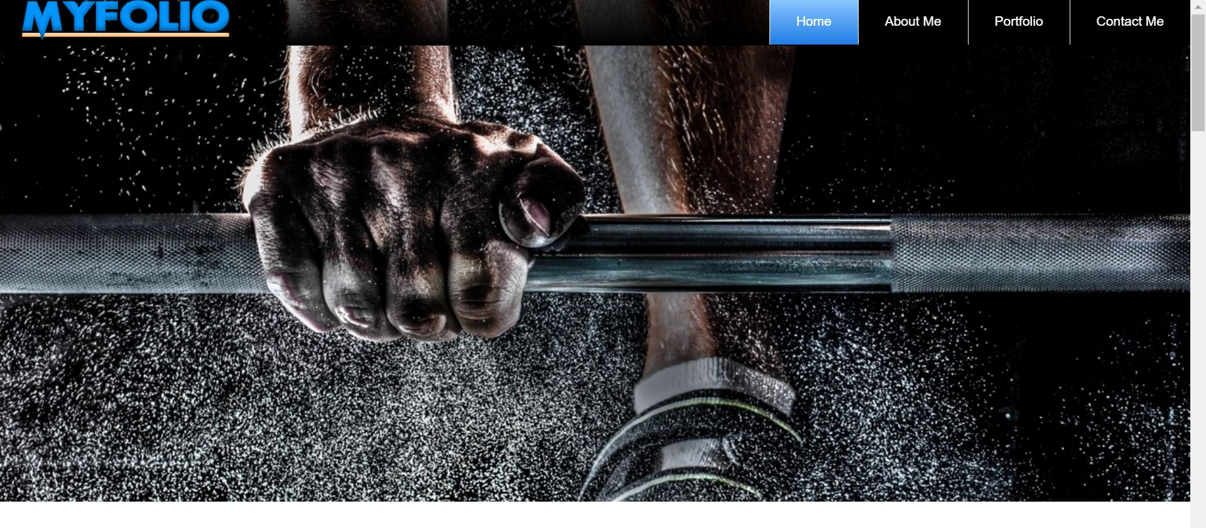**Home**

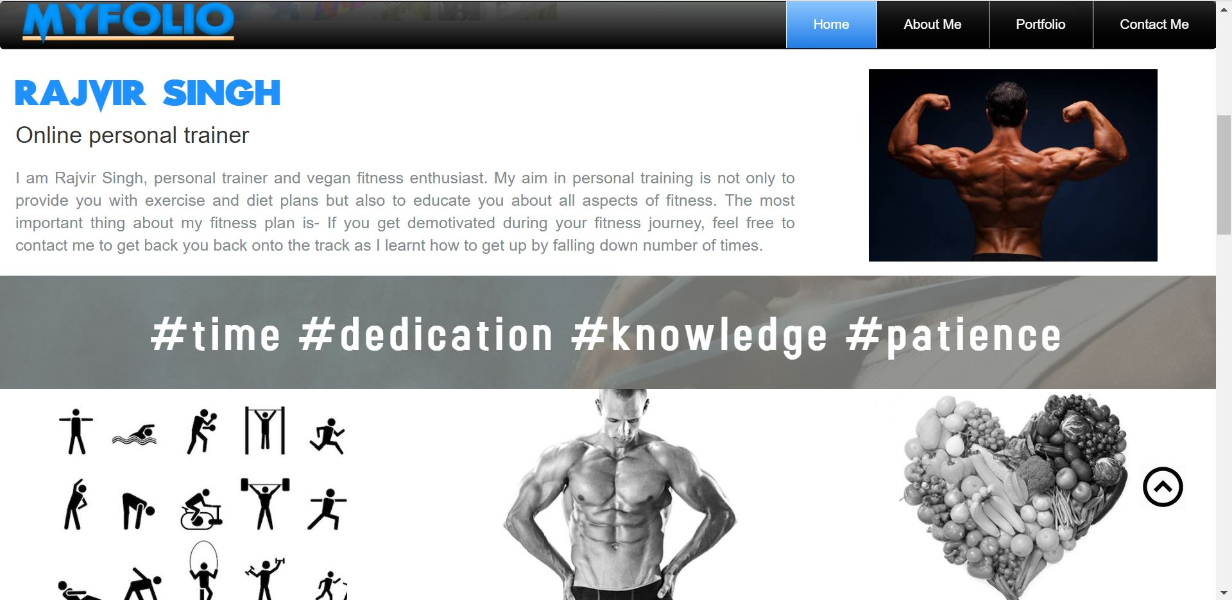**About me**

**Portfolio**

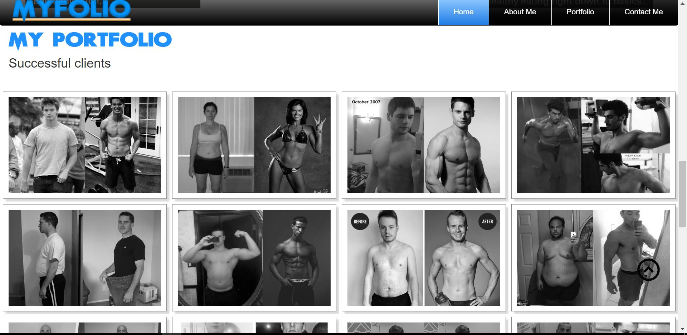

**Contact me**

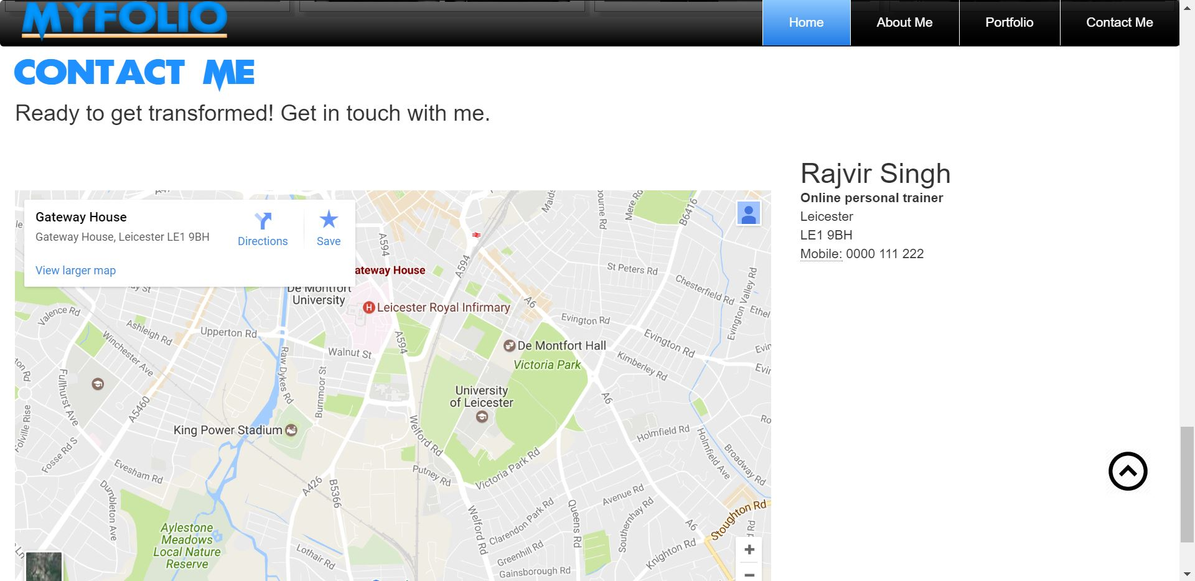

# Development stages