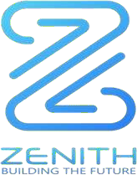

**A Hybrid Blockchain The Whitepaper** [info@zenithchain.co](mailto:info@zenithchain.co) [www.zenithchain.co](http://www.zenithchain.co/)

Contents

* 1. Abstract 2
  2. System Reward Distribution 2
  3. Infrastructural Components of Zenith Chain 2
  4. How it works 2
  5. Limitations of the Purchasers 2
  6. The Blockchain and Cryptocurrency Era. 2
  7. Decentralization of the Blockchain Network 3
  8. The Seller-Buyer-Deposit Escrow Trade Protocol 4
  9. Introduction
  10. Our Company 3
  11. Products Overview 4
  12. Industry Overview 5
  13. Market opportunity 5
  14. Peer-to-Peer Exchange. 6
  15. Market Trends 6
  16. Future of Cryptocurrency 6
  17. ZTC Token Overview 7
  18. The Zenith Chain Solution 7
  19. Zenith Chain Token Smart Contract 7
  20. Benefits of the Zenith Chain Smart Contracts 7
  21. Token Allocation 7
  22. Sales projection for Zenith Chain 7

4.1 Development Roadmap 8

5.1 Zenith Chain Team 8

6.1 Risk Factors 8

Important disclaimer 8

* 1. Abstract

The crypto market capitalization enjoyed a fantastic bull run in 2017, with financial experts valuing it at $90 billion. The wide acceptance by investors has pushed the market to grow more than ten times in valuation in just two years and has stimulated and kept the pace of the bull run.

There are different types of digital currencies in the market today that has caught the world’s attention as the blockchain technology it is based on is advanced. For an individual or company to thrive in today's digital age, it must adapt to the dynamic technologies that may threaten its existence if not properly harnessed. More companies are shifting their sights to digital marketplaces as it enables them to connect to people outside their target. It has proven to be more effective than traditional advertising. These transformational trends are a mix of technology and effective business models. They are based on patterns such as investments and the influence of the younger generation. With the advent of the 5G technology, the cost of reliable internet and mobile telephony will crash as people will demand more effective and cheaper access. More people will require access to affordable connectivity and data.

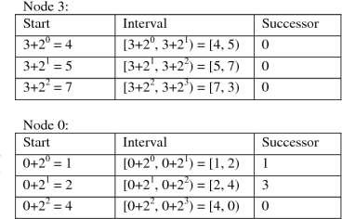

The number of online shoppers in 2020 increased astronomically as more people shopped for food and groceries from their homes. In the past, it was difficult to get people to shop for food online as consumers did not mind the inconvenience of going to the supermarkets to get their groceries. The 2020 lockdown necessitated the digital transformation. The ease of getting fresh products and cooked meals convinced shoppers to do more online transactions. The financial institutions also profited immensely as most of these deliveries were paid for by cashless transactions.

There is a dire need for a reliable cryptocurrency that can be used for online transactions. An underlying feature of the cryptocurrency that made it easily accessible is the exquisite blockchain technology. Technological advancements allow for a decentralized network. This means it casts out the need for third parties such as banks and online exchange platforms. This enabled it to reduce third-party costs and further enhance peer-to-peer purchasing. Transaction histories are also accessible to the public. It can be compared to Microsoft Teams. It's like a folder several people can access at once. This reduces the chance of fraudulent acts drastically.

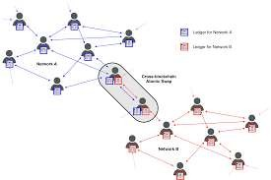

Zenith Chain is an innovative solution that brings programmability and interoperability. One of the banes of eCommerce is that the parties involved in the transaction do not know or even trust the intentions of each other. We have always used third-party mechanisms to sort out such issues. This is a dilemma for eCommerce where third-parties are non-existent. With the rigid

blockchain protocols that serve to protect the integrity of eCommerce, there are still lingering doubts about whether either of the parties can circumvent the system.

There are twenty-one validators with Proof of Staked Authority consensus that can enable Zenith Chain to have a shorter time for block generation and lower fees. In addition, Zenith Chain would guarantee native support of interoperability; provide security and safety with the validators.

* 1. System Reward Distribution

Zenith Chain has an impressive system reward structure, and certain parameters may guide the distribution. The Zenith Chain system reward distribution is done using a decentralized peer-to-peer exchange network. In the Zenith Chain, decentralized network users can earn rewards from apps that offer points using blockchain technology. The rules that will guide the distribution of rewards on the Zenith Chain include-

* + - The Zenith Chain Validators block generators will receive a total of 0.9375 of the gas fee.
    - System reward contracts receive a total of 0.0625 of the gas fee.
  1. Infrastructural Components of Zenith Chain

Zenith Chain Validators: Zenith Chain validators verify each transaction on the blockchain before adding it to a distribution ledger. The validators, also called miners, “earn’ the right to verify these transactions after solving varied computational problems. The validators are also given rewards for work done.

dApps: Decentralised apps are computer applications without a central authority that run on a distributed network. The overall performance of dApps is dependent on the users of the devices utilized to access the network. dApps are created to perform a particular function on the device, and it is often the device that determines the performance of the Decentralised apps.

Cross Chain Contract: A Cross-Chain Contract is a smart contract that deals with exchanging tokens or services across two different networks on the blockchain. Zenith Chain cross-chain contract is a secure and fast decentralized mechanism that can handle exchanges of two or more tokens, between Ethereum and BSC, without an escrow.

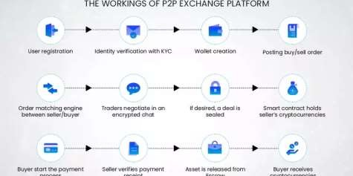

Safety: ES and EB will serve as safety for both parties in the transaction. Either party would want to get shorted by the escrow and would prefer the transaction to continue as is. This is a Perfect Nash Equilibrium, and it would curb fraudulent acts from either party.

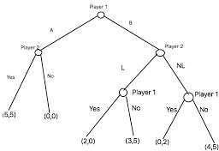

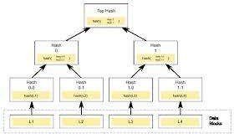Merkle Proof Verification Library: To efficiently organize the ton of data through our nodes, Zenith Chain understands that the data gotten would have to be hashed, compacted, and verified using a computational process.

Source: bitcoin.eu

* 1. How it works

We designed the consensus engine of Zenith Chain to achieve the following goals:

* + - Wait for a few blocks to confirm (it should be less than Ethereum 1.0).
    - Blocking time should be shorter than Ethereum 1.0 (i.e., 5 seconds or less).
    - No inflation. The block reward is transaction gas fees.
    - As much as compatible as Ethereum.
    - With staking and governance as powerful as cosmos.
  1. Limitations of the Purchasers

The sale of Zenith Coin (ZTC) will be open to all interested subscribers except nationalities of countries where the purchase of cryptocurrencies is expressly and legally prohibited by extant laws. For example, countries such as the People’s Republic of China and India prohibit purchasing cryptocurrencies within their borders. It means individuals from these countries cannot purchase the Zenith Coin (ZTC).

Individuals and entities desiring to purchase the Zenith Coin (ZTC) must understand the requirements for purchasing cryptocurrencies as

* 1. The Blockchain and Cryptocurrency Era

The main goal of bitcoin then was to control the distribution of digital coins. Within a few years, the value of the bitcoin coin has gone to a whopping market cap of 70 billion dollars. Far higher than venture-based industries, the blockchain industry has generated more than 1.3 billion dollars based only on ICOs, which is incomparable to the $500 million the venture-based industries raised. This also brought about the introduction of other coins like Ethereum, Litecoin, and others. In their way, these new coins have also become a hit in the stock market, all of them banking on the huge success of their predecessor. Here are a few things about the crypto market in 2021; bitcoin’s market cap has succinctly exceeded 70 billion as of 2018. There have also

been early predictions that as soon as 2027, the global GDP would be continually stored on blockchain technology. This means that at least 10% of the Global GDP would be developed solely on blockchain technology.

* 1. Decentralization of the Blockchain Network

Decentralization is when power or control over a particular phenomenon is transferred from one entity and distributed among several people.

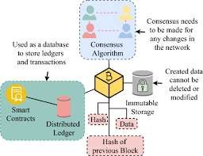

Source: [www.ethereum.com](http://www.ethereum.com/)

A decentralized blockchain network allows everyone using the network to have control over said network. This improves the functionality of the network and also strives to enhance people's trust in one another.

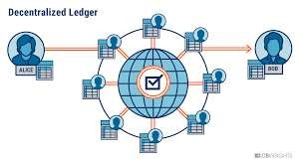

Source: [www.ethereum.com](http://www.ethereum.com/)

* 1. The Seller-Buyer-Deposit Escrow Trade Protocol

The Seller-Buyer-Deposit Escrow Trade Protocol mandates both parties in the transaction, the seller and buyer, to deposit the total value of the product into an escrow account.

* + - The Seller’s deposit is denoted by ES
    - The Buyer’s deposit is denoted by EB

To initiate this kind of transaction and open a smart contract, the seller must make known-

* + - * The contract nonce (denoted by ID)
      * The value of the product (denoted by Pd.)
      * The hash of the product (denoted by h(d)

If the transaction does not occur after negotiations, both parties will have their deposits refunded. If the seller rescinds on the transaction, the buyer’s deposit is wholly refunded, and the seller is only refunded half the sum. If the buyer rescinds on the transaction, the seller’s deposit is wholly refunded, and the buyer is only refunded half the sum.

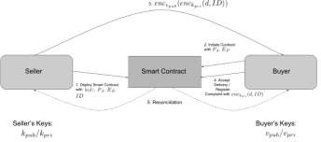

# Introduction

* 1. Our Company

|  |  |
| --- | --- |
| Coin Name | Zenith |
| Coin sign | ZTC |
| Blockchain name | Zenith Chain |
| Company Name | UAB ZENITH CHAIN |
| Address | Vytauto str33, Vilnius Lithuania |
| Owners | Jonathan Emmanuel |
| Rajesh Chinnadurai |
|  | Jerrome Jones |
|  | Dimeji Tomori |
| Email | [info@zenithchain.co](mailto:info@zenithchain.co) |
| [sales@zenithchain.co](mailto:sales@zenithchain.co) |
| Website | https://zenithchain.co |
| https://zenithchain.net |
| Total Coin in Circulation | 21 million Zenith |

UAB Zenith Chain is a blockchain technology company operating out of Vilnius Lithuania, and aids clients own digital goods, digital assets, and data. The startup company performs the following functions-

* + - Offer new tools for authentication and authorization in the digital world that preclude the need for many centralized administrators.
    - Offer value exchange protocols for internet-based transactions.
    - Provide other related cryptocurrencies and digital payment system consulting and advisory services.

We perform these diverse roles, understanding that our operations must be transparent and efficient if we want the public’s confidence. This means ensuring our platform is an interactive and educative ecosystem that can facilitate the accessibility of authentic information to clients, investors, and the general public. Zenith Chain will work with different exchange and trading companies cum bitcoin traders and people and organizations that make online transactions in our immediate community, and people in cyberspace who make online transactions from all over the world.

* 1. Products Overview
* Zenith Chain- A Hybrid Blockchain
* Zenith Coin – ZTC Digital Cryptocurrency
* Z-Exchange Centralized Exchange
* Zenith Pay A Digital Crypto Bank
* Zenith Stay Tokenized Realtors
  1. Industry Overview

This whitepaper aims to facilitate potential investors in the hybrid blockchain Zenith Chain by providing an overview of the industry with the hope that such information as provided herein will help the potential investors in crucial investment decisions. The data would be sourced from reports, brochures, market forecasts, and editorials with the conviction that these literary materials are accurate and precise.

E-commerce, in 2020, rose past the expectations of industry experts as most people were on lockdown for most parts of the year, and this increased the value of the global e-commerce market size from about USD 1.9 trillion in 2016 to more than USD 4 trillion in 2020. Revenues from online sales have guaranteed a paradigm shift as more Americans are delving into e- commerce. More people are utilizing mobile payment gateways, and the mobile payment volume in the United States will surpass $270bn before the end of 2021. There are infinite possibilities for blockchain companies that can provide reliable and efficient services.

* 1. Market opportunity

The trend in the global cryptocurrency market shows that there is an increase in the purchase of digital currencies and the number of transactions across decentralized networks on blockchain technology. However, it is the increase in digitization, the legitimization of digital currency, and the widespread acceptance of cryptocurrencies as legal tender that has spurred the growth of the market.

As a digital peer-to-peer network, Zenith Chain will efficiently utilize the ethereum blockchain to secure the transfer of digital curries and assets between parties.

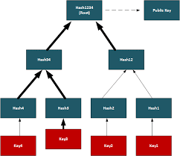

* 1. Peer-to-peer exchanges

The digital peer-to-peer exchange is a system that allows the movement of digital currencies from one account to another without utilizing the services of a financial institution. It can also involve the decentralized exchange of data or assets between parties. There is no central authority that censors P2P exchanges. The P2P exchanges depend on an internet connection before they can be processed.

* 1. Market Trends

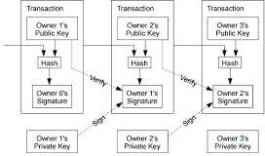Zenith Coin (ZTC) will leverage on the acceptance of cryptocurrencies such as Bitcoin, Ethereum, and Litecoin. The Zenith Chain will offer better security and privacy than most public blockchains, and the chain data will be accessible to the public. Transactions using blockchain-enabled cryptocurrencies may have unprecedented security and anonymity, but that does not make them untraceable. Today there are companies specialized in the art of tracking down suspicious activities on blockchains to prevent people from using blockchain technology for nefarious activities.

Source: [www.satoshinakamoto.me](http://www.satoshinakamoto.me/)

Bitcoin started the demand for cryptocurrencies, and it has become the de facto standard for digital currencies. It would seem that the other cryptocurrencies, called altcoins, are altered versions of Bitcoin but with the same principle. Its growth is spurred by the need for a decentralized digital currency that can’t be controlled by governments as it is operated on revolutionary blockchain technology. As a result, the value of bitcoin is increasing exponentially, and it has had a meteoric rise from its value of $0.39 in 2010 to its value of $7,319 in November 2017.

Ethereum can be referred to as the blockchain computer that provides secure interfaces to developers on its platform. It functions as a programmable blockchain primarily for developers and merchants. It is these features that set it aside from Bitcoin.

The operations are on the digitally encrypted blockchain technology. So developers and merchants can harness its benefits, such as not being censored, altered, or modified without the permission of the developer. Ethereum has its currency token called Ether, which can be used to pay for fees on the Ethereum network. Ethereum is the second most valuable digital currency today as it presently has a market capitalization of $41.4 billion.

Litecoin is the third most valuable digital currency in the world. Its technology is based on an open-source global network, and its operations are not controlled by any central authority. Launched in the year 2011 and created by Charlie Lee to address the challenges faced by Bitcoin on blockchain technology. The innovative feature of Litecoin is that its rate of block generation is faster than Bitcoin blockchain technology. This guarantees that Litecoin will have quicker and more efficient transaction confirmation. Litecoin presently has a market capitalization of $3.82 billion.

* 1. Future of Cryptocurrency

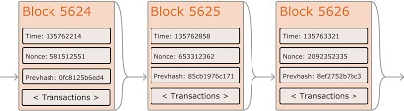Blockchain technology has been widely accepted for business transactions and many other sectors of the economy in different parts of the world. It is now applied in the Agricultural sector, Electronics and Communications, Automotive, Consumer Goods, Healthcare, Logistics, and Supply chains to streamline and make seamless the process of doing business. The value of some cryptocurrencies such as Bitcoin, Ethereum, and Litecoin has surpassed the value of fiat currency as more people are turning to them to avoid devaluation.

Source: [www.ethereum.org](http://www.ethereum.org/)

The evolution of cryptocurrency may require ‘smart contracts’- a feature that will ensure the digitization of some processes done manually. Smart Contracts will shorten the transaction process as well as streamline the process of doing business.

Cryptocurrency is the currency of the future as it is likely to replace fiat currency as governments embrace blockchain technology. Blockchain protocols are increasingly becoming immersive and will enable cryptocurrencies to be the next logical step in the evolution of money.

* 1. ZTC Token Overview

Zenith Chain, after critically understanding the demands for tokens, studying the underlying token standards, and determining the acceptable features of our crypto coin, has decided to redesign the token as ZRC-20 and ZRC-721.

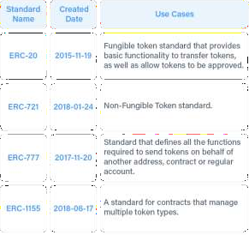

Source: crypto.com

The features we are searching for in our token will be

* + - Optimal Security: The security of the ZTC Token will be from Ethereum or by a pool of professional validators
    - It must be efficient and compatible but also have flexibility, adaptability, and ease of use
    - The ZTC Token must be customable to fit with the requirements of investors
    - Its sovereignty is inalienable.
  1. The Zenith Chain Solution

Zenith Chain is bringing innovative solutions to P2P exchanges. A unique way we can do this is to link people who do interwoven business practices. Vendors will be connected to clients who desire their products. We will also have retailer platforms and shopping apps to connect with enthusiasts and reinvigorate the P2P program. Another innovative solution we are coming with is ensuring that Zenith Chain Smart contracts always remain composable. Zenith Chain is an ever-evolving blockchain technology company, and we will do more to always innovate and stay ahead of the competition and ensure that the token will be compatible with existing decentralized exchanges.

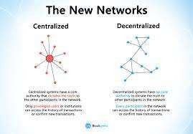

Source: [www.blockgeeks.com](http://www.blockgeeks.com/)

* 1. Zenith Chain Token Smart Contract

A smart contract is a digital contract, also referred to as self-executing contracts, between two parties using a decentralized ledger on the blockchain as a database. This contract may streamline the exchange of assets, document, digital currencies or anything can be valuable to the concerned parties.

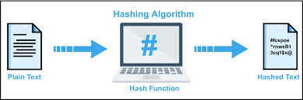

The ledger contains the terms of the digital contract and can also determine when the ‘digital conditions’ have been fulfilled. Zenith Chain Smart Contracts cannot be changed once the code has been programmed. Smart Contracts are self-enforcing and usually self-verifies according to the automated agreement.

* 1. Benefits of the Zenith Chain Smart Contracts

The users’ Zenith Chain Smart Contracts enjoy the following services-

* + - The Zenith Chain Smart Contracts get the same optimal security level as the ethereum network, which is impressive.
    - The Zenith Chain network will still ensure that work in the smart contract is carried out as determined in the terms.
    - The Zenith Chain Smart Contracts will enjoy the speed of block generation of the ethereum network. This speed will shorten the time spent on transactions and other business processes.
    - The parties on the Zenith Chain Smart Contract will rest assured that the automated process of the smart contract will ensure that both parties will meet the terms and conditions without disputes.
    - There is no need for a third party when the two parties use a Zenith Chain Smart Contract.
    - The Zenith Chain Smart Contract can always be accessed on the ledger and cannot be lost, stolen, or destroyed.

However, Smart contracts alone cannot get information about "real-world" events because they can't send HTTP requests. This is by design. Relying on external information could jeopardize consensus, which is important for security and decentralization.

* 1. Token Allocation

|  |  |
| --- | --- |
| **Allocations** | **Number of Tokens** |
| Total Coin in Circulation | 21 million Zenith |
| Initial Coin Offering | 3 million Zenith |

* 1. Sales projection for Zenith Chain

|  |  |
| --- | --- |
| **Period** | **Value** |
| First Fiscal Year (FY1) | $700,000 |
| Second Fiscal Year (FY2) | $1,550,000 |
| Third Fiscal Year (FY3) | $3.5 million |

This conservative sales projection for Zenith is dependent on key factors such as the location of the business and the diverse services offered. It is also dependent on factors such as government policies and inflation.

4.1 Development Roadmap

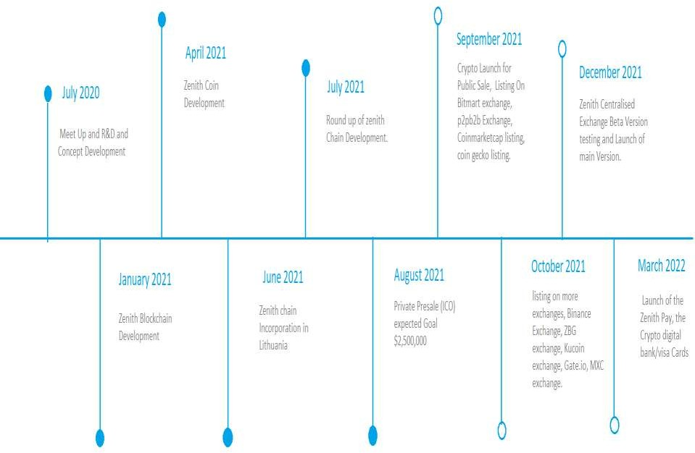

5.1 Zenith Chain Core Team **Jonathan Emmanuel** Founder/Chief Executive Officer

# Rajesh Chinnadurai

Co-Founder/ Chief Technical Officer (CTO)

# Dimeji Tomori

Director /Chief Operating Officer (COO)

# Jerrome Jones

6.1 Risk Factors

A major security risk that a Zenith Coin Token holder will face is losing his private keys. Such a loss will mean that the token holder will not access his digital wallet and stands the risk of losing all his tokens as it is irretrievable. Anyone who has private keys will have access to these tokens without the knowledge of the owner and can misappropriate the tokens in the digital wallet.

ZTC may also be susceptible to attacks from hackers, denial of service, consensus-based attacks, Sybil attacks, smurfing and spoofing, and malware, as the ethereum platform is open-source software that may have bugs. It is the responsibility of the token holder to guard against such a possibility.

The value of the Zenith token is subject to market speculations which may drive the value of a token up or render it valueless.

Important disclaimer

PLEASE READ THESE TERMS OF USE CAREFULLY. BY DOWNLOADING, ACCESSING, OR USING THIS WHITEPAPER, YOU AGREE TO BE BOUND BY THE TERMS AND CONDITIONS. IF YOU DO NOT AGREE TO ALL OF THESE TERMS, DO NOT USE THIS WHITEPAPER.

This whitepaper was written by Zenith Chain (‘UAB Zenith Chain’) to provide potential investors with information that will enable them to make critical investment decisions. It may be used only for informational purposes only and not seen as an offer. This whitepaper is not a contractual agreement and should not be viewed as such.

The primary purpose of this whitepaper is to educate and inform and should not be seen to constitute financial or other professional advice or service.

You will do your due diligence, independently of UAB Zenith Chain, to verify any views and opinions in this whitepaper as there may be errors, omissions, and inaccuracies in parts or whole, and UAB Zenith Chain will assume no responsibility.

UAB Zenith Chain reserves the right to change or modify any of the terms and conditions contained in the Terms at any time and our sole discretion. UAB Zenith Chain reserves the right to change or modify any of the data and information contained in the Whitepaper at any time and our sole discretion.

UAB Zenith Chain reserves the right to change or modify any of the data and information contained in the Whitepaper at our sole discretion at any time before, during, and after the sale of UAB Zenith Chain tokens.

You must understand that by downloading, accessing, or using this whitepaper, you waive any right you may have to receive specific notice of such changes or modifications. References provided are for informational purposes only and do not constitute an endorsement of any sources.

You cannot modify or reproduce any of the information and data contained in this whitepaper without the express and written permission from the UAB Zenith Chain, and doing otherwise will be interpreted as a deliberately malicious and illegal act that UAB Zenith Chain will address using legal measures.