**Wireframe & Annotations**

**index**

|  |  |
| --- | --- |
| **Navigation bar** | |
|  | |  | | --- | | Title |  |  | | --- | | **Slide show** | |
| Information about holiday insight |
| Google maps |

**pictures**

|  |  |
| --- | --- |
| **Navigation bar** | |
|  | |  | | --- | | **images** |  |  | | --- | | Title |  |  | | --- | | Title |  |  | | --- | | **images** | |

|  |  |
| --- | --- |
| **Navigation bar** | |
|  | |  | | --- | | **video** |  |  | | --- | | Title |  |  | | --- | | **video** |  |  | | --- | | Title | |

Video

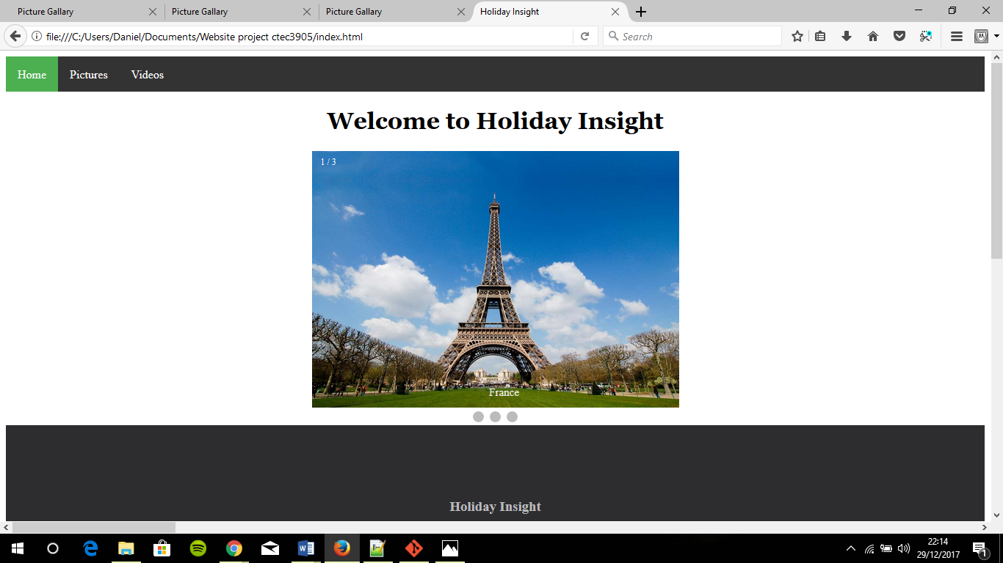

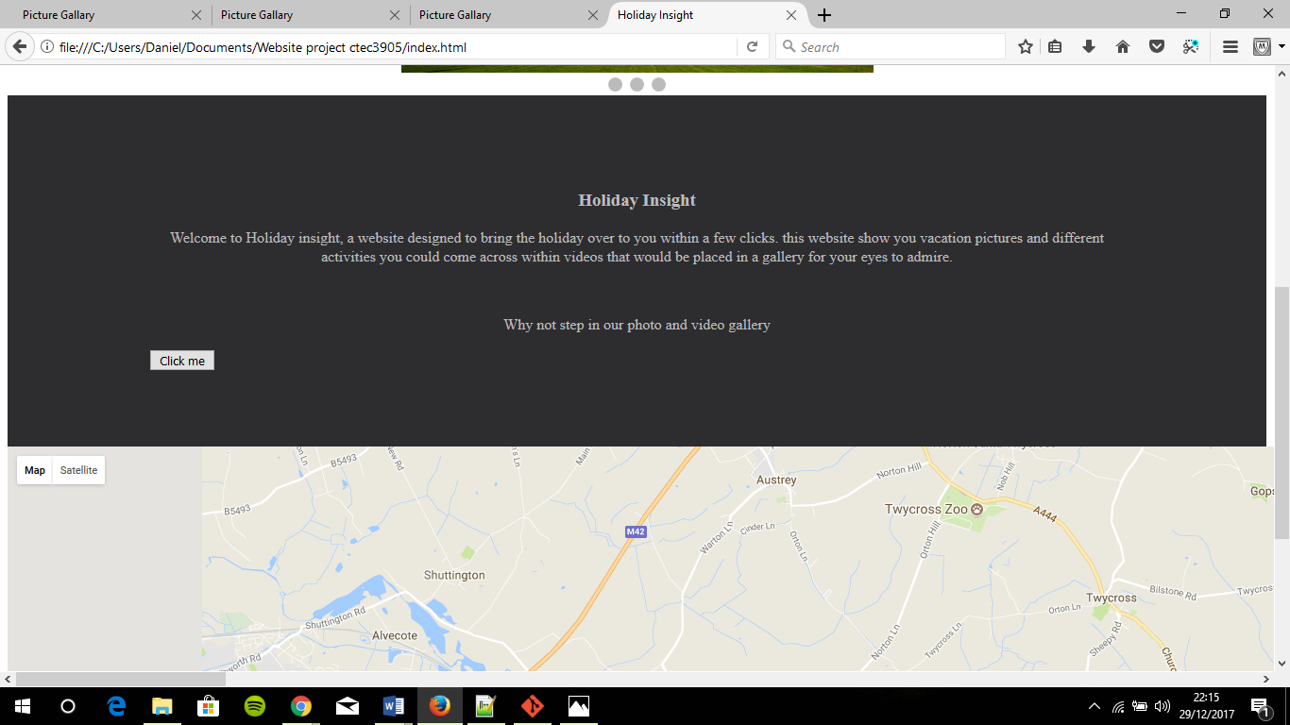

* This is the index page which consists of the navigation bar, title, slideshow, google maps and a click me button.
* The click me button will alert you to view google maps.
* I have implemented a google Api that you can use to located areas.

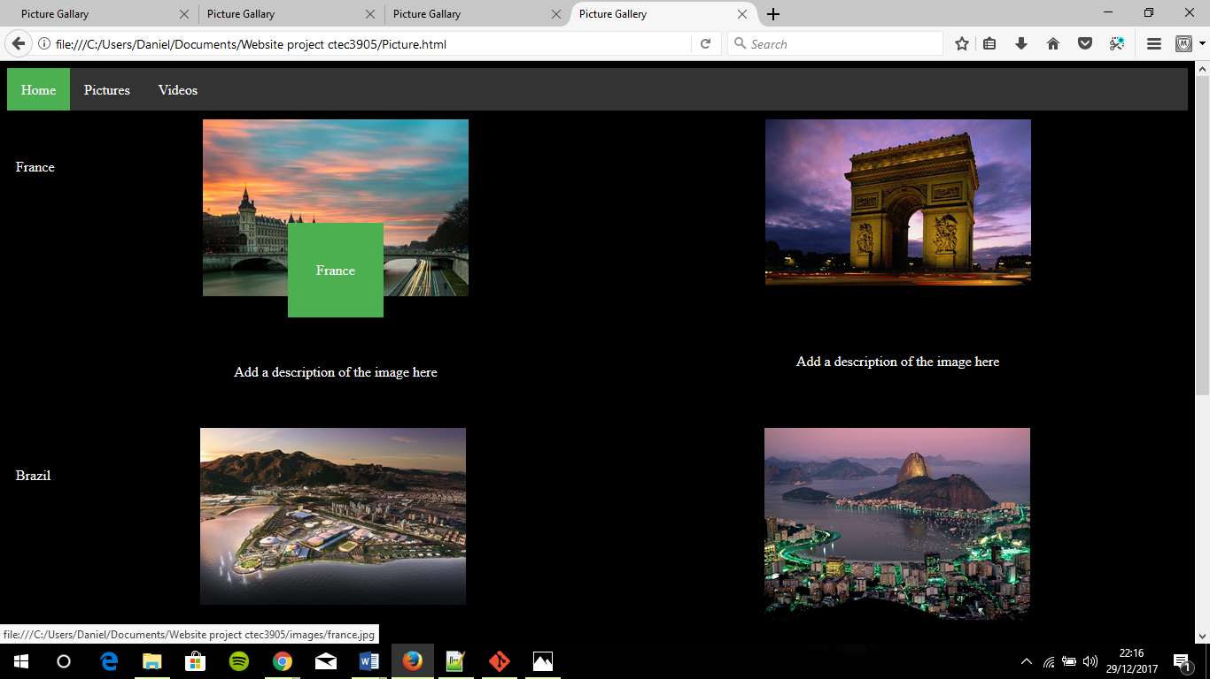

* This is my picture gallery which consists of images that can be enlarged when click on and they also have hover effect over the images as seen above saying “France” above the first image

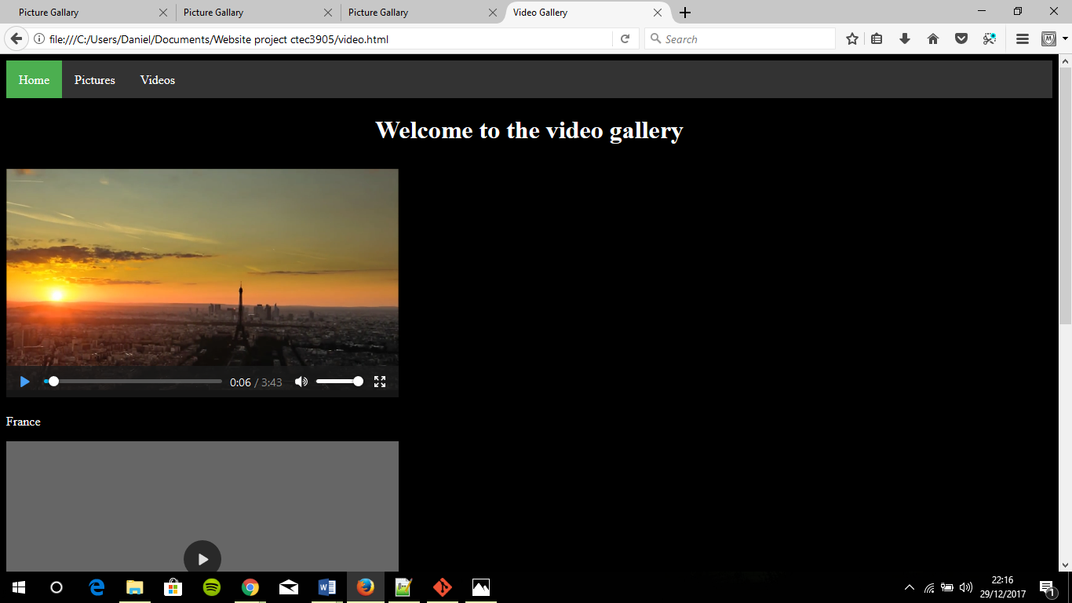

* I have videos on the video gallery with have all been set the same size, the background is black with white texts so it’s visible.

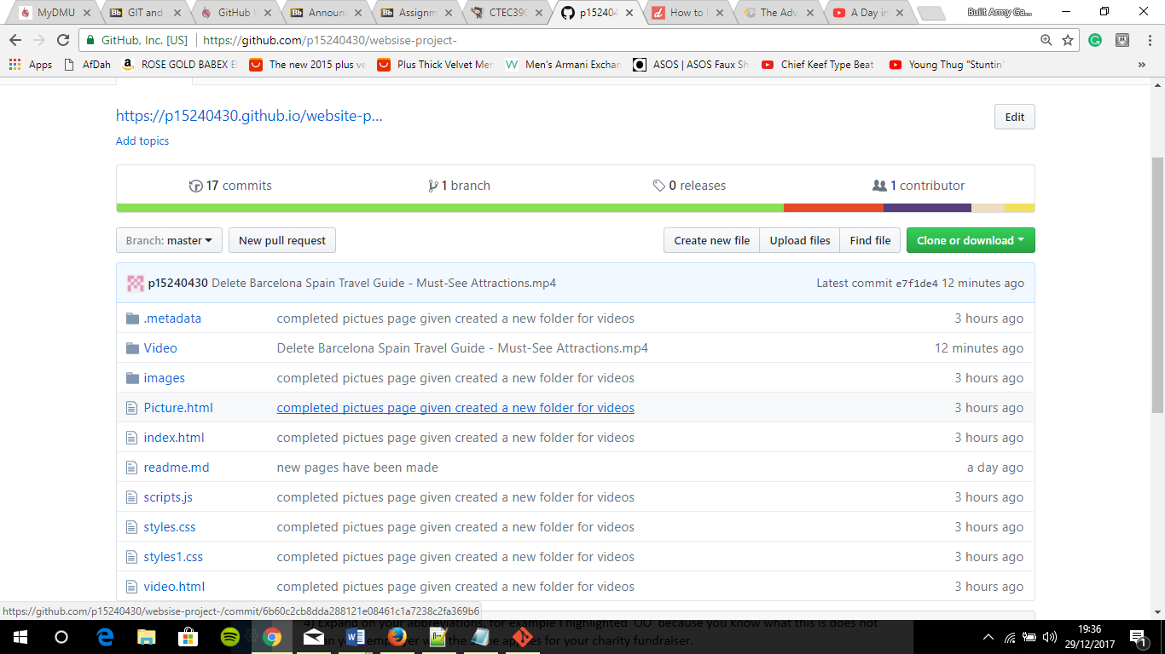

* I’ve had problems with my previous repository as I could not upload it to it hub using the git push command, so I have evidence to show that I made multiple commits previously and that they are all the same files. Reasons for me making a new repository is because of the following problems.