Simple Gesture Controlled Calculator

Mansoor Ahmed (P15-6069)
Shahkar Khan (P15-6150)
Section: A

Abstract

In this paper we describe a real-time system for simple gesture controlled calculator. Given an input video frames we predict the numeric gestures as well as special gestures for numeric operators to perform simple arithmetic operations. The system also help the users to feed their own gestures for any number or operator and the perform calculations accordingly.

1. Introduction

Human gesture recognition in image sequences has many applications including human-computer interaction, surveillance, and video games. In this paper we describe a system for real-time gesture controlled calculator that takes human gestures as input and perform arithmetic operations on it and print the desired output on screen.

In this work we focus on recognizing gestures from the live camera streaming and perform different digital image processing like converting the image into gray scale, performing Gaussian Blur and Median Blur for the reduction of noise and details in the image and then we applied binary threshold to extract the object from the image but our ROI is the gesture not the background. Each video frame was saved after performing image processing to create a data-set of gesture and use it for training the classifier.

CNN classifier is used for training on the dataset because our dataset contain raw features(pixels of image). The reason why CNN is used for this job is that CNN works very well on raw features and gives good result on it. For implementing the CNN classifier we have used the keras library with back-end tensorflow. CNN is trained by image dataset that the user will create from live video stream and then predicts his/her gestures to perform the arithmetic operations.

3. Results

A 4 layer CNN was used implemented and 1/3 of data-set was used for training and 2/3 was used for testing. The batch size of 128 was selected under 3 epoch. After training the our CNN classifier, the following results were produced:

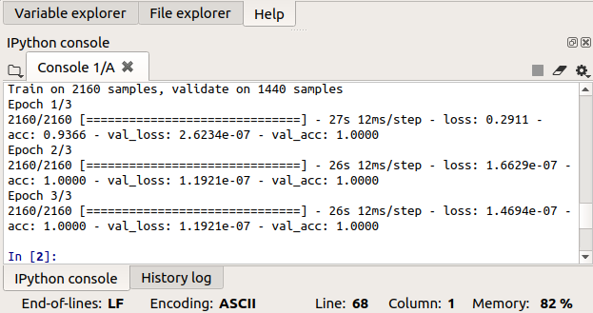

5. Conclusions

It is common to include a conclusions section to summarize the content of your paper, discuss future directions, and state any open problems or conjectures. A conjecture is something the authors believe to be true, but cannot prove. For example, one of the most famous, and most difficult, problems in graph theory is the following.

References

[1] A. Fathi and G. Mori, “Action recognition by learning mid-level motion features,” in Proc. IEEE Comput. Soc. Conf. Comput. Vision and Pattern Recogn., 2008.

[2] P. Viola and M. Jones, “Robust real-time face detection,” Int. Journal of Computer Vision, vol. 57, no. 2, pp. 137–154, 2004.

[3] M.-H. Yang and N. Ahuja, Face Detection And Gesture Recognition For Human-Computer Interaction. Kluwer Academic Publishers, 2001

