**ASSIGNMENT JAVA_WEB**

**Repository:** [**https://github.com/nh-duy/PRJ321_G7**](https://github.com/nh-duy/PRJ321_G7)

|  |  |  |  |
| --- | --- | --- | --- |
| Qualification | PRJ321-Web-based Java Applications | | |
| Unit and title | Assignment | | |
| Student name | Nguyễn Hữu Duy | Student ID | CE140 |
| Student name | Tạ Nguyễn Thuý Vy | Student ID | CE140 |
| Student name | Trương Thanh Toàn | Student ID | CE140640 |
| Class | SE1402 | | |

**TABLE OF CONTENT**

1.Problem definition

2.User requirement

2.1 Form

2.2 Hardware and softwar

3.Schedule and role

4. Use-case diagram

5. Database

4.1 Database diagram

4.2 Model details

4.3 Class diagram

1. Problem definition

Today, the lives of people are increasing so that the demand for shopping, eating and drinking is also increasing, especially cake.

The cake is a familiar folk dish, with an unforgettable unique flavor. With that demand, bakeries have appeared in abundance to serve people. But, managing a store is extremely difficult and complicated. There are still a number of restaurants that use handwritten management, which carries a lot of risks because of the inconvenience, low security, time-consuming, labor-intensive, and possible damage or loss of paper of management in store. Understanding this problem, we decided to create a website and we believe that store management is now no longer as difficult and time consuming as before. It will be convenient and fast for users because of its multifunction as well as ease of use

1. **User requirement**

1. Form

2. Hardware and software

*Hardware

Hardware minimum requirement

* CPU: Interl (R) Core 2 (TM) Duo or higher
* RAM: 256MB
* VGA: Onboard
* HDD: 100MB

*Software

Software requirement

• Windows 7 or higher

• JVM/JDK runtime installed

1. **Schedule and role**

3.1 Role

|  |  |  |  |
| --- | --- | --- | --- |
| No | Name of member | Role | Responsibility |
| 1 | DuyNH | Leader | Assignment of tasks |
| 2 | ToanTT,ViTNT | Analyst | Define problem, input, output,process |
| 3 | DuyNH,ViTNT,ToanTT | Design | Design interface |
| 4 | DuyNH,ViTNT,ToanTT | Coder | Program all functions for project |
| 5 | DuyNH,ViTNT,ToanTT | Tester | Testing all functions for project |
| 6 | DuyNH,ViTNT,ToanTT | Maintenaner | Check and backup data |

1. **Use-case diagram**

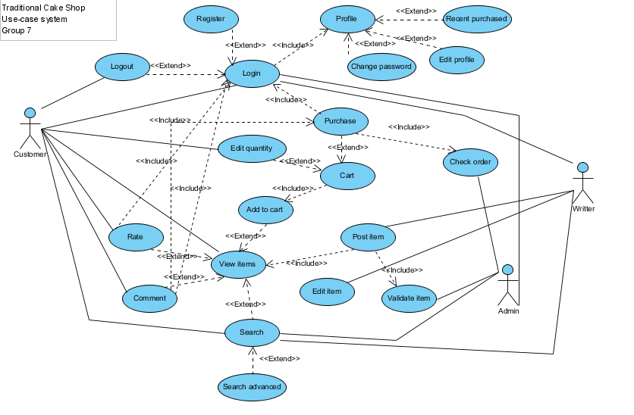

1. **Database**

4.1 Database diagram

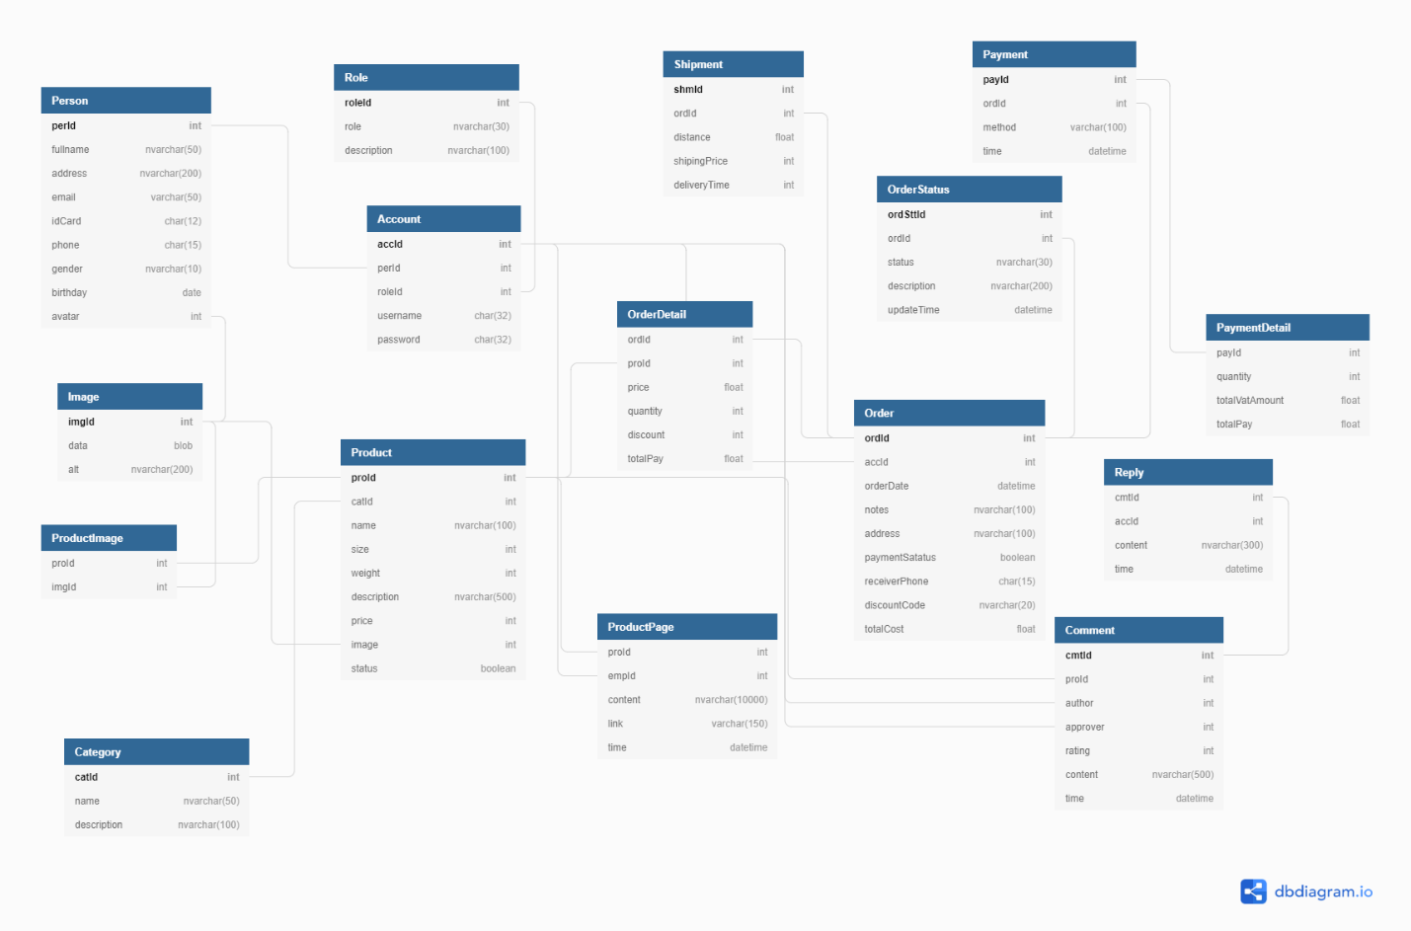

4.2 Model details

Table 1: Product

|  |  |  |  |
| --- | --- | --- | --- |
|  |  |  |  |
| **Field Name** | **Data Type** | **Constraint** | **Description** |
| ProID | int(20) | PRIMARY KEY | ID’s product |
| CatID | Int(20) | NOT NULL | Category of product |
| Name | nvarchar(100) | NOT NULL | Name of product |
| Size | int(5) | NOT NULL | Size of product |
| Weight | int(5) | NOT NULL | Weight of product |
| Description | nvarchar(100) | NOT NULL | Description of product |
| Price | Int(10) | NOT NULL | Price of product |
| Image | Int | NOT NULL | Image of product |
| Status | Boolean | NOT NULL | Status of product |

Table 2: Person

|  |  |  |  |
| --- | --- | --- | --- |
| **Field Name** | **Data Type** | **Constraint** | **Description** |
| perID | Int | PRIMARY KEY | ID’s person |
| Fullname | Nvarchar(50) | NOT NULL | Fullname’s person |
| Address | Nvarchar(200) | NOT NULL | Address’s person |
| Email | Varchar(50) | NOT NULL | Email’s person |
| IDCard | Char(12) | NOT NULL | Id’s card |
| Phone | (char15) | NOT NULL | Phone’s person |
| Gender | Nvarchar(10) | NOT NULL | Gender |
| Birthday | Date | NOT NULL | Birthday’s person |
| avatar | Int | NOT NULL | Avatar’s person |

Table 3: Account

|  |  |  |  |
| --- | --- | --- | --- |
| **Field Name** | **Data Type** | **Constraint** | **Description** |
| accId | Int | PRIMARY KEY | Id’s account |
| perId | Int | NOT NULL | ID’s person |
| roleId | Int | NOT NULL | Id’s Role |
| Username | Char(32) | NOT NULL | Username |
| Password | Char(32) | NOT NULL | Password |

Table 4: Order

|  |  |  |  |
| --- | --- | --- | --- |
| **Field Name** | **Data Type** | **Constraint** | **Description** |
| ordId | Int | PRIMARY KEY | Id’s order |
| accId | Int | NOT NULL | Id’s account |
| OrderDate | Datetime | NOT NULL | Date and time order |
| Notes | Nvarchar(100) | NOT NULL | Note |
| Address | Nvarchar(100) | NOT NULL | Address’s customer |
| paymentStatus | Boolean | NOT NULL | paymentStatus |
| receiverPhone | Char(15) | NOT NULL | receiverPhone |
| discountCode | Nvarchar(20) | NOT NULL | discountCode |
| totalCost | float | NOT NULL | totalCost |

Table 5: OrderDetail

|  |  |  |  |
| --- | --- | --- | --- |
| **Field Name** | **Data Type** | **Constraint** | **Description** |
| ordId | Int | NOT NULL | Id’s order |
| ProId | Int | NOT NULL | Id’s product |
| Price | Float | NOT NULL | price's order |
| Quantity | Int | NOT NULL |  |
| Discount | Int | NOT NULL |  |
| totalPay | Float | NOT NULL |  |

Table 6: Product Page

|  |  |  |  |
| --- | --- | --- | --- |
| **Field Name** | **Data Type** | **Constraint** | **Description** |
| proId | Int | NOT NULL | Id’s product |
| empId | Int | NOT NULL |  |
| Content | Nvarchar(10000) | NOT NULL |  |
| Link | Varchar(150) | NOT NULL | Link |
| Time | datetime | NOT NULL | Date and time update product |

Table 7: Order Status

|  |  |  |  |
| --- | --- | --- | --- |
| **Field Name** | **Data Type** | **Constraint** | **Description** |
| ordSttID | Int | PRIMARY KEY |  |
| ordId | Int | NOT NULL | Id’s order |
| Status | Nvarchar(30) | NOT NULL | Status’s order |
| Description | Nvarchar(200) | NOT NULL | description |
| updateTime | datetime | NOT NULL | Time |

Table 8: PaymentDetail

|  |  |  |  |
| --- | --- | --- | --- |
| **Field Name** | **Data Type** | **Constraint** | **Description** |
| payId | Int | NOT NULL | Id’s payment |
| Quantity | Int | NOT NULL |  |
| totalVaAmount | Float | NOT NULL |  |
| totalPay | Float | NOT NULL |  |

Table 9: Payment

|  |  |  |  |
| --- | --- | --- | --- |
| **Field Name** | **Data Type** | **Constraint** | **Description** |
| payId | Int | PRIMARY KEY | Id’s payment |
| ordId | Int | NOT NULL | Id’s order |
| Method | Varchar(100) | NOT NULL |  |
| Time | datetime | NOT NULL | Time |

Table 10: Shipment

|  |  |  |  |
| --- | --- | --- | --- |
| **Field Name** | **Data Type** | **Constraint** | **Description** |
| ShmId | Int | PRIMARY KEY | Id’s shipper |
| OrdId | Int | NOT NULL | Id’s order |
| Distance | Float | NOT NULL | Distance |
| ShippingPrice | Int | NOT NULL | Price’s shipper |
| deliveryTime | Int | NOT NULL | Delivery Time |

Table 11: Role

|  |  |  |  |
| --- | --- | --- | --- |
| **Field Name** | **Data Type** | **Constraint** | **Description** |
| roleId | Int | PRIMARY KEY | Id’s role |
| Role | Nvarchar(30) | NOT NULL | Name’s role |
| description | Nvarchar(100) | NOT NULL | description |

Table 12: Category

|  |  |  |  |
| --- | --- | --- | --- |
| **Field Name** | **Data Type** | **Constraint** | **Description** |
| CatID | Int | PRIMARY KEY | Id’s category |
| Name | Nvarchar(50) | NOT NULL | Name’s category |
| description | Nvarchar(100) | NOT NULL | description |

Table 13: Image

|  |  |  |  |
| --- | --- | --- | --- |
| **Field Name** | **Data Type** | **Constraint** | **Description** |
| imgID | Int | PRIMARY KEY | Id’s image |
| Data | Blob | NOT NULL |  |
| Alt | Nvarchar(200) | NOT NULL |  |

Table 14: Product Image

|  |  |  |  |
| --- | --- | --- | --- |
| **Field Name** | **Data Type** | **Constraint** | **Description** |
| proId | Int | NOT NULL | Id’s product |
| imgID | Int | NOT NULL | Id’s image |

Table 15: Comment

|  |  |  |  |
| --- | --- | --- | --- |
| **Field Name** | **Data Type** | **Constraint** | **Description** |
| CmtId | Int | PRIMARY KEY | Id’s comment |
| ProId | Int | NOT NULL | Id’s product |
| Author | Int | NOT NULL | Author |
| Approver | Int | NOT NULL | Approver |
| Rating | Int | NOT NULL | Rating |
| Content | Nvarchar(5000) | NOT NULL | Content |
| Time | Datetime | NOT NULL | Time |

Table 16: Reply

|  |  |  |  |
| --- | --- | --- | --- |
| **Field Name** | **Data Type** | **Constraint** | **Description** |
| CmtId | Int | NOT NULL | Id’s comment |
| AccID | Int | NOT NULL | Id’s account |
| content | Nvarchar(300) | NOT NULL | Content |
| time | datetime | NOT NULL | Time |

4.3 Class diagram

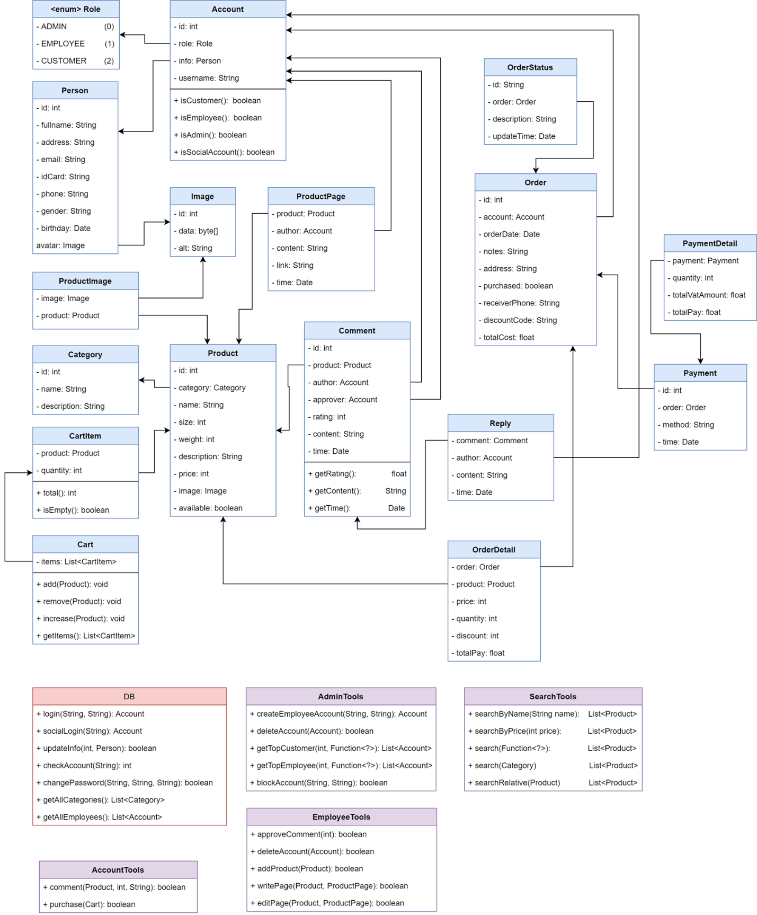

4.4 Code Explanation

4.5 Result