**Vietnamese Traditional Cake**

**Home page**

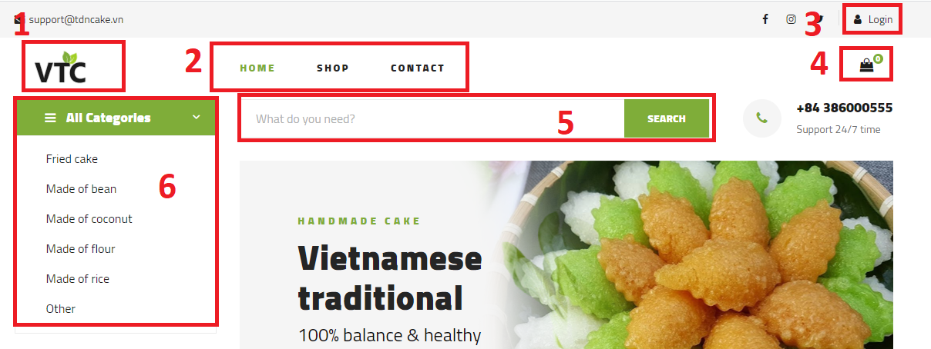

1. Goto home
2. Navigation bar: Home, Shop, Contact page
3. Login
4. Goto shopping cart page
5. Search by name
6. Search by category

**Shop page**

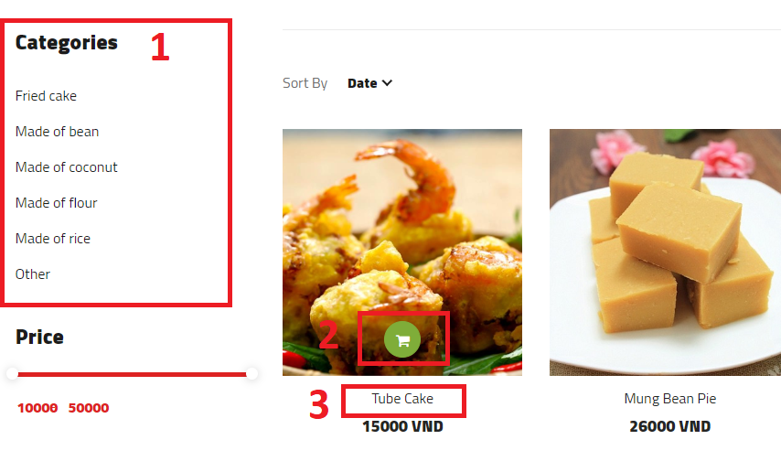

1. Search by category
2. Add to cart
3. View product details

**Login page**

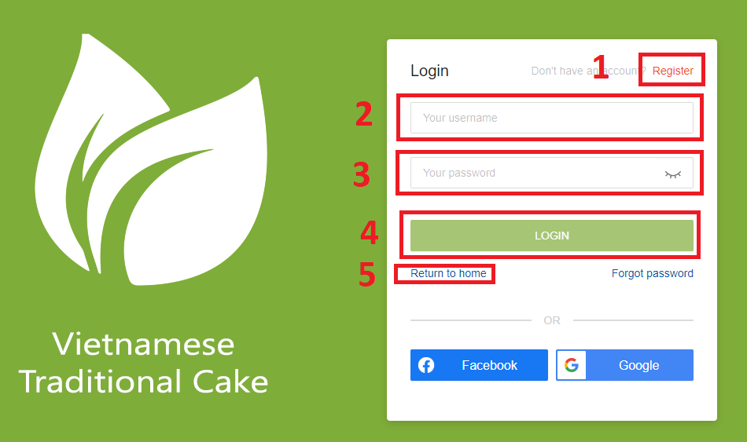

1. Goto register page
2. Input username
3. Input password
4. Login
5. Return to home page

**Register page**

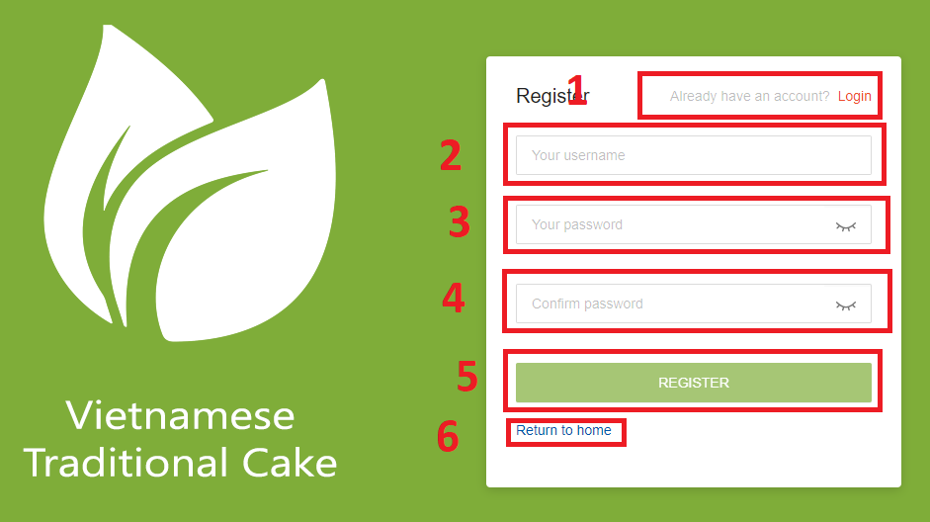

1. Goto login page
2. Enter username
3. Enter password
4. Confirm password
5. Register
6. Return to home page

**Shopping cart page**

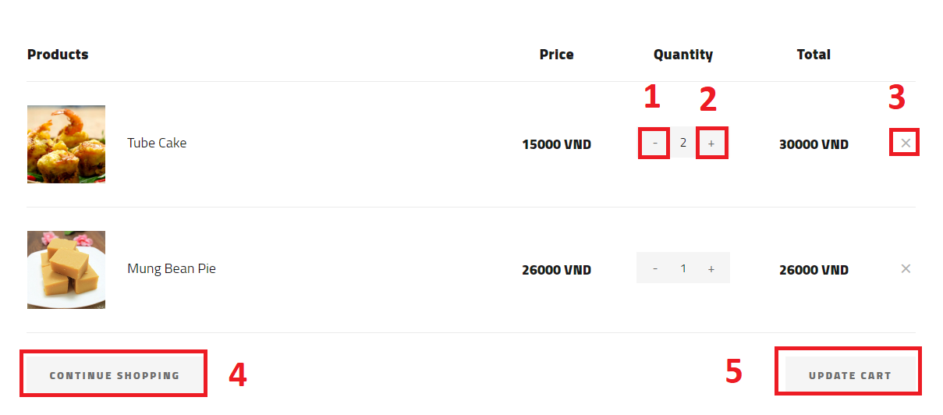

1. Decrease item quantity
2. Increase item quantity
3. Remove item
4. Goto shop page
5. Update cart

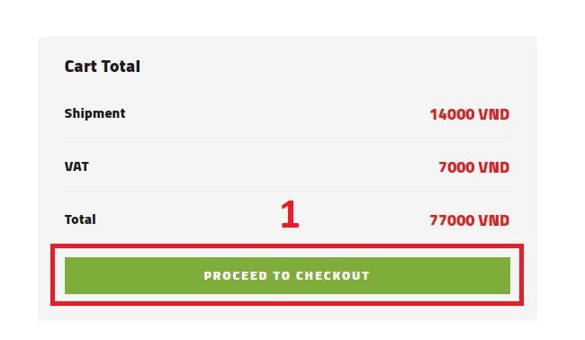

1. Goto checkout page

**Checkout page**

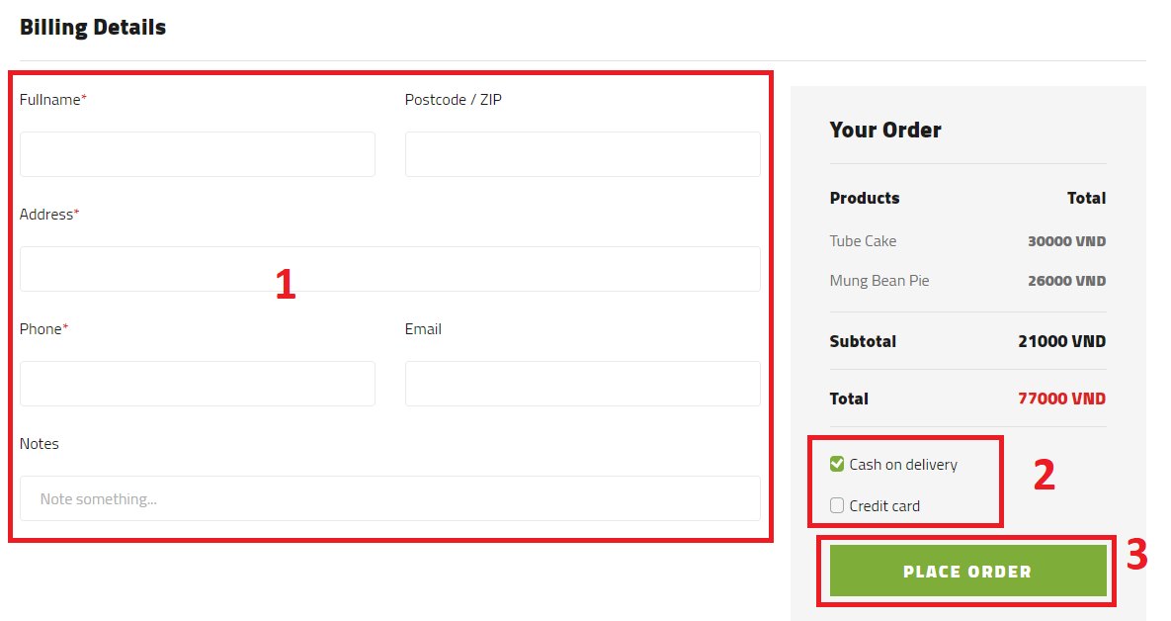

1. Input required information
2. Choose payment method
3. Make order

**Header bar** (customer account logged in)

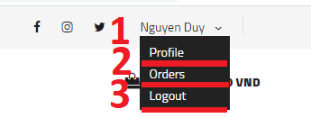

1. Goto profile page
2. Goto orders history page
3. Logout account

**Profile page**

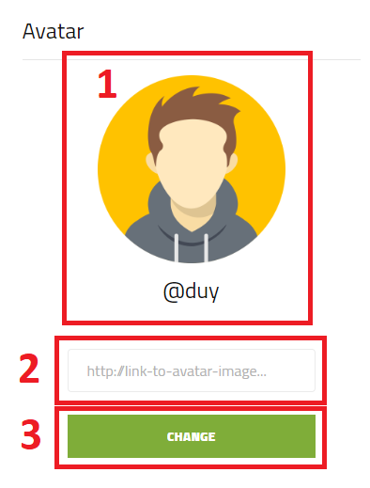

1. User avatar
2. Input new avatar image link to change avatar
3. Do change avatar

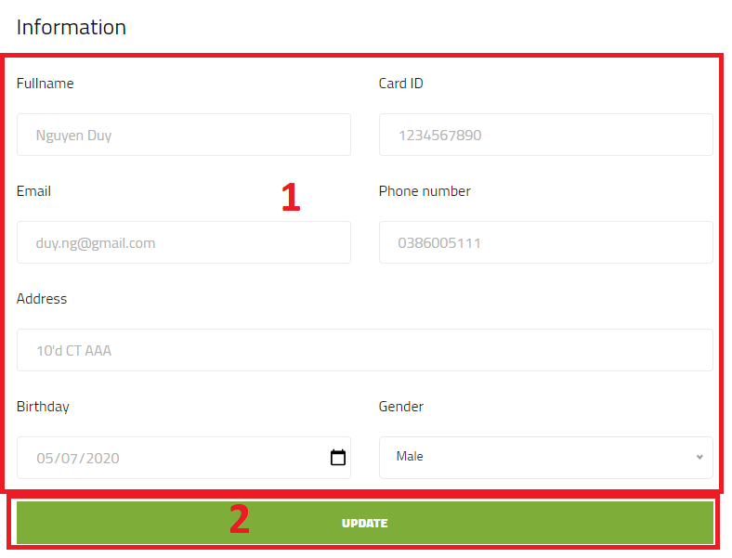

1. User infromation
2. Update information after change input value in (1)

**Orders page**

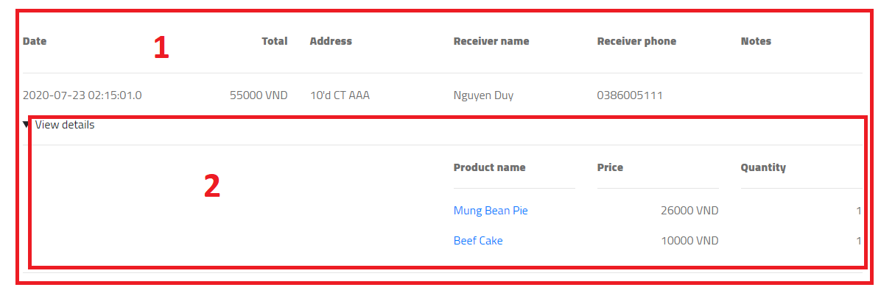

1. Order overview
2. Order details

**Header bar** (admin logged in)

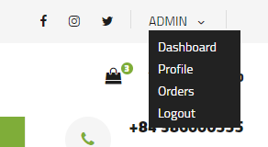

**Admin dashboard** (views)

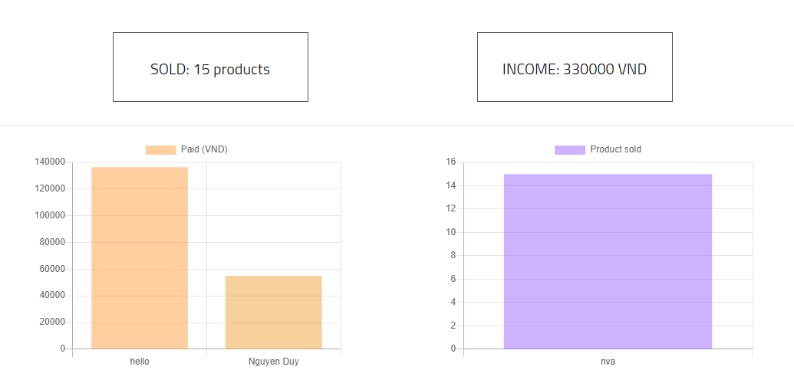

**Header bar** (employee logged in)

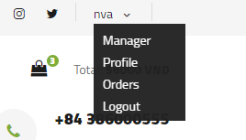

**Employee manager page**

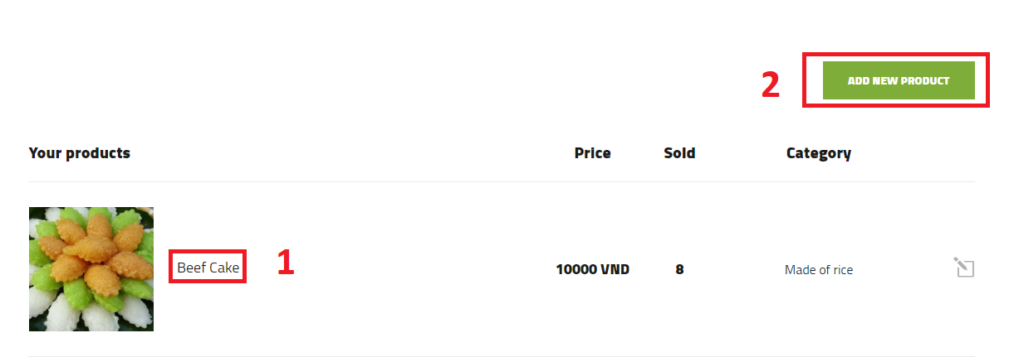

1. Goto product details
2. Add new product

**Product details page**

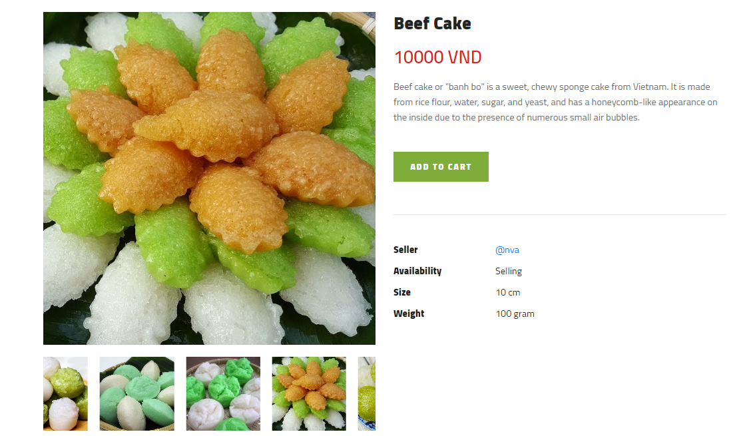

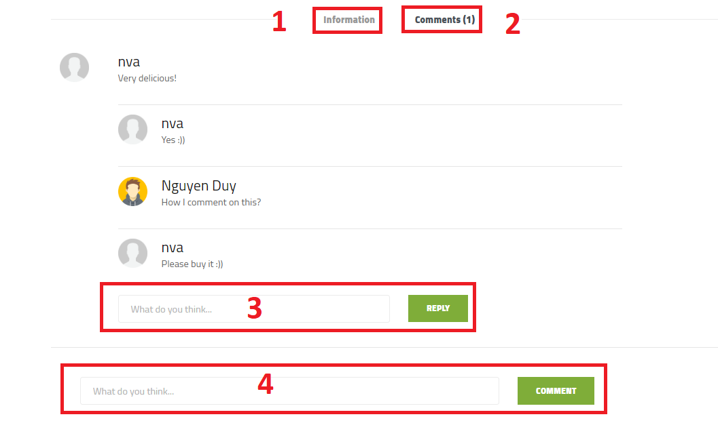

1. View more product information
2. View product comments
3. Reply someone
4. Comment on product

Add new product page

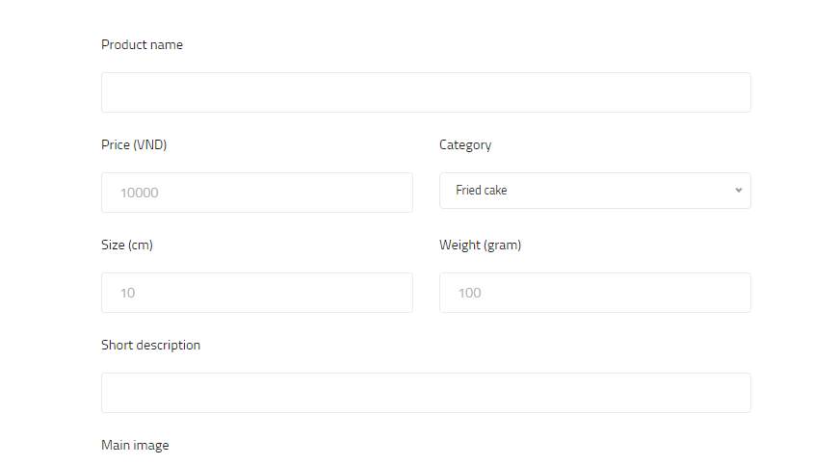

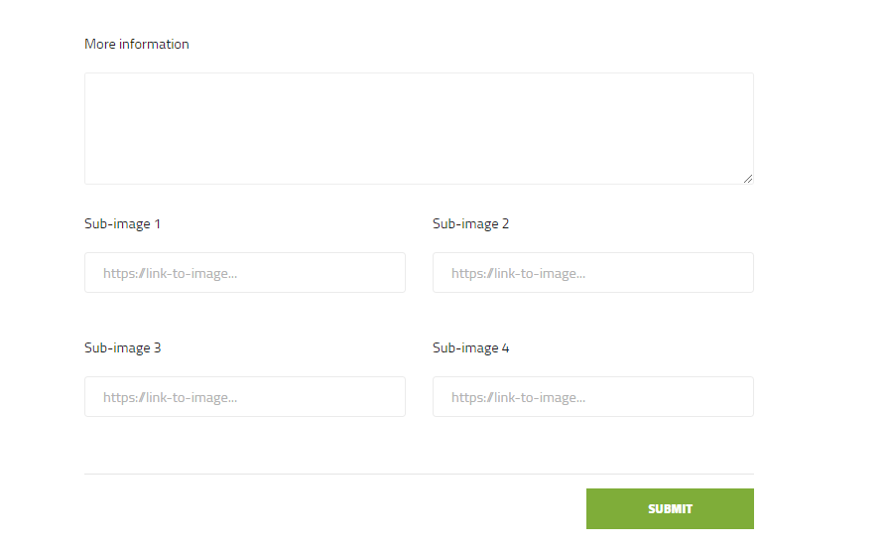

**END.**