Main Text — Tables and Figures
Racial and Ethnic Differences in Breast Cancer Incidence in the United States: A Systematic Review with Quantitative Synthesis
Table 1. Incidence rate ratios of invasive breast cancer among U.S. racial and ethnic groups relative to non-Hispanic White women, by analytic dimension
Group | Effect | Estimate [95% CI] | Representative study | Registry family | RoB
Overall invasive breast cancer
Hispanic | IRR | 0.718 [0.707, 0.731] ‡ | Ellington 2022 (2018) | USCS(NPCR+SEER ~99%) | Low
Asian American, Native Hawaiian, and Pacific Islander (AANHPI) | IRR | 0.769 [0.752, 0.788] ‡ | Ellington 2022 (2018) | USCS(NPCR+SEER ~99%) | Low
American Indian and Alaska Native (AI/AN) | IRR | 0.87 (point est.) | Melkonian 2019 (2010-2015) | IHS-PRCDA | Low
non-Hispanic Black (NHB) | IRR | 0.933 [0.920, 0.946] ‡ | Ellington 2022 (2018) | USCS(NPCR+SEER ~99%) | Low
Asian American subgroups
Hmong | IRR | 0.164 [0.120, 0.224] ‡ | Mills 2005 (Hmong 1988-2000 / NHW 1995-1999) | California-CCR | Low
Cambodian | IRR | 0.264 [0.204, 0.341] ‡ | Kem 2007 (1998-2002) | California-CCR | Moderate
Laotian/Kampuchean | IRR | 0.388 [0.350, 0.430] ‡ | Gomez 2026 (2018-2022) | SEER-national | Moderate
Vietnamese | IRR | 0.586 [0.566, 0.608] ‡ | Gomez 2026 (2018-2022) | SEER-national | Moderate
Korean | IRR | 0.677 [0.654, 0.701] ‡ | Gomez 2026 (2018-2022) | SEER-national | Moderate
Chinese | IRR | 0.760 [0.745, 0.775] ‡ | Gomez 2026 (2018-2022) | SEER-national | Moderate
Filipina | IRR | 0.857 [0.839, 0.874] ‡ | Gomez 2026 (2018-2022) | SEER-national | Moderate
Asian Indian/Pakistani | IRR | 0.958 [0.937, 0.979] ‡ | Gomez 2026 (2018-2022) | SEER-national | Moderate
Japanese | IRR | 1.045 [1.009, 1.083] ‡ | Gomez 2026 (2018-2022) | SEER-national | Moderate
Asian American (aggregate) | IRR | 0.792 [0.784, 0.800] ‡ | Gomez 2026 (2018-2022) | SEER-national | Moderate
Native Hawaiian and Pacific Islander (NHPI) subgroups
Guamanian/Chamorro/Samoan | IRR | 0.723 [0.641, 0.817] ‡ | Gomez 2026 (2018-2022) | SEER-national | Moderate
Native Hawaiian | IRR | 1.211 [1.123, 1.305] ‡ | Miller 2008 (1998-2002) | NAACCR/CiNA (~93%) | Low
Native Hawaiian and Pacific Islander (NHPI) | IRR | 1.212 [1.168, 1.258] ‡ | Gomez 2026 (2018-2022) | SEER-national | Moderate
Hispanic/Latina by country of origin
Mexican | IRR | 0.512 [0.382, 0.686] ‡ | Pinheiro 2009 (1999-2001) | State: Florida | Low
New Latino | IRR | 0.697 [0.629, 0.771] ‡ | Pinheiro 2009 (1999-2001) | State: Florida | Low
Cuban | IRR | 0.769 [0.688, 0.860] ‡ | Pinheiro 2009 (1999-2001) | State: Florida | Low
Puerto Rican | IRR | 0.833 [0.738, 0.939] ‡ | Pinheiro 2009 (1999-2001) | State: Florida | Low
American Indian and Alaska Native (AI/AN) by region
AI/AN (Navajo) | IRR | 0.49 [0.44, 0.55] | Yazzie 2025 (2014-2018) | IHS-PRCDA | Low
AI/AN (Southwest) | IRR | 0.57 (point est.) | Melkonian 2019 (2010-2015) | IHS-PRCDA | Low
AI/AN (East) | IRR | 0.61 (point est.) | Melkonian 2019 (2010-2015) | IHS-PRCDA | Low
AI/AN (Pacific Coast) | IRR | 0.93 (point est.) | Melkonian 2019 (2010-2015) | IHS-PRCDA | Low
AI/AN (Northern Plains) | IRR | 1.05 (point est.) | Melkonian 2019 (2010-2015) | IHS-PRCDA | Low
Alaska Native | IRR | 1.09 [0.99, 1.21] † | Nash 2019 (2009-2014) | Alaska Native Tumor Registry (IHS-linked) | Low
AI/AN (Southern Plains) | IRR | 1.33 [1.26, 1.41] | Melkonian 2021 (2012-2016) | IHS-PRCDA | Low
Middle Eastern
Middle Eastern | IRR | 0.86 [0.84, 0.88] | Nasseri 2009 (1988-2004) | California-CCR | Moderate
Triple-negative breast cancer
Chinese | IRR | 0.53 [0.31, 0.93] † ‡ | Loo 2019 (2000-2016) | Hawaii Tumor Registry (SEER) | Low
Asian American (aggregate) | IRR | 0.61 [0.58, 0.65] | Gomez 2017 (2009-2013) | California-CCR | Low
Asian American, Native Hawaiian, and Pacific Islander (AANHPI) | IRR | 0.700 [0.680, 0.720] | Sung 2023 (2015-2019) | USCS(NPCR+SEER ~99%) | Low
Filipina | IRR | 0.84 [0.60, 1.18] † ‡ | Loo 2019 (2000-2016) | Hawaii Tumor Registry (SEER) | Low
American Indian and Alaska Native (AI/AN) | IRR | 0.860 [0.800, 0.930] | Sung 2023 (2015-2019) | USCS(NPCR+SEER ~99%) | Low
Hispanic | IRR | 0.860 [0.840, 0.880] | Sung 2023 (2015-2019) | USCS(NPCR+SEER ~99%) | Low
Native Hawaiian | IRR | 0.86 [0.60, 1.22] † ‡ | Loo 2019 (2000-2016) | Hawaii Tumor Registry (SEER) | Low
Japanese | IRR | 1.08 [0.79, 1.46] † ‡ | Loo 2019 (2000-2016) | Hawaii Tumor Registry (SEER) | Low
non-Hispanic Black (NHB) | IRR | 1.950 [1.930, 1.980] | Sung 2023 (2015-2019) | USCS(NPCR+SEER ~99%) | Low

Note. Each cell shows one representative population-based estimate — the most recent, broadest-coverage registry estimate per registry family — not a pooled estimate; the selection rule and its robustness are given in the Methods and Supplementary Table 6. The effect measure is the incidence rate ratio (IRR) unless marked as a standardized incidence ratio (SIR); comparisons are versus non-Hispanic White (NHW) women. † the study's reference was an unstratified White group (not stratified by Hispanic origin), examined in the NHW-comparator sensitivity analysis (Supplementary Table 6c). ‡ the 95% confidence interval was computed by the reviewers from published rates rather than reported in the source. NHB, non-Hispanic Black; AANHPI, Asian American, Native Hawaiian, and Pacific Islander (NHPI, the Pacific Islander subset, shown separately); RoB, risk-of-bias rating of the representative study. Full per-estimate detail is in the Supplementary Materials.

Figure 1. PRISMA 2020 flow diagram
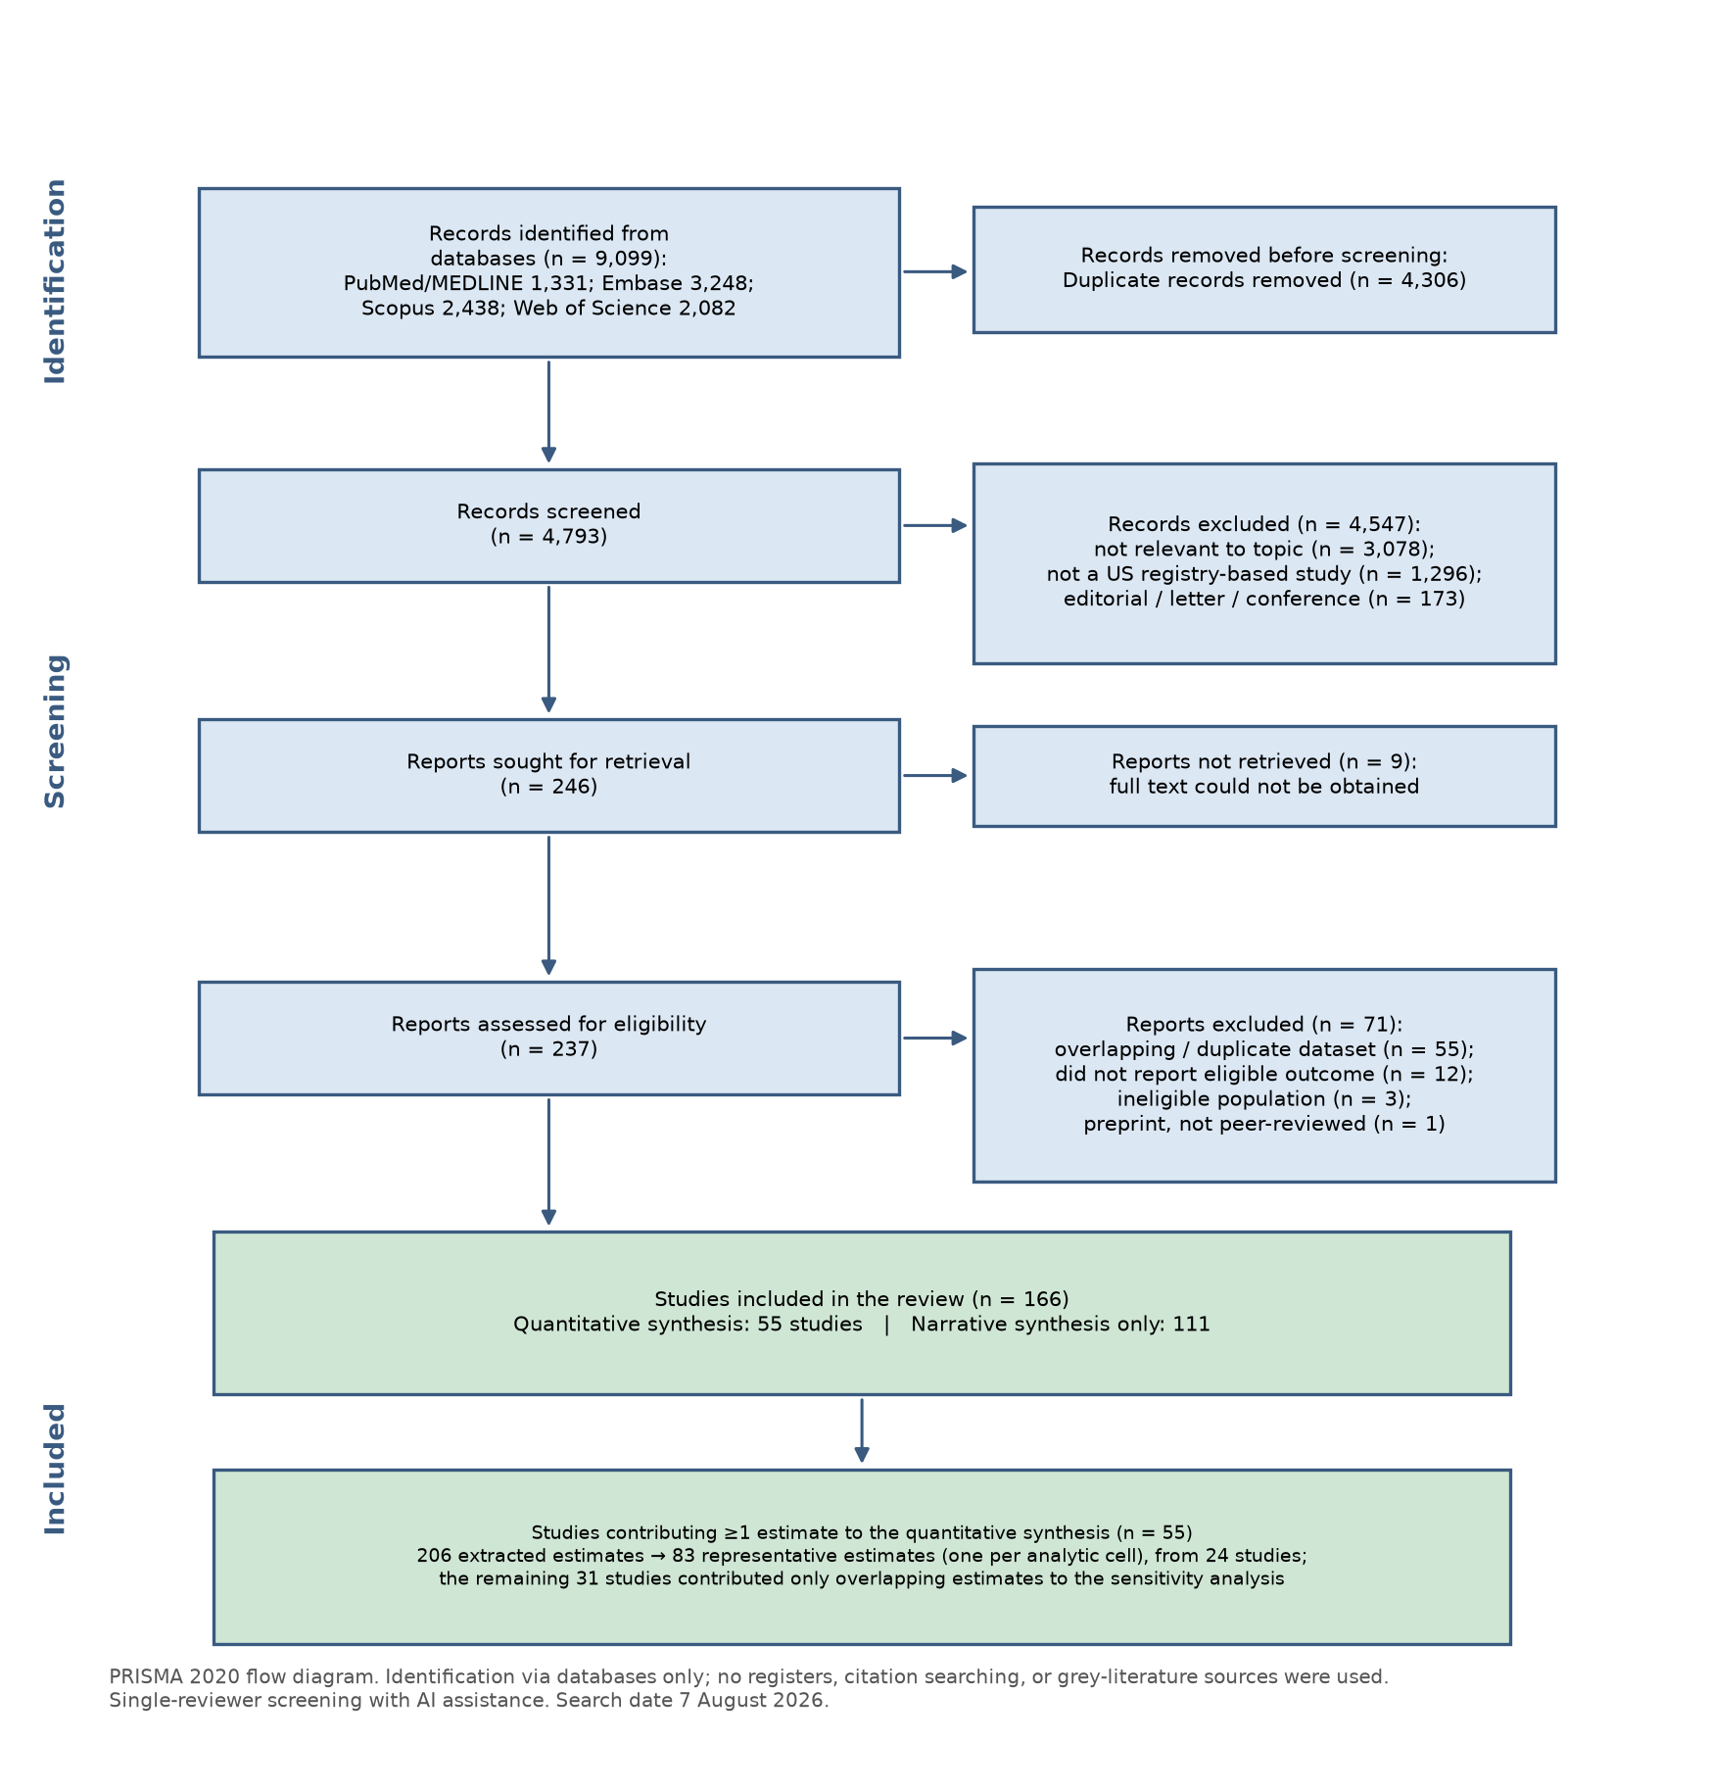

Figure 2. Aggregate-to-disaggregated heterogeneity in breast cancer incidence (representative IRR vs non-Hispanic White, 95% CI): the Asian American, Native Hawaiian and Pacific Islander (AANHPI), Hispanic/Latina, and American Indian and Alaska Native (AI/AN) aggregates, each shown with its subgroups
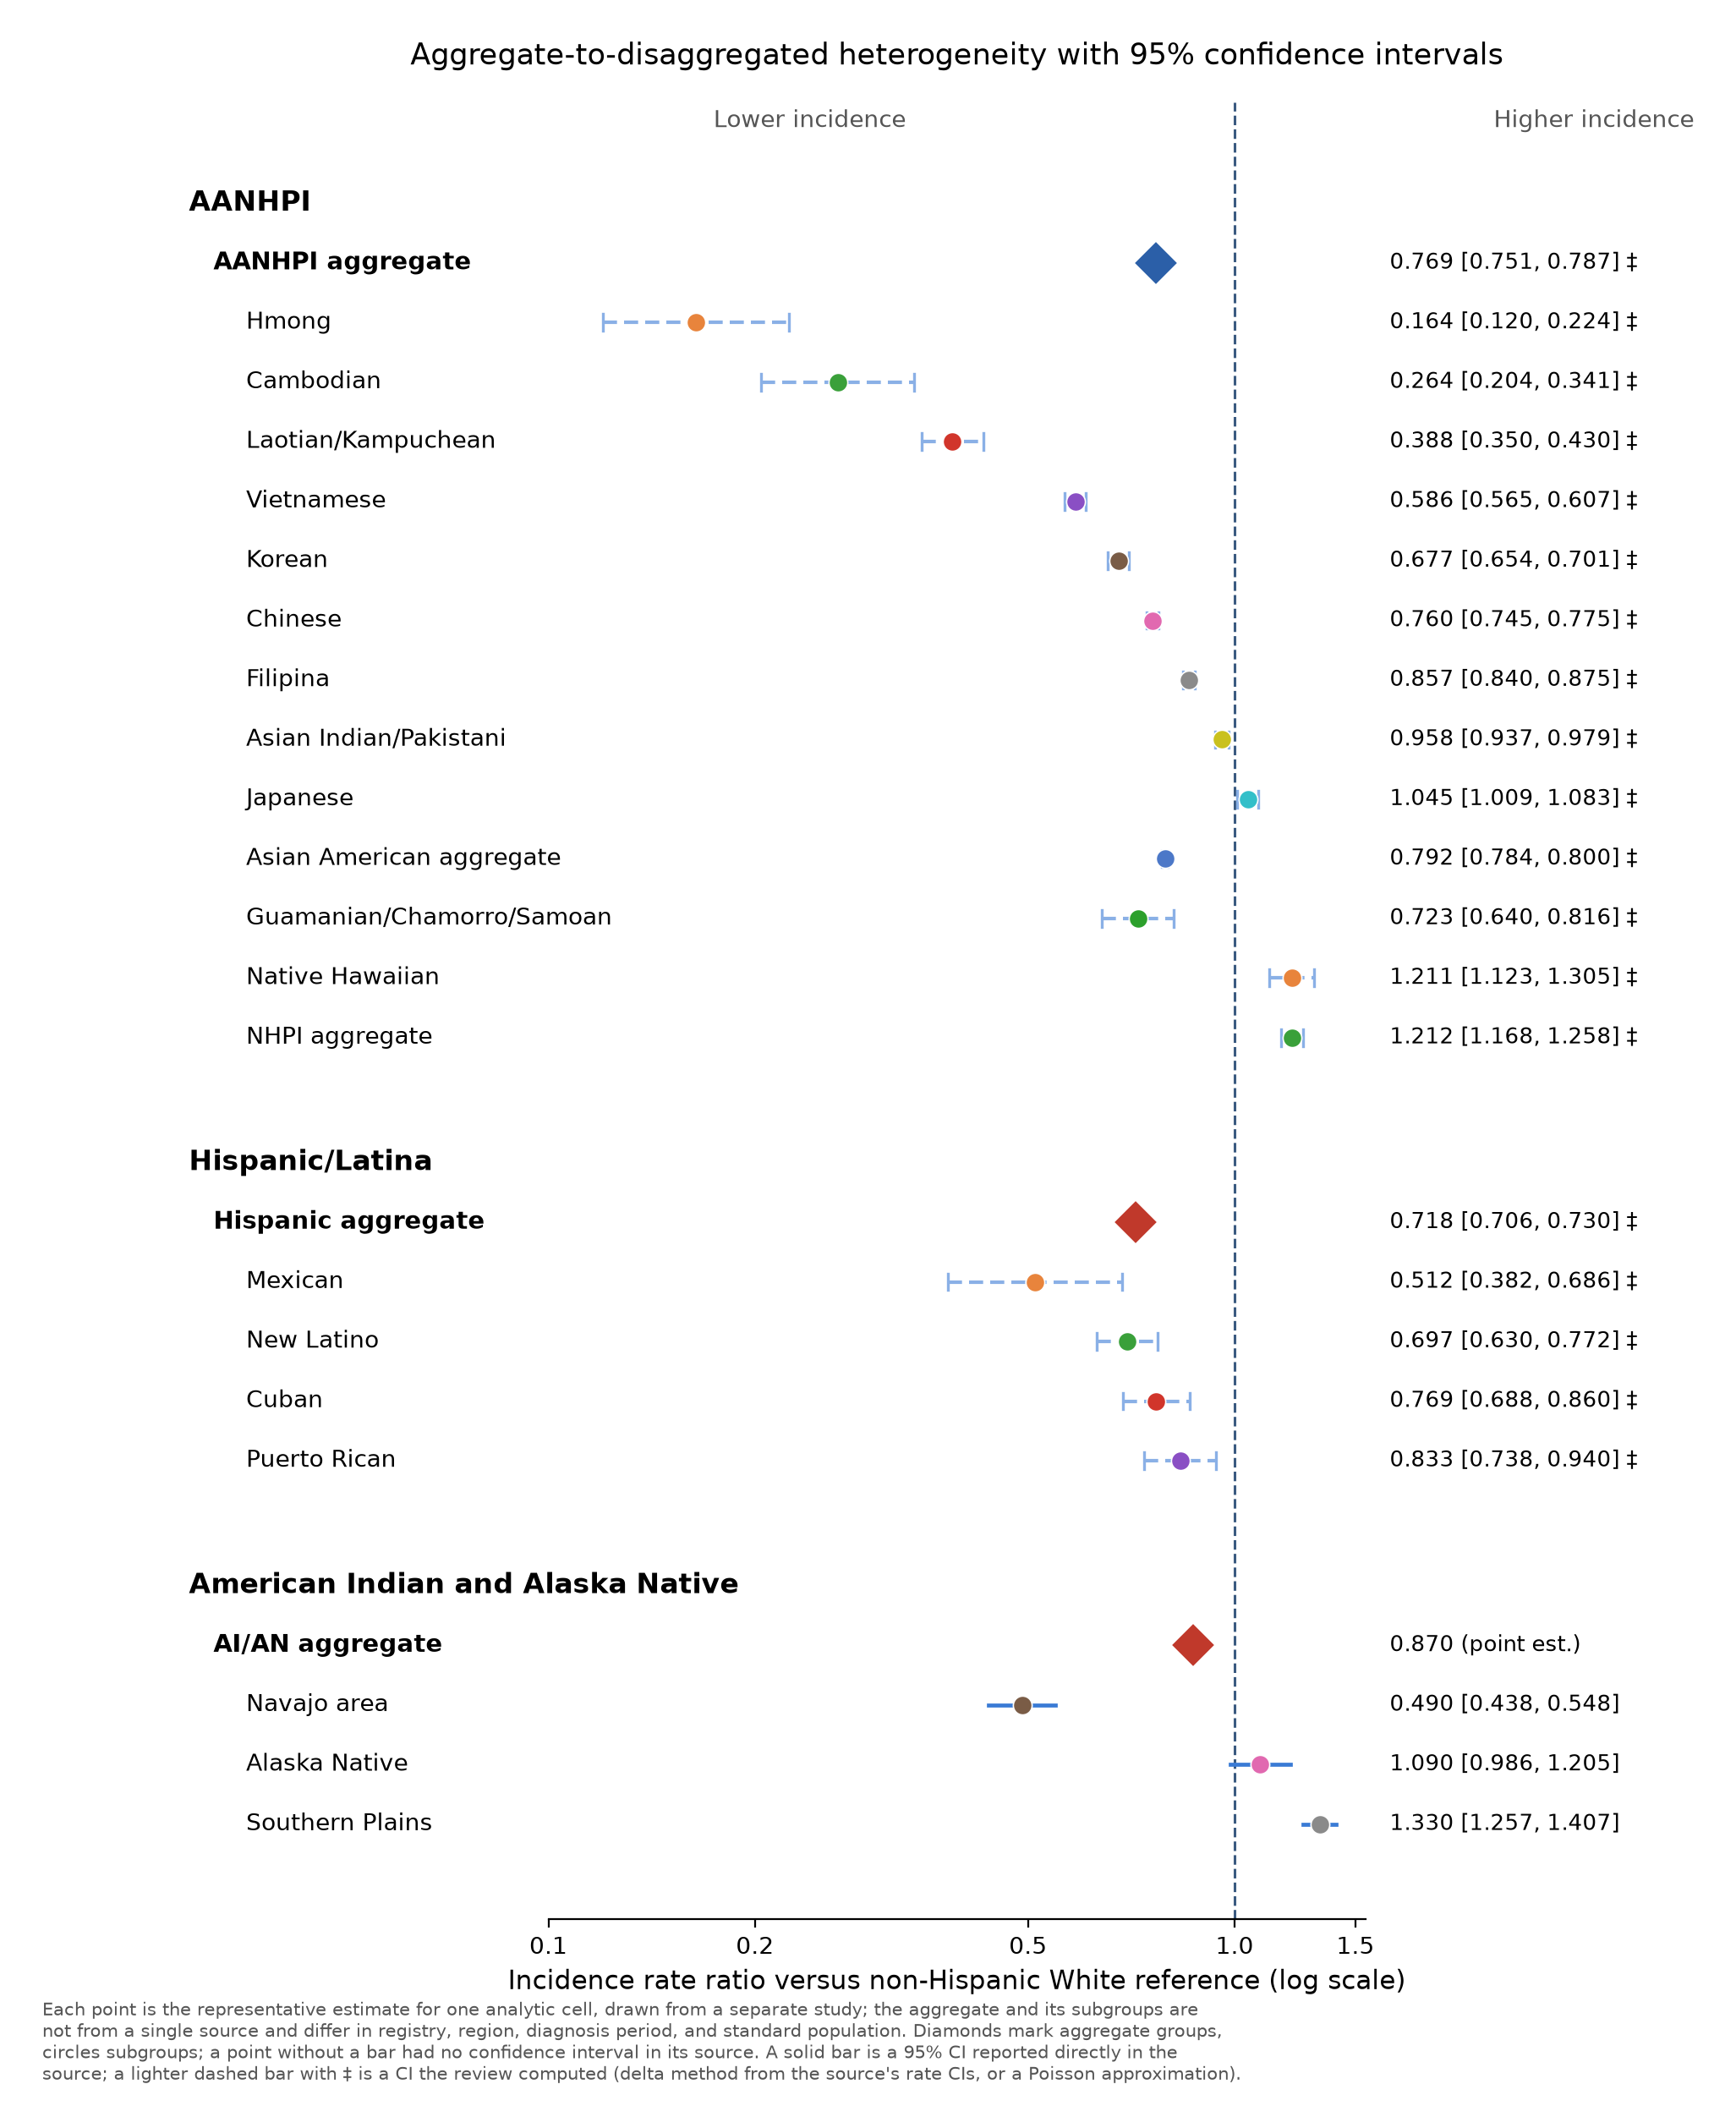

Figure 3. Incidence rate ratio by racial or ethnic group and analytic dimension (representative estimate vs non-Hispanic White; 1.0 = the NHW rate)
