Main Text — Tables and Figures
Racial and Ethnic Differences in Breast Cancer Incidence in the United States: A Systematic Review with Quantitative Synthesis
Table 1. Incidence rate ratios of invasive breast cancer among U.S. racial and ethnic groups relative to non-Hispanic White women, by analytic dimension
Group | Effect | Estimate [95% CI] | Representative study | Registry family | RoB
Overall invasive breast cancer
Hispanic | IRR | 0.718 [0.707, 0.731] ‡ | Ellington 2022[25] (2018) | USCS(NPCR+SEER ~99%) | Low
Asian American, Native Hawaiian, and Pacific Islander (AANHPI) | IRR | 0.769 [0.752, 0.788] ‡ | Ellington 2022[25] (2018) | USCS(NPCR+SEER ~99%) | Low
American Indian and Alaska Native (AI/AN) | IRR | 0.87 (point est.) | Melkonian 2019[53] (2010-2015) | IHS-PRCDA | Moderate
non-Hispanic Black (NHB) | IRR | 0.933 [0.920, 0.946] ‡ | Ellington 2022[25] (2018) | USCS(NPCR+SEER ~99%) | Low
Asian American subgroups
Hmong | IRR | 0.164 [0.120, 0.224] ‡ | Mills 2005[6] (1988-2000) | California-CCR | Low
Cambodian | IRR | 0.264 [0.204, 0.341] ‡ | Kem 2007[55] (1998-2002) | California-CCR | Moderate
Laotian/Kampuchean | IRR | 0.388 [0.350, 0.430] ‡ | Gomez 2026[31] (2018-2022) | SEER-national | Moderate
Vietnamese | IRR | 0.586 [0.566, 0.608] ‡ | Gomez 2026[31] (2018-2022) | SEER-national | Moderate
Korean | IRR | 0.677 [0.654, 0.701] ‡ | Gomez 2026[31] (2018-2022) | SEER-national | Moderate
Chinese | IRR | 0.760 [0.745, 0.775] ‡ | Gomez 2026[31] (2018-2022) | SEER-national | Moderate
Filipina | IRR | 0.857 [0.839, 0.874] ‡ | Gomez 2026[31] (2018-2022) | SEER-national | Moderate
Asian Indian/Pakistani | IRR | 0.958 [0.937, 0.979] ‡ | Gomez 2026[31] (2018-2022) | SEER-national | Moderate
Japanese | IRR | 1.045 [1.009, 1.083] ‡ | Gomez 2026[31] (2018-2022) | SEER-national | Moderate
Asian American (aggregate) | IRR | 0.792 [0.784, 0.800] ‡ | Gomez 2026[31] (2018-2022) | SEER-national | Moderate
Native Hawaiian and Pacific Islander (NHPI) subgroups
Guamanian/Chamorro/Samoan | IRR | 0.723 [0.641, 0.817] ‡ | Gomez 2026[31] (2018-2022) | SEER-national | Moderate
Native Hawaiian | IRR | 1.270 [1.213, 1.330] ‡ | Gomez 2026[31] (2018-2022) | SEER-national | Moderate
Native Hawaiian and Pacific Islander (NHPI) | IRR | 1.212 [1.168, 1.258] ‡ | Gomez 2026[31] (2018-2022) | SEER-national | Moderate
Hispanic/Latina by country of origin
Mexican | IRR | 0.512 [0.382, 0.686] ‡ | Pinheiro 2009[8] (1999-2001) | State: Florida | Low
New Latino | IRR | 0.697 [0.629, 0.771] ‡ | Pinheiro 2009[8] (1999-2001) | State: Florida | Low
Cuban | IRR | 0.769 [0.688, 0.860] ‡ | Pinheiro 2009[8] (1999-2001) | State: Florida | Low
Puerto Rican | IRR | 0.833 [0.738, 0.939] ‡ | Pinheiro 2009[8] (1999-2001) | State: Florida | Low
American Indian and Alaska Native (AI/AN) by region
AI/AN (Navajo) | IRR | 0.49 [0.44, 0.55] | Yazzie 2025[48] (2014-2018) | IHS-PRCDA | Low
AI/AN (Southwest) | IRR | 0.57 (point est.) | Melkonian 2019[53] (2010-2015) | IHS-PRCDA | Moderate
AI/AN (East) | IRR | 0.61 (point est.) | Melkonian 2019[53] (2010-2015) | IHS-PRCDA | Moderate
AI/AN (Pacific Coast) | IRR | 0.93 (point est.) | Melkonian 2019[53] (2010-2015) | IHS-PRCDA | Moderate
AI/AN (Northern Plains) | IRR | 1.05 (point est.) | Melkonian 2019[53] (2010-2015) | IHS-PRCDA | Moderate
Alaska Native | IRR | 1.09 [0.99, 1.21] † | Nash 2019[11] (2009-2014) | Alaska Native Tumor Registry (IHS-linked) | Low
AI/AN (Southern Plains) | IRR | 1.33 [1.26, 1.41] | Melkonian 2021[58] (2012-2016) | IHS-PRCDA | Low
Middle Eastern
Middle Eastern | IRR | 0.86 [0.84, 0.88] | Nasseri 2009[46] (1988-2004) | California-CCR | Moderate
Triple-negative breast cancer
Chinese | IRR | 0.53 [0.31, 0.93] † ‡ | Loo 2019[24] (2010-2013) | Hawaii Tumor Registry (SEER) | Low
Asian American (aggregate) | IRR | 0.61 [0.58, 0.65] | Gomez 2017[35] (2009-2013) | California-CCR | Low
Asian American, Native Hawaiian, and Pacific Islander (AANHPI) | IRR | 0.700 [0.680, 0.720] | Sung 2023[23] (2015-2019) | USCS(NPCR+SEER ~99%) | Low
Filipina | IRR | 0.84 [0.60, 1.18] † ‡ | Loo 2019[24] (2010-2013) | Hawaii Tumor Registry (SEER) | Low
American Indian and Alaska Native (AI/AN) | IRR | 0.860 [0.800, 0.930] | Sung 2023[23] (2015-2019) | USCS(NPCR+SEER ~99%) | Low
Hispanic | IRR | 0.860 [0.840, 0.880] | Sung 2023[23] (2015-2019) | USCS(NPCR+SEER ~99%) | Low
Native Hawaiian | IRR | 0.86 [0.60, 1.22] † ‡ | Loo 2019[24] (2010-2013) | Hawaii Tumor Registry (SEER) | Low
Japanese | IRR | 1.08 [0.79, 1.46] † ‡ | Loo 2019[24] (2010-2013) | Hawaii Tumor Registry (SEER) | Low
non-Hispanic Black (NHB) | IRR | 1.950 [1.930, 1.980] | Sung 2023[23] (2015-2019) | USCS(NPCR+SEER ~99%) | Low

Note. This table shows 38 of the 85 analytic cells, those covering the principal comparisons; the rest, chiefly the other receptor-defined subtypes and the age-specific comparisons, are in Supplementary Table 4. Each cell shows one representative population-based estimate — the most recent, broadest-coverage registry estimate per analytic cell — not a pooled estimate; the selection rule and its robustness are given in the Methods and Supplementary Table 6. Each representative study is followed by its number in the reference list. The effect measure is the incidence rate ratio (IRR) throughout; comparisons are versus non-Hispanic White (NHW) women. † the study's reference was an unstratified White group (not stratified by Hispanic origin), examined in the NHW-comparator sensitivity analysis (Supplementary Table 6c); 5 of the 19 cells so marked appear in this table. ‡ the 95% confidence interval was computed by the reviewers from published rates rather than reported in the source. NHB, non-Hispanic Black; AANHPI, Asian American, Native Hawaiian, and Pacific Islander (NHPI, the Pacific Islander subset, shown separately); RoB, risk-of-bias rating of the representative study. Full per-estimate detail is in the Supplementary Materials.

Figure 1. PRISMA 2020 flow diagram
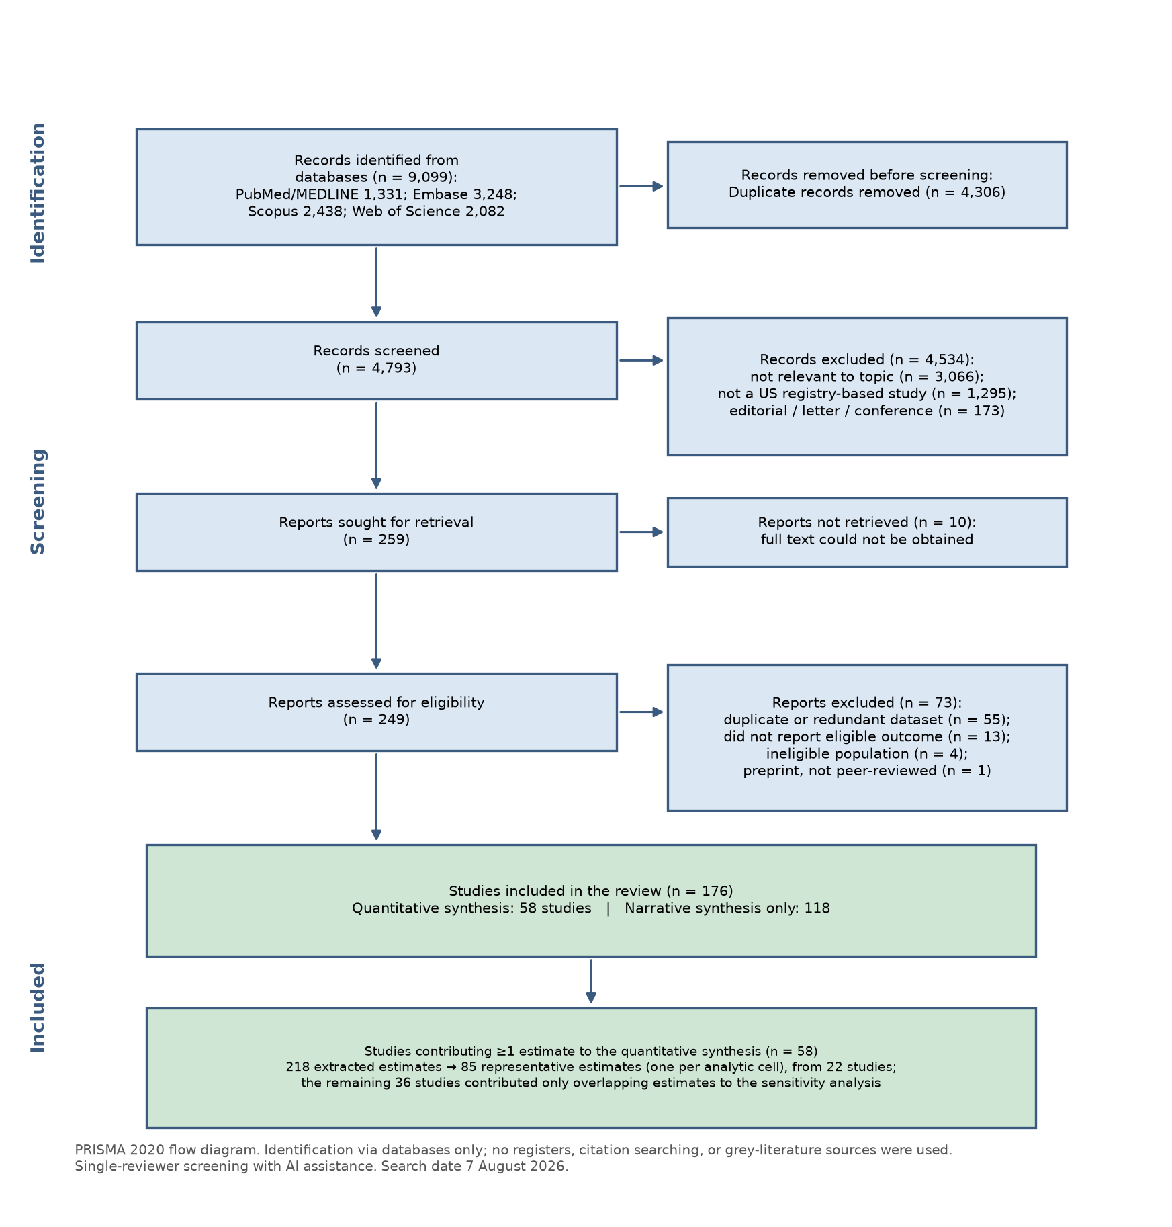

Figure 2. Aggregate-to-disaggregated heterogeneity in breast cancer incidence (representative IRR vs non-Hispanic White, 95% CI): the Asian American, Native Hawaiian and Pacific Islander (AANHPI), Hispanic/Latina, and American Indian and Alaska Native (AI/AN) aggregates, each shown with its subgroups
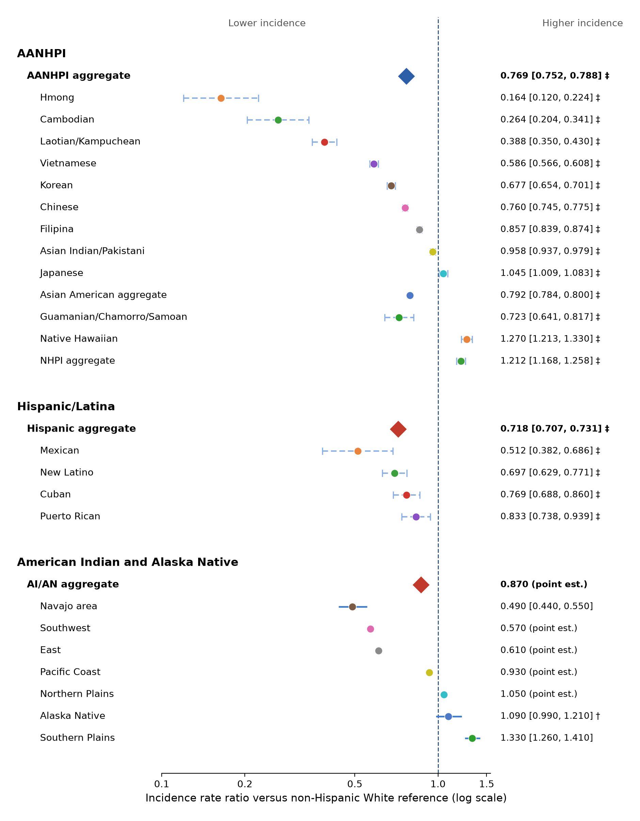

Note. Each point is the representative estimate for one analytic cell, drawn from a separate study; an aggregate and its subgroups differ in registry, region, diagnosis period, and standard population. Diamonds mark aggregate groups, circles subgroups. A solid bar is a 95% CI reported in the source; a dashed bar marked ‡ is one computed for this review; a point without a bar had no interval in its source. † reference was an unstratified White group, not NHW. Values match Table 1.

Figure 3. Incidence rate ratio by racial or ethnic group and analytic dimension (representative estimate vs non-Hispanic White; 1.0 = the NHW rate)
