**A PROJECT REPORT**

**ON**

**Fashion Apparel Detection**

**Submitted to**

**KIIT Deemed to be University**

In Partial Fulﬁlment of the Requirement for the Award of

**BACHELOR’S DEGREE IN**

**COMPUTER SCIENCE AND ENGINEERING**

**by**

**Pankaj Shaw 1505230**

**Abhinav Vatsa 1505005**

**Vikram 1505086**

**P. Mouli Prasad 1505229**

**UNDER THE GUIDANCE OF**

**Prof. Arup Sarkar**



**School of Computer Engineering**

**KALINGA INSTITUTE OF INDUSTRIAL TECHNOLOGY**

**BHUBANESWAR, ODISHA – 751024**

**April, 2019**

**KIIT Deemed to be University**

**School of Computer Engineering**

**Bhubaneswar, ODISHA 751024**



**CERTIFICATE**

This is certify that the project entitled

**Fashion Apparel Detection**

Submitted by

**Pankaj Shaw 1505230**

**Abhinav Vatsa 1505005**

**Vikram 1505086**

**P. Mouli Prasad 1505229**

Is a record of bonaﬁde work carried out by them, in the partial fulﬁlment of the requirement for the award of Degree of Bachelor of Engineering (Computer Science & Engineering OR Information Technology) at KIIT Deemed to be university, Bhubaneswar. This work is done during year 2018-2019, under our guidance.

**Date:** 01**/**04**/**2019

**Prof. Arup Sarkar**

(Project Guide)

**ACKNOWLEDGMENT**

The achievement that is associated with the successful completion of any task would be incomplete without mentioning the names of those people whose endless cooperation made it possible. Their constant guidance and encouragement made all our efforts successful.

We take this opportunity to express our deep gratitude towards our project mentor, **Prof. ARUP SARKAR** for giving such valuable suggestions, guidance and encouragement during the development of this project work.

**Pankaj Shaw 1505230**

**Abhinav Vatsa 1505005**

**Vikram 1505086**

**P. Mouli Prasad 1505229**

Table of Contents

**1.** Introduction 7

Project Overview: 7

Project Description: 7

2. Problem Definition 8

Existing system 8

Drawbacks 8

Proposed system 8

3. Feasibility Study 9

3.1 Technical Feasibility 9

3.2 Operational Feasibility 10

3.3 Economic Feasibility 10

4. System Analysis 11

Overview 11

Number of Modules (Functional Requirement) 11

1. Data Collection 12

2. Data Cleaning 12

3. Data Pre-processing 12

4. Data Analysis 13

5. Model Selection 13

6. Training and Testing of model 13

5. Environment 14

Software requirement: 14

Hardware Specifications: 14

6. System Design 15

6.1 Module Design: 15

6.2 Data Flow Diagrams 16

7. Implementation of Project 17

Convolutional Layer 17

Max-Pooling Layer 18

FULLY CONNECTED LAYER 18

8. Output Screenshots 19

9.Conclusion and Future Scope 20

9.1 Conclusion 20

9.2 Future Scope 20

10. References 21

**List of Figures**

**1.2 Figure 1: Sample Image Segmentation**…………………………………………………..**7**

**6.2 Figure 2: CNN data flow diagram……………………………………………………………………14**

**7.1 Figure 3: Convolutional Layer…………………………………………………………………………….15**

**7.2 Figure 4: Max- Pooling Layer………………………………………………………………………………16**

**8.1 Output figure 1……………………………………………………………………………………………………….17**

**8.2 Output figure 2……………………………………………………………………………………………………….18**

# Introduction

Software life cycle (Software process)

Series of identifiable stages that a software product undergoes during its life time:

* Feasibility study
* Requirement Analysis
* Design
* Coding
* Testing
* Maintenance (Deployment)

## 

## Project Overview:

The primary goal of this project is to detect the type of apparel (Cloth) from a given image which can be further used for search engine optimization.

## 

## Project Description:

We are using Fashion MNIST dataset to train our deep learning model. Fashion MNIST is a dataset of Zalando’s article images – consisting of a training set of 70,000, which has been further divided into training set of 60,000 examples and a test set of 10,000 examples. Each example is a 28x28 grayscale image associated with a label from 10 classes.

# Problem Definition

Existing system**:**

The project “Fashion Apparel Detection” can be used for the optimization of a search engine wherever image data is available along with the text data.

Currently existing systems uses only the text data to provide the relevant result to the user. What if we can use the image data too to provide the result?

They do not use image data that may cause the loss of important information that might be important for the user.

Drawbacks**:**

* The project requires a real time running system
* Requires tons of image data
* Lack of proper hardware infrastructure

Proposed system**:**

The existing system does uses image data to improve the search results, we can implement this model to provide a better result in the field of apparel shopping.

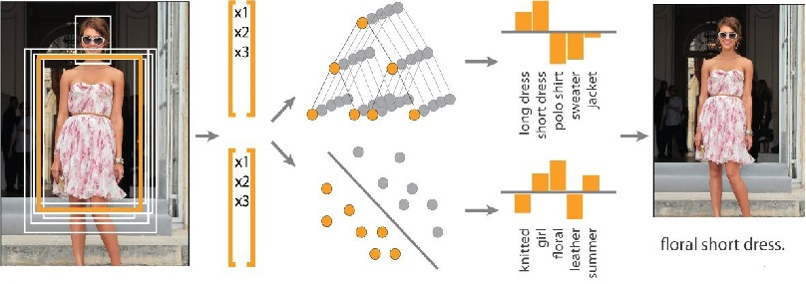

(Figure 1: Sample Image Segmentation)

# Feasibility Study

Preliminary investigation examine project feasibility, the likelihood the system will be useful to the organization. The main objective of the feasibility study is to test the Technical, Operational and Economical feasibility for adding new modules and debugging old running system. All system is Feasible if there are unlimited resources and infinite time. Different modes of feasibility study are:

- Technical Feasibility

- Operation Feasibility

- Economical Feasibility

### 

## 3.1 Technical Feasibility

The technical usually raised during the feasibility stage of the investigation includes the following:

- Does the necessary technology exist to do what is suggested?

- Do the proposed equipment have the technical capability to hold the data required to use the new system?

- Will the proposed system provide adequate response to inquiries, regardless of the number or Location of users?

- Are there technical guarantees of accuracy, reliability, ease of access and data security?

## 3.2 Operational Feasibility

Proposed projects are beneficial only if they can be turned out into information system. That will meet the organization’s operating requirements. Operational feasibility aspects of the project are to be taken as an important part of the project implementation. Some of the important issues raised are to test

The operational feasibility of a project includes the following:

- Is there sufficient support for the management from the users?

- Will the system be used and work properly if it is being developed and implemented?

- Will there be any resistance from the user that will undermine the possible application benefits?

## 3.3 Economic Feasibility

A system can be developed technically and that will be used if installed must still be a good investment for the organization. In the economic feasibility, the development cost in creating the system is evaluated against the ultimate benefit derived from the new systems. Financial benefits must equal or exceed the Costs.

The system is economically feasible. It does not require any addition hardware or software. Since

The interface for this system is developed using the existing resources and technologies available at NIC. There is nominal expenditure and economic feasibility for certain.

# System Analysis

**4.1 Software Requirement Specifications**

## Overview

The purpose of this project is to detect fashion apparel in an effective and efficient manner.

This system helps the customer to search their clothes by using images. It helps in search engine optimization. This system helps in reducing the time and effort of the customer.

## Number of Modules (Functional Requirement)

The system after careful analysis has been identified to be presented with the following modules:

**Fashion Apparel Detection deals with the following modules:**

**1. Data Collection**

**2. Data cleaning**

**3. Data pre-processing**

**4. Data analysis**

**5. Model selection**

**6. Training and Testing of model**

## 1. Data Collection

The process of gathering and measuring information for some targeted variables is known as Data collection. In this project MNIST dataset has been used. MNIST (Modified National Institute of Standards and Technology) consist of large database of handwritten digits. These datasets are used for image processing systems. It is very useful for training and testing in the field of Machine Learning. The creators felt that NIST’S dataset was not useful for machine learning experiments because training datasets was taken from American Census Bureau employees, while the testing set was taken from American high school students. The MNIST dataset consists of 60,000 training images and 10,000 testing images.

## 2. Data Cleaning

The process of detecting and cleaning the corrupt or inadequate record from a record set is called data cleaning. This step involves identification of incomplete, incorrect, inaccurate or irrelevant parts of data and then replacing the dirty or coarse data. Data becomes consistent with other similar datasets in the system after cleaning. The inconsistencies detected or removed may have caused due to human entry errors, by corruption in storage or transmission. Removal of typological error is the actual process of data cleaning step.

## 3. Data Pre-processing

The transformation of raw data into simple understandable format is known as data pre-processing. Data pre-processing is a proven method of resolving incomplete, inconsistent data issues or error related with it. Steps involved in Data pre-processing are:

1. Import the libraries

2. Import the data sets

3. Check out the missing values

4. See the categorical values

5. Splitting the data sets into Training and test set

6. Feature scaling

## 4. Data Analysis

The process of inspecting, transforming, and modelling data is known as data analysis. The goal of data analysis is discovering useful information and support decision making. One of the data analysis technique is data mining which focuses on modelling and knowledge discovery. Data analysis can be divided as:

* Descriptive statistics
* Exploratory data analysis
* Confirmatory data analysis

## 5. Model Selection

Model selection is a very important step in any project. In this projects we have used CNN (CONVOLUTIONAL NEURAL NETWORK). It is a class deep neural networks for analysing visual images. A CNN architecture has different layers:

* Convolutional layer- This layer is the core building blocks of CNN. This layer’s parameters are set of learnable filters.
* Pooling layer-The input is partitioned into non-overlapping rectangles, and for each region maximum is selected.
* Fully connected layer-High level reasoning is done in neural network through fully connected layer.

## 6. Training and Testing of model

The dataset is divided into training set and testing set. Model is trained using training set and then tested using test set. In this project we have used 60,000 training sets and 10,000 test sets.

# Environment

## 

## Software requirement:

**Operating System Server: Linux Ubuntu 16.04 LTS**

**Database server: Google Drive**

**Client: Google Chrome**

**Tools: Jupyter Notebook, Google Colab**

**Code behind: Python**

**Dependencies: Tensorflow, numpy, matplotlib, math, tqdm.**

## 

## Hardware Specifications:

**Processor: Intel Core i5-5200U**

**Ram: 16GB**

**Hard Disk: PC with 1TB**

# System Design

## 

## 6.1 Module Design:

Software design sits at the technical kernel of the software engineering process and is applied regardless of the development paradigm and area of Application. Design is the first step in the development phase for any engineered product or system. The Designer’s goal is to produce a model or representation of an entity that will later be built.

Beginning, once system requirement have been specified and analysed, system design is the first of the three technical activities -design, code test that is required to build and verify software.

The importance can be started with a single word “Quality”. Design is the place where quality is fostered in software development. Design provides us with representations of software that can assess for quality. Design is the only way that we can accurately translate a customer’s view into a finished software product or system. Software design serves as a foundation for all the software engineering steps that follow. Without a strong design we risk building an unstable system-one that will be difficult to test, one whose quality cannot be assessed until the last stage.

During design, progressive refinement of data structure, program structure, and proceduraldetails are developed reviewed and documented. System design can be viewed from either technical or project management Perspective. From the technical point of view, design is comprised of three activities-

**Architectural design, data structure design and procedural design**.

## 6.2 Data Flow Diagrams

A data flow diagram is graphical tool used to describe and analyse movement of data through a system. These are the central tool and the basis from which the other components are developed. The transformation of data from input to output, through processed, may be described logically and independently of physical components associated with the system.

These are known as the logical data flow diagrams.

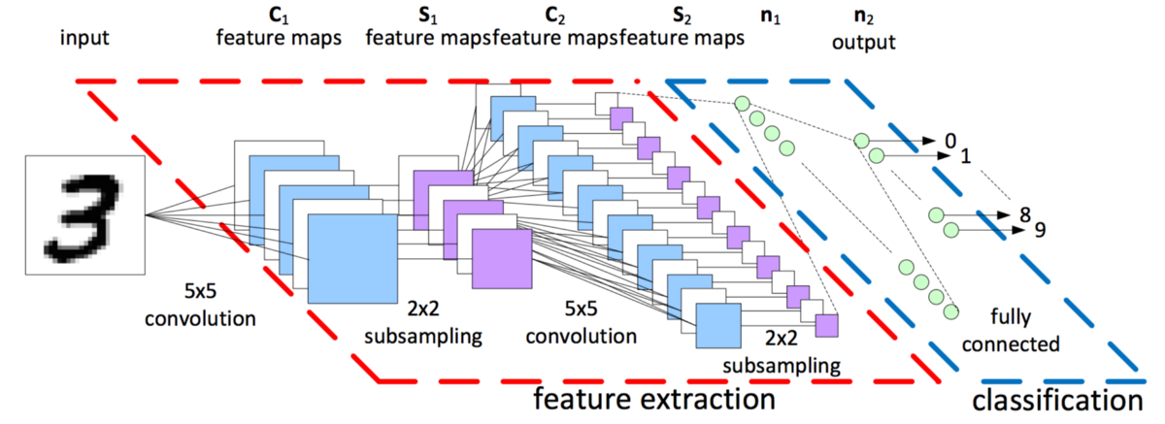

**(Figure 2: CNN data flow diagram)**

# Implementation of Project

CNN (Convolutional Neural Network) is a class of deep neural networks, which is used for analysing visual images.

Convolutional networks were inspired by biological processes. The connectivity pattern between neurons resembles. The organization of animal visual cortex.

CNN architecture consists of different layers that transform input volume into output volume. These layers are discussed below:

Convolutional Layer**:**

Convolutional layer is also called the core building block of CNN. It consists of learnable filters that uses small receptive field. During forward pass, each filter is convolved across the width and height of input volume. It then computes the dot product between the entries of filter and input.

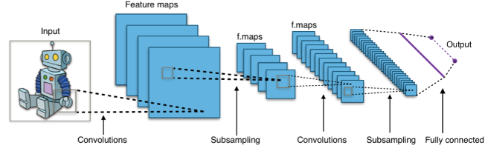

**(Figure 3: Convolutional Layer)**

Max-Pooling Layer**:**

In this layer the input volume is divided into number of non-overlapping rectangle and for each sub-rectangles the maximum is taken as output and input for the next layer i.e. fully connected layer.

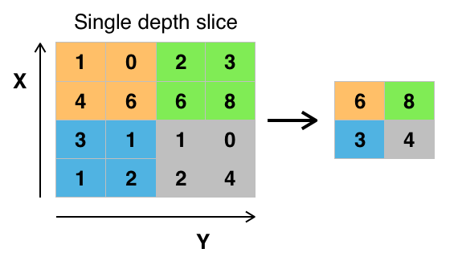

**(Figure 4: Max pooling Layer)**

FULLY CONNECTED LAYER**:**

After several convolutional and max-pooling layers, fully connected layers are responsible for high level reasoning in neural network. The neurons in a fully. Fully connected layer have connection to all the activation in previous layer.

# Output Screenshots

Output Figure 1:

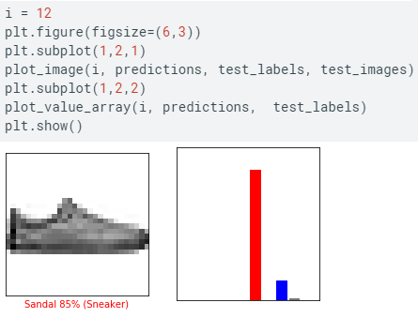

Output Figure 2:

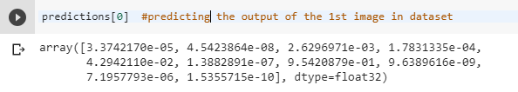

# Conclusion and Future Scope

## 9.1 Conclusion

**The CNN deep neural network model was trained on Training Data of 60,000 images, we got an accuracy of 87.7% and step-loss 3.4.**

**The model was correctly able to distinguish the class value properly.**

## 9.2 Future Scope

**Apart from using it in E-commerce search engine we can further improve the same concept to leverage it for other aspects where fashion apparel is being used such as fashion vlog, information retrieval etc.**

# References

**[1] Fashion-MNIST: A noble image dataset for benchmarking machine learning algorithms by Han Xiao, Kashif Rasul, Ronald Vollgraf**

**[2] CNN Models that can classify your fashion images by James Le**

**[3] Deep learning for image classification by Y LeCun, G Hinton**