Finished Dashboard – Executive Summary
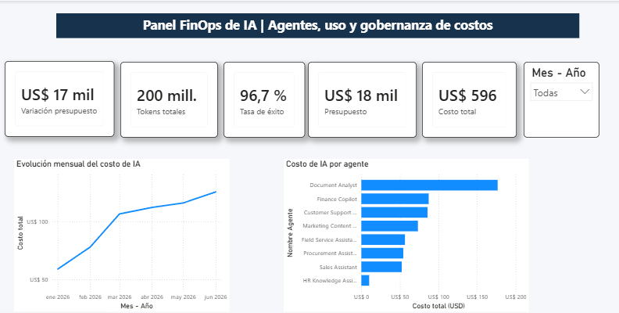

Finished Dashboard – Agent Detail
