AI Adoption & Business Value Dashboard
Tableau Public — End-to-End Build Walkthrough
Manual web-authoring process documented with the original build screenshots
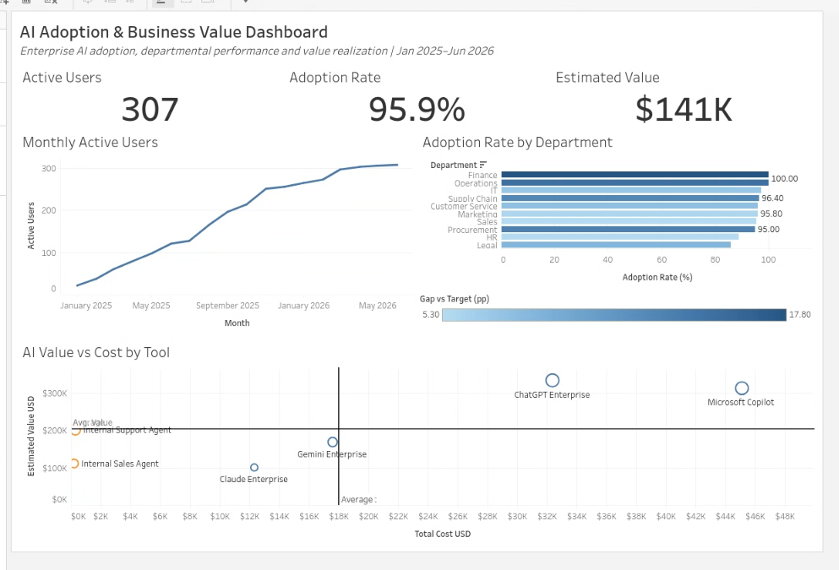
Published Tableau Public view: AI Adoption Analytics / Dashboard1
Primary data file: AI_Adoption_Advanced_Tableau_Dataset.csv | Reference file: AI_Adoption_Data_Dictionary.csv

How to use this walkthrough
This document focuses only on how the Tableau dashboard was built from start to finish. It intentionally avoids project architecture and broader business context so those can remain in the GitHub README.
• The screenshots are shown in build order and include configuration dialogs, intermediate layout states, corrections, and final polish.
• The analytical output was created manually in Tableau Public web authoring.
• Repeated screenshots are retained when they show a meaningful change in configuration or layout.

Key calculated field used
COUNTD(IF [Active Flag] = 1 THEN [User ID] END) / COUNTD([User ID])

Final KPI snapshot
Active Users | Adoption Rate | Estimated Value
307 | 95.9% | $141K

1. Tableau Public setup and data connection
The build started in Tableau Public web authoring. The primary CSV was connected for analysis, while the data dictionary was retained as a separate reference connection.
Step 1. Open Tableau Public and enter the web authoring workflow.
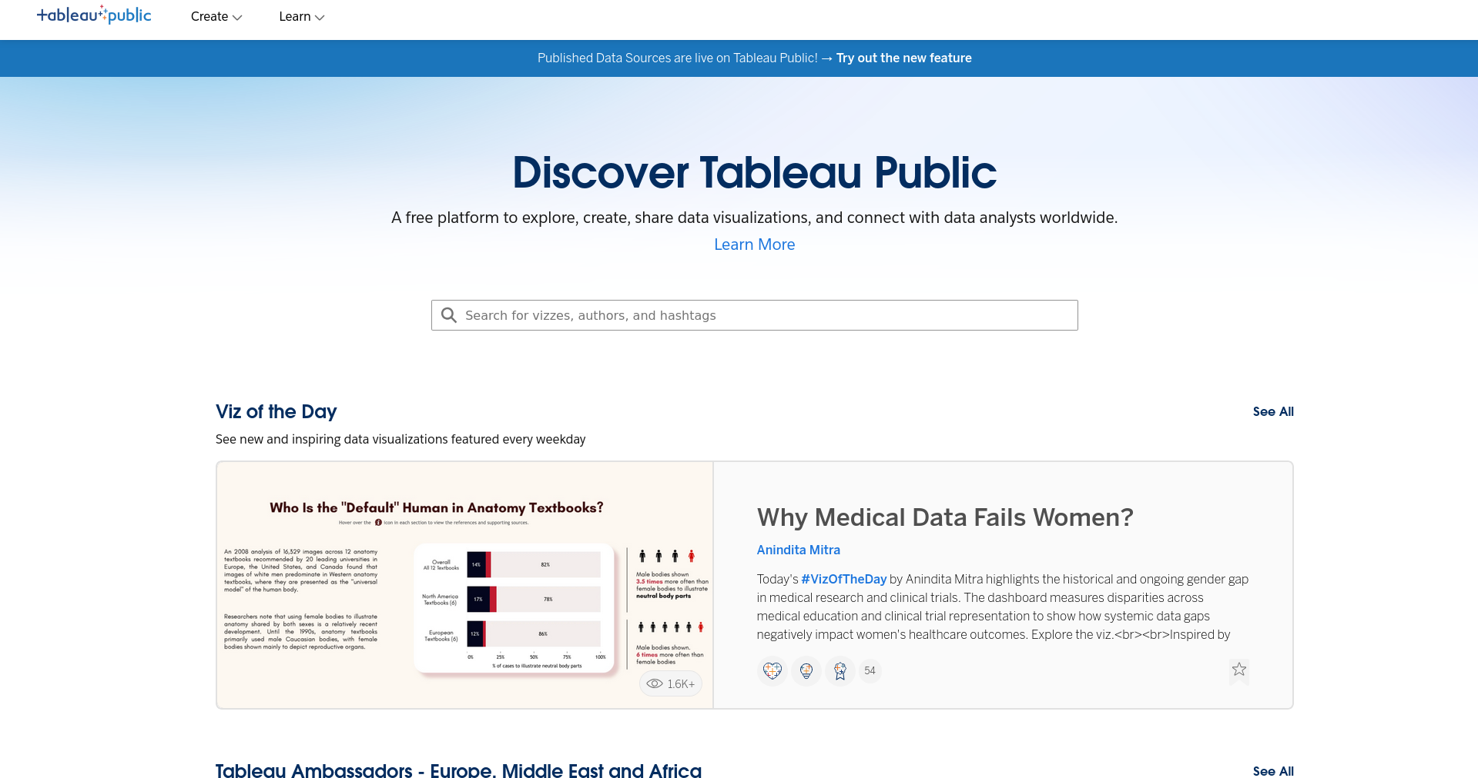

Step 2. Complete the Tableau Public account setup required to author workbooks.
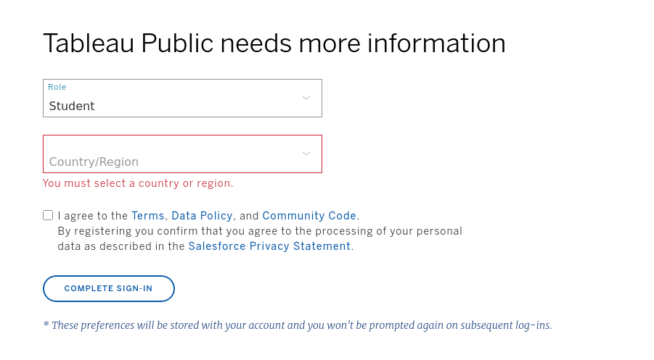

Step 3. Create a new workbook and open the Connect to Data dialog.
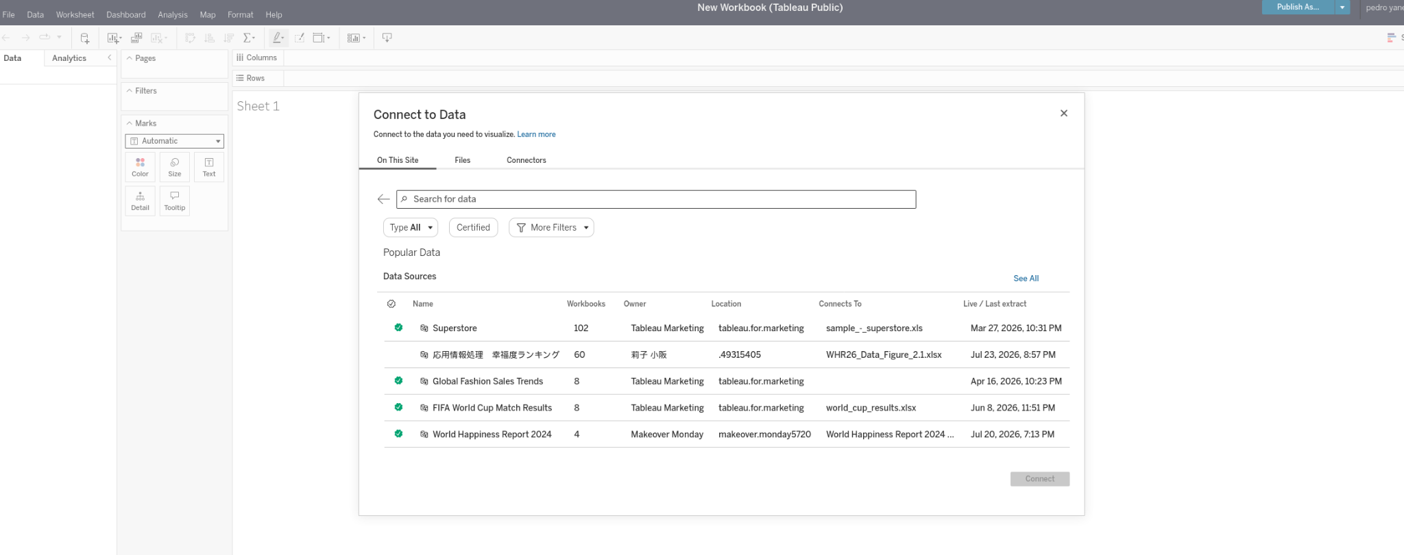

Step 4. Load the primary AI adoption CSV and verify the data source structure.
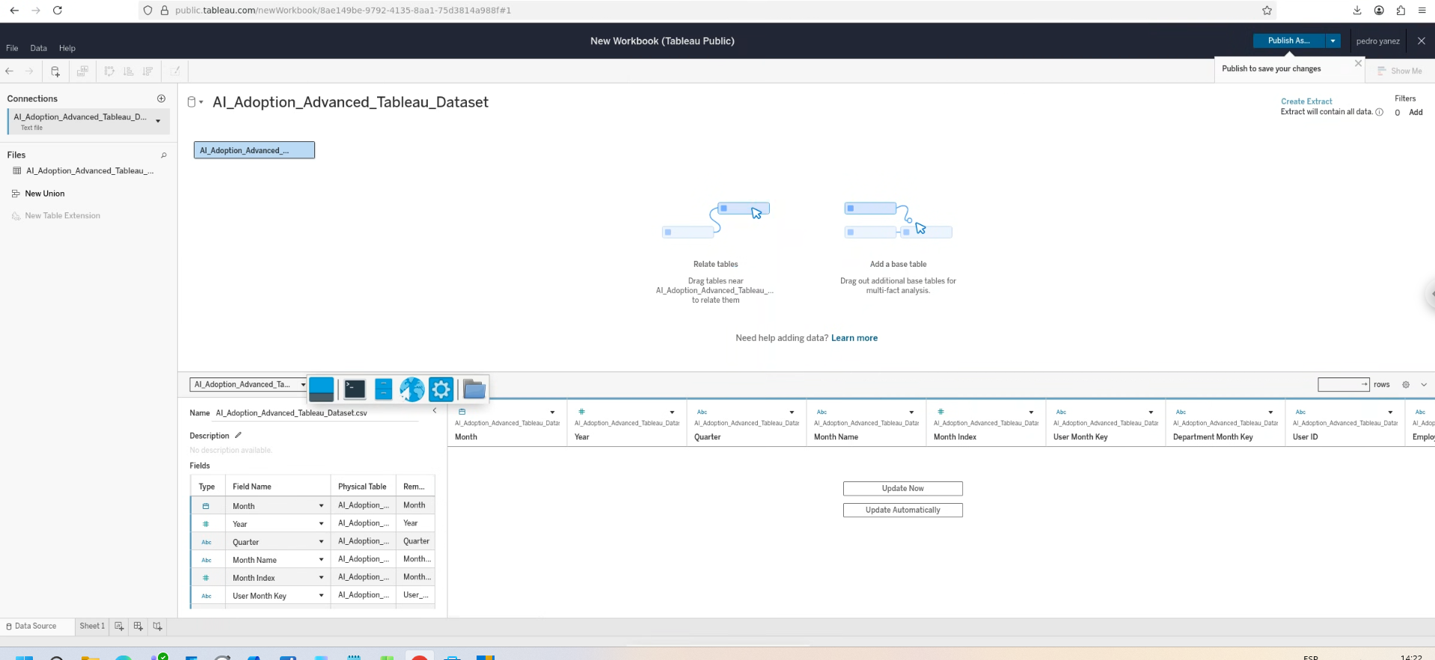

Step 5. Add the data dictionary as a second connection for reference.
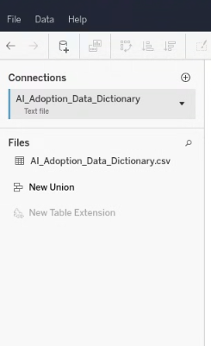
Step 6. Inspect the data dictionary fields while keeping it separate from the analytical source.
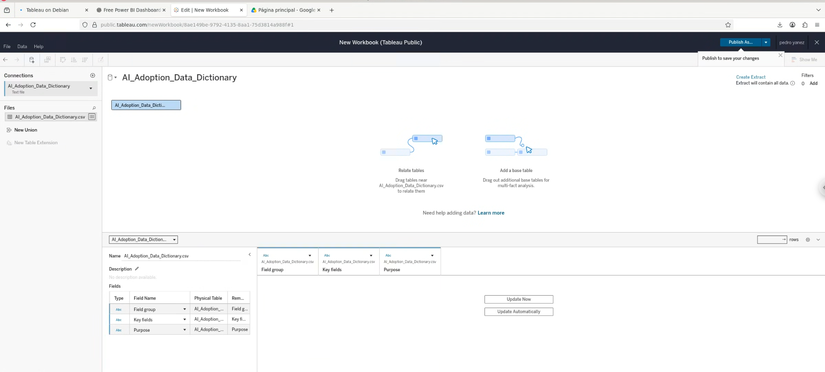

Step 7. Open the first worksheet and switch back to the primary analytical dataset.
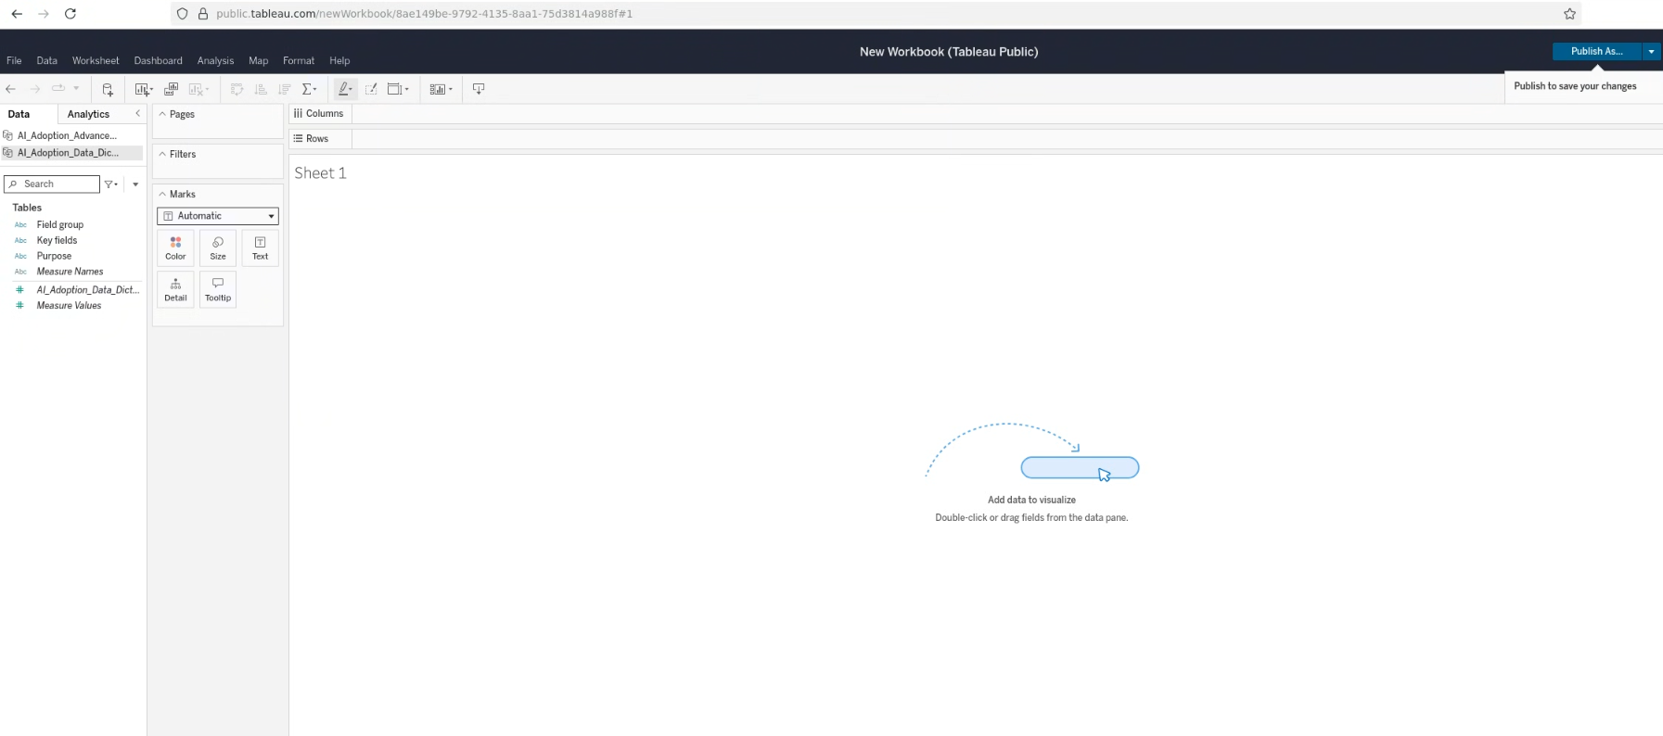

Step 8. Start the first view by placing Month on Columns and User ID on Rows.
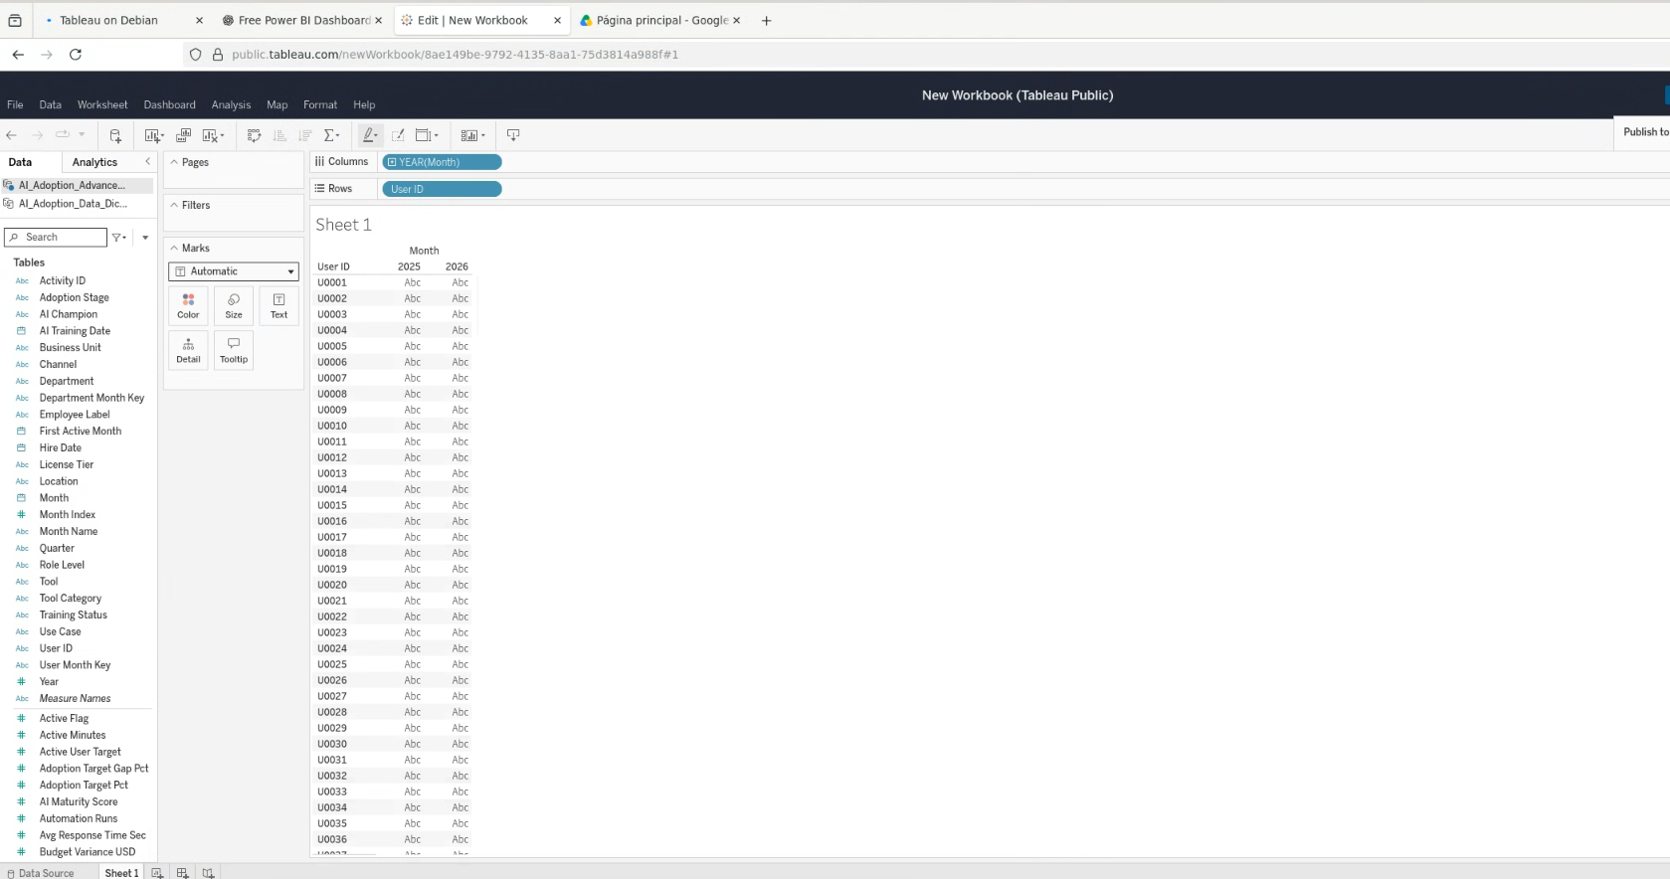

Step 9. Publish the workbook as “AI Adoption Analytics” to establish the saved online version.
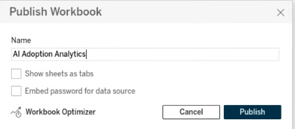
Step 10. Confirm the workbook has been published successfully.
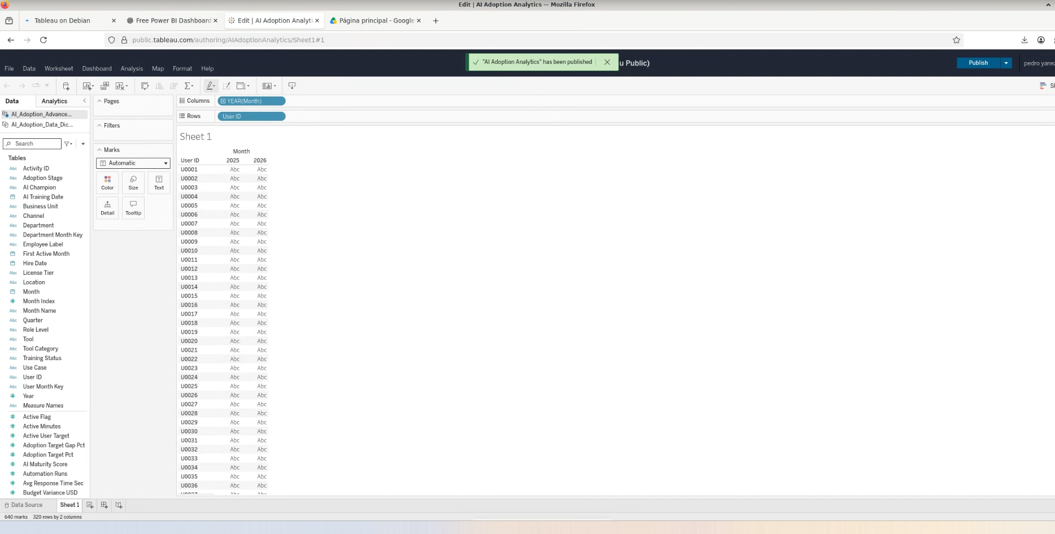

Step 11. Reopen the published workbook in Tableau Public web authoring.
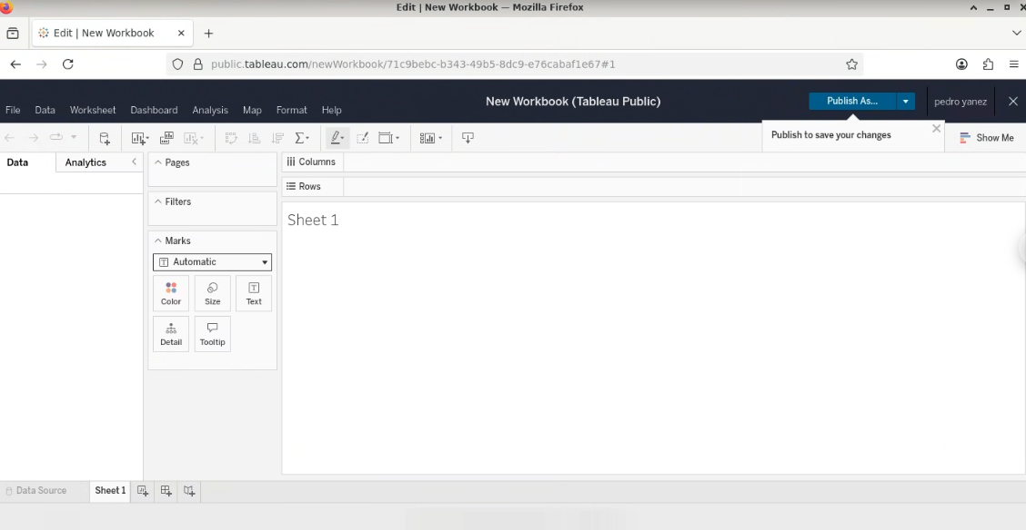

Step 12. Check the published workbook page before continuing the build.
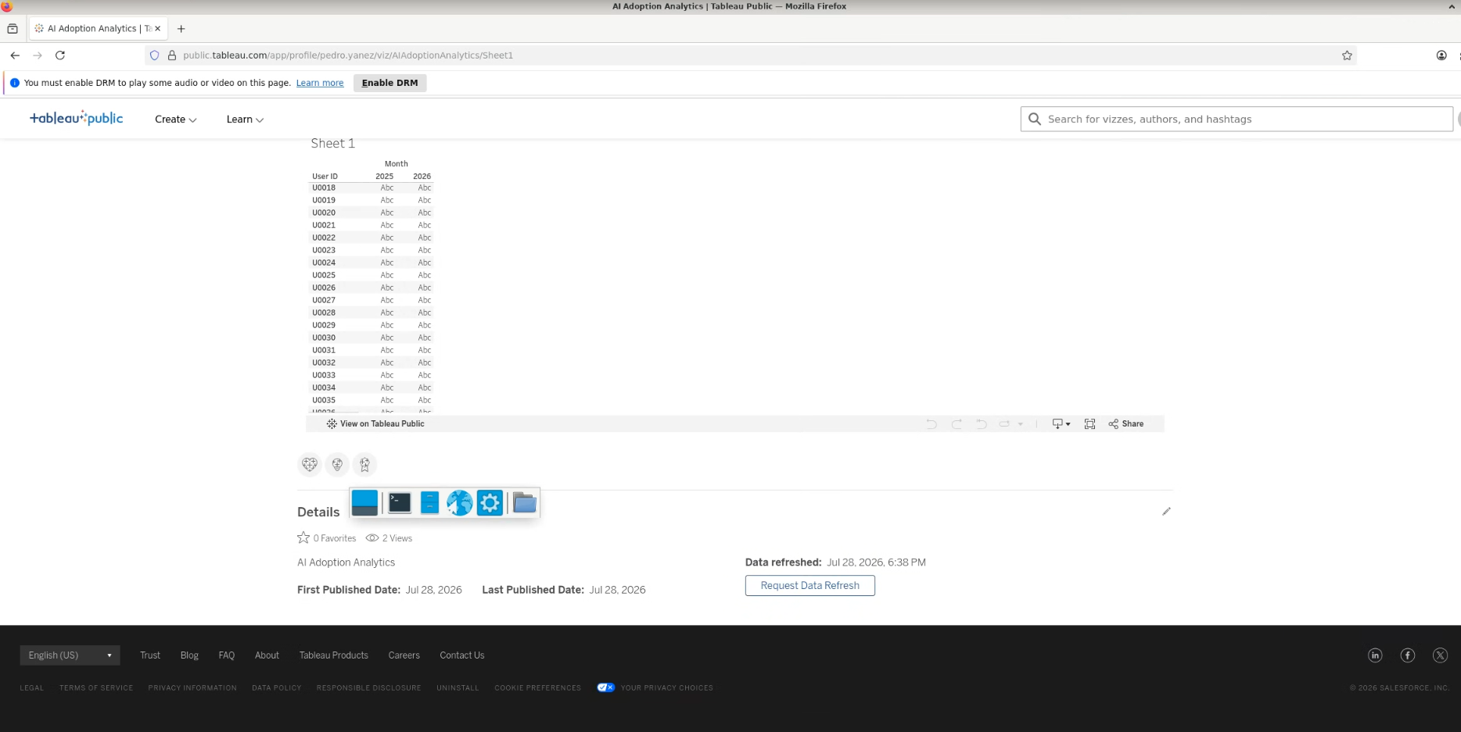

Step 13. Return to the authoring view and continue from the saved workbook.
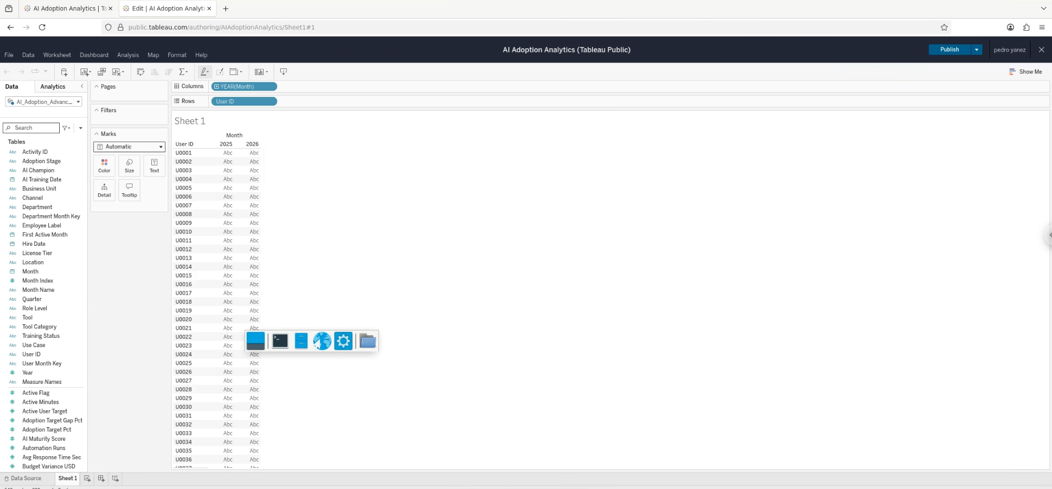

2. Monthly Active Users worksheet
The first analytical sheet tracks distinct active users over time. Active Flag was restricted to 1 and the date axis was changed to continuous Month.
Step 14. Convert User ID to a distinct count to create the active-user measure.
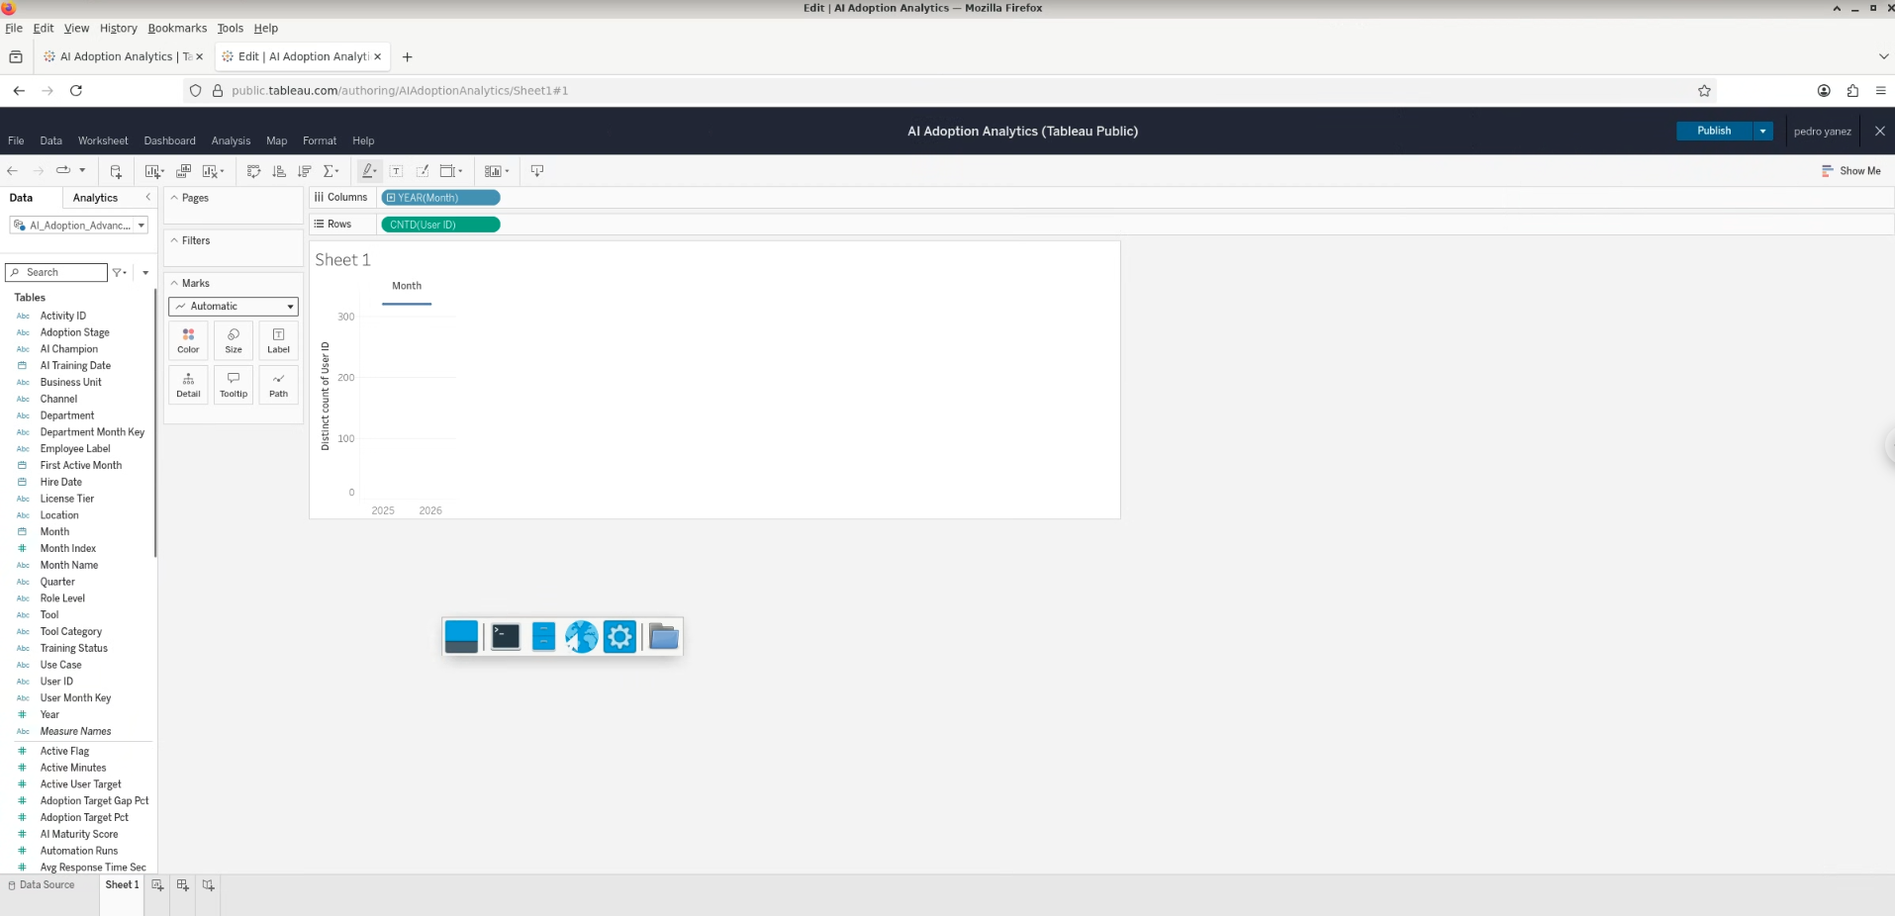

Step 15. Add Active Flag to Filters and choose the all-values filtering mode.
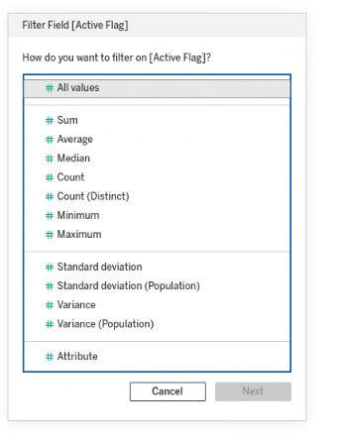
Step 16. Inspect the Active Flag range before restricting it.
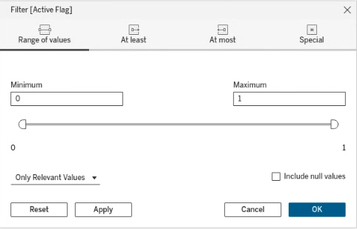
Step 17. Set Active Flag to 1 only.
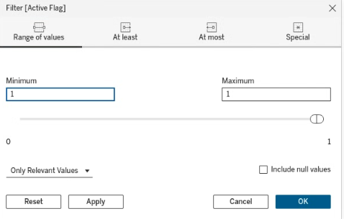
Step 18. Confirm the active-user trend after filtering.
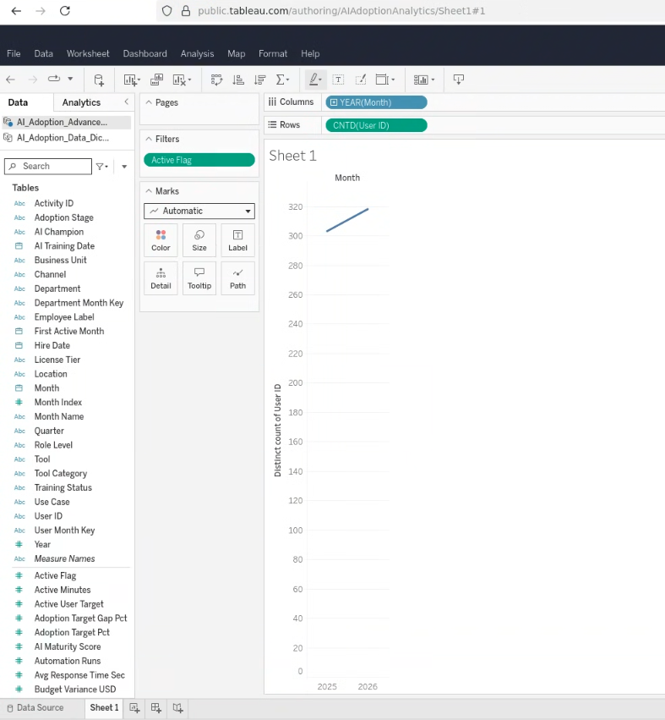
Step 19. Change the Month date level from Year to continuous Month.
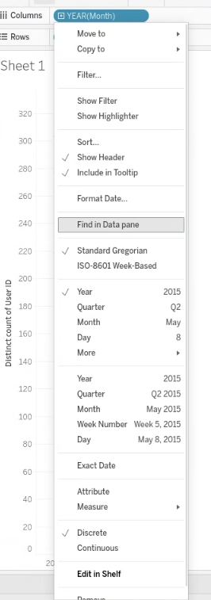
Step 20. Review the full monthly active-user trend across the 2025–2026 period.
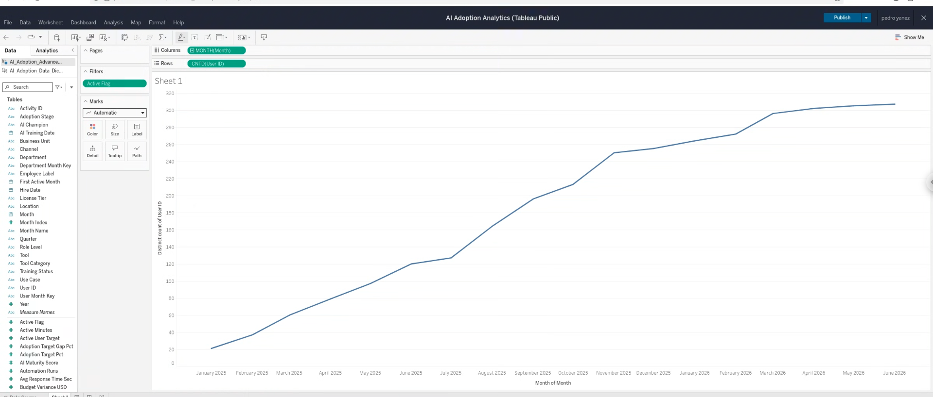

Step 21. Publish the completed Monthly Active Users worksheet.
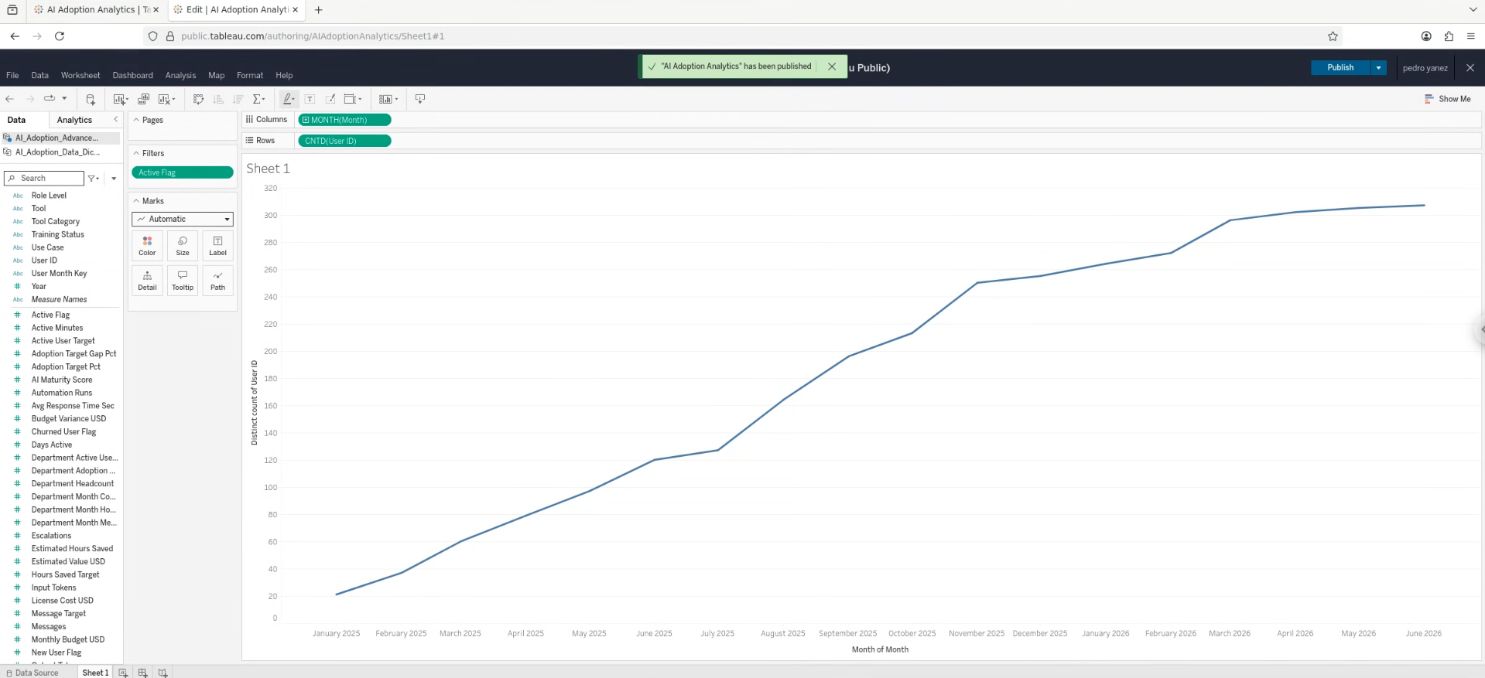

Step 22. Verify the published Monthly Active Users view.
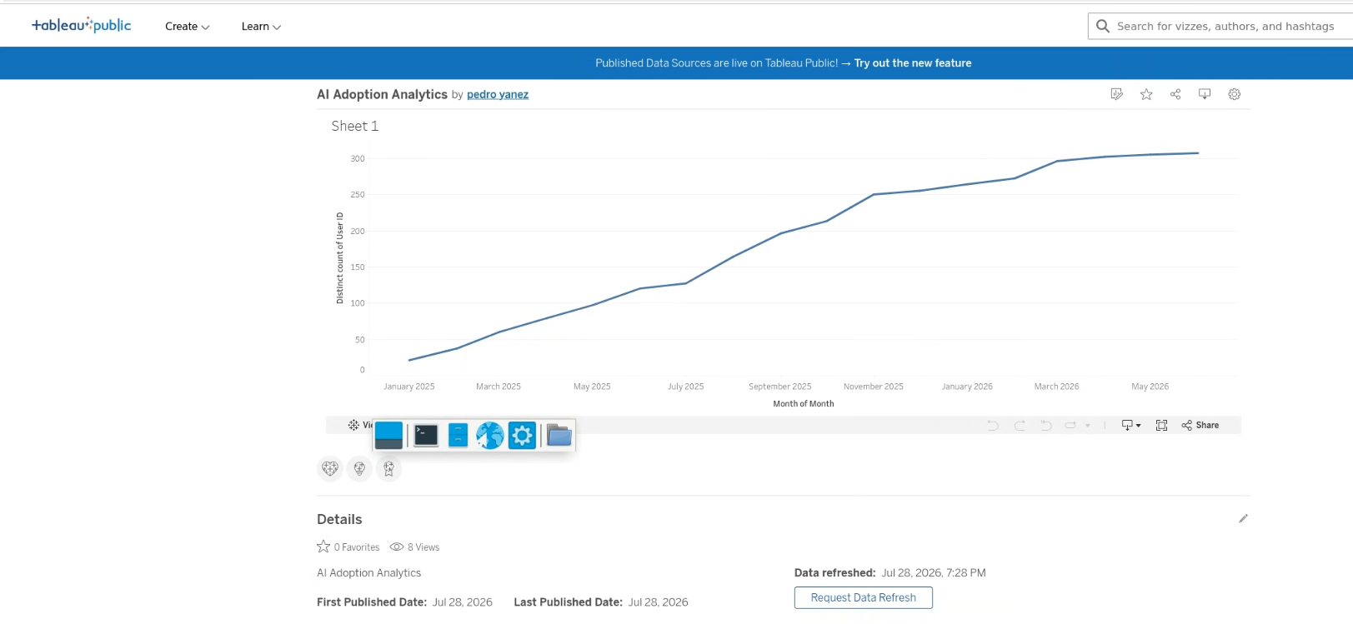

Step 23. Reopen the workbook and continue editing the monthly trend worksheet.
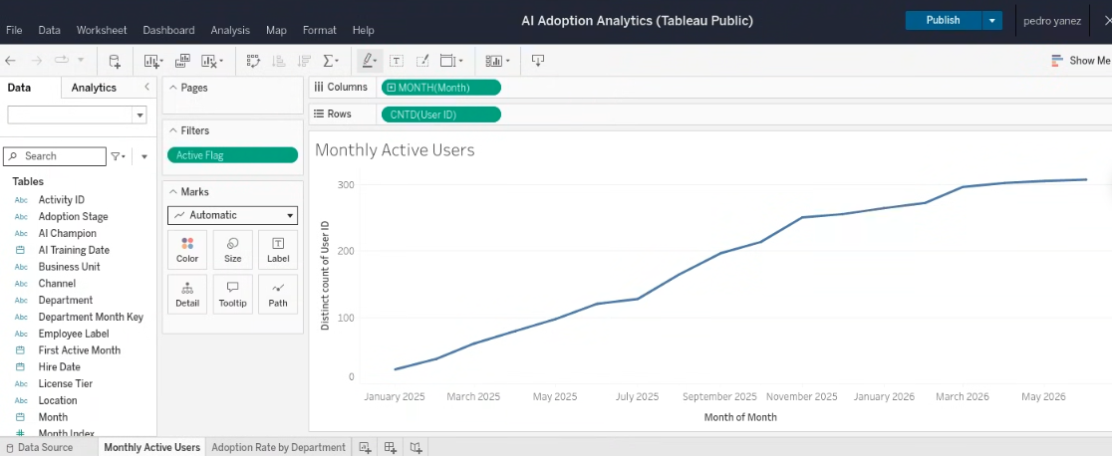

3. Adoption Rate by Department worksheet
The second worksheet compares department adoption for June 2026, adds labels, uses target-gap color encoding, and sorts the departments by adoption rate.
Step 24. Create a new worksheet for Adoption Rate by Department.
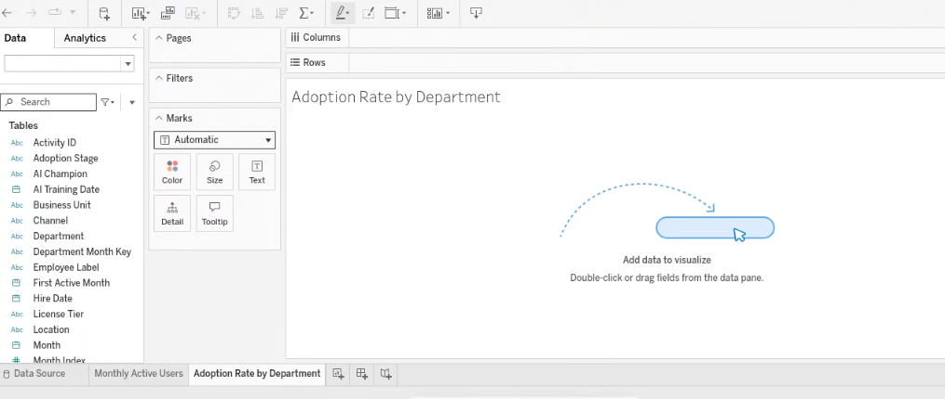

Step 25. Add Month to Filters and choose Individual Dates.
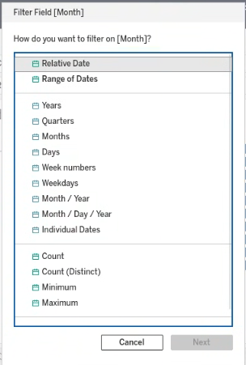
Step 26. Build the horizontal department adoption-rate bar chart for June 2026.
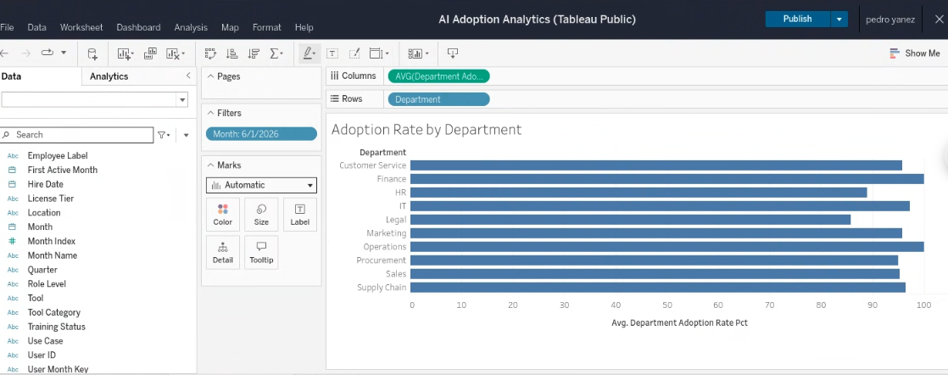

Step 27. Add adoption-rate labels and color the bars by the target gap.
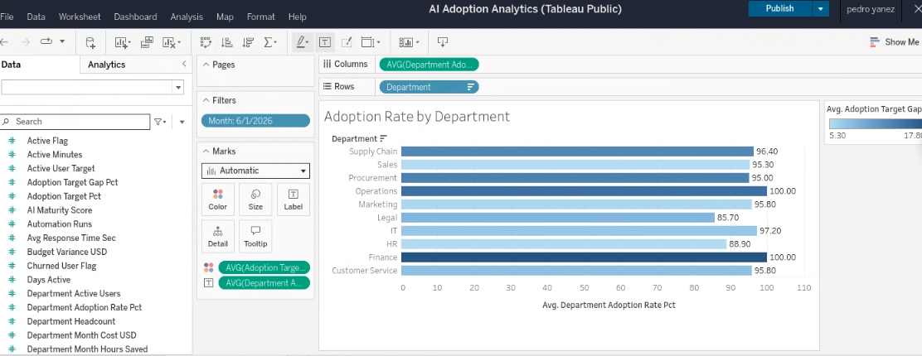

Step 28. Open Department sorting controls.
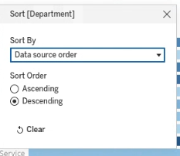
Step 29. Inspect measure controls while preparing field-based sorting.
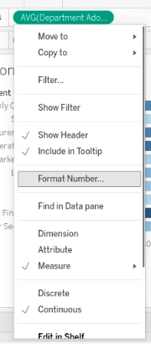
Step 30. Sort departments by Average Department Adoption Rate in descending order.
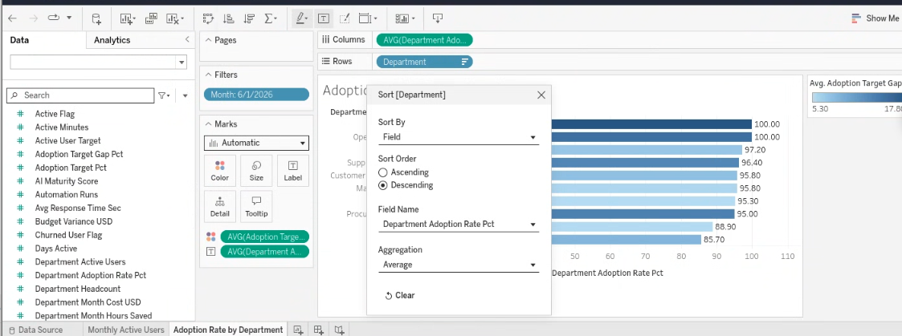

4. AI Value vs Cost by Tool worksheet
The third worksheet positions each AI tool by total cost and estimated value. Message volume controls mark size, and tool category provides categorical color.
Step 31. Filter Tool and exclude No Activity before building the value-vs-cost view.
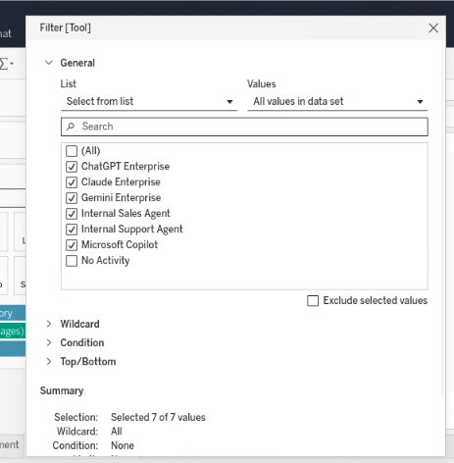
Step 32. Build AI Value vs Cost by Tool: cost on X, estimated value on Y, messages by size, category by color.
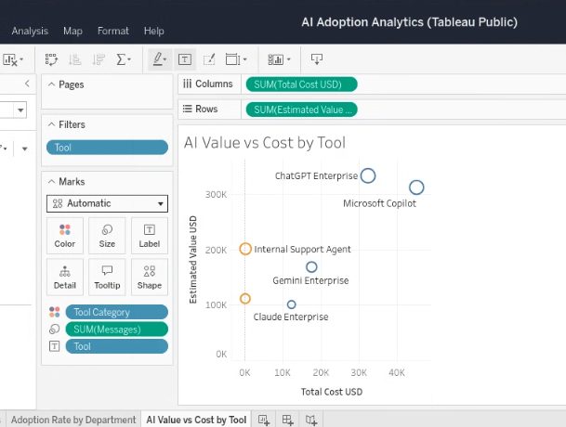
Step 33. Fit the scatter plot to the worksheet view.
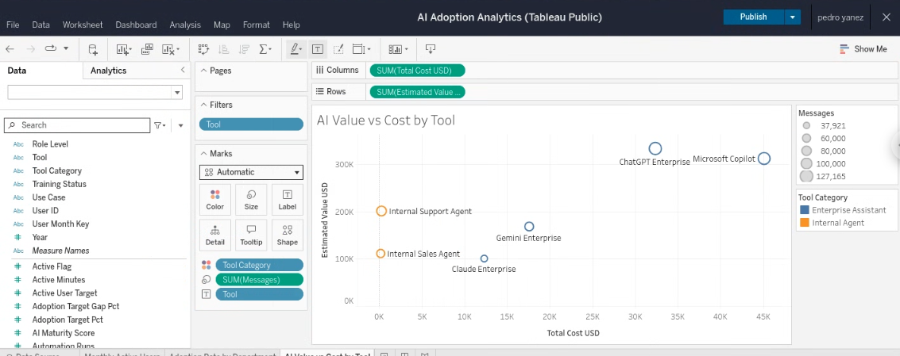

5. Dashboard layout construction
The dashboard was rebuilt with tiled containers to obtain a stable 1200 × 800 layout: two analytical charts in the upper area and the value-vs-cost scatter plot across the bottom.
Step 34. Create a dashboard and add Monthly Active Users.
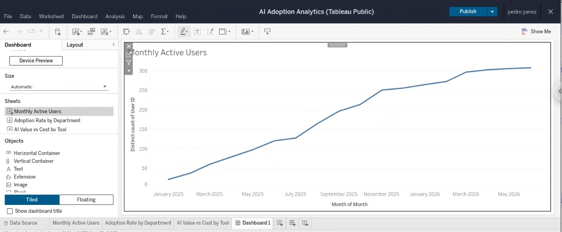

Step 35. Add all three worksheets to the initial dashboard layout.
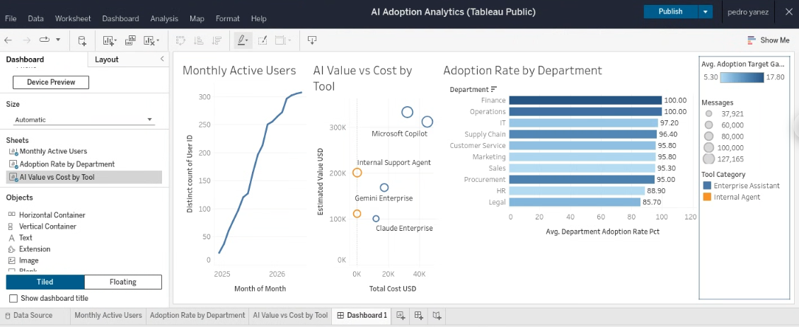

Step 36. Review the first crowded dashboard arrangement before rebuilding the layout.
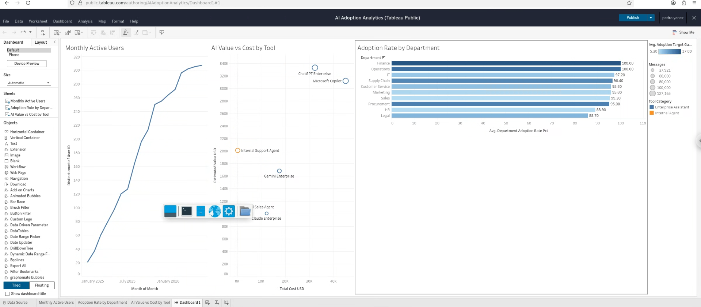

Step 37. Set a fixed dashboard size of 1200 × 800.
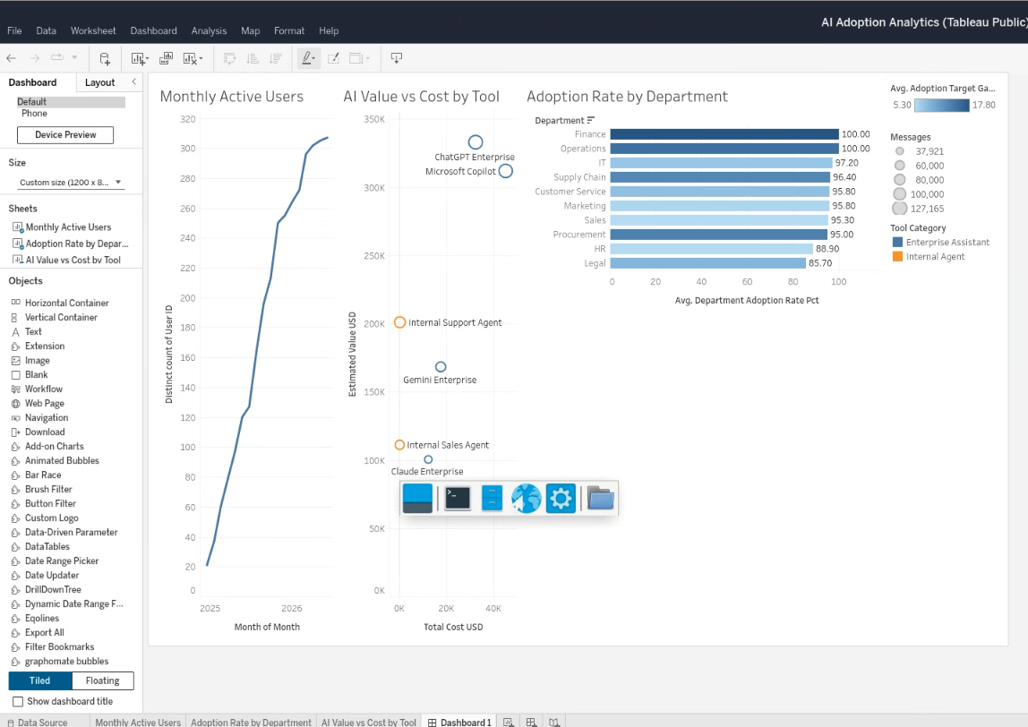
Step 38. Remove the dashboard chart objects while preserving the source worksheets.
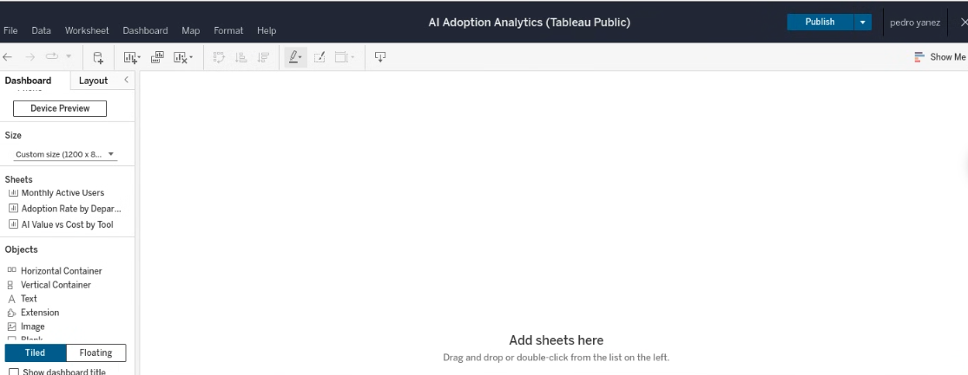

Step 39. Add a full-page vertical container.
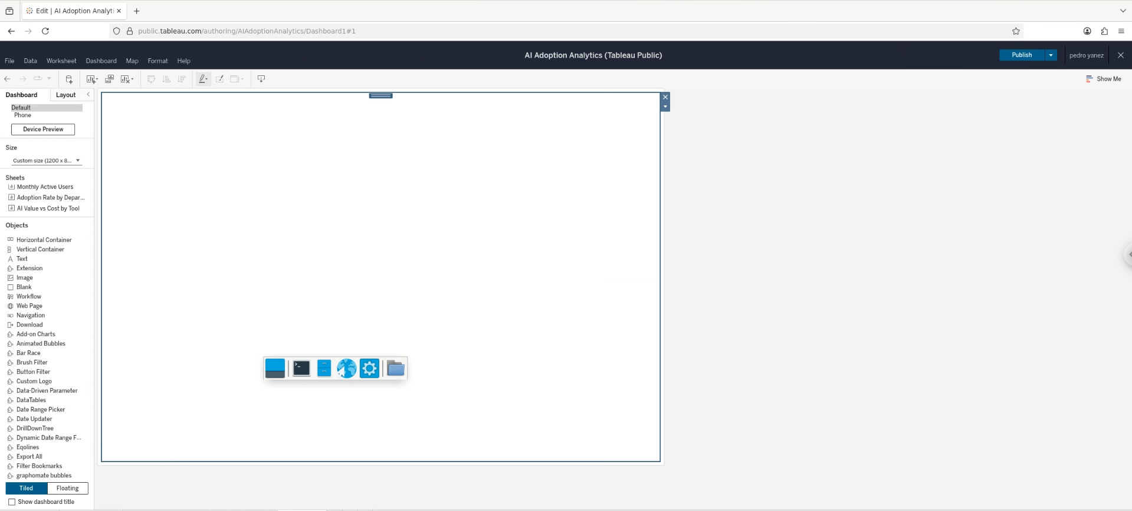

Step 40. Place Monthly Active Users in the upper section and a horizontal container beneath it.
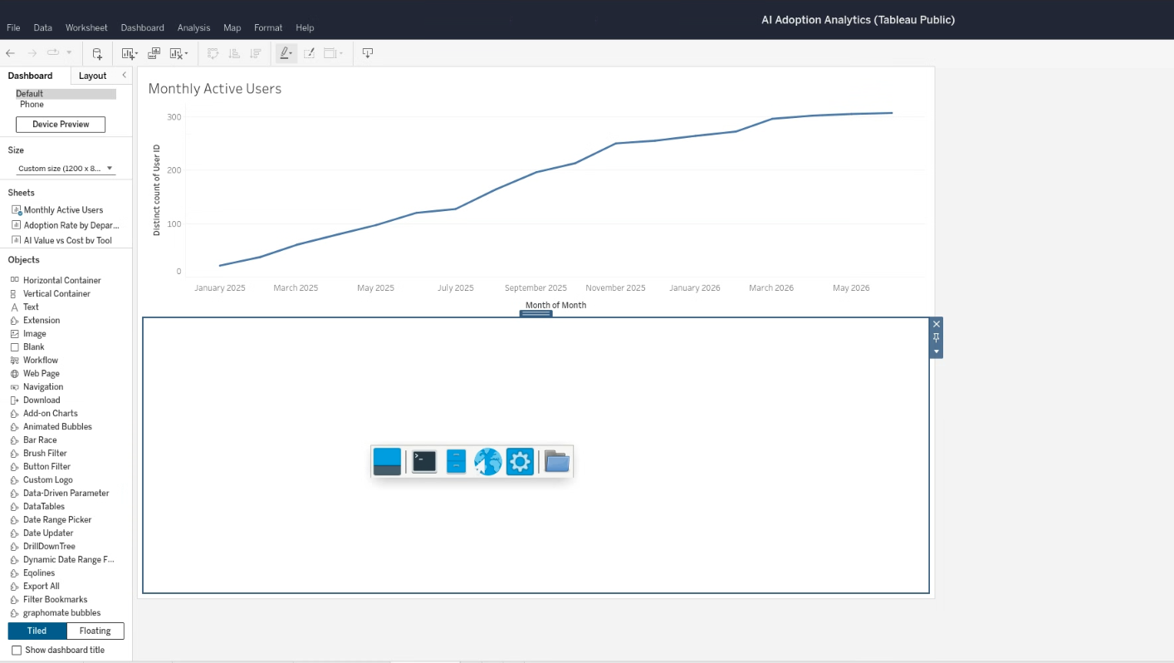

Step 41. Place AI Value vs Cost by Tool into the lower section.
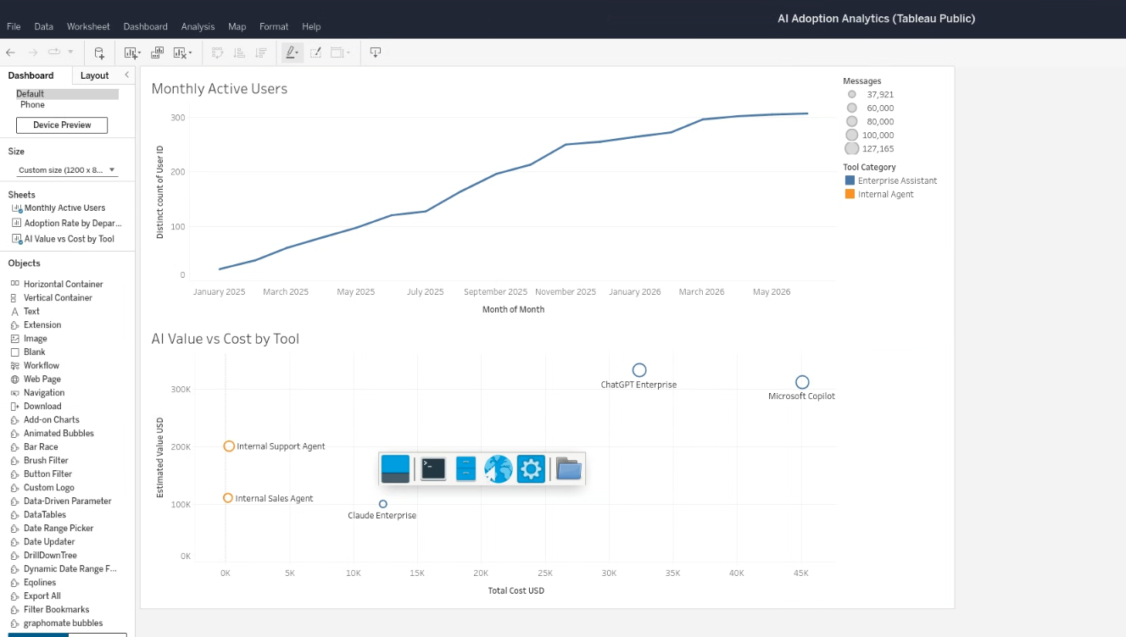

Step 42. Add Adoption Rate by Department and identify space lost to legends.
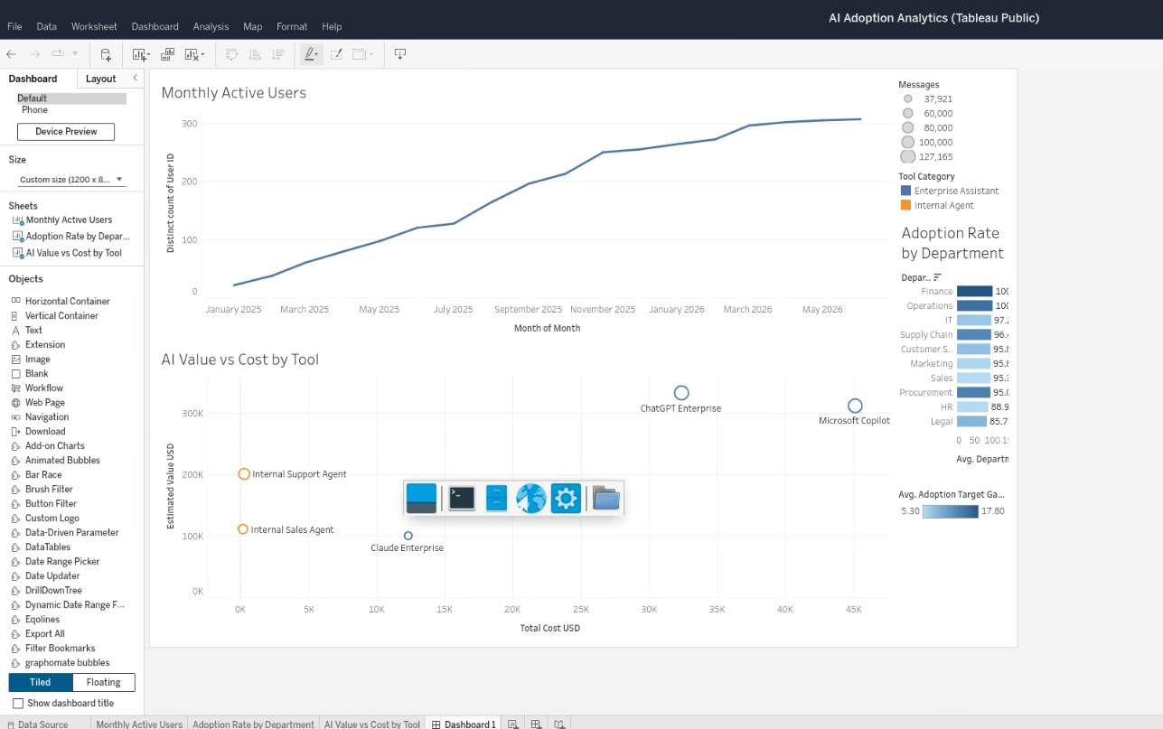
Step 43. Remove unnecessary legends and rebalance the dashboard.
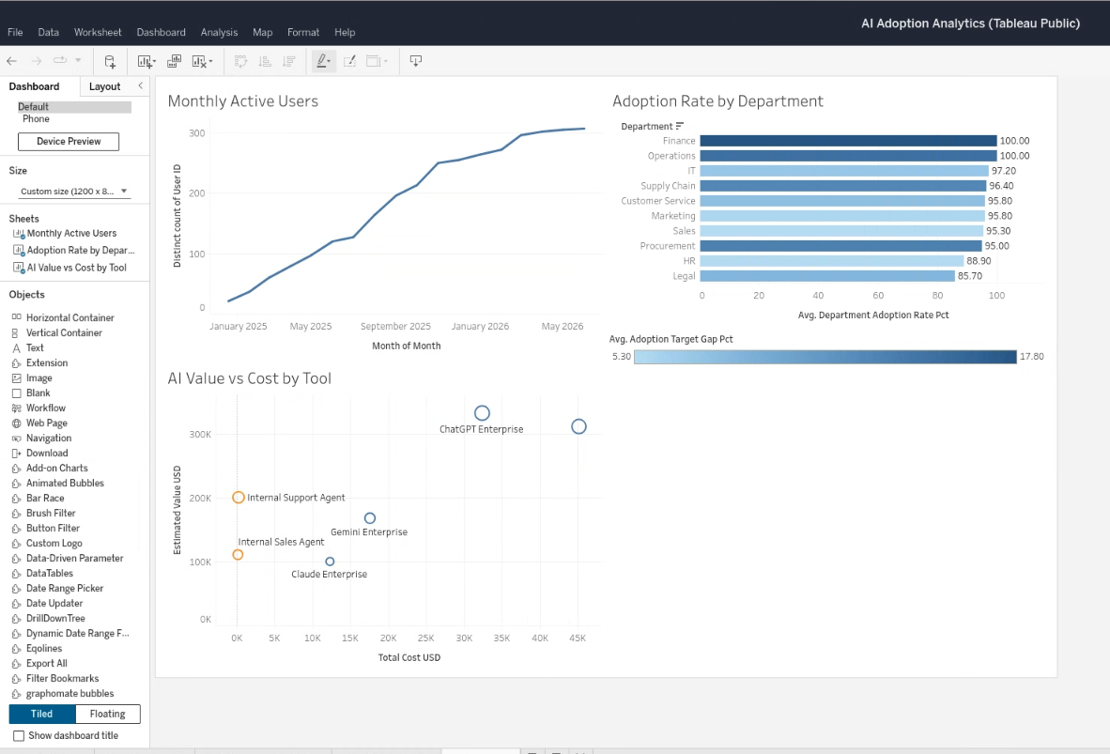
Step 44. Test full-width placement for the bottom scatter plot.
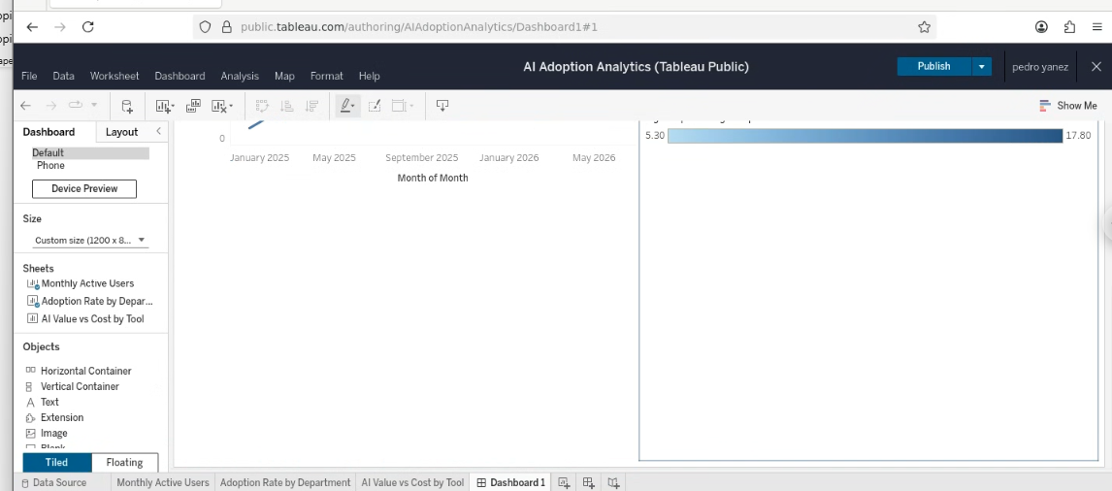

Step 45. Confirm the final two-top / one-bottom dashboard structure.
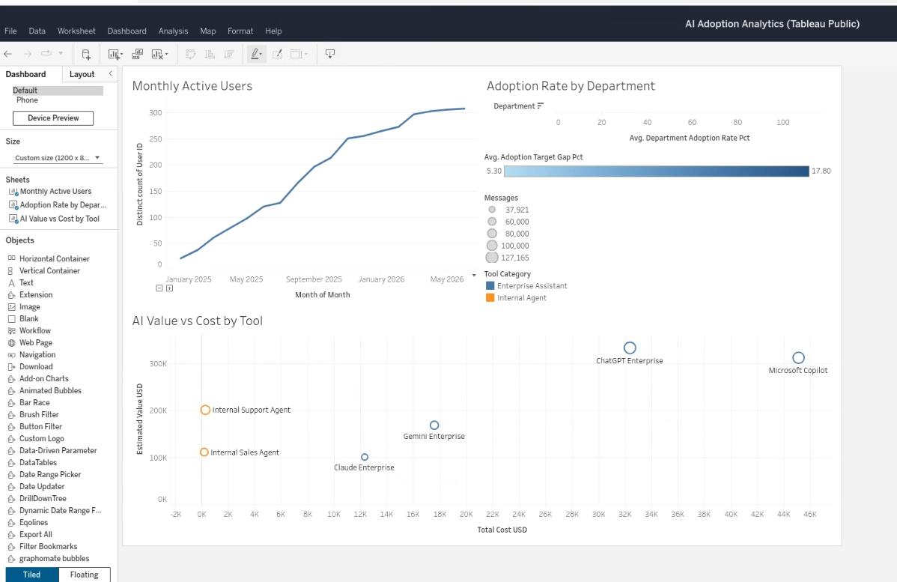

6. Visual polish and axis formatting
The next pass focused on presentation quality: dashboard naming, axis titles, percentage labels, currency formatting, and removal of negative padding on the cost axis.
Step 46. Resume dashboard editing after removing unnecessary legends.
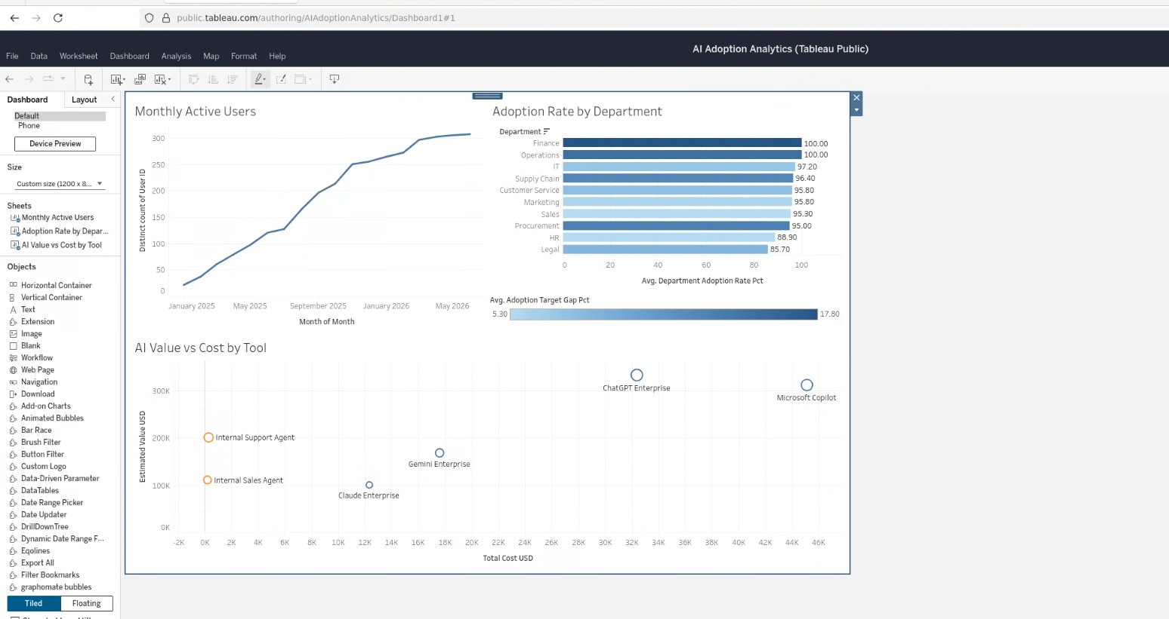

Step 47. Add the dashboard title and subtitle.
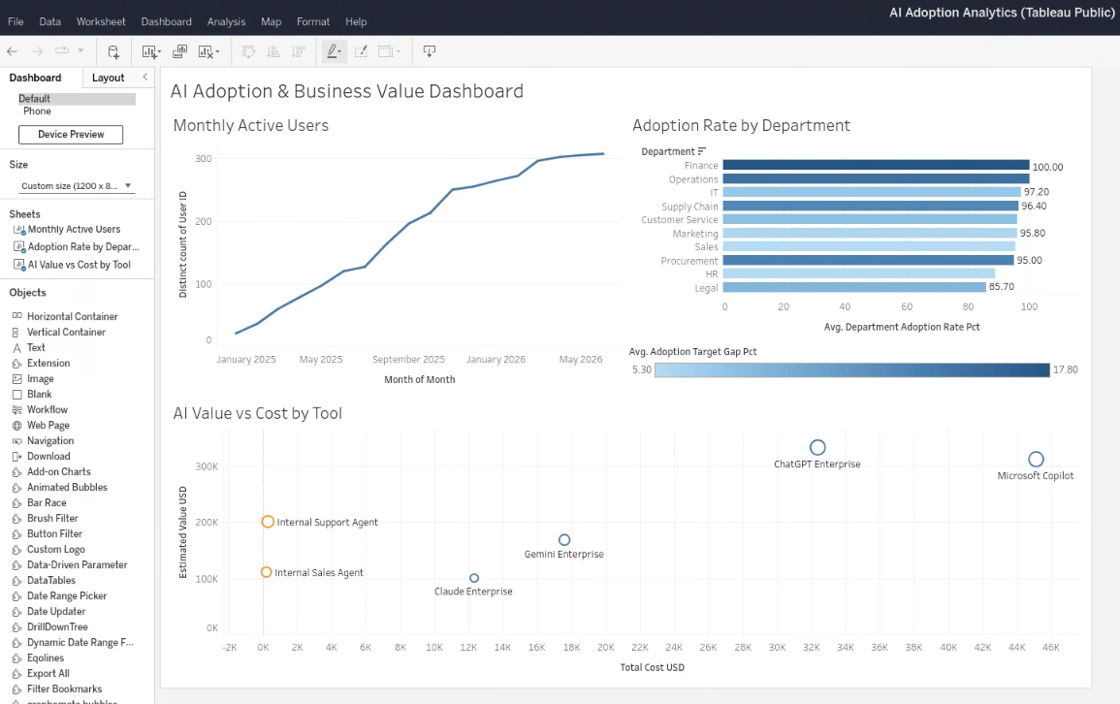
Step 48. Review the titled dashboard before axis cleanup.
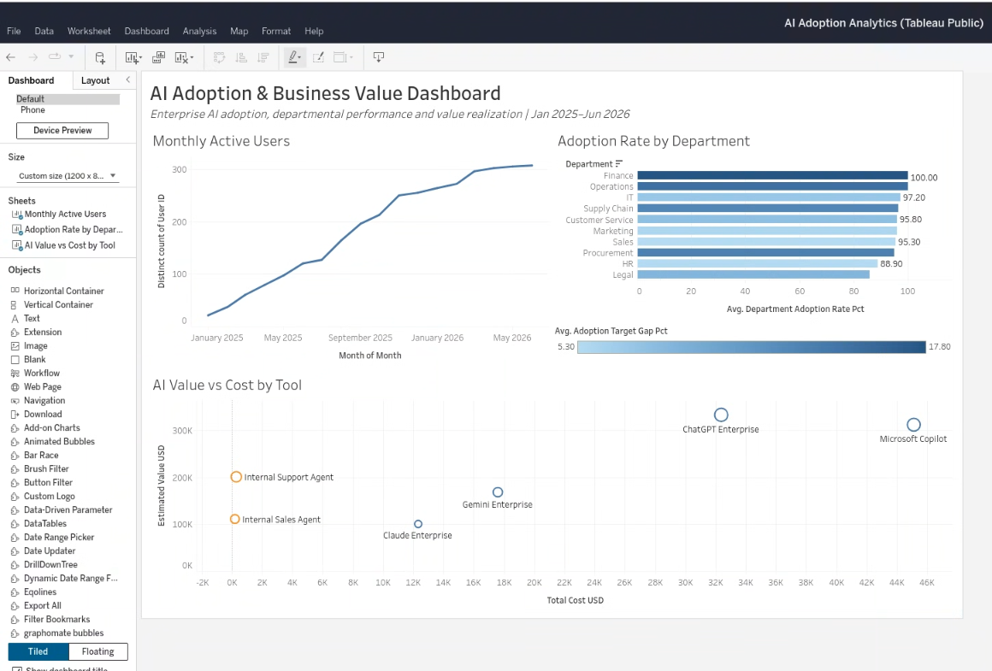
Step 49. Rename the Monthly Active Users axes to “Active Users” and “Month”.
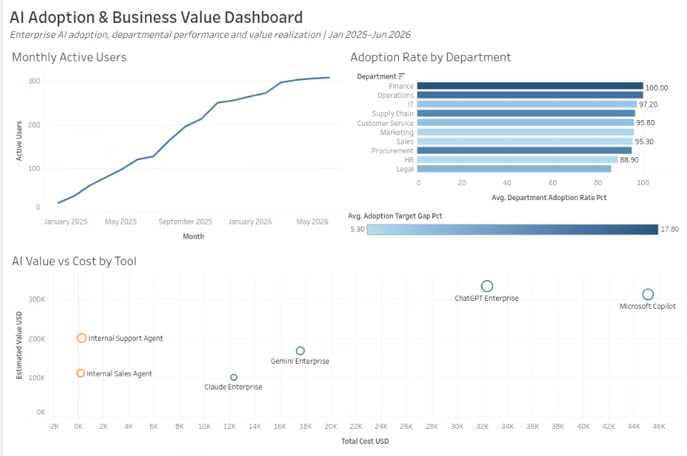
Step 50. Rename the department axis and target-gap legend.
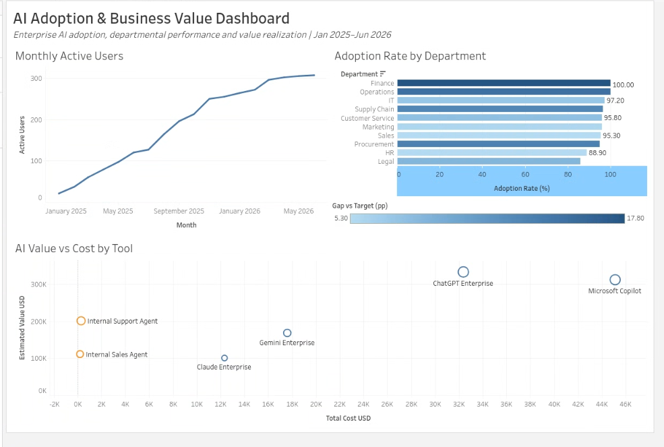
Step 51. Inspect Total Cost axis settings; Include zero was already enabled.
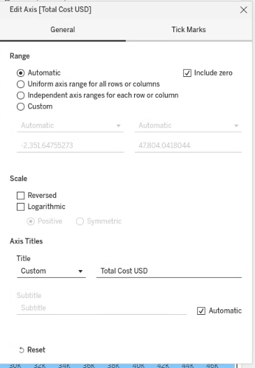
Step 52. Inspect the Tick Marks tab in Edit Axis.
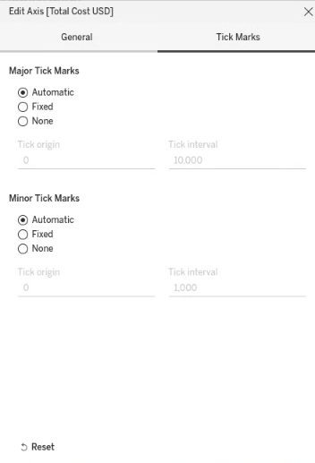
Step 53. Review axis configuration while locating number-format controls.
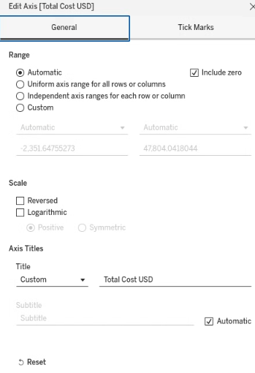
Step 54. Confirm that dashboard-axis formatting is not available from the context menu.
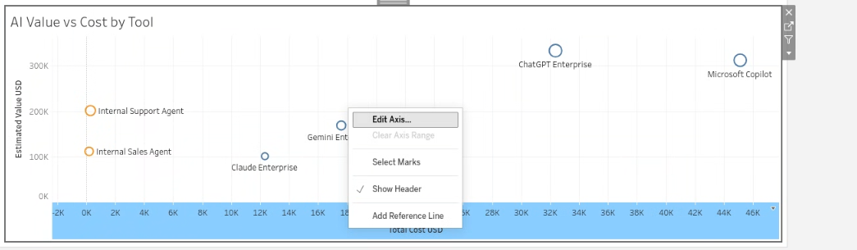

Step 55. Open number formatting from the worksheet measure.
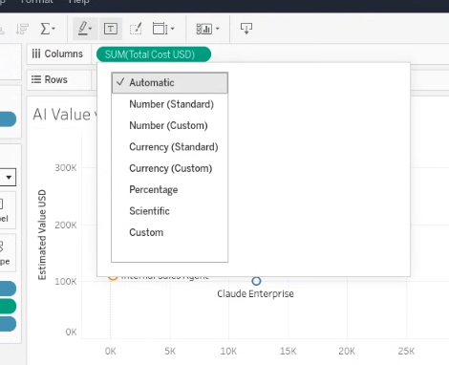
Step 56. Navigate from Custom to Currency (Custom).
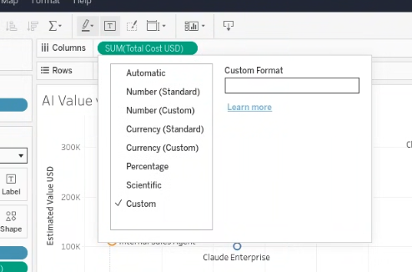
Step 57. Format Total Cost USD with zero decimals, thousands display units, and a dollar prefix.
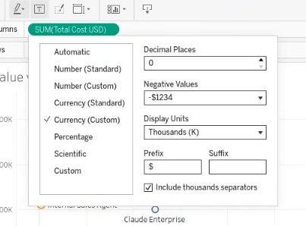
Step 58. Return to the dashboard and inspect the currency-formatted scatter plot.
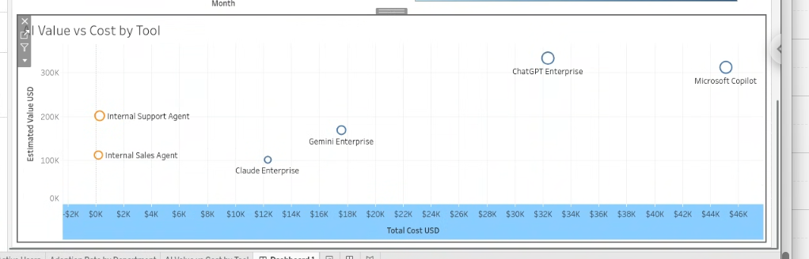

Step 59. Identify the remaining negative padding on the X-axis.
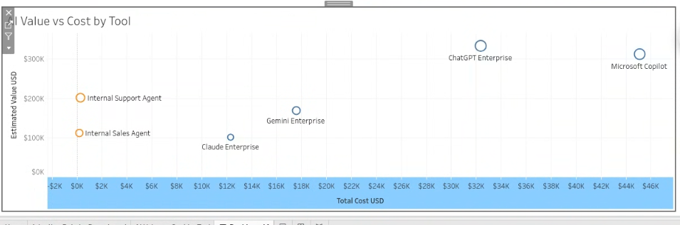

Step 60. Set the cost axis to start at $0K.
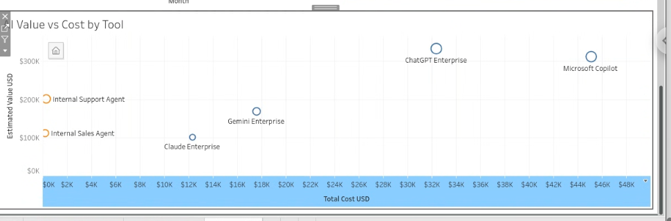

Step 61. Verify the cleaned USD axes on the scatter plot.
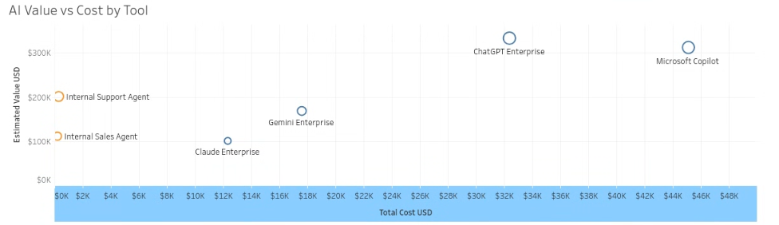

7. Average cost and average value reference lines
Two table-level average reference lines were added to make the scatter plot more analytical and easier to read as four quadrants.
Step 62. Attempt to add a reference line directly from the dashboard view.

Step 63. Open the Edit Line dialog for the cost reference line.
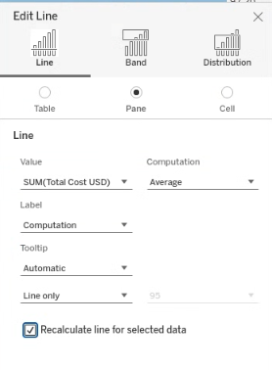
Step 64. Configure the average-cost line; the initial scope is Pane.
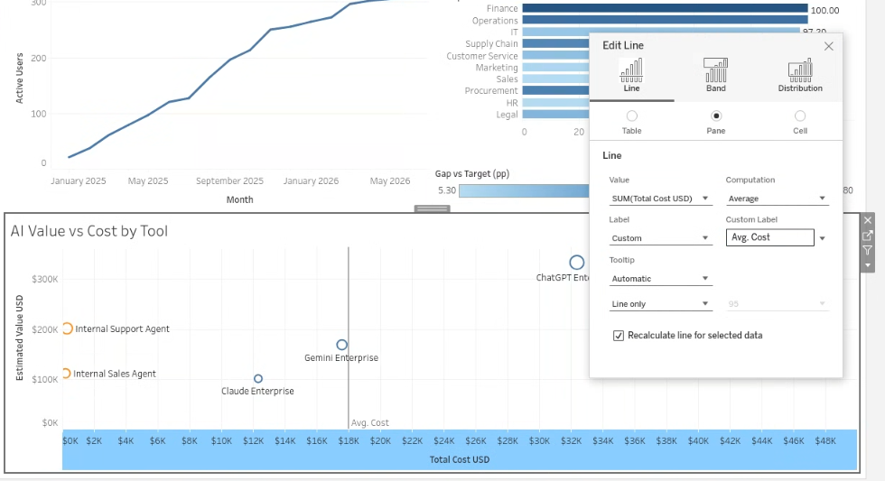

Step 65. Change the Avg. Cost reference-line scope to Table.
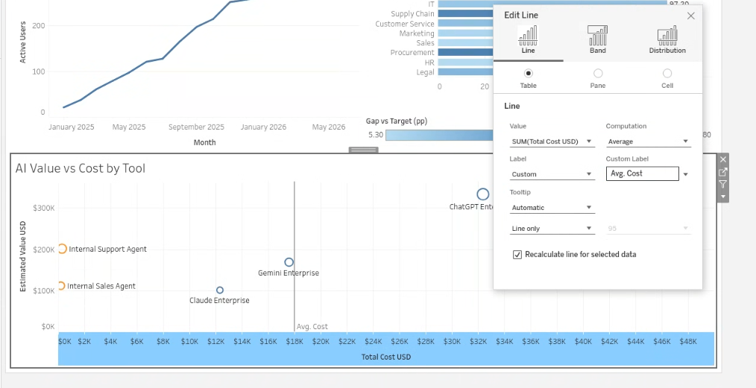

Step 66. Confirm the vertical Avg. Cost reference line on the scatter plot.
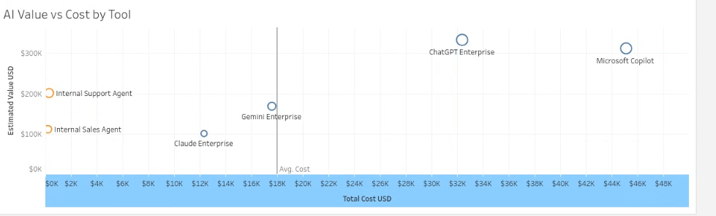

Step 67. Open the configuration for a second reference line.
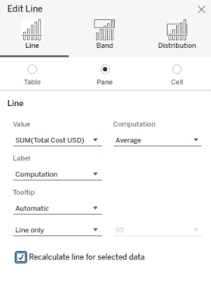
Step 68. Navigate back to the scatter worksheet to use the Analytics pane.
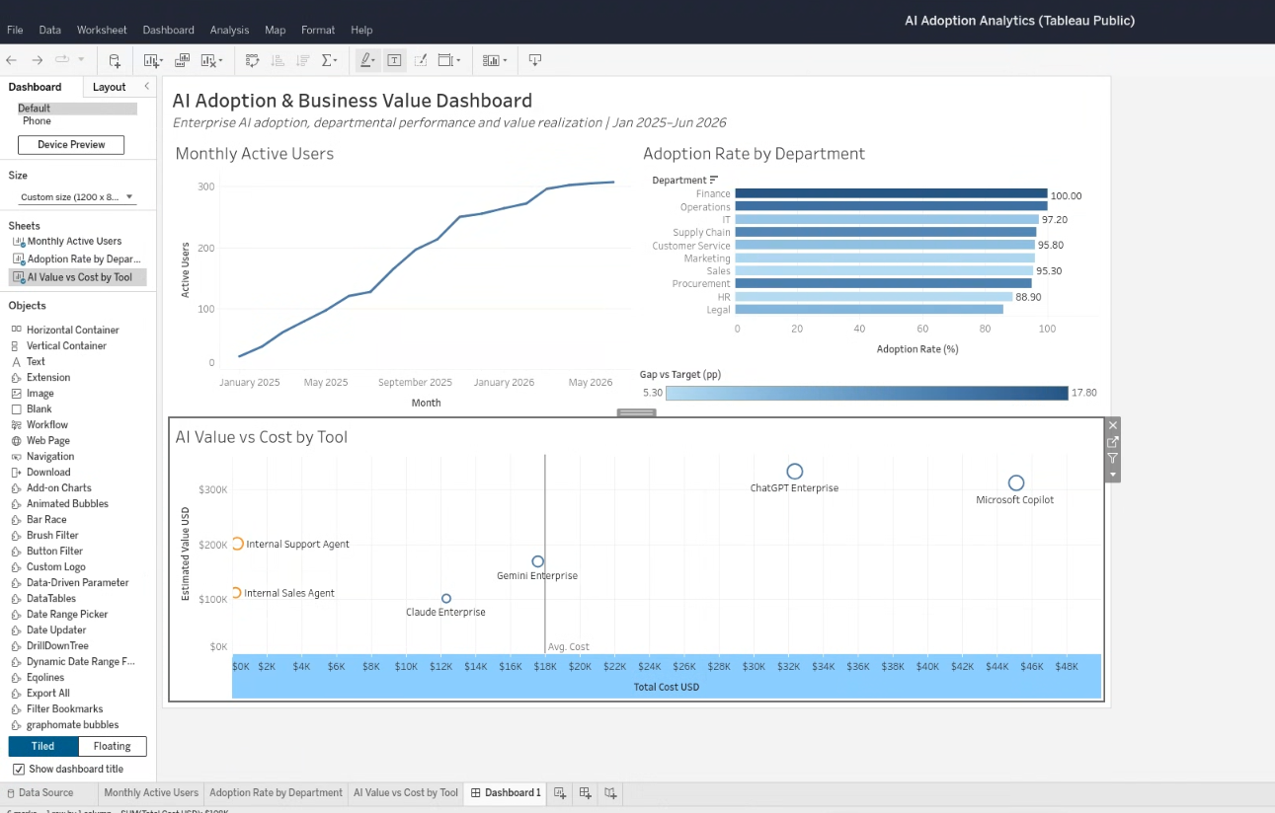
Step 69. Open the Analytics pane in the AI Value vs Cost by Tool worksheet.
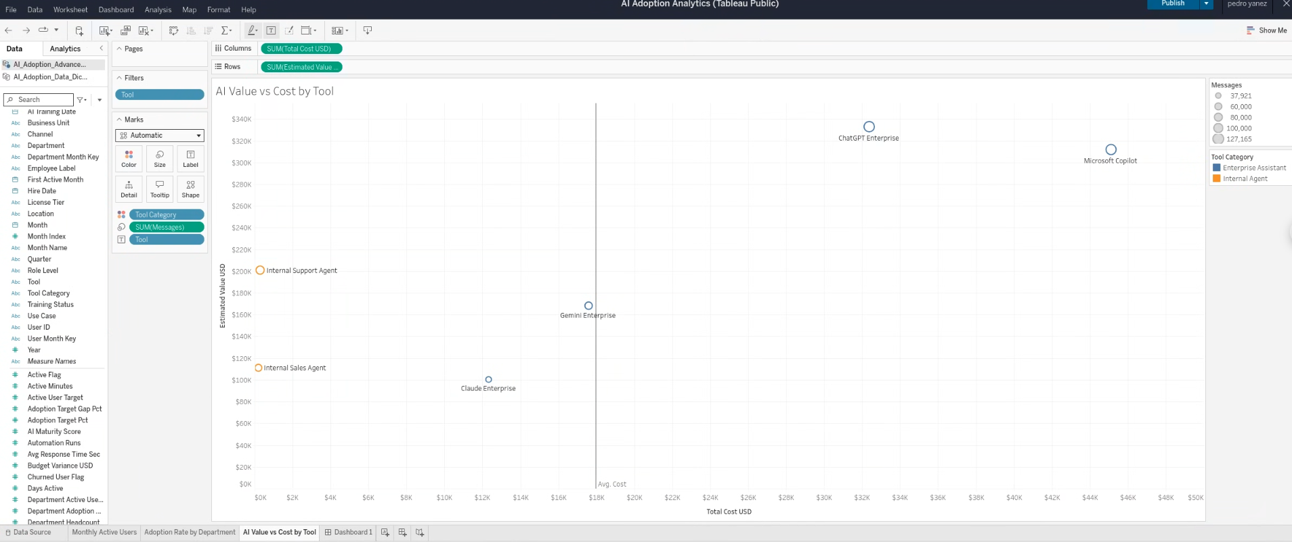

Step 70. Edit a second reference line while targeting the value axis.
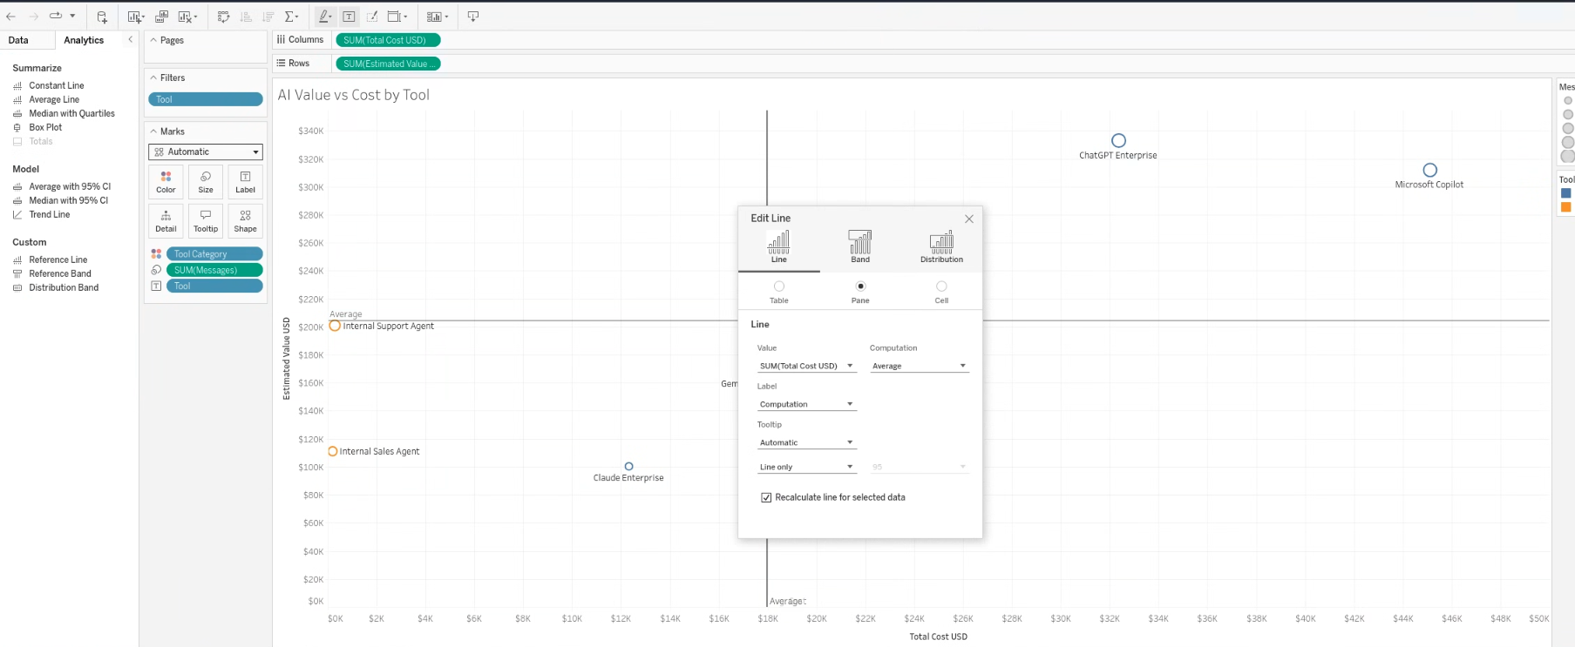

Step 71. Identify an incorrect X-axis drop target because Estimated Value is not available.
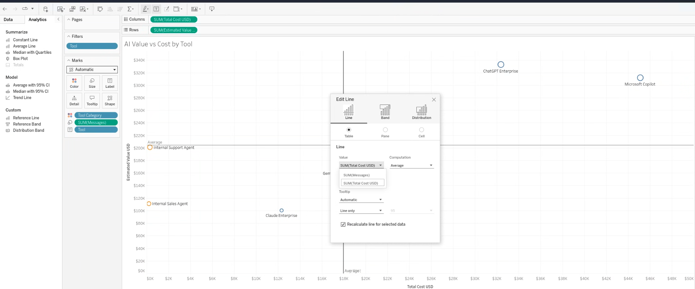

Step 72. Inspect the available values and confirm the wrong target.
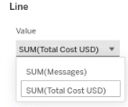
Step 73. Drag Reference Line and target the lower row for SUM(Estimated Value USD).
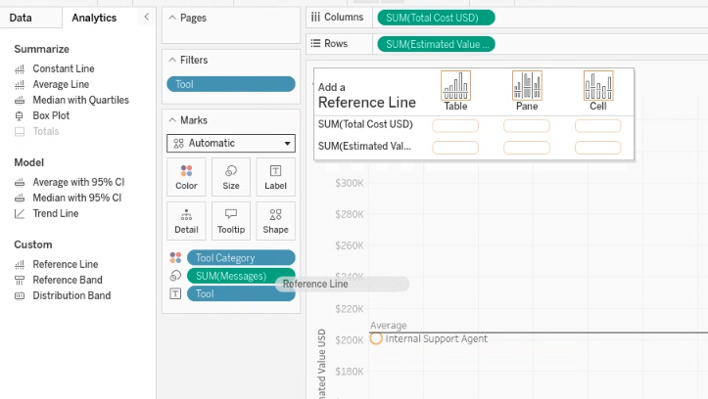
Step 74. Confirm SUM(Estimated Value USD) is available in the Edit Line dialog.
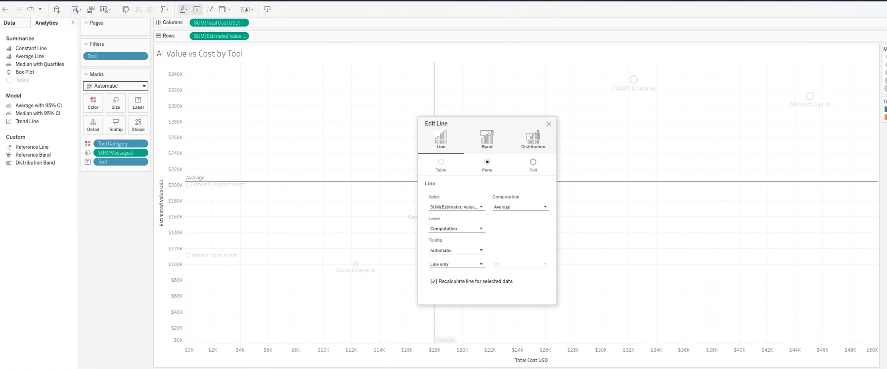

Step 75. Set the value line to Table scope and label it “Avg. Value”.
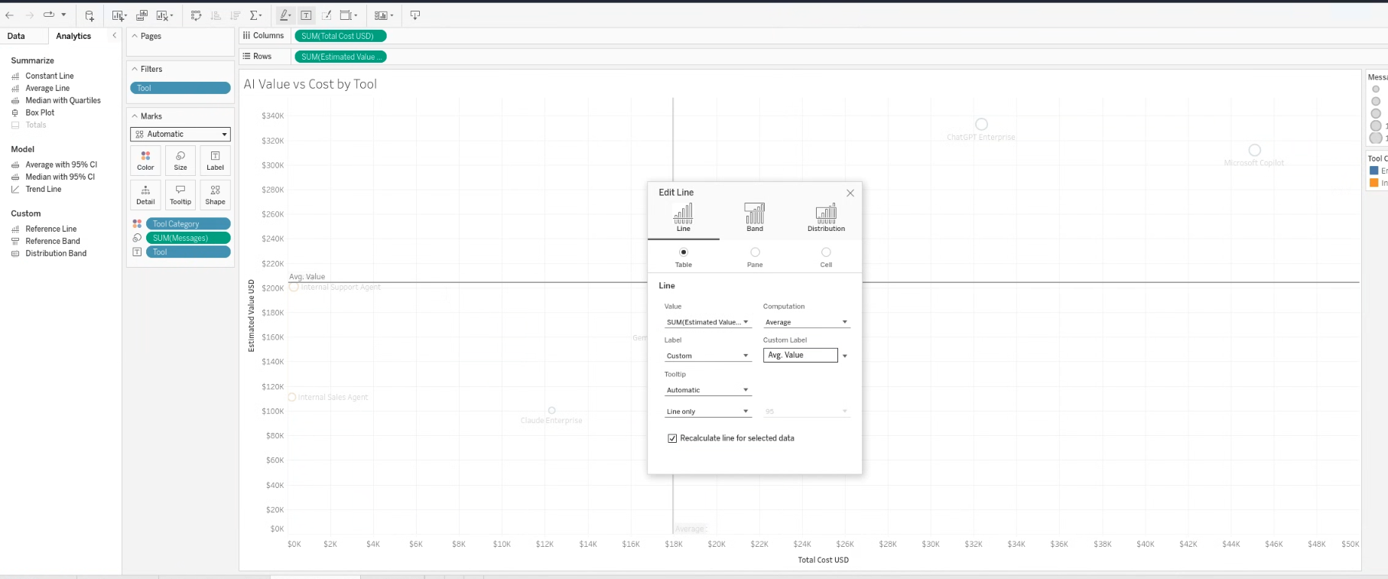

Step 76. Verify the completed four-quadrant scatter plot with Avg. Cost and Avg. Value.
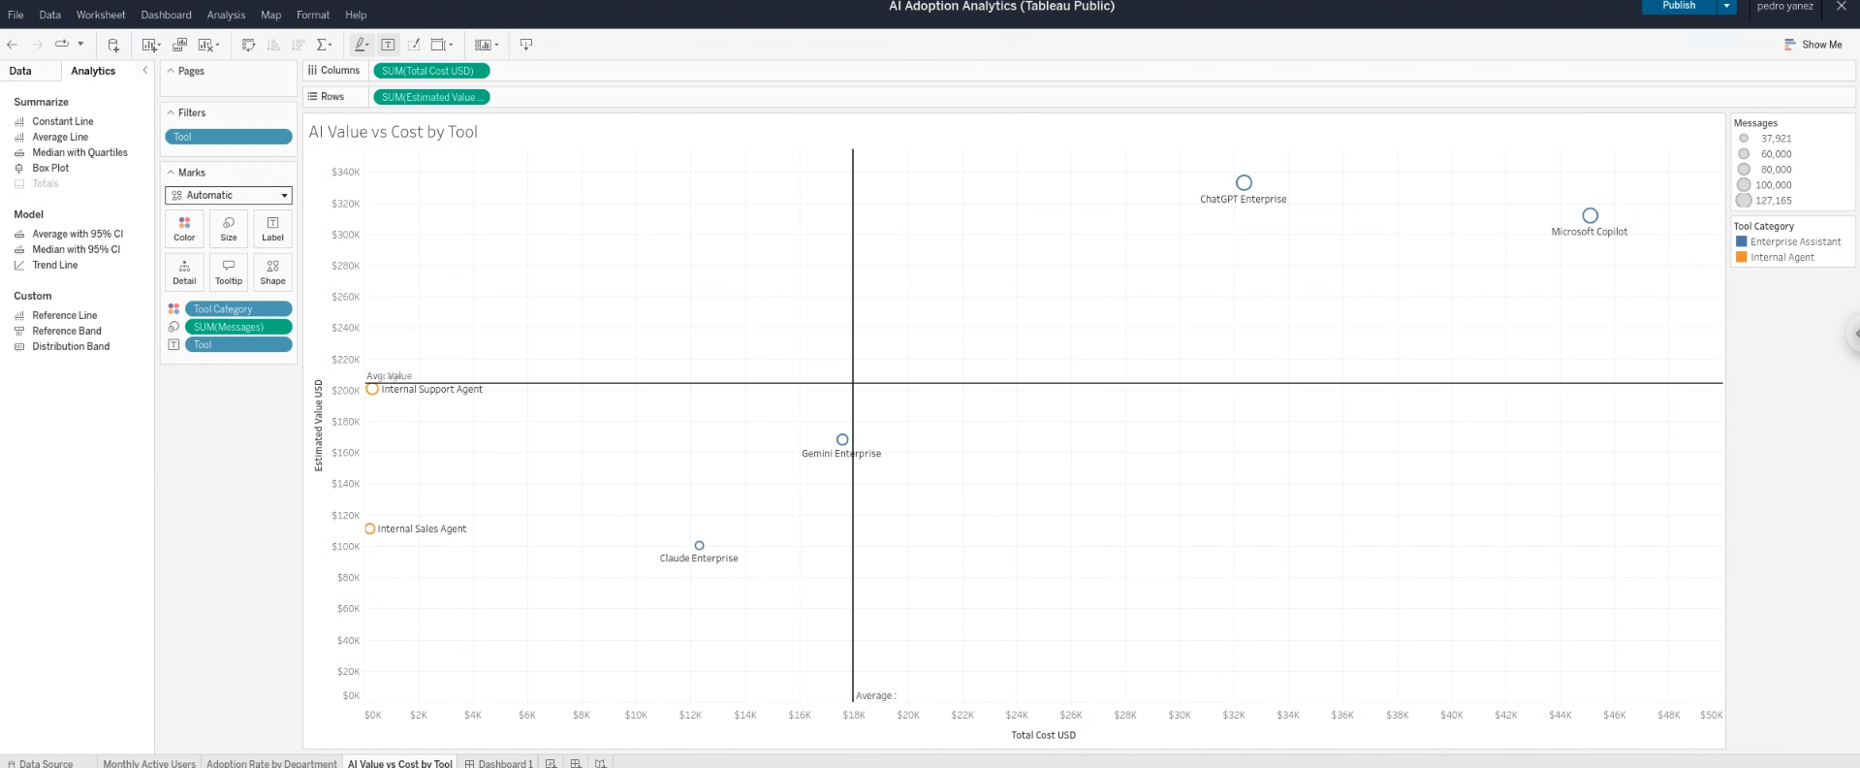

8. Active Users KPI card
The first KPI card uses June 2026, active records only, and COUNTD(User ID). The worksheet was formatted as a single large number and then placed in a dedicated KPI row.
Step 77. Create and rename the KPI - Active Users worksheet.
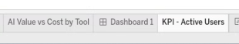
Step 78. Add Month to Filters and choose Individual Dates.
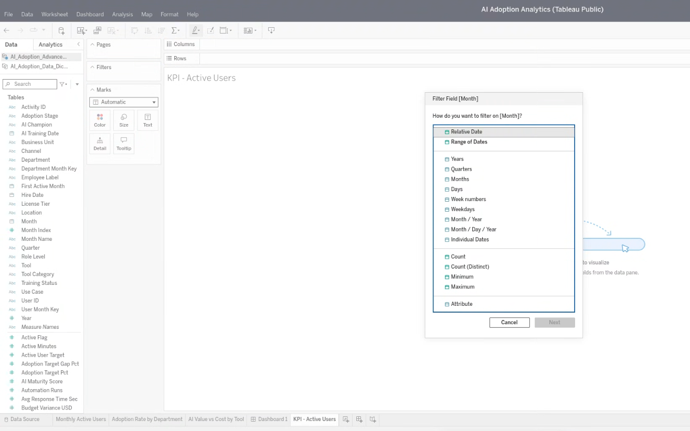
Step 79. Select June 1, 2026 only.
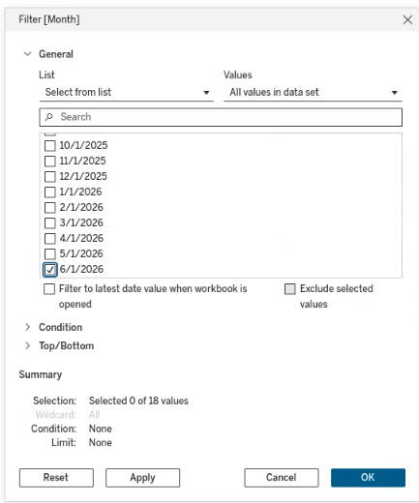
Step 80. Apply the selected month in the Tableau web filter dialog.
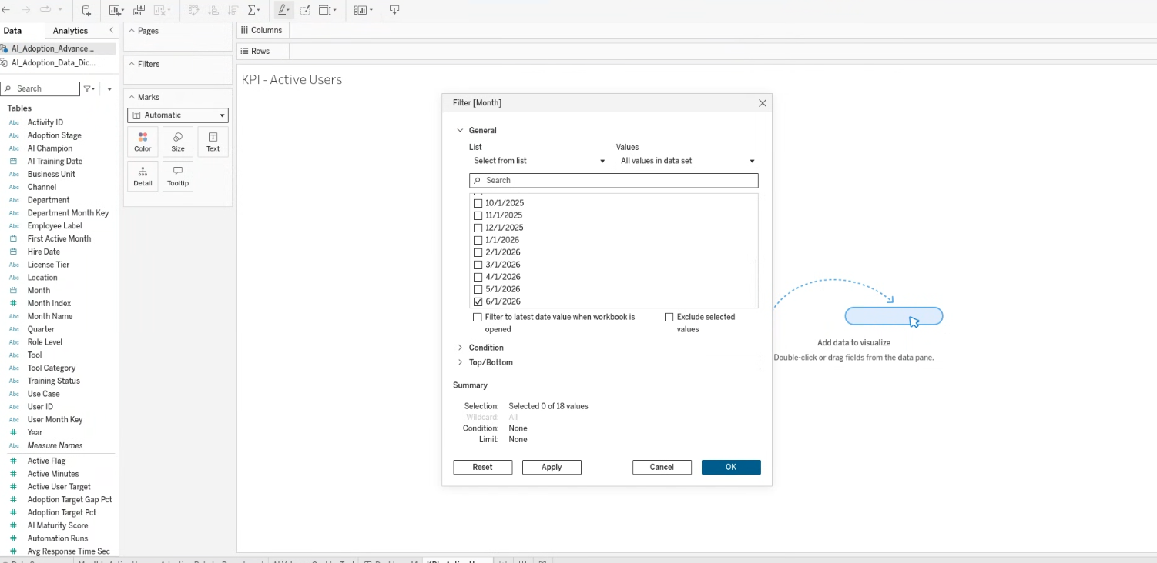

Step 81. Confirm the filter selection reads 1 of 18 values.
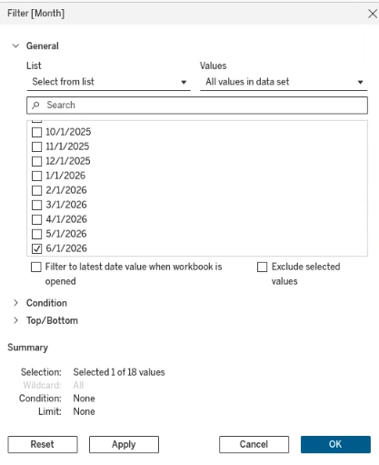
Step 82. Use Apply when the web dialog does not close immediately.
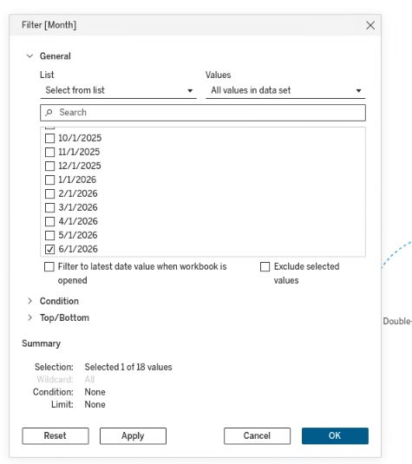
Step 83. Verify Month: 6/1/2026 appears on the Filters shelf.
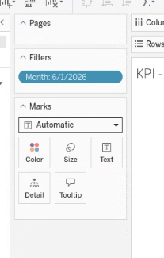
Step 84. Add Active Flag to Filters and keep active records only.
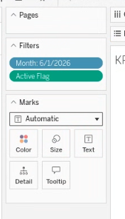
Step 85. Place User ID on Text and aggregate it as COUNTD, producing 307 active users.
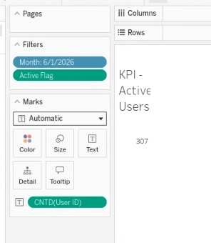
Step 86. Format the KPI label at 36 pt, bold, and centered.
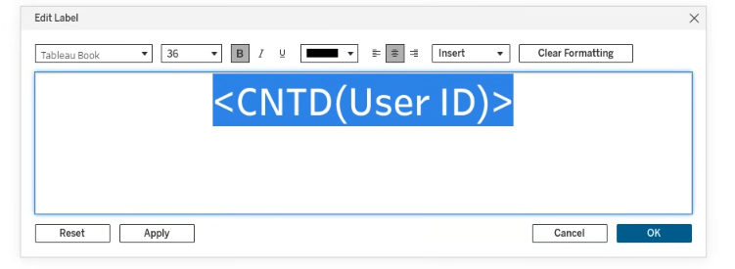
Step 87. Confirm the large 307 KPI value.
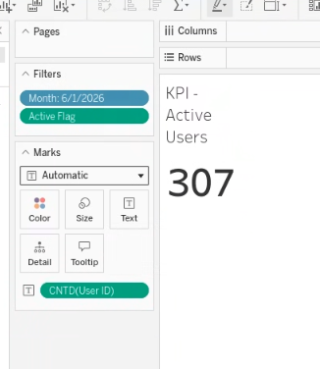
Step 88. Review the KPI worksheet before fitting it to the full view.
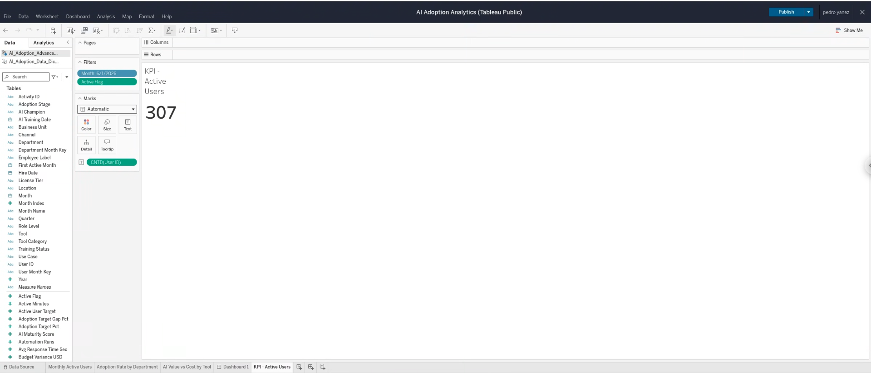

Step 89. Inspect the Worksheet menu while locating the fit controls.
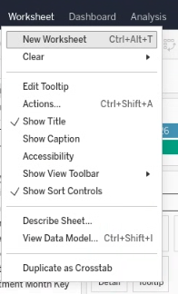
Step 90. Confirm the Worksheet menu does not contain Fit in web authoring.
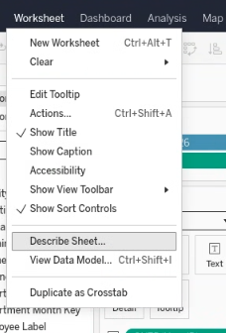
Step 91. Review the full worksheet toolbar location.
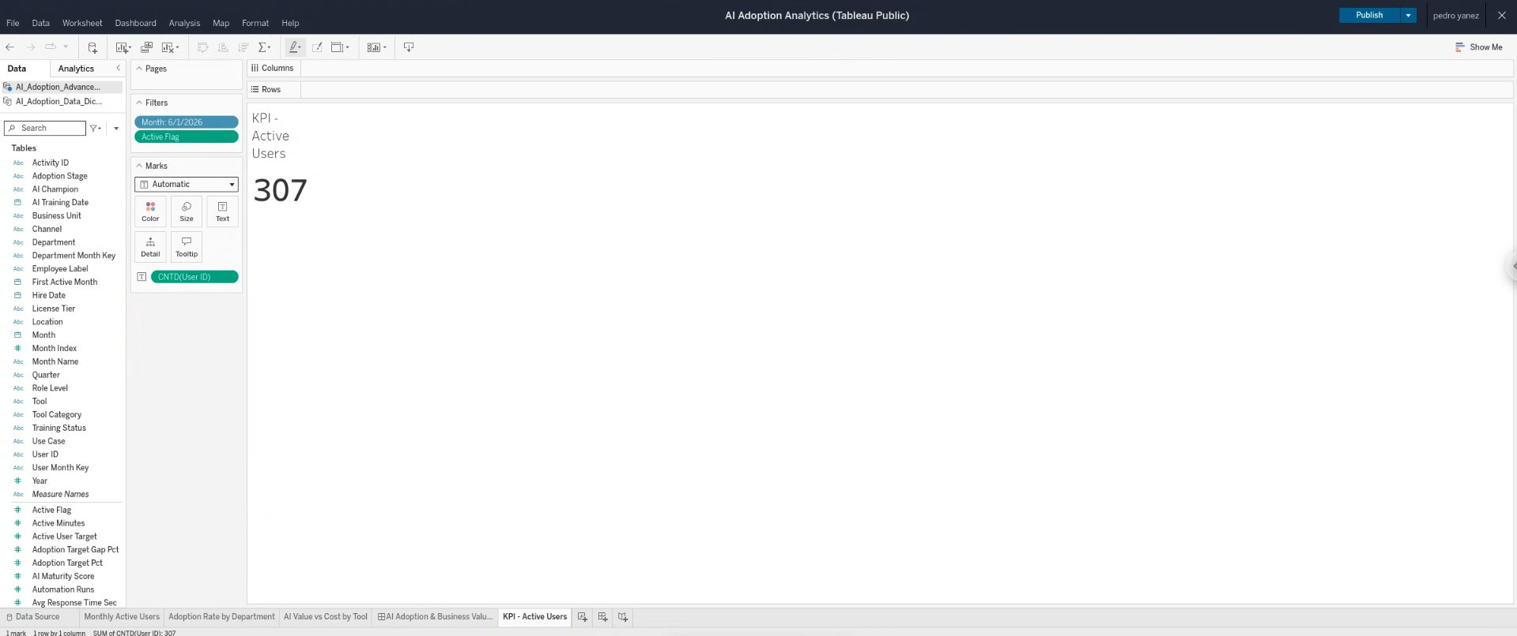

Step 92. Inspect the Format menu while checking alternative alignment controls.
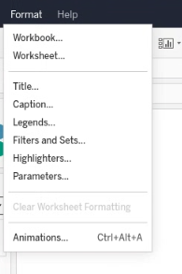
Step 93. Distinguish the Worksheet menu from the worksheet toolbar.
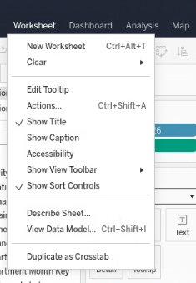
Step 94. Open the Fit dropdown and choose Entire View.
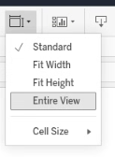
Step 95. Confirm the 307 value is centered in the full worksheet area.
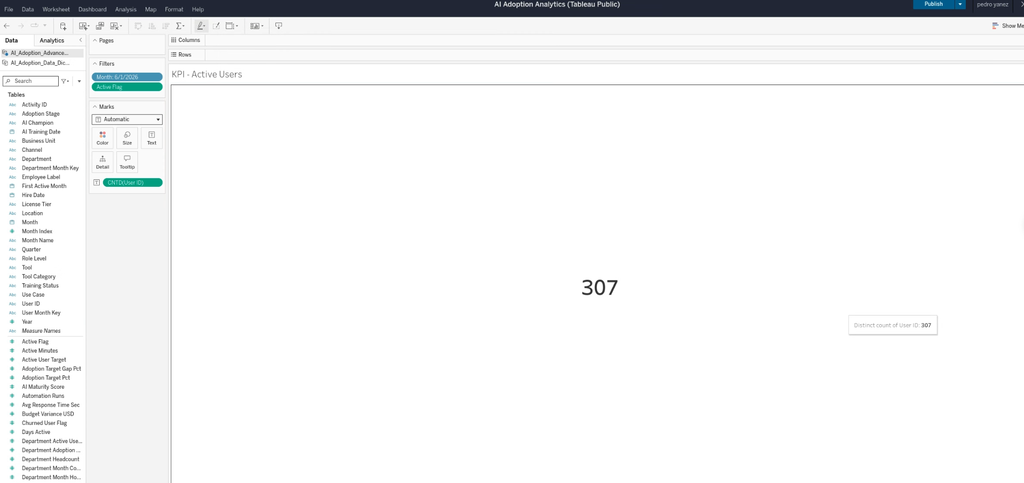

Step 96. Verify the centered KPI formatting before dashboard placement.
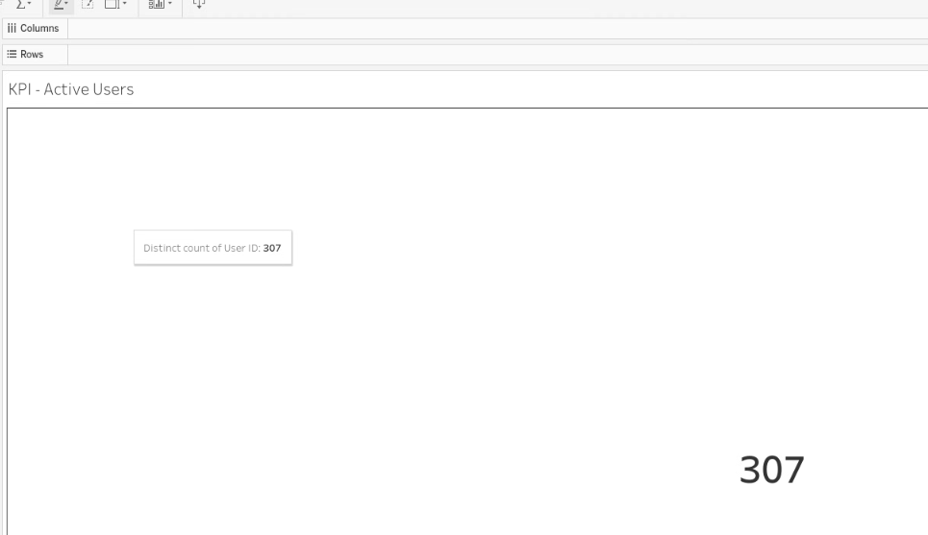

Step 97. Intermediate state: the KPI was added as an oversized tiled section.
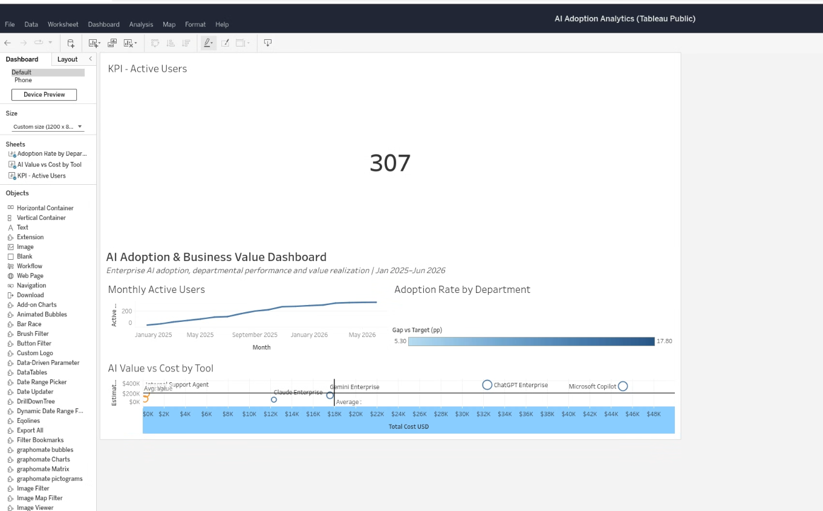
Step 98. Remove the oversized KPI object and return to the base dashboard.
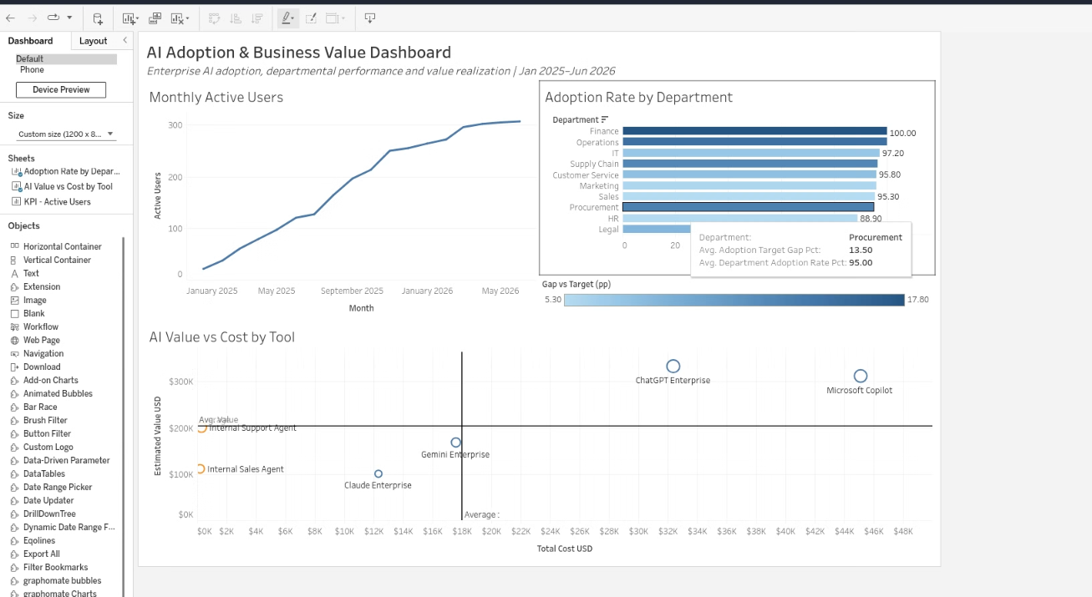

Step 99. Add a horizontal KPI container directly beneath the subtitle.
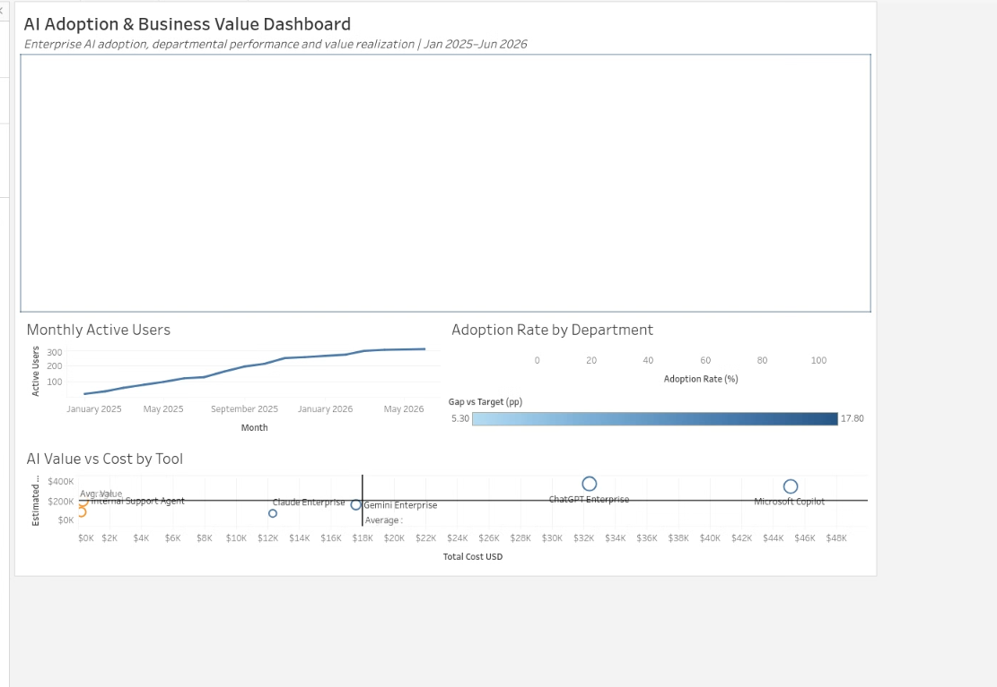
Step 100. Place Active Users into the KPI row.
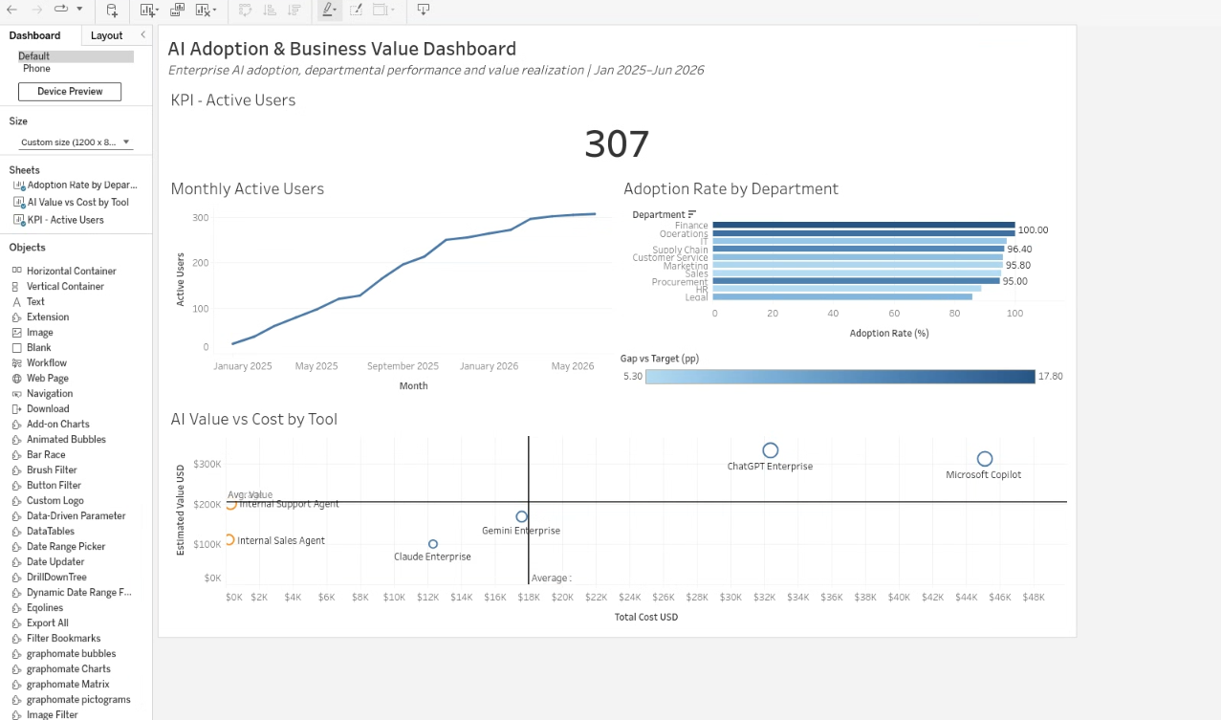

Step 101. Resize the KPI row to a compact executive-summary height.
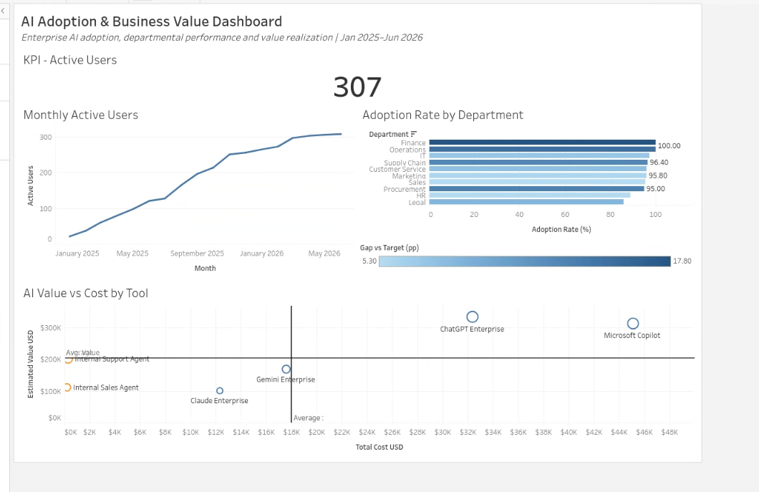

9. Adoption Rate KPI card
The second KPI was created by duplicating the first KPI worksheet, removing the active-only filter, and replacing the text measure with a calculated adoption rate.
Step 102. Create the Adoption Rate calculated field.
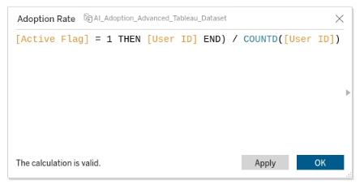
Step 103. Correct the calculation after an incomplete edit.
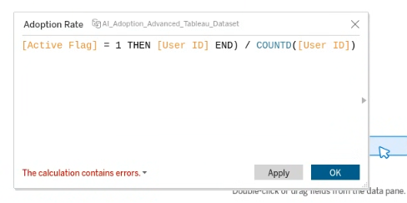
Step 104. Review the full calculation while troubleshooting validation.
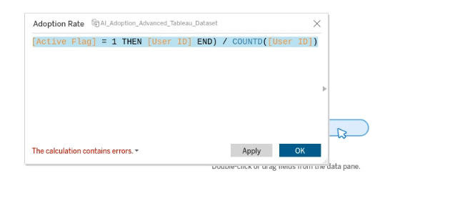
Step 105. Resolve the duplicate calculated-field name error.
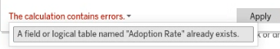
Step 106. Save the calculated field after Tableau validates the formula.
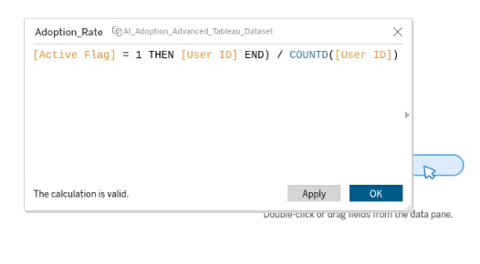
Step 107. Replace the active-user text measure with the Adoption Rate field.
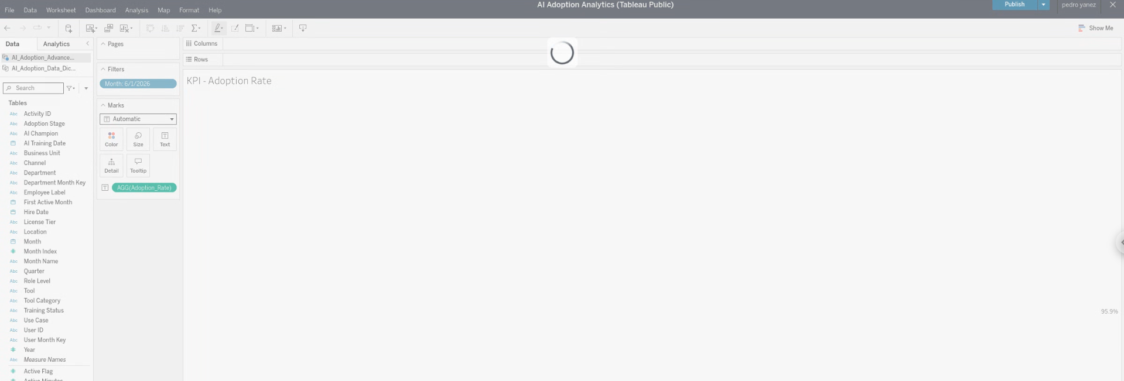

Step 108. Format and center the Adoption Rate KPI at 95.9%.
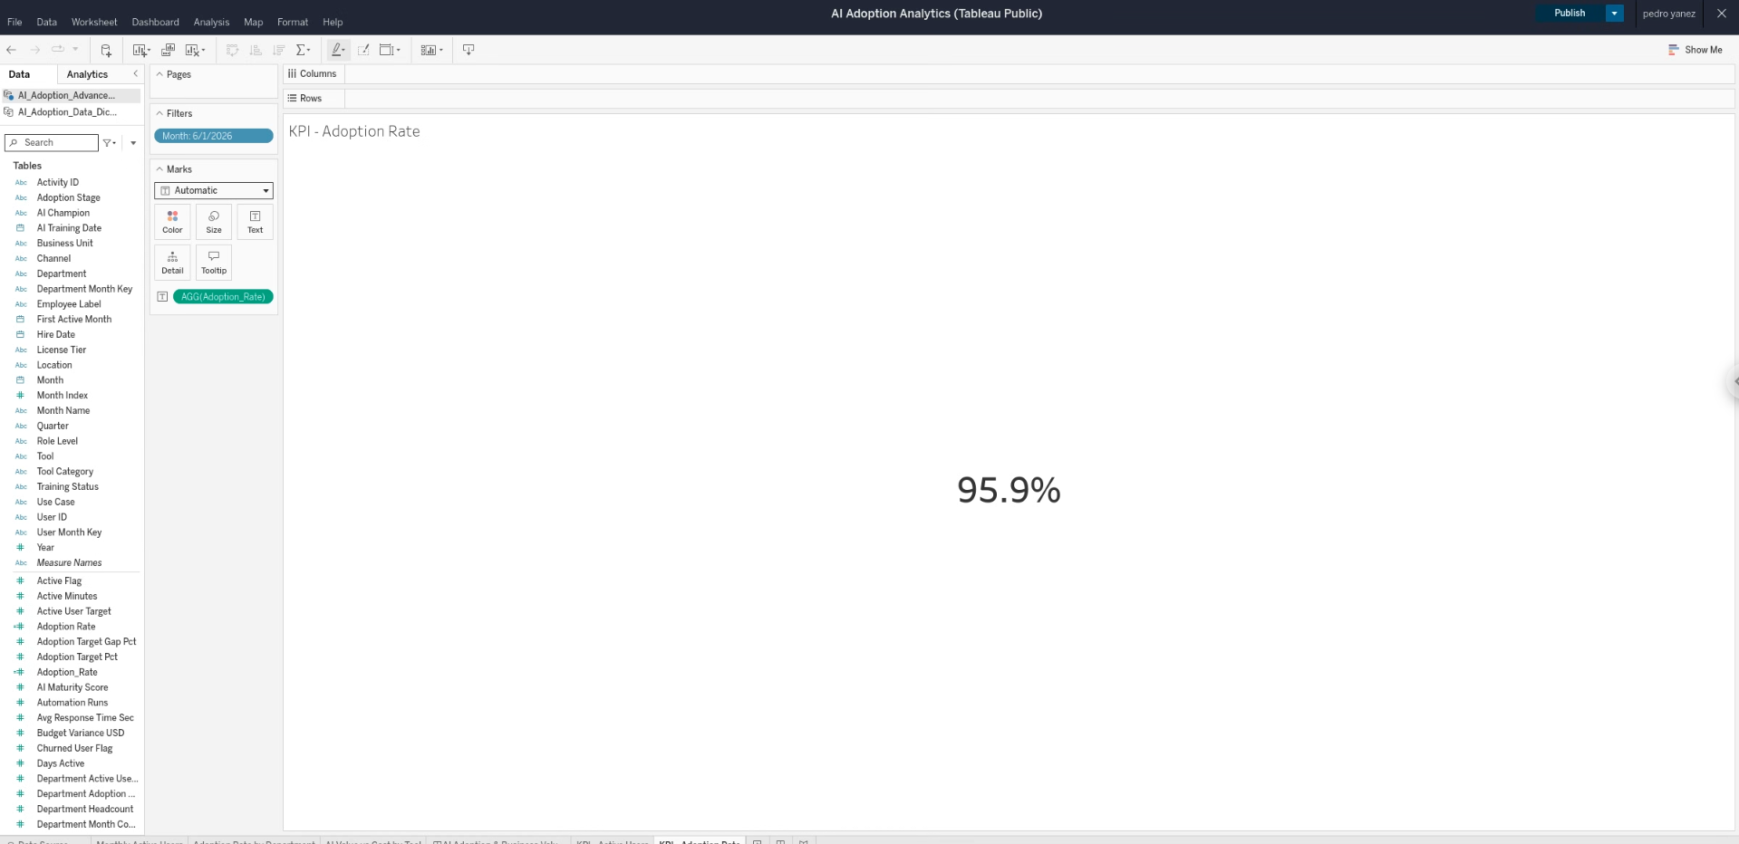

Step 109. Place the Active Users and Adoption Rate KPIs side by side in the dashboard.
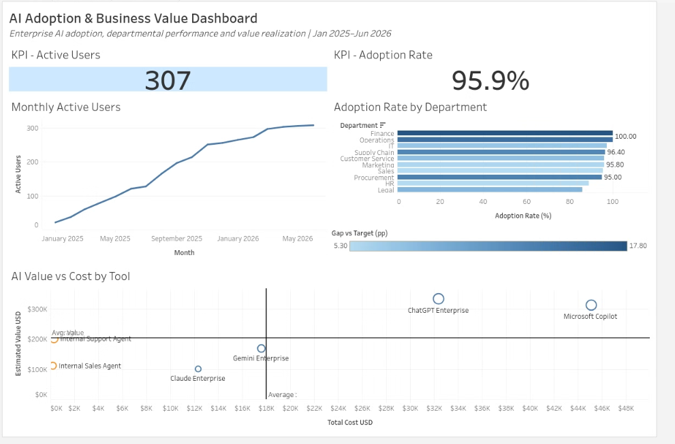

10. Estimated Value KPI card
The final KPI uses SUM(Estimated Value USD) for June 2026 and displays the result in thousands with a currency prefix.
Step 110. Duplicate the KPI worksheet and rename it KPI - Estimated Value.
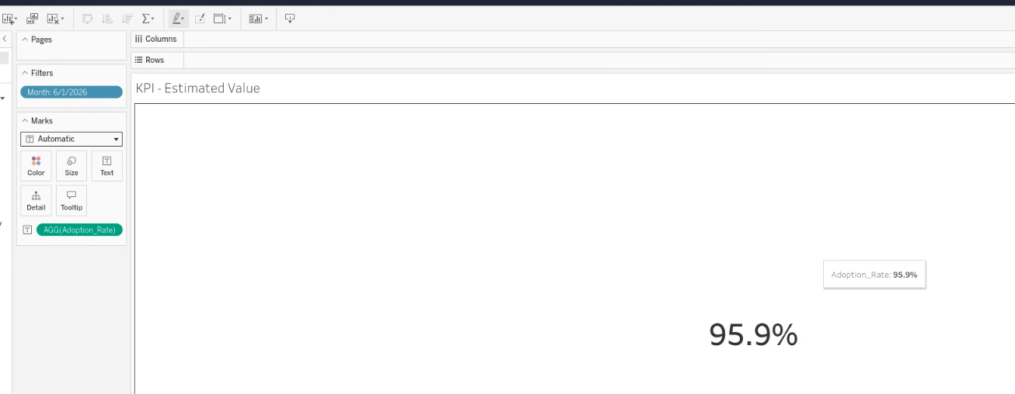

Step 111. Open Currency (Custom) formatting for Estimated Value USD.
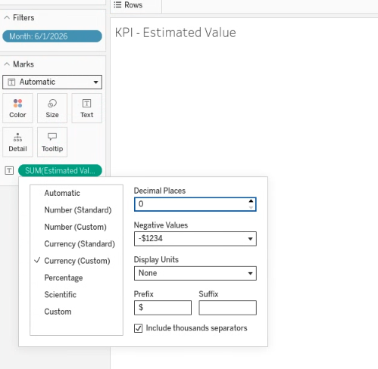
Step 112. Set zero decimals, Thousands (K), and a dollar prefix.
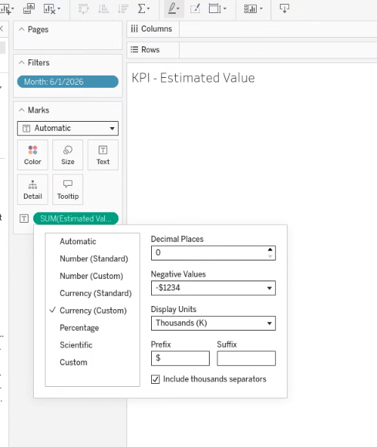
Step 113. Review the first Estimated Value result before enlarging the label.
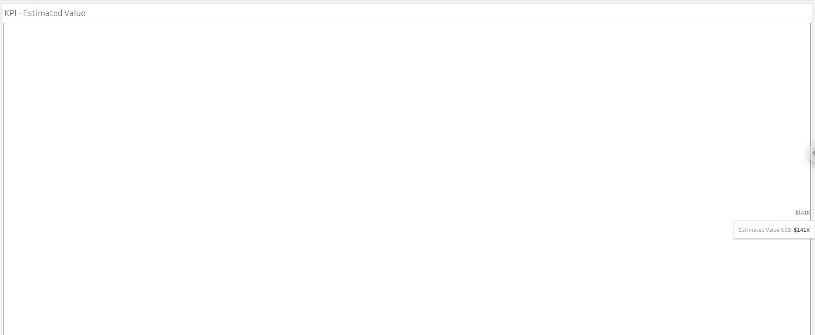

Step 114. Format the KPI label so $141K is large and centered.
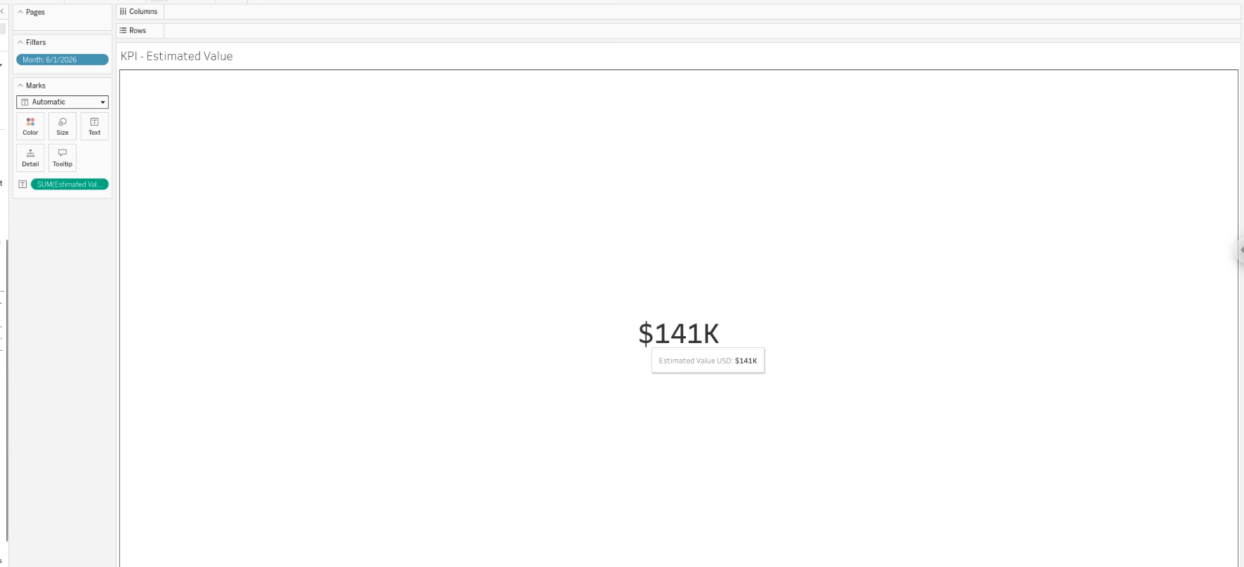

Step 115. Place the third KPI into the dashboard row.
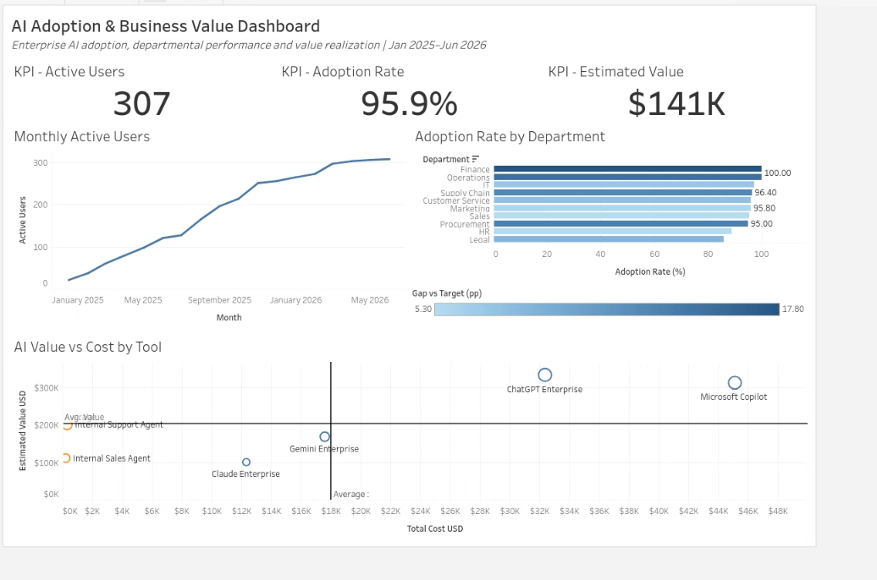

11. Final naming, publish, and sharing
The final pass simplified KPI titles, standardized the reference-line label, published the workbook, and prepared the public Tableau link for portfolio use.
Step 116. Inspect the dynamic <Sheet Name> title token used by dashboard worksheet titles.
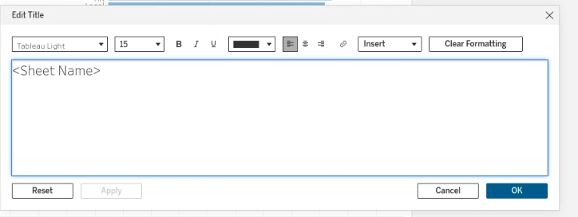
Step 117. Open the worksheet-title menu before simplifying the KPI titles.
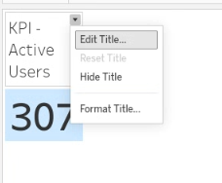
Step 118. Use the title menu while standardizing the KPI naming.
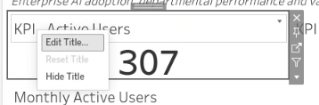
Step 119. Confirm the clean KPI titles: Active Users, Adoption Rate, Estimated Value.

Step 120. Return to the scatter worksheet for the final Avg. Cost label cleanup.
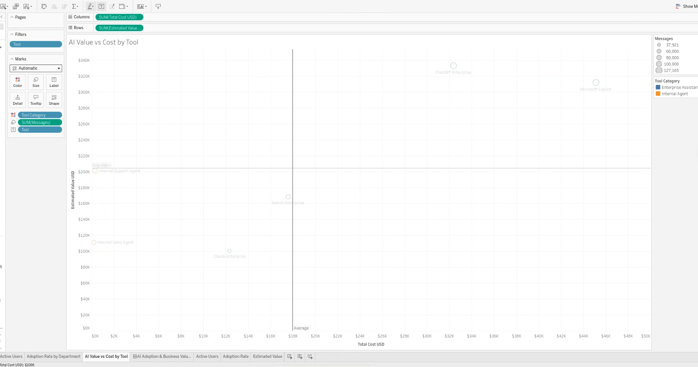

Step 121. Open the Avg. Cost reference-line editor.
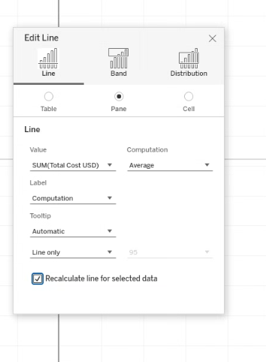
Step 122. Change the cost line label to the custom text “Avg. Cost”.
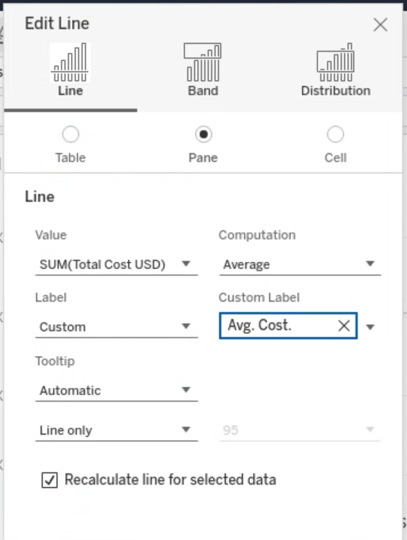
Step 123. Review the fully assembled dashboard in Tableau Public authoring.
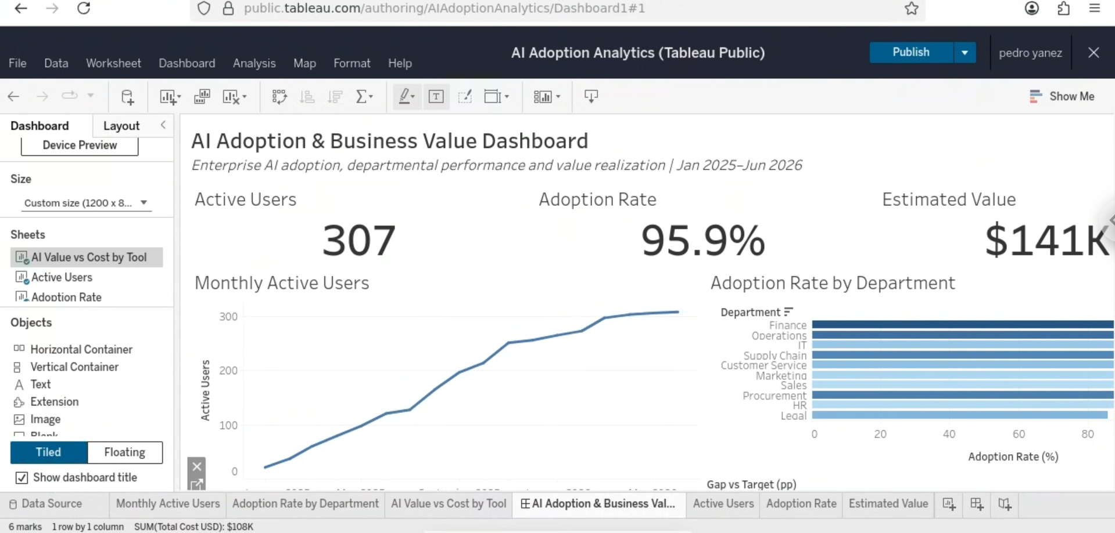

Step 124. Copy the Tableau Public dashboard URL for recruiter-facing sharing.

12. Published output
The completed dashboard was published to Tableau Public and exported to PDF for a static quality check. The live Tableau Public view remains the primary portfolio artifact because it preserves interactivity.

Open the live Tableau Public dashboard

