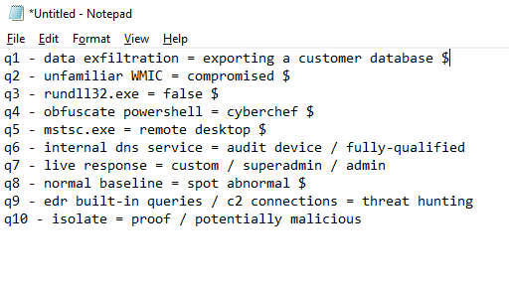

Q7 superadmin/custom sagot diyan

c2 connections - Cobalt - Open network

In the Sophos Threat Hunting Framework, what's the next suggested step after Propose Hypothesis? - Acquire data

TRUE or FALSE: The following command will execute rundll32.exe on the remote machine [192.168.0.142](http://192.168.0.142/?fbclid=IwAR1AmMyLmL8BYb3wAszdXGgOmNbAfF--2kCRakEJ1_Q46eWgF2qZEgY7noc):

cmd.exe /C wmic /node:192.168.0.142 process call create “rundll32.exe C:Programdatasys.dll entryPoint"

-true

Which of these PowerShell command parameters indicates an encoded command? (select all that apply) mali yung solo -EncodedCommand at -EncodedCommand at -ec na sabay

