**Types of Membership functions**

1. **Triangular Membership Function**

Triangularfunction is defined by the following equation:

0 x < a

x-a

a ≤ x ≤ b ــــــــ

b-a

c-x

b ≤ x ≤ c ــــــــ

c-b

0 c ≤ x

Triangular (x;a,b,c) =

Where a and b and c represent the x_coordinate for capital triangle, x represents the real value (Crisp Value) from the private variable fuzzy universe of discourse.

Function outputs ranging between 0 and 1 and represents the value of the degree of membership of x. b has a value of 1 membership degree, increase membership degree of elements located between a and b closer to the element of b, while the elements located between b and c are considerably less degree its membership slowly closer to the element of c. Figure 1 shows an example of the triangular function when the operators:

a= 3 و b = 5 و c= 8

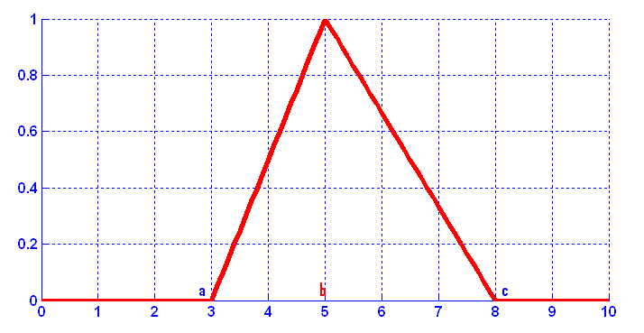

Triangular Membership Function

1. **Trapezoidal Membership Function:**

This function is described using the following equation:

Trapezoidal (x;a,b,c,d) = 

Where :

x: represents real value (Crisp Value) within the universe of discourse.

 a, b, c, d represent a x- coordinates of the four heads of the trapezoidal and values should validated the following condition:

a < b < c < d

Real values which lies between b and c is the degree of membership 1, but values between a and b, the degree of membership increases closer to the element of b, while the elements located between c and d less than the degree of membership gradually closer to the element of d, and membership degree is zero otherwise. The diagram given below shows an example of the trapezoidal function when a = 1, b = 5, c = 7 and d = 8.

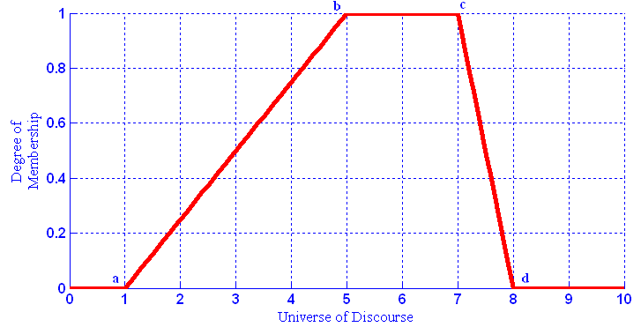

Trapezoidal Membership Function

It is worth mentioning that the symmetry enjoyed by this function allows the emergence of special cases of trapezoidal functions are:

**2.1 Leftmost Trapezoidal :**

are trapezoidal function when value of c and d equal with the value of the last item in the universe of discourse, and sometimes a function is called Upward Slope. Elements between a and b increases its degree of membership whenever element is closer to b while elements between b and c has a membership degree 1. The following figuare gives an example of a trapezoid function:

d = 10 c = و b=7 و3 a = .

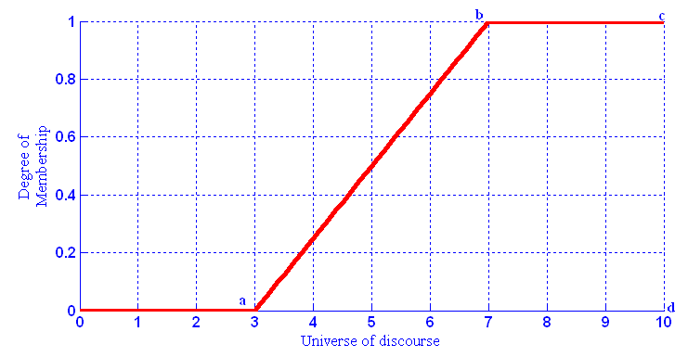

Leftmost Trapezoidal

**2.2 Rightmost Trapezoid:**

It is trapezoidal function when value of a and b equal with the value of the first element in the universe of discourse, and sometimes this function is called Downward Slope. Elements located between b and c has a membership degree 1 while degree decrease for elements located between c and d whenever closer to the element d. The following figuare gives an example of a Rightmost trapezoid function where:

d = 6 وc = 3 و b =0 a = .

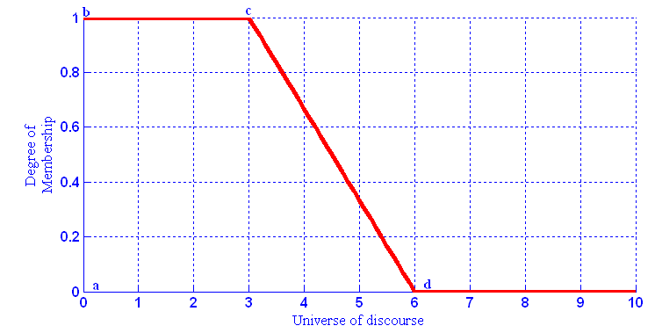. Rightmost Trapezoid

1. **Gaussian Membership Function:**

This function is defined by the following equation:

Gaussian (x;c,σ) = e

Where c is a function center and σ represents the function width. Gauss function is the popular function considered among the most membership functions for the following reasons:

* enjoys Smoothness where dealing with continuous values.
* Easy application of equations: It does not include options and multiple conditions compared to the previous functions.
* All values are non-zero.

And with the gauss function it has many advantages, but it's not applicable in matters that need to be Asymmetric Membership Functions which are necessary in many applications.

The diagram given below shows an example of a function gauss when c = 5 and σ = 2.

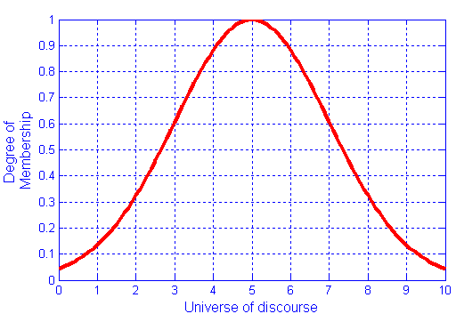

Gaussian Membership Function.

1. **Sigmoidal Membership Function:**

This function is widely used as a activation function in artificial neural networks and this function is defined using the following equation:

sig (x;a,c) = 

whereas :

 c: is the point at which the curved change its direction and this point has a degree of membership 0.5 (μ(c)) = 0.5.

a: controls the slope at the intersection point x = c.

Sigmoidalfunction is a asymmetric functions and can be open to the left or right hand relying on sign of operator a, If the sign is positive, the function will be open to the right, but if is negative, the function will be open to the left. The following figuare shows these cases:

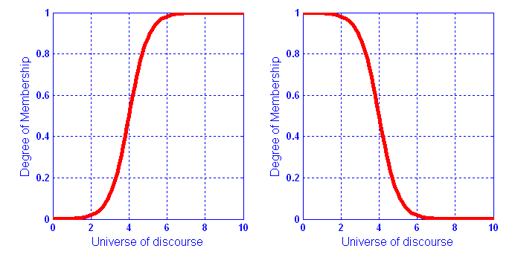

Sigmoidal Membership Function.

Photos figure above two Sigmoidal Membership Function and the values for each of them is (a = 2) and (c = 4), but the function on the left side of the figure was have positive a therefore become open to the right, while the function plotted on the right side was negative a which became open to the left.

1. **Polynomial based Membership Function:**

Set of functions based Polynomial include three functions gained its name relative to the forms, and are a function that takes the form of Z (Z-shape) and function that takes the form of S (S-shape) and function that takes the form of fixed-rate mark Π (Pi -shape). The following shows the format of these functions:

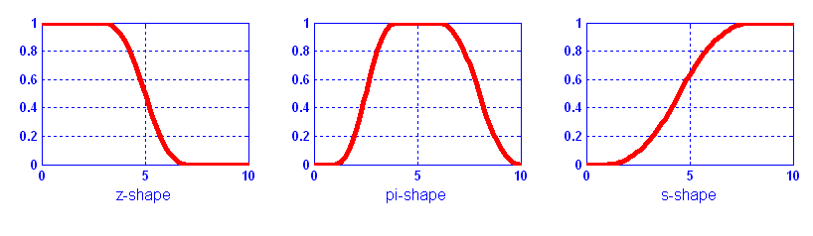

Polynomial based Membership Function.

Fuzzy set building depends on two factors: determine the appropriate universe of discourse and the selection of appropriate Membership function. The objective and non-random in Fuzzy set constitute a fundamental difference between Fuzzy set Theory and Probability Theory (Probability Theory).

Next lecture spooler:

we will learn how to evaluate the conclusion part , implication of fuzzy rules , the types of fuzzy systems and the difference between them.