Install GitHub for Windows: https://windows.github.com/
GitHub tutorial: https://guides.github.com/activities/hello-world/
GitHub Flow: https://guides.github.com/introduction/flow/index.html
Git Basics: http://git-scm.com/book/en/v2/Getting-Started-Git-Basics

GitHub:
Web site of public projects that enables sharing entire Git repositories.
Public repositories are free. Private ones are not.

Set up GIT
- Download and install the latest version of GitHub for Windows
- open the Git Shell application
- git config --global user.name "Ralph Whitney"
- git config --global user.email rkwhit4@cox.net
- When you connect to a GitHub repository from Git, you'll need to authenticate with GitHub using either HTTPS or SSH.

- Caching your GitHub password in Git:
- git config --global credential.helper wincred

Creating a repository
- In the upper-right corner of any page, click +, and then click New repository.
- Create a short, memorable name for your repository. For example, "hello-world".
- Optionally, add a description of your repository. For example, "My first repository on GitHub."
- Choose a Public repository.
- Select Initialize this repository with a README.
- Click Create repository.

Creating your first change
- A commit snapshots of all the files in your project at a particular point in time
- In your repository's list of files, click README.md.
- Above the file's content, click the edit icon (a pen).
- On the Edit file tab, add some additional information.
- Above the new content, click Preview changes.
- Review the changes you made to the file. You'll see the new content in green.
- At the bottom of the page, type a short, meaningful commit message that describes the change you made to the file.
- Below the commit message fields, decide whether to add your commit to the current branch or to a new branch. If your current branch is master, you should choose to create a new branch for your commit and then create a pull request.
- Click Propose file change.

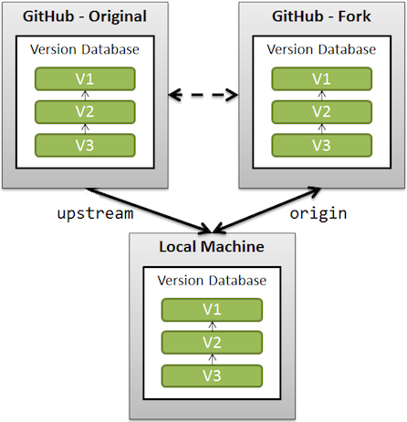

Forking a repository
- Allows you to make a copy of somebody else's repository directly on the GitHug servers without pulling down the code to your local machine first
- Forking links the new repository back to the original
- Makes it easier to suggst changes back to the original repository
- A fork is a remote, server-side copy of a repository, distinct from the original
- A clone is not a fork; a clone is a local copy of a remote repository.
- In the top-right corner of the original repository page (e.g. octocat/Spoon-Knife), click Fork
- Forking a repository allows you to freely experiment with changes without affecting original project.
- Forks are used to either propose changes to someone else's project or to use someone else's project as a starting point for your own idea.
- e.g. using forks to propose changes for bug fixes:
- Fork the repository.
- Make the fix locally. (create new branch, checkout new branch, make change, add, commit, and push)
- Submit a pull request to the project owner

Keeping Your Fork Synced
- Do this if you want to regularly sync your fork with the upstream repository
- upstream generally refers to the original repo that you have forked
- origin is your fork: your own repo on GitHub, a copy of the original repo of GitHub
- When a repo is cloned to your local machine, it has a default remote called origin that points to your fork on GitHub, not the original repo it was forked from.
- To keep track of original repo, you need to add another remote named upstream (e.g. git remote add upstream original_URL)
- You will use upstream to fetch from the original repo (in order to keep your local copy in sync with the project you want to contribute to).
- You will use origin to pull and push since you can contribute to your own repo.
- You will contribute back to the upstream repo by making a pull request.

Create a Clone of Your Fork Locally on your Computer
- In right sidebar of your fork's repository page (e.g. Spoon-Knife), click HTTPS clone URL to copy clone URL for your fork (or click Clone in Desktop button)
- Open a Git shell
- git clone https://github.com/p26625/Spoon-Knife.git
- Now, you have a local copy of your fork of the Spoon-Knife repository!

Configure Git to sync your fork with the original Spoon-Knife repository
- In right sidebar of the original repository page (e.g. octocat/Spoon-Knife), click HTTPS clone URL to copy clone URL for the repository.
- Open a Git shell
- cd directories to the fork of Spoon-Knife repository (cd Spoon-Knife)
- git remote –v, shows current configured remote repository for your fork:
origin https://github.com/p26625/Spoon-Knife.git (fetch)
origin https://github.com/p26625/Spoon-Knife.git (push)

- git remote add upstream https://github.com/octocat/Spoon-Knife.git, synced to upstream directory
- git remote –v:
origin https://github.com/p26625/Spoon-Knife.git (fetch)
origin https://github.com/p26625/Spoon-Knife.git (push)
upstream https://github.com/octocat/Spoon-Knife.git (fetch)
upstream https://github.com/octocat/Spoon-Knife.git (push)

Follow People
- When you follow someone on GitHub, you'll get notifications on your dashboard about their activity.
- Once you are on one of their pages, click the green "Follow" button

Watch A Project
- At some point you may want to stay up-to-date with a specific project
- When you're on a project page, you can click the “Watch” button at the top of the page

Collaborators
- When you want to give someone else access to your repository
- Go into repository, select Settings, select Collaborators, Search by username, full name or email address, then Add collaborator

The GitHub Flow:
Create a Repository
Open an Issue
Create a Branch
Make a Commit
Open a Pull Request
Merge Your Pull Request

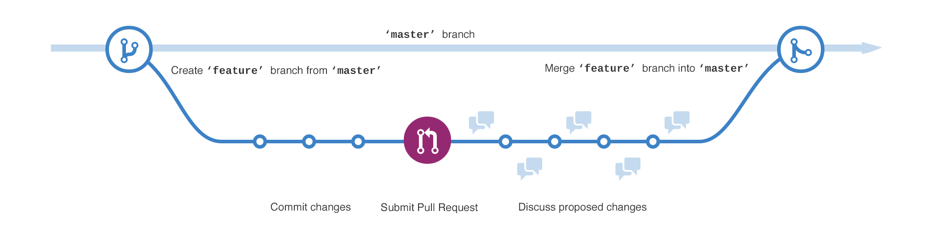

Open an Issue
- An Issue is a note on a repository about something that needs attention
- It could be a bug, a feature request, a question or lots of other things
- You can label, search and assign Issues.
- Click the Issues tab from the sidebar.
- Click New Issue.
- Give your Issue a title and description
- Click Submit new Issue when you’re done.
- Now this issue has a permanent home (URL) that you can reference even after it is closed.
- Issues are assigned a number sequentially that you can reference for auto-closure in a commit

Create a Branch
- Rule: master branch always remains deployable.
- When you create a repository, by default it has one branch with the name master.
- When you create a branch, copy of original branch is made as it was at that point in time (i.e. photo snapshot)
- Go to your repository.
- Click the drop down at the top of the file list that says branch: master.
- Type a branch-name into the new branch text box.
- Select the blue Create branch box or hit “Enter” on your keyboard.
- Now you have two branches.

Add Commits
- Write clear commit messages.
- Click the file to edit.
- Click the pencil icon in the upper right corner of the file view to edit.
- In the editor, write some text, make your changes.
- Write a commit message that describes your changes.
- Click Commit changes.

Open a Pull Request
- Pull Requests initiate discussions about your commits.
- Anyone can see exactly what changes would be merged if they accept your request.
- Open a Pull Request at any point during the development process
- When you have little code, share screenshots/ideas, stuck/need help, someone to review your work
- Use @mention system in Pull Request message to ask for feedback from specific people
- Fork & Pull Model, open source projects, notify project maintainers about changes to consider
- Shared Repository Model, private shared repository, start code review on changes before merge into master branch
- Click the Pull Request icon on the sidebar
- Then from the Pull Request page, click the green New pull request button.
- Select the branch-name you made to compare with master (the original).
- Look over your changes in the diffs on the Compare page, make sure they’re what you want to submit.
- The changes, additions and subtractions, are shown in green and red.
- Give your pull request a title
- If it relates directly to an open issue, include “fixes #” and the issue number in the title
- Write a brief description of your changes
- When you’re satisfied with these changes, click the big green Create Pull Request button.

Discuss and review your code
- Pull Request questions/comments are written in Markdown, can embed images, etc
- Can push more changes to your branch based on questions/comments.

Deploy
- Once your pull request has been reviewed, you can deploy your changes to verify them in production

Merge
- Once your changes are verified in production, merge your code into the master branch.
- Once merged, Pull Requests preserve a record of the historical changes to your code.
- By using certain keywords into the text of your Pull Request, you can associate issues with code
- When the Pull Request is merged, the related issues are also closed
- Click the green Merge pull request button to merge the changes into master.
- Click Confirm merge.
- Delete the branch, if its changes have been incorporated, with Delete branch button in the purple box.

Closing issues via commit messages
- include keywords in your commit messages to automatically close issues in GitHub.

Closing an issue in the same repository
- Use keyword in list below followed by reference to issue no. from commit message
- close, closes, closed, fix, fixes, fixed, resolve, resolves, resolved
- e.g. “Fixes #45” will close issue 45 in that repository once the commit is merged into the default branch
- If commit is in a non-default branch, issue will remain open and issue will be referenced with a tooltip

Closing an issue in a different repository
- Use “username/repository#issue_number” syntax, as described in "Writing on GitHub".
- e.g. “Closes example_user/example_repo#76” will close issue #76 in example_repo, provided example_user has push access to example_repo.

