Chief Complaint:

History of Present Illness (HPI):

Allergies:

Current Medications:

History of Illnesses (Onset of symptoms, Location/Duration, Characteristics, Aggravating/Alleviating factors, Related symptoms, Attempts at self-treatment, Severity) & Hospitalizations:

Vaccine Status:

Medical/Surgical History:
Family History:

Social History (Domains - Economic stability/Neighborhood/social belonging/education/healthcare access & quality:

Diet (24-hour recall and typicals including fluids):

Review of Systems (ROS):
*ROS Support Tool
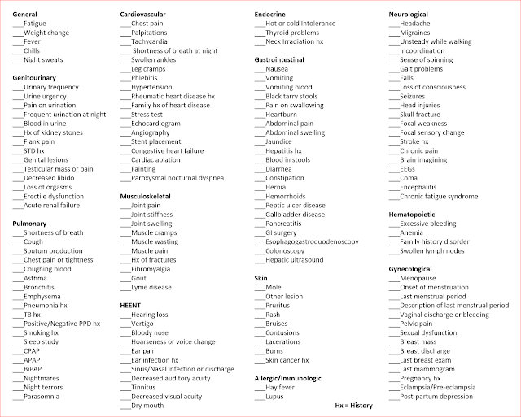

Objective Findings:
*Physical Exam Brief Support Tool
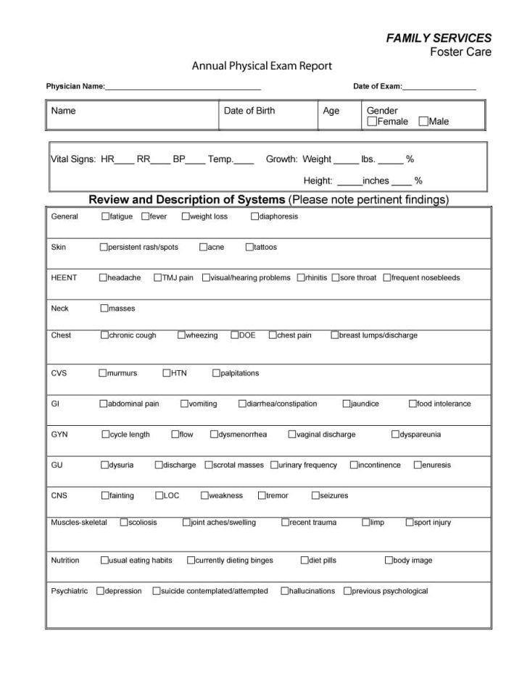
Plan:

Follow Up:

Education:

