Complaint Tracking System

Internship Report

By
Abhishek M Ajay

Internship Organization: BHEL ISG, Bengaluru Duration: 1st Sep 2025 – 24th Nov 2025

CERTIFICATE
This is to certify that Mr. Abhishek M Ajay, a student of Bachelor of Technology in Computer Science and Engineering at REVA University, Bengaluru, has successfully completed his 12 weeks internship at BHEL Industrial Systems Group (ISG), Bengaluru, during the period from 1st September 2025 to 24th November 2025. This report is a record of the work completed by him during the internship period under supervision

Project Guide: AJEET KUMAR CHOUDHARY
Head of the Department: AJEET KUMAR CHOUDHARY (DGM) Date: 24-11-2025 Place: Bengaluru

DECLARATION
I, Abhishek M Ajay, hereby declare that the internship report is the record of original work carried out by me during my internship at BHEL ISG, Bengaluru, from 1 September 2025 to 24th November 2025. This report has not been submitted to any other institution for the award of any degree or diploma.

Place: Bengaluru Date: 24-11-2025

Signature:
(Abhishek M Ajay)

ACKNOWLEDGEMENT
I express my sincere gratitude to BHEL ISG, Bengaluru for providing me the opportunity to undertake this internship project. I am grateful to my project guide at BHEL ISG for continuous guidance and support. I also thank the faculty members of REVA University– Department of CSE for their encouragement.

ABSTRACT

The Complaint Tracking System (CTS) is a web-based application developed using ASP.NET Core MVC (C#) with Entity Framework Core and a relational database (e.g., SQL Server) as the backend. The CTS focuses on core modules for complaint ticket management: creating new tickets, listing and viewing ticket details, editing tickets, adding comments, and displaying dashboard statistics. The system employs dependency injection for services (e.g., ITicketService, TicketCommentService), Entity Framework Core for database operations with migrations, ASP.NET Core Identity for user authentication, parameterized queries via EF to prevent SQL injection, and client/server-side validation for data integrity. This report documents the system analysis, design, implementation details (based on the actual project code), testing, results, and future enhancements.

TABLE OF CONTENTS
- Introduction
- Company Profile – BHEL ISG
- Internship Overview
- System Analysis
- System Design
- Implementation (detailed)
- Database Design
- Testing and Test Cases
- Results and Discussion
- Conclusion and Future Scope
- References

INTRODUCTION

This project, Complaint Tracking System (CTS), was developed during a one-month internship. The CTS provides a web-based interface to manage complaint tickets. The project is built using ASP.NET Core MVC for the presentation layer, C# controllers and services for business logic, and Entity Framework Core with SQL Server as the data store. The implementation focuses on primary operations: Create Ticket, View Tickets, Edit Ticket, Ticket Details with Comments, and Dashboard.

COMPANY PROFILE – BHEL ISG
Bharat Heavy Electricals Limited (BHEL) is a leading engineering and manufacturing company in India. The Industrial Systems Group (ISG) in Bengaluru specializes in integrated automation and control systems for industrial applications. During the internship, exposure to industrial-grade processes and data handling practices was provided, along with access to internal documentation that helped in understanding practical enterprise development.

INTERNSHIP OVERVIEW
Objectives:
  - Gain hands-on experience in ASP.NET Core MVC and Entity Framework Core with SQL Server.
  - Implement core modules for complaint ticket management (Create, View, Edit, Details, Dashboard).
  - Learn database connectivity using Entity Framework Core, dependency injection for services, and server-side validation.
Duration: 1st September 2025 – 24th November 2025

Tools & Technologies Used:
  - ASP.NET Core MVC (C#)
  - Entity Framework Core with Microsoft SQL Server
  - ADO.NET (SqlConnection, SqlCommand, SqlDataReader)
  - ApplicationDbContext for ORM
  - Visual Studio (IDE)
  - Razor Views, Bootstrap, HTML/CSS/JavaScript

Learning Outcomes:
  - Practical experience in ASP.NET Core MVC development and controller-service model.
  - Understanding of Entity Framework Core patterns for secure database access via ApplicationDbContext.
  - Familiarity with debugging, exception handling, dependency injection (e.g., ITicketService), and application testing.

SYSTEM ANALYSIS

Existing System:
The organization previously maintained complaint records using spreadsheets and manual forms, which caused redundancy and difficulty in tracking and retrieval.

Proposed System:
The CTS centralizes complaint data in a SQL Server database and provides web interfaces for creating, viewing, editing, and managing tickets. The system reduces manual errors and improves accessibility and tracking.

Functional Requirements:
- Create new ticket [`TicketCreateDto`](Models/DTOs/TicketCreateDto.cs)
- List and view tickets (Index, Details with comments)Validate inputs (mandatory fields, email format)
- Edit existing ticket
- Dashboard statistics [`DashboardStatsDto`](Models/DTOs/DashboardStatsDto.cs)
- Validate inputs (mandatory fields, priority/status enums)

Non-Functional Requirements:
- Security: Entity Framework Core ORM with parameterized queries to prevent SQL injection.
- Usability: Responsive Razor views with Bootstrap for intuitive data entry and display.
- Maintainability: MVC separation, dependency injection for services (e.g., [`ITicketService`](Core/Interfaces/ITicketService.cs)).

SYSTEM DESIGN

Architecture Overview:
The application follows the MVC pattern: Presentation Layer (Razor Views), Business Logic Layer (Controllers like [`TicketsController`](Controllers/TicketsController.cs) and Services like [`TicketService`](Core/Services/TicketService.cs)), and Data Access Layer (Entity Framework Core [`ApplicationDbContext`](Data/ApplicationDbContext.cs) with migrations). Views like Index.cshtml, Create.cshtml, Edit.cshtml, and Details.cshtml handle UI and invoke controller actions for operations.

User Interface:
The Razor Views use HTML forms, Bootstrap components (e.g., tables, modals), Tag Helpers, and partial views (e.g., [`_LoginPartial`](Views/Shared/_LoginPartial.cshtml)) to capture and display data. Includes validation attributes and model state checks for success/error messages.

Data Flow:

User actions on views trigger HTTP requests to controller actions. Controllers use injected services to collect inputs, validate via model binding, perform CRUD via EF Core DbContext (e.g., `Tickets.Add()`, `SaveChangesAsync()`), and return views or JSON. Data retrieval uses LINQ queries on DbSet&lt;[`Ticket`](Models/Entities/Ticket.cs)&gt;.

DATABASE DESIGN
A simplified schema used in the project is described below. The primary table is Tickets.

Table: Tickets
  - ID INT PRIMARY KEY IDENTITY(1,1)
- Title NVARCHAR(200) NOT NULL
- Description NVARCHAR(2000) NOT NULL
- Category NVARCHAR(100)
- Priority INT NOT NULL [`TicketPriority`](ComplainTracking/Models/Entities/Enums/TicketPriority.cs)
- Status INT NOT NULL [`TicketStatus`](ComplainTracking/Models/Entities/Enums/TicketStatus.cs)
- CreatedAt DATETIME2 DEFAULT GETUTCDATE()
- ClosedAt DATETIME2
- UpdatedAt DATETIME2
- AttachmentPath NVARCHAR(500)
- SubmitterId NVARCHAR(450) NOT NULL (FK to AspNetUsers)
- AssignedAgentId NVARCHAR(450) (FK to AspNetUsers)

Notes:
  - Email in AspNetUsers has a UNIQUE constraint to prevent duplicate entries. EF Core handles violations via [`DbUpdateException`](ComplainTracking/Data/ApplicationDbContext.cs) and model validation informs the user.
  - Relationships configured in [`OnModelCreating`](ComplainTracking/Data/ApplicationDbContext.cs:16) with cascade deletes and indexes for performance (e.g., on Status, CreatedAt).

TESTING AND TEST CASES

Testing Strategy:
Unit testing was performed for individual modules (Create, Edit, Details) primarily through manual functional testing. Integration testing validated the interaction between controllers/services and the database via Entity Framework Core.

Sample Test Cases:
- Create Ticket with valid data: Expectation – record inserted via TicketService and success message displayed in Create.cshtml.
- Create Ticket with duplicate title or invalid fields: Expectation – model validation errors handled, user-friendly error shown via ModelState.
- Edit Ticket and change status/priority: Expectation – record updated in database and reflected in Index/Dashboard.
- Invalid input (empty title/description): Expectation – server-side validation (DataAnnotations) prevents DB operation and prompts user to correct input.
- View Details with comments: Expectation – ticket loads with associated TicketComments.

Results:
All primary test cases passed during manual testing. The system reliably performs CRUD on tickets, handles relationships (submitter, agent, comments), and validation prevents incorrect data from being stored.

RESULTS AND DISCUSSION
The CTS implemented during the internship successfully supports creating, viewing, editing, and managing complaint tickets with comments and dashboard stats. Error handling (e.g., DbUpdateException) and validation improve robustness. Database constraints and indexes maintain data integrity (e.g., unique emails in AspNetUsers). The system is suitable as a base for additional modules such as ticket assignment, email notifications IEmailService, advanced reporting, and role-based access controls.

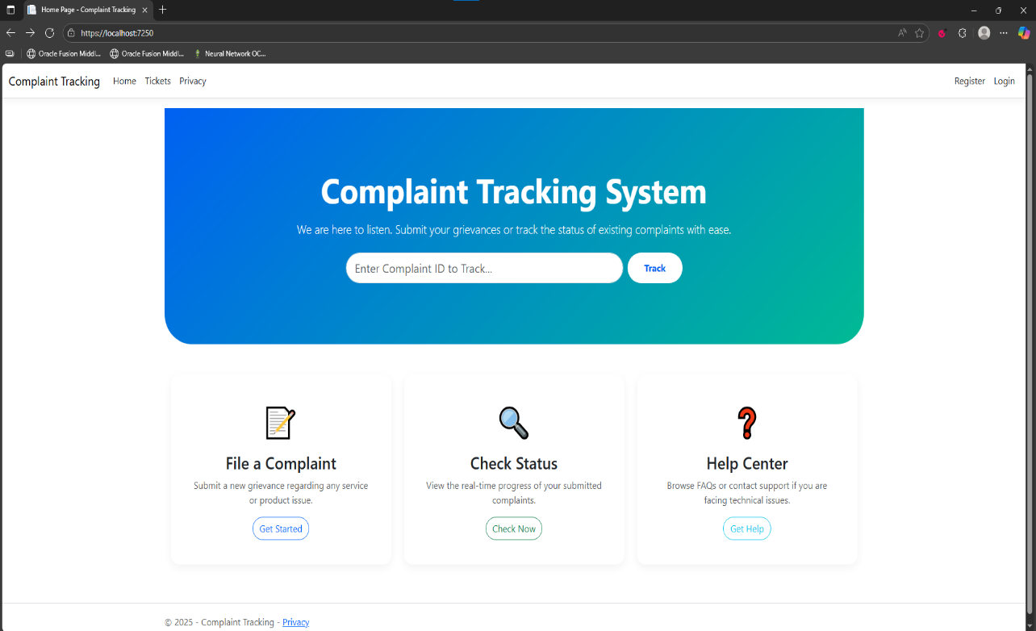
Home
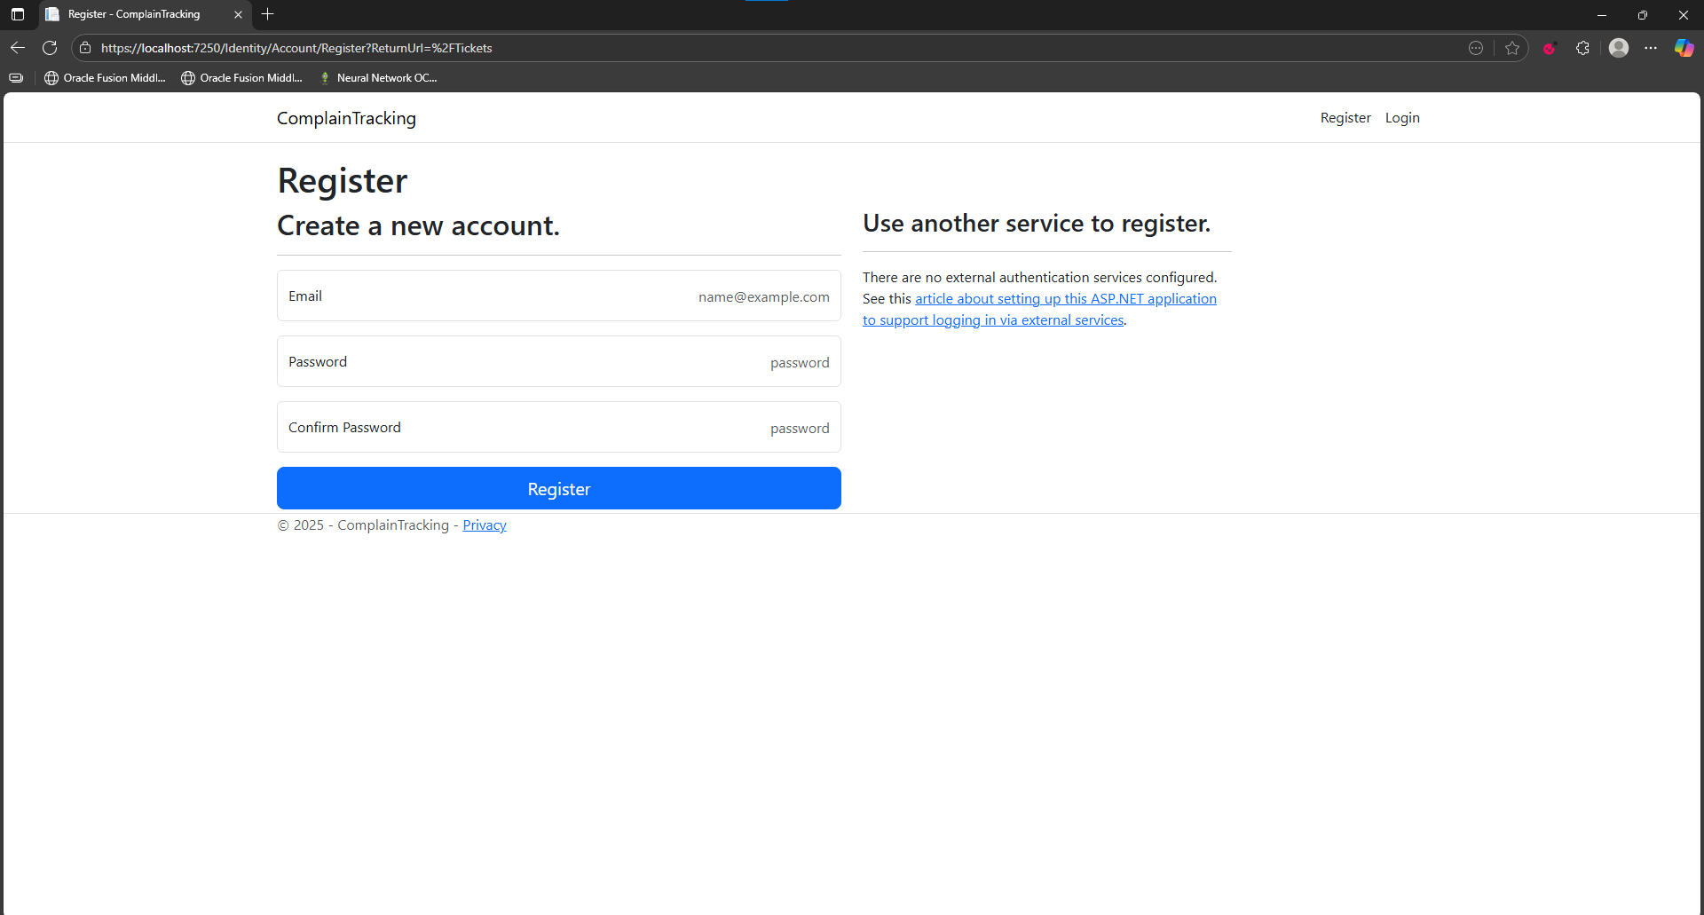
Register

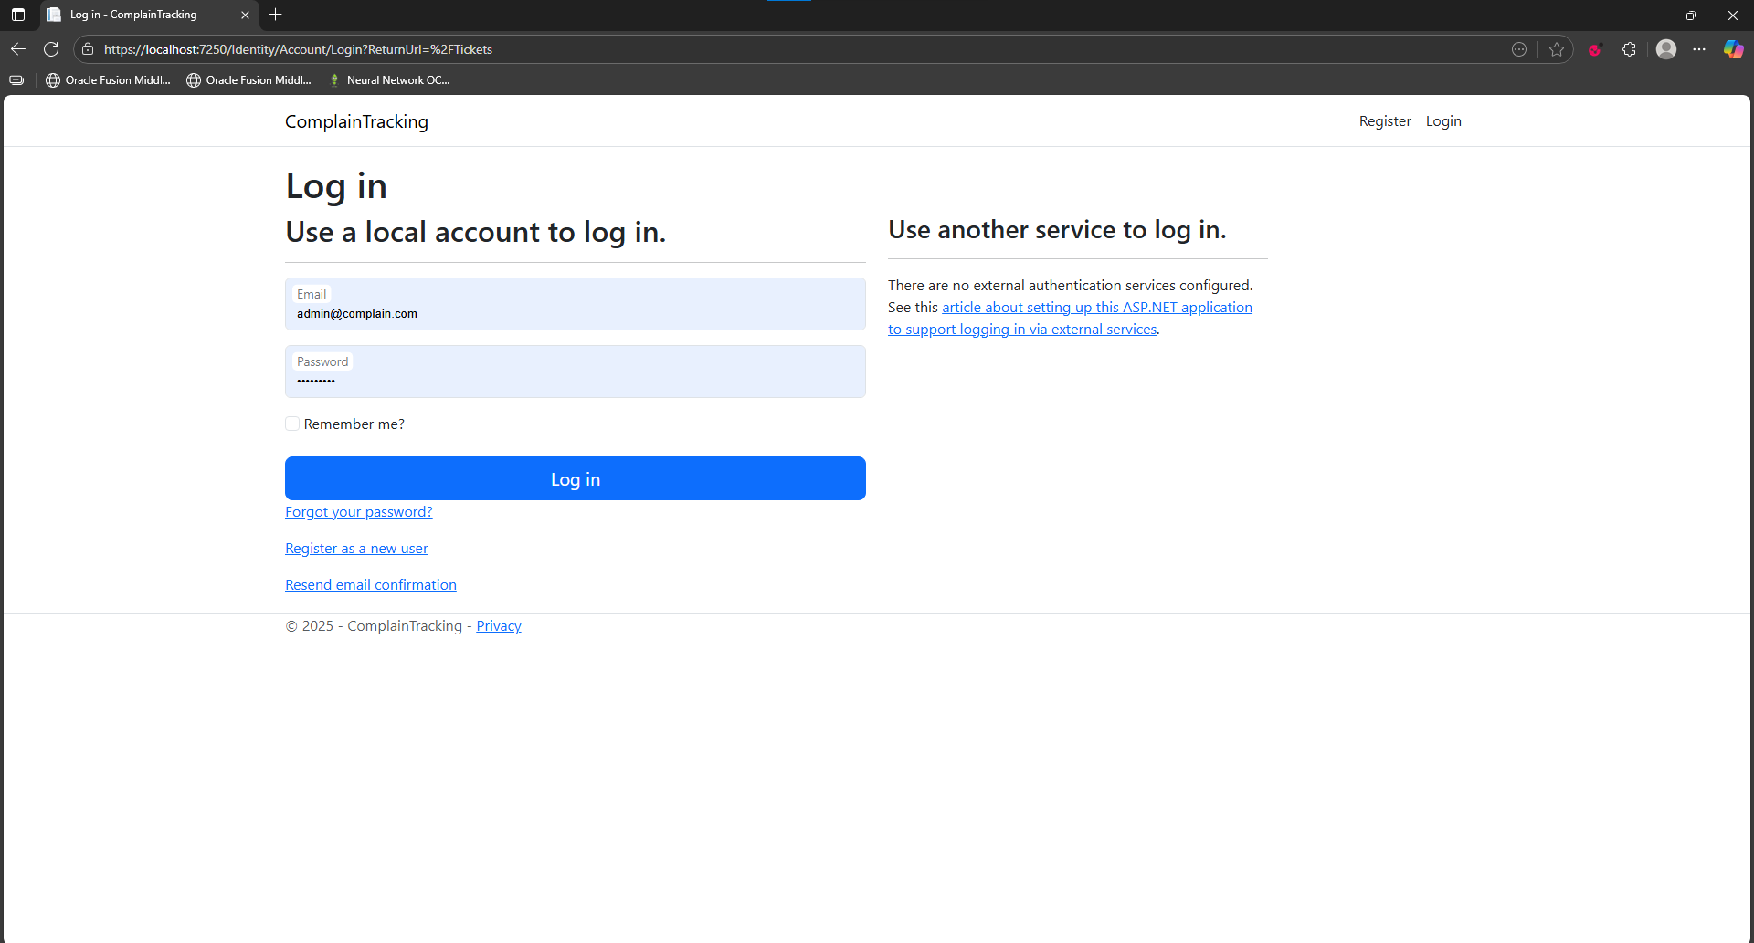
Login
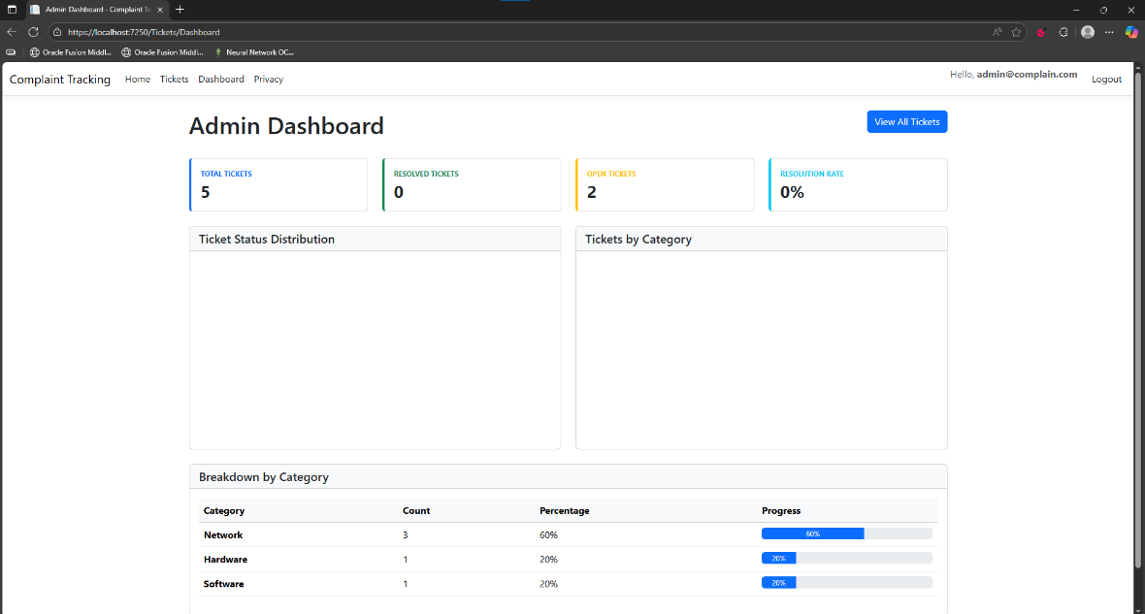
Admin Dashboard

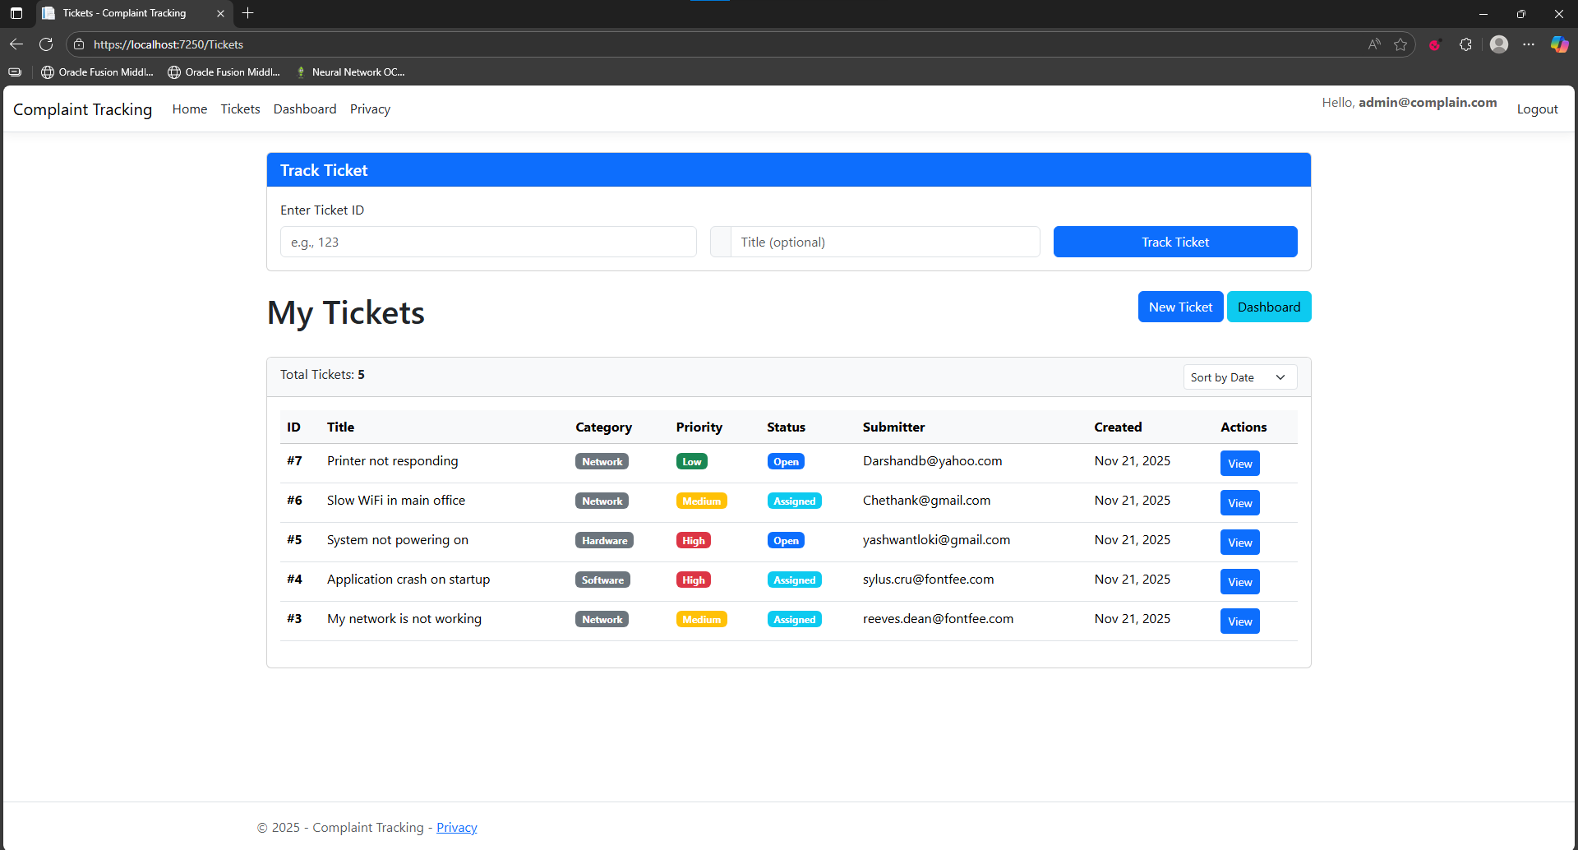
All Tickets
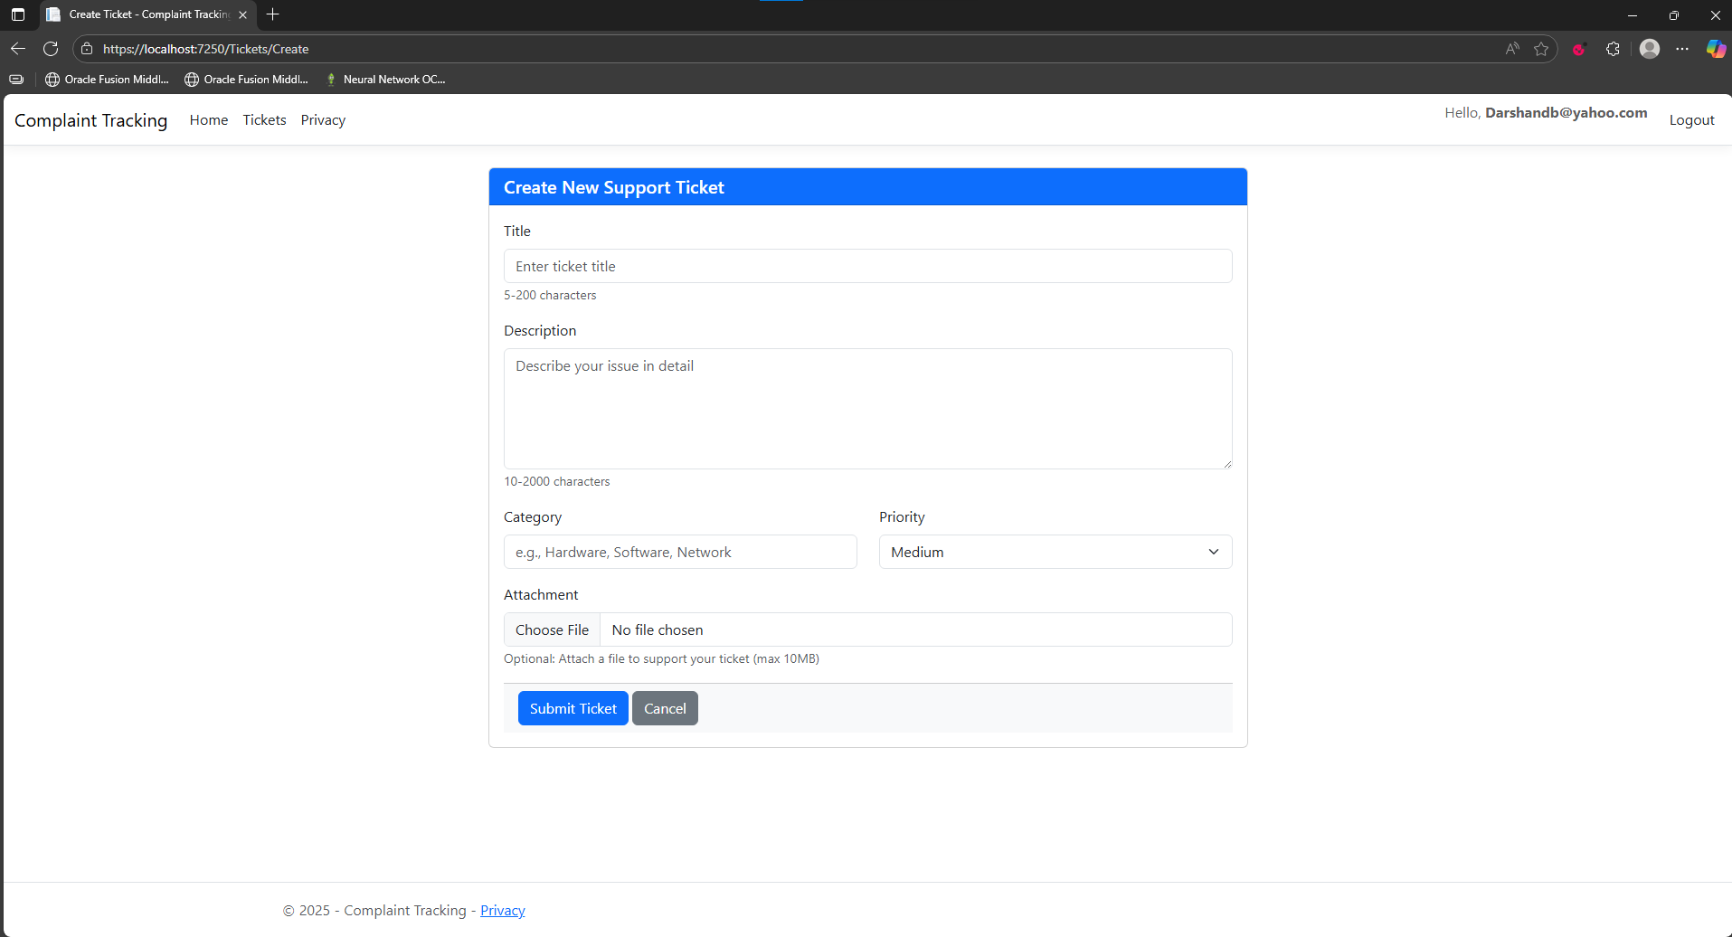
New Support Ticket

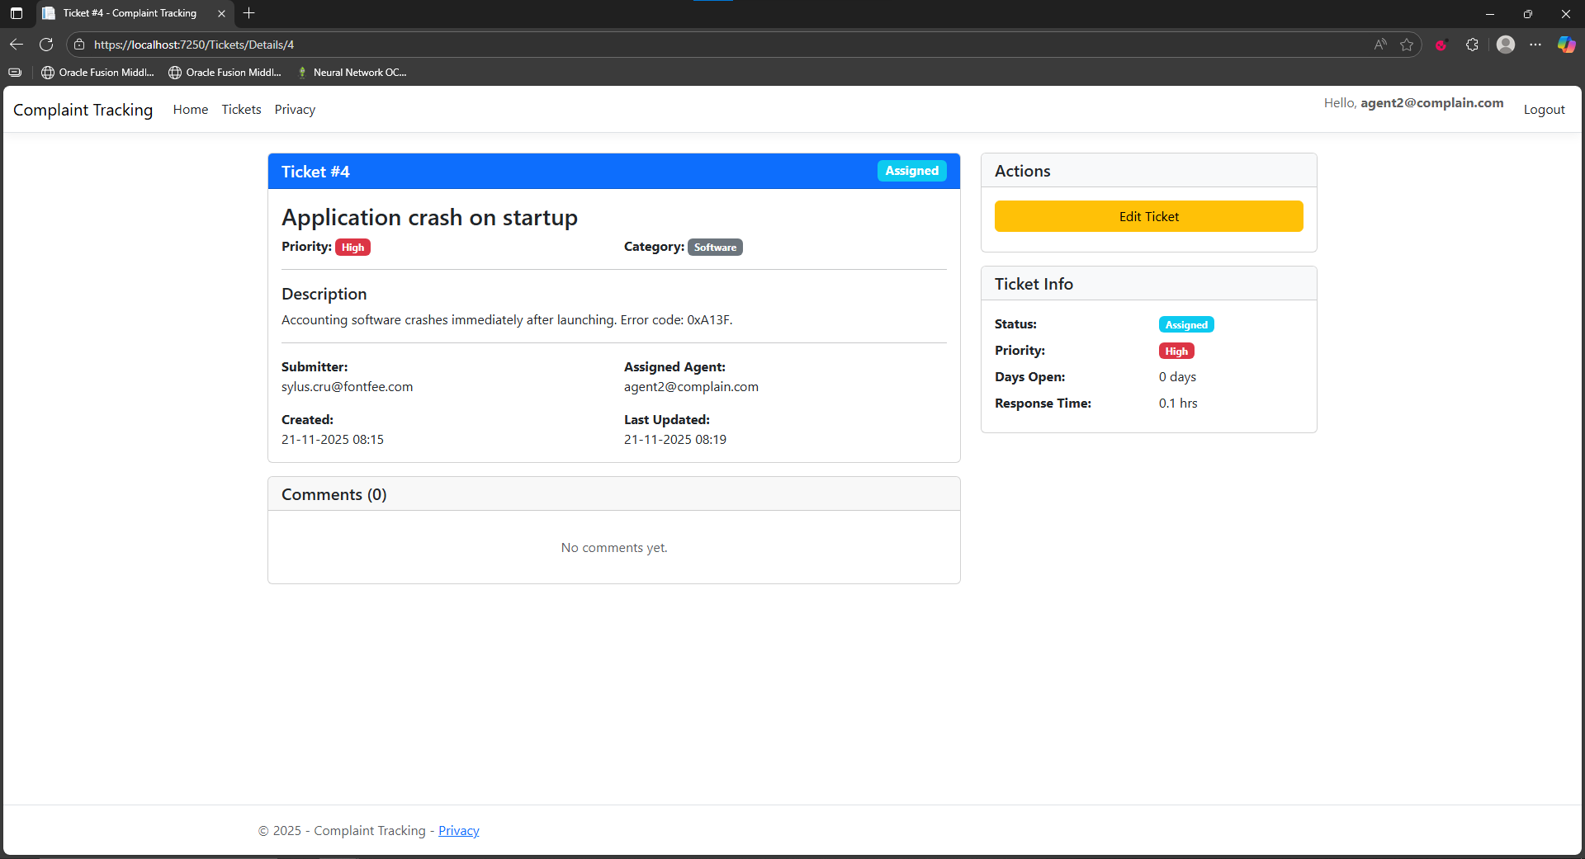
Assigned Ticket Page
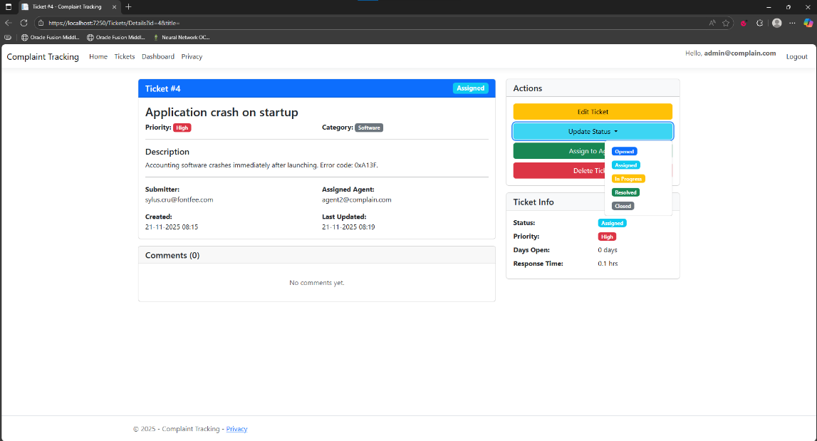
Update Ticket Status

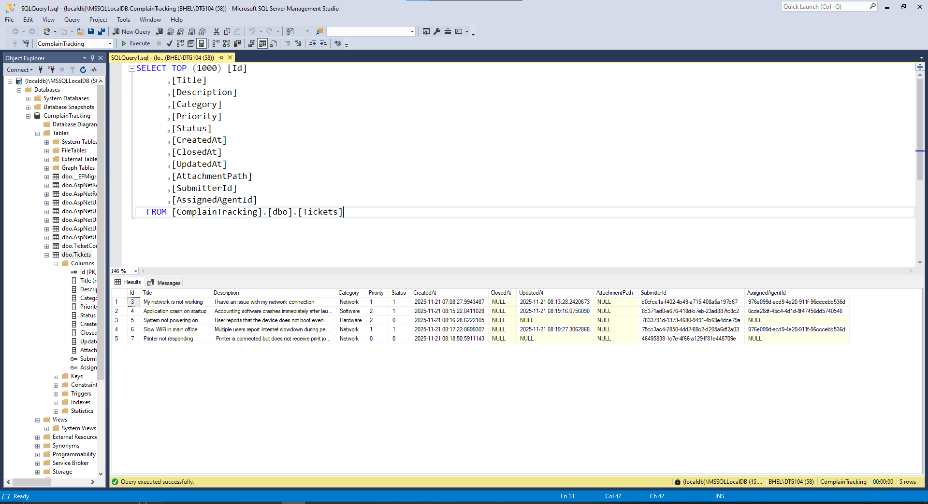
Tickets stored at Backend
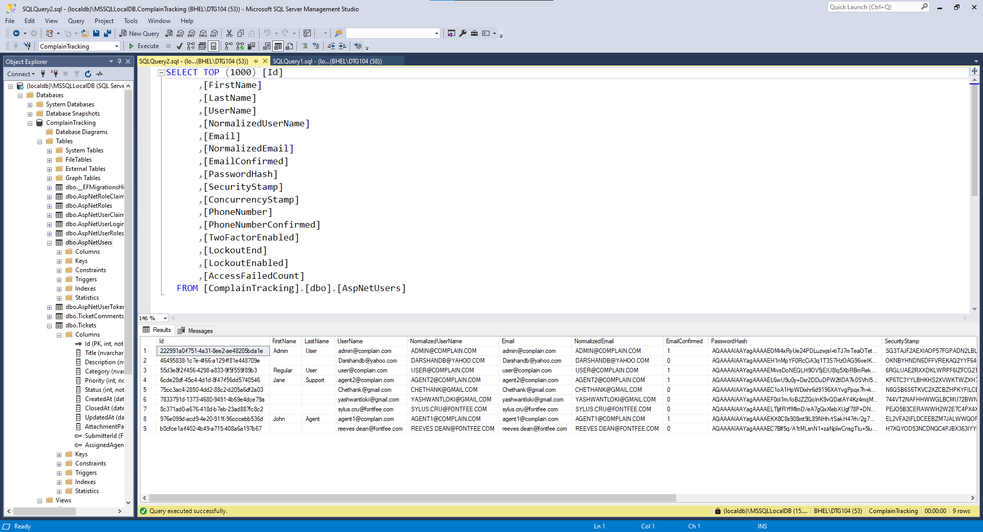
Registered Users

CONCLUSION AND FUTURE SCOPE

Conclusion:
The project met its objectives of implementing a functional Complaint Tracking System that streamlines complaint ticket handling. The internship provided practical exposure to enterprise development practices and strengthened understanding of ASP.NET Core MVC, Entity Framework Core [`ApplicationDbContext`](ComplainTracking/Data/ApplicationDbContext.cs), and SQL Server integration with ASP.NET Identity.

Future Scope:
  - Implement Delete ticket with confirmation dialogs and audit logging.
  - Enhance role-based authorization (e.g., agent-only edit/assign) using ASP.NET Identity.
  - Introduce server-side pagination [`PaginatedResult`](Models/DTOs/PaginatedResult.cs) and advanced search/filtering in Index/Dashboard for scalability.
  - Implement reporting features, dashboard charts, and export to Excel/PDF.
  - Add real email notifications via [`IEmailService`](Core/Interfaces/IEmailService.cs), file upload handling for attachments, and ticket assignment workflow.

REFERENCES
- Microsoft Docs – ASP.NET Core MVC
- Microsoft Docs – Entity Framework Core
- Microsoft SQL Server Documentation
- Visual Studio Documentation
- Project notes and implementation guidance (e.g., [`IMPLEMENTATION_SUMMARY.md`](ComplainTracking/IMPLEMENTATION_SUMMARY.md))

