Maritime Ship Simulator V2
  - User Guide and Operator Reference
Version 2.3.0 | User guide revision 2.0 | 19 October 2026
An operator guide for setting up vessel motion, AIS traffic, marine protocol outputs and online or offline maps.

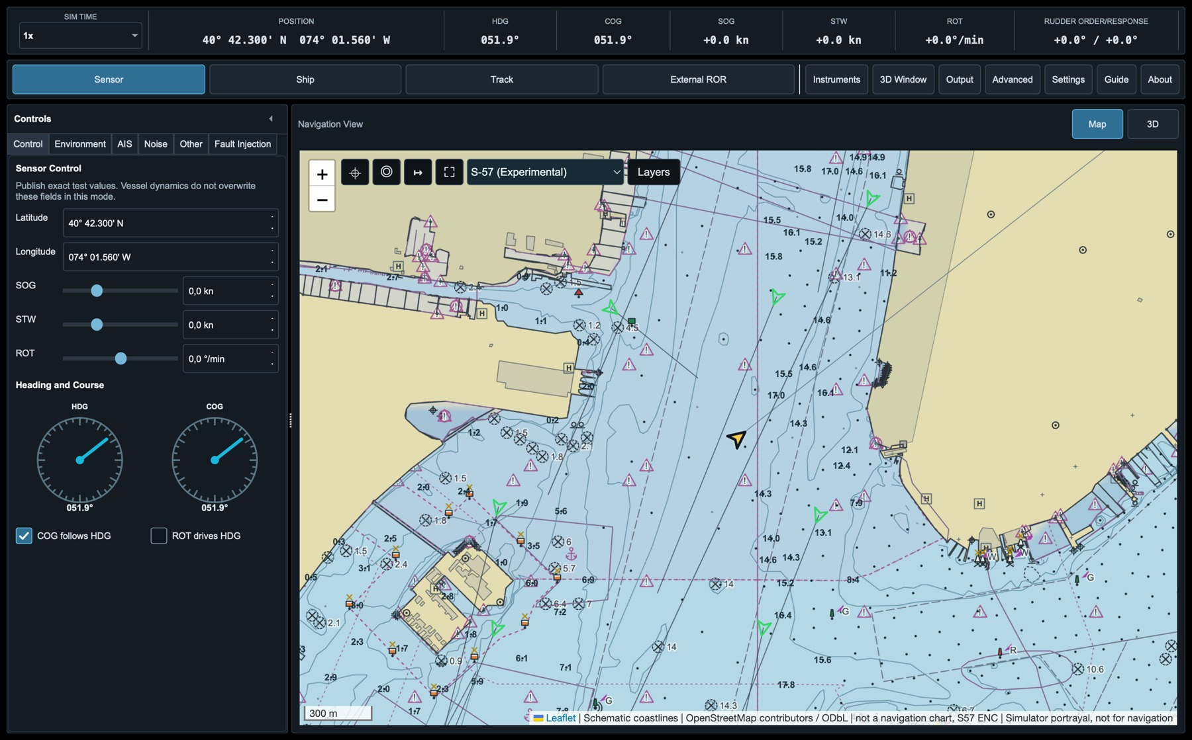
Figure 1. Maritime Ship Simulator V2 main window in Sensor Control.
This guide covers Maritime Ship Simulator 2.3.0, including the tunnel bow thruster, external rudder/engine/thruster inputs and configurable source fallback. It is independent of any particular radar, ECDIS or third-party simulator. Start with installation, choose a control mode, then configure the receiver. Screens vary with operating system, display scale, route and provider availability.

Document Control
Item | Value
Document | Maritime Ship Simulator V2 User Guide
Application | Maritime Ship Simulator V2 2.3.0
Manual revision | User guide 2.0
Release type | Unsigned production build
Supported platforms | Windows, Ubuntu and macOS Apple silicon; check package architecture and minimum OS.
Scope | Manufacturer-independent operation, configuration, transport setup, maps, diagnostics and limitations
Table 1. Document identification.

Safety and intended use
Maritime Ship Simulator V2 is a demonstration and integration tool. It is not a certified navigation system, training simulator or hydrodynamic predictor. Do not use its positions, routes, traffic, environmental values, 2D map or 3D imagery for real-world navigation decisions.
The vessel models are designed to be stable and plausible for equipment demonstrations. Exact turning circles, stopping distances, squat, clearance, collision risk and weather effects are not authoritative vessel-performance predictions.

Conventions
Convention | Meaning
Button or tab name | Shown in bold in procedural text.
HDG / COG / SOG / STW / ROT | Standard navigation abbreviations; see the glossary.
PORT / STBD | Port and starboard rudder channels.
Fixed | A stored start-up value intentionally captured by the operator.
Last Saved | The saved operating state updated only by an explicit save action.
Table 2. Manual conventions.

Contents
1. Product Overview 5
1.1 Purpose 5
1.2 Main capabilities 5
1.3 Operating modes at a glance 5
2. Installation and First Start 6
2.1 Package choices 6
2.2 Windows 6
2.3 Ubuntu 6
2.4 macOS 6
2.5 First-start check 6
2.6 Local UDP quick start 6
3. How the Simulator Works 7
3.1 Shared state 7
3.2 Timing 7
4. Main Window 8
4.1 Screen areas 8
4.2 Status strip 8
4.3 Small screens 8
5. Sensor Control 9
5.1 Recommended workflow 9
6. Ship Control 10
6.1 Manual manoeuvring 10
6.2 Telegraph and keyboard 10
6.3 Bow thruster 11
7. Track Control 11
7.1 Control ownership 11
7.2 Route Planning table 12
7.3 Route actions 12
7.4 Wheel-over and invalid geometry 12
8. External Input 13
8.1 Main and fallback sources 13
8.2 Rudder inputs 14
8.3 Bow thruster input 15
8.4 Engine telegraph input 16
8.5 Loss actions and status 17
9. 2D Map 18
9.1 Map toolbar 18
9.2 Mouse and trackpad 18
9.3 Right-click actions 18
10. 3D Navigation View 19
10.1 Opening and provider selection 19
10.2 Controls 19
10.3 Gestures 19
10.4 Overlays and performance 19
10.5 Memory management 20
11. Instrument Cluster 21
12. Environment, AIS, Noise, Other and Fault Injection 22
12.1 Environment 22
12.2 AIS control 23
12.3 Noise 24
12.4 Other 25
12.5 Fault Injection 25
13. AIS Traffic 26
13.1 Generated AIS 26
13.2 Synthetic Traffic Generator 27
13.3 Live AIS 30
13.4 Update and dead reckoning 30
13.5 AIS output 30
14. Protocol Output Settings 31
14.1 Independent paths 31
14.2 UDP 31
14.3 TCP 32
14.4 Serial 32
14.5 Sensor groups 32
15. Output Monitor and Advanced Output 33
15.1 Output Monitor 33
15.2 Advanced IEC output 34
15.3 XDR 34
16. Settings and Configuration 35
16.1 Complete configuration versus Start-up setup 35
16.2 Vessel Models 36
16.3 Offline settings 37
16.4 Map sources and S57 ENC settings 38
17. Operating Workflows 39
17.1 Exact receiver test 39
17.2 Manual bridge demonstration 39
17.3 Track demonstration 39
17.4 External steering loop 39
17.5 Synthetic encounter and fault test 39
17.6 Offline demonstration 39
17.7 S57 ENC operating workflow 43
18. Diagnostics and Troubleshooting 47
18.1 Packet capture method 48
18.2 Performance Monitor 48
18.3 Serial input diagnostics 48
Appendix A. Address reference 49
Appendix B. Abbreviations 49
Appendix C. Licensing Privacy and Support 50

1. Product Overview

1.1 Purpose
Maritime Ship Simulator V2 creates one coherent own-ship state and projects it to operator controls, protocol outputs, maps, instruments and optional external steering inputs. It sits between a basic telegram generator and a full-mission simulator: the application can publish exact manual sensor values, run a simplified vessel model, follow an RTZ route or accept external rudder input while keeping all outputs synchronized.

1.2 Main capabilities
- Four operating modes: Sensor Control, Ship Control, Track Control and External steering.
- Five built-in vessel profiles plus editable custom vessels.
- Independent UDP, TCP and Serial output paths, including additional parallel paths.
- IEC 61162/NMEA-style GNSS, gyro, log, depth, wind, meteorological, XDR, rudder and AIS output.
- Generated, synthetic or live AIS traffic, editable encounters, dead reckoning between real reports and paced VDM/VDO output.
- RTZ route import and editing, wheel-over geometry, planned turn rate/radius and route-position seek.
- 2D route map, optional Google/Cesium 3D navigation view and configurable instrument cluster.
- Portable complete configurations and group-based unattended Start-up setup.
- Post-model Fault Injection for repeatable sensor, GNSS and transmission failures.

1.3 Operating modes at a glance

Mode | Owner of speed | Owner of rudder | Typical use
Sensor | Operator sensor value | Operator sensor value | Exact repeatable protocol and display tests
Ship | Engine telegraph | Operator rudder order | Manual manoeuvring demonstration
Track | Telegraph or planned speed | Track Controller | Route-following and wheel-over demonstration
External steering | Engine telegraph | Selected validated external source | Closed-loop bridge/steering integration
Table 3. Command ownership by operating mode.

2. Installation and First Start

2.1 Package choices
Platform | Recommended package | Portable alternative | Notes
Windows 11 | Setup EXE | Portable ZIP | Unsigned build can trigger SmartScreen.
Ubuntu | DEB installer | AppImage or tar.gz | DEB registers icon/menu entry and dependencies.
Ubuntu 22.04 | Self-build only | No prebuilt package | Build on 22.04; validate locally.
macOS | DMG | Application ZIP | Unsigned build can require right-click Open or Privacy & Security approval.
Table 4. Release package selection.

2.2 Windows
1. Close any older instance and run the setup EXE for the expected application version.
2. The release is unsigned. Use the author's release page and verify SHA256. If offered, choose More info > Run anyway only for this verified installer. Do not disable Windows security globally.
3. Allow required traffic through Windows Defender Firewall on the intended network profile. Start the application and check About.

2.3 Ubuntu
Install the local package through APT so dependencies are resolved:
sudo apt install ./Maritime-Ship-Simulator-V2-2.3.0-ubuntu-installer.deb
The package declares Qt/XCB libraries, including libxcb-icccm4 and libxcb-keysyms1. Match the release's Ubuntu version and architecture. No 22.04 binary is provided; on 22.04, run bash scripts/build-v2-ubuntu-22.04.sh from the source instead.

2.4 macOS
1. Open the DMG and copy the application to Applications or another writable location.
2. If macOS blocks first launch, attempt to open the verified application once, then use System Settings > Privacy & Security > Open Anyway. Confirm only this application; do not disable Gatekeeper globally.
3. Grant local-network access when macOS asks and network output/input is required.

2.5 First-start check
Confirm version 2.3.0 in About. In Sensor mode, check that a changed value reaches the status strip and own ship appears on Map. Check Settings endpoints before connecting equipment; begin without provider credentials.

2.6 Local UDP quick start
1. Start a local test receiver on UDP port 19002 accepting IEC 61162/NMEA sentences with CRLF endings.
2. Select Sensor Control. Set heading to 090 degrees and SOG to 8.0 kn for a repeatable test.
3. In Settings, configure one UDP output to 127.0.0.1 port 19002. Disable other paths. Enable HDT and RMC at 1 Hz and start Cycle Active.
4. Check sentence contents and timestamps in Output Monitor, then verify reception independently. Freeze pauses only the monitor, not transmission.
5. For remote equipment use its reachable IPv4 address and check port, interface and firewall. TCP needs one Server and one Client. Serial needs the correct port, baud rate and access permissions.

3. How the Simulator Works

3.1 Shared state
Controls, maps, instruments and protocol outputs use the same simulated vessel state. The selected mode determines who controls motion: the operator, the vessel model, the route controller or a validated external rudder input. Changing a value in the active control updates the same ship everywhere. Maps and protocol encoders display or transmit that state; they do not create an independent vessel model.
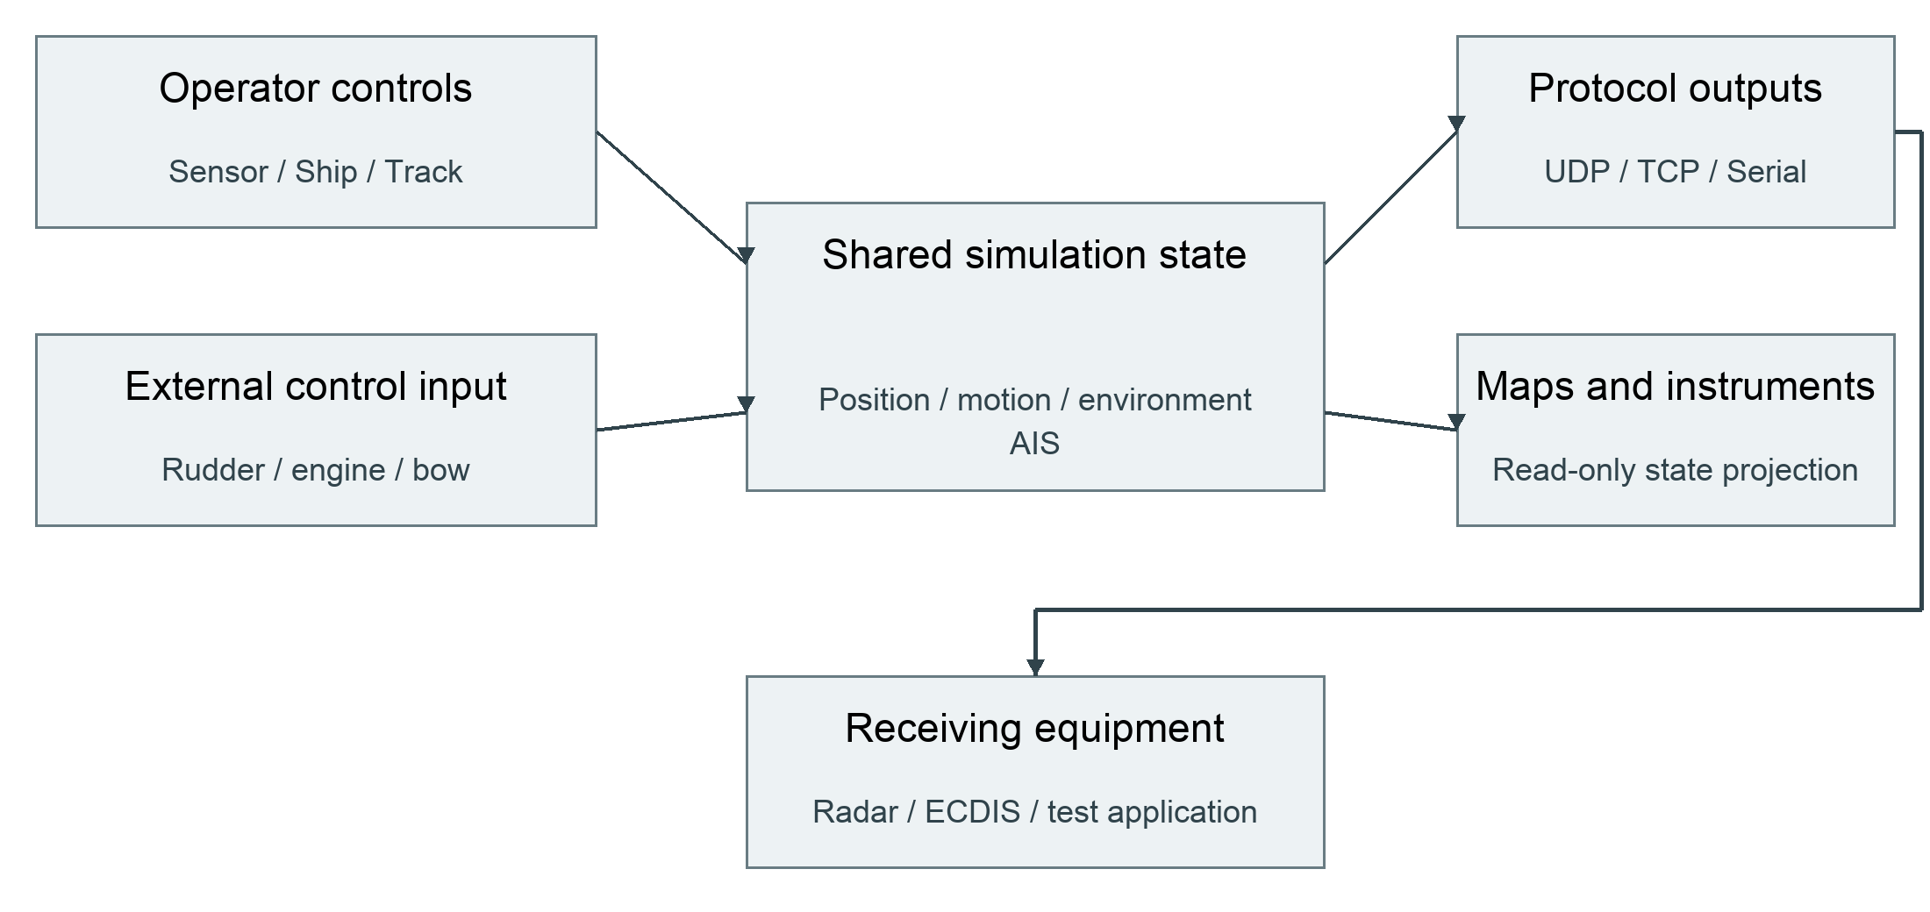
Figure 2. Authoritative command, simulation, output and visualisation flow.

3.2 Timing
Simulation Time scales simulated time only. Protocol rates remain wall-clock rates, so a 10 Hz output stays 10 Hz at 1x and 30x. The output scheduler runs independently from the UI and 3D renderer. Map vectors and predicted paths use their documented simulation horizons rather than the wall-clock output interval.

4. Main Window
Figure 3. Main window in Sensor Control. The status strip, mode bar, control tabs and navigation view remain available without opening a dialog.

4.1 Screen areas
Area | Purpose
Status strip | Simulation time scale, marine position, HDG, COG, SOG, STW, ROT and rudder order/response; XTE in Track mode only.
Mode bar | Select Sensor, Ship, Track or External Rudder; open Instruments, 3D, Output, Advanced, Settings, Guide and About.
Controls | Mode-specific Control plus Environment, AIS, Noise and Other tabs. Collapse for compact vertical controls.
Navigation View | Switch between the interactive 2D map and embedded 3D view.
Route Planning | Visible in Track mode; edit route, seek position and choose planned/manual ownership.
Table 5. Main-window regions.

4.2 Status strip
Values in the status strip are the current projected simulator values. XTE appears only in Track mode; the other readouts redistribute smoothly when modes change. RUDDER ORDER/RESPONSE shows order first and response second. Simulation Time above 1x is highlighted red to distinguish accelerated operation from real time.

4.3 Small screens
The left controls and Route Planning sections are independently collapsible. Use the arrow beside Controls to retain only key vertical sliders. Use the Route Planning arrow to retain the route status and route-position control while hiding the table. Control, Environment, AIS, Noise, Other and Fault Injection use scroll areas and adaptive field widths for smaller screens and Windows display scaling.

5. Sensor Control
Figure 4. Main window in Sensor Control, with direct sensor data control.
Sensor Control is the exact-value mode for receiver tests. Direct values are not overwritten by vessel dynamics. Position accepts marine degrees-and-decimal-minutes input as well as decimal degrees. HDG and COG use circular dials; COG follows HDG preserves the current offset, and ROT drives HDG integrates manual ROT into heading.

5.1 Recommended workflow
1. Select Sensor mode.
2. Set position, SOG, STW and ROT.
3. Set HDG and COG directly, or enable the required coupling.
4. Set Environment and Other values.
5. Enable only the required output sentences in Settings and verify them in Output Monitor.
Noise is intentionally applied only to protocol sensor snapshots. It does not alter the authoritative values shown in the controls or feed back into vessel dynamics.

6. Ship Control
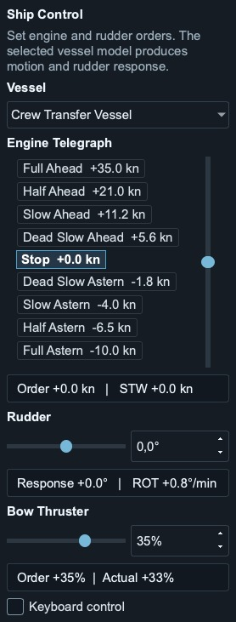
Figure 5. Ship Control with Rudder and Bow Thruster below the telegraph; Keyboard control is at the bottom.

6.1 Manual manoeuvring
Ship Control runs the selected vessel model. Manual or selected external controls own engine and bow demand; manual rudder order drives the steering gear. The model owns motion and response. Wind and current act through Environment. External engine/bow inputs also work in other model modes; Sensor Control keeps manual sensor semantics.
1. Select the vessel before starting the manoeuvre.
2. Set the telegraph by clicking a stage or dragging the slider between stages.
3. Set rudder order with the slider or numeric field.
4. Observe order and response separately in the status strip or instruments.
5. Return the telegraph and rudder to zero before changing to a test that expects a steady state.

6.2 Telegraph and keyboard
Full Ahead is at the top and Full Astern at the bottom. The selected stage is bold; when the order lies between stages, both surrounding stages are bold. Enable Keyboard control before using Up/Down for telegraph stage steps and Left/Right for one-degree rudder changes. Keyboard commands are ignored unless that option is active.

6.3 Bow thruster
The horizontal Bow Thruster slider below Engine Telegraph orders signed motor demand. Negative means bow to port; positive means bow to starboard. Double-click for zero. A selected valid external source moves the disabled slider; the displayed order remains visible.
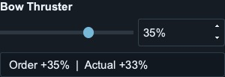
Figure 6. Manual bow demand and ramped actual response below the telegraph.
Run-up and reversal take time. The single Bow Thruster instrument combines a horizontal actual-output bar with a yellow order triangle. Displayed percent represents signed motor/RPM state, not constant lateral force at every speed.
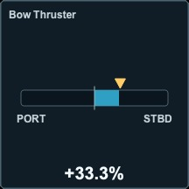
Figure 7. Bow Thruster instrument with yellow demand marker.
Tunnel effectiveness decreases with the magnitude of speed through water, including astern motion, not SOG. The factory curve gives 50% effectiveness at 3 kn STW and about 6% at 6 kn. Configure power, ramp time and the curve in Vessel Models. These are demonstration assumptions, not calibrated ship-trial predictions. Zero installed power means no thruster force.

7. Track Control
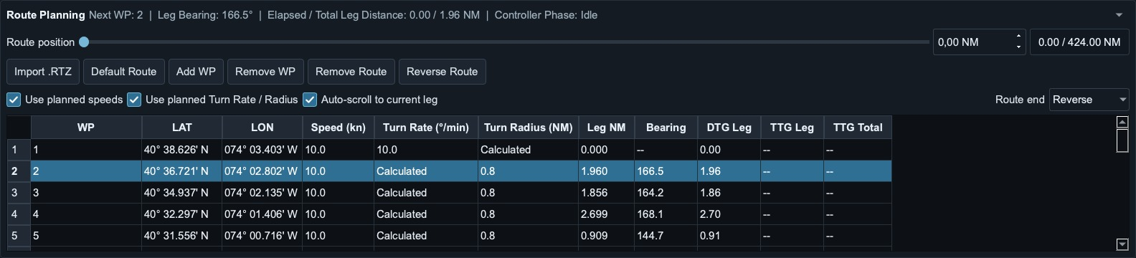
Figure 8. Route Planning for the bundled USNYC-USBAL route: 10.0 kn planned speeds, planned turns, Auto-scroll and Reverse enabled.

7.1 Control ownership
The Track Controller owns rudder order. Speed remains on the telegraph unless Use planned speeds is selected. Turn Rate and Turn Radius are paired controls: operating one makes it authoritative, calculates and dims the other, and updates planned geometry. When Use planned Turn Rate / Radius is selected, both manual turn controls are disabled until the operator moves one, which automatically returns ownership to manual control.

7.2 Route Planning table
Column | Meaning / edit rule
WP | Waypoint name.
LAT / LON | Marine coordinate input; drag on map updates the same route.
Speed | Numeric planned speed with one decimal; default 10.0 kn.
Turn Rate | Numeric fixed rate or Calculated when radius owns the turn.
Turn Radius | Numeric fixed radius or Calculated when rate owns the turn.
Leg NM / Bearing | Calculated leg geometry.
DTG / TTG | Live distance/time information for the active route.
Table 6. Route Planning columns.

7.3 Route actions
- Import .RTZ loads an RTZ route. Default Route restores USNYC-USBAL, a New York-to-Baltimore simulation route with 82 waypoints and 10.0 kn planned speed on every leg. It enables Use planned speeds, Use planned Turn Rate / Radius and Auto-scroll, and selects Reverse at route end. These are also the factory defaults on a fresh installation. Saved configurations and Start-up profiles can override them; loading Default Route does not change those saved files. The supplied route is for simulation, not navigation.
- Add WP inserts after the selected row; Remove WP removes selected rows; Remove Route clears all waypoints.
- Reverse Route reverses waypoint order and synchronizes route progress.
- Standard copy/paste works for editable table cells; the table context menu can apply a speed or turn value to all waypoints.
- Route end can Stop, Restart or Reverse.
- Route position moves own ship along the route and aligns heading to the active leg.

7.4 Wheel-over and invalid geometry
Wheel-over points and planned arcs use the Track Controller geometry. Invalid or overlapping turns are highlighted red without changing speed, rate or radius. Conflicts receive an average transition marker and dashed compromise path, followed within the vessel steering and ROT limits.

8. External Input
Open Settings > External Input. Rudder, Bow Thruster and Engine Telegraph have independent source choices, input-loss actions and UDP/TCP/Serial endpoints. External rudder controls steering only in External mode. Ship retains manual steering; Track retains route steering. Engine and bow sources can be external in all model-driven modes. Sensor Control remains a manual sensor test mode.

8.1 Main and fallback sources
Control Sources normally shows a compact summary. Click its arrow to expand the three radio-button columns, make the required choices, then collapse it again. Choices remain saved when closed.
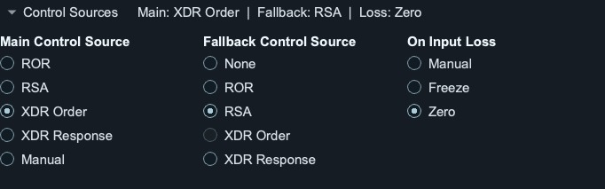
Figure 9. Expanded source selection; the closed summary retains the chosen settings.
Selection | Effect
Main Control Source | Preferred protocol, or Manual for continuous operator control.
Fallback Control Source | None, or a different protocol used after main has no valid sample for 2.5 s.
On Input Loss | Manual, Freeze or Zero when neither configured external source is current.
Table 7. Three-stage input ownership for each control.
Main resumes on its first valid matching sentence. Main and fallback cannot be the same protocol. Manual as main disables the other choices but keeps input monitoring active. Source selection is independent of transport: configure each protocol's endpoint in its own tab. Identical endpoints are shared internally, so several matching messages can arrive over one connection.
Example: select XDR Order as Rudder main, RSA as fallback and Zero on loss. XDR Order drives the steering gear while fresh. After 2.5 s without it, fresh RSA controls the measured response. If both expire, zero is ordered. The first valid XDR Order sentence returns control to main.
Listeners run asynchronously and reconnect after loss. View Port shows the exact received sentences. Invalid checksums, statuses, non-finite/out-of-range numbers or malformed groups never renew command freshness. Check Active source as well as lamp colour before a control test.

8.2 Rudder inputs
ROR and XDR Order enter before the steering gear; RSA and XDR Response supply measured rudder angle. A parallel valid order may still be shown when response owns the model. PORT/STBD are never mixed across sources. Native ROR/RSA retain their single/dual-channel validity handling.
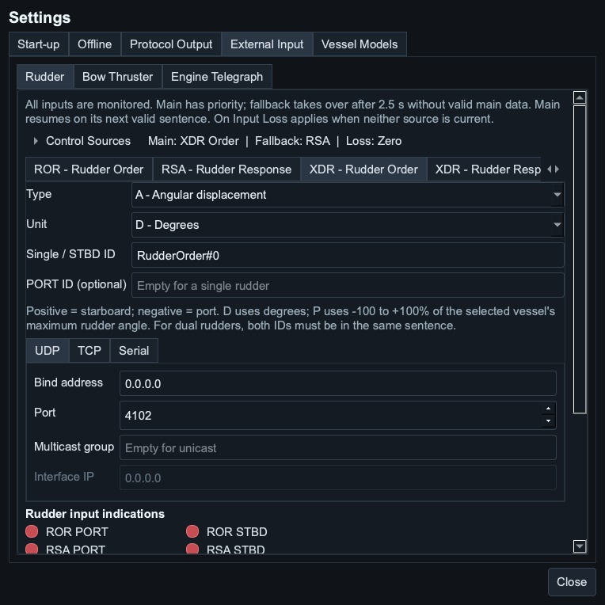
Figure 10. Rudder main/fallback/loss choices and XDR Order filter.
Rudder XDR field | Accepted values
Type and Unit | A/D: degrees. A/P or legacy G/P: -100 to +100% of vessel maximum rudder angle.
Single / STBD ID | RudderOrder#0 for order; Rudder#0 for response by default. Exact match.
Optional PORT ID | Blank means single rudder. If set, both matching values must be in one sentence.
Table 8. Rudder XDR filters and conversions.
For a 35-degree vessel, -50% means 17.5 degrees to port. Degrees outside the vessel limit are rejected. Type/Unit dropdowns expose only implemented combinations. IDs are editable and case-sensitive; order and response IDs must differ on a shared endpoint with the same Type/Unit.

8.3 Bow thruster input
TRC defaults to thruster number 1 and uses signed RPM demand. Mode P is -100 to +100%; mode R is signed RPM converted using the selected vessel's rated RPM. Valid C/R reports are accepted as simulation control data. Pitch and azimuth do not steer the tunnel. Positive means bow to starboard.
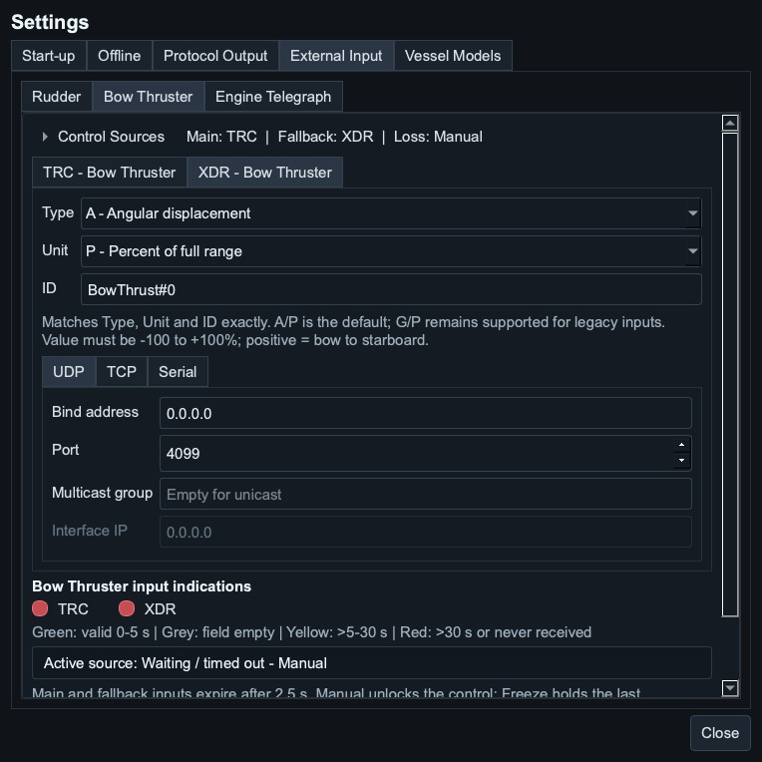
Figure 11. Independent bow source policy, XDR filter and endpoint.
XDR Bow Thruster defaults to Type A, Unit P and ID BowThrust#0. Legacy G/P remains selectable. The signed value must be within -100 to +100%; Type, Unit and ID must match exactly. A zero-power vessel still receives/indicates input, but cannot produce thruster force.

8.4 Engine telegraph input
PRC defaults to engine/shaft number 1 and uses lever demand position -100 to +100% with valid status A. Positive is ahead, negative astern. RPM/pitch fields are not used. Percent describes lever position across the vessel's telegraph detents, with interpolation, not a linear fraction of max speed.
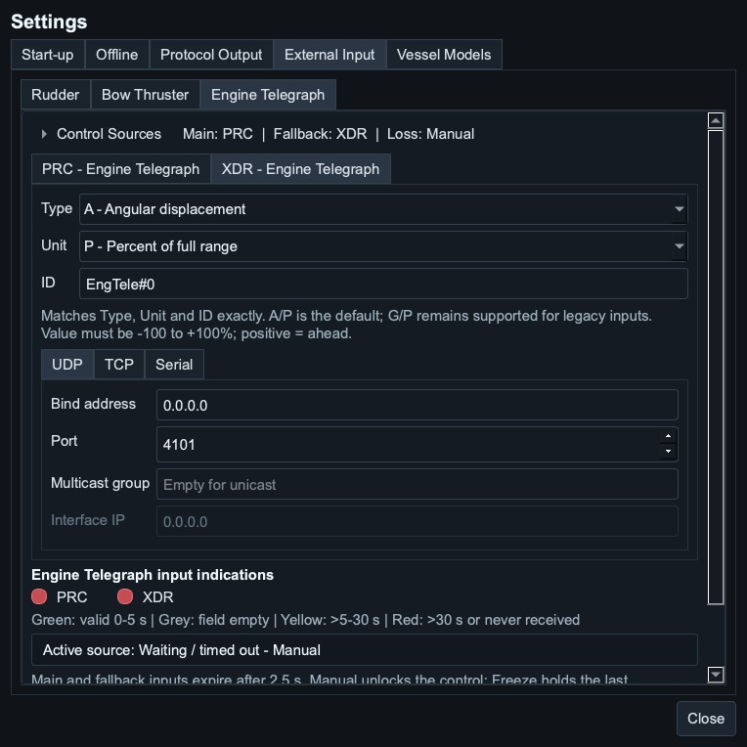
Figure 12. Independent engine source policy, XDR filter and endpoint.
XDR Engine Telegraph defaults to A/P and EngTele#0; legacy G/P is also supported. Selecting an external engine policy overrides Track planned speed. A completed route set to Stop still orders zero effective speed. Configure this deliberately before an unattended route test.

8.5 Loss actions and status
Action | When no selected external source is current
Manual | Unlock manual control. Rudder/bow start at zero; engine holds its last order until edited.
Freeze | Hold the last command, or measured angle for a response source. Manual edits remain locked.
Zero | Order zero; motor/steering response follows its normal dynamics. Manual edits remain locked.
Table 9. Configurable loss-of-input actions.
Freeze holds only this control; it does not pause vessel motion or protocol output. Before first reception, Freeze retains the existing command. Main or fallback regains ownership on fresh valid input. Select Manual as main to prevent automatic external takeover.
Lamp | Meaning
Green | Valid matching channel received within 0-5 s.
Grey | Matching sentence received with an empty relevant field.
Yellow | Last valid matching channel older than 5 s, up to 30 s.
Red | Older than 30 s or no valid reception.
Table 10. Input age indications for rudder, bow and engine.
The lamp thresholds differ from the 2.5 s control timeout. A lamp can remain green after a source has already timed out. Use Active source and whether the manual control is enabled to verify ownership. Logs/status retain rejected input without applying it to the model.

Commissioning checklist
1. Back up configuration; select a vessel and Ship mode with engine and bow main set to Manual.
2. Confirm ahead/astern and port/starboard signs with small demands at low speed.
3. Configure one external endpoint and match number or XDR Type/Unit/ID exactly.
4. Send a valid small demand; verify Active source, instrument and moving disabled control.
5. Stop main for more than 2.5 s; verify fallback, then stop fallback and verify the chosen loss action.
6. Restore main and confirm return. Save/export settings and capture the intended Start-up group.

9. 2D Map

9.1 Map toolbar
Control | Action
+ / - | Zoom in or out.
Crosshair | Centre once on own ship.
Follow | Keep own ship in view; target popups are accommodated without map oscillation.
Vector | Switch heading/predicted-path presentation.
Expand | Move the same live map into a separate window; F11 toggles full screen and Escape restores.
Table 11. 2D map controls.

9.2 Mouse and trackpad
- Drag to pan; mouse wheel or pinch to zoom.
- On a multitouch trackpad, a two-finger swipe pans the map rather than applying page zoom.
- Drag a waypoint marker to update its route position.
- In Synthetic Traffic mode, drag a target hull to move it or drag its vector handle to change course, heading and speed.
- Selecting an AIS target opens its details; generated/live target positions continue updating.
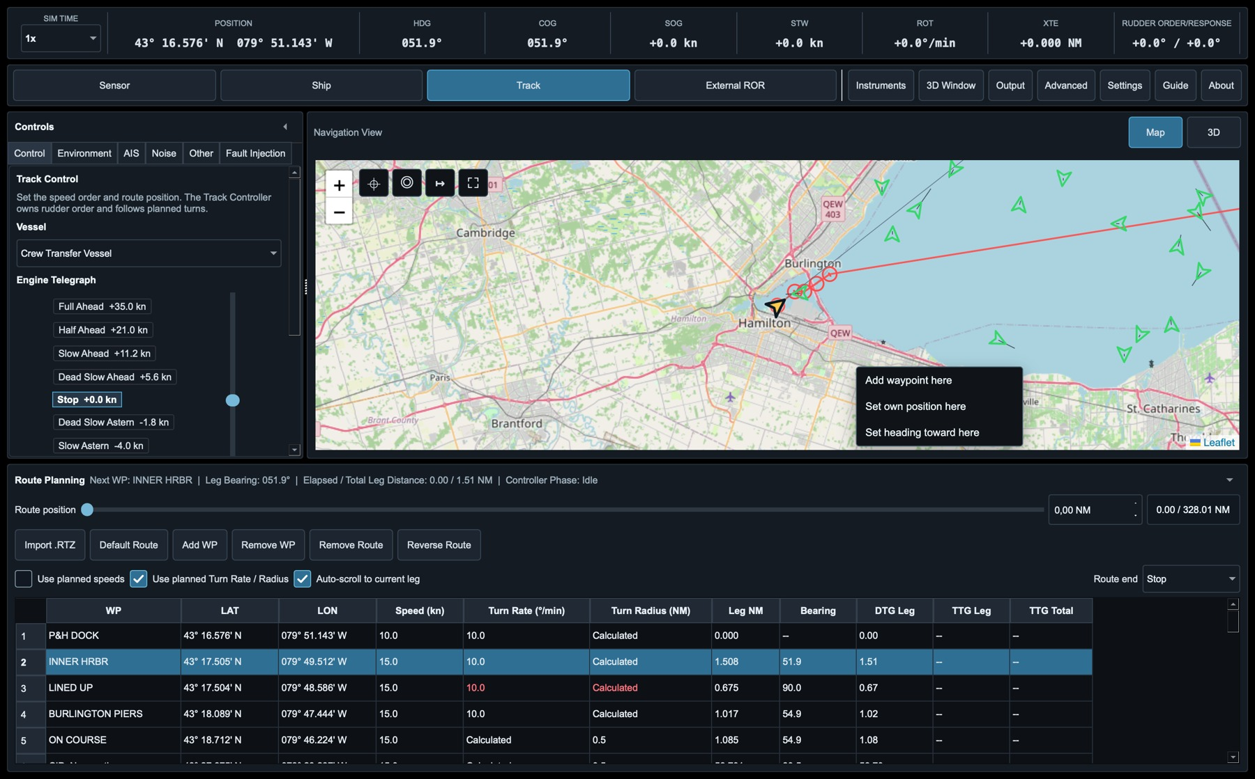
Figure 13. Map right-click menu. Remove waypoint appears when the pointer is close to a route waypoint.

9.3 Right-click actions
Action | Availability | Effect
Add waypoint here | Track mode | Appends a waypoint at the clicked position.
Remove waypoint | Track mode, near waypoint | Removes the selected waypoint.
Set own position here | All modes | Moves own ship and resets map history.
Set heading toward here | All modes | Sets heading to the bearing from own ship to the clicked point.
Add synthetic AIS target here | Synthetic mode; Avoid Land optional | Opens target details with the clicked position preselected.
Table 12. Map right-click actions.

10. 3D Navigation View
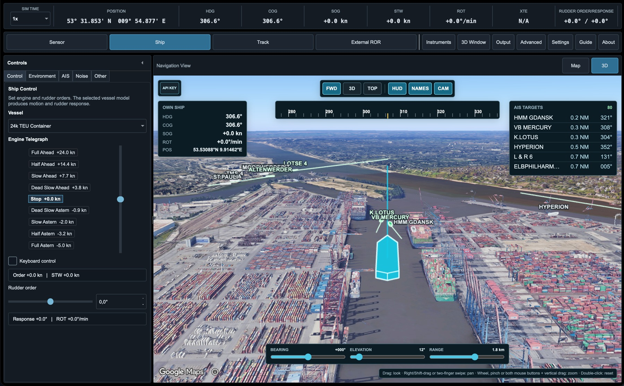
Figure 14. Google 3D view with valid API key and simulator overlays shown.

10.1 Opening and provider selection
Use Map / 3D above the main navigation area to switch the embedded view. 3D Window moves the same renderer into a separate scalable window; it does not start a second tile stream. Use the operating-system maximise control, F11 or Escape for full-screen operation on a second monitor.
The API KEY action stores a Google Maps Platform key and selects Auto, Google 3D Maps or Photorealistic Tiles/Cesium. Enable Maps JavaScript API for Google 3D Maps and Map Tiles API for Cesium. No key is bundled. Complete configuration exports intentionally include the effective Google and AIS credentials and must be treated as sensitive.

10.2 Controls
Control | Function
FWD | Defined forward view with horizon visible and own ship low in the frame.
3D | Oblique overview.
TOP | Near-vertical satellite-style view.
HUD | Show/hide own-ship and target information.
NAMES | Show/hide AIS labels without hiding hulls or vectors.
CAM | Show/hide bearing, elevation and range sliders.
Table 13. 3D view controls.

10.3 Gestures
- Left-drag orbits through 360 degrees and changes elevation.
- Right-drag, Shift-drag or a two-finger trackpad swipe pans the camera.
- Mouse wheel or pinch changes range. With a two-button mouse, hold both buttons and move vertically to zoom.
- Double-click restores the defined forward view.
- Gestures over HUD or text overlays remain assigned to the 3D camera; browser page zoom is locked to 100 percent.

10.4 Overlays and performance
Own ship is cyan with a white outline. AIS targets eligible for protocol output are green; excluded targets are grey. Hull length and beam use vessel/AIS dimensions, while display height is estimated. Heading line, predicted path and AIS vectors use a three-minute horizon and remain above provider scenery.
Auto quality adapts overlays, frame rate and (for Cesium) tile cache/detail to available RAM; recovery is gradual. External imagery is not a chart and its vessels are not live AIS. Memory pressure never changes the provider or switches the display to 2D.

10.5 Memory management
A background monitor checks available RAM every five seconds. Local map and water caches share a retained-data budget of 64, 96, 128 or 192 MiB, depending on available RAM. Budgets decrease promptly and recover after 60 seconds of stable availability. New swap-out activity also reduces the budget on macOS and Ubuntu. These are local-cache targets, not limits for the whole application, graphics memory or Google's tile cache. Active AIS water coverage is protected, and no saved map or chart cell is deleted.
- Below 1.5 GiB available RAM: 64 MiB local cache pool.
- 1.5 to below 3 GiB available RAM: 96 MiB local cache pool.
- 3 to below 6 GiB available RAM: 128 MiB local cache pool.
- 6 GiB or more available RAM: 192 MiB local cache pool.
Hidden or minimized map pages stop rendering. Under memory pressure, an unused page can be unloaded after 60 seconds. Reopening reloads the same map provider and restores camera, zoom, Follow Own Ship and HUD choices, then applies the latest ship, route and AIS data. Temporary pop-ups and the browser-only ship trail restart. Unfinished area selections or target drags are not unloaded. Keep 3D quality on Auto and close unnecessary windows when a virtual machine leaves little RAM available.
If the display slows down, open About > Performance Monitor and inspect available RAM and swap activity. Repeated paging can affect the whole operating system even when local caches are small. Reduce 3D quality or close other memory-intensive applications, then allow the quality profile to recover. Windows does not expose the same swap-out counter here; its policy uses available physical RAM. No manual cache deletion is needed.

11. Instrument Cluster
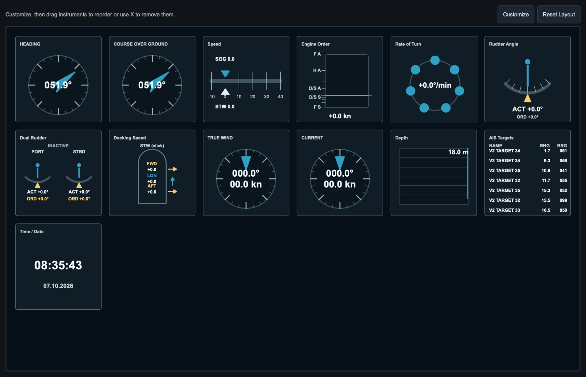
Figure 15. Configurable snapshot-driven instruments including heading, speed, ROT, rudder, docking speeds and AIS.
Choose Customize to add, remove or drag instruments. Choose Reset Layout to restore all standard tiles. The layout is stored in the complete configuration and Instruments Start-up group. Instrument data is read-only; it never commands the model. Dual Rudder and Docking Speed present PORT/STBD and longitudinal/transversal values graphically.

12. Environment, AIS, Noise, Other and Fault Injection

12.1 Environment
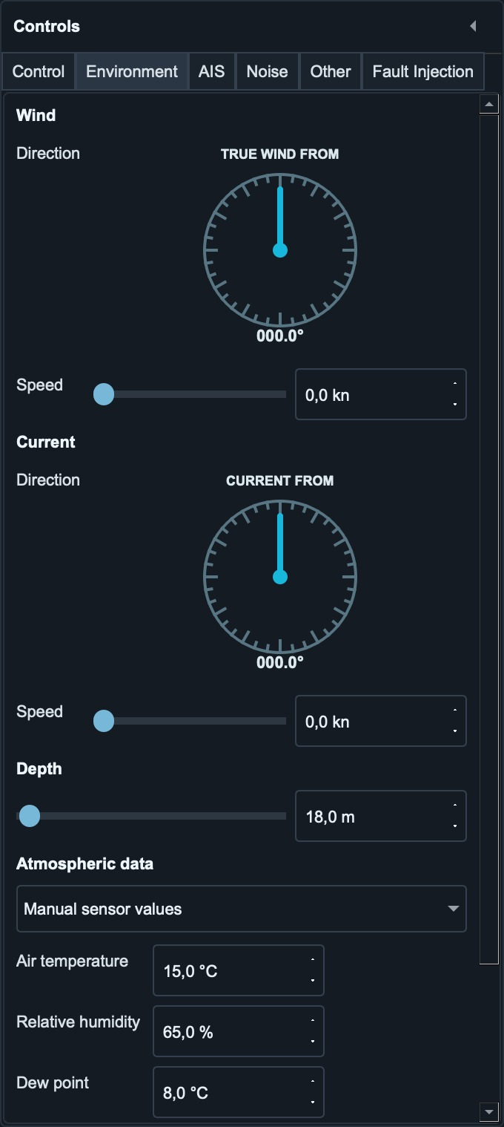
Figure 16. Environment tab with wind/current dials, depth and atmospheric data.
Wind and current directions are FROM directions. Depth covers 0-2000 m. Atmospheric XDR values can be manual or obtained asynchronously from Open-Meteo at own-ship position without an API key. Live failure retains the previous values and never blocks simulation or output.

12.2 AIS control
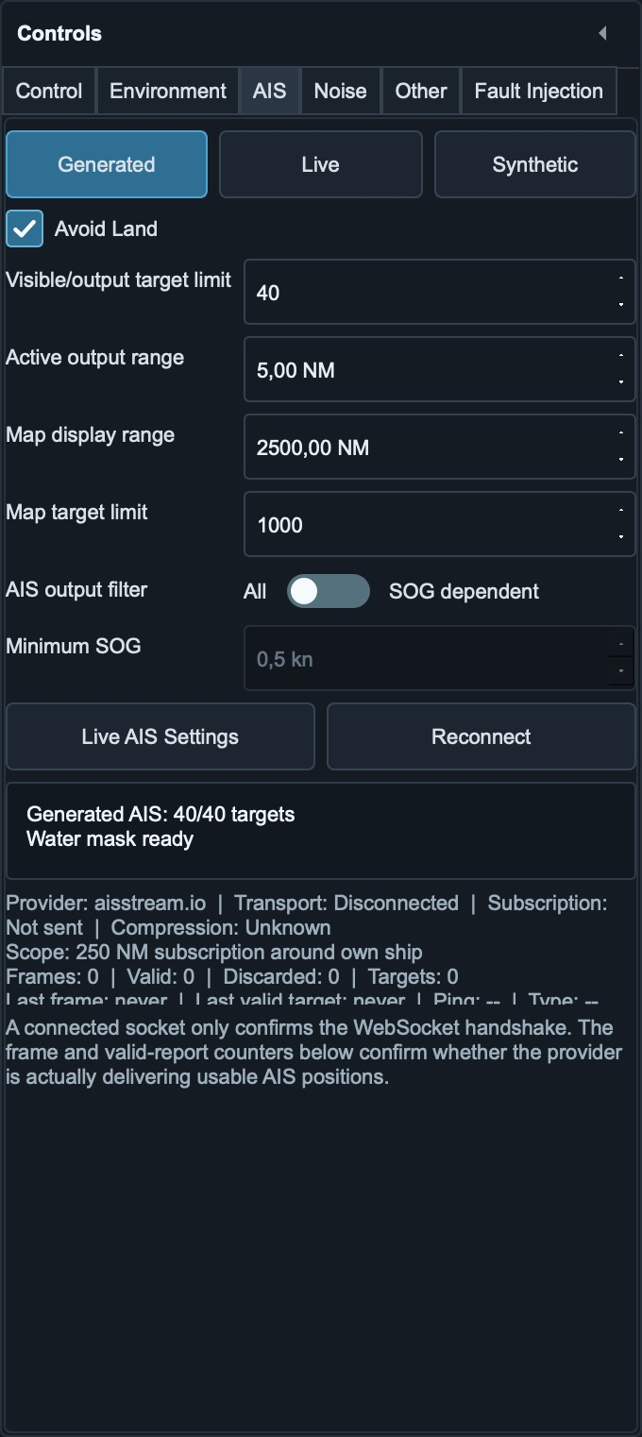
Figure 17. Generated AIS with Avoid Land enabled and the complete operating region prepared from installed S57 cells.
Generated, Live and Synthetic select the traffic source. Avoid Land controls water-only placement and shoreline avoidance for Generated and Synthetic; it can use saved areas offline. Disable it for unrestricted traffic or incomplete coverage. Visible/output target limit caps unique MMSIs eligible for VDM. Active output range controls range eligibility; Map display range and Map target limit control presentation. AIS output filter switches between All and SOG dependent; only SOG strictly greater than Minimum SOG is eligible in the latter mode. The default threshold is 0.5 kn.

12.3 Noise
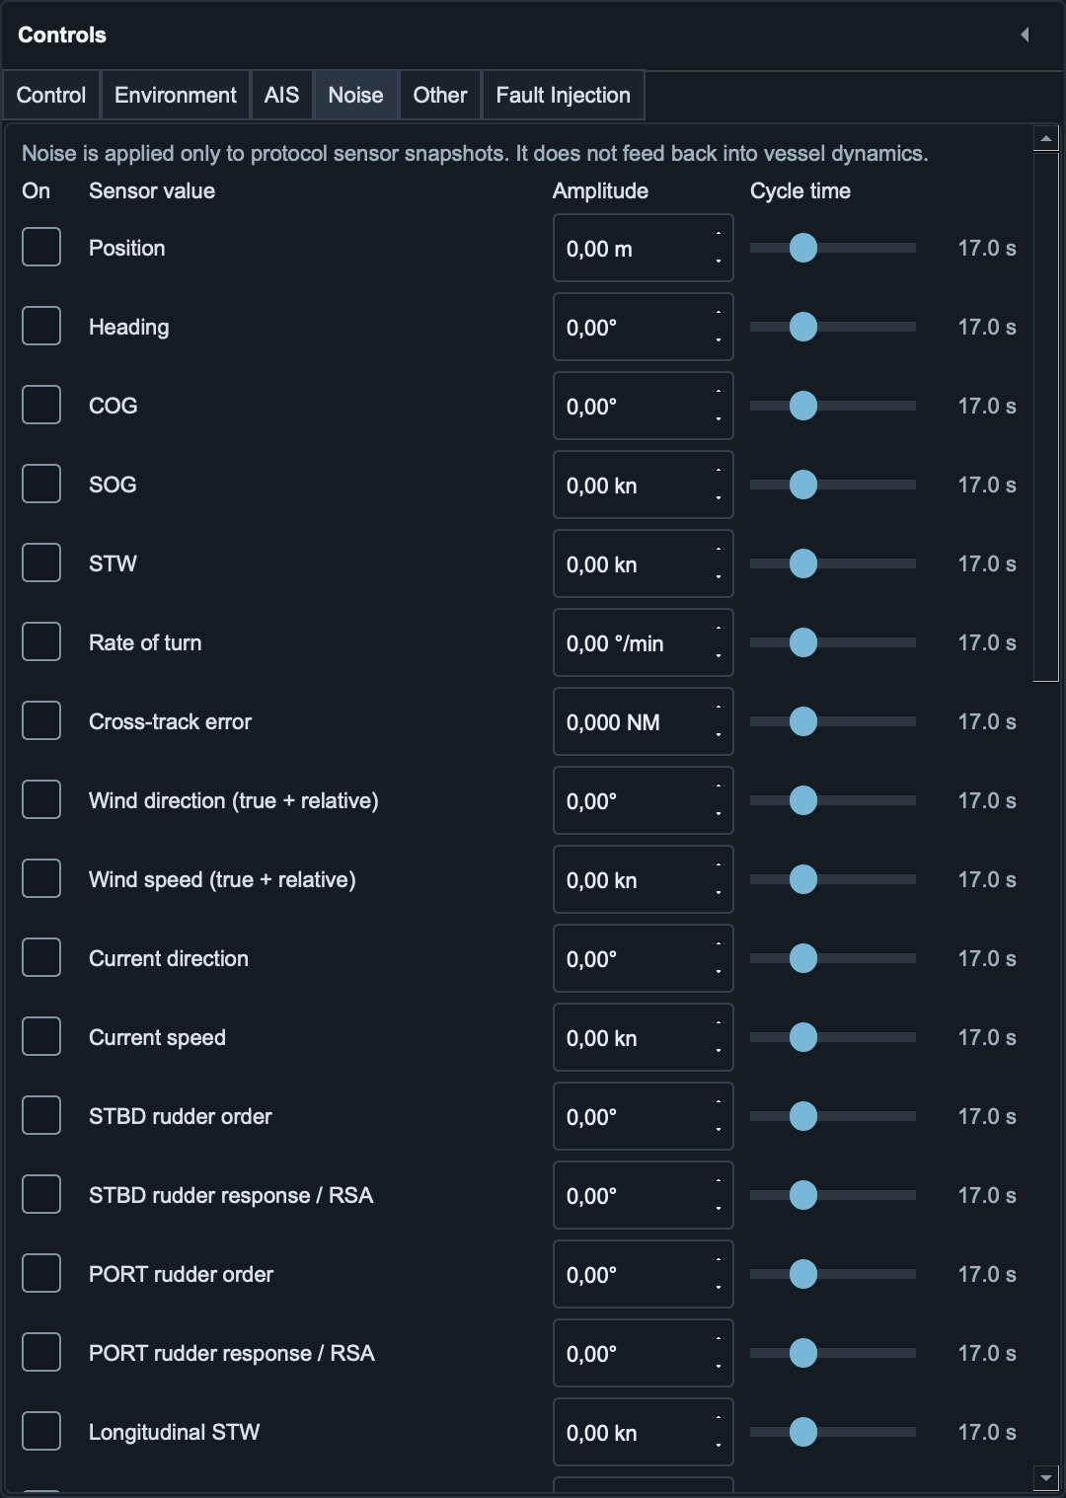
Figure 18. Noise tab. Each channel has an independent amplitude and 0.1-60.0 s cycle time.
Noise affects protocol projection only. Linked true/relative wind values use one coherent noise source. The cycle time is one complete deterministic oscillation, not a random update interval. Amplitude and cycle time are included in configurations and Start-up snapshots.

12.4 Other
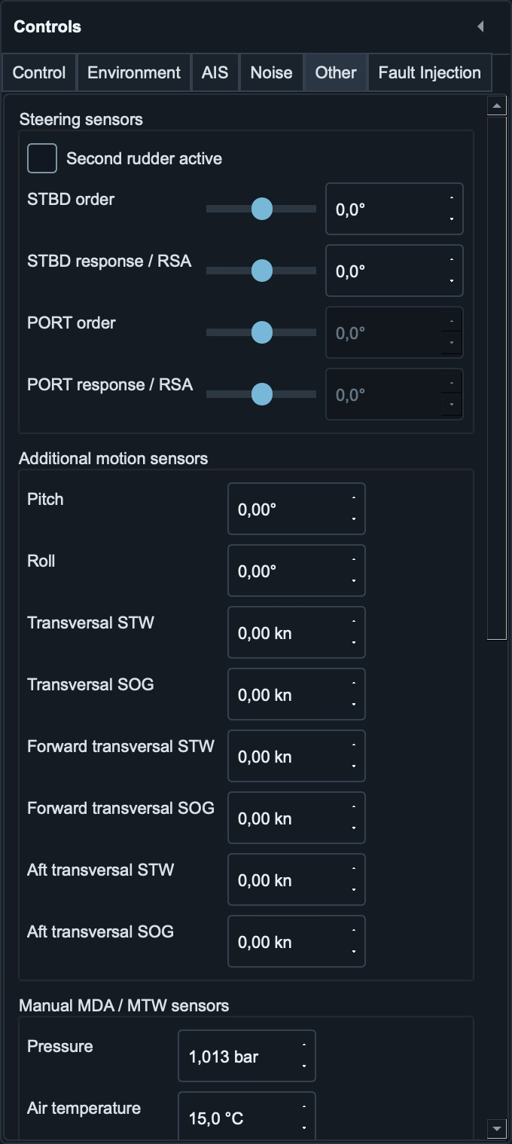
Figure 19. Other tab for dual rudder, motion and manual MDA/MTW sensor values.
Second rudder active enables PORT order/response. In model-driven modes, values owned by the vessel model are disabled. The tab also contains pitch, roll, longitudinal/transversal docking speeds, propulsion/thruster values and separate manual MDA/MTW meteorological values. Output enable checkboxes are intentionally centralized in Settings.

12.5 Fault Injection
Fault Injection applies faults after vessel dynamics, so the authoritative vessel continues normally while selected instruments and protocol outputs receive the faulty data. Available scenarios include GNSS jamming, intermittency, drift and spoofing; heading, speed, rudder and wind freezes or biases; GNSS sentence loss; packet loss; checksum corruption; and output latency.
Choose the scenario parameters and switch the fault on only for the intended test. Configurations and Start-up snapshots can retain the selections, but every fault is deliberately inactive after loading or restarting. This prevents a saved demonstration setup from silently starting with a navigation fault active.
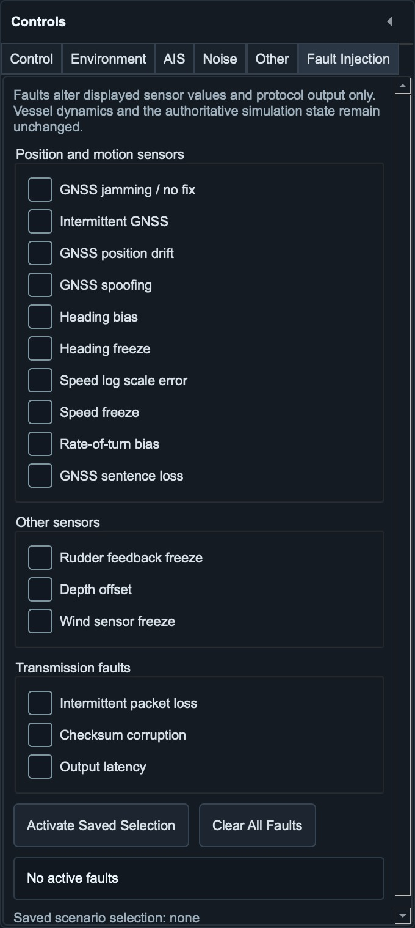
Figure 20. Fault Injection selections remain inactive after loading until explicitly enabled.

13. AIS Traffic

13.1 Generated AIS
Generated targets move continuously in their heading direction and keep COG within 5 degrees of heading. With Avoid Land enabled, position and initial forward course require confirmed water clearance. Near land, each target evaluates port and starboard paths, favours early small course corrections and reduces speed progressively when clearance becomes constrained. With Avoid Land disabled, targets are created and move without water-map checks; they can cross land and no longer wait for unresolved inland map tiles.
Avoid Land is enabled by default. It works offline with saved water-source geometry and locally prepared masks. Switch it off for unrestricted scenarios or incomplete water coverage. Disabling it clears pending avoidance manoeuvres and restores cruising speed for targets slowed by avoidance. Re-enabling it resumes checks without relocating existing targets. This is a shared Generated/Synthetic setting; it is disabled in Live mode and does not filter provider targets.
The Avoid Land choice is included in complete configuration exports and the AIS Start-up group. Existing configurations without it retain the enabled default. Capture the required Fixed or Last Saved AIS group for unattended starts. Enable the operating area's ENC cells before using an S57-based mask.

AIS water-mask preparation
When S-57 is the selected map source, Avoid Land uses the finest enabled ENC cells around own ship, independently of map zoom, display layers and shallow-water colours. Generated AIS prepares its entire configured circle in the background before initial placement; the AIS status reports ready tiles and failures. A large region may need tens of seconds on first use. Moving own ship or changing the radius prepares the new region while reusing cached overlap.
The mask uses raw chart water/land geometry, not a screenshot or depth-based safety assessment. Regional sampling and precise position/hull checks have bounded caches. Failed tiles back off and retry without blocking other tiles; unclassified positions are not assumed to be water. S57 avoidance is experimental and does not account for draught, under-keel clearance or safe navigation.
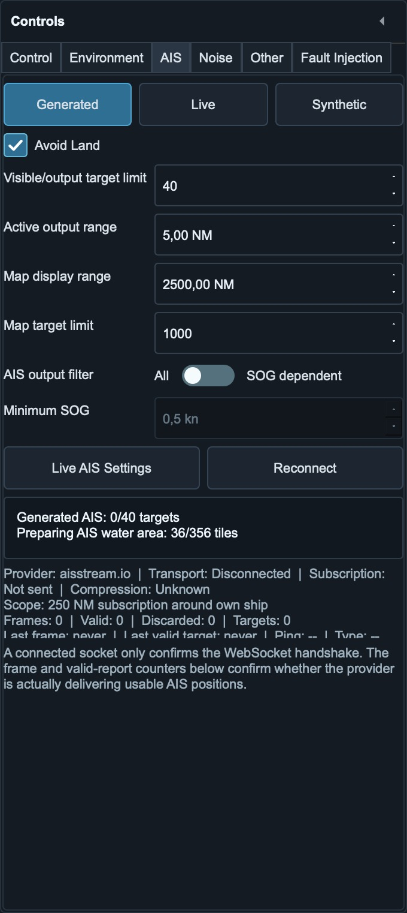
Figure 21. AIS region preparation runs in the background; wait for water coverage before expecting all generated targets.

13.2 Synthetic Traffic Generator
Synthetic Traffic Generator holds multiple operator-defined targets. Add Target accepts type, relative bearing, range, course, heading and speed; Advanced identity can override MMSI, call sign and dimensions. Right-click the 2D map to add a target at the selected position. With Avoid Land enabled, the position must be confirmed water; with it disabled, offline or unrestricted placement is allowed. Drag the hull to reposition it, or drag the vector handle to change course and heading together; vector length changes speed.
Add Encounter creates Head-on, Crossing from Starboard, Crossing from Port, Overtaking Own Ship, Own Ship Overtakes and Close Passing scenarios from editable CPA and TCPA. Crossing targets start on the named side. Overtaking Own Ship requires a faster target astern; Own Ship Overtakes requires a slower target ahead. The dialog proposes a suitable speed and naturally separated bearing, range and TCPA values for repeated additions; invalid overtaking speed relationships are rejected.
Generated and Synthetic traffic use the selected S57 source when available; otherwise saved Protomaps water geometry, coastline data and cached local masks provide water identification. A new Synthetic target may wait briefly and retry while its local mask loads. If coverage cannot be confirmed, placement is rejected rather than accepted on unknown ground. Disable Avoid Land for unrestricted scenarios or incomplete coverage; targets can then cross land. Target settings and the switch are stored in the AIS configuration.
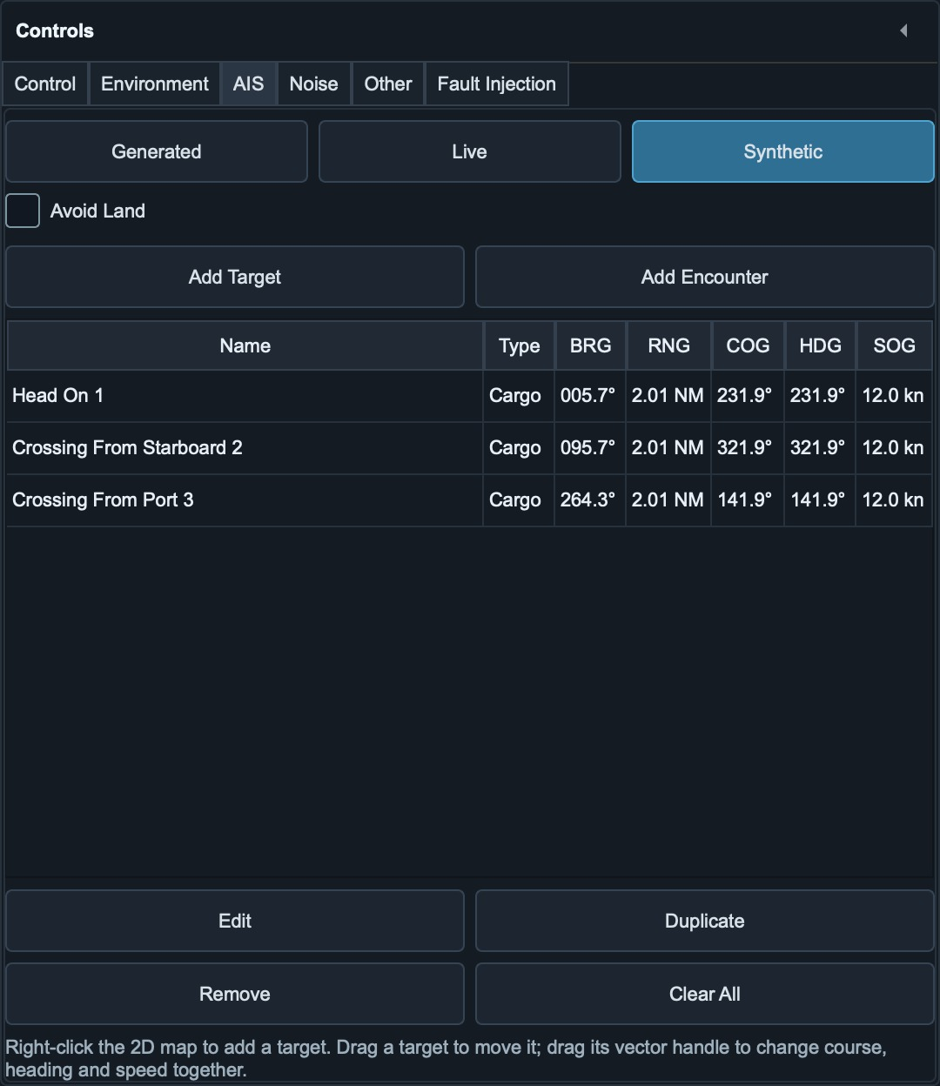
Figure 22. Synthetic Traffic with three encounters and Avoid Land disabled.
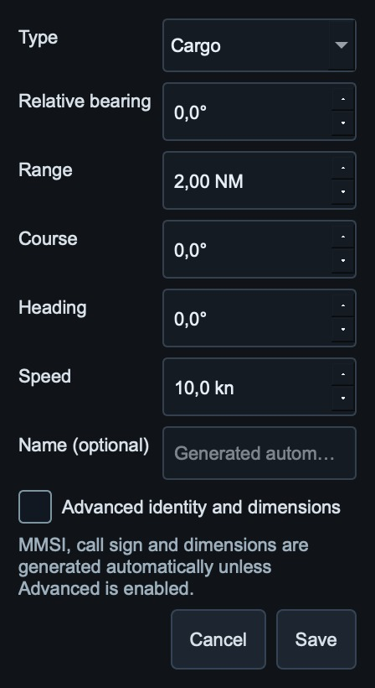
Figure 23. Add Target defines relative position, movement and optional identity.
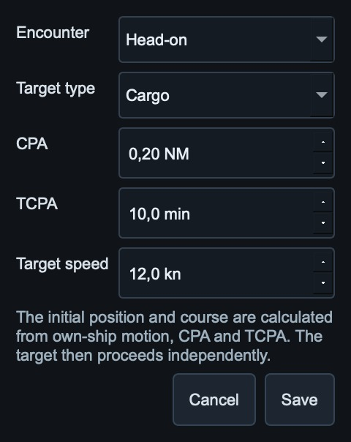
Figure 24. Add Encounter proposes an encounter type, CPA, TCPA and target speed.

13.3 Live AIS
Live AIS supports aisstream.io and Norwegian Coastal Administration data through BarentsWatch. aisstream.io requires an API key; its range/worldwide settings define the provider subscription. BarentsWatch requires client ID and secret, is limited to Norwegian coverage, and applies range locally around own ship. Moving own ship meaningfully refreshes the local selection; aisstream receives a replacement geographic subscription on the existing connection.
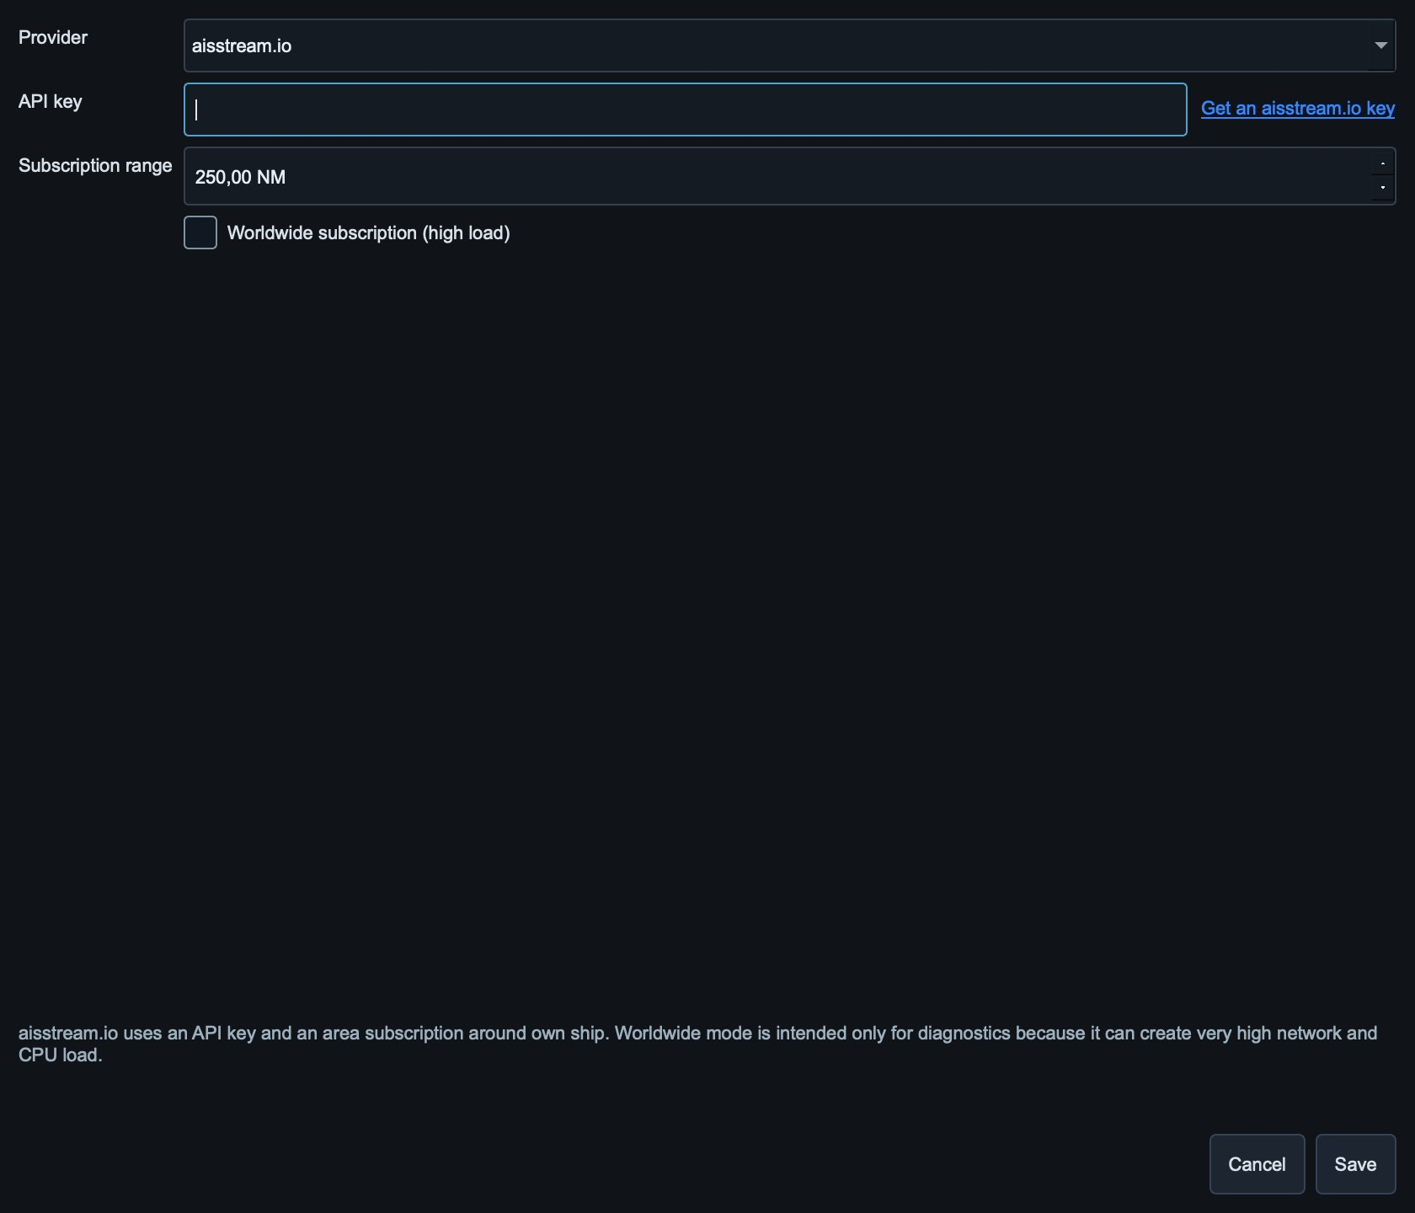
Figure 25. Live AIS provider settings. Credentials are intentionally blank in this guide.

13.4 Update and dead reckoning
The provider decides real report frequency; the simulator cannot request one vessel faster. Between reports, position is dead-reckoned from the last SOG and COG, then corrected when a real report arrives. Prediction stops after 300 seconds without a new motion report; the provider target is retained for up to six minutes without a fresh report. Diagnostics separate connection, subscription, frame count, valid reports, last real update, provider interval and dead-reckoning age.

13.5 AIS output
VDM sends selected target traffic; VDO sends simulated own ship and starts disabled. The VDM rate sets the position cycle for all selected targets: 1 Hz means one position report per target per second, paced across that second rather than sent as one burst. This is separate from live-provider update frequency. Available static/voyage Type 5 data is sent initially, after metadata changes and every 360 seconds, paced separately; its two fragments are kept together. A target can therefore produce several AIS lines without exceeding the unique-target limit.

14. Protocol Output Settings
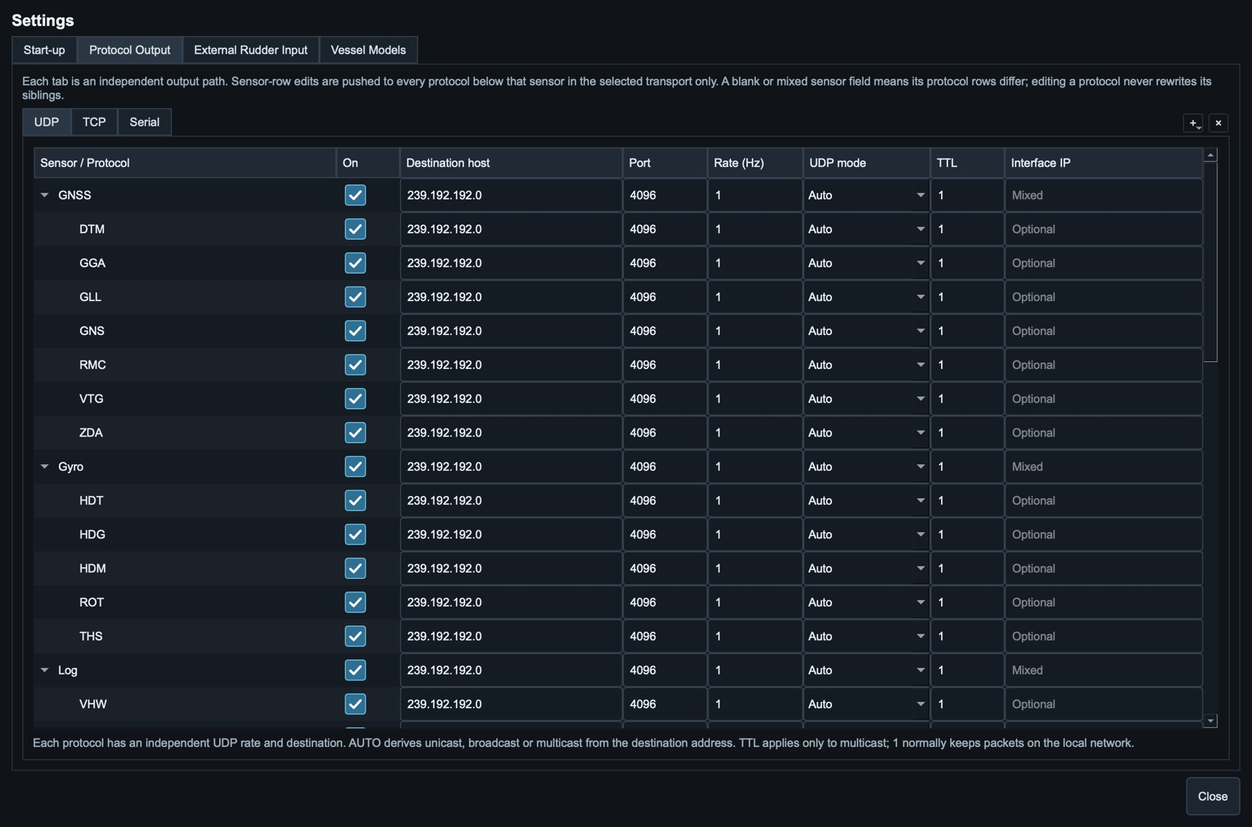
Figure 26. Protocol Output settings. Each path has independent sentence enable, destination and rate.

14.1 Independent paths
Settings starts with one UDP, TCP and Serial path. The + menu adds additional independent paths of any transport; x removes only the selected additional path. Primary UDP, TCP and Serial tabs cannot be removed. Added paths start with every protocol disabled. The same sentence can be enabled on several paths with different rates and endpoints.

14.2 UDP
Field | Meaning
Destination | Remote unicast, broadcast or multicast address.
Port | Destination UDP port.
UDP mode | AUTO derives mode from address; explicit Unicast/Broadcast/Multicast is also available.
TTL | Multicast hop limit. TTL 1 normally remains on the local network; irrelevant to unicast/broadcast rate.
Interface IP | Local adapter used for multicast routing. Empty lets the OS choose; use the wired local IP on multi-adapter hosts.
Table 14. UDP output fields.

Multicast on the same computer
For a sender and receiver on the same computer, multicast reception depends on the selected local interface. Use the receiver's loopback adapter option when supported, and verify that it joins the configured group and port. A successful send operation alone does not prove that the local receiver accepted the data.
For remote receivers, use the appropriate physical network adapter. If Interface IP is empty, the operating system chooses the multicast route; specify the local adapter address when several adapters are present. Sender and receiver must use a compatible group and interface. If the receiver supports UDP unicast, 127.0.0.1 is an alternative for same-host communication, but it is not a multicast destination and requires matching receiver configuration.

14.3 TCP
Client mode connects to a remote server and retries refused, reset, timed-out and half-open connections. Server mode listens on a local bind address and serves all connected clients through bounded queues. Use 0.0.0.0 to listen on all local IPv4 adapters, 127.0.0.1 for local clients only, or a specific local address for one adapter. A remote client must connect to the simulator's reachable IP, never to 0.0.0.0.

14.4 Serial
Serial tabs list ports reported by the operating system and remain editable for custom device paths. Configure baud, parity and stop bits to match the receiving device. High sentence rates can exceed serial capacity; check Port load in the Output Monitor.
Serial protocol output and External Rudder serial input are independent paths. A 4800-baud ROR/RSA input remains event-driven even when idle; it does not share the output Port load scheduler.

14.5 Sensor groups
Group | Available regular outputs
GNSS | DTM, GGA, GLL, GNS, RMC, VTG, ZDA
Gyro | HDT, HDG, HDM, ROT, THS
Log | VHW, VBW, VLW
Depth | DBT, DPT
Wind | MWV relative + true theoretical, MWD
Meteorological | MDA, MTW
XDR Environment | Air#0 temperature, Air#1 humidity, Air#2 dew point, Baro#0 pressure
Current / Rudder / AIS | VDR; RSA/ROR; VDM/VDO
Additional | PRC, TRC, TRD
Table 15. Regular protocol groups.

15. Output Monitor and Advanced Output

15.1 Output Monitor
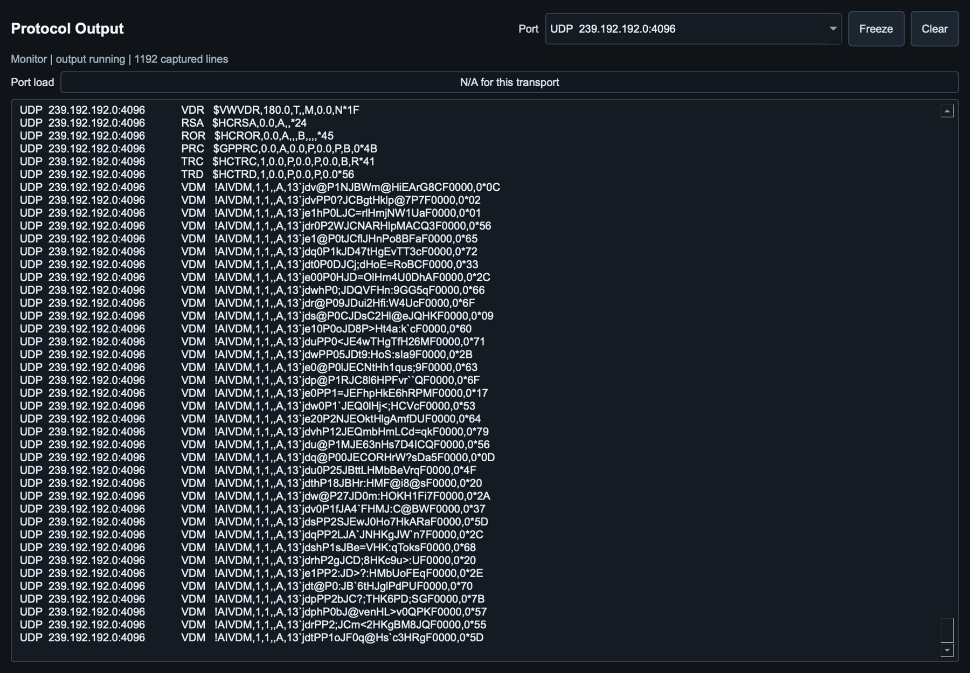
Figure 27. Output Monitor showing lines accepted by the selected configured path.
Output is a monitor only. Opening, closing, freezing or clearing the monitor does not start, stop or restart the scheduler. Freeze pauses display updates while transmission continues; Resume repopulates the visible stream. Port load is meaningful for Serial and shown as N/A for network transports.

15.2 Advanced IEC output
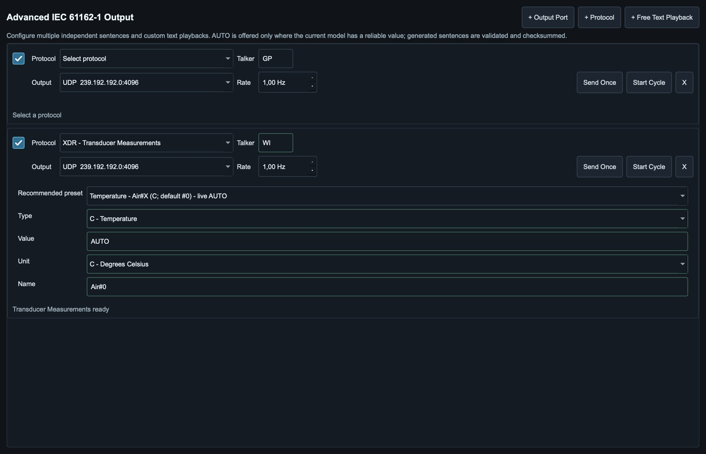
Figure 28. Advanced IEC 61162-1 output with independent rows and output ports.
Advanced can hold multiple sentence rows and free-text playbacks. Each row selects an advanced output port, update rate and Send Once/Cycle state. + Output Port creates a persistent UDP, TCP or Serial endpoint even when it is not used by regular output. Active cycles continue when the window is hidden and restart only when their captured Start-up state is active.

15.3 XDR
Recommended XDR identifiers are grouped by transducer type and limit Unit choices to valid combinations. AUTO is offered only when a live simulator value exists. Standard environment presets use Air#0 for air temperature in Celsius, Air#1 for relative humidity, Air#2 for dew point and Baro#0 for surface pressure. In an identifier such as Air#X, X is the editable data-instance number 0-9999.

16. Settings and Configuration

16.1 Complete configuration versus Start-up setup
Item | Complete configuration | Start-up setup
Purpose | Apply a full operating snapshot immediately. | Choose Last Saved or Fixed source per group for future launches.
Route | Embedded in the file. | Captured as Route group; no separate Choose RTZ field.
Credentials | Included; file is sensitive. | Included in captured AIS/3D groups; export is sensitive.
Update timing | When Save Configuration As is used. | Last Saved changes on Close and Save or explicit capture; Fixed only on explicit capture.
Table 16. Configuration and Start-up setup roles.
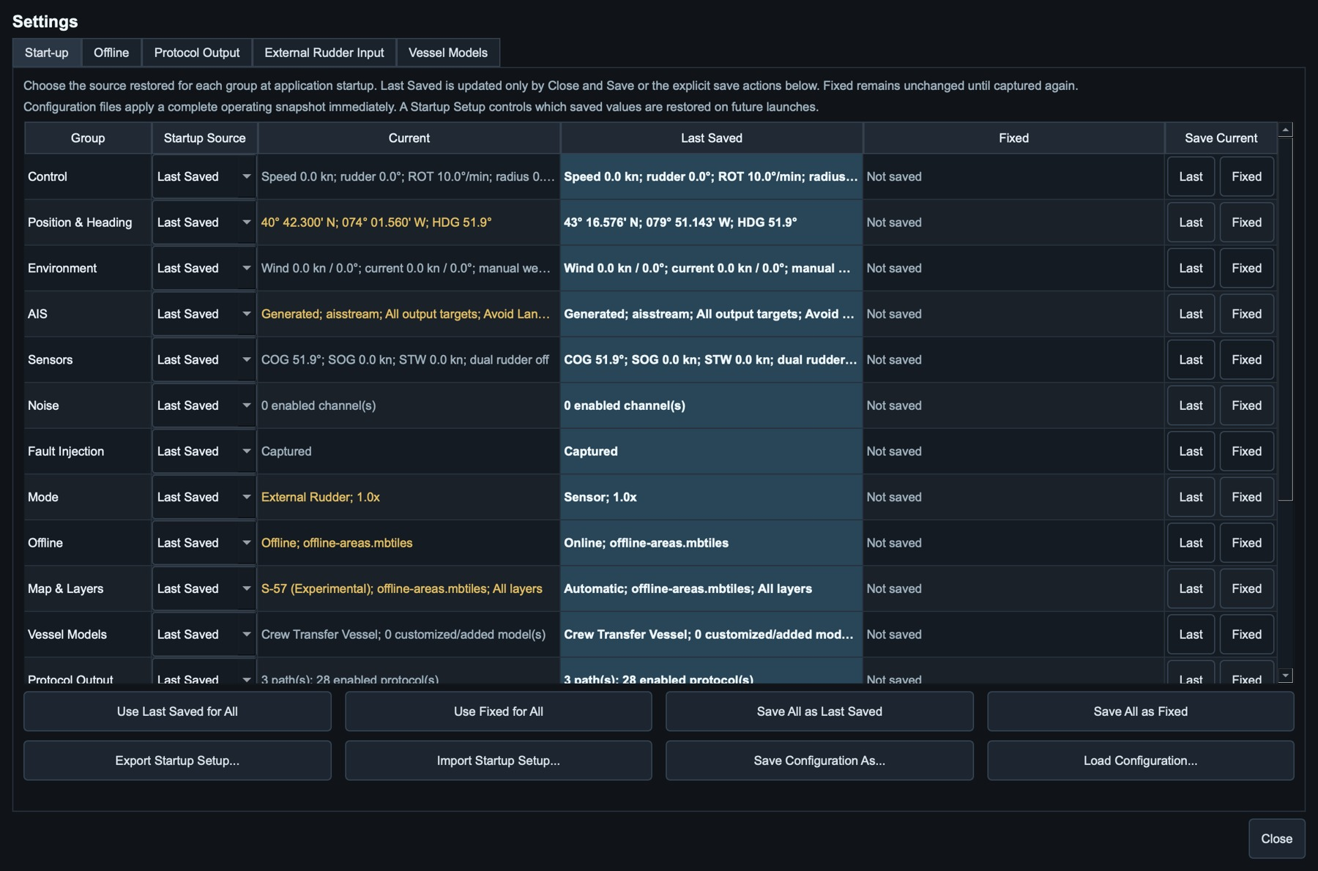
Figure 29. Start-up includes independent Offline and Map & Layers groups. Current, Last Saved and Fixed remain separate.
Use Last Saved or Use Fixed on the left side of a group row. Capture buttons are on the right. Save all current settings captures a complete snapshot without silently changing source selection. Close without saving restores the launch baseline and does not update Last Saved. Offline saves Internet/offline mode and the water-mask selection. Map & Layers separately saves the map source, raster package, enabled ENC cells, layer selection and Base preset. Older setups migrate their previous Offline map selection into Map & Layers. Configuration files reference local chart packages; they do not embed the map or ENC bytes.

16.2 Vessel Models
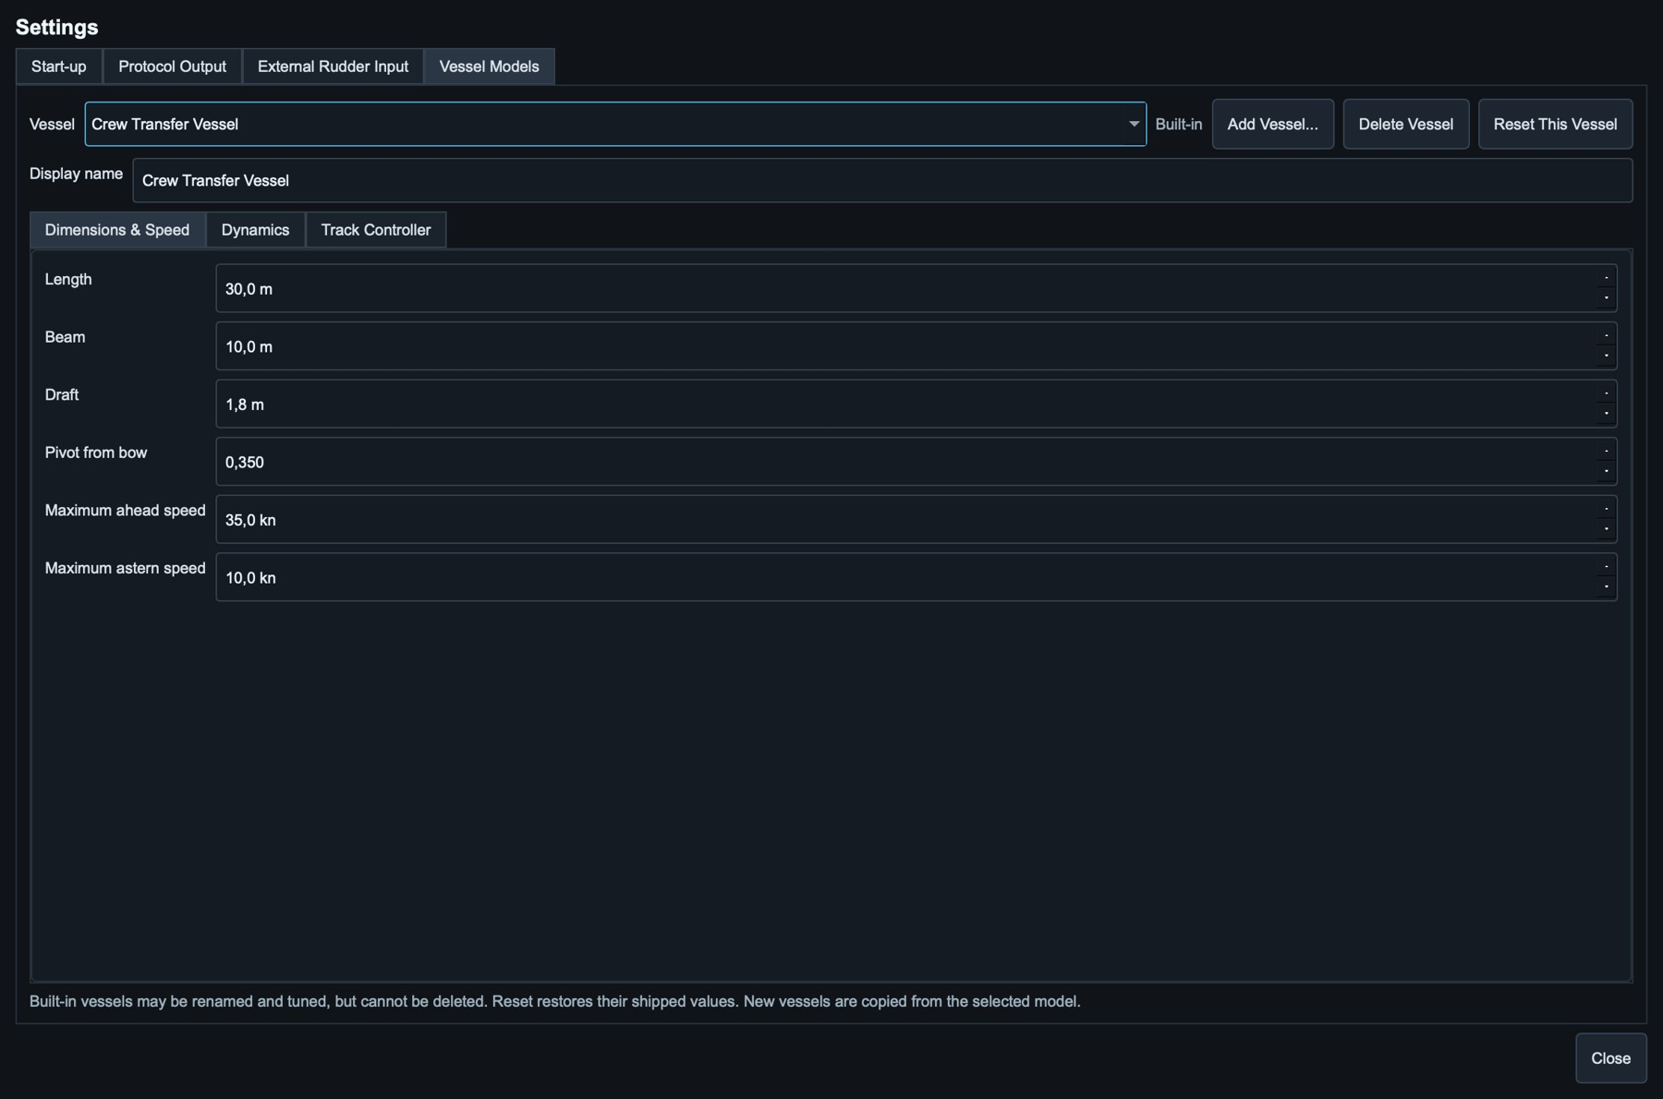
Figure 30. Vessel Models: built-in profiles can be renamed/tuned/reset; custom vessels can be added/deleted.
Built-in order | Length | Max speed | Max ROT | ROT time constant | Rudder rate
Crew Transfer Vessel | 30 m | 35 kn | 95°/min | 2.5 s | 8.0°/s
Container Feeder | 170 m | 20 kn | 32°/min | 8.0 s | 4.2°/s
15k TEU Vessel | 370 m | 22 kn | 16°/min | 18.0 s | 2.6°/s
24k TEU Vessel | 400 m | 24 kn | 10°/min | 28.0 s | 1.9°/s
VLCC | 330 m | 17 kn | 6°/min | 45.0 s | 1.2°/s
Table 17. Selected factory dynamics. Values are functional defaults, not certified manoeuvring data.

Parameter groups
- Dimensions & Speed: length, beam, draft, pivot position, maximum ahead/astern speed.
- Dynamics: acceleration/deceleration, maximum ROT, ROT time constant, maximum rudder, rudder speed, wind/current gains and sway response.
- Rudder effectiveness: 1.0 preserves the shipped linear partial-rudder curve; higher values increase partial-rudder effect; lower values reduce it. Full-rudder maximum ROT remains authoritative.
- Track Controller: straight-leg capture, bias, recovery, turn, counter-rudder and wheel-over parameters.
- Calculate Values: conservative interpolation from built-in profiles for a new/modified vessel; representative route tests remain necessary.

Bow Thruster parameters
Rated power accepts kW or MW; changing units preserves power. Rated RPM converts TRC mode R. Zero-to-full RPM time controls run-up/reversal. Speed at 50% effectiveness sets the tunnel loss curve. Static thrust per kW, position from bow and displacement affect lateral acceleration/yaw. Zero power means not fitted. Each vessel stores its own values in configurations and Vessel Models Start-up settings.
Factory vessel | Aggregate bow power
Crew Transfer Vessel | 100 kW
Container Feeder | 900 kW
15k TEU Vessel | 3000 kW
24k TEU Vessel | 4000 kW
VLCC | 2500 kW
Table 18. Representative bow-thruster defaults, adjustable and not manufacturer ratings.
External source policies, loss actions, endpoints and XDR filters are included in complete configuration exports and the External Input Start-up group. Older settings preserve their source policies; existing G/P filters remain G/P. New bow/engine XDR filters use A/P. Legacy rudder loss behavior remains Zero until changed; bow/engine default to Manual on loss.

16.3 Offline settings
Settings > Offline contains the Offline mode switch and separate Protomaps and S57 / ENC tabs. Protomaps manages saved rectangle/polygon areas and portable map exports. S57 / ENC imports original cells or folders and downloads NOAA charts. Offline mode pauses Internet-backed maps, Live AIS and weather while local simulation, routes, instruments and configured UDP/TCP/Serial keep operating. Detailed maps must be saved or imported before disconnecting. See sections 17.6 and 17.7.
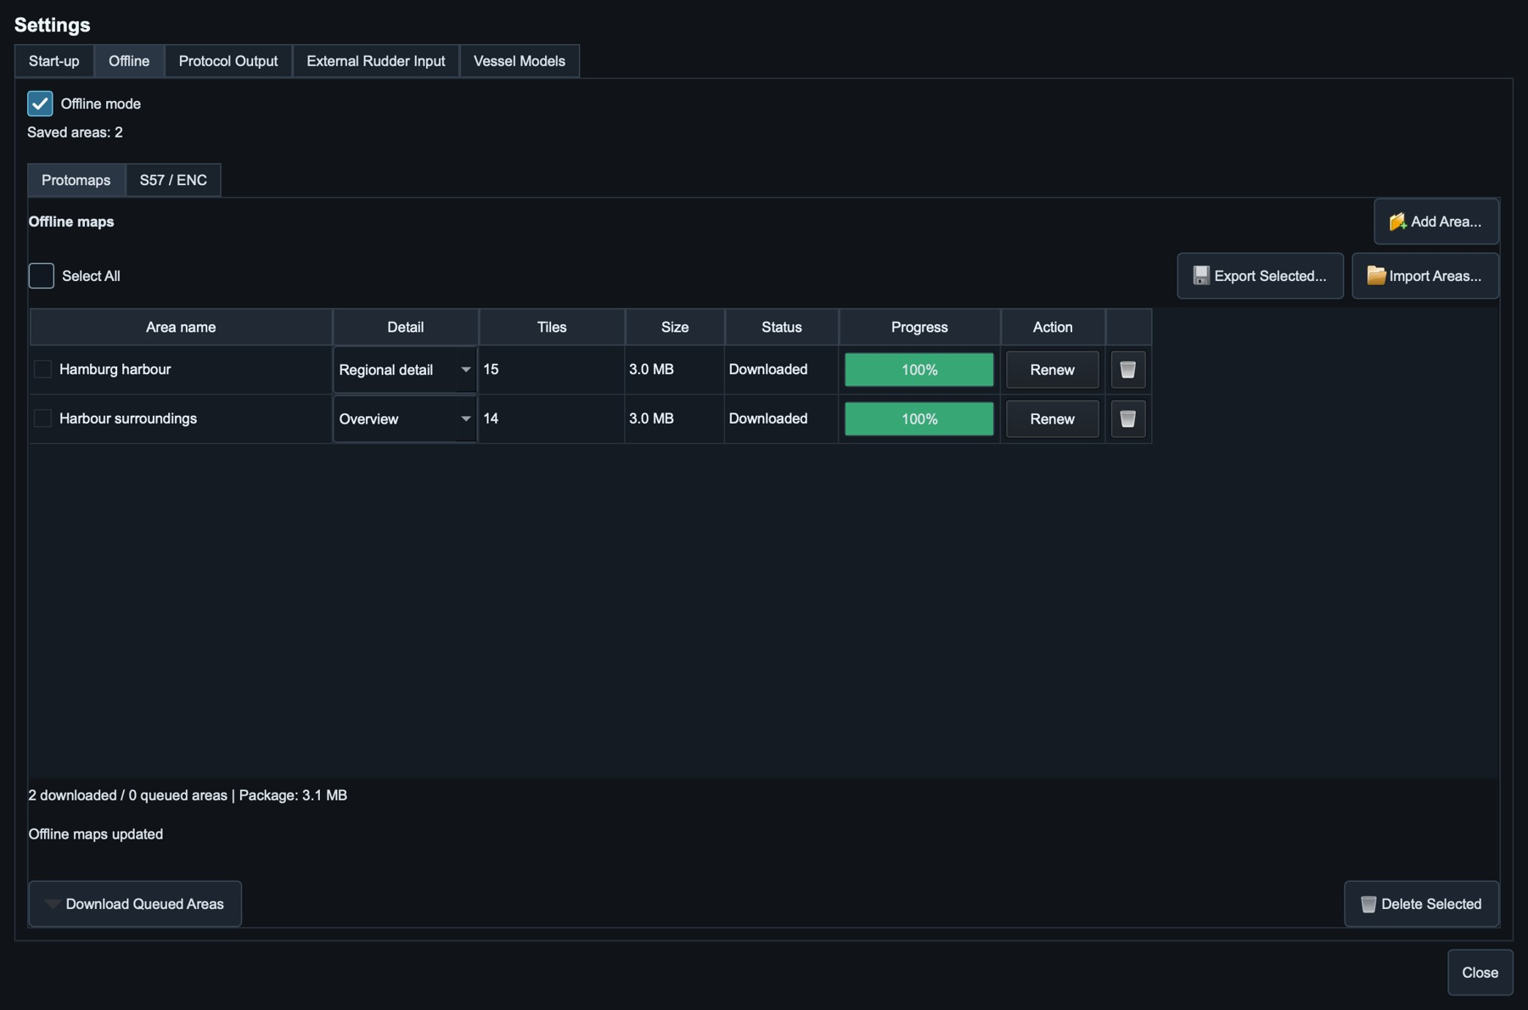
Figure 31. Offline settings contain separate Protomaps and S57 / ENC management tabs.
The table distinguishes Downloaded areas from Queued selections. Download processes one row; Download Queued Areas processes the pending batch sequentially. Tile counts, actual content sizes and progress are shown per area. Queued areas can already show progress when shared tiles are available from another area, including low-zoom tiles. This does not mean their own download has started. Shared tiles occupy disk space once; the package size in the summary also includes database overhead.
Names save immediately. Renew and Detail changes start a background update directly, with confirmation for at least 500 unique tiles or previously saved content above 100 MiB. Deletion asks for confirmation and preserves shared coverage. Select several saved areas and press Delete Selected to remove them together. Existing maps remain usable during updates and are retained if a job fails or is cancelled.
Select area-name checkboxes or Select All, then Export Selected for a portable MBTiles file. Import Areas adds its coverage without Internet, retaining existing areas and skipping exact duplicate shapes. Polygon outlines survive export/import, including different shapes with the same bounds. See section 17.6 for preparation, offline operation and USB transfer.

16.4 Map sources and S57 ENC settings
The 2D map offers OpenSeaMap (Online), Protomaps (Offline) and S-57 (Experimental). S-57 stays offline; Experimental identifies the limited portrayal. Missing local sources are disabled. Selecting local charts does not stop Live AIS or weather; Offline mode controls Internet access. Availability depends on installed packages and enabled cells, not a configuration filename.
S57 cells contain identifiers, editions and updates. The index selects visible cells by scale: overview first, harbour detail when zoomed in. Fine-cell coverage owns overlaps; coarser charts fill uncovered areas. At very wide views, the bundled schematic world coastline helps locate an operating area. It is not detailed ENC coverage. Older indexes derive coverage from chart surfaces; Renew/reimport retains exact M_COVR coverage and additional portrayal attributes. GDAL is bundled. S63 and compiled SevenCs .7CB/.7CR are unsupported; obtain unencrypted .000 cells.
The S57 and NOAA tables format visible rows on demand rather than creating separate widgets for every catalogue cell. Search and Select All Visible still use the complete metadata catalogue. Chart IDs retain selections during refresh; progress updates preserve the scroll position. You can scroll during a download/import job, while chart-changing controls remain disabled until the job finishes.
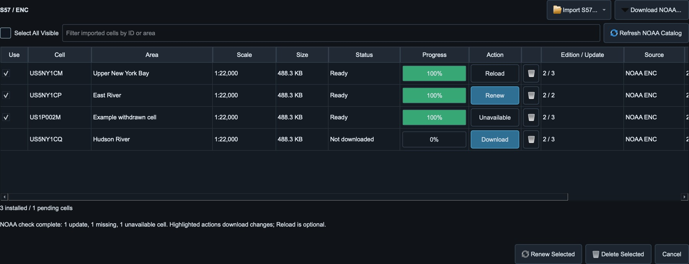
Figure 32. Example S57 manager: Renew and Download highlight available changes; current cells show Reload, withdrawn cells Unavailable.
Use controls whether a cell is displayed. Selecting rows is a separate action and does not change Use. Search filters cell ID and area name; Select All Visible selects only the rows currently shown. Show on Map enables selected installed cells and fits their coverage. Size reports stored geometry and attributes, excluding shared database overhead; older cells can show -- until reimported. Status and Progress describe a background job, not chart accuracy or currency.
Renew Selected skips current revisions. The online manager checks NOAA once in the background; Refresh NOAA Catalog repeats it. Renew and Download highlight updates/missing data; current cells show Reload (no downgrade). Unavailable disables withdrawn cells; local charts offer Import. Only required ZIP downloads above 100 MiB ask once, with Download/Cancel buttons. Failures do not stop later cells; cancellation keeps completed imports. Scroll during work; chart changes are disabled. Deletion requires confirmation.
Layers lists object names and IDs. Other Layers branches into traffic, ports, infrastructure, areas, natural features and chart information. All in this group switches a complete branch; Some indicates partial selection. All Layers restores all objects. Base retains land/coast, depth background, the selected safety contour or next deeper available contour, and conditional isolated dangers. Depth & Safety changes contour/depth settings; defaults are 30 m. Normal soundings, aids and routing are not Base. Custom checkbox changes leave Base. This simplified display is not a safety guarantee.
The independent Map & Layers Start-up group saves the selected source, package, enabled ENC identifiers, layer selection and Base preset. Configuration export does the same, but neither embeds chart data. Unknown cell identifiers on a second computer do not download or install charts. Import their original exchange sets and verify the selected source after restoring the configuration.

17. Operating Workflows

17.1 Exact receiver test
1. Select Sensor mode and set exact values.
2. Disable unrelated sentences on the selected output path.
3. Open Output Monitor, select the path and verify accepted lines.
4. Capture the receiver and network/serial stream independently when formal evidence is needed.

17.2 Manual bridge demonstration
1. Load a known complete configuration.
2. Select Ship mode and the intended vessel.
3. Verify own-ship data at the bridge before applying engine/rudder commands.
4. Enable generated or live AIS only after the own-ship loop is stable.
5. Open 3D on the main or second monitor if credentials, Internet and GPU resources are available.

17.3 Track demonstration
1. Select Track mode; the saved/default route appears automatically.
2. Check route direction, geometry highlights, speed and turn ownership.
3. Use Route position to place own ship before the required leg.
4. Confirm Controller Phase and XTE before increasing Simulation Time.
5. Observe wheel-over, planned turn and rollout; do not treat highlighted impossible geometry as valid planning data.

17.4 External steering loop
1. Configure the required ROR/RSA or XDR rudder endpoints in Settings > External Input.
2. Expand Control Sources; select main, optional fallback and the required loss action. Confirm Active source and input lamps.
3. Select External mode and retain a suitable engine command, manual or externally controlled.
4. Apply an external order/angle and verify order, response, heading and ROT in sequence.
5. Interrupt the preferred source to verify the 2.5 s priority fallback, then restore it and verify immediate return.

17.5 Synthetic encounter and fault test
1. Select Synthetic Traffic Generator and add one encounter with the required CPA and TCPA.
2. Confirm target position, vector and intended passing side on the 2D map before starting output.
3. Open Fault Injection, select one scenario and enable it only after baseline data has been verified.
4. Compare instruments, Output Monitor and receiver behaviour; then disable the fault and verify recovery.

17.6 Offline demonstration
Offline means no Internet; the local bridge LAN and serial connections remain available. Prepare the operating area and a repeatable Start-up configuration before a disconnected demonstration. Maps and avoidance masks are simulation aids, not certified navigation charts.

Save areas while online
1. Open Settings > Offline > Protomaps and select Add Area. Saved coverage is filled with a solid border; new selections are dashed. Colours identify detail: cyan Harbour, blue Regional, yellow Overview. Small labels show the name, plus actual whole MB for saved areas with known sizes. New areas have no size forecast. Saved coverage is not queued again. Navigate allows pan/zoom; Follow Own Ship pauses during selection.
2. Choose Harbour detail, Regional detail or Overview for the next area. Select Rectangle and drag, or Polygon and click 3 to 64 corners. Close a polygon with Close Polygon, Enter, double-click or its first corner. Crossed edges are rejected. Only intersecting tiles are saved; their edges may extend slightly outside the line. Navigate allows pan/zoom between areas or polygon corners. Each completed area retains its detail. Undo removes the last unfinished corner or completed area; Cancel or Escape discards the selection.
3. Select Continue. New areas appear as Queued directly in Settings > Offline, without a separate download window. Rename areas and adjust individual detail before downloading. Harbour stores zoom 15, Regional zoom 14 and Overview zoom 13, including lower levels. Areas above 20,000 tiles warn instead of being rejected. The memory safety ceiling is 200,000 unique tiles per download, with up to 32 areas; the package is limited to 3 GiB. Higher zoom enlarges the finest saved tile without adding detail.
4. Press Download for one area or Download Queued Areas for the batch. Jobs with at least 500 unique tiles or previously saved content over 100 MiB require confirmation. One background worker processes areas sequentially, fetching shared tiles once with bounded grouped archive reads. Downloading covers reading, rendering and saving; the status no longer alternates with Reading. Actual saved content is shown alongside tiles and progress. Maps and water-source geometry are saved without an API key; needed masks are prepared locally during AIS use and cached. Existing maps survive cancellation or failure.
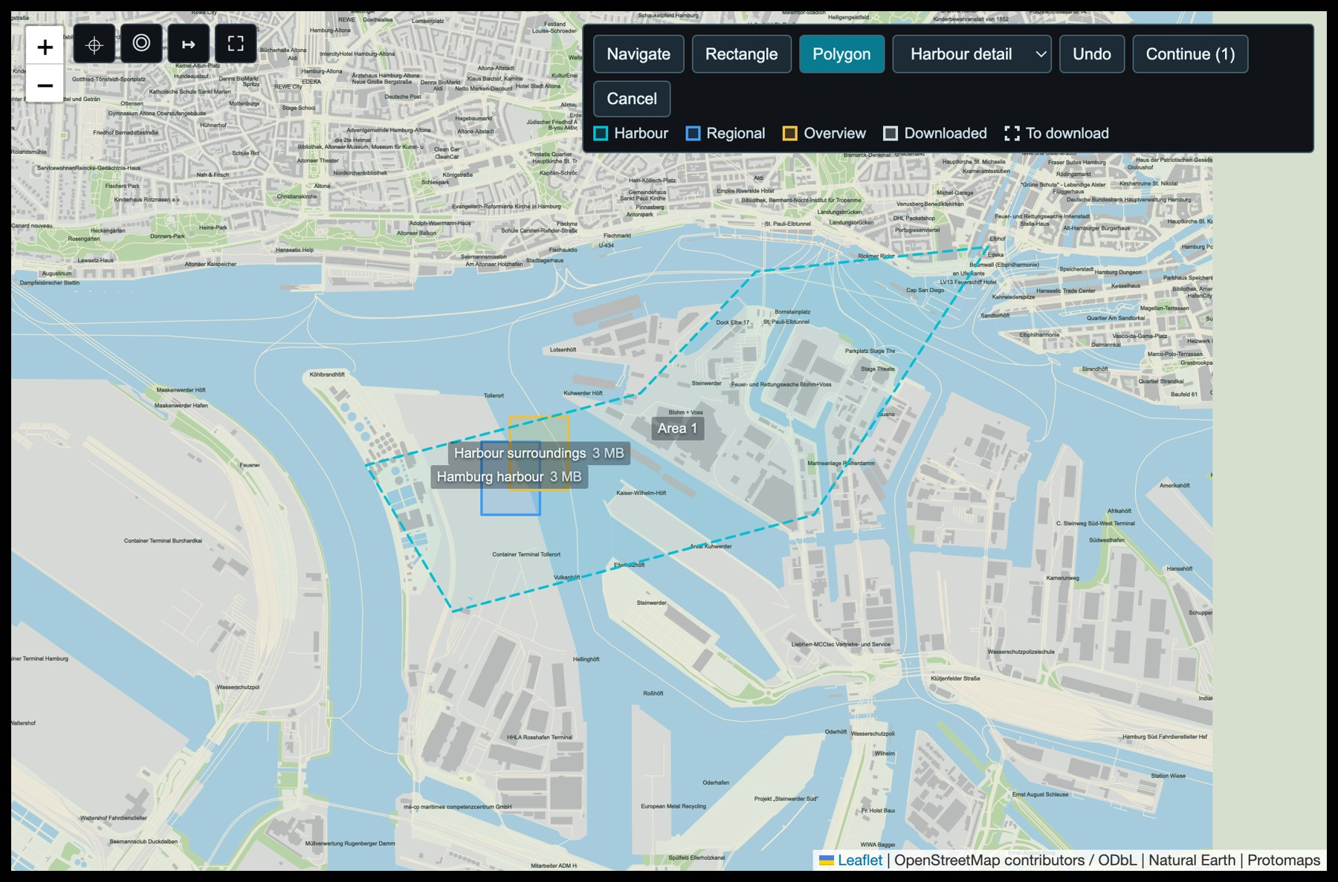
Figure 33. Draw a polygon around the operating area; saved coverage remains visible for reference.
Figure 34. Downloaded Protomaps areas show actual tile count, stored content size and per-area completion.

Manage saved areas
Names save immediately. Change Detail or press Renew to download an updated area; confirmation uses the tile count or previously saved content, not a guessed size. Renew/detail changes need Internet; rename/delete work offline. The trash icon asks before deleting a saved area. Check multiple saved names or Select All and press Delete Selected for one confirmation, with No as the default. Unchecked saved areas, required shared data and queued downloads are retained. Cancel Download stops a running job without replacing saved maps; failed queued areas remain available for retry. Deleting the last saved area restores the schematic fallback.
After download, each row shows actual tile count and content size. Shared tiles count in each relevant area but occupy disk space once; this can also give queued areas progress before their turn. The summary shows physical package size, including database overhead. Column widths stay stable as counters and status change. Hover over a shortened area name for its full name, bounds and shape. Polygon outlines are retained during management; different shapes with identical bounds remain distinct. Only one package-changing job runs at a time.
Figure 35. Saved-area management: select rows for export or deletion; rename, change detail and renew directly.

Run the demonstration offline
1. Enable Offline mode and select Protomaps (Offline), or S-57 (Experimental) with installed cells. Saved data is served locally. Outside detailed coverage, a bundled schematic world coastline provides orientation, not harbour detail or chart accuracy. Google 3D remains online-only and is not downloaded.
2. Use Generated or Synthetic AIS. Avoid Land uses enabled S57 cells when S-57 is selected, or saved Protomaps/coastline geometry and local masks otherwise. Allow initial background preparation; no Internet request is needed for installed chart data. Disable Avoid Land for unrestricted traffic or missing coverage, accepting that targets can cross land. Live AIS is paused; retained targets still use the 360-second expiry and 300-second prediction limit.
3. Use manual Environment values or retain the last live weather reading. Check traffic speed, VDM output, filters, range and target limit. Freeze in Output Monitor only freezes its display, not transmission. Verify reception on the actual Radar/ECDIS.
4. Capture Offline and Map & Layers, plus AIS, Environment, Route, Mode, Control and Protocol Output as appropriate in Start-up. Use Fixed for a repeatable baseline and verify it after restart. Explicit captures/source selections persist immediately; ordinary changes need a configuration save or Close and Save. Close without saving does not update Last Saved. On another computer, import the referenced map/ENC data separately before testing the restored configuration.
5. On the same Radar/ECDIS computer, select its loopback receive adapter if multicast reception otherwise fails. For remote equipment retain the local LAN and matching adapters. For serial I/O verify access rights and baud settings.
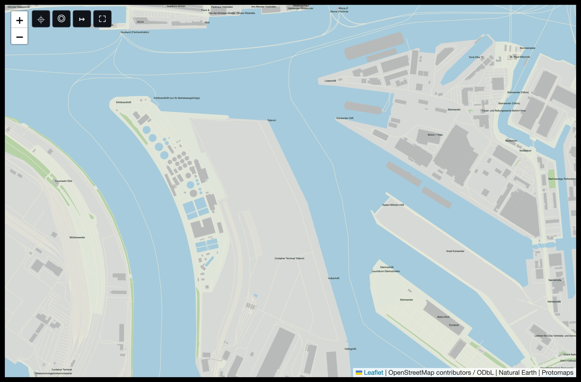
Figure 36. A saved Hamburg harbour area rendered locally with no Internet connection.

Storage and USB transfer
Maps and water-source geometry are stored together in offline-packages/offline-areas.mbtiles under the user configuration directory. macOS uses ~/Library/Application Support/Ship Simulator/v2; Windows uses %APPDATA%\Ship Simulator\v2; Ubuntu uses ~/.config/Ship Simulator/v2. Generated masks are kept separately in geodata-cache/offline-water-tiles with a bounded cache and can be rebuilt from the package.
Check one or more saved area names, or Select All, then press Export Selected and choose a portable MBTiles destination, including an attached USB drive. Export runs in the background with progress and cancellation; large packages can take time. Transfer the completed file and choose Import Areas on the destination. Areas are imported without Internet and the local package is selected automatically. Existing shared tiles remain unchanged; exact duplicate shapes are skipped. Names, detail and rectangle/polygon outlines are retained.
Import files over 100 MiB require confirmation. Cancel Export or Cancel Import stops the background transfer safely; invalid/incomplete files are rejected without replacing existing maps. Map exports include selected coverage and local water-source data, not credentials. JSON configuration exports store filenames, not map bytes; transfer them separately to match the simulation setup. Missing packages are reported and use the schematic fallback. Updates need temporary space for a replacement package.
Downloads use the permitted Protomaps archive, not bulk downloads from public OSM raster tile servers. They can look different from the online map. Google imagery and API credentials are not bundled in map packages. Full JSON configuration exports can contain Google/AIS credentials and must be protected.

Ubuntu installation and builds offline
Installed applications bundle Python and Qt, but Ubuntu still needs the declared system libraries. Install and launch once while online, or prepare the matching Ubuntu packages through your normal offline package process. APT cannot download missing dependencies without a reachable repository. Source builds also require preinstalled tools/dependencies or a matching wheelhouse; those prerequisites are separate from offline operation of the installed simulator.

17.7 S57 ENC operating workflow

Import local files or a complete catalogue
1. Open Settings > Offline > S57 / ENC > Import S57. Choose Import Files for .000 cells or ZIP exchange sets, or Import Folder for a complete directory including subfolders. Keep .001, .002 and later updates beside the corresponding .000 file or inside its ZIP. Do not rename update files or omit an intermediate update.
2. A batch accepts up to 20,000 cells and 250,000 source files, including the complete NOAA All_ENCs.zip. ZIPs are not unpacked wholesale: one cell and its updates are staged and imported at a time, using a reused archive handle. The unpacked 512 MiB safety limit applies to each cell/update set, not the combined catalogue. macOS ._* files, __MACOSX folders and unrelated text/images are ignored; symlinks are not followed.
3. If a folder contains both an unpacked catalogue and a ZIP whose cells are all present unpacked, the unpacked cells take precedence and the redundant ZIP is skipped. Select the ZIP itself instead if its edition is intended. Other duplicate editions require selecting one source. Missing updates, unsafe ZIP paths, invalid geometry and imports older than the installed revision are rejected. Full-catalogue conversion can take considerable time and more disk space than the source ZIP; progress is shown and disk space checked throughout.
4. When import completes, select S-57 (Experimental), choose cells and Show on Map, then inspect Layers. Cancel stops after the last completed cell without discarding it. An unfinished cell cannot partially replace its installed chart. A partial failure reports retained cells; correct the source problem before retrying.

Download NOAA cells while online
1. Select Download NOAA to refresh the official catalogue, then search by cell ID or area name. Select All Visible checks displayed results and retains hidden selections. Status distinguishes Missing, Update needed and Up to date. Only missing/outdated selections contribute to the download total; installed NOAA cells are compared by edition, update and issue date, including local imports.
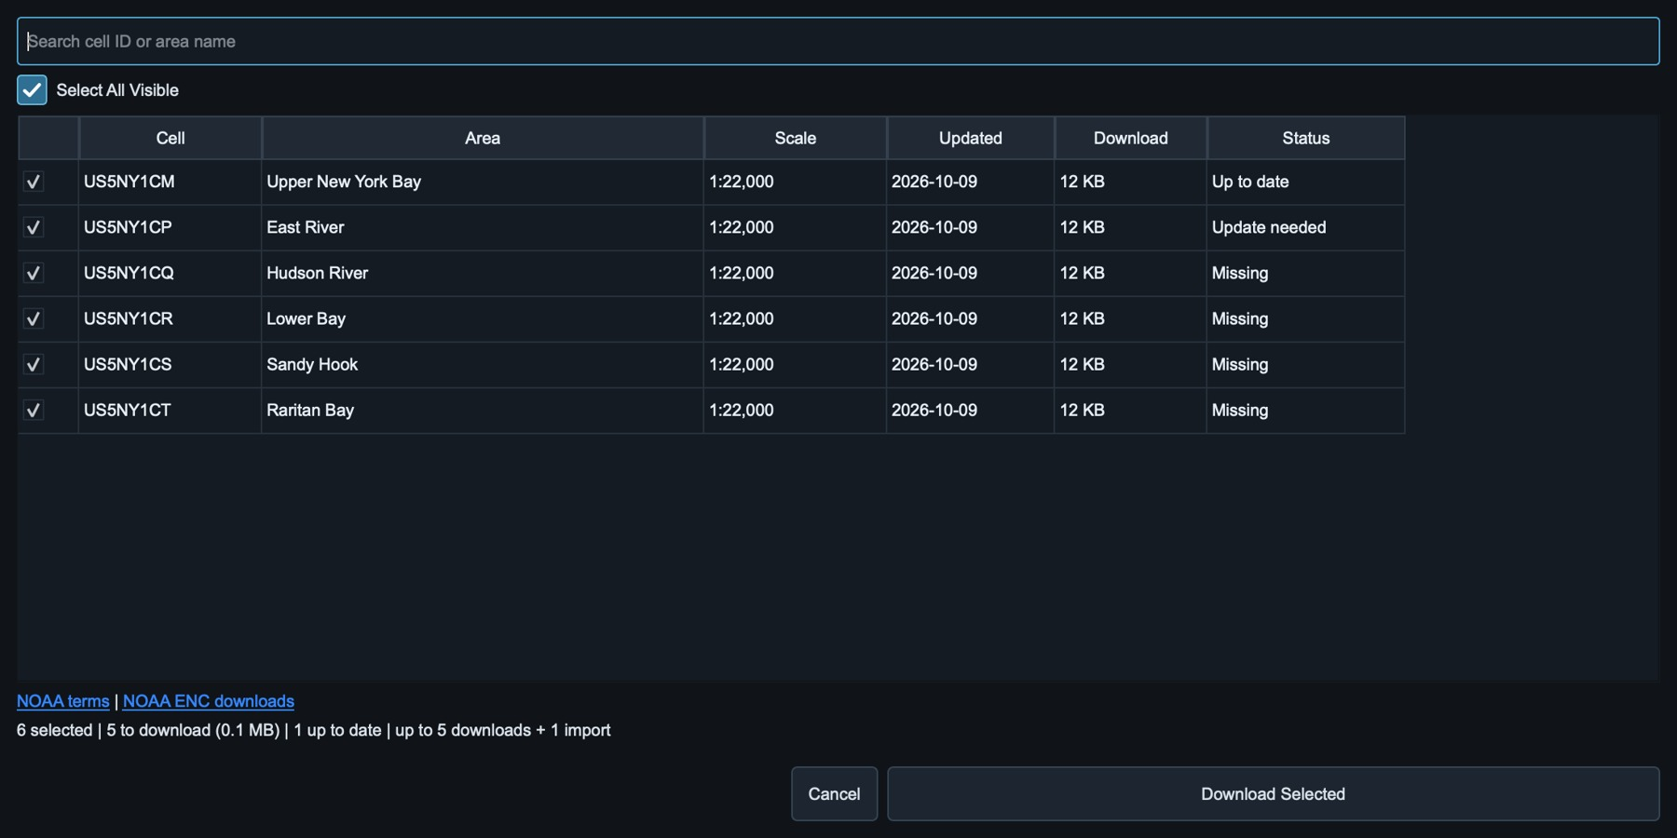
Figure 37. Example NOAA selection with Missing, Update needed and Up to date states. Download Selected skips current cells, including hidden selections.
2. Press Download Selected and confirm required ZIP downloads above 100 MiB. Up to five downloads feed one importer, with at most ten cells staged ahead. Verified HTTPS connections are reused. ZIPs are removed after import; stored geometry size differs from ZIP size. Scroll the list during work. Cancel retains completed imports and existing charts, discards unimported ZIPs and rolls back an unfinished import. The next run skips completed current cells. Individual failures do not stop later cells; inspect the final summary before assuming completion.
3. Check issue date, edition/update and source. Enable cells needed for the demonstration, select S-57 (Experimental), and inspect the area. Download/NOAA renewal needs Internet; local imports and installed charts work offline.

Use charts offline and transfer them
Capture Map & Layers and Offline separately for unattended chart/network settings. Configurations reference cell IDs but do not contain the ENC database, stored under the user configuration directory. Transfer original .000/update files or exchange-set ZIPs by USB and import on the destination; Protomaps Export Selected does not export S57 charts.
S57 supplies the AIS Avoid Land mask when S-57 is the selected source. Enable the relevant detailed cells and allow background preparation of the Generated AIS region; Protomaps is not required for this path. Display zoom and layer changes do not select a different avoidance scale. Experimental masks and portrayal are not complete S-52, certified ECDIS or navigation equipment. Never use them to assess safe water.
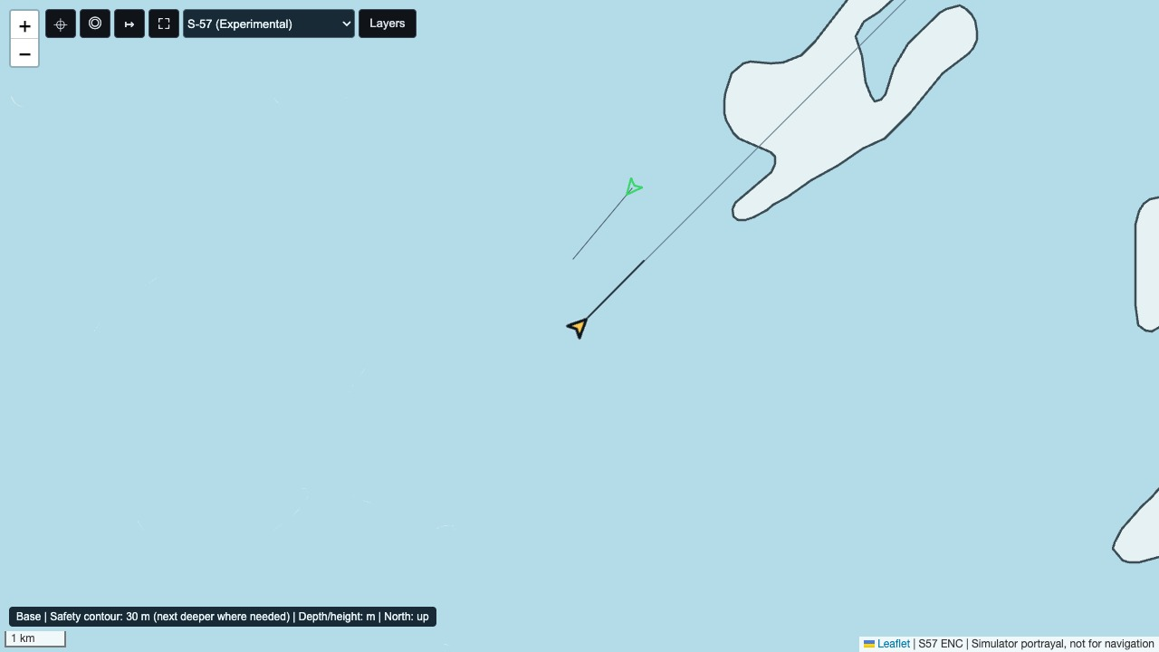
Figure 38. Example S57 Base portrayal retains depth areas and the safety contour; its limited simulator presentation is not a certified navigation display.

Experimental chart symbols
S57 uses simplified S-52-oriented portrayal, not the complete IHO Presentation Library. Aids, lights, hazards, traffic lanes, anchorages, restrictions, cables and pipelines have distinct symbols, lines or annotations. Landmarks, radar reflectors, pontoons, floating and dry docks, gates, hulks, weed/kelp, marine farms, dumping grounds and service/signal stations also have simplified marks. Unknown objects remain generic; symbols do not imply a certified ECDIS display.

Interpreting depth colours
Depth & Safety selects a requested safety contour and a separate safety depth. Each chart uses the next available depth contour or encoded depth-area boundary at or deeper than the request. The effective value is shown in the object popup; a map status explains substitutions and missing contours. Adjacent cells may therefore legitimately have different water colours. Missing contours are not silently reported as available.
Blue indicates a depth area's minimum is below the effective contour or unknown; pale water indicates its minimum is at or above it. A 13 m sounding inside a 0-15 m area does not make the whole area deep water. Dredged areas use their own minimum depth and are drawn above ordinary depth areas. Safety depth emphasizes soundings and hazards; it does not recolour whole areas. Avoid Land uses independent raw land/water geometry, not these colours. There is no grounding alarm or navigational safety guarantee.
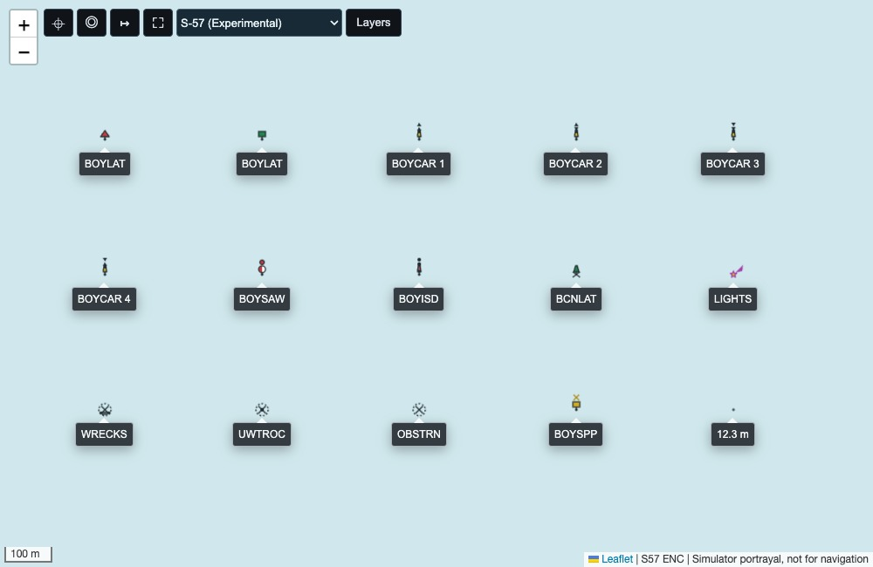
Figure 39. Symbol examples: lateral/cardinal buoys, safe-water and isolated-danger marks, beacon, light, hazards and sounding position. Cardinal numbers 1 to 4 mean north, east, south and west.

18. Diagnostics and Troubleshooting
Symptom | Checks and corrective action
Own ship does not move | Check active mode, speed/telegraph, Simulation Time and whether an external source is stale.
No output at receiver | Check sentence enabled state, selected path, destination/bind role, port, local interface, firewall and Output Monitor.
Multicast visible in Wireshark but not app | Verify group, port and matching sender/receiver adapters. On the same computer, select the receiver loopback adapter where supported; a successful sender send operation alone does not prove local application reception.
TCP client remains red | Confirm one side is Server and listening; verify reachable host/port and firewall. A simulator server waits for the remote client to reconnect.
Serial gaps | Reduce rates, inspect Port load, confirm baud and avoid transmitting unnecessary sentences.
ROR/RSA lamp grey | Sentence/checksum is valid but that PORT/STBD field is empty. Check source sentence topology.
Live AIS connected, no targets | Connection alone is insufficient. Check subscription sent, frame count, valid report count, provider coverage and credentials.
More AIS lines than target limit | The limit counts unique MMSIs; each target can send position plus multi-fragment static/voyage reports.
3D 403 | Check API key, enabled API, restrictions, quota/billing account and provider selection. No key is embedded in the build.
3D slow on 8 GB host | Use Auto/Low Memory, close heavy applications or VM where possible, lower target count and prefer the detached single view.
Ubuntu GLIBC error | Use a matching Ubuntu build; on 22.04 use the source build script. AppImage does not remove GLIBC requirements. Do not replace system GLIBC.
Application will not start | Open the rotating startup.log in the user configuration logs directory and verify package architecture/dependencies.
Serial ROR/RSA makes the UI slow | Use version 2.1.10 or newer. Confirm the selected device, baud, parity and stop bits; inspect View Port for repeated invalid-status or malformed sentences. The event-driven input worker should keep the UI responsive even at 4800 baud or while the adapter is idle.
Offline AIS cannot be placed or stops | Check Avoid Land coverage: selected S57 cells or saved Protomaps water geometry. Allow regional preparation before generation; zoom does not change the S57 avoidance source. Inspect failed-tile status. Disable Avoid Land only when land crossing is acceptable. Check speed and output filters separately.
Offline map is blank | Enable Offline mode and check that the map package exists on this computer. Download areas while online, or use Export Selected / Import Areas to transfer saved coverage. Outside coverage a schematic coastline is shown; Google 3D remains online-only.
NOAA renewal reports skipped/failed cells | Other selected cells continue. Installed failed/skipped charts are retained. Retry failed downloads; reimport original files for local or withdrawn cells absent from the active NOAA catalogue.
Large offline export appears inactive | Check background transfer progress and destination space/write access. Do not disconnect USB media until completion. Cancel safely before retrying; configurations do not embed map data.
Table 19. Symptom-led troubleshooting.

18.1 Packet capture method
- Capture on the interface carrying the traffic: physical bridge adapter for remote equipment, or the selected loopback/local capture interface for same-host tests.
- Filter by UDP/TCP port, source, destination or multicast group.
- For gaps, compare simulator Output Monitor timestamps with packets on the wire and receiver timestamps.
- For TCP, inspect SYN/SYN-ACK/ACK, resets, retransmissions and which side closes the connection.
- For IEC sentences, verify delimiters, null fields and checksum independently from the network checksum.

18.2 Performance Monitor
Open About > Performance Monitor. Recent UI/simulation/track timing, output-worker timing and transport errors drive health warnings. UDP/TCP sentence count alone is not a serial bandwidth limit; active serial outputs are compared with their actual baud rate and framing. Memory shows current resident RAM for the application and child processes when available, including WebEngine. Shared pages may be counted more than once; main-process peak RAM is the fallback when current data is unavailable. Technical details include available RAM, swap activity and cache budgets; they refresh slowly and retain the scroll position.
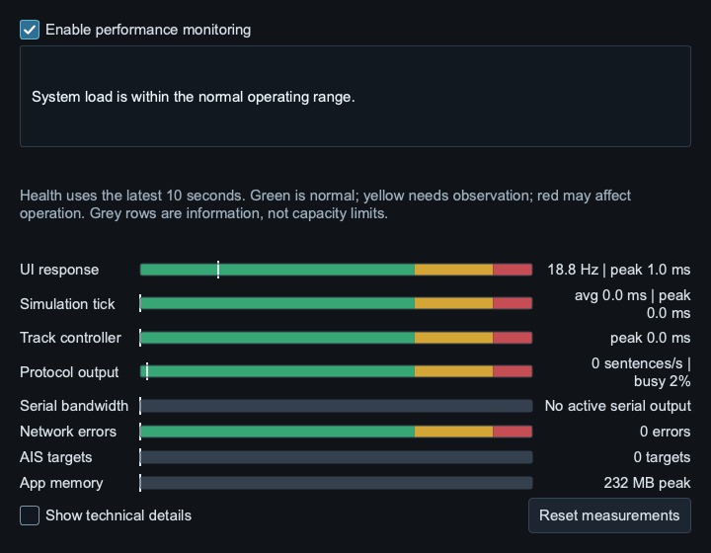
Figure 40. Performance Monitor separates network-output health from serial bandwidth and informational AIS/memory figures.

18.3 Serial input diagnostics
For a USB-to-RS422 adapter, confirm the operating-system device, 4800 baud or the sender's configured rate, parity and stop bits. View Port should show complete ROR/RSA sentences while the four channel lamps show validity and age. On Ubuntu, verify device access for the logged-in user. A repeated invalid rudder-order status normally indicates status V or an empty required field in the source sentence; it is not converted into a valid model command.

Appendix A. Address reference
Term | Definition
Bind address | Local listening address, not the remote sender/server. 0.0.0.0 listens on all local IPv4 adapters; 127.0.0.1 accepts this computer only; a specific local IP restricts the listener to that adapter. TCP clients use the server computer's actual IP, never 0.0.0.0.
Interface IP | Local adapter used for multicast. Empty lets the OS choose its route; a local adapter IP selects that interface explicitly. Do not enter the remote sender address.
Multicast group | Shared destination in 224.0.0.0/4 joined by receivers.
Destination | Remote unicast/broadcast/multicast address for output.
TTL | Maximum multicast routing hops; normally 1 on a local bridge network.
Table 20. Network terminology.

Appendix B. Abbreviations
Term | Meaning
AIS | Automatic Identification System
COG | Course Over Ground
DTG / TTG | Distance / Time To Go
HDG | Heading
IBS | Integrated Bridge System
IEC 61162 | Maritime navigation and radiocommunication data interface family
MMSI | Maritime Mobile Service Identity
ROR | Rudder Order
ROT | Rate Of Turn
RSA | Rudder Sensor Angle
RTZ | Route Plan Exchange Format
SOG / STW | Speed Over Ground / Speed Through Water
VDM / VDO | AIS received-target / own-vessel encapsulation sentences
WOP | Wheel-Over Point
XDR | Transducer measurement sentence
XTE | Cross-Track Error
CPA | Closest Point of Approach
TCPA | Time to Closest Point of Approach
Table 21. Abbreviations used in the application and this guide.

Appendix C. Licensing Privacy and Support
Original project code and documentation are available under the Mozilla Public License 2.0. Third-party software, charts and service data retain their own licenses. Read LICENSE, NOTICE and THIRD_PARTY_NOTICES with the source/downloads. No paid signing certificate or purchase is required to use the simulator. The optional book support does not unlock features.
Configuration exports can include Google and AISstream API keys and BarentsWatch client credentials. Treat those files as sensitive. Do not attach them unredacted to a public issue. Online providers receive requests relevant to location, subscriptions or weather; offline mode pauses the application's Internet-backed features but is not an operating-system firewall.
Report problems with application version, operating system, display scale, RAM, map source, transport settings and repeatable steps. Remove credentials and private equipment details from screenshots and logs. Supporting the author's book is optional; it does not unlock features.
Version 2.3.0 is the public source baseline. This guide incorporates the former bow-thruster/external-input addendum; no companion addendum or vendor integration manual is required. Some unchanged map/workflow screens show the shared 2.2.x interface. Package availability and platform qualification are stated on the release page. Maintenance is best effort, without promised response times or future releases.

References
Book support: https://mybook.to/MaritimeKnowledgeBites
Project source and release information: https://github.com/p2htf65ggk-bit/maritime-ship-simulator
MPL 2.0: https://www.mozilla.org/en-US/MPL/2.0/
Apple guidance for unsigned applications: https://support.apple.com/en-us/102445
IHO S-52 publications: https://iho.int/en/standards-and-specifications
OpenStreetMap attribution and licence: https://www.openstreetmap.org/copyright
NOAA ENC downloads: https://www.charts.noaa.gov/ENCs/ENCs.shtml

