# Tailwind css installation process

* Installing tailwind css

npm install -D tailwindcss postcss autoprefixer

* Initialize the tailwindcss

npx tailwindcss init –p

* Update the tailwind.config.js file reference from <https://tailwindcss.com/docs/guides/nextjs>

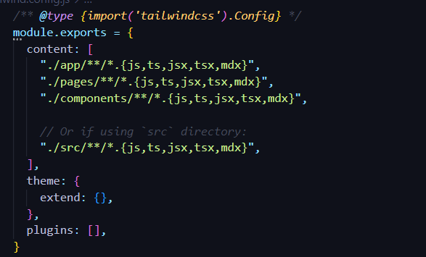

* Update the globals.css file

