Abstract

In this project, we are focusing on implementation of BitTorrent like file sharing protocol which operates in a peer-to-peer fashion. Here, all the files are stored on client side called peers and server would handle only the metadata of the files. The file will be transferred on the network among peers using a direct connection without any server involvement. The server will only co-ordinates this transfer. The data to be shared is divided into many equal-sized portions called chunks. All peers interested in sharing this data re grouped together, each of which is managed by a central entity named the tracker. Each peer independently finds a file called torrent, that contains information of the tracker along with hash of each chunk. Peers keep each other updated on the status of their download. Peer download from other peers who claim they have corresponding data. Once a peer has a chunk, it will send a signal of 'owned chunk' to the trackers as a representation of availability of specified chunk.

Introduction

Peer-to-Peer file sharing systems have become ubiquitous these days and at present it has become one of the most popular concept in the computer science field. P2PShare is a distributed application architecture that partitions workload or file in between peers. BitTorrent is one of the most popular protocol for file sharing. It provides an advantage as when multiple downloads of the same file take place at same time, the downloaders or peers upload to each other, making it possible for the file source to support very large number of peers with modest increase in load. The objective of our project is to implement a subset of bitTorrent functionalities as breaking a file into pieces and sharing those pieces called chunks among peers.

The application achieves a higher level of resource utilization as compared to current known cooperative techniques. It works by grouping peers with common interest in specific file download. These peers cooperate with one another in order to speed up the download process. This is what has made a big difference between P2PShare and other conventional file transfer methods.

BitToreent protocol make it possible to distribute large amounts of data without the need of high capacity server and expensive bandwidth. As the transfer of files doesn't depends upon a single source , it is distributed across number of such sources. Here, the sources as well as peers are responsible for file sharing. This makes the workload evenly distributed across peers and it will partially free the source from this process which will eventually reduce the network traffic.

Motivation

The project “P2PShare” aims at designing and the implementation of a synchronized multi-threaded concurrent server-client file sharing application. The server is designed in a way to support more than one users and the main motivation behind the application is to provide communication between different clients (or peers). The concurrency feature of server ensures that the number of clients at any point will not be an issue for the server.

The application is real time implementation of file sharing between different clients over a network. The file sharing service is managed by server which is concurrent and multi-threaded in nature. A server is said to be concurrent if it handles more than one request from peer or client at same time. If the server is non-concurrent, then blockage of resources will happen and the application will fail to achieve its objective and will be non-efficient. Multi-threading will provide a separate thread to each and every request initiated by client. Both, multi-threading and concurrency helps the application to achieve efficiency and file delivery in a timely manner.

Components of P2PShare
1. Registry (server)
The registry act as a directory of all files on the network. Each record of a file will have the md5 sum of the file and its chunks. It will keep a list of the trackers tracking the file. The major function of registry will be to maintain the search of shares and to add a share in the registry when not present.

2. Tracker (server)
The tracker will coordinate file transfer and manage chunks distribution at the size of 4 megabyte for
each chunk among peers. Tracker is the server that assists in the communication between peers using the bitTorrent protocol. It traces out a client or peer list that participate in the network. Moreover, peers know nothing about each other until a response is received from the tracker. Peers connect to the tracker to obtain the related information about the file which they want to download. The tracker role ends, once peers get to know about each other. From then, the communication took place directly between the peers and there will be no involvement of tracker in the network.

Its main role is to allow peers to find peers with data they require and start communication. Whenever a peer contacts the tracker, it reports the chunks of a file they have. Same way, when another peer inquire the tracker, it provides a list of peers who are participating in the torrent and have the required chunk.
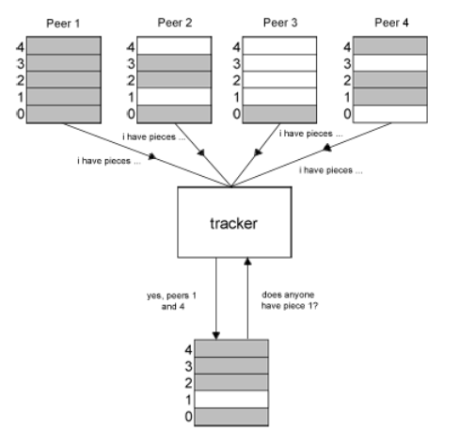

FIG. 1 A tracker provide peers with require files

3. Peer (client and server)
Peers are the participating users having partial or complete file. Chunks are requested from peers but depending on peer status they are not guaranteed to be sent. A peer will register itself to a tracker with any chunks of the file it has. To get new chunk of a file, it will request it to a tracker and the tracker will respond with a list of its availability among peers. The peer will then connect to the peer with the available chunk and download it. Once a peer has a chunk, then it will send a signal of ‘owned chunk’ to the trackers as a representation of availability of a specified chunk. BitTorrent make use of TCP I.e Transmission Control Protocol to send messages and data between the peers.

