School of Webcraft – coding the design
We created the graphic design using the Gimp. This is the result of our efforts:
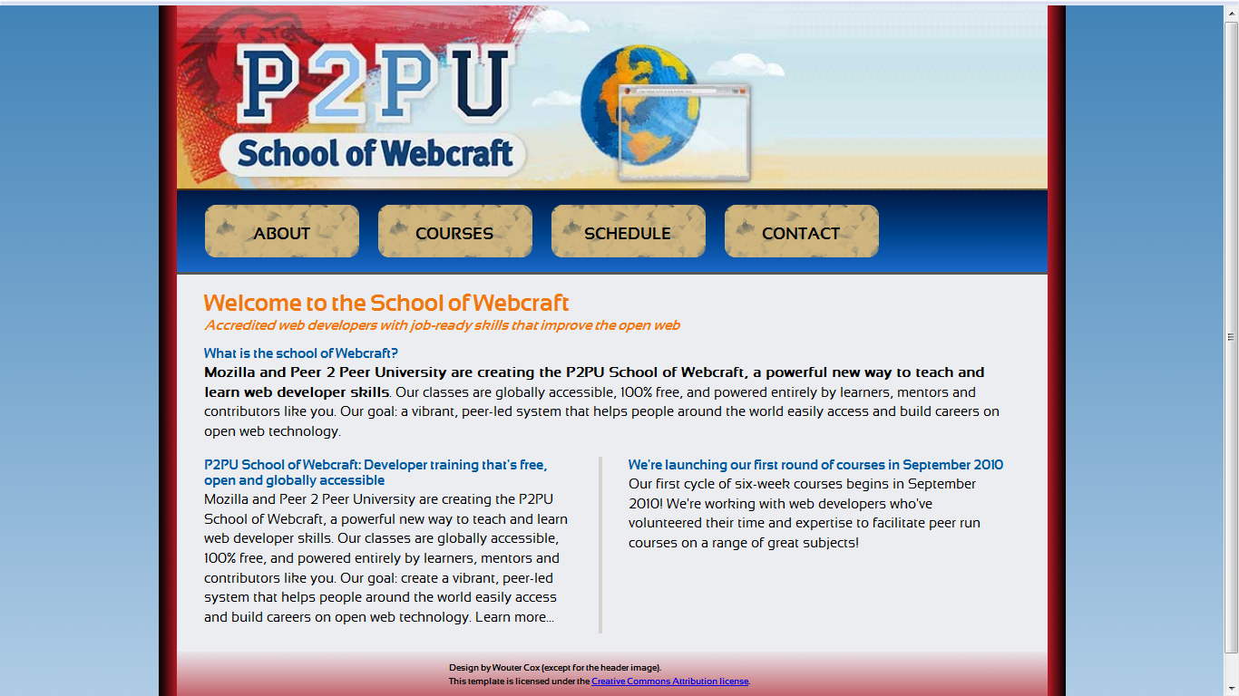
We are going to code this design in three steps:
- Coding the HTML
- Styling the major blocks
- Applying the images

Coding the HTML
When coding a page, try to think of the parts of the website as if they were building blocks, you know, the ones you perphaps played with as a kid. Only in a webpage, the blocks do not stack from bottom to top, but from top to bottom. You will soon see what I mean.
The very first thing to do then, is to identify the major building blocks. In my case, I have the following:
- a header
- a menu bar
- a content area, which I will call the 'body' and its content then is the 'body content'
- a footer

In HTML, you can create those building blocks using several tags. But when it comes to page lay-out, you should lay out the major building blocks using DIV tags. These will be unique on the page, which is why we will identify each one of them using the ID attribute. This will allow us to select and style that block in the CSS code.
We will code using the HTML strict DOCTYPE. That means that the following code will be your starting point:
<!DOCTYPE html PUBLIC "-//W3C//DTD XHTML 1.0 Strict//EN" "http://www.w3.org/TR/xhtml1/DTD/xhtml1-strict.dtd">
<html xmlns="http://www.w3.org/1999/xhtml" xml:lang="nl">
<head>
<meta http-equiv="Content-Type" content="text/html;charset=UTF-8" />
<title>School of Webcraft</title>
</head>
<body>

</body>
</html>

Now we will put our 'building blocks' (the DIVs) inside the body tags:

<!DOCTYPE html PUBLIC "-//W3C//DTD XHTML 1.0 Strict//EN" "http://www.w3.org/TR/xhtml1/DTD/xhtml1-strict.dtd">
<html xmlns="http://www.w3.org/1999/xhtml" xml:lang="nl">
<head>
<meta http-equiv="Content-Type" content="text/html;charset=UTF-8" />
<title>School of Webcraft</title>
</head>
<body>
<div id="header">Header</div>
<div id="menu">Menu</div>
<div id="body">Body Content</div>
<div id="footer">Footer</div>
</body>
</html>

Take a look at it in the browser window. Does not look like much yet, but remember, we will style it in the next chapters. Notice how each of the blocks 'stacks' below its previous block? Elements that behave this way are called 'block level' elements. DIV is a block level element, but so it the P (paragraph) tag, which is why subsequent paragraphs break off and have spacing between them. Element that instead occupy the element they are in are called inline elements. A couple of those tags are span, strong, em, and a.
For the text inside the header, we will use h1 (heading level 1). In fact, this is a big image, but we will use a trick later to replace the text with the image, yet making sure that text remains accessibly for screen readers or when images are turned off. You'll see in the final chapter.
The menu is a little trickier, but essentially what we have here is a list of navigation links, so we will use the unordered list (UL) tag with the list tag (LI) for each link.
For the body content, we have a heading followed by a paragraph. Below that, two heading+paragraph blocks side by side. For now, all of those will be placed below each other. For the headings, we will use h2 (heading level 2, a sort of 'subtitle' of h1). An for the paragraphs, we'll use plain old P tags. We'll use those same P tags for the Footer.
This gives us the following code:
<!DOCTYPE html PUBLIC "-//W3C//DTD XHTML 1.0 Strict//EN" "http://www.w3.org/TR/xhtml1/DTD/xhtml1-strict.dtd">
<html xmlns="http://www.w3.org/1999/xhtml" xml:lang="nl">
<head>
<meta http-equiv="Content-Type" content="text/html;charset=UTF-8" />
<title>School of Webcraft</title>
</head>
<body>
<div id="header"><h1>P2PU: School of Webcraft</h1></div>
<div id="menu">
<ul>
<li><a href="#">Link 1</a></li>
<li><a href="#">Link 2</a></li>
<li><a href="#">Link 3</a></li>
<li><a href="#">Link 4</a></li>
</ul>
</div>
<div id="body">
<h2>Title of the first paragraph</h2>
<p>The first paragraph</p>

<h2>Title of the second paragraph</h2>
<p>The second paragraph</p>

<h2>Title of the third paragraph</h2>
<p>The third paragraph</p>

</div>
<div id="footer"><p>The Footer</p></div>
</body>
</html>
Let's now fill the tags with their appropriate content:

<!DOCTYPE html PUBLIC "-//W3C//DTD XHTML 1.0 Strict//EN" "http://www.w3.org/TR/xhtml1/DTD/xhtml1-strict.dtd">
<html xmlns="http://www.w3.org/1999/xhtml" xml:lang="nl">
<head>
<meta http-equiv="Content-Type" content="text/html;charset=UTF-8" />
<title>School of Webcraft</title>
</head>
<body>
<div id="header"><h1>P2PU: School of Webcraft</h1></div>
<div id="menu">
<ul>
<li><a href="#">Link 1</a></li>
<li><a href="#">Link 2</a></li>
<li><a href="#">Link 3</a></li>
<li><a href="#">Link 4</a></li>
</ul>
</div>
<div id="body">
<h2>Welcome to the School of Webcraft</h2>
<h3>Accredited web developers with job-ready skills that improve the open web </h3>

<h2>What is the school of Webcraft?</h2>
<p>Mozilla and Peer 2 Peer University are creating the P2PU School of Webcraft, a powerful new way to teach and learn web developer skills. Our classes are globally accessible, 100% free, and powered entirely by learners, mentors and contributors like you. Our goal: a vibrant, peer-led system that helps people around the world easily access and build careers on open web technology.</p>

<h2>P2PU School of Webcraft: Developer training that's free, open and globally accessible </h2>
<p>Mozilla and Peer 2 Peer University are creating the P2PU School of Webcraft, a powerful new way to teach and learn web developer skills. Our classes are globally accessible, 100% free, and powered entirely by learners, mentors and contributors like you. Our goal: create a vibrant, peer-led system that helps people around the world easily access and build careers on open web technology. Learn more...</p>

<h2>We're launching our first round of courses in September 2010</h2>
<p>Our first cycle of six-week courses begins in September 2010! We're working with web developers who've volunteered their time and expertise to facilitate peer run courses on a range of great subjects!</p>

</div>
<div id="footer"><p>Design by Wouter Cox (except for the header image, which is copyright its respective creator).
Except for the header image, this template and its images are free for you to use and adapt.</p></div>
</body>
</html>

As you can see, I added a h3 tag as a subtitle to the first h2 ('Welcome to the School of Webcraf').
Believe it or not, but this code is (almost) all we need to create the final page. I say almost, because we need a couple of extra divs. Take a look at the design again and notice that everything on the page is center inside one wide column with red borders. For this column, we will need another DIV that goes around all of the other DIVs. And for the two-column effect in the body area, we also need a few extra DIVs: a DIV which we'll give an id of 'leftcol' for the left column, a DIV we'll give an id of 'rightcol' for the right column and a DIV as a container for these two, which'll have an id value of 'twocols'.
When assigning the id values, be careful, as those are case sensitive in CSS. So 'twoCols' (which we will use) is NOT the same as 'twocols'. We also want to emphasize the first sentence of the first paragraph. To do that, we'll use STRONG tags. These are used for 'strong emphasis'. For 'normal' emphasis, we can use EM tags.

The code now becomes:

<!DOCTYPE html PUBLIC "-//W3C//DTD XHTML 1.0 Strict//EN" "http://www.w3.org/TR/xhtml1/DTD/xhtml1-strict.dtd">
<html xmlns="http://www.w3.org/1999/xhtml" xml:lang="nl">
<head>
<meta http-equiv="Content-Type" content="text/html;charset=UTF-8" />
<title>School of Webcraft</title>
</head>
<body>
<div id="centralCol">
<div id="twoCols">
<div id="header"><h1>P2PU: School of Webcraft</h1></div>
<div id="menu">
<ul>
<li><a href="#">Link 1</a></li>
<li><a href="#">Link 2</a></li>
<li><a href="#">Link 3</a></li>
<li><a href="#">Link 4</a></li>
</ul>
</div>
<div id="body">
<h2>Welcome to the School of Webcraft</h2>
<h3>Accredited web developers with job-ready skills that improve the open web </h3>

<h2>What is the school of Webcraft?</h2>
<p>Mozilla and Peer 2 Peer University are creating the P2PU School of Webcraft, a powerful new way to teach and learn web developer skills. Our classes are globally accessible, 100% free, and powered entirely by learners, mentors and contributors like you. Our goal: a vibrant, peer-led system that helps people around the world easily access and build careers on open web technology.</p>

<div id="twoCols">
<div id="leftcol">
<h2>P2PU School of Webcraft: Developer training that's free, open and globally accessible </h2>
<p>Mozilla and Peer 2 Peer University are creating the P2PU School of Webcraft, a powerful new way to teach and learn web developer skills. Our classes are globally accessible, 100% free, and powered entirely by learners, mentors and contributors like you. Our goal: create a vibrant, peer-led system that helps people around the world easily access and build careers on open web technology. Learn more...</p>
</div>

<div id="rightcol">
<h2>We're launching our first round of courses in September 2010</h2>
<p>Our first cycle of six-week courses begins in September 2010! We're working with web developers who've volunteered their time and expertise to facilitate peer run courses on a range of great subjects!</p>
</div>
</div>

</div>
<div id="footer"><p>Design by Wouter Cox (except for the header image, which is copyright its respective creator).
Except for the header image, this template and its images are free for you to use and adapt.</p></div>
</div>
</div>
</body>
</html>

And that's it! That's basically all the HTML we will need for our webpage.

Styling the major blocks
Next thing to do: style the page using CSS. We actually need to create a stylesheet for this, so create a CSS file called 'webcraft.css' in the same folder your html file is in, and create a link to it in your HTML page between the HEAD tags. Like so:

<head>
<meta http-equiv="Content-Type" content="text/html;charset=UTF-8" />
<title>School of Webcraft</title>
<link rel="stylesheet" type="text/css" href="webcraft.css" media="all" />
</head>

