Welcome to this discussion for the DLMOOC preview discussion of Academic Mindsets.
This collaborative document is a place for us all to record notes. There is also a chat space to the right.
This pad text is synchronized as you type, so that everyone viewing this page sees the same text.
Guests on our panel today:
- Rob Riordan, High Tech High - moderator
- Eduardo Briceño, CEO of Mindset Works
- Camille Farrington, Research Associate (Assistant Professor) at the University of Chicago, School of Social Service Administration (SSA)
- Carissa Romero, Stanford University, Department of Psychology
More resources on DLMOOC and Academic Mindsets available at the DLMOOC web site http://dlmooc.deeper-learning.org/
Great report from Camille and her colleagues: http://ccsr.uchicago.edu/publications/teaching-adolescents-become-learners-role-noncognitive-factors-shaping-school
Mindset assessment tools:
- Test your mindset from Carol Dweck http://mindsetonline.com/testyourmindset/step1.php
- What’s my mindset? from Mindset Works (ages 12 and up) http://community.mindsetworks.com/my-mindset?force=1
- What’s my classroom mindset? from Mindset Works (educator oriented) http://community.mindsetworks.com/classroom-mindset?force=1
- What’s my school’s mindset? from Mindset Works (educator oriented) http://community.mindsetworks.com/whats-my-school-mindset-survey?force=1
- The Mindset Self- Assessment from Global Innovations (career oriented) http://www.globalnovations.com/powerofchoicefiles/pdfs/POC_ChapterEndAssessments_2_MindsetAssessment.pdf
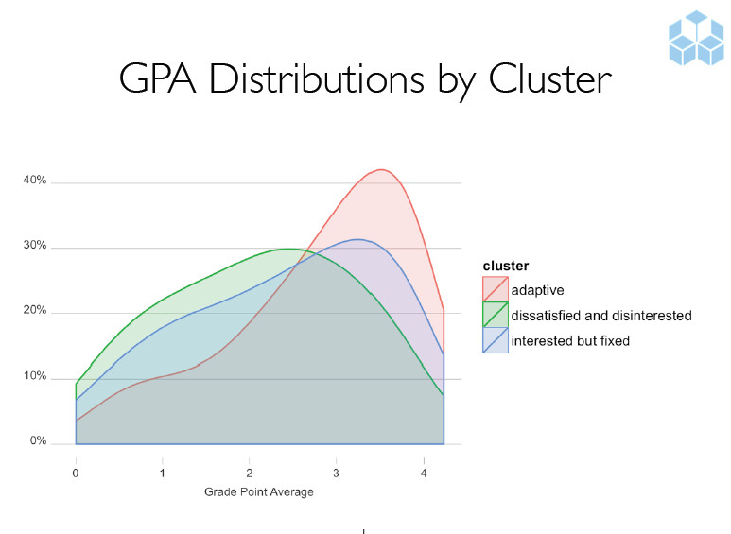
Source: Paunesku, D. (2013). Psychology at scale: Raising achievement with online psychological interventions. Social Lab, Stanford, CA.

More notes and conversations at our G+ community at https://plus.google.com/u/1/communities/109999014963590178695

